CSE0001 – Digital Literacy
Task 3 – Coding & Collaboration Platforms
Name: Aadi Agarwal | Reg No: 22BCE11517 | Branch: CSE | VIT Bhopal

This document covers Task 3 of the CSE0001 Digital Literacy project. It is divided into two parts — Part A covers a coding challenge completed on HackerRank, and Part B covers a Digital Literacy Awareness Quiz created using Google Forms.

Part A – Coding Practice (HackerRank)
- Platform: HackerRank (hackerrank.com)
- Challenge: Java STDIN and STDOUT — reading integers from standard input and printing them
- Language used: Java
- Result: Challenge successfully solved — earned 5.00 points, 32% progress toward Java badge (8/25)
- Both test cases passed with 'Success' status
Screenshot – HackerRank Completed Challenge:
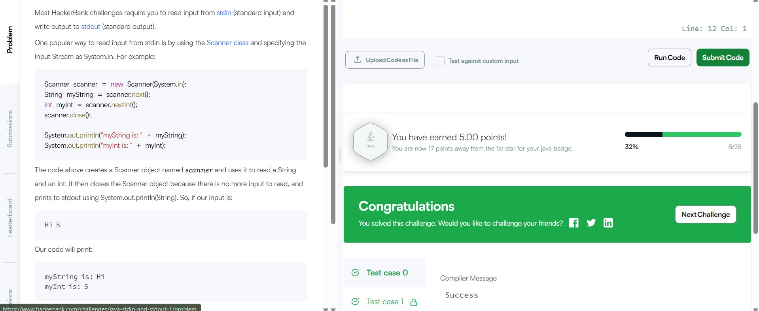

Part B – Google Form (Digital Literacy Awareness Quiz)
- Tool used: Google Forms (forms.google.com)
- Form title: Digital Literacy Awareness Quiz
- Total questions: 5 (4 Multiple Choice + 1 Short Answer)
- Created using VIT Bhopal college Google account
- Responses linked to a Google Sheet automatically via the Responses tab
Questions included in the form:
- Q1 (MCQ): What does 'Digital Literacy' mean?
- Q2 (MCQ): Which of the following is a safe internet practice?
- Q3 (MCQ): A website URL beginning with 'https://' is safer than 'http://' because:
- Q4 (MCQ): Which platform is best suited for showcasing your coding projects?
- Q5 (Short Answer): What is the purpose of a GitHub README file?
Screenshot – Google Form (Questions 1 & 2):
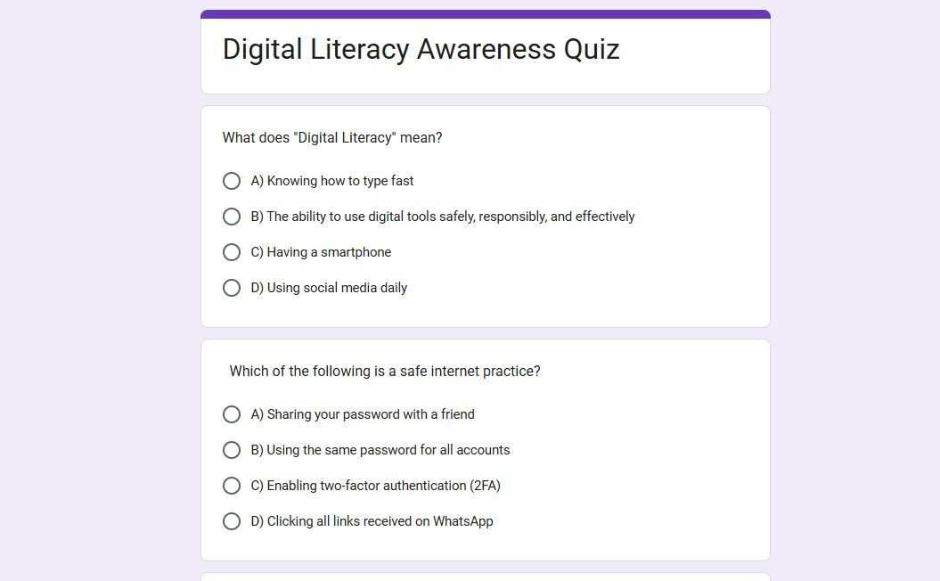
Screenshot – Google Form (Questions 3, 4 & 5):
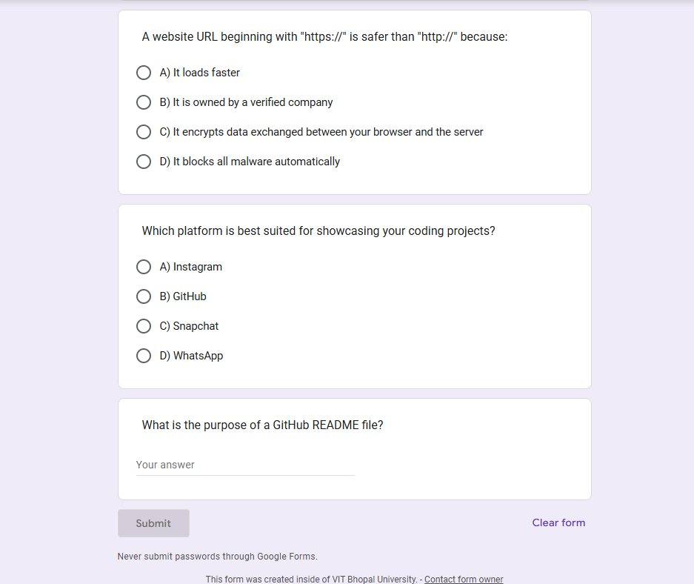

Summary
In Part A, I completed a Java coding challenge on HackerRank that involved reading integers from standard input and printing them to standard output. This helped me understand how programs interact with user input — a fundamental programming concept. In Part B, I created a 5-question Digital Literacy Awareness Quiz using Google Forms with my college account. The form includes multiple choice and short answer questions covering key topics like cybersecurity, platform awareness, and digital tools. Both the form and the linked Google Sheet response view have been set up successfully. These tools will be highly useful academically — HackerRank for consistent coding practice and Google Forms for conducting surveys and quizzes in collaborative projects.

