CSE0001 – Digital Literacy
Task 2 – Student Digital Portfolio
Name: Aadi Agarwal | Reg No: 22BCE11517 | Branch: CSE | VIT Bhopal

For Task 2, I set up professional digital profiles on three platforms: GitHub, Kaggle, and HackerRank. Screenshots of each profile are documented below along with a brief description of each platform.

1. GitHub Profile
- Platform: github.com
- Username: aadi8906
- Repository: 22BCE11517 (Profile README)
- The README includes my name, branch, year, college email, and learning goals.
Screenshot:
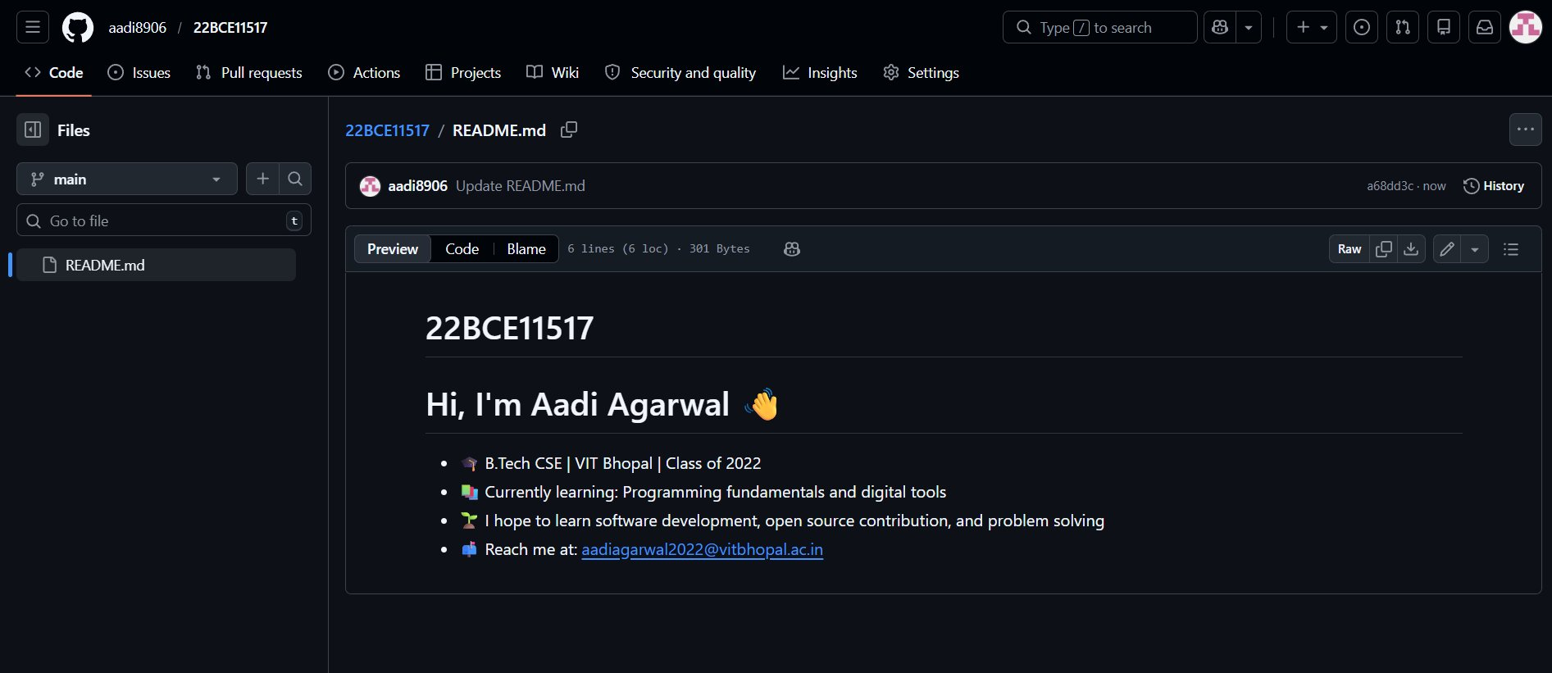

2. Kaggle Profile
- Platform: kaggle.com
- Username: Aadi2022
- Kaggle is a data science platform for competitions, datasets, and notebooks.
- Account is newly created and active with a 1-day login streak.
Screenshot:
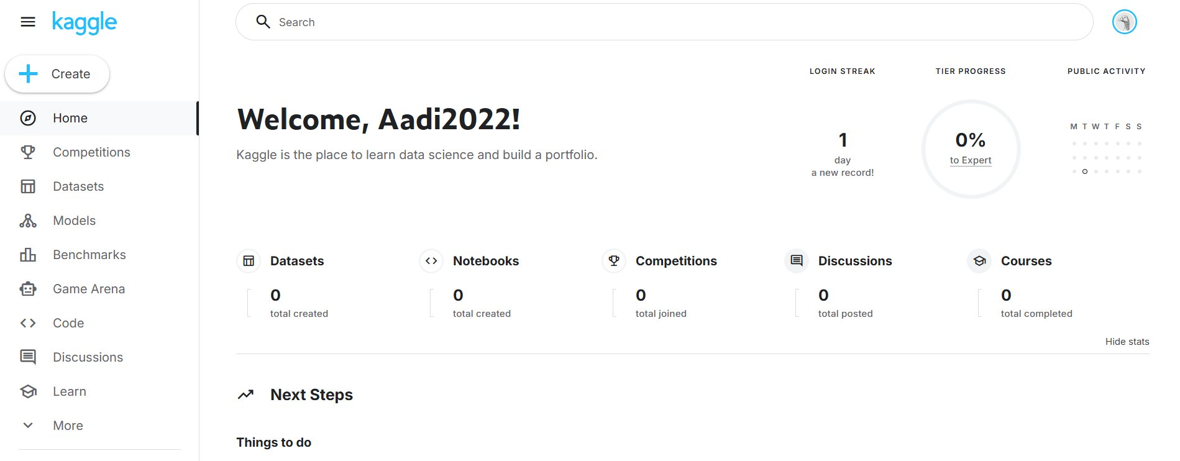

3. HackerRank Profile
- Platform: hackerrank.com
- Username: @aadiagarwal2022
- Email: aadiagarwal2022@vitbhopal.ac.in | Location: India
- HackerRank is used for coding practice, skill badges, and certifications.
Screenshot:
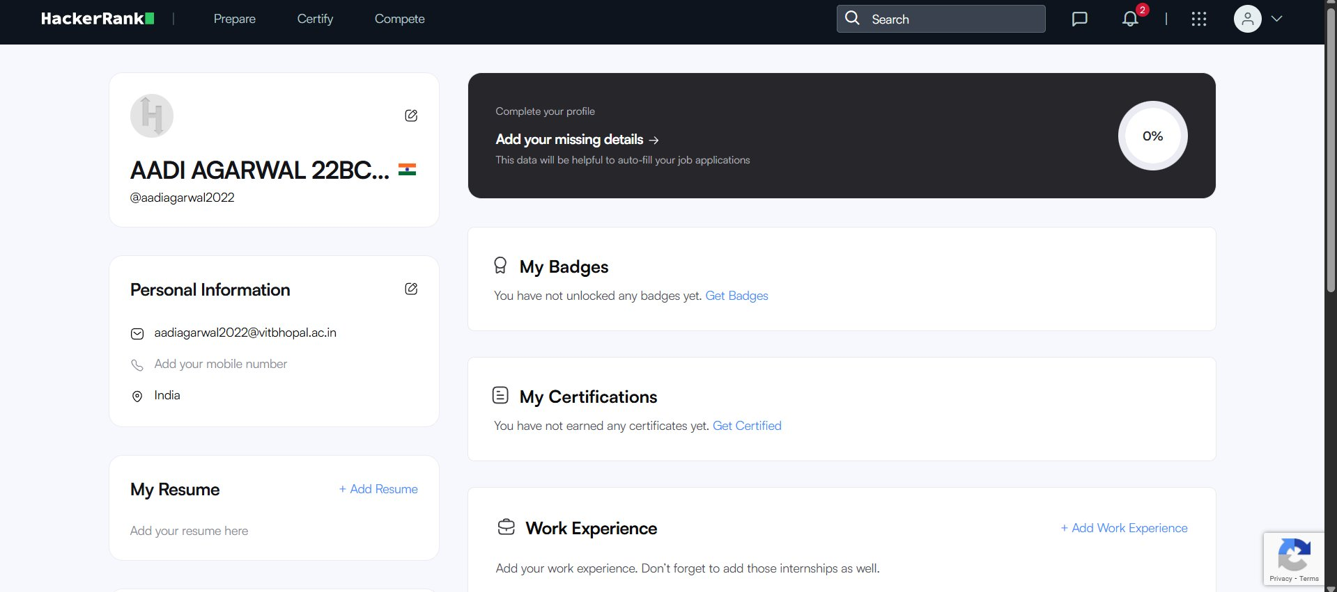

Summary
All three platforms have been successfully set up using my college email address. Profiles are kept professional and minimal as required. These platforms will form the foundation of my digital portfolio throughout my B.Tech journey.

