Step 1 — Open Google Colab
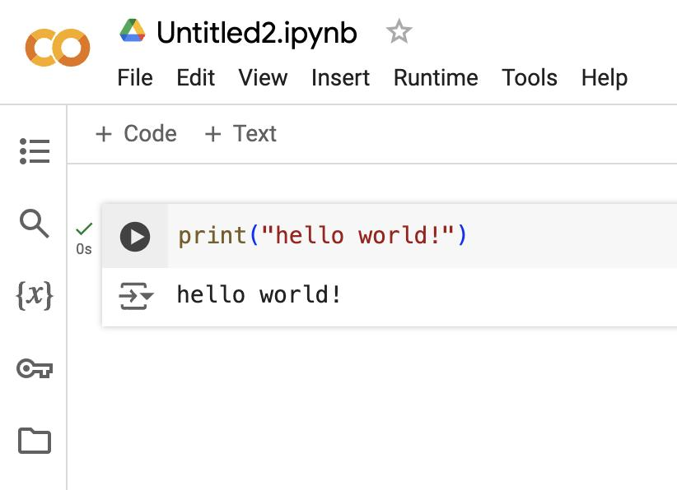
Open Google Colab.
Sign in with your Google account. Colab lets you run Python code on a hosted computer, so you do not need to install TensorFlow or download the dataset onto your Windows C: drive.
Next:
- Click File → Upload notebook.
- Select your downloaded plantvillage_tomato_colab.ipynb.
- Wait for the notebook to open.
The notebook will display numbered sections and code cells. A code cell has a ▶ button on its left.
Step 2 — Select a GPU runtime
Before training, configure Colab to use a GPU if one is available on your account.
- Open Runtime → Change runtime type.
- Select Python 3 as the runtime.
- Select T4 GPU or another available GPU under hardware accelerator.
- Click Save.
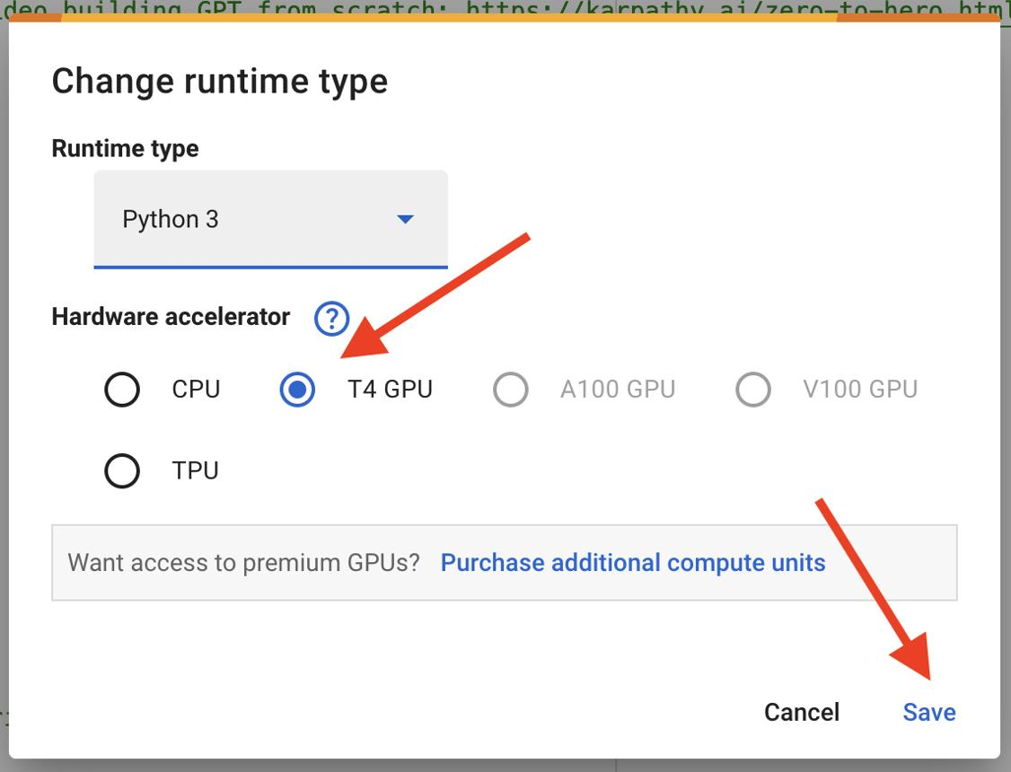
bdunagan.com
The exact menu and available hardware can vary by account. A GPU is recommended, but availability is not guaranteed.
Step 3 — Upload the CropCare ML source files
This is an important step in your particular notebook.
Opening the notebook does not automatically provide its training code. Cell 2 searches for the CropCare source package and config/train.tomato.yaml. If the repository has not been pushed to GitHub, it asks you to upload a ZIP file.
Create a small ZIP on Windows
You do not need to upload your entire project with node_modules, virtual environments or datasets.
Open PowerShell and run the following, assuming your repository is at the path shown in Cursor's report:
$ml = "C:\Users\lenovo\AadiTech\Product\CropDiseaseDetection\ml"
$zip = "$env:USERPROFILE\Desktop\cropcare-ml-source.zip"

Compress-Archive -Path `
"$ml\src", `
"$ml\config", `
"$ml\requirements.txt", `
"$ml\requirements-train.txt", `
"$ml\README.md" `
-DestinationPath $zip -Force
This creates a small ZIP containing the ML source code and configuration. It excludes datasets, model artifacts and virtual environments.
If any of those files are missing, stop and check the actual ml folder rather than silently omitting required files.
Upload it to Colab
Return to the notebook and run Cell 2, under “Get this version of the repository.”
When the file chooser appears:
- Select cropcare-ml-source.zip from your Desktop.
- Wait for the upload and extraction to finish.
- Look at the final output. It should display a path to the ML project directory.
If you see Could not find ml/config/train.tomato.yaml, the ZIP structure is not correct or a required file is missing.
Step 4 — Install the training dependencies
Run Cell 4, under “Install the training dependencies.”
It runs:
pip install -r requirements-train.txt
You do not need to type this yourself; just click ▶ on Cell 4.
This installs TensorFlow and the other packages required by the training pipeline. Installation may take several minutes.
Then run Cell 5. It checks the TensorFlow version and lists available GPUs.
Expected output includes a TensorFlow version between 2.16 and 2.20 and a list of available GPUs. If the list is empty, the runtime might not have a GPU.
If Colab requests a runtime restart: restart it, then run the notebook from the beginning again. Cell 2 may ask you to upload the source ZIP again.
Step 5 — Check the dataset licence
Run Cell 7.
This downloads the PlantVillage dataset card and checks its licence against the experiment configuration.
The notebook is designed to stop if the licence check fails. If it stops, read the error rather than bypassing the check.
The dataset's licence is relevant because the exported trained model is intended to be used in your CropCare application.
Step 6 — Download the tomato images
Run Cell 9, under “Download the mapped tomato color folders.”
This is the main dataset download step.
The notebook uses the PlantVillage Git repository and sparse checkout to select the mapped tomato colour-image folders. It excludes grayscale and segmented variants.
This may take time and use a substantial amount of Colab storage and network bandwidth. Your Windows C: drive should not need to store these images.
Next, run Cell 11. It performs three operations:
- Checks that the expected image folders exist and contain enough images.
- Prepares the dataset and creates training, validation and test splits.
- Verifies that all configured classes are present and that duplicate leaf groups do not cross the splits.
The split is 70% training, 15% validation and 15% testing, using seed 42.
If a cell fails, do not continue to training until the error has been resolved.
Step 7 — Train the AI model
Run Cell 13, under “Train MobileNetV3Small and read the test-set report.”
This is the main training step. It uses a pretrained MobileNetV3Small image-classification model and fine-tunes it on your prepared tomato dataset.
Training can take a while. Keep the Colab tab open while it runs.
When successful, the output should include:
- Number of test images.
- Test accuracy.
- Macro-F1.
- Precision, recall and F1 for each disease class.
- A confusion matrix.
- The directory where the model artifacts were saved.

