PAWAR PUBLIC SCHOOL
PRACTICE WORKSHEETS
Std. I
Q1. Add – ‘ing’ to the following action words on the given model.
Model : sing + ing = singing
- draw + ___________ = _____________
- paint + ___________ = _____________
- jump + ___________ = _____________
- colour + ___________ = _____________
Q2. Match the words to make complete sentences.
1. | Humpty Dumpty is | a farm
2. | The mouse is on | an egg
3. | Jack and Jill are | twinkle in the sky
4. | Stars | children
5. | The little lamb is fond of | the clock
6. | Old Mcdonald had | Mary

Q3. Join the following words.
- Pan + cake = ________________
- Butter + fly = ________________
- Foot + ball = ________________
- Post + man = ________________
- Birth + day = _________________
Q4. Match the animals with their young ones.

1. | horse | kitten
2. | cat | ducklings
3. | dog | cub
4. | cow | kid
5. | duck | calf
6. | sheep | puppy
7. | lion | foal
8. | goat | lamb

Mathematics

Q.1] Write in words for the following
a) 259 = _______________________________________________________________________
b) 172 = ________________________________________________________________________
c) 276 = ________________________________________________________________________
d) 149 = ________________________________________________________________________
e) 283 = ________________________________________________________________________
Q.2] Write in figures for the following
a) One hundred and thirty three = _________________
- Two hundred and ninety nine = _________________
- One hundred and seventeen= _________________
- Forty five= _________________
- One hundred and two= _________________
Q.3] What comes after
A) 78 ___
b) 89___
c) 31__
d) 70____
e) 56 ____
Q.4 What comes before
a)____60
b)____93
c)____30
d)____13
e)____82

Q.5 What comes in between
1) 35___37
2)84_____86
3)97_____99
4)15_____17
5)48_____50

Q.6 Write the following numbers in ascending and descending orders.
1)11 7 23 26
Ascending order
Descending order
2)42 58 63 79
Ascending order
Descending order
3)89 100 25 7
Ascending order
Descending order
4) 82 28 65 17
Ascending order
Descending order
5) 38 99 76 43
Ascending order
Descending order

Q.7 Fill in the blanks
1) 3 x 9
2) 4 x 3
3) 5 x 5
4) 2 x 8
5) 3 x 7
6) 4 x 6
7) 2 x 9
8) 3 x 3
9) 5 x 7
10) 4 x 2

Q. 8 Solve the following
1)

Circle has _____ sides and ______ corners.

- Square has _____ sides and ______ corners.

- Rectangle has ______ sides and ______ corners.

Q. 9 Match the shapes to their names

Sphere

Cone

Cube

Cuboid

Cylinder

PAWAR PUBLIC SCHOOL
PRACTICE WORKSHEETS
Std. II

English
- Answer in complete sentences.
- How did the old woman look?
- What was the old woman doing and why?
- When did sabuk sleep?
- What did the voice tell sabuk?
- What did Kamala think she would cry?
- Who found amit’s old rabbit and where?
- What did Kamala get on her birthday?
- What did Amit’s mother buy him at the exhibition?
- Grammar:
- Write Prurals for the following-
a) bus b) Potato
c) brush d) Knife
e) Wife f) Life
2. Do page 20 and 21(verbs) of the Good Grammar.

Mathematics
A. Add the following:
6 9 4 |  | 3 2 9 |  | 2 9 6
+ 2 1 8 |  | + 4 0 0 |  | + 1 5 7

B. Subtract the following :
9 2 7 |  | 4 2 |  | 6 4
- 3 0 2 |  | - 3 1 |  | - 1 2
C. Solve the Word Problems.
- Jane bought chocolates for Rs. 89 for her family and Peter bought chocolates for Rs. 42. How much did they spend altogether?
- There were 54 students in II A, 62 students in II B and 79 sutdents in II C. How many students were there in all the 3 classes?
- Rema scored 46 marks in English exam and 39 marks in Maths. Find the sum of the two scores.
- Priya weighed 63 kgs, Riya weighed 53 kgs and Siya weighed 68 kgs. What is the total weight of all the three girls ?
- There were 128 Mango trees and 243 apple trees. How many total trees were there in that garden

PAWAR PUBLIC SCHOOL
PRACTICE WORKSHEETS
Std. III
English
- Answer the following questions:
  - What was floating on the river? What did the river smell of?
  - How was Sona rewarded?
  - In what state does the poet find the song again? How does he compare it with the arrow he finds?
  - Why did the people of Mols sit in a circle?
  - What did Pareka give the Egyptians to take back to their queen?
- Write about 10-12 sentences on each of the following:
- My School
- A rainy day
- Good Grammar page nos. 12 to 20.
Environmental Science
- Answer the following
  - Give any 5 points we should follow to have our food and keep healthy.
  - Draw the food items which help us to grow and colour them. Explain how they help us to grow.
  - Name the foods which help us for the following:
    - To build the body
    - To give energy
    - To keep the body healthy.
  - Give three differences between a cow and a human being.
  - What functions do the following perform
    - Arms
    - Brain
    - Tongue
Mathematics
- Word problems:
- A water tank contains 7563 liters of water. Futher 2876 liters of water is pumped into it. How much water does it contain now?
- A library has 4762 school textbooks, 2146 works of fiction and 1862 reference books. How many books are there in library?
- St. Mathew’s school has 6432 boys, girls and teaching staff. There are 695 teaching staff and 2076 boys. How many girls study in the school?
- Ram travelled 7648 kilometers by train and car. If he travelled 3190 kilometers by car. How much distance did he travel by train?
- Draw line segments of the following length.
  - 7 cm b) 4cm c) 10cm d) 6cm
- Write tables (2 to 12)
Science
- Answer the following questions:
  - How plants obtain water?
  - What happens to the plant if the roots are damaged?
  - Why is the ladybird bettle called the farmers’ friend?
  - If you have to separate 10 different types of leaves in two groups, which part of the leaves will you study?
  - What are leaf veins?
  - Why do animals move?
- Explain the following terms with examples:
- Herbivores 2. Carnivores 3. Omnivores

PAWAR PUBLIC SCHOOL
PRACTICE WORKSHEETS
Std. IV

Social Studies

- Answer the following questions in brief:

  - What is a lagoon ? Where do you find lagoons in India’s coastline ?
  - Which are the groups of islands in India ? Where are they located ?
  - Why are deltas fertile tracts of land ?
  - Which plateaus are part of the Southern Plateau ?
  - Which are the major rivers flowing through the Deccan Plateau ?
  - Which minerals are found in the Chota Nagpur plateau ?
  - Which crop is best suited to be grown in the Malwa Plateau ? Why ?
  - What is a desert ?
  - What are sand dunes ?
  - What is an Oasis ?
  - Why are camels known as ‘Ships of the Desert’ ?
  - Why are dust storms common in the desert region ?
  - Why are the northern rivers so polluted ?
  - Why are the northern Plains very fertile ?
  - What is a delta ?

English
- Answer the following questions:
  - Do you think Phayader wanted to make friends with Frith? Write a reason for your answer.
  - How did Raju throw the golden fish back into the stream?
  - Why do you think the villagers loved the old priest?
  - What is still the same on the island of Mauritius?
  - Is it possible for somebody to really have so many pets? What do you think would happen, if , for example, the lion were to see the bardicoot?
- Write about 12-15 sentences on each of the following:
- My Pet
- Independence Day
- Good Grammar page nos. 14 to 20, 21 to 23

Science
- Answer the following questions:
- Explain how is a fruit formed?
- Explain photosynthesis with a neat diagram.
- What is adaptation? Explain 2 adaptations in plants of the coastal regions.
- Explain habitat. Give examples of different habitats.
- What are nocturnal animals? Give examples.
- Define- a) Terrestrial animals b)aquatic animals
- List adaptations in desert animals.

Mathematics
- Write tables- 6 to 16
- Word problems:
- 3,46,218 men, 3,39,464 women and 1,12,894 children live in a town. What is the total population of the town.
- 1,41,732 students appeared for an examination, out of which 80,497 were boys. How many girls appeared for the examinations?
- The sum of two numbers is 7,51,356. If one of the numbers is 2,00,008. Find the number.
- In a year, a factory produced 3,84,740 bulbs, out of which it sold 2,96,800 bulbs. How many bulbs were left unsold?
EVS

- Answer the following questions:
- What is the liver? How does it function?
- What is respiration? Explain the process.
- Explain these terms: a) Irrigation b)Drought
- What are canals and how are they used?
- The length of daylight keeps changing round the year. Give reason.
- How can people avoid being struck by lightning?
- ‘The different parts of plants are eaten as food’. Explain this statement with suitable examples.
- How are animals classified on the basics of their eating habits?
- What are the different sources of water?
- Explain the various uses of water.

PAWAR PUBLIC SCHOOL
PRACTICE WORKSHEETS
Std. V

Mathematics
- Word Problems

  - A business man had Rs. 1,54,32,386 with him. He spent Rs. 25,43,321 on raw materials and Rs. 1,51,005 on transportation. How much amount is left with him.

  - Mrs. Kumar purchased a flat for Rs. 38,64,298. She spent Rs. 2,32,438 on furniture and Rs. 50,000 on painting. What is her total expenditure ?

  - Mr. Shenoy needed Rs. 3,25,765 to buy a new car. He had Rs. 1,12,700 but needed to borrow the rest from a bank. How much did he borrow from the bank ?

  - A box holds 64,520 bricks. How many bricks can fit in 259 such boxes ?

  - A tile factory had to pack 21,86,514 tiles. If 409 tiles could be packed in 1 box how many boxes will be needed for packing all the tiles ?

  - A large library had 19,457 books at the beginning of the month. During the course of the month it lent 7,654 books but brought in 13,871 books. How many books were in the library at the end of the month ?

- Write tables from 6 to 16
English
Section A
- Answer the following questions:
- Describe the bear
- When did George dance for the speaker ? why does he say so?
- Why did Hawthorne do work which he disliked ?
- Why did the two cousins return from the islet without doing anything?
- Who were the trespassers on the author’s piece of land ? Why was the author helpless in stopping them ?
Section B
    - Write a letter to your friend advising him / her as to what precaution he / she should take to avoid getting H1N1
    - Write a paragraph on how you spent your break from school closure due to H1N1 Pandemic.
Section C
Good Grammer - Noun - Do pages 25 - 33 Articles – Do pages 49 – 51

Social Studies
- Answer the following:
- Why do different regions have different types of Climate?
- Give the points of difference between
  - Latitudes and longitudes
  - Torrid Zone and Temperate Zone
  - Graphical Scale or Linear scale and as a statement
  - Tropic of Cancer and Tropic of Capricorn
- How is globe useful to us?
- How does the distance of a place from the sea affect its climate?
- Explain in few lines about the climate and forests of Zaire

Science
- Answer the following questions:
- What are amphibians?
- Explain how soil was formed?
- How does a turtle differ from dolphin?
- What is terrace farming? What are its advantages?
- How are forests useful? How can forests be protected?

EVS

- Answer the following questions:
  - Why is it important to keep good health?
  - What is the importance of Environment day?
  - Why do we celebrate Literacy Day?
  - How do you celebrate children’s day in school?
  - What are the functions of a Panchayat?
  - How does the health centre look after the health of the people?
  - How does the police maintain law and order in an area?
  - which kind of help do you get by dialing 101?
  - How are proteins useful for us?
  - Which are the protective foods in our diet?
  - Why is water very important for the body?
  - What is a balanced diet and how does it help us ?
  - Name some of the important mountain hill ranges of India.
  - Name five mountain valleys of India.
  - What is a valley? How are valleys formed?

Marathi

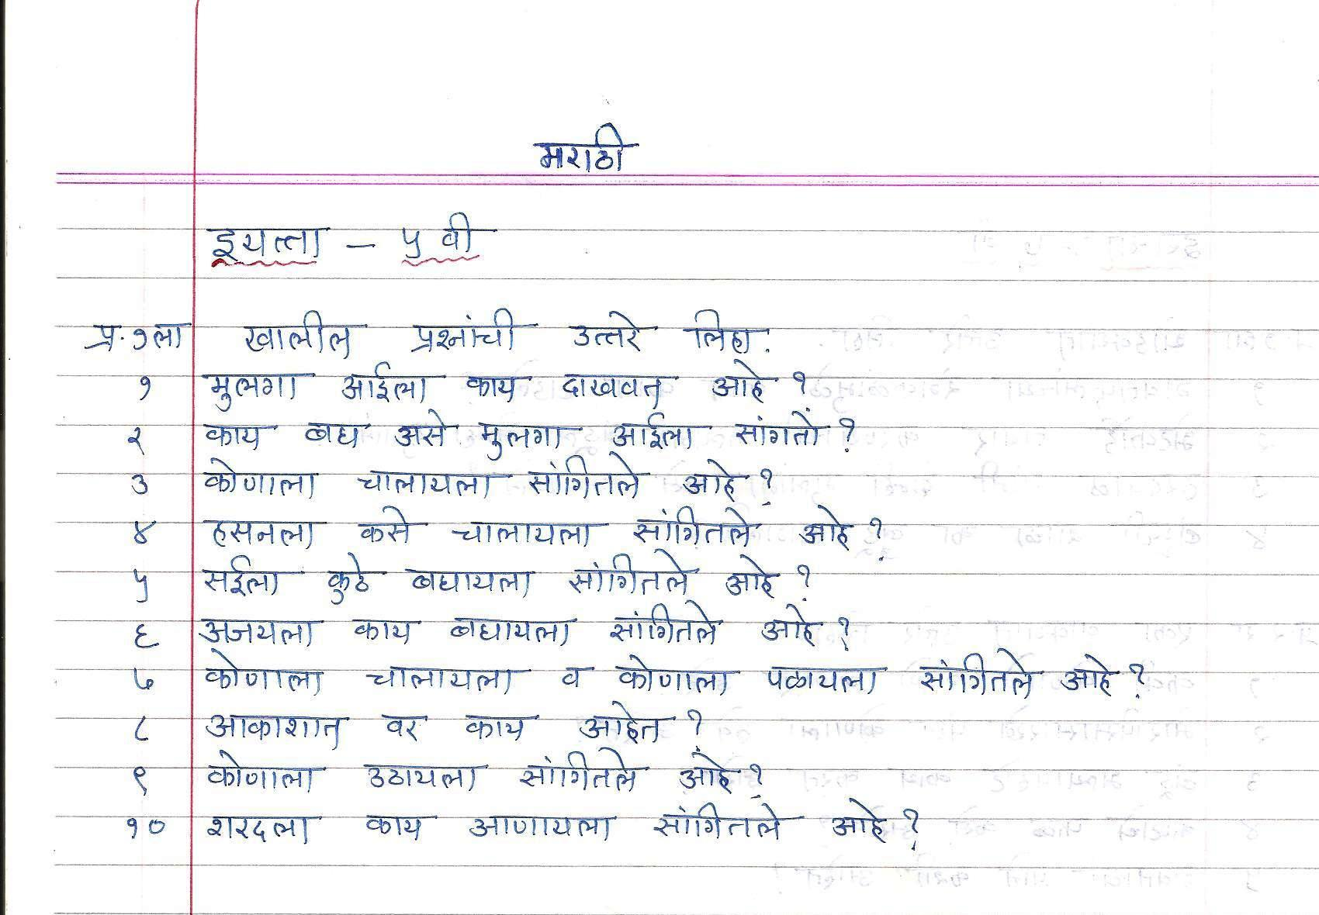

PAWAR PUBLIC SCHOOL
PRACTICE WORKSHEETS
Std. VI

English
- Usually people who travel have interesting stories to tell their friends back home. Imagine you are McBain and write down what you would tell your friends.
- Write a paragraph on what you can do to conserve nature.
- Write a letter to your friend in another country telling him/her about the lifestyle of the people and the culture of your country.
- Complete all the exercises upto Unit-4 in the Gulmohar Companion text book in pencil.

History
- Answer the following :
  - Make a list of all the useful things invented by the Chinese.
  - Decsribe the religious beliefs of early man
  - Explain the following
    - Occupations of the people of ancient Egypt
    - Hammurabi’s code of law
    - Buildings on the citadel
    - Discovery of fire
  - What changes did the invention of the wheel bring about in man’s life ?
  - What were the main achievements of the Mesopotamians in architecture?
Science
- What is a molecule? Write with reasons that O₂ is an element.
- Write the names & symbols of those elements whose symbols are derived from Latin names of elements.
- How many atoms are present in H₂O₂ & CaCl₂?
- Identify the names of compounds: - CaO, ZnO, MgO
- How are plants classified on the basis of size? Give suitable examples to explain your answer.
- Write down 3 important characteristics of class Arthropods, Crustaceae, Amphibians, Mammals. Give 2 examples of each.
- Write how stems can be modified to give 1) support 2) for storage of food.
- How are leaves modified for trapping of insects. Give examples.
- What is force ? What are the changes that force can bring ?
- Define frictional force and list the advantages of friction?
- Explain the procedure and find the area of the given irregular object ?
- What would be the volume of air in a class room if it were empty ? Where length = 10m, breadth =3m and height = 7m.
Environmental Science
- List items involved in biotic and abiotic parts of environment.
- Explain how we are dependent on plants to get food, fibre & medicines.
- ‘Sunlight supports all life on earth’ Explain.
- ‘It is not advisable for the patients of swine flu to go to different picnic spots’ Explain.

Marathi
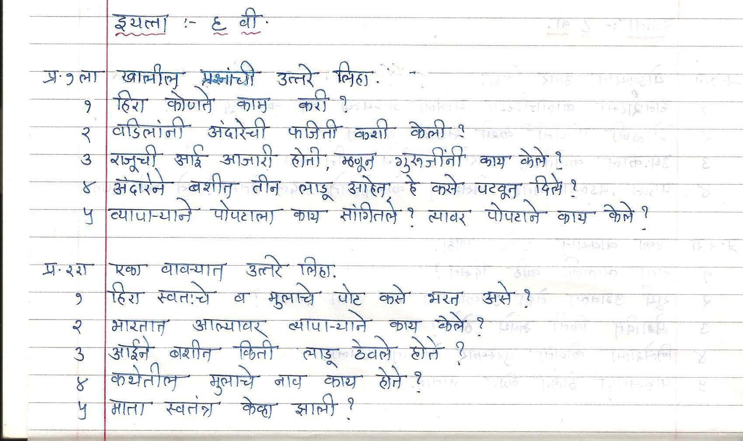

PAWAR PUBLIC SCHOOL
PRACTICE WORKSHEETS
Std. VII
English
- Miep describes her heroic effort to protect the Franks as an act of human duty. Write a paragraph on some of the ways in which we can do our human duty.
- Write an informal letter to a friend in another city. Tell him/her about your city. You can write about the type of people, the climate and the places of interest etc.
- Describe in 150-200 words about your visit to the archaeology museum.
- Complete all the exercises upto Unit-5 in the Gulmoher Companion text book in pencil.
History
    - Reference to the statement given below answer the questions that follows :
      - He defeated Muhammad Ghori at the First Battle of Tarain in AD 1191.
        - Which Indian ruler defeated Muhammad Ghori
        - When was the second battle of Tarain fought ? What was the consequence of it?
        - Name the famous poem written by Chandbardai.
      - The practice of salaries to officials by giving pieces of land, in lieu of cash.
        - When did this practice start ?
        - Name the three categories the feudatories belonged to
        - In this System who were the worst affected and why ?
      - The Constitution of India Gives power to three organs.
        - Name the three organs
        - How much time and cost did it take for the completion of the constitution ?
        - Name the chairman of the Drafting Committee
        - Who was the viceroy of India before Independence ? Who was after the independence.
    - Answer the following questions :
      - What were the main teaching of Jesus ?
      - Briefly explain each of the five principles of Islam
      - List the powerful Rajput Kingdoms of the period (AD 800 -1200)
      - What was the state of education during AD 800-1200 in North India
      - Social life was dictated by the caste system. Name the caste system prevalent at that time.
      - What is the date of commencement of our constitution? Why was this specific date chosen?
      - Explain the significance of our Preamble.
Biology
- Write short notes on:
- Cell membrane
- Nucleus
- Mitochondria
- Plastids.
- Name the nine major organ systems in human beings. Write the parts involved in each system and the functions.
- Draw a schematic diagram of the types of plant tissues.
Chemistry
- Define: - Atom.’ Atoms are electrically neutral’ Give reason.
- The reaction between sodium chloride & silver nitrate forms a white precipitate of silver chloride. Write the complete & balanced reaction. What type of reaction is this?
- Write the names of following compounds: - SO₂, H₂0, CaCl₂, PbO.
- What are monoatomic & diatomic molecules? Give three examples of each.
Physics
- Give Reasons:
  - Rotation of earth is periodic motion.
  - The lower end of a hydrometer is filled with mercury or lead.
- Solve the numericals:
  - Find the relative density of a liquid from the following observations.
    - mass of the empty R.D. bottle=25.2g
    - mass of R.D. bottle +water=57.7g
    - mass of the R. D. bottle +liquid =52.7g.
- Answer the following:
  - What is translatory motion? Name two kinds of translatory motion.
  - What is simple pendulum? What are the factors affecting the time period of a pendulum?
  - Differentiate between Density and Relative Density.

Environmental Science

1. Suggest the ways for rain water harvesting in your own words.
2. Whether ‘swine flu’ is air born disease? Write what care should be taken to avoid it.
3. What is acid rain? What are its effects?
4. How do roots of trees prevent erosion of soil?

Mathematics

- Solve the followings:
- In class VII of a boy’s school,all 36 students like either basketball or badminton. If 20 girls like playing only badminton but not basketball and 7 students like to play both the games, how many boys do not like to play badminton.
- A first-aid kit is to contain an ointment for Rs.11.75, bandages for Rs. 4.60, a bottle of antiseptic lotion for Rs.12.50 and pair of scissors for Rs.13.25. how many such first-aid boxes can be purchased for Rs.3100?
- What would be the maximum length of a piece of ribbon if two ribbons, one 16.8m long and the other 26.46m long are cut up into equal sized pices?
- In a village of 1000 people, 600 speak Bengali in 500 speak Oriya. How many in the village speak only in Oriya if:
- All the villagers speak at least one of the two languages?
- 50 villagers speak a language other than Bengali and Oriya.
Marathi
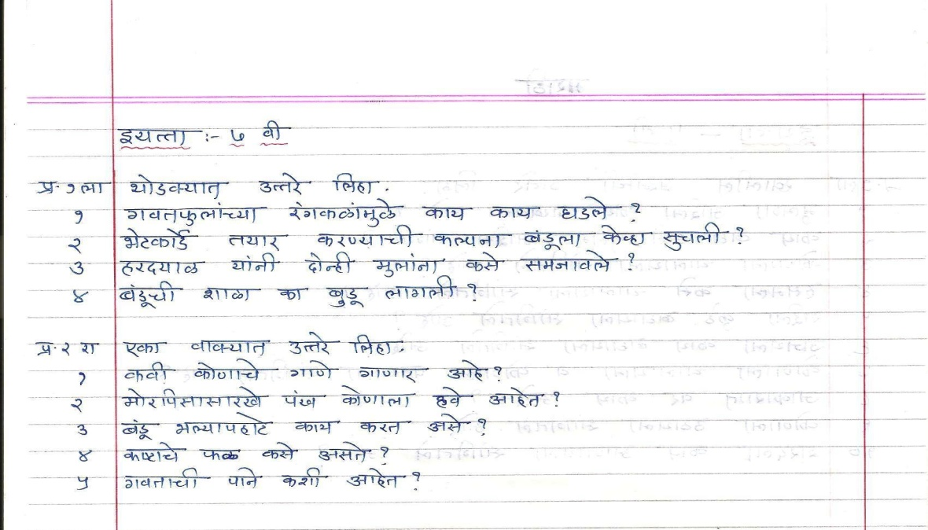

Hindi

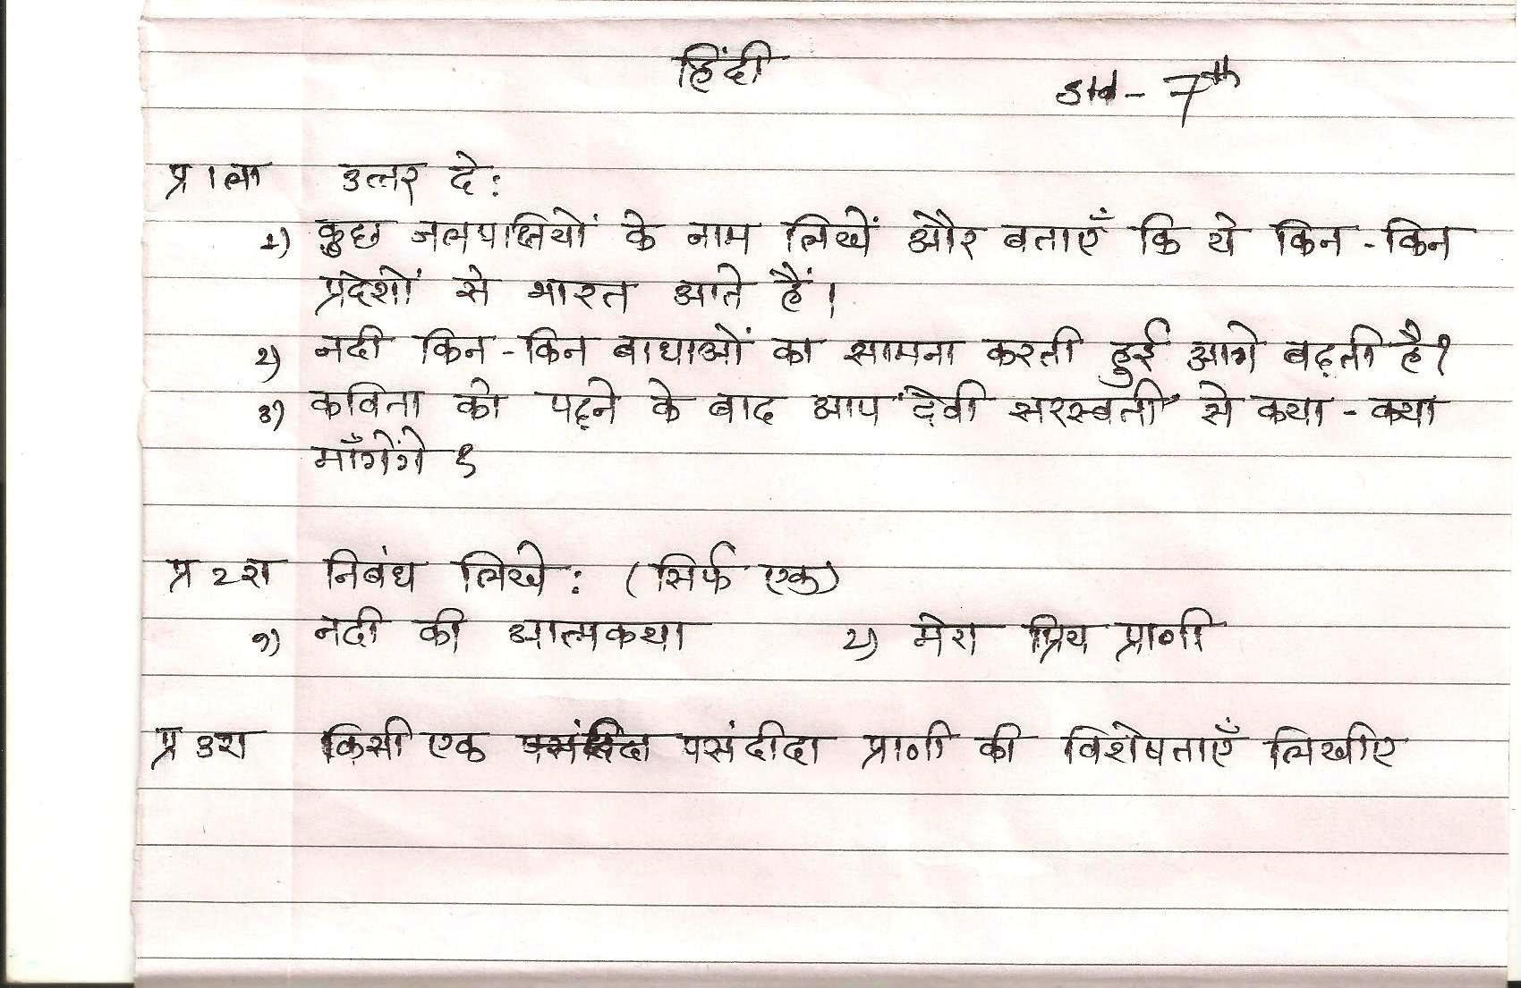

PAWAR PUBLIC SCHOOL
PRACTICE WORKSHEETS
Std. VIII

History
- Reference to the statements given below answer the question that follows :-
- The representative of the Third Estate formed the National Assembly.
  - What was the middle class in France known as ?
  - Name the Two royalties who were arrested and later rescued ?
  - In which year and which event marked the beginning of French Revolution ?
  - Name the other two estates.
- But he was defeated once again at the battle of waterloo
  - In which year this battle was fought and who was defeated ?
  - What punishment was he given?
  - His dislike of Britain was such that he called Britain __________

- Answer the following questions :
- Mention the principle contained in the ‘Declaration of Independence’
- What reason do historian give to Napolean’s style of standing with one hand placed in his vest ?
- Discuss the main issues which divided the Northern and the Southern states ?
- Garibaldi worked towards the unification of which country. What were his soldiers known as ? Why ?
- Why did Industrial Revolution first start in England
- What is imperialism ? What led to the race for acquiring colonies ?
Biology
      - What are the functions of blood?
      - How are minerals and water transported in plants?
      - Write short notes on:
        - Food-borne diseases
        - Vector-borne diseases
- Distinguish between congenital and acquired diseases.
- What are the factors that lead to development of disease?
Chemistry
- Write the electronic configuration of ₁H,₂₀Ca,₁₂Mg,₁₁Na,₃Li,₁₄Si,₁₅P,₁₆S,₁₉K
- He shows valency 0, Na shows valency 1 while Mg shows valency 2.Explain.
- Explain with diagramme formation of CaO, H20.
- Balance the following :-
a) FeCl₂ + Cl₂ FeCl₃
b) FeCl₃ + SO₂+ H₂O FeCl₂ + HCl + H₂SO₄

Physics
- Give Reasons:
  - It is difficult to place a test tube over erect pencil while looking at it through a glass slab.
  - Pluto is the coldest planet.
- Answer Briefly:
  - List four ways in which artificial satellites are useful to us.
  - What is the relation between a light year and parsec?
  - Define: 1)Principal Axis 2) Focal length
  - Draw a ray diagram to show the position, size and nature of images formed by a convex lens.

EVS
- ‘Increasing slums has become a headache’ Explain.
- ‘Crowded areas not only block the roads but also spread diseases like swine flu’ Explain.
- Explain: - Role of human beings in an ecosystem.
- Prepare a pamphlet about energy saving tips’

Mathematics
- Solve the followings:
- 75% of the students chose to participate in a drama feat and 50% of the students chose to participate in a sports meet. If 24 students have chosen to take part in both and 6 students have chosen to attend neither of the two events, how many students study in the class?
- At a birthday party out of 53 children 8 children have neither ice cream nor cold drinks. If 30 children have ice cream and 23 children have cold drinks, find :
a)How many children have only ice cream
b)How many children have only cold drinks
c) How many children have both ice cream and cold drinks.
- Rajiv inherited 2/9 of the money his grand father left behind while his cousin Rakesh’s share was 1/7. if Rajiv’s share was 60000 more than Rakesh’s share, find how much money their grand father left behind.
- Mrs. Rane gives 0.025 part of her salary to her son Vinod as pocket money every month. Vinod spends 0.8 of his pocket money and saves the rest. If he saves Rs. 277.50 in three months, how much does Mrs. Rane earn every month.
- Find the HCF of 0.286, 0.3718 and 0.3146

Marathi

