Mini-project 27
Gene-expression-based drug sensitivity prediction
Reproducible oncology / pharmacogenomics mini-project
CCLE / DepMap molecular profiles and GDSC2 fitted drug-response measurements | October 2026
Research use only. Predictions concern cancer cell lines in laboratory assays, not patient treatment.

Abstract
The study predicts fitted natural-log IC50 (LN_IC50) using cancer-cell-line gene expression, mutation records, copy number and drug annotations. From the original experimental files, 649 cell lines and 286 drug-name groups were conservatively matched, producing 160,512 observed cell-drug responses. Two five-fold evaluations withheld complete cell-line identities or complete drug groups during training. A fixed Ridge regression pipeline using 100 training-selected expression features, a ten-gene mutation/copy-number panel and known drug descriptors was compared with strong baselines. For unseen cell lines, mean test RMSE was 1.355, versus 1.462 for a training-only per-drug mean. For unseen drug groups, RMSE was 2.387 versus 2.651 for genomics-only Ridge. However, median within-drug Pearson correlation was only 0.449, and some mechanistically related drugs were poorly predicted. The original paired cell-plus-drug holdout achieved RMSE 2.418 versus 2.476 for annotations alone. A retrospective GDSC-assay-ID-to-PubChem-CID regrouping of known aliases achieved RMSE 2.452 in cold drugs and 2.501 in simultaneous cold cells and drugs (32,149 held-out pairs). Verified source-linked CIDs and InChIKeys cover 236 of 286 drug-name groups; the remaining 50 plus unverified assay salt forms prevent claiming perfect chemical separation or external validation.

1. Challenge and scientific background
Cancer cell lines may respond differently to the same compound because gene activity, genomic variation and gene dosage differ across biological contexts. Gene expression provides an RNA-level view of cell state, while mutation and copy-number data add genomic information. The objective is to estimate LN_IC50 for a particular cell and drug. Lower fitted IC50 generally implies a lower inhibitory concentration in that assay; a negative logarithm is valid and does not indicate a bad measurement.
CCLE established links between molecular features and preclinical drug response [1], while GDSC work illustrated pharmacogenomic associations across larger screens [2]. Updated CCLE characterization provides detailed molecular reference data [3]. Modern evaluations distinguish unseen cells from unseen drugs because random observation-level splits can reuse familiar entities and overstate generalization [4,5]. This mini-project therefore compares both entity-level tasks and reports drug-specific error, rather than relying on one pooled correlation.

2. Datasets and curation
Data item | Observed / verified
Original GDSC2 fitted response records | 242,036 rows
Conservatively cross-omics matched cell lines | 649
Distinct normalized drug-name groups | 286
Observed matched cell-drug measurements | 160,512
Available measurements in potential matched grid | 86.5% of 185,614 possible pairs
Omics reference | DepMap Public 19Q4
Response reference | GDSC2 fitted dose response, 27 Oct 2023

The original ZIP contains sample metadata, CCLE expression, mutations, gene copy-number profiles, a GDSC2 workbook and a DepMap README. Cell lines were joined by exact COSMIC/DepMap mappings and checked for name/Sanger-ID discrepancies. Only cells represented in all three molecular sources were kept. Repeated numeric drug IDs under one normalized drug name were consolidated using coverage, independent of response value. The subset represents all eligible matched responses, not the complete GDSC2 release. Missing outcomes were never fabricated.
Data-provenance checks include an archive SHA-256/CRC audit, schema validation, finite-value checks, unique response-curve IDs and saved fold identifiers. The updated source-ID-linked identity audit obtains PubChem CIDs and InChIKeys for 236 of 286 drug-name groups from public GDSC-derived annotations [8]; 50 remain unresolved, largely unpublished internal compound codes. Twenty stereochemical structures were present in the earlier local pilot; 236 linked identifiers are not 236 independently validated assay formulations. Two exact-CID name-pairs, plus two potential salt/active-parent pairs, are conservatively held together in the revised folds. MK-2206 and oxaliplatin show alternative salt/structure forms in prior annotations, flagged for manual review. No structure was guessed for missing internal codes.

3. Processing and prediction pipeline
The model uses 100 expression columns selected by variance among unique training cell lines; the same genes need not be selected in every fold. A fixed genomic panel (TP53, KRAS, BRAF, EGFR, PIK3CA, PTEN, APC, RB1, MYC, CDKN2A) contributes ten binary nonsilent-variant-record indicators and ten numeric copy-number measurements. Drug descriptors comprise the supplied GDSC2 putative-target and pathway labels. For previously encountered drugs, a one-hot identity feature additionally distinguishes compounds with the same target/pathway annotations; an unseen-drug identity token cannot be learned in the training fold.
Training-only preprocessing applies median imputation, standardization and a fixed Ridge regression model (alpha=100, LSQR solver). Baselines include the global training response mean, a per-drug training-only mean for new-cell evaluation, and a genomics-only Ridge model for new-drug evaluation. An independent cold-drug annotation-only ablation isolates the additional contribution of genomics. These baselines prevent drug-average differences from being mistaken for cellular predictive performance.
End-to-end pipeline: source integrity -> conservative identity join -> fold generation over unique entities -> training-only feature selection and encoding -> fit baseline and Ridge -> infer on excluded entities -> recompute metrics -> subgroup and biological interpretation.
Prediction application: a separate full-data Ridge checkpoint for inference is saved in checkpoints/full_gdsc_ln_ic50_ridge.joblib and used by model_code/predict_ln_ic50.py. For any recognized cell/drug pair, the script retrieves its real expression, recorded variant/CN features and GDSC drug annotations to produce predicted LN_IC50; it also supports CSV batch inference and a complete 649 by 286 grid. The grid contains 185,614 predictions: 160,512 have measured LN_IC50 and 25,102 are model-only estimates, explicitly marked unmeasured. This model was fitted on all available observed pairs, so its predictions are not held-out performance evidence. All reported evaluation scores come strictly from the saved grouped cross-validation folds.

4. Experimental design
Test | Held-out entity | Fold construction | Primary comparison
New cancer cell lines | DepMap cell-line ID | Five nonoverlapping cell-line folds; all known drugs remain represented during training | Per-drug training mean versus genomics + drug Ridge
New drug groups | Normalized drug name | Five nonoverlapping drug-group folds; all known cells remain represented | Genomics-only and annotation-only versus combined model
New cells AND new drugs | Paired cell-ID and drug-name folds | Five simultaneous double-holdout folds; other pairs excluded | Genomics only and annotations only versus combined model

The two tests answer different questions. For cell holdouts, the same compound is familiar from other cell lines. For drug holdouts, the drug-name group is absent from training, but cell lines can be shared by design. Preprocessing is refitted inside each fold, and fold labels, measured responses and predictions are saved. All 286 compounds and 649 cells appear in one test fold within their respective evaluation. Fold standard deviation is descriptive, not an independent external confidence interval. The additional full-catalog simultaneous experiment uses the intersection of cell and drug test folds with the same index. Training excludes all test cells and all test drugs. This design evaluates 31,998 of 160,512 measured pairs (19.9%) across five disjoint test intersections; it does not establish performance on the untested 80.1%. It uses sparse, non-centered scaling with an intercept, as does the optimized primary model; these experiments still differ in split membership and feature combinations. The new PubChem-CID-grouped tests address known cross-name collisions, grouping both aliases of one CID together and leaving unknown structures as provisional unique GDSC IDs. They were designed after finding those collisions and are therefore retrospective checks, NOT an untouched holdout. Assay salt/stereo identity and missing compounds can still leak as yet-unknown chemical equivalents. All four model families are compared on the SAME identity-grouped folds.

5. Main predictive results
Test | Predictor | Mean RMSE ± fold SD | Mean MAE | Pooled Pearson r
New cells | Global training mean | 2.745 ± 0.025 | 2.082 | Undefined
New cells | Per-drug training mean | 1.462 ± 0.060 | 1.103 | 0.847
New cells | Genomics + drug features | 1.355 ± 0.039 | 1.023 | 0.870
New drugs | Global training mean | 2.742 ± 0.278 | 2.089 | Undefined
New drugs | Genomics-only Ridge | 2.651 ± 0.279 | 2.019 | 0.259
New drugs | Genomics + drug annotations | 2.387 ± 0.175 | 1.827 | 0.476

Additional same-fold cold-drug ablation: annotation-only mean RMSE 2.488, compared with 2.387 for combined genomic and drug annotations. This indicates approximately 4.0% improvement beyond drug annotations under the primary unseen-drug protocol. Drug identity is absent for previously unseen drug groups, so target/pathway labels supply the transferable drug signal.

5.1 Simultaneous unseen cells and unseen drugs
Five-fold paired double-holdout model | Mean RMSE | Mean MAE
Global training mean | 2.733 | 2.082
Genomics only | 2.682 | 2.047
Drug annotations only | 2.476 | 1.895
Genomics + drug annotations | 2.418 | 1.854

The combined model obtained RMSE 2.418 versus 2.476 for drug annotations alone and 2.682 for genomics alone. The incremental advantage over annotation-only is approximately 2.4%. This task excludes all test cell and drug identities from training, but it is still restricted to the same in-vitro screen and inherits unresolved chemical synonym risk. Full test rows, group IDs, metrics and protocol are saved under research/full_gdsc/strict_generalization/.

5.2 Chemical-identifier-grouped robustness checks (retrospective)
Cold setting | Model | 5-fold mean RMSE ± SD | Mean MAE
New drug CIDs | Annotations only | 2.550 ± 0.101 | 1.945
New drug CIDs | Genomics + annotations | 2.452 ± 0.109 | 1.870
New cells + drug CIDs | Annotations only | 2.554 ± 0.083 | 1.948
New cells + drug CIDs | Genomics + annotations | 2.501 ± 0.097 | 1.909

New-drug combined RMSE 2.452 versus annotation-only 2.550 (3.8% reduction). Both unseen together RMSE 2.501 versus 2.554 (2.1% reduction) on 32,149 observed pairs. These are not directly comparable to the original drug-name split because folds were reassigned and sparse fold pipelines differ. The original model weights and LN_IC50 inference checkpoint remain unchanged; this is a leakage-aware internal sensitivity analysis. The full four-model comparison is available in the fold CSVs. Five-fold split files, predictions and foldwise metrics are saved in research/full_gdsc/chemistry_grouped/.
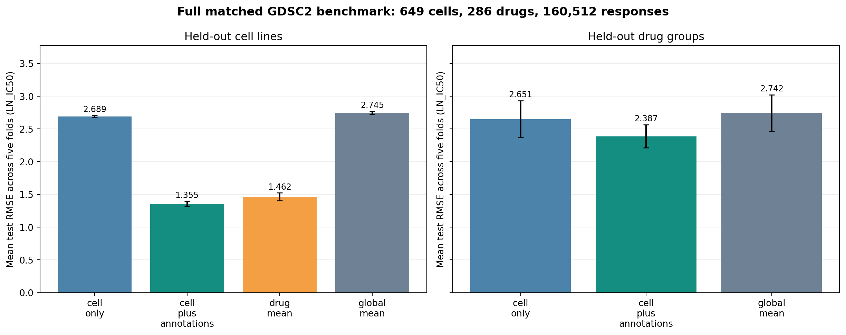
Figure 1. Original held-out performance over five normalized-name/entity folds; not PubChem-identifier-grouped.
Compared with meaningful baselines, genomic and drug features reduced mean RMSE by 7.3% for new cell lines and 9.9% versus genomics-only Ridge for new drugs. These are numerical in-vitro screening results on one matched dataset. No model was tested on an independent PRISM or CTRP response cohort.

6. Drug-specific and biological-context analysis
Pooled new-cell Pearson correlation was 0.870, but the median Pearson correlation computed separately for each drug was 0.449. This drop is important: pooled correlation partly reflects differences in average response between compounds. The Ridge model reduced RMSE relative to the training-only per-drug mean for 229/286 compounds; for 57 it did not.
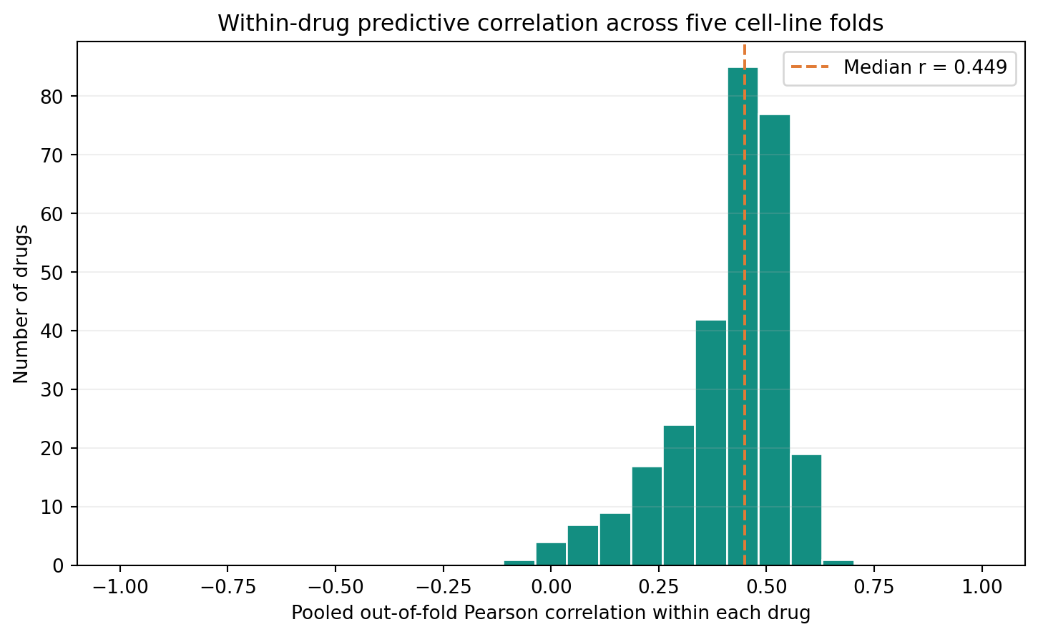
Figure 2. Distribution of within-drug correlation based on out-of-fold cell predictions.
MEK-pathway examples illustrate the failure modes. Despite distinct identity encodings for familiar drugs, selumetinib and trametinib did not beat their own per-drug training-mean baselines. Drug-specific error and tissue-lineage error tables are included to prevent a high pooled score from obscuring these cases.
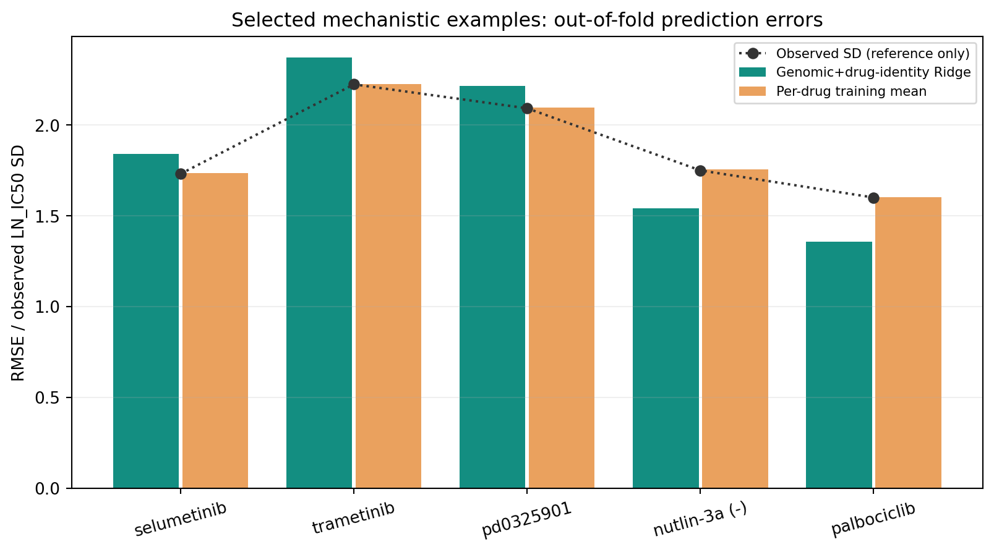
Figure 3. Selected drugs: model RMSE, per-drug mean RMSE and observed response SD.

7. Biological interpretation
Five compounds were chosen before the drug-specific biological analysis: Nutlin-3a, trametinib, palbociclib, selumetinib and taselisib. For each, an independent expression-plus-panel Ridge model was evaluated on five cell-line folds. In held-out cells, the mutation-plus-copy-number values of mechanism-related genes were permuted 40 times per fold to measure changes in RMSE. The result measures how a fitted predictor relies on genomic variables; it does not establish a causal biomarker.
Drug | Per-drug mean RMSE | Drug-specific genomics Ridge
nutlin-3a (-) | 1.752 | 1.213
palbociclib | 1.595 | 1.221
selumetinib | 1.733 | 1.496
taselisib | 1.702 | 1.564
trametinib | 2.223 | 1.825

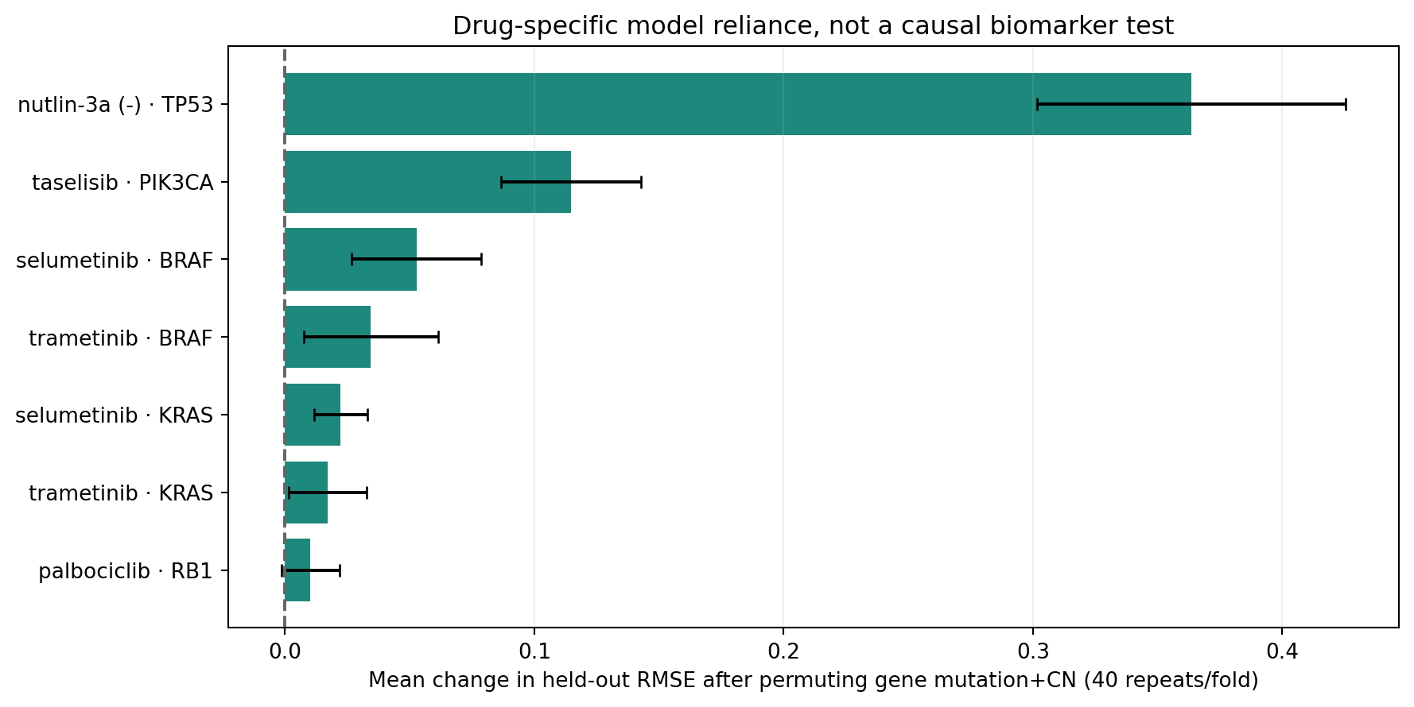
Figure 4. Held-out model reliance on predetermined mutation + copy-number gene groups.
For Nutlin-3a, permuting the TP53 group increased held-out RMSE by approximately 0.364 on average. The MDM2-p53 pathway has a known mechanistic link to Nutlin-3a response [6]. Nevertheless, sequence-variant record presence is not equivalent to functional TP53 status and is not an independently replicated clinical biomarker.

8. Discussion and limitations
The model succeeds most clearly for familiar drugs tested on unseen cell lines. Its gains are meaningful but modest against each drug’s own training mean. Generalization to unseen drug-name groups is harder: the model learns transferable pathway and target information but has only provisional PubChem mappings for 236 of 286 names, not audited experimental salt/stereo forms. Testing within each drug and lineage makes this limitation visible. The older 200-cell/20-drug MEK fingerprint finding is exploratory: the claimed 1.4% average gain was not robust across seeds and should not be applied to the 649-cell benchmark. The older MG-132 permutation result was weak; current TP53/Nutlin-3a permutation is on a drug-specific held-out model rather than the deployed full model. A previous 20-compound fingerprint experiment gave inconsistent results and is kept as exploratory appendix data, not as evidence that fingerprints reliably solve novel-compound generalization.
Limitations: (1) DepMap 19Q4 genomics were matched to GDSC2 2023 responses; (2) 50 drug identities remain unresolved, 2 previously recorded chemical forms conflict, and no assay reagent form has been fully confirmed; (3) original paired cold-holdout covers 19.9% of pairs, and the new CID-grouped retrospective paired test covers a similar fraction, without independent external or pristine prospective validation; (4) test observations were revisited to improve split protocol and must not be interpreted as a fresh unbiased independent test; (5) mutation-record absence does not establish functional wild-type status, and IC50 does not predict patient outcomes. Fold test predictions remain the independent evaluation evidence. A separate all-data inference checkpoint was saved using sparse scaling, but it has not been independently externally validated.

9. Conclusion
A reproducible genomics-plus-drug-annotation Ridge pipeline predicts held-out laboratory drug responses better than appropriate baselines on the matched CCLE/GDSC2 dataset, including a measured but modest improvement in the simultaneous cold-cell/cold-drug task. The strongest evidence is for new cell lines with known drugs. Drug-specific correlations, several challenging compounds and the lack of an independent validation set impose important boundaries on the claim. This is a transparent research mini-project, not a clinical precision-oncology system.

AI assistance and integrity disclosure
OpenAI ChatGPT assisted with implementation, testing, drafting this report and presentation. All tabulated numerical outcomes are derived from saved experimental response records and executable evaluation code. This is educational, preclinical research, not a clinical decision system.

References
[1] Barretina J, et al. The Cancer Cell Line Encyclopedia enables predictive modelling of anticancer drug sensitivity. Nature 483, 603-607 (2012). https://doi.org/10.1038/nature11003
[2] Iorio F, et al. A Landscape of Pharmacogenomic Interactions in Cancer. Cell 166, 740-754 (2016). https://doi.org/10.1016/j.cell.2016.06.017
[3] Ghandi M, et al. Next-generation characterization of the Cancer Cell Line Encyclopedia. Nature 569, 503-508 (2019). https://doi.org/10.1038/s41586-019-1186-3
[4] Codicè F, et al. The specification game: rethinking the evaluation of drug response prediction for precision oncology. J Cheminform 17, 33 (2025). https://doi.org/10.1186/s13321-025-00972-y
[5] TransCDR: a deep learning model for enhancing generalizability of drug activity prediction. BMC Biology (2024). https://doi.org/10.1186/s12915-024-02023-8
[6] Small-molecule MDM2 antagonists reveal aberrant p53 signaling in cancer. Cancer Research (2006). https://pmc.ncbi.nlm.nih.gov/articles/PMC1413632/
[7] Original user-supplied DepMap Public 19Q4 README and GDSC2 27 Oct 2023 response workbook. data/source_depmap_README.txt; source archive hash in docs/DATA_PROVENANCE.md
[8] GCNPath2026 supplementary GDSC annotation and structure records, Drug_ID / Drug_CID / InChIKey, repository snapshot referenced in identity audit. https://github.com/MinhoLee-DGU/GCNPath2026/tree/main/data/drug_data
[9] PubChem PUG REST documentation and compound records. https://pubchem.ncbi.nlm.nih.gov/docs/pug-rest

