OS LAB – 1
Aadi Shantanu Deshpande
A-46 (B2)
180905402

// Q1 print the lines that contain a given word as a program argument.

#include<fcntl.h>
#include<sys/types.h>
#include<sys/stat.h>
#include<unistd.h>
#include<stdio.h>
#include<string.h>
int main(int argc, char* argv[])
{
// argv[1] is the file we have chosen to be searched
// argv[2] is the keyword we have to search
int n = open(argv[1], O_RDONLY);

char buffer[256];
char ch;
int i = 0;
int lin_num = 0;
while(read(n, &ch, sizeof(ch)) > 0)
{
if(ch != '\n')
{
buffer[i++] = ch;
}
else
{
lin_num += 1;
buffer[i] = '\0';
i = 0;
//printf("the buffer is %s \n", buffer);
//char* ans = strstr(buffer, argv[2]);
if(strstr(buffer, argv[2]))
{
printf("%d %s \n",lin_num, buffer);
}
}
}
close(n);
}
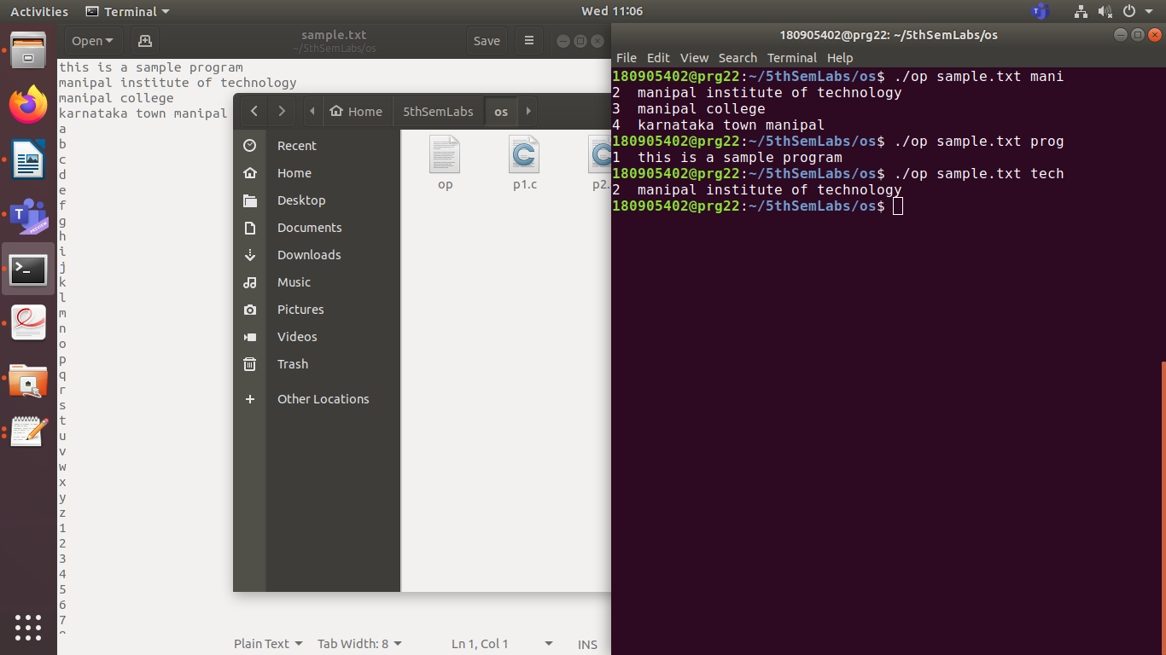
//Q2 list the lines of a file. Once 20 lines are hit, press a key to continue

#include<unistd.h>
#include<sys/types.h>
#include<sys/stat.h>
#include<stdio.h>
#include<string.h>
#include<fcntl.h>
int main(int argc, char* argv[])
{
int a = open(argv[1], O_RDONLY);
char buffer[128];
int line_count = 0;
int i = 0;
char ch;
//char op[21][128];
while(read(a, &ch, sizeof(ch)) > 0)
{
if(ch == '\n')
{
buffer[i++] = ch;
buffer[i] = '\0';
i = 0;
line_count++;
//printf("linecount is: %d \n", line_count);
printf("%s", buffer);
if(line_count == 20)
{
line_count = 0;
printf("20 lines done, press any key to continue \n");
getchar();
}

}
else
{
buffer[i++] = ch;
}
}

}

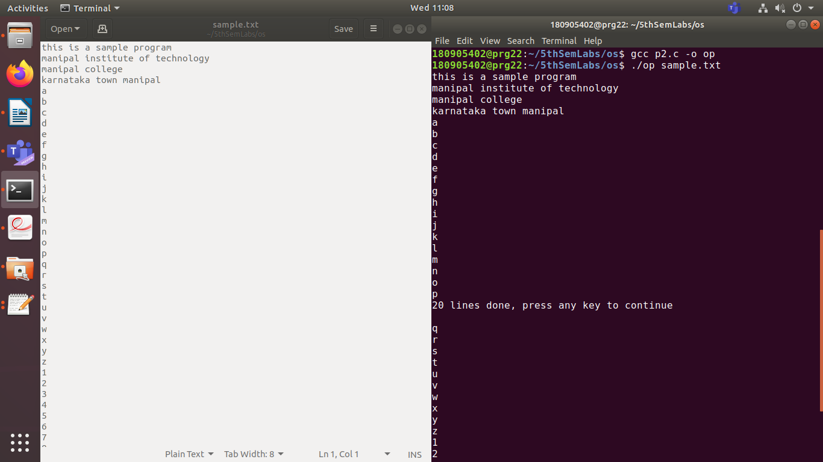
//Q3 use of conversion specifiers

#include<stdio.h>
#include<stdlib.h>
#include<errno.h>
int main(int argc, char* argv[])
{
char ch = 'A';
char* name = "John";
char age = 25;
float height = 6.2;
printf("char = %c, string = %s, int = %d, float = %f \n",ch, name, age, height);
printf("hex for INT: %x \n", age);
errno = EPERM;
printf("error is: %m \n");
}

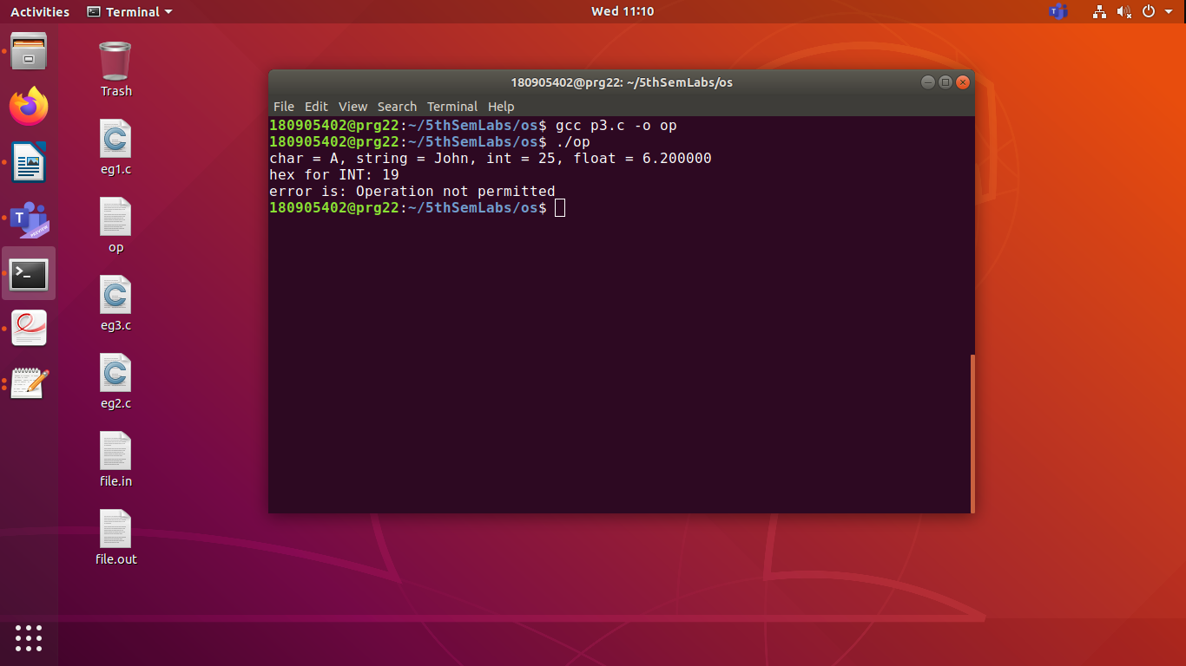

//Q4 character wise copy using stdio.h references

#include<stdio.h>
int main(int argc, char* argv[])
{
FILE *fp1 = fopen(argv[1], "r");
FILE *fp2 = fopen("sample_output.txt", "w");

char c;
while((c = fgetc(fp1)) != EOF)
{
fputc(c, fp2);
}
fclose(fp1);
fclose(fp2);
}

