MY IP ADDRESS: 172.16.58.154
Q3.1)
I went on the website workfence.in and tracked the packets.
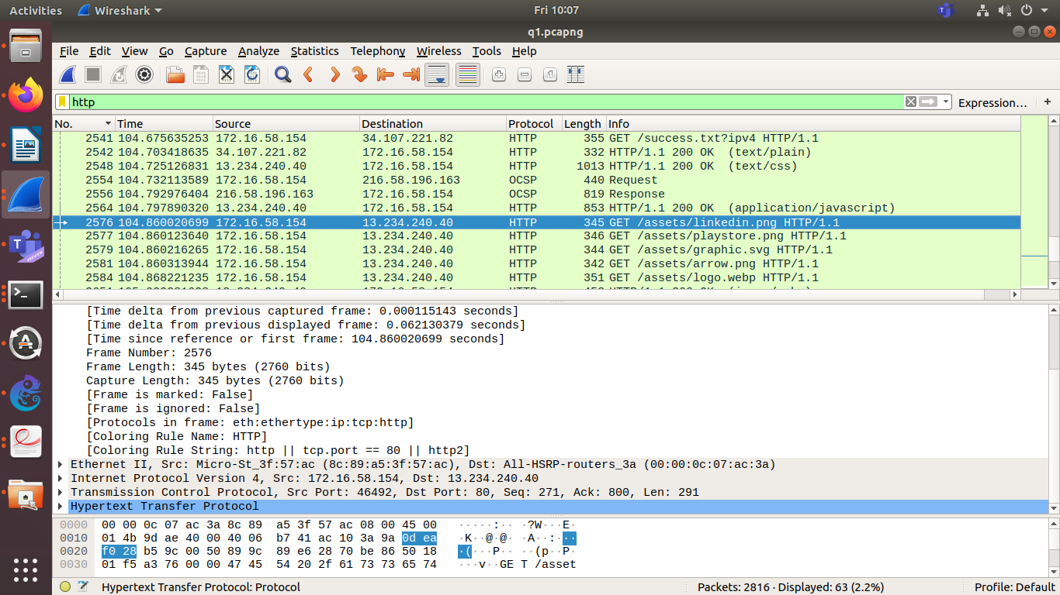
Line 2478, my web browser sends a request to the server (a GET request)
Line 2485, server sends an acknowledgement back to my browser.

Example of receiving an image from the server:
In line 2576 as shown in above screenshot, web browser sends a request to the web server asking to send a .png file. This is a GET request.

In line 2657, our web browser has received the image and has acknowledged.
Most common HTTP methods are GET and POST.

Q2)

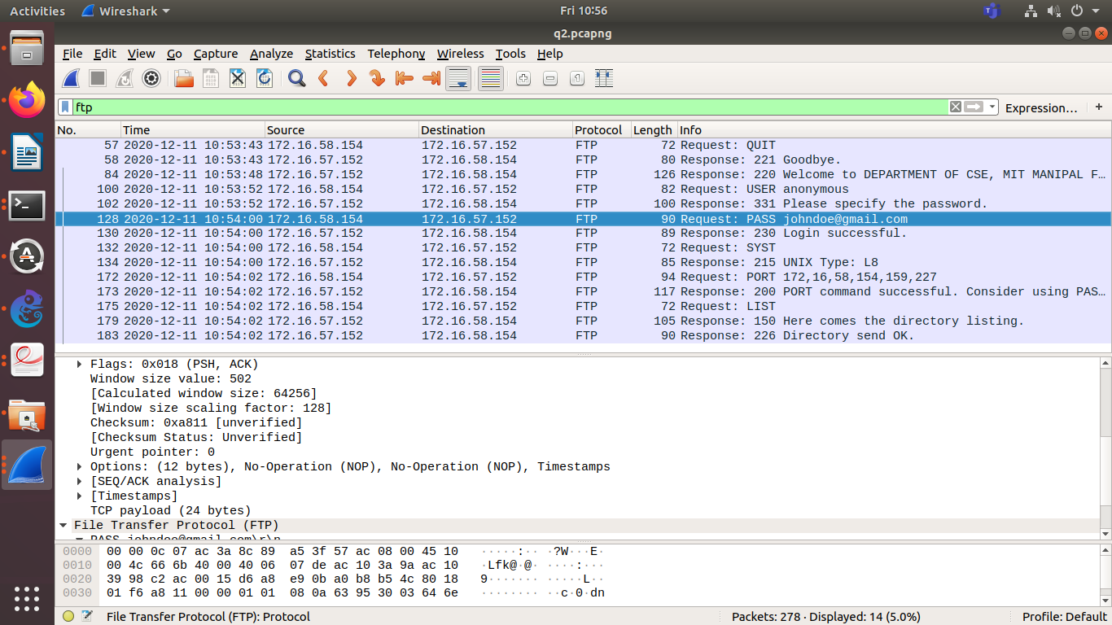
Clearly, on line 128, my password is visible in plaintext, hence it is an insecure protocol.

Q3)

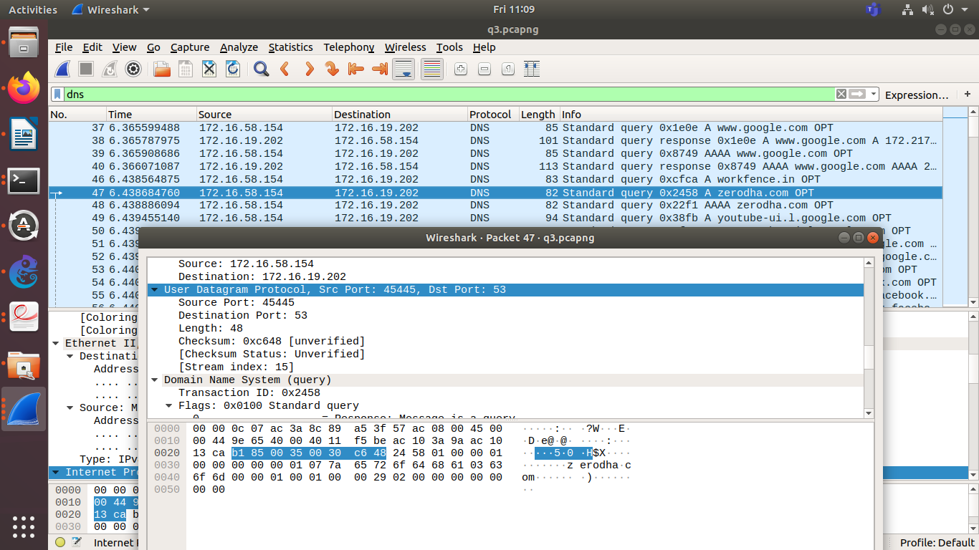
my web browser sends a DNS query to the server. It uses the Ipv4 protocol to do this.

Q4.1 and 4.3)
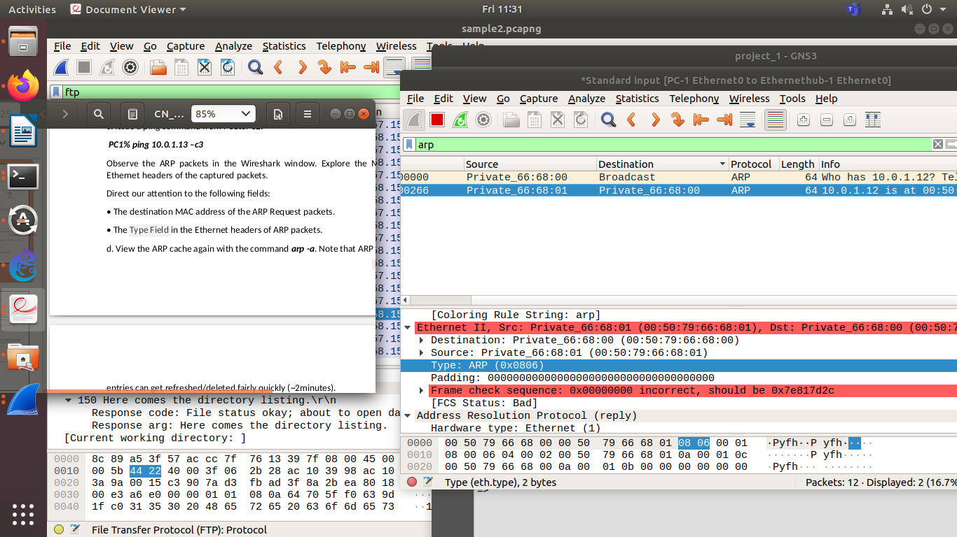
type: ARP

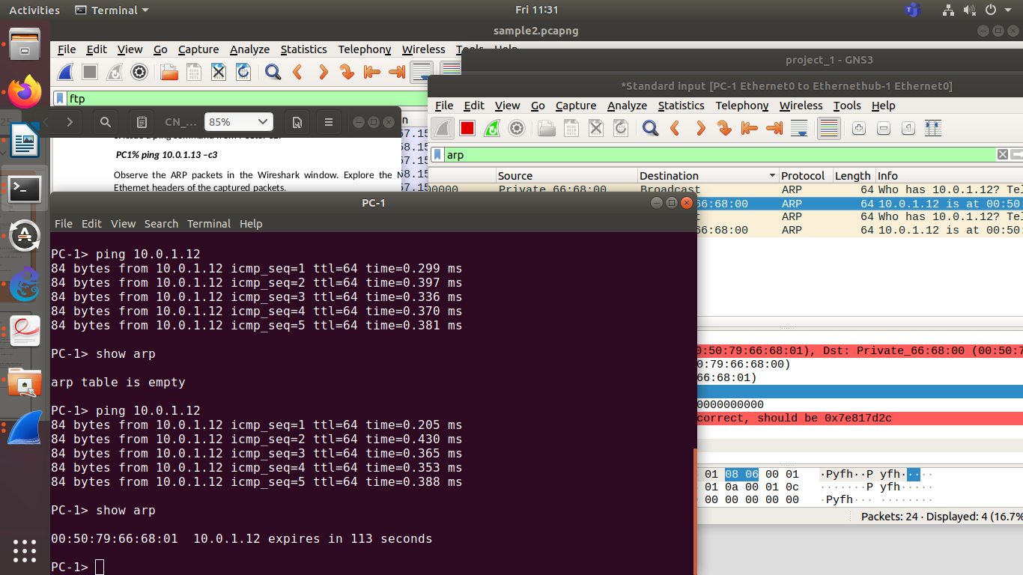
ARP table contains the MAC address of the client.

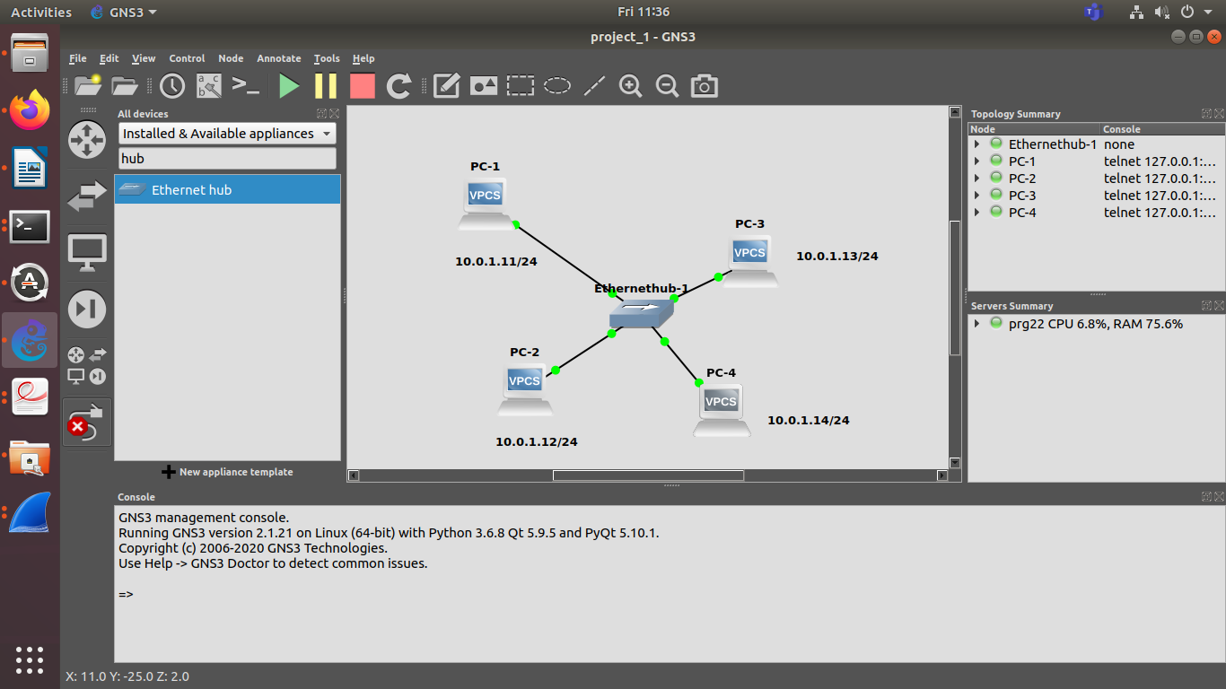

Q4.2
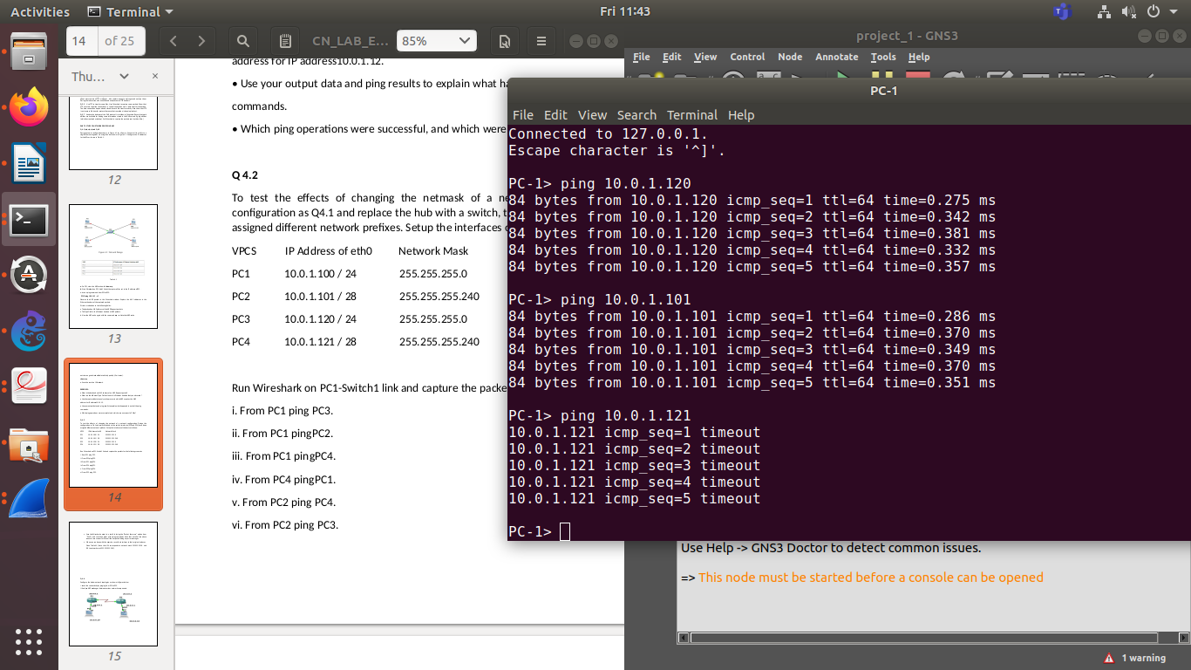
PC1 to PC3: pinging correctly
PC1 to PC3: pinging correctly
PC1 to PC4 not pinging(timeout error) as they have different network gateway

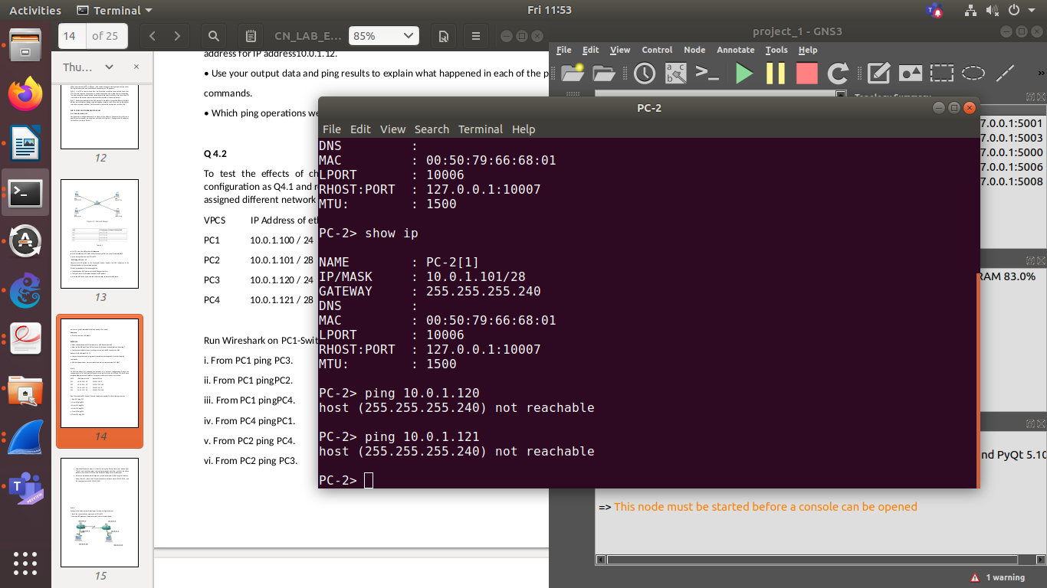

PC4 to PC1: host not reachable(different gateway)
PC2 to PC4: host not reachable(different gateway)
PC2 to PC3: host not reachable(?)

