CD LAB 6

q1)
#include<stdio.h>
#include<string.h>
#include<ctype.h>
#include<stdlib.h>

/*
S -> a | > | (T)
T -> T,S | S

after removing left recursion

S -> a | > | (T)
T -> ST'
T' -> ,ST'|eps

*/

int curr = 0;
char str[100];

void S();
void T();
void T_prime();

void invalid()
{
printf("-----------------ERROR!----------------\n");
exit(0);
}

void valid()
{
printf("----------------SUCCESS!---------------\n");
exit(0);
}

void S()
{
if(str[curr] == 'a')
{
curr++;
}
else if(str[curr] == '>')
{
curr++;
}
else if(str[curr] == '(')
{
curr++;
T();
if(str[curr] == ')')
{
curr++;
}
}
}

void T()
{
//T -> ST'
S();
T_prime();
}

void T_prime()
{
//T' -> ,ST'|eps
if(str[curr] == ',')
{
curr++;
S();
T_prime();
}
}

int main()
{
printf("Enter String: ");
scanf("%s", str);
S();
if(str[curr] == '$')
{
valid();
}
else
{// printf("%c\n", str[curr]);
invalid();
}
}

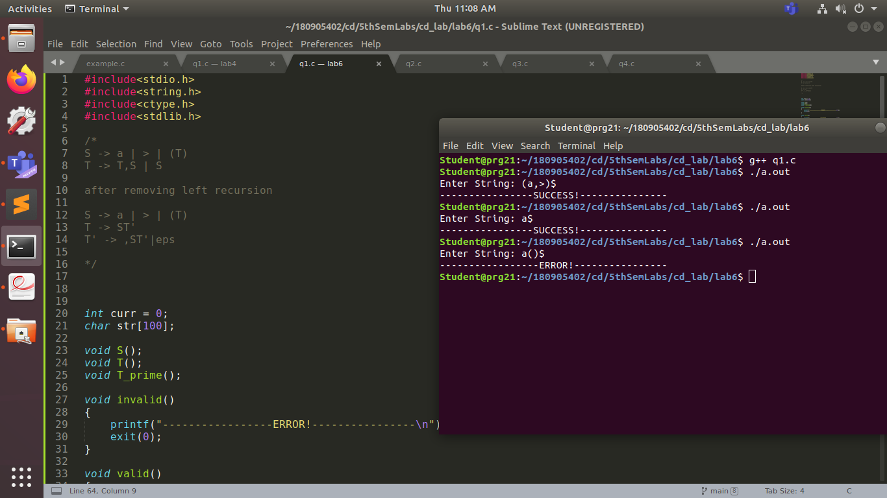

q2)

#include<stdio.h>
#include<string.h>
#include<ctype.h>
#include<stdlib.h>

/*
S -> UVW
U -> (S) | aSb | d
V -> aV | eps
W -> cW | eps
*/

int curr = 0;
char str[100];

void S();
void U();
void V();
void W();

void invalid()
{
printf("-----------------ERROR!----------------\n");
exit(0);
}

void valid()
{
printf("----------------SUCCESS!---------------\n");
exit(0);
}

void S()
{
U();
V();
W();
}

void U()
{
if(str[curr] == '(')
{
curr++;
S();
if(str[curr] == ')')
{
curr++;
}
else
{
invalid();
exit(0);
}
}
else if(str[curr] == 'a')
{
curr++;
S();
if(str[curr] == 'b')
{
curr++;
}
else
{
invalid();
exit(0);
}
}
else if(str[curr] == 'd')
{
curr++;
}
else
{
invalid();
exit(0);
}
}
void V()
{
if(str[curr] == 'a')
{
curr++;
V();
}
}

void W()
{
if(str[curr] == 'c')
{
curr++;
W();
}
}
int main()
{
printf("Enter String: ");
scanf("%s", str);
S();
if(str[curr] == '$')
{
valid();
}
else
{// printf("%c\n", str[curr]);
invalid();
}
}
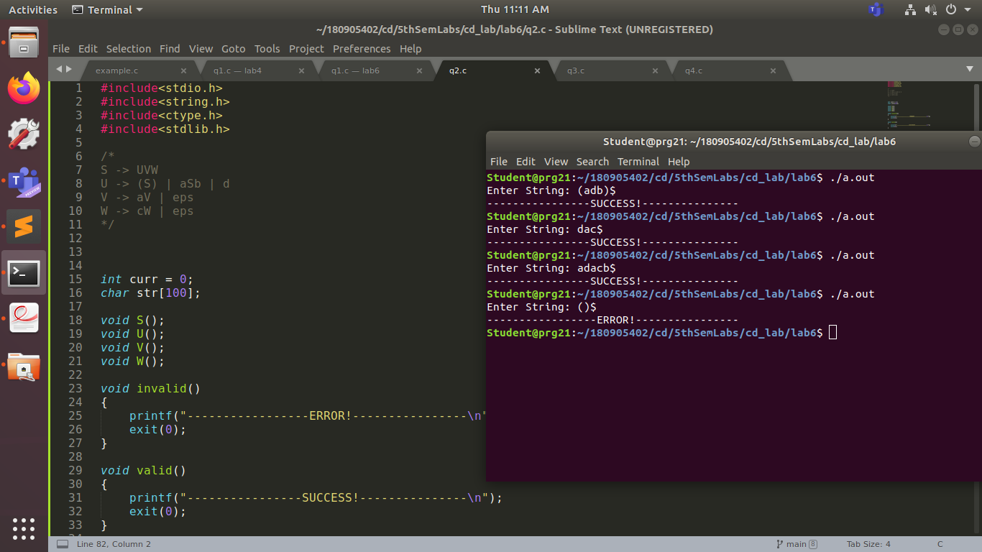
q3)

#include<stdio.h>
#include<string.h>
#include<ctype.h>
#include<stdlib.h>

/*
S -> aAcBe
A -> Ab | b
B -> d

S -> aAcBe
A -> bA'
A' -> bA' | eps
B -> d

*/

int curr = 0;
char str[100];

void S();
void A();
void A_prime();
void B();

void invalid()
{
printf("-----------------ERROR!----------------\n");
exit(0);
}

void valid()
{
printf("----------------SUCCESS!---------------\n");
exit(0);
}

void S()
{
if(str[curr] == 'a')
{
curr++;
A();
if(str[curr] == 'c')
{
curr++;
B();
if(str[curr] == 'e')
{
curr++;
}
}
}
}

void A()
{
//A -> bA'
//A' -> bA' | eps
if(str[curr] == 'b')
{
curr++;
A_prime();
}
}
void A_prime()
{
if(str[curr] == 'b')
{
curr++;
A_prime();
}
}

void B()
{
if(str[curr] == 'd')
{
curr++;
}
}
int main()
{
printf("Enter String: ");
scanf("%s", str);
S();
if(str[curr] == '$')
{
valid();
}
else
{// printf("%c\n", str[curr]);
invalid();
}
}

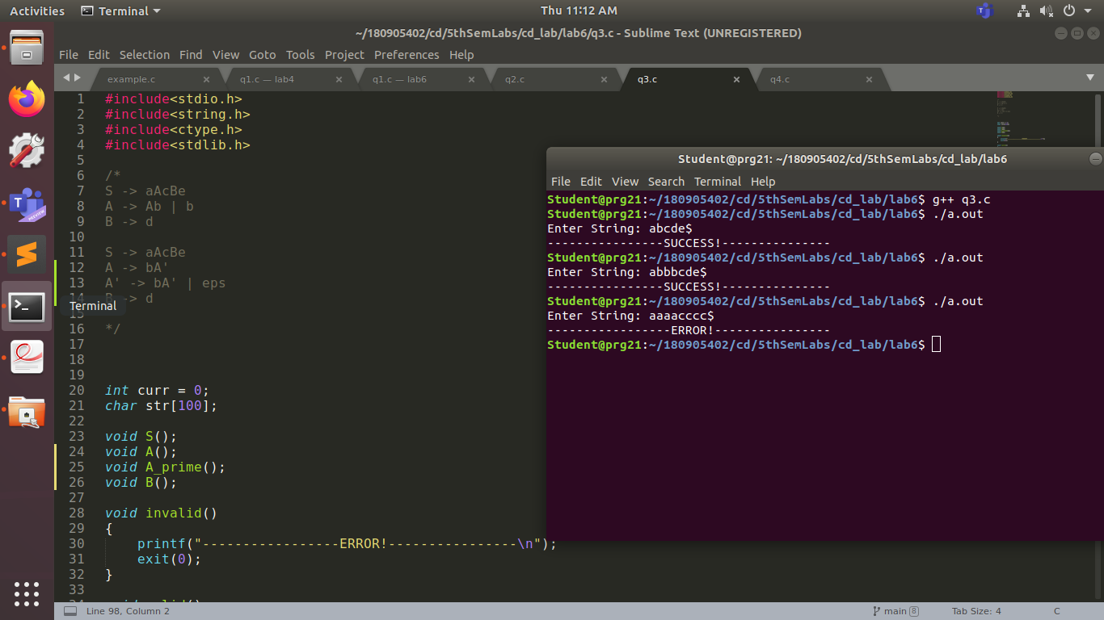

q4)
#include<stdio.h>
#include<string.h>
#include<ctype.h>
#include<stdlib.h>

/*
S -> (L) | a
L -> L,S | s

S -> (L) | a
L -> sL'
L' -> ,SL' | eps

*/

int curr = 0;
char str[100];

void S();
void L();
void L_prime();

void invalid()
{
printf("-----------------ERROR!----------------\n");
exit(0);
}

void valid()
{
printf("----------------SUCCESS!---------------\n");
exit(0);
}

void S()
{
if(str[curr] == '(')
{
curr++;
L();
if(str[curr] == ')')
{
curr++;
}
}
else if(str[curr] == 'a')
{
curr++;
}
}

void L()
{
//L -> sL'
//L' -> ,SL' | eps
if(str[curr] == 's')
{
curr++;
L_prime();
}
}

void L_prime()
{
if(str[curr] == ',')
{
curr++;
S();
L_prime();
}
}

int main()
{
printf("Enter String: ");
scanf("%s", str);
S();
if(str[curr] == '$')
{
valid();
}
else
{
invalid();
}
}

