//LAB3

q5.1

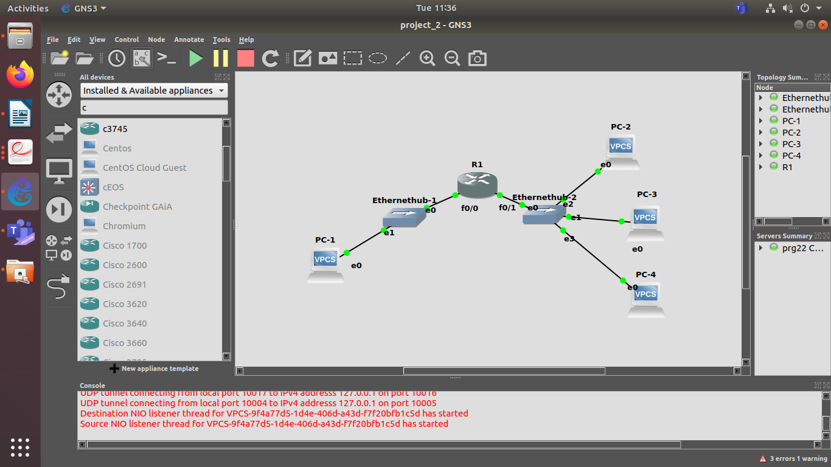

Ping from PC1 to PC3
refer
pc1_pc3.pcapng and pc2_pc1.pcapng

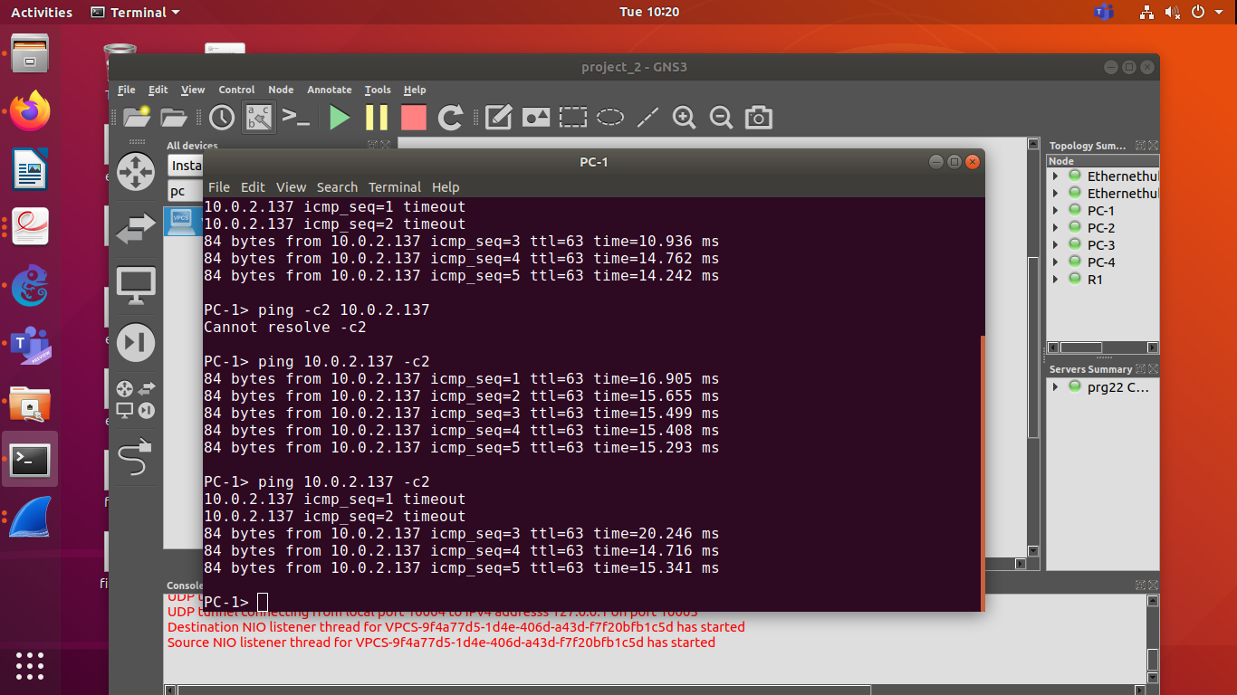

ARP showing for PC1 and PC3
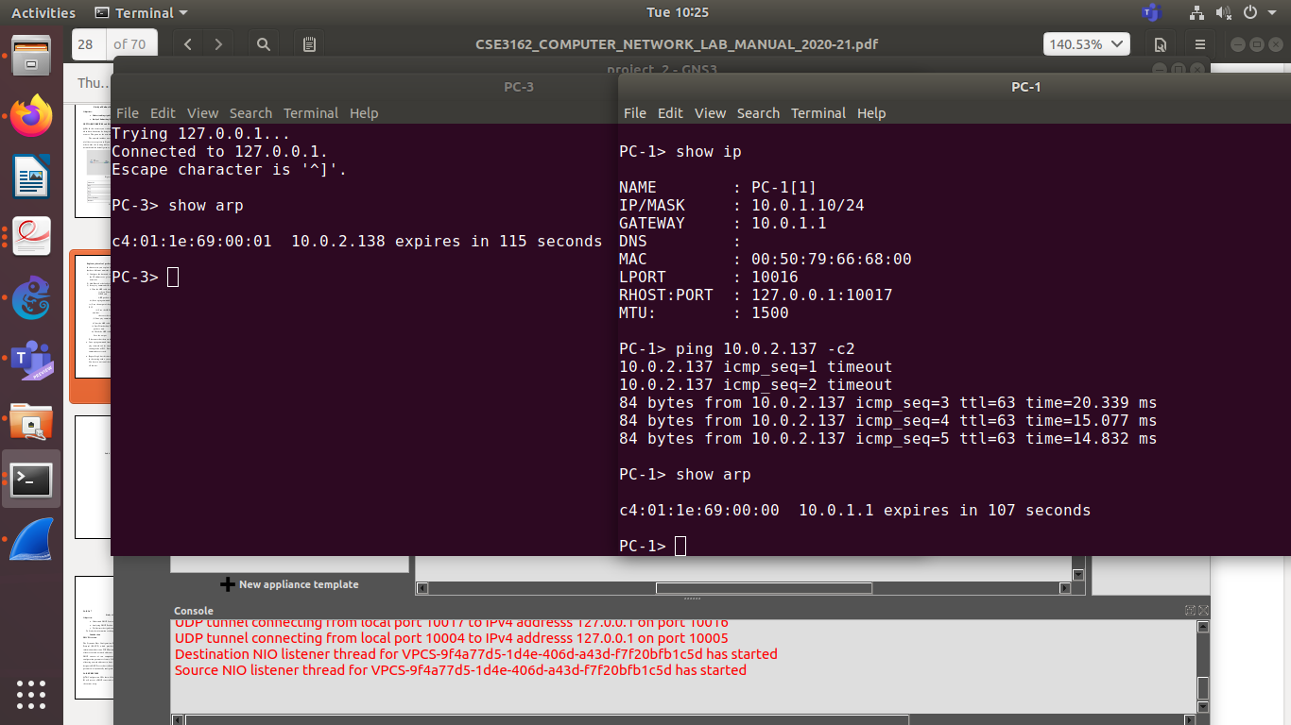

IP ROUTE
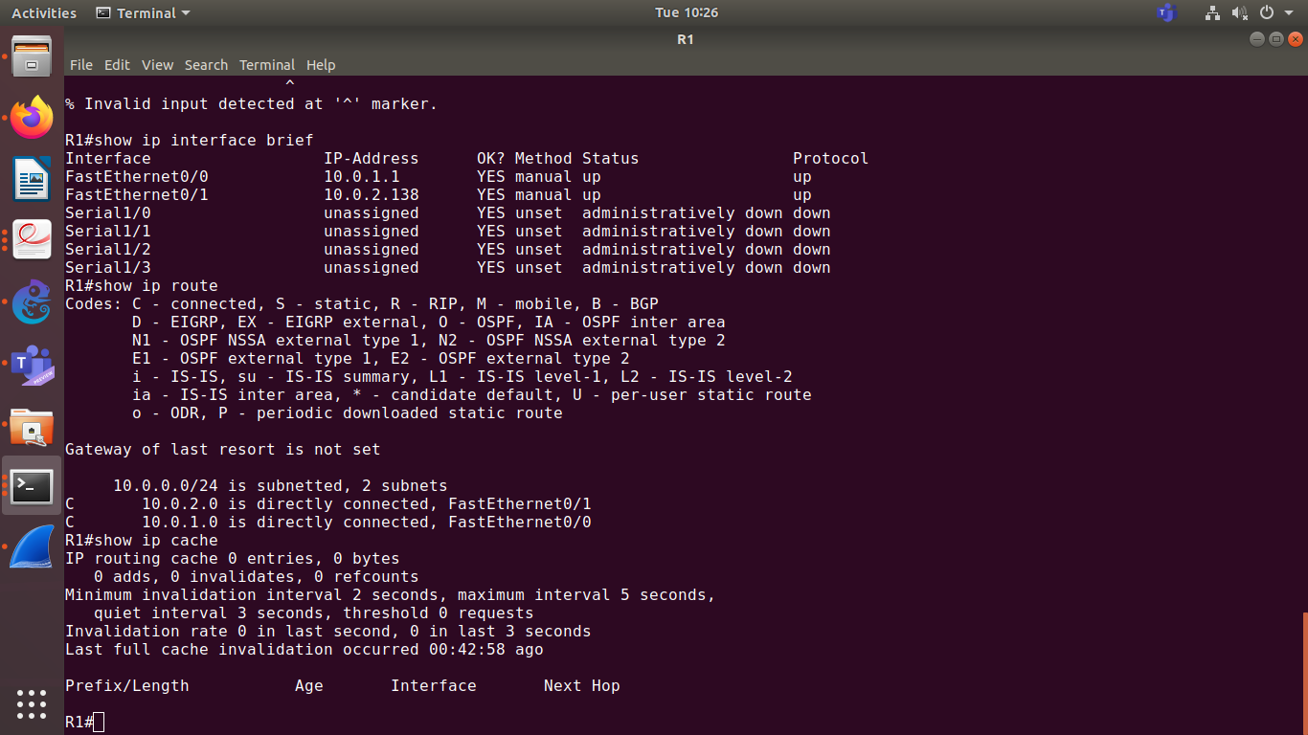

ARP for ping from PC3 to PC4
refer to pc3_pc4.pcapng and pc4_pc3.pcapng

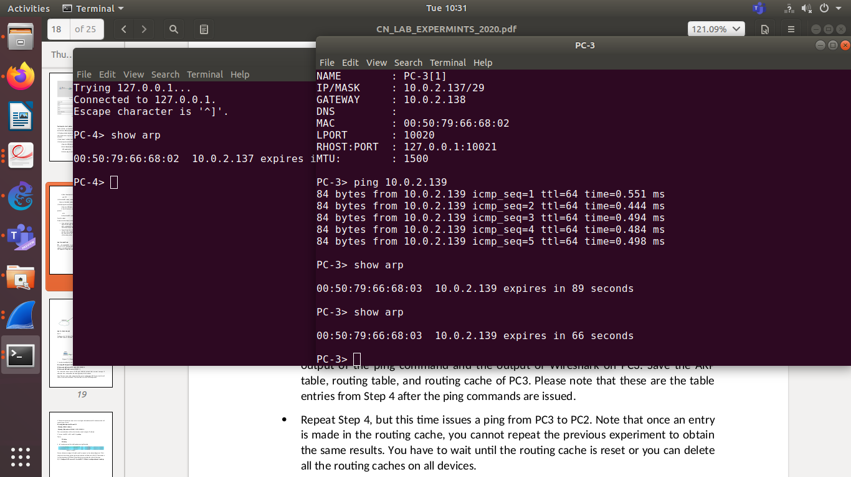
showing the routes
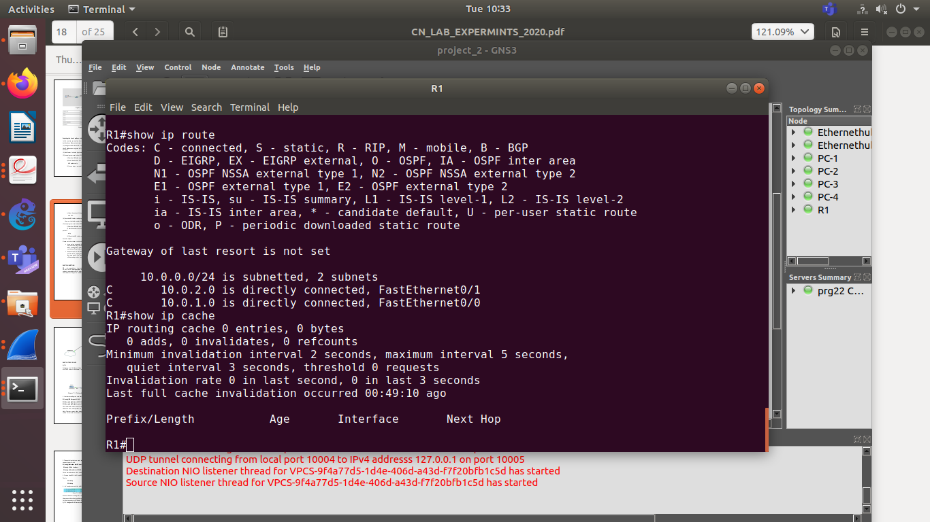
Q2)

block of addresses: 14.24.74.0/24

1st subblock = 100 addresses
hence, 128 possible
32 – log(128) = 25 (this is the prefix size)
=> 14.24.74.0/25 to 14.24.74.127/25

2nd subblock = 60 addresses
hence, 64 possible
32 – log(64) = 26 (this is the prefix size)
=> 14.24.74.128/26 to 14.24.74.191/26

3rd subblock = 10 addresses
hence, 16 possible
32 – log(16) = 28(this is the prefix size)
=> 14.24.74.192/28 to 14.24.74.207/28

q3) study of dhcp

refer:
q_7__pc1.pcapng
and
q_7__pc2.pcapng
