Q1)

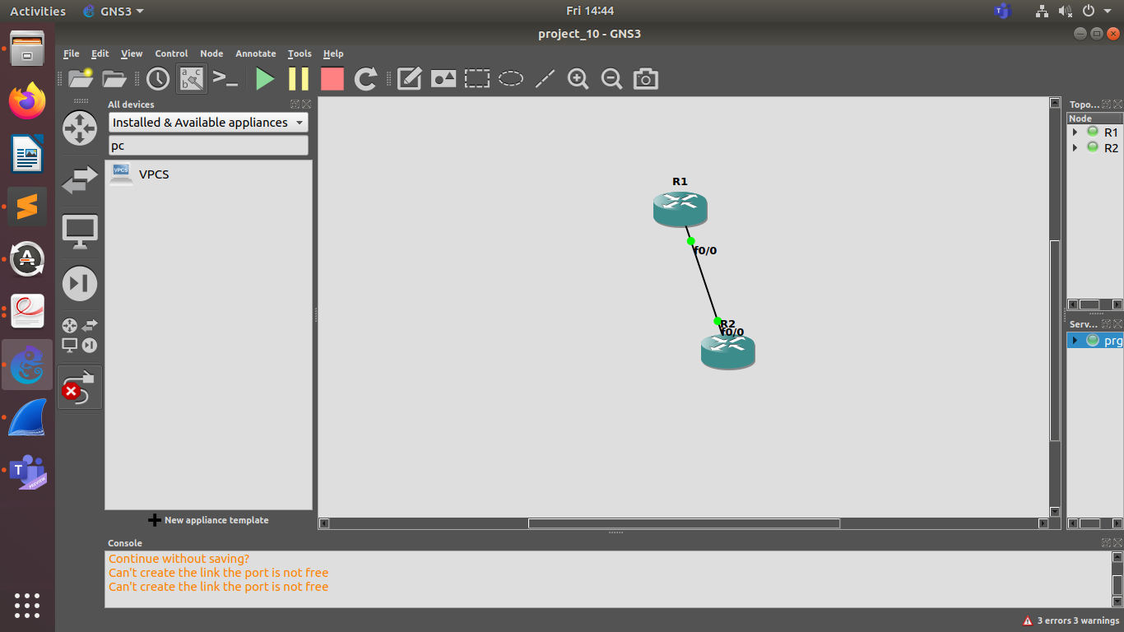

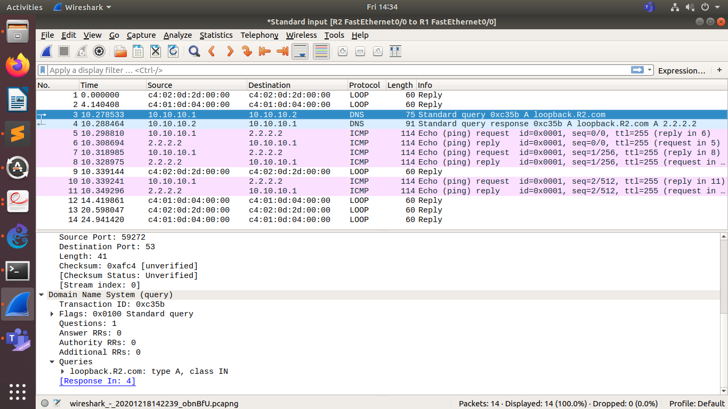
We set up R2 as a DNS server.
Then we set up R1 to use R2 as a default getaway.
When we ping to loopback.R2.com from R1, we get the above output.
Q2)

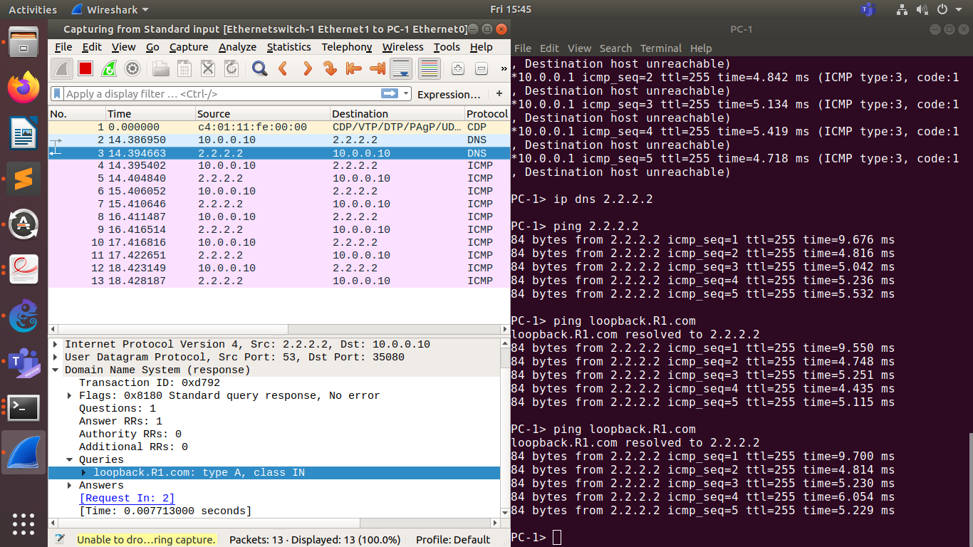
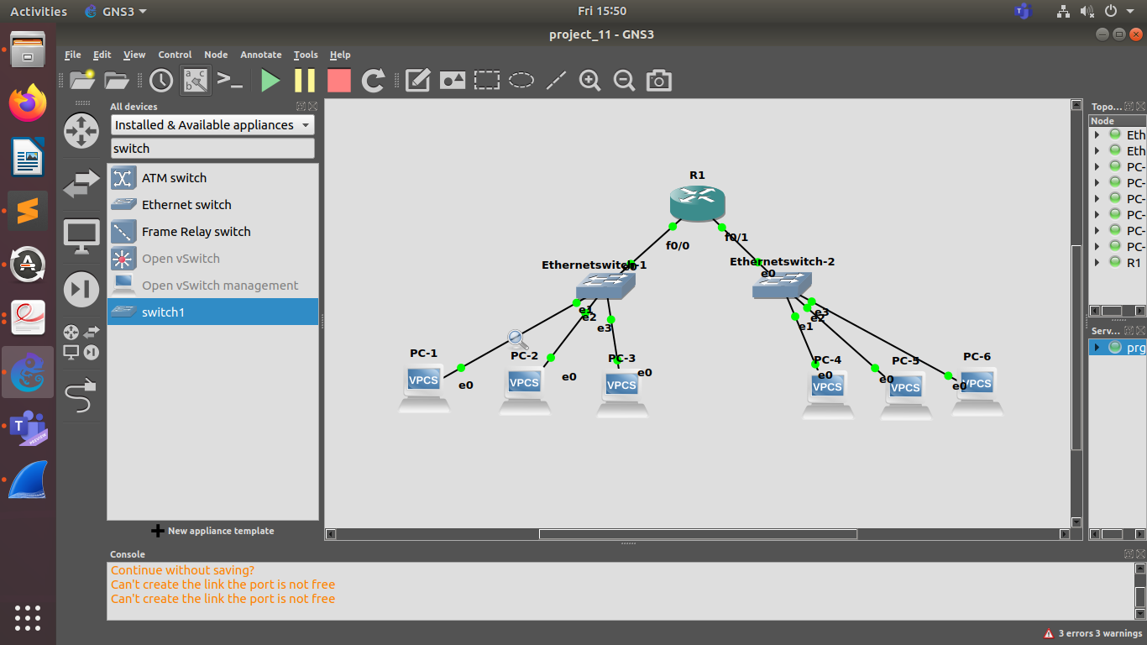
We configure both the interfaces(f0/0 and f0/1) of R1.
After this, we configure dhcp on R1.
Then we can set up all the Pcs.
Finally, we ping to loopback.R1.com from any of the Pcs.

In above screenshot, I have pinged using PC-1.

Q3)

