OS LAB 2
q1. print all files and access privileges for the current directory
#include <unistd.h>
#include <stdio.h>
#include <sys/stat.h>
#include <sys/types.h>
#include<dirent.h>
#include<stdlib.h>
int main()
{
DIR* dp;
struct dirent* entry;
struct stat statbuf;
if((dp = opendir(".")) == NULL)
{
printf("Cannot open directory \n");
return 0;
}
chdir(".");
while((entry = readdir(dp)) != NULL)
{
lstat(entry->d_name,&statbuf);
if(!S_ISDIR(statbuf.st_mode))
{
//printf("%s \t ",entry->d_name);
printf( (S_ISDIR(statbuf.st_mode)) ? "d" : "-");
printf( (statbuf.st_mode & S_IRUSR) ? "r" : "-");
printf( (statbuf.st_mode & S_IWUSR) ? "w" : "-");
printf( (statbuf.st_mode & S_IXUSR) ? "x" : "-");
printf( (statbuf.st_mode & S_IRGRP) ? "r" : "-");
printf( (statbuf.st_mode & S_IWGRP) ? "w" : "-");
printf( (statbuf.st_mode & S_IXGRP) ? "x" : "-");
printf( (statbuf.st_mode & S_IROTH) ? "r" : "-");
printf( (statbuf.st_mode & S_IWOTH) ? "w" : "-");
printf( (statbuf.st_mode & S_IXOTH) ? "x" : "-");
printf("\t %s \t ", entry->d_name);
printf("\n");
}
}
}

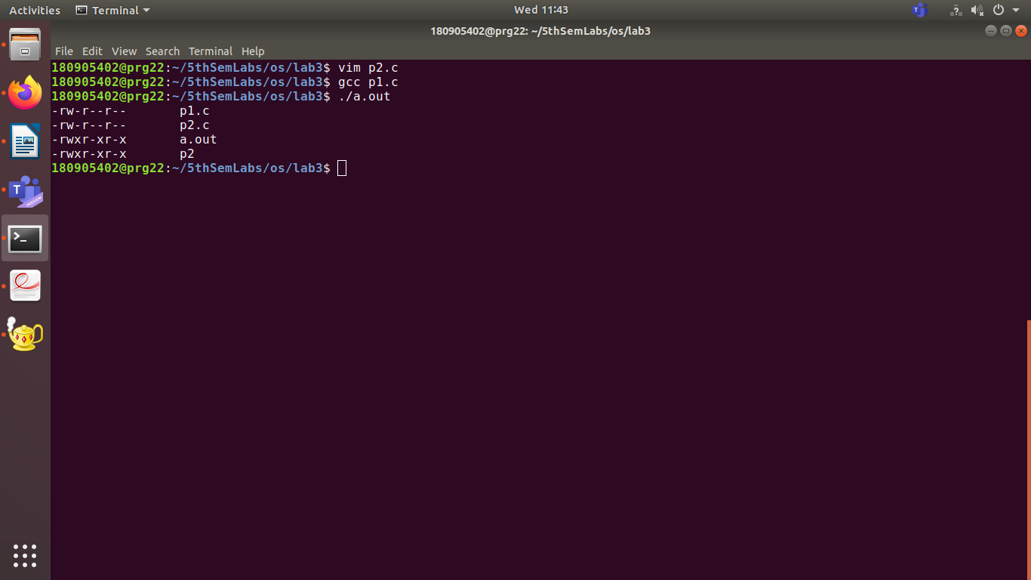
q2. List all the directories and the subdirectories

#include <unistd.h>
#include <stdio.h>
#include <dirent.h>
#include <string.h>
#include <sys/stat.h>
#include <stdlib.h>
void printdir(char *dir, int depth)
{
DIR* dp;
struct dirent* entry;
struct stat statbuf;
if((dp = opendir(dir)) == NULL)
{
fprintf(stderr,"cannot open directory: %s\n", dir);
return;
}
chdir(dir);
while((entry = readdir(dp)) != NULL)
{
lstat(entry->d_name,&statbuf);
if(S_ISDIR(statbuf.st_mode))
{
/* Found a directory, but ignore . and .. */
if(strcmp(".",entry->d_name) == 0 || strcmp("..",entry->d_name) == 0)
{
continue;
}
printf("%*s%s/\n",depth,"",entry->d_name);
/* Recurse at a new indent level */
printdir(entry->d_name,depth+4);
}
else
{
printf("%*s%s\n",depth,"",entry->d_name);
}
}
chdir("..");
closedir(dp);
}

int main()
{
printf("Directory scan of current one:\n");
printdir(".",0);
printf("done.\n");
exit(0);
}

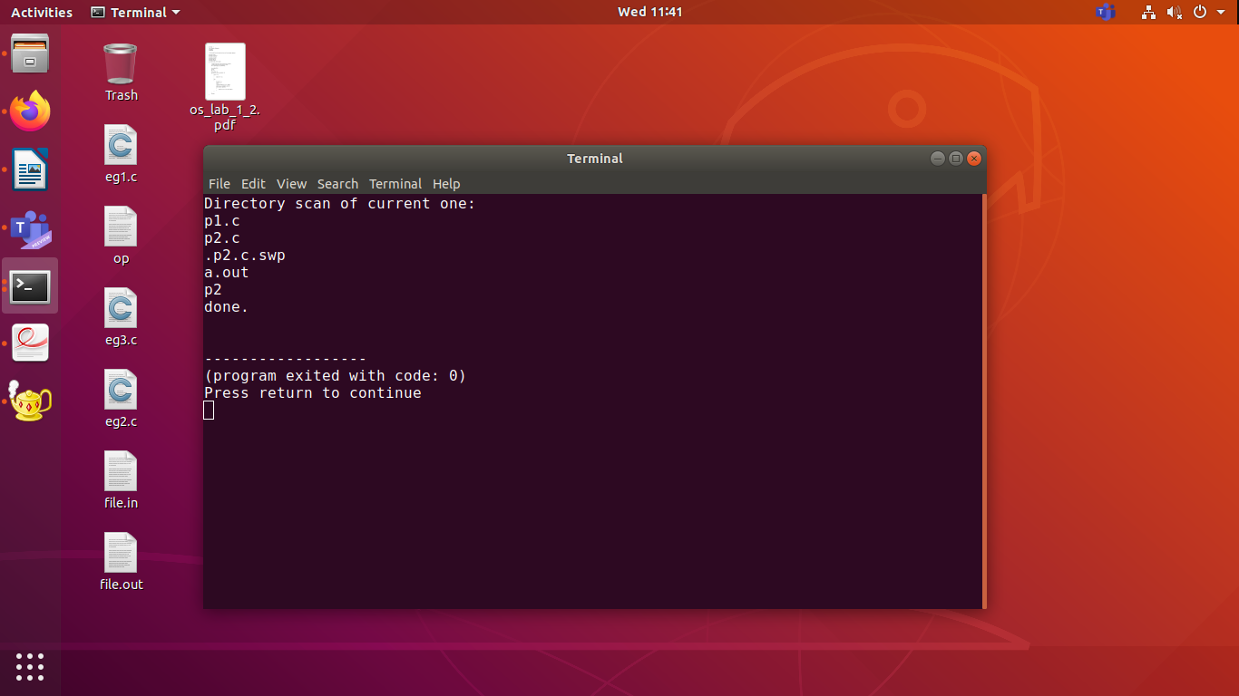
q3.
command to list all installed programs:

dpkg -l
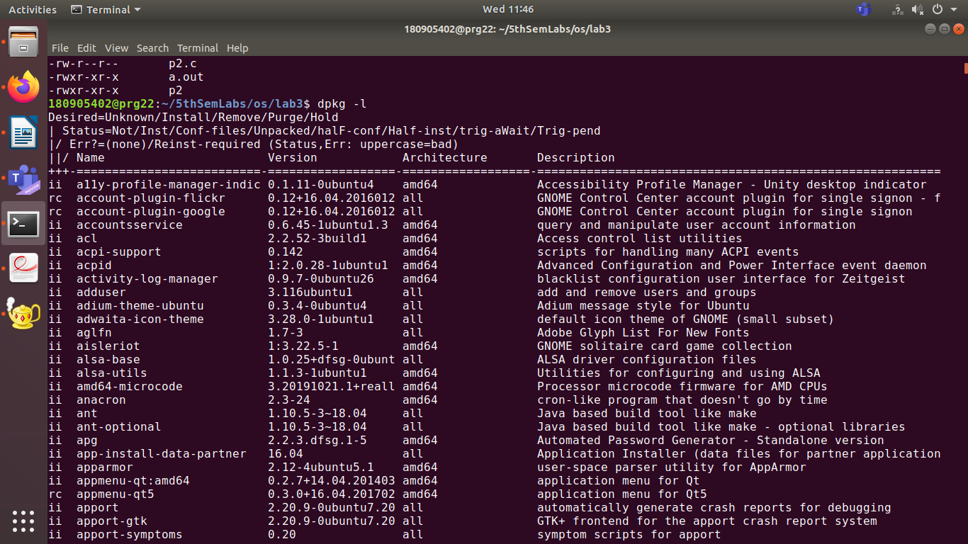
q4. List the rpm packages.

Rpm -qa

