Faculty Performance Based Appraisal System

**Submitted to the**

**International Institute of Professional Studies**

**Devi Ahilya University, Indore**

**By**

**(Sweta Rathore)**

**In partial fulfillment of the requirements for the Award of Degree of**

|  |  |
| --- | --- |
|  | **Master of Computer Applications** |
|  | **Under Supervision of** |
| **Internal** | **External Guide** |
| **Name** | **Name** |
| **Designation** | **Designation** |
| **Place** | **Place** |

**DISSERTATION APPROVAL SHEET**

The Dissertation Entitled Faculty Performance Based Appraisal System being submitted by Sweta Rathore in Partial fulfillment for award of degree in MCA, to Development Center of IIPS DAVV, is Satisfactory and approved.

Internal Examiner External Examiner

**Acceptance from the guides**

**To whomsoever it may concern**

I ________________________, working as ___________________________with

________________give my consent to guide _______________for a project titled

______________________________. The tentative duration for the project will be from _________to_________________.

Signed by

**Project Guide**

**Certificate of completion of project from the company**

**(to be submitted along with project report)**

(on the company’s letterhead in three copies and to be binded along with the report)

**To Whomsoever It May concern**

This is to certify that Mr./Ms. _____________________has completed project titled

___________________________________in our organization from date____________to_____________. His/her performance and conduct has been found satisfactory.

Signature

Authorized Signatory

**Table of Contents**:

**Acknowledgement**

**Abstract**

1. **Introduction**
2. **Company Profile**
3. **Software and Hardware Requirement**
4. **System Analysis**
5. **System Design**
6. **System Coding and implementation**
7. **Output Forms and Reports**

1. **System Testing**
2. **System maintenance**
3. **Conclusion**

**Appendix A: List of abbreviation Appendix B: Diagrams References and Bibliography Books Referred**

**Websites Referred**

|  |  |  |
| --- | --- | --- |
|  |  | |
|  |  | |
|  |  |
|  |  |
|  |  |
|  |  |
|  |  |





**Introduction:**

**1.1The Client Organization**

Devi Ahilya Vishwavidhyalya is University of Indore, which have one department *International institute of Professional studies* . All the IIPS Faculty submits the summary of their professional activity at the end of the session in the form of self appraisal. The Information is filled in a professional format of word document available at the university’s website. The information needs to be submitted with related documents has to be searched at the time of submission and then arranging the information in the given format is very time consuming and complex task.

**1.2 Problem Definition**

The following points describe the problem domain at the existing system:-

* It is not an automated system to manage faculty information.
* It does not provide persistent storage of the information.
* Information is recorded on paper, which is a time consuming process.
* Updating and retrieving the needed information from the previous records is very difficult and complex.
* It does not provide security.
* Being a manual system, it requires more manpower.
* Loss of data is another problem which could occur.

**1.3 Aim**

To design and develop a Computerized System, it is necessary to manage information of faculties more effectively using the concepts of database design and easy-to-use GUI interface which would help the user to save time and effort.

**1.4. Objective**

The objectives of the development are as follow:

* Computerization of present system which results in effective and efficient use of time and effort.

* Integrating information at one place.
* To provide security of information.
* To increase efficiency of Information management.
* Storing Academic ,Personal and Professional at a one place.
* To generate reports at a single click.

**1.5 Benefits**

The various benefits that can be realized from this project are as follows:

* **Easy maintenance of information**

The proposed system maintains the Academic, personal and professional details of user . This proposed system will keep the track of all the information in a user friendly environment. Thus, it helps user in efficient searching of information.

* **No dependency** on a specific person to get required information

System generates reports as per the requirements.

* **Saves time and effort**

It will be helpful in maintaining the records and information in efficient time. Searching of desired information can be achieved in a time efficient manner.

**2. PROJECT PLANNING**



**PROJECT PLANNING**

|  |
| --- |
|  |



The most important and critical phase of managing system projects is planning. Information systems have become increasingly important during the past decade. Information is now recognized as a vital resource. And there is growing need for formal long-range planning with Information systems.

**2.1 Project Scope**

The scope of the project can be described in the following manner:

* Software can deal with an operator or an admin.
* It can be used by any IIPS Teachers who have a valid ID.
* Report will be generated according to the format of UTD’s self appraisal form.

**2.2 Documentation Plan**

Documentation plan will be as listed below:-

* IEEE standard will be followed for all documentation purpose.
* All documents would be discussed with the project in-charge.
* All documents will be reviewed with the project in-charge.
* All documents will be available in soft copy and hard copy.
* All documents would be submitted on mentioned date of schedule.

**2.3 Team Structure**

Team Structure involves:-

* Team involves software developer

Ritika Barethia

Shubham Neema

Sweta Rathore

Vikas Chouhan.

**2.5Gantt Chart**

Gantt chart is a time-phased bar chart display that lists tasks or activities along the left side and a corresponding bar for each task. The length of the bar represents the duration of the activity. This scheduling tool used to display the status of a project’s tasks. The Gantt chart shows each task’s duration as a horizontal line. The ends of the lines correspond to the task’s start and end dates.

|  |  |  |  |  |  |  |  |  |  |  |  |  |  |  |  |  |
| --- | --- | --- | --- | --- | --- | --- | --- | --- | --- | --- | --- | --- | --- | --- | --- | --- |
| **TIME LAG**  **PHASES** | **SEPTEMBER** | | | | **OCTOBER** | | | | | | **NOVEMBER** | | | | | |
| **01-10** | **10-20** | | **20-29** | **01-10** | **10-20** | | | **20-31** | | **01-10** | | **10-20** | | **20-30** | |
|  |  |  | |  |  |  | | |  | |  | |  | |  | |
| **ANALYSIS** |  |  |  |  |  |  | | |  | |  | |  | |  | |
|  |  |  | |  |  |  | | |  | |  | |  | |  | |
| **DESIGN** |  |  | |  |  |  |  | |  | |  | |  | |  | |
|  |  |  | |  |  |  | | |  | |  | |  | |  | |
| **CODING** |  |  | |  |  |  | |  |  | |  | |  | |  | |
|  |  |  | |  |  |  | | |  | |  | |  | |  | |
| **TESTING** |  |  | |  |  |  | | |  |  |  |  | |  | |  | |

**3.CURRENT SYSTEM AND PROPOSED SYSTEM**

**CURRENT AND PROPOSED SYSTEM**



**3.1 Current System**

The current system used by the user involves entry of each user’s information in a register or a doc file. Admin needs to find each record at a regular interval of time in order to assess the users performance based on two months, three months and to manage information of all the users. Thus all the information are on paper. The searching of desired information takes a lot of time and effort. There exist no backup of the prepared report.

**3.2 Limitations of Current System**

The current system has a large number of limitations. These limitations encourage the improper maintenance of Information. At the time of requirement gathering and analysis, the following limitations are discovered.

.

* Since the system is manual there is scope of error due to carelessness and manipulation.
* No backups of the records are maintained due to the tedious nature of the work.
* Searching for particular records gets more and more difficult as the records get older.
* Report is prepared at the regular interval so there is a possibility that some information may get left.
* The manual system is not consistent in nature.
* Important reports cannot be generated on time due to cumbersome nature of task.
* Since there is a lot of repetition of information, which has to be done manually, there is no check for wrong replication of records.
* No recovery of data is possible by any means if it gets lost.

**3.3 Proposed System**

The following points gives an overview of the proposed system :

* The proposed system is a completely automated system, which manages the entire information of an individual.
* The system also generates appropriate reports.
* The proposed system helps the user to retrieve the information as quickly as possible.
* The system provides backup plans to avoid data loss that is of high priority.
* The system provides a user-friendly interface with a realistic view.
* The system provides an error free environment.
* The system is capable enough to reduce the number of register.

**3.4 Objectives of Proposed System**

Following are the objectives of the proposed system:-

* The objectives of the proposed system are to remove the limitations of the current system.
* To reduce data duplication.
* Implement validation techniques and checks that will help reduce the margin of error in operations.
* The system ensures consistency.

**4.FEASIBILITY STUDY**

**FEASIBILITY STUDY** 



Feasibility Study is the step to determine exactly what the candidate system is to do by defining its expected performance. This step involves selecting of the best candidate system among the alternatives such that it should be feasible or beneficial in terms of Economical, Technical and behavioral considerations of feasibility study

**4.1 Economic Feasibility**

Economic analysis is the most frequently used method for evaluating the cost effectiveness of the system. It is more commonly known as cost/benefit analysis.

The CSMS is tested for economic feasibility and is completely feasible economically. Following table justify the economic feasibility of CSMS.

|  |  |  |
| --- | --- | --- |
| **S. No.** | **Points of consideration** | **Justification** |
| 1 | Computer System for development process | Available in the lab of the institute |
| 2 | Electricity cost | Available in the institute |
| 3 | Internet connection | Available in the institute |
| 4 | Cost of the front-end and back-end tool used | Available for free of cost |
| 5 | Cost for the preparation of documents | Nominal |
| 6 | Complete cost of software for selling (Selling Price) | Easily affordable |

**4.2 Technical Feasibility**

The CSMS is technically feasible considering the following criteria:-

* EASE OF USE: User can operate the system easily who have the basic knowledge of operating a computer.
* SECURITY : The data of the individual is secure and well protected
* O.S COMPATIBILITY: It can be operated in a windows based system which is available at client’s sight.
* HARDWARE COMPATIBILITY: It requires very nominal storage as the information will be in the form of plain text.
* MAINTAINABILITY: The system being developed is made general purpose with respect to user’s requirement hence there will be less maintenance .

**4.3 Behavioral Feasibility**

Behavioral feasibility is an important consideration in feasibility study. Being an application for a general user PBAS is a feasible in terms of behavioral feasibility. Following points justify the behavioral feasibility of PBAS:-

* Easy to operate.
* Convenient in maintenance.
* Effective in its function.
* Retrieval of information is according to user’s requirement.
* Retrieval of information is easy, fast and accurate than the previous system.
* Help is provided for the easy understanding of the functions of CSMS.

**5.ANALYSIS**

**ANALYSIS**



**5.1 Form**

The following Interview questions were taken for further analysis :-

Question : Tell us about your organization.

Answer : It is a co operative society which have around 700 members. The main purpose of this society is to provide loan to its members.

Question : What all information are recorded while registering a member?

Answer : Following are the information that are recorded while registering new member :

Name, Address, Date of Birth, Contact number, Date of joining, Witness1 name, Witness1 contact, Witness1 address,Witness2 name, Witness2 contact, Witness2 address, Designation, Department, Branch, Gender, Category.

Question : How a loan is issued to a member? What is the amount limit of a loan?

Answer : A member can be given a loan upto_______ if he has not issued a loan previously. Loan is registered against that member considering two witnesses of him. The amount of loan, type of loan i.e. Education loan, Home loan etc., date of granting.

The member will pay instalment in each month and the simple interest will be calculated on the due amount.

Question : What if the instalment is not paid on time?

Answer : If the member fails to pay instalment for two month than we make a list of those who have not paid the instalment since two month and issue a notice to pay the same. Similar case is for three months but if the member fails to pay after three months notice than the witnesses are being notified.

Question : Is the rate of interest different for different types of loan? Do you change the rate of interest for different types of loan?

Answer : Yes, the rate of interest is different for different type of loan. we change the rate of interest on certain factors.

Question : Any other thing related to calculation?

Answer : Yes, on every financial year, the sum of interest being calculated every month is added to the due amount of loan.

Question : What types of Report you prepare?

Answer : Following reports are prepared:

1. Two month defaulters list - List of those who have not paid their instalment since two months.
2. Three month defaulters list - List of those who have not paid their instalment since three months. Witnesses details are also listed.
3. Members List - List of all the registered members, with their details
4. Account Summary details
5. Duration wise report - Payment received during a given period of time.

|  |  |
| --- | --- |
|  |  |
|  |

**6.DESIGN**

**DESIGN**



**6.1 Logical Design**

**Data Flow Diagram**

**LEVEL 1 DFD:** 



**DETAILED DFD**















**Activity Diagram**

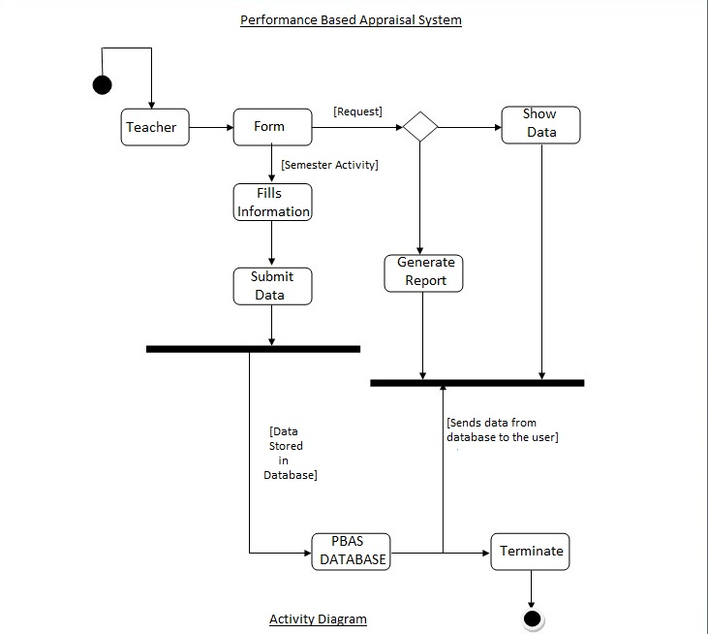

**Use case Diagram**









 



**6.2 Physical Design**

**Database Structure**

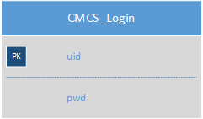

**6.3 User Interface**

Login

Login Form

Account creation form

Home Page

**7.TESTING**

**TESTING**



In PBAS , we have used various Testing types , Testing methods, Testing techniques to test the system for efficient functionality

.

Testing Scenario include as follow:-

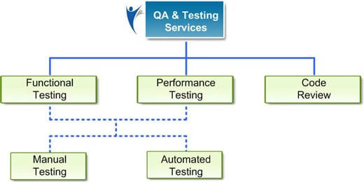

|  |  |  |  |
| --- | --- | --- | --- |
| **Testing** | **White Box Testing** | **Black Box Testing** | **Technique**  **used** |
| **Unit Testing** | Unit Testing done individually by developer in Code. Unit Testing is done in :  (Login, Profile Page, Research_pub , Alumni, Co-curricular, PDF report, overview, Gmail login )  Done By : RitikaBarethia , Sweta Rathore, Shubham Neema , Vikas Chouhan. | Unit Testing done individually by developer by giving input and validate output. Unit Testing is done in :  (Login, Profile Page, Research_pub , Alumni, Co-curricular, PDF report, overview, Gmail login )  Done By : Ritika Barethia , Sweta Rathore , Shubham Neema , Vikas Chouhan. | 1. Equivalence Partition. 2. Statement Coverage. 3. Code Coverage. 4. Data Flow 5. Path coverage |
| **Integration Testing** | Integration testing done by Integrating all different modules(Profile Page, Researchpub , Co-curricular , pdf report, overview) by reviewing Code. | Integration testing done by Integrating all different modules(Profile Page, Research_pub , Co-curricular , pdf report, overview) by giving valid and invalid inputs and corresponding its validate output. | **(Approaches)**   1. Top Down. |
| **System Testing** | System Testing done by validating the all modules by verifying the code. | System Testing done by validating the all modules by giving valid and invalid inputs and corresponding its validate output.. | **(Verifiy)**  1. Functional   1. Non functional Requirement |
| **Regression**  **Testing** | Regression Testing is done by validating all the module by code to see the side effects if any.  (Automation testing By Sweta Rathore) | Regression Testing is done by giving valid input and verify output to verify any side effect if required.  (Automation testing By Sweta Rathore, Ritika Barethia) | **Tools Used:**  Selenium .  Test Data.  Test Cases Execution. |
| **Acceptance Testing** | Acceptance Testing is done by reviewing it to Users. | Acceptance Testing is done by reviewing it to Users by valid and invalid inputs to verify valid output. | By reviewing System to Users manually filling the form. |

**TEST CASES :**

**TestCase of Login ; (To verify Login Module with valid User_id and Password.)**

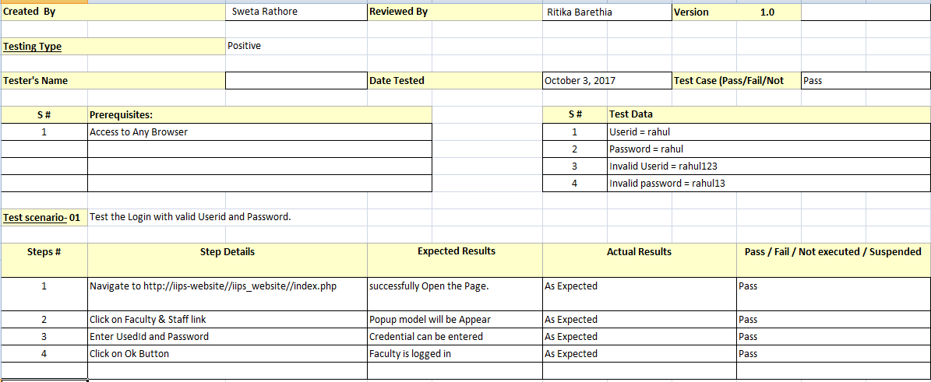

**1.1 TestCase of Login : (To verify Login Module with invalid User_id and invalid Password.)**

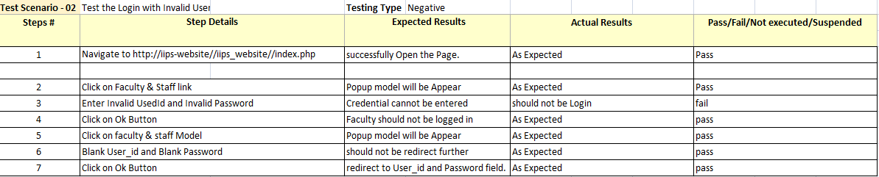

* 1. **TestCase of Profile Page :**

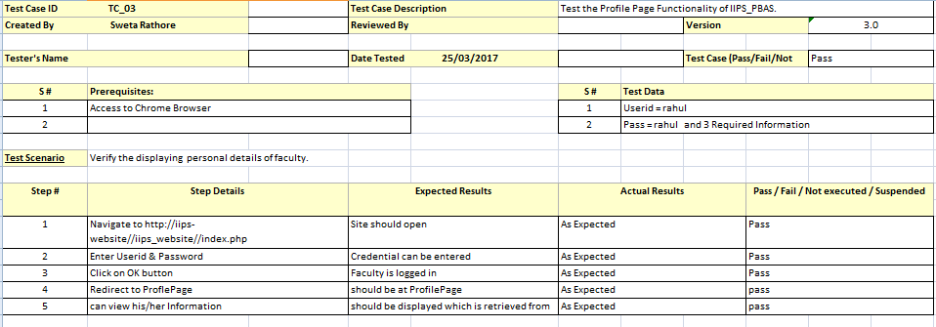

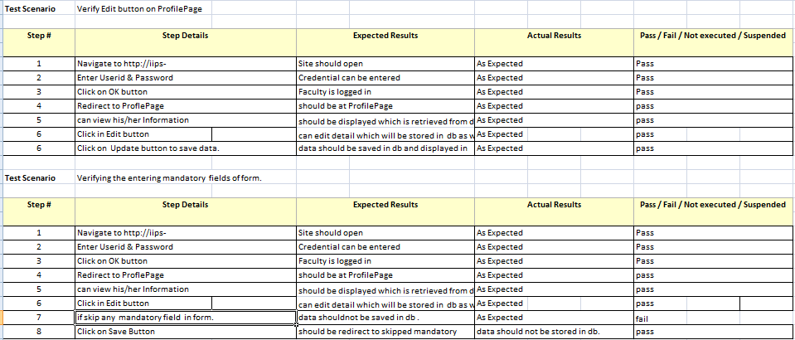

**TestCase : to verify Save, update, delete and View Button**

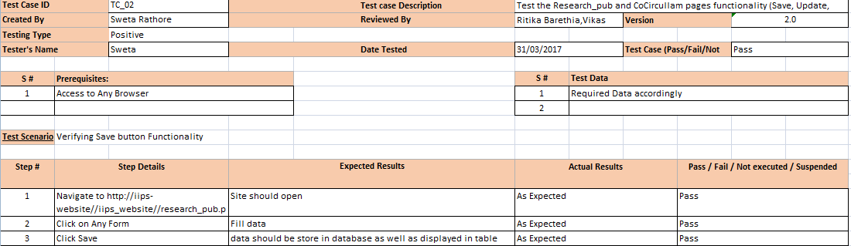

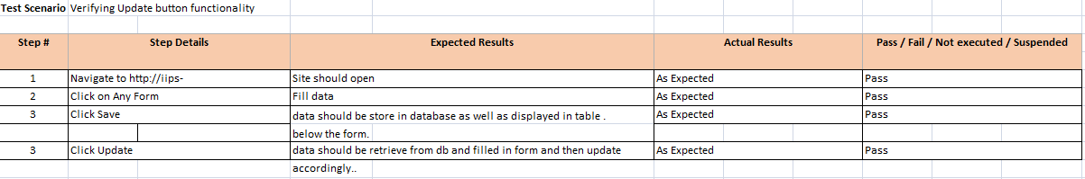

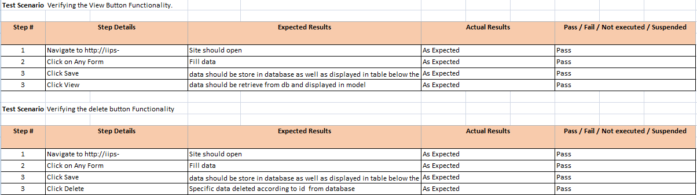

**Bug Report**

During development phase various bug were reported by tester , to enhance the effectiveness of System . Different Module Bug Report presented below:

**Defeat Report for (Not appropriate title)**

|  |  |
| --- | --- |
| **Defect ID:** | 01 |
| **Author:** | Sweta Rathore |
| **Release/Build** | Co-Curricular Form |
| **Open Date:** | 22/04/2017 |
| **Close Date** | 26/04/2017 |
| **Problem Area** | Co-Curricular link |
| **Defect or Enhancement:** | Defect |
| **Problem Title:** | Not appropriate titles. |
| **Problem Description:** | Subtitle is irrelevant according Co-Curricular Link. |
| **Current Environment:** | Win7/WAMP Server/Any Browser |
| **Other Environment(s):** | Win7/WAMP Server/Any Browser |
| **Defect Type:** | Functionality , Usability |
| **Who Detected:** | Faculty |
| **How Detected:** | Alpha Testing  Review |
| **Assigned To:** | Vikas Chouhan |
| **Priority:** | High |
| **Severity:** | Low |
| **Status:** | Being Reviewed by Development |
| **Fixed by:** | Vikas Chouhan |

**2 . Defeat Report of Session save.**

|  |  |
| --- | --- |
| **Defect ID:** | 03 |
| **Author:** | Ritika Barethia |
| **Release/Build** | Session log |
| **Open Date:** | 1/04/2017 |
| **Close Date:** | 29/04/2017 |
| **Problem Area:** | Session Problem. |
| **Defect or Enhancement:** | Enhancement |
| **Problem Title:** | Session not maintained. |
| **Problem Description:** | Session is not maintained properly. |
| **Current Environment:** | Win7/8/10, WAMP Server/Any Browser. |
| **Other Environment(s)** | Win7/8/10, WAMP Server/Any Browser. |
| **Defect Type:** | Functionality |
| **Who Detected:** | Development |
| **How Detected:** | Review  Walkthrough |
| **Assigned To** | Shubham Neema |
| **Priority:** | High |
| **Severity:** | High |
| **Status:** | Open |
| **Status Description:** | Not Fixed |
| **Fixed by:** | Not Fixed |

1. **Defeat Report of Profile Page**

|  |  |
| --- | --- |
| **Defect ID:** | 02 |
| **Author:** | Sweta Rathore |
| **Release/Build** | Profile Page (profile.php) |
| **Open Date** | 20/03/2017 |
| **Close Date:** | 20/04/2017 |
| **Problem Area:** | Profile Page of Faculty |
| **Defect or Enhancement:** | Defect |
| **Problem Title:** | to save data need to fill it twice. |
| **Problem Description** | To save information in db as well as to display, need to fill it twice in form. |
| **Current Environment:** | Win7/8/10, WAMP/ Any Browser. |
| **Other Environment(s):** | Win7/8/10, WAMP/ Any Browser. |
| **Defect Type:** | Database Integrity  Performance |
| **Who Detected:** | Development |
| **How Detected:** | Review |
| **Assigned To** | Sweta Rathore , Shubham Neema. |
| **Priority:** | Critical |
| **Severity:** | Critical |
| **Status** | Ready for Testing in the Next Build |
| **Status Description:** | “Ready for Testing in the Next Build” |
| **Fixed by:** | Shubham Neema and Sweta |

1. **Defeat Report Of Profile Page disability**

|  |  |
| --- | --- |
| **Defect ID:** | 05 |
| **Author:** | Sweta Rathore |
| **Release/Build #** | Profile Page |
| **Open Date:** | 26/04/2017 |
| **Close Date:** | 29/04/2017 |
| **Problem Area:** | Profile Form Name disable. |
| **Defect or Enhancement:** | Defect |
| **Problem Title:** | Disability of Name Field |
| **Problem Description:** | When Faculty fill the form , name field should be disable by default. |
| **Current Environment:** | Win7/8/10, WAMP Server, Any Browser |
| **Other Environment(s)** | Win7/8/10, WAMP Server, Any Browser |
| **Defect Type:** | Usability |
| **Who Detected:** | Quality Assurance |
| **How Detected:** | Walkthrough |
| **Assigned To:** | Ritika Barethia |
| **Priority:** | Medium |
| **Severity:** | Low |
| **Status:** | Open (Default) |
| **Status Description:** | Solved |
| **Fixed by:** | Ritika Barethia |

**Defeat Report in Ongoing Project Form**

|  |  |
| --- | --- |
| **Defect ID:** | 04 |
| **Author:** | Ritika Barethia |
| **Release/Build** | Research_publication |
| **Open Date:** | 25/03/2017 |
| **Close Date:** | 25/04/2017 |
| **Problem Area:** | Ongoing Prjoect not loading |
| **Defect or Enhancement:** | Enhancement |
| **Problem Title:** | Form not loading or appeared |
| **Problem Description:** | On clicking on Ongoing project , it is not appeared |
| **Current Environment:** | Win7/8/10, WAMP Server, Any Browser |
| **Other Environment(s):** | Win7/8/10, WAMP Server, Any Browser |
| **Defect Type:** | Functionality . |
| **Who Detected:** | Development |
| **How Detected:** | Testing |
| **Assigned To:** | Shubham Neema |
| **Priority:** | High (Default) |
| **Severity:** | High (Default) |
| **Status:** (Required) | Open (Default) |
| **Status Description:** | Open and solve it . |
| **Fixed by:** | Shubham |

**6. Defeat Report of Days/Month Clarification.**

|  |  |
| --- | --- |
| **Defect ID:** | 06 |
| **Author:** | Sweta Rathore |
| **Release/Build #** | Research Publication and Co-Curricular sub links. |
| **Open Date** | 25/03/2017 |
| **Close Date:** | 30/04/2017 |
| **Problem Area:** | Days/Month field is not clear. |
| **Defect or Enhancement:** | Enhancement |
| **Problem Title:** | Suitable Fields in forms |
| **Problem Description:** | Forms days/month field should be clear , so that faculty can fill it easily. |
| **Current Environment:** | Win7/8/10, WAMP Server, Any Browser |
| **Other Environment(s)** | Win7/8/10, WAMP Server, Any Browser |
| **Defect Type:** | Usability |
| **Who Detected:** | Development |
| **How Detected:** | Review |
| **Assigned To:** | Vikas Chouhan |
| **Priority:** | Medium |
| **Severity:** | Low |
| **Status:** | Open (Default) |
| **Status Description:** | Fixed |
| **Fixed by:** | Ritika Barethia, Vikas |

**8. FUTURE PROSPECTIVE**



**FUTURE PROSPECTIVE**



The project can be expanded further to manage the information in a very easy and convenient way:-

* System can be made online at UGC level if UGC approves the system.
* API scores can be automated.
* Submission process of performance based appraisal system can be made online if UGC approved the system.
* A general message or announcement can be informed directly on the user’s mobile or PC.
* Project can be converted to be used as a mobile application.
* Facilities can be made more integrated, safe and easy.

**9.BIBLIOGRAPHY**



**BIBLIOGRAPHY**



**9.1BOOKS REFERRED**

* Elias M.Awad, System Analysis and Design,

Edition: II edition 2009

Publication: Galgotia Publication Pvt. Ltd, New Delhi.

* Pankaj Jalote, An Integrated Approach to Software Engineering

Edition: III Edition

Publication: Narosa Publishing House (for India).

**9.2WEBSITES REFERRED**

* <http://www.vbtutor.net/vb6/vbtutor.html>
* <http://visualbasic.freetutes.com/learn-vb6/>
* <http://www.youtube.com/watch?v=Adi3jwkta8o>
* <http://www.dbforums.com/microsoft-access/988090-connecting-vbulletin-6-0-ms-access.html>