1) VCS (version control sys) records all the changes made to a file or set of files a specific version may called later.

Always works with latest version.

Compare changes made to files from one version to another

Allows to store multiple versions of a sys file in remote repository.

---------------------------------------------------------------------------------------------------------------------------

2) VCS:

can create version and track and share

--------------------------------------------------------------

3) types of VCS:

centralized

Here, there’s a central repo shared with all the developers, and everyone gets their own working copy.

Whenever you commit, the changes get reflected directly in the repo.

Unlike distributed systems, developers directly commit to the remote.

Which means they may affect files knowingly or unknowingly.

distributed

Distributed Version Control Systems: In distributed systems, there is a local copy of the repo for every developer on their computers.

They can make whatever changes they want and commit without affecting the remote repo.

They first commit in their local repo and then push the changes to the remote repo. This is the type used majorly today.

-----------------------------------------------------------------------------------------------------------------------------------------

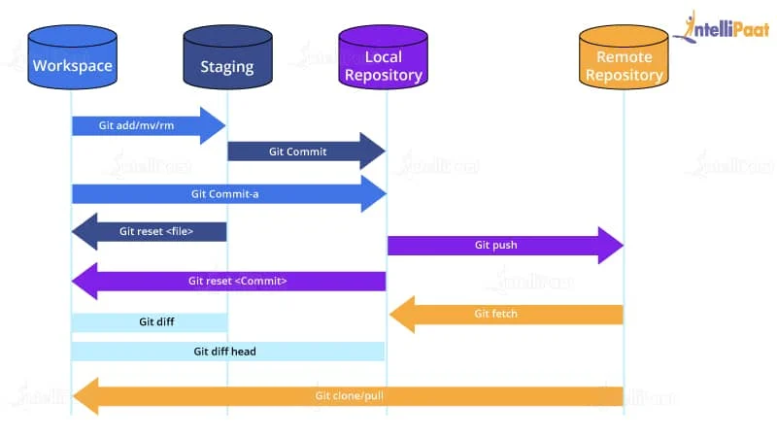 GIT ARCHITECTURE

4) GIT

Git is a distributed VCS tool used for source code management

Used to track changes in source code

Allows multiple developers to work together

Has the ability to handle large projects efficiently

---------------------------------------------------------------------------------------------

5) GIT GITHUB

* git is a software tool GitHub is a service
* Installed on local sys hosted on web

* used to manage diff version of source code Gui
* command line interface used to have copy of local repository code

