**Lab 07 - Installing and Configuring a SIEM using Wazuh**

1. **Network Configuration Screenshot**

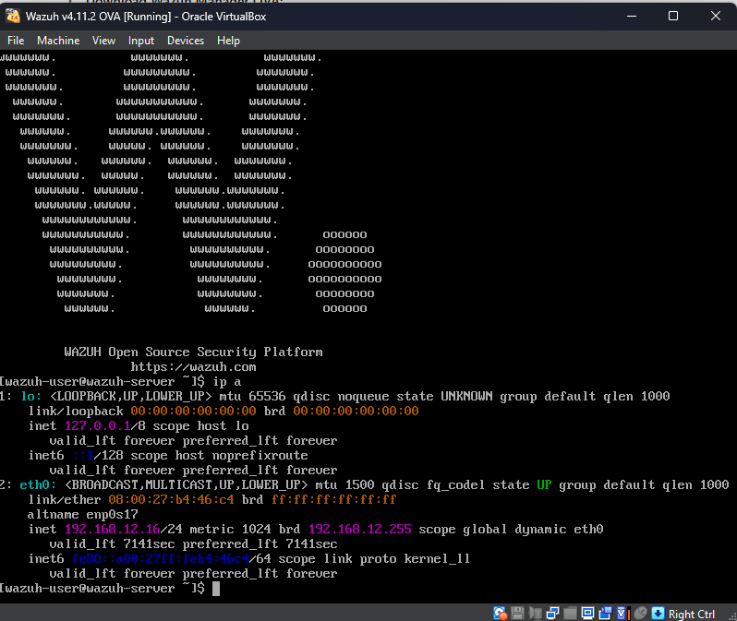

To display all network interfaces and their corresponding IP addresses, use the ip a command, which stands for ip addr show. The broadcast address is 192.168.12.255, whereas the eth0 interface IP, 192.168.12.16, has the same range as the internal address.

1. **Ping Test Screenshot**

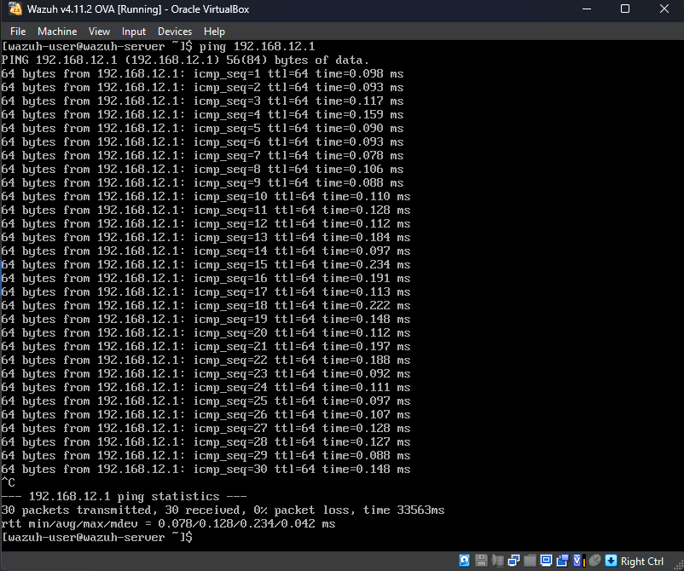

To determine whether the host computer is reachable, the ping program sends an ICMP ECHO_REQUEST to the designated IP address. In this instance, 192.168.12.1 is the pfsense's IP address. The reachability of pfsense is demonstrated via the ping command.

1. **Component Status Screenshot**

The command sudo systemctl status obtains details about the specified service. In this instance, the command is being used to determine whether the service is operational.

* 1. **wazuh-dashboard**

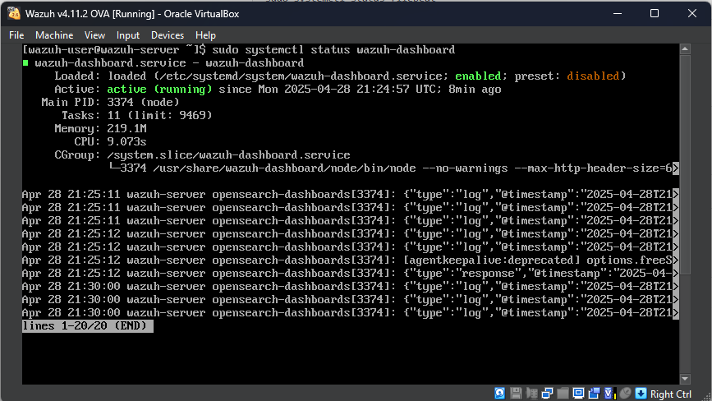

The wazuh-dashboard component is in the active/running state.

* 1. **wazuh-indexer**

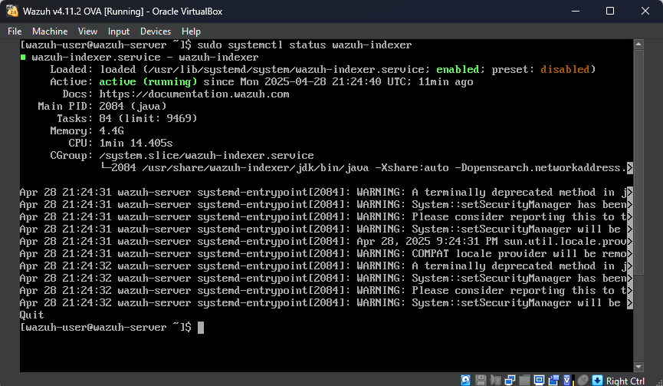

The wazuh-indexer component is in the active/running state.

* 1. **wazuh-manager**

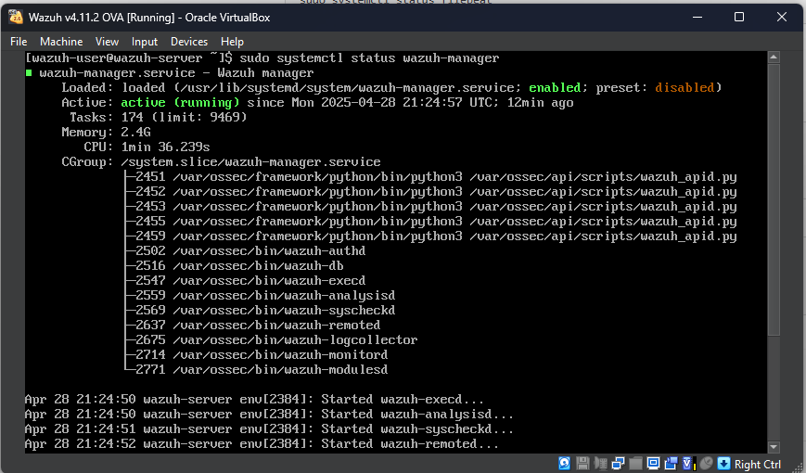

The wazuh-manager component is in the active/running state.

* 1. **filebeat**

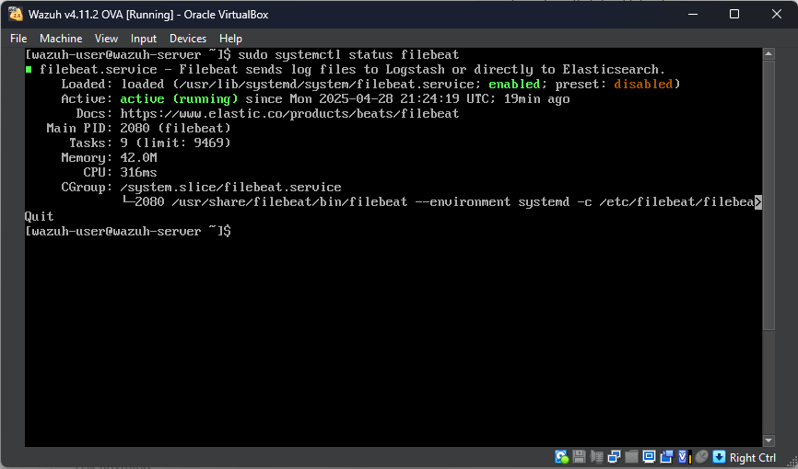

The filebeat component is in the active/running state.

1. **Dashboard Login Screenshot**

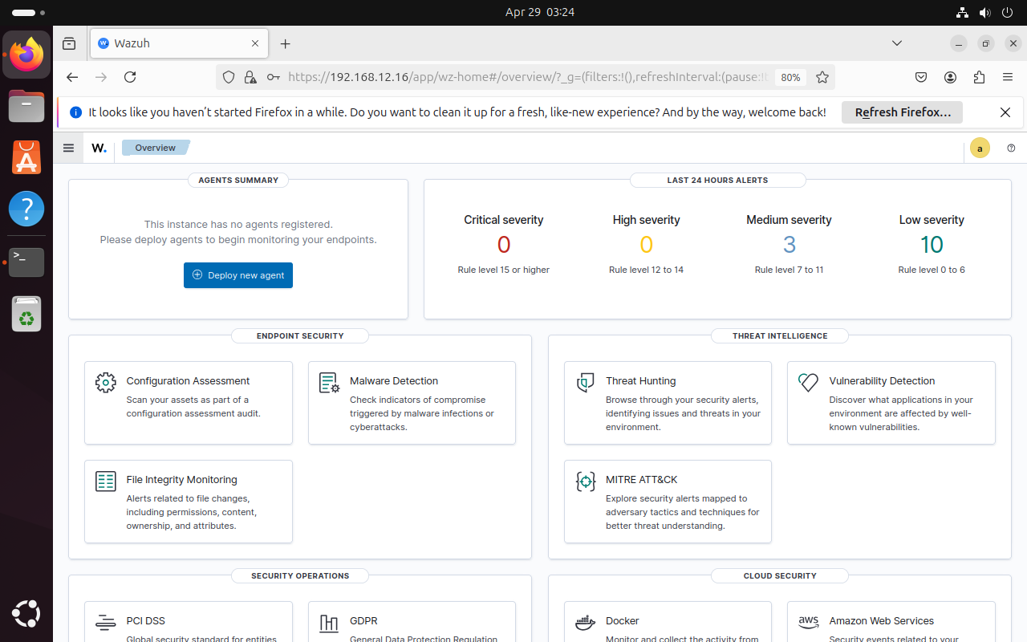

After setting up the Wazuh Manager, I accessed the Wazuh Dashboard from the Admin Client Ubuntu VM to verify the installation. I ensured both VMs were on the same internal network. Using a web browser, I navigated to https://192.168.12.16, the IP address of the Wazuh Manager. I logged in successfully with the default credentials (username: admin, password: admin). This confirmed that the Wazuh Manager and Dashboard services were properly configured and accessible. A screenshot of the logged-in dashboard was captured as the fourth deliverable.

1. **Agent Deployment Screenshot**

What ought to have occurred is this: Within the dashboard, we went to the summary page and then to the agents management. A fresh agent with environment type ____ was then deployed. After that, the agent was set up and set up using the Wazuh server's IP address, 192.168.12.16.