1)
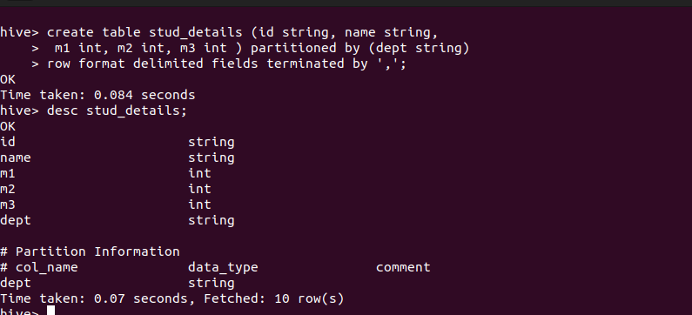
create table stud_details_cse (id string, name string,
m1 int, m2 int, m3 int ) partitioned by (dept string)
row format delimited fields terminated by ',';

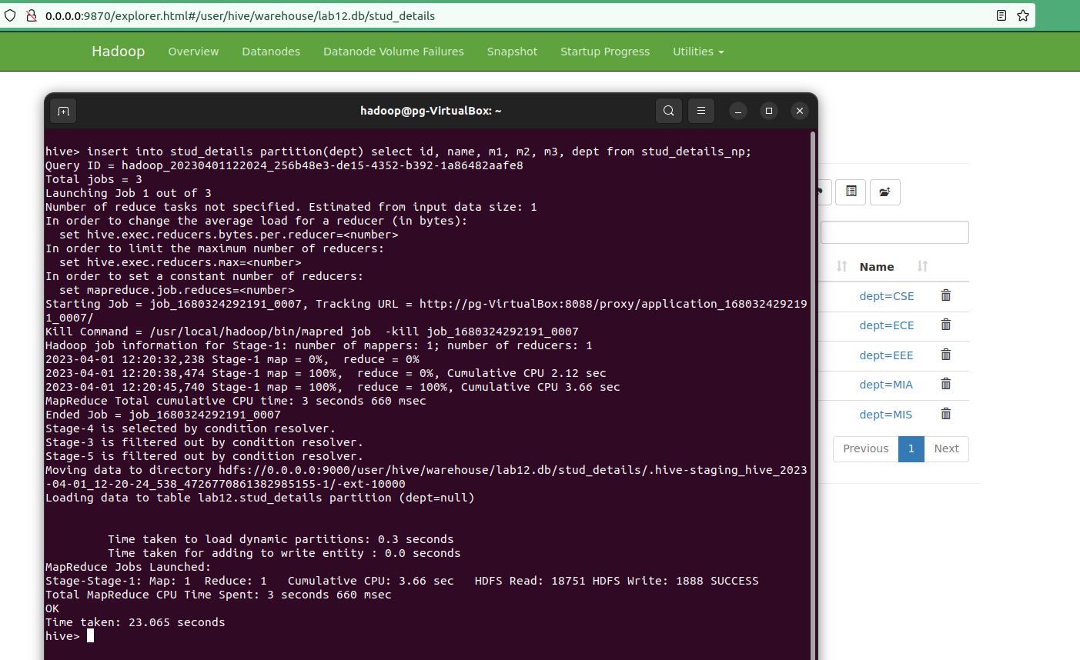


2)
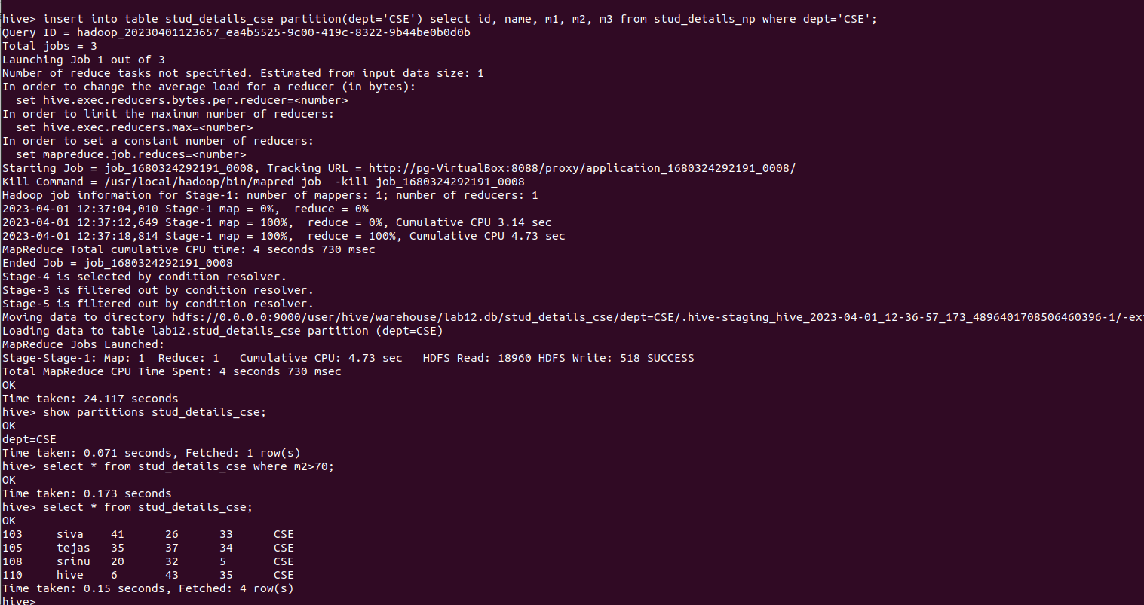
3)
