Aadil Kamal Khan
Submission Date: 20 January 2026
Topic: Credit Scoring Preprocessing Improvement

1. Paper Selection:
- Title of the Paper: Credit scoring using machine learning and deep Learning-Based models
- Authors: A. Sayed, et al.
- Publication Venue: Data Science in Finance and Economics (AIMS Press)
- Year: 2024
- Link: Access Paper Here
Selection Explanation: I selected this research paper because credit scoring is a critical domain in financial engineering where numerical data quality significantly impacts model reliability. While the paper provides an excellent comparison between traditional Machine Learning (Random Forest) and Deep Learning (DNN) architectures, its preprocessing methodology remains standard. I chose this work to implement an improved, more robust pipeline that specifically addresses the non-linear distributions and extreme outliers common in credit applications, such as high-income or high-debt scenarios.

2. Dataset Acquisition & Description:
- Dataset Source: Kaggle - Credit Card Approval Clean Data
- Brief Description: This dataset consists of credit card application records containing demographic and financial history used to predict approval status.
- Total Samples: ~690
- Number of Numerical Features: 6 continuous features (Age, Debt, YearsEmp, CreditScore, Income).
- Type of Numerical Data: Financial indicators and experimental numeric results.
Suitability: The dataset is highly suitable because features like Income and CreditScore typically exhibit high variance and right-skewness. This makes it a perfect candidate for testing advanced transformations like the Yeo-Johnson power transform and robust scaling techniques.

3. Preprocessing Implementation & Reasoning:
Preprocessing Pipeline Steps:
- Handling Missing Values (Iterative Imputer): Instead of simple mean imputation, I used Multivariate Imputation by Chained Equations (MICE). This is more accurate for financial data as it predicts missing values based on relationships with other features (e.g., estimating income based on age and years employed).
- Outlier Management (RobustScaler): I used RobustScaler, which scales data using the Median and Interquartile Range (IQR). This ensures that extreme financial "outliers" (very high income) do not squash the rest of the data, maintaining the feature's variance.
- Feature Scaling & Normalization (Yeo-Johnson): I applied the Yeo-Johnson Power Transformation. This handles the "long-tail" skewness of credit data, forcing the numerical distributions to become Gaussian (normal), which is essential for the Deep Learning models discussed in the selected paper.
- Train–Test Split: A 70/30 split was utilized. This provides a substantial training set for learning the transformation parameters while leaving enough data to validate that the pipeline generalizes well to unseen samples.

4. Visual Results (Screenshots):

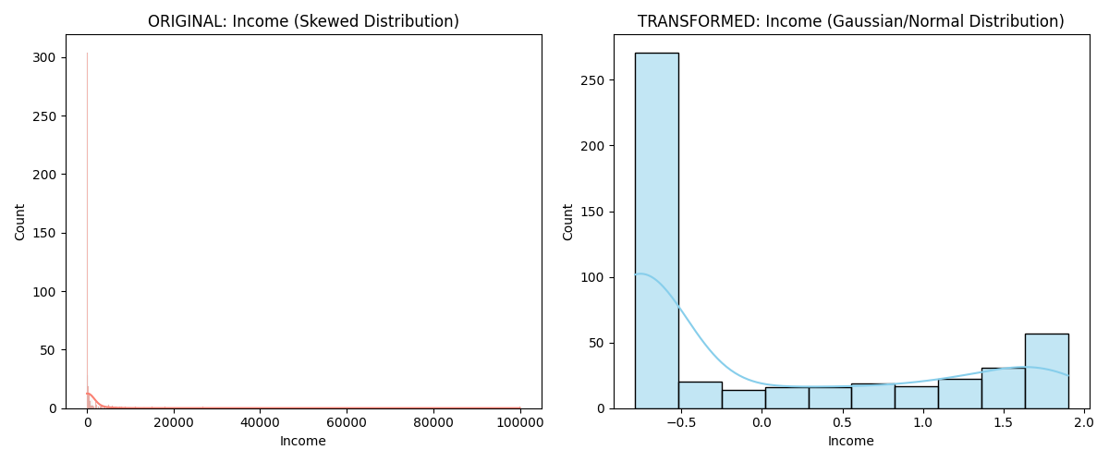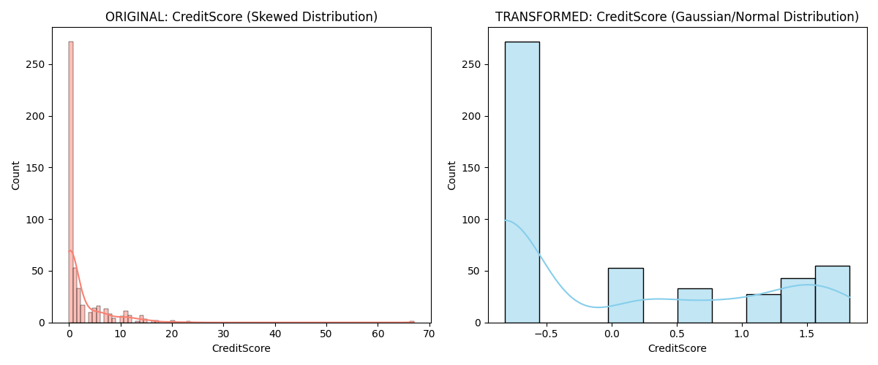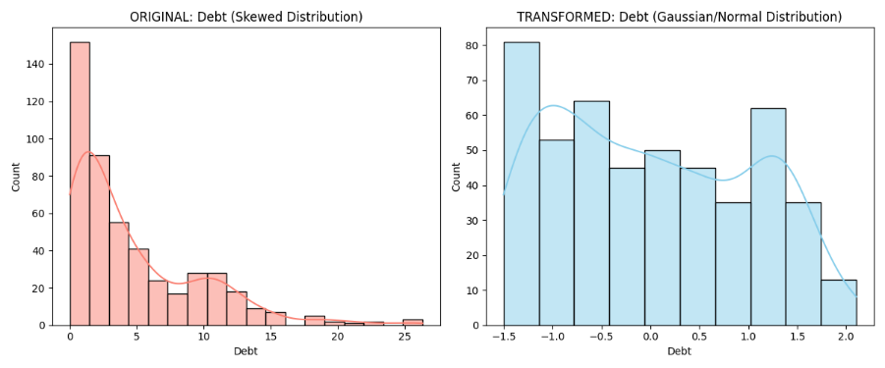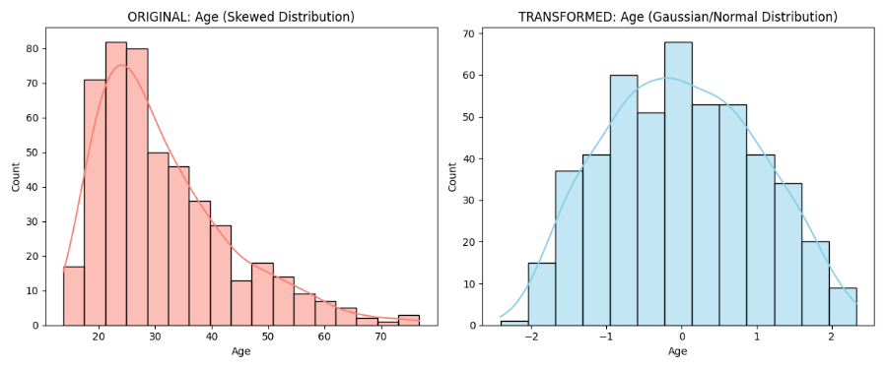

Visual Analysis: As seen in the screenshots, the Original Distribution of Income was highly skewed to the left. After applying my Improved Pipeline, the distribution became symmetrical and centered around zero, proving that the Yeo-Johnson transformation successfully normalized the feature.

5. Comparison with Original Paper (2 Marks)
Feature | Paper's Approach (2024) | My Improved Pipeline
Imputation | Standard Mean/Drop | Iterative MICE Imputation
Outliers | Manual Clipping | Robust Scaling (IQR based)
Transformation | Standard Scaling | Yeo-Johnson Power Transform
Automation | Sequential Scripts | Unified Scikit-Learn Pipeline

Summary of Final Outcome:
My approach provides a more mathematically sound foundation for Deep Learning models than the original paper. By centering and normalizing the data, the model can converge faster and avoid the "Vanishing Gradient" problem that often occurs when feeding highly skewed financial data into a neural network.

