MOBILE APP DEVELOPMENT 700
PRACTICAL ASSIGNMENT REPORT
402413832
GitHub repository: https://github.com/aadilmahomed25/SmartPantryManager2

Table of Contents
1. Introduction
2. Aim and Objectives
3. System Design
4. Implementation
5. Key Code Explanations
6. Testing Approach and Evidence
7. Challenges, Limitations and Solutions
8. Conclusion and Reflection
9. References

1. Introduction
Household food waste often occurs when people forget which ingredients they already have or struggle to decide what to cook from the items left in their kitchen. Smart Pantry Manager is a Java-based Android application intended to help users keep a simple record of pantry ingredients and identify recipes that can be prepared using those ingredients.
The defining requirement is strict recipe matching. A recipe should appear in the main suggested-recipe list only when every ingredient required by that recipe is present in the pantry. A recipe that is missing even one required ingredient must be excluded. This rule helps ensure that suggestions are practical and do not encourage users to shop for additional ingredients.
The supplied project uses Android Activities for its screens and SQLite for local persistence. The source includes pantry management, a seeded recipe collection, recipe suggestions, recipe details and a settings screen. The public project repository is available at https://github.com/aadilmahomed25/SmartPantryManager2.

2. Aim and Objectives
The aim is to provide a small, locally stored pantry and recipe application that supports informed use of leftover ingredients.
- Allow users to create, view, update and delete pantry ingredient records.
- Store pantry data locally using SQLite so records can remain available between app sessions.
- Provide a pre-populated recipe collection with preparation instructions.
- Filter the recipe collection using strict ingredient matching rather than partial matching.
- Display recipe details and provide navigation between the application's main screens.
- Validate ingredient form inputs to reduce invalid records.
- Demonstrate the application design and implementation through a report, GitHub repository and narrated video, as required by the assignment.

3. System Design

3.1 Application architecture
The application is organised into separate Java Activities. MainActivity presents the pantry list and navigation actions. IngredientActivity handles adding and editing an ingredient. SuggestedRecipesActivity displays recipes that pass the matching rule. RecipeDetailActivity presents the selected recipe's ingredients and preparation steps. SettingsActivity provides a separate settings screen. DatabaseHelper centralises SQLite table creation, seeding and data operations.
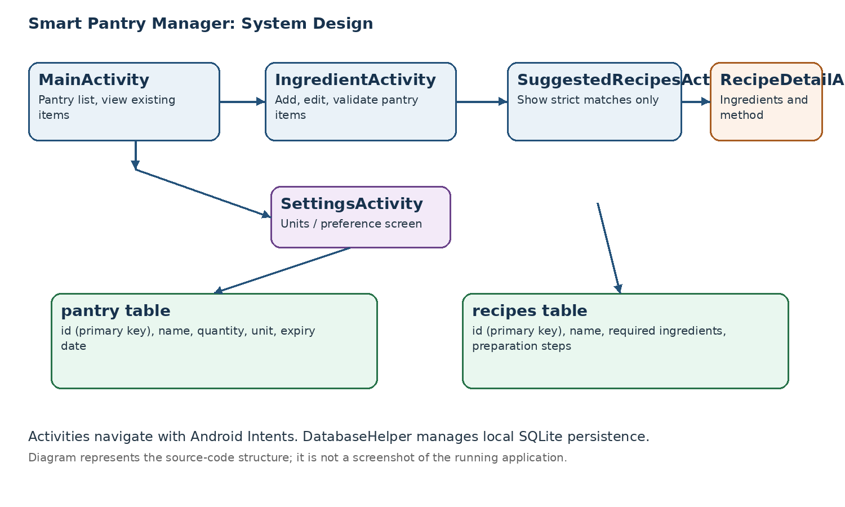

3.2 Navigation and data transfer
Android Intents are used to open the separate Activities and to pass identifiers where a screen needs to load a selected record. When an ingredient is edited, the ingredient screen can receive an item identifier. When a recipe is selected, the detail screen can receive a recipe identifier and retrieve the corresponding record from the database. This keeps navigation separate from the database implementation.

3.3 Database model
Table | Purpose | Main fields
pantry | Stores ingredients available to the user | id, name, quantity, unit, expiry
recipes | Stores the recipe collection | id, name, required ingredients, preparation steps
The pantry table uses an auto-incrementing identifier as its primary key. The ingredient name, quantity and unit describe the pantry item, while expiry information is optional. The recipes table stores the recipe name, its required ingredients and a preparation method. Recipe records are seeded when the database is first created, providing a starting collection without requiring the user to enter every recipe manually.

3.4 Strict-matching rule
The matching routine first creates a normalised set of pantry ingredient names for pantry records with a positive quantity. It then evaluates each recipe's required ingredients. If any required ingredient is not present in the pantry set, that recipe is not included in the strict suggestions. A recipe is returned only if all of its required ingredients pass the check.
The source includes lightweight name normalisation, including lowercase conversion, whitespace trimming, accent handling and common plural-ending handling. This is intended to reduce trivial mismatches such as singular and plural forms, although it is not a full synonym or natural-language processing system.

4. Implementation

4.1 Android Activities and interface
The project is written in Java and uses Android Activities to separate the main user tasks. The user can move between the pantry, ingredient form, recipe suggestions, recipe details and settings. The supplied UI helper class reduces repeated interface-building code. The interface is built programmatically in Java rather than relying on a large collection of XML layout files.

4.2 SQLite persistence and CRUD
DatabaseHelper extends SQLiteOpenHelper and is responsible for creating the pantry and recipes tables. The pantry functions correspond to the four standard CRUD operations: Create inserts a new ingredient, Read retrieves the saved ingredient list, Update changes an existing record, and Delete removes a record. Because SQLite is stored locally on the device, pantry records are intended to persist when the app is closed and reopened.

4.3 Input validation
The ingredient form checks that required values are provided and parses quantity as a number. Empty names or units, invalid numeric values, zero quantities and negative quantities should be rejected with user feedback instead of being saved. This protects the stored data from common input errors.

4.4 Recipe collection and details
The project seeds 20 recipe records during database creation. Each recipe includes a name, required ingredient list and preparation steps. SuggestedRecipesActivity requests strict matches from the database helper, while RecipeDetailActivity loads and presents the selected recipe's information.

4.5 Settings
SettingsActivity provides a distinct settings or profile screen, which contributes to the multi-screen structure required by the assignment. The exact usefulness of each preference should be checked during the live demonstration and explained accurately in the video.

5. Key Code Explanations
The following short examples explain the main implementation patterns represented in the supplied source. They are illustrative excerpts of the project's design, not a substitute for opening the full source files during the video.

5.1 SQLite helper
public class DatabaseHelper extends SQLiteOpenHelper {
// Creates and manages the local application database.
}
DatabaseHelper centralises database creation and data access. SQLiteOpenHelper provides lifecycle callbacks such as onCreate, which is where the tables and initial recipe records can be established. Keeping database operations in one helper reduces duplication across Activities.

5.2 Strict recipe matching
for (String requiredIngredient : recipeIngredients) {
if (!pantryIngredients.contains(normalize(requiredIngredient))) {
matches = false;
break;
}
}
The key idea is that every required ingredient must be found in the normalised pantry ingredient set. The loop stops as soon as one required ingredient is missing. The recipe is only eligible for the strict suggestions list if no required ingredient fails the check.

5.3 Input validation
if (name.isEmpty() || unit.isEmpty()) {
// Show feedback and stop saving.
return;
}
if (quantity <= 0) {
// Reject non-positive quantities.
return;
}
Validation is performed before the save operation. The user receives feedback for invalid entries, and the method returns before a bad record is written. The exact wording and branching should be confirmed against the current source when explaining the code.

5.4 Intent-based navigation
Intent intent = new Intent(this, RecipeDetailActivity.class);
intent.putExtra("recipe_id", recipeId);
startActivity(intent);
An explicit Intent identifies the Activity to open. An identifier is passed as extra data so the destination screen can load the selected recipe. This avoids passing the entire database record between screens.

6. Testing Approach and Evidence
The assignment requires evidence from a running emulator or physical Android device, including screenshots of every screen and core function. The project files available for this report did not include genuine screenshots of the application running, and this report-generation process did not execute the application in an Android emulator. Therefore, no runtime test is falsely labelled as passed.
Test area | Expected behaviour to verify on the running app | Evidence required
Pantry list | Saved ingredients appear in the list and the empty state is understandable | Screenshot of populated pantry
Create | A valid ingredient is saved and appears in the pantry | Screenshot before/after adding
Validation | Missing fields and invalid/non-positive quantities are rejected with feedback | Screenshot of validation feedback
Read and persistence | Previously saved pantry items remain after closing and reopening the app | Screenshots before and after restart
Update | Editing an ingredient changes the saved record | Screenshots showing changed value
Delete | Deleting an ingredient removes it from the list | Screenshot after deletion
Strict matching | A recipe appears only when all required ingredients are present; removing one required ingredient removes it from suggestions | Before/after screenshots of suggestions
Recipe detail | Selecting a suggestion opens its ingredients and preparation method | Recipe detail screenshot
Settings | The settings screen opens and its available controls can be demonstrated | Settings screenshot

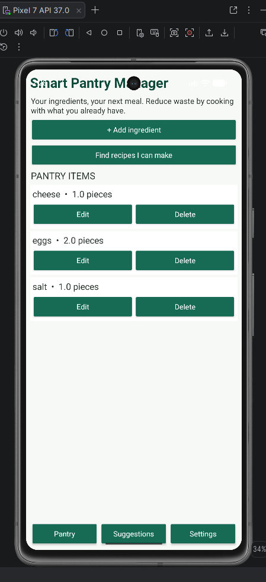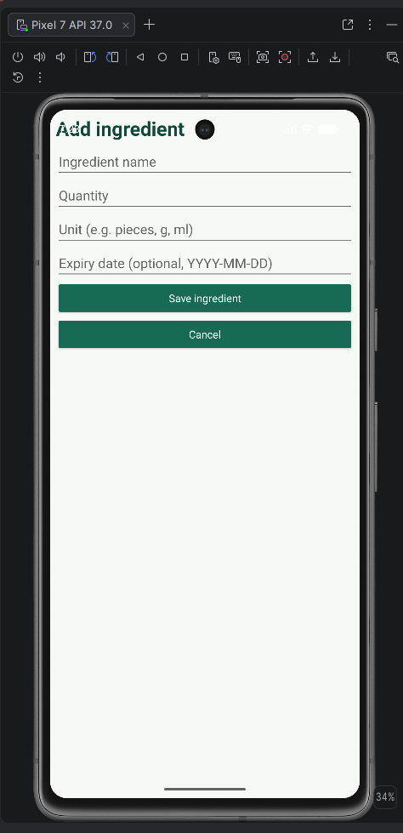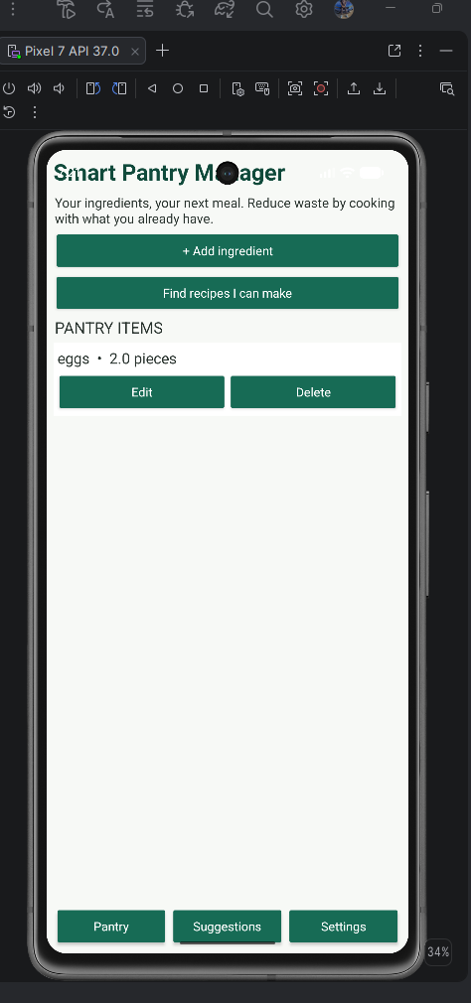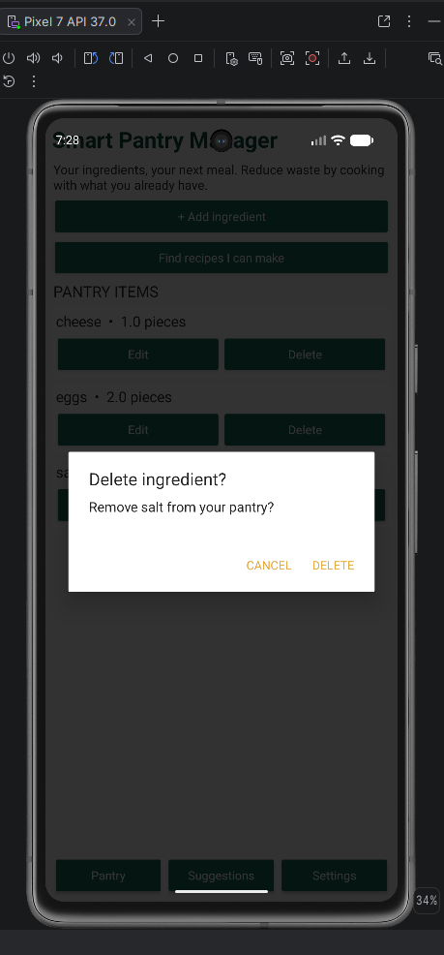

7. Challenges, Limitations and Solutions

7.1 Environment and build verification
A potential practical challenge for Android projects is ensuring that the Gradle configuration, Android Gradle Plugin, SDK and Java source are compatible. The correct response is to open the project in Android Studio, allow Gradle sync to finish, resolve any reported dependency or SDK errors, and run the application on an emulator or physical device. A successful build should be confirmed before claiming that the issue is resolved.

7.2 Ingredient-name variation
Ingredient names may be entered in different forms, such as singular and plural words or with extra spaces and differences in capitalisation. The project uses lightweight normalisation to reduce some of these differences. More complete matching could include a controlled synonym dictionary and consistent units, while preserving the strict rule that every required ingredient must be available.

7.3 Evidence and reproducibility
The assignment requires screenshots, a narrated demonstration and a meaningful GitHub history. These items must reflect the actual application and the real development process. The supplied repository screenshot showed an empty repository setup page at that point, so the existence of a complete code upload or a sequence of ten meaningful commits cannot be established from that image alone. The repository should be checked directly to ensure all source files are uploaded and the commit history accurately reflects the work performed.

8. Conclusion and Reflection
Smart Pantry Manager addresses a practical household problem by combining pantry tracking with recipe suggestions based on ingredients already available. The design brings together Java Activities, Intent-based navigation, form validation and SQLite persistence. The strict-matching rule is the most important business requirement because it prevents recipes that need missing ingredients from appearing as ready-to-cook suggestions.
The supplied source provides the structure for the required screens, pantry CRUD operations and a seeded collection of 20 recipes. Before the project can be described as fully demonstrated, the application must be built and exercised in Android Studio, the strict-match behaviour and persistence must be verified, and genuine screenshots and a narrated 5–7 minute video must be captured. Future improvements could include quantity-aware recipe portions, a broader ingredient synonym list, more detailed expiry notifications, and a more polished list adapter and interface.

9. References
Android Developers (n.d.) ‘Activities’. Available at: https://developer.android.com/guide/components/activities/intro-activities (Accessed: 28 October 2026).
Android Developers (n.d.) ‘Intents and intent filters’. Available at: https://developer.android.com/guide/components/intents-filters (Accessed: 28 October 2026).
Android Developers (n.d.) ‘Save data using SQLite’. Available at: https://developer.android.com/training/data-storage/sqlite (Accessed: 28 October 2026).
Richfield Graduate Institute of Technology (2026) *Mobile App Development 700: Practical Assignment, Smart Pantry Manager*. Assignment brief supplied for the module.
Smart Pantry Manager (2026) *Project source code and repository*. Available at: https://github.com/aadilmahomed25/SmartPantryManager2 (Accessed: 28 October 2026).

