QR CODE GENERATION AND MANAGEMENT SYSTEM
(QRCode Pro)
A PROJECT REPORT
Mini Project (01CE0609)
Submitted by
Dhruvil Janani
92420103002
Dhaval Chauhan
92100103297
Aadil Parmar
92200103068
BACHELOR OF TECHNOLOGY
in
Computer Engineering
Faculty of Engineering & Technology
Marwadi University, Rajkot


April, 2026


Mini Project (01CE0609)
Department of Computer Engineering
Faculty of Engineering & Technology
Marwadi University
A.Y. 2025-26
CERTIFICATE
This is to certify that the project report submitted along with the project entitled QR Code Generation and Management System (QRCode Pro) has been carried out by Dhruvil Janani (92420103002), Dhaval Chauhan (92100103297), Aadil Parmar (92200103068) under my guidance in partial fulfilment for the degree of Bachelor of Technology in Computer Engineering, 6th Semester of Marwadi University, Rajkot during the academic year 2025-26.

Prof. Niraj Bhagchandani Sir, | Prof. (Dr.) Rachit Adhvaryu Sir,
Assistant Professor | Professor & Associate Dean
Department of Computer Engineering | Department of Computer Engineering


Mini Project (01CE0609)
Department of Computer Engineering
Faculty of Engineering & Technology
Marwadi University
A.Y. 2025-26
DECLARATION
We hereby declare that the Mini Project (01CE0609) report submitted along with the Project entitled QR Code Generation and Management System (QRCode Pro) submitted in partial fulfilment for the degree of Bachelor of Technology in Computer Engineering to Marwadi University, Rajkot, is a bonafide record of original project work carried out by us at Marwadi University under the supervision of Prof. Niraj Bhagchandani Sir and that no part of this report has been directly copied from any students' reports or taken from any other source, without providing due reference.
S.No | Student Name | Sign
1 | Dhruvil Janani (92420103002)
2 | Dhaval Chauhan (92100103297)
3 | Aadil Parmar (92200103068)

ACKNOWLEDGEMENT

We would like to express our sincere gratitude to all those who have contributed to the successful completion of this project. This work would not have been possible without the guidance, support, and encouragement of several individuals and institutions.

We would like to express our sincere gratitude to our project supervisor, Prof. Niraj Bhagchandani Sir, for his invaluable guidance, support, and encouragement throughout the course of this project. His expertise and insightful feedback have been instrumental in the successful completion of this work.

We would also like to thank Dr. Krunal Vaghela Sir, Head of the Computer Engineering Department, for providing us with the opportunity to work on this project.

Finally, we would like to thank Prof. Shailendrasinh R. Chauhan for his unwavering encouragement, support and belief in us.

We extend our sincere appreciation to Marwadi University, Rajkot for providing an excellent academic platform that encourages project-based learning and practical application of theoretical knowledge. The university's emphasis on hands-on experience in software development has been a driving force behind this project.

We would also like to acknowledge the contributions of the open-source community. This project extensively utilizes several open-source libraries and technologies, including QRCode.js for QR code generation, Tailwind CSS for responsive design, JSZip for bulk ZIP archive creation, FileSaver.js for client-side file downloads, and Lucide Icons for the user interface. The availability of high-quality, well-documented open-source tools significantly accelerated our development process and improved the overall quality of the application.

We extend our gratitude to the PHP development community and the SQLite project team for creating robust, reliable, and well-documented technologies that form the backbone of our application. The comprehensive documentation and active community support were invaluable during the development phase.

Special thanks to our fellow students and classmates who provided valuable feedback during the testing phase of this project. Their insights helped identify usability issues and improve the overall user experience of the application.

Last but not least, we express our profound gratitude to our parents and families for their unwavering support, encouragement, and patience throughout our academic journey. Their sacrifices and belief in our abilities have been the foundation upon which all our achievements are built.

Dhruvil Janani (92420103002)
Dhaval Chauhan (92100103297)
Aadil Parmar (92200103068)

Date: April, 2026
Place: Rajkot, Gujarat

ABSTRACT

Quick Response (QR) codes have emerged as a ubiquitous technology in the modern digital landscape, bridging the gap between physical and digital information exchange. From contactless payments and digital menus to event ticketing and marketing campaigns, QR codes have become an essential tool for businesses, organizations, and individuals alike. Despite the widespread adoption of QR technology, most existing QR code generation tools suffer from significant limitations including restricted type support, lack of customization options, absence of user management features, and poor bulk generation capabilities.
This project presents the design, development, and implementation of "QR Code Generation and Management System" (QRCode Pro), a comprehensive web-based QR code generation and management system that addresses these limitations. The application supports over 24 distinct QR code types, including standard formats such as URL, plain text, email, and phone, as well as specialized formats like WiFi network configuration (IEEE 802.11), vCard 3.0 contact cards, iCalendar events, geographic coordinates, UPI payment links, Bitcoin addresses, and social media deep links for platforms including YouTube, Twitter/X, Instagram, Facebook, LinkedIn, and Spotify.
The system is built on a modern web technology stack featuring PHP 8.0+ as the server-side runtime, SQLite 3 as the embedded relational database with WAL (Write-Ahead Logging) mode for concurrent read performance, and Tailwind CSS for a responsive, utility-first frontend design. QR code generation is performed client-side using QRCode.js, which leverages the HTML5 Canvas API and SVG rendering for high-quality output. The system provides extensive customization options including foreground and background color selection, multiple size presets (256x256, 512x512, 1024x1024 pixels), and configurable error correction levels (L: 7%, M: 15%, Q: 25%, H: 30%).
Key features of the application include a complete user authentication system with bcrypt password hashing (cost factor 10), CSRF token protection using cryptographically secure random bytes, session fixation prevention through session ID regeneration, and comprehensive input validation. The dashboard provides real-time statistics including total codes generated, cumulative scan counts, and type distribution analysis. The bulk generation feature allows users to create up to 100 QR codes simultaneously through manual entry or CSV file upload, with automatic ZIP archive packaging using JSZip and FileSaver.js for convenient batch downloads.
The application also exposes a RESTful API endpoint (POST /api/generate) that accepts JSON payloads, enabling programmatic QR code generation for integration with external systems and workflows. The API implements proper HTTP status codes, authentication guards, type whitelist validation, and structured JSON error responses.
The project demonstrates practical application of software engineering principles including the MVC architectural pattern, singleton database connections, idempotent schema initialization, clean URL routing via both Apache mod_rewrite and PHP built-in server routing, and defense-in-depth security strategies. Testing results confirm reliable operation across all 24+ QR code types with proper encoding, successful cross-device scanning compatibility, and consistent performance under normal load conditions.

Keywords:
QR Code Generation, Web Application, PHP, SQLite, Tailwind CSS, QRCode.js, User Authentication, CSRF Protection, Bulk Generation, vCard, iCalendar, UPI, RESTful API, Responsive Design, Client-Side Rendering

TABLE OF CONTENTS

Certificate ii
Declaration iii
Acknowledgement iv
Abstract v
Table of Contents vi
List of Figures vii
List of Tables viii
List of Abbreviations ix

Chapter 1: Introduction 1
1.1 Project Overview 1
1.2 Problem Statement 3
1.3 Objectives of the Project 4
1.4 Core Concepts of QR Code Technology 5
1.5 Scope and Limitations 7

Chapter 2: Literature Review 8
2.1 QR Code Technology Background 8
2.2 Existing Systems Analysis 10
2.3 Research Paper Review 13
2.4 Gap Analysis 17

Chapter 3: System Design and Architecture 18
3.1 System Architecture Overview 18
3.2 System Workflows 20
3.3 Technology Stack Analysis 23
3.4 Database Design 25
3.5 API Design 27
3.6 Security Architecture 28
3.7 QR Code Encoding System 29

Chapter 4: Implementation 31
4.1 Development Environment Setup 31
4.2 Database Implementation 32
4.3 Authentication System 34
4.4 QR Code Generation Engine 36
4.5 Frontend Implementation 39
4.6 Dashboard Implementation 41
4.7 History and Management System 42
4.8 Bulk Generation System 43
4.9 API Implementation 44
4.10 Security Implementation 45

Chapter 5: Testing and Results 47
5.1 Testing Methodology 47
5.2 Unit Testing Results 48
5.3 Integration Testing 49
5.4 Security Testing 50
5.5 Performance Testing 51
5.6 Screenshots and Results 52

Chapter 6: Conclusion and Future Scope 55
6.1 Summary of Achievements 55
6.2 Challenges Faced 56
6.3 Future Enhancements 57

References 59
Appendix A: Source Code Listings 61
Appendix B: Screenshots 65

LIST OF FIGURES

Figure 1: QRCode Pro - Landing Page / Homepage 52
Figure 2: User Registration Page 52
Figure 3: User Login Page 52
Figure 4: User Dashboard with Statistics 52
Figure 5: QR Code Generator Interface - URL Type 53
Figure 6: QR Code Generator - WiFi Configuration 53
Figure 7: QR Code Generator - vCard Contact 53
Figure 8: Real-time QR Code Preview with Customization 53
Figure 9: QR Code History Page with Type Filtering 54
Figure 10: Bulk QR Code Generator Interface 54
Figure 11: CSV Upload for Bulk Generation 54
Figure 12: System Architecture Diagram 18
Figure 13: Database ER Diagram 25
Figure 14: User Registration Workflow 20
Figure 15: QR Code Generation Workflow 21
Figure 16: API Request-Response Flow 27

LIST OF TABLES

Table 1: Comparison of Existing QR Code Generators 11
Table 2: Comparison of QR Code Libraries 12
Table 3: Comparison of Web Frameworks 12
Table 4: Comparison of Database Systems 13
Table 5: Research Paper Comparison Matrix 16
Table 6: Technology Stack Summary 23
Table 7: Database Schema - users Table 26
Table 8: Database Schema - qr_codes Table 26
Table 9: Database Schema - bulk_jobs Table 26
Table 10: API Endpoint Specification 27
Table 11: API Error Codes 28
Table 12: Supported QR Code Types and Encoding Formats 29
Table 13: Unit Test Results Summary 48
Table 14: QR Type Encoding Test Cases 48
Table 15: Integration Test Results 49
Table 16: Security Test Results 50
Table 17: Performance Benchmarks 51
Table 18: Browser Compatibility Matrix 51
Table 19: Project File Structure 31
Table 20: List of Abbreviations xii

LIST OF ABBREVIATIONS

Table 1: List of Abbreviations
Abbreviation | Full Form
QR | Quick Response
API | Application Programming Interface
REST | Representational State Transfer
CRUD | Create, Read, Update, Delete
CSRF | Cross-Site Request Forgery
XSS | Cross-Site Scripting
SQL | Structured Query Language
PDO | PHP Data Objects
WAL | Write-Ahead Logging
MVC | Model-View-Controller
CSS | Cascading Style Sheets
HTML | Hypertext Markup Language
HTTP | Hypertext Transfer Protocol
HTTPS | HTTP Secure
JSON | JavaScript Object Notation
CSV | Comma-Separated Values
SVG | Scalable Vector Graphics
PNG | Portable Network Graphics
URL | Uniform Resource Locator
URI | Uniform Resource Identifier
UPI | Unified Payments Interface
SMS | Short Message Service
GPS | Global Positioning System
CDN | Content Delivery Network
IDE | Integrated Development Environment
vCard | Virtual Contact File
iCal | Internet Calendar (iCalendar)
WiFi | Wireless Fidelity (IEEE 802.11)
ZIP | Zone Information Protocol (archive format)
BCRYPT | Blowfish Crypt (password hashing)
PHP | PHP: Hypertext Preprocessor
FK | Foreign Key

Chapter 1
INTRODUCTION
1.1 Project Overview
In the contemporary digital ecosystem, Quick Response (QR) codes have transcended their original application in automotive manufacturing to become one of the most widely adopted technologies for bridging physical and digital information spaces. Invented in 1994 by Denso Wave, a subsidiary of Toyota, QR codes were initially designed to track vehicle parts during assembly. Today, they serve as a universal gateway for instant information access, contactless transactions, digital identity verification, and seamless user engagement across virtually every industry sector.
The COVID-19 pandemic dramatically accelerated the adoption of QR codes worldwide. Restaurants replaced physical menus with QR-accessible digital menus, governments implemented QR-based vaccination certificates, retailers introduced contactless payment systems using QR codes, and event organizers adopted QR ticketing to minimize physical contact. According to industry reports, QR code usage increased by over 300% between 2019 and 2023, with billions of scans recorded globally each year. This surge in adoption has created a substantial demand for reliable, versatile, and user-friendly QR code generation tools.
The "QR Code Generation and Management System" (QRCode Pro) project addresses this demand by providing a comprehensive, web-based platform for generating, customizing, and managing QR codes across more than 24 distinct content types. Unlike existing solutions that typically support only basic URL and text encoding, QRCode Pro offers specialized encoding for WiFi network configurations (using the IEEE 802.11 standard WIFI: format), vCard 3.0 contact cards, iCalendar events, geographic coordinates (geo: URI scheme), UPI payment links (Unified Payments Interface), Bitcoin payment addresses, and deep links for major social media platforms.
The application is designed with a strong emphasis on user experience, security, and extensibility. It features a modern, responsive user interface built with Tailwind CSS and custom design tokens, providing a consistent visual language across all pages. The QR code generation engine operates entirely client-side using QRCode.js, ensuring fast real-time previews without server round-trips. The backend, powered by PHP 8.0+ and SQLite 3, provides robust data persistence, user authentication, and a RESTful API for programmatic access.
A key differentiator of QRCode Pro is its bulk generation capability, allowing users to generate up to 100 QR codes simultaneously through manual entry or CSV file upload. This feature is particularly valuable for businesses that need to create QR codes for product inventories, event badges, marketing materials, or asset tracking at scale. The generated codes are automatically packaged into a ZIP archive for convenient download, using JSZip and FileSaver.js for client-side archive creation.
The project demonstrates practical application of several important software engineering concepts including clean architecture with separation of concerns, secure authentication with bcrypt hashing and session management, CSRF protection, input validation and sanitization, RESTful API design, database schema design with proper normalization and indexing, and responsive web design principles. The system supports both development (PHP built-in server with custom router) and production (Apache with .htaccess rewrite rules) deployment configurations.
1.2 Problem Statement
Despite the proliferation of QR codes in everyday life, existing QR code generation tools present several significant limitations that hinder their effectiveness for users who require more than basic functionality. A comprehensive analysis of the current landscape reveals the following critical problems:
• Limited Type Support: Most free QR code generators support only URL and text encoding. Specialized formats such as WiFi configuration, vCard contacts, calendar events, UPI payments, and cryptocurrency addresses are either unavailable or require premium subscriptions. Users who need to create these specialized QR codes must often resort to manual encoding, which is error-prone and requires technical knowledge of the specific data format.
• Lack of Customization: Many existing tools offer limited or no customization options. Users cannot change foreground and background colors, select different sizes, or choose error correction levels. This limitation is particularly problematic for businesses that need to integrate QR codes into branded materials while maintaining visual consistency.
• No User Management: The majority of free QR code generators operate as stateless tools with no concept of user accounts or persistent storage. Users cannot track their previously generated QR codes, view usage statistics, or manage a library of codes. Each visit to the tool starts from scratch, forcing users to regenerate codes they have previously created.
• Poor Bulk Generation: Businesses frequently need to generate large numbers of QR codes simultaneously for product labels, event management, or marketing campaigns. Most existing tools either do not support bulk generation or impose severe limitations on the number of codes that can be created in a single session.
• Privacy Concerns: Many popular QR code generators are cloud-based services that store user data on external servers, raising concerns about data privacy and ownership. For sensitive use cases such as payment QR codes or contact information, users may be reluctant to entrust their data to third-party services.
• No API Access: Developers and businesses that need to integrate QR code generation into their existing workflows or applications find that most tools lack programmatic access via APIs. This forces manual generation, which is impractical for automated or large-scale operations.
1.3 Objectives of the Project
The primary goal of this project is to design and develop a comprehensive, secure, and user-friendly web-based QR code generation and management system that addresses the limitations identified in existing solutions. The specific objectives are:
• Multi-Type QR Generation: Support 24+ QR code types including standard formats (URL, text, email, phone, SMS) and specialized formats (WiFi, vCard, iCalendar, GPS, UPI, Bitcoin, social media deep links) with correct encoding for each type.
• Real-Time Preview: Implement client-side QR code generation using QRCode.js with Canvas and SVG rendering to provide instant visual preview as users enter data, eliminating server round-trip latency.
• Customization Options: Provide comprehensive customization including foreground and background color selection, multiple size presets (256x256, 512x512, 1024x1024), and configurable error correction levels (L, M, Q, H) to meet diverse use cases.
• Multi-Format Export: Enable export in PNG (raster), SVG (vector), and direct print formats, ensuring QR codes can be used across digital and print media.
• Bulk Generation: Develop a bulk generation system supporting up to 100 QR codes per batch through manual text entry or CSV file upload, with automatic ZIP archive packaging for convenient download.
• User Authentication: Implement a secure user authentication system with registration, login, logout, and profile management, using bcrypt password hashing and session-based authentication with fixation prevention.
• Dashboard Analytics: Create an interactive dashboard displaying user statistics including total codes generated, cumulative scan counts, QR type distribution, and recent activity for data-driven insights.
• History Management: Develop a QR code history system with type-based filtering, pagination (12 codes per page), inline QR preview regeneration, and secure deletion with user ownership verification.
• RESTful API: Expose a POST /api/generate JSON API endpoint with proper authentication, input validation, type whitelist enforcement, and structured error responses for programmatic integration.
• Security Implementation: Apply defense-in-depth security measures including CSRF token protection, input sanitization, prepared SQL statements, session ID regeneration, and access control for sensitive directories.
• Responsive Design: Build a fully responsive user interface using Tailwind CSS with custom design tokens, ensuring optimal usability across desktop, tablet, and mobile devices.
• Zero-Configuration Database: Utilize SQLite as an embedded database requiring no external server setup, with idempotent schema initialization, WAL mode for concurrent read performance, and automatic directory creation.
1.4 Core Concepts of QR Code Technology
Understanding the fundamental principles of QR code technology is essential for appreciating the design decisions and implementation choices made in this project. This section provides an overview of the key concepts underlying QR code systems.
1.4.1 QR Code Structure
A QR code is a two-dimensional matrix barcode that encodes information in both horizontal and vertical directions, unlike traditional one-dimensional barcodes that encode data only horizontally. The QR code structure consists of several key components: Finder Patterns (three large squares at the corners for orientation detection), Alignment Patterns (smaller squares for perspective correction in larger codes), Timing Patterns (alternating black and white modules that define the grid coordinates), Format Information (error correction level and mask pattern), Version Information (size specification for version 7 and above), and the Data and Error Correction region (the encoded payload and Reed-Solomon error correction codewords).
1.4.2 Error Correction Levels
QR codes employ Reed-Solomon error correction to maintain readability even when portions of the code are damaged or obscured. The ISO/IEC 18004 standard defines four error correction levels, each providing a different balance between data capacity and damage tolerance:
Table 2: QR Code Error Correction Levels
Level | Designation | Recovery Capacity | Use Case
L | Low | ~7% codeword recovery | Clean environments, maximum data capacity
M | Medium | ~15% codeword recovery | General purpose (default), moderate protection
Q | Quartile | ~25% codeword recovery | Outdoor/industrial use, higher reliability
H | High | ~30% codeword recovery | Heavy damage expected, logo overlay capability

1.4.3 Encoding Modes
QR codes support multiple encoding modes optimized for different types of data: Numeric mode (digits 0-9, most efficient), Alphanumeric mode (digits, uppercase letters, and special characters), Byte mode (any 8-bit character, used for UTF-8 text), and Kanji mode (double-byte characters for Japanese text). The QRCode.js library used in this project automatically selects the most efficient encoding mode based on the input data, maximizing the data capacity within the selected version size.
1.5 Scope and Limitations
1.5.1 Scope
• Web-based QR code generation for 24+ content types with real-time preview
• User registration, authentication, and profile management
• Dashboard with generation statistics and type distribution analytics
• QR code history management with filtering, pagination, and deletion
• Bulk generation of up to 100 QR codes with CSV upload support
• Multi-format export: PNG, SVG, and direct browser printing
• RESTful API for programmatic QR code generation
• Responsive design supporting desktop, tablet, and mobile viewports
• Deployment support for both PHP built-in server and Apache environments
1.5.2 Limitations
• QR code generation is performed client-side; server-side rendering (e.g., for email embedding) is not supported in the current version.
• The application uses SQLite, which may encounter write contention under very high concurrent write loads; a migration to MySQL or PostgreSQL would be needed for enterprise-scale deployments.
• Dynamic QR codes (where the encoded content can be changed after printing) are not supported; all generated QR codes are static.
• The scan tracking counter relies on optional server-side increment and does not provide real-time analytics such as geographic distribution or device type tracking.
• Logo embedding within QR codes (watermarking) is not implemented in the current version, though the error correction level H provides sufficient redundancy to support this feature in future iterations.
• The application does not include native mobile applications; it is a web-only solution accessed through mobile browsers.
• Payment QR codes (UPI, Bitcoin) are generated based on user input and are not validated against actual payment networks.

Chapter 2
LITERATURE REVIEW
2.1 QR Code Technology Background
2.1.1 History and Evolution
The Quick Response (QR) code was invented in 1994 by Masahiro Hara and his team at Denso Wave, a subsidiary of the Toyota Group in Japan. The primary motivation was to create a barcode system that could be scanned at high speed to track vehicle components during the manufacturing process. Traditional one-dimensional barcodes were limited in data capacity (typically 20-25 characters) and required precise alignment during scanning, making them inadequate for the fast-paced automotive assembly line.
The QR code design introduced several revolutionary features: two-dimensional data encoding (enabling significantly higher data capacity), omnidirectional scanning (the finder patterns enable detection regardless of orientation), built-in error correction (using Reed-Solomon codes for damage tolerance), and a compact, standardized format. The technology was made available under a royalty-free license by Denso Wave, which proved instrumental in its worldwide adoption.
The QR code standard was formalized through several key milestones: AIM International adopted it as the ISS 97-001 standard in 1997, the Japanese Industrial Standards Committee published it as JIS X 0510 in 1999, and the International Organization for Standardization published it as ISO/IEC 18004 in 2000, with subsequent revisions in 2006 and 2015. These standardization efforts ensured interoperability across devices and platforms worldwide.
2.1.2 QR Code Standards and Specifications
The ISO/IEC 18004:2015 standard defines the QR code symbology specification, including 40 versions (sizes) ranging from Version 1 (21x21 modules) to Version 40 (177x177 modules). Each version increase adds 4 modules per side, providing progressively larger data capacity. The maximum capacity depends on the encoding mode and error correction level: up to 7,089 numeric characters, 4,296 alphanumeric characters, or 2,953 bytes in byte mode at the lowest error correction level.
The standard also defines the data encoding process, which involves: data analysis (selecting the optimal encoding mode), data encoding (converting input to bit stream), error correction coding (generating Reed-Solomon codewords), structure final message (interleaving data and error correction blocks), module placement (filling the matrix according to specified patterns), data masking (applying one of eight mask patterns to improve readability), and format and version information encoding.
2.1.3 Reed-Solomon Error Correction
The error correction capability of QR codes is implemented using Reed-Solomon (RS) error correction codes, a class of cyclic error-correcting codes based on polynomials over finite fields (Galois fields). The RS coding system divides the QR code data into blocks, each consisting of data codewords and error correction codewords. The number of error correction codewords determines the recovery capability.
The mathematical foundation involves polynomial arithmetic over GF(2^8), the Galois field with 256 elements. For each data block, a generator polynomial is used to compute the error correction codewords. During decoding, the syndrome polynomial is computed, and the Berlekamp-Massey algorithm or Euclidean algorithm is used to locate and correct errors. This enables the QR code to recover from damage, dirt, or partial obstruction, making it suitable for real-world environments.
2.2 Existing Systems Analysis
A thorough analysis of existing QR code generation systems was conducted to identify gaps and opportunities. The following table provides a comprehensive comparison of popular QR code generators against our system:
Table 3: Comparison of Existing QR Code Generators
Feature | QR Monkey | QR Code Gen. | GoQR.me | ME-QR | QRCode Pro
QR Types | 8-10 | 6-8 | 5 | 10-12 | 24+
Color Customization | Yes | Premium | Limited | Yes | Yes
Size Options | Limited | 3 sizes | 2 sizes | 3 sizes | 3 presets + custom
Error Correction | Fixed | Premium | No | L/M/H | L/M/Q/H
Bulk Generation | No | Premium | No | Premium | Up to 100 (Free)
User Accounts | No | Premium | No | Yes | Yes (Free)
History/Dashboard | No | Premium | No | Limited | Full Dashboard
API Access | No | Premium | No | Premium | Free REST API
Export Formats | PNG | PNG/SVG | PNG | PNG/PDF | PNG/SVG/Print
WiFi QR | Yes | Premium | No | Yes | Yes
vCard QR | Yes | No | No | Yes | Yes (v3.0)
UPI Payment | No | No | No | No | Yes
Crypto Payment | No | No | No | No | Yes (Bitcoin)
Social Media | Limited | No | No | Limited | 7 Platforms
Self-Hosted | No | No | No | No | Yes
Cost | Free/Ads | $7-39/mo | Free/Ads | Free/$6/mo | Free

The comparison reveals that most existing solutions either lock advanced features behind premium paywalls or provide limited type support. QRCode Pro addresses these gaps by offering the most comprehensive free feature set while maintaining a clean, ad-free user experience.
2.2.1 QR Code Library Comparison
Table 4: Comparison of QR Code Libraries
Library | Language | License | Rendering | Size | Active
QRCode.js | JavaScript | MIT | Canvas + SVG | ~15KB | Yes
qrcode (Python) | Python | MIT | Server-side PNG | ~50KB | Yes
phpqrcode | PHP | LGPL | Server-side PNG | ~80KB | Minimal
ZXing | Java | Apache 2.0 | Server-side | ~2MB | Yes
qr-code-styling | JavaScript | MIT | Canvas + SVG | ~45KB | Yes

QRCode.js was selected for this project due to its lightweight footprint (~15KB), dual rendering capability (Canvas for raster output, SVG for vector), MIT license compatibility, client-side execution (zero server load for generation), and active maintenance. The client-side approach eliminates server-side image processing dependencies and provides instantaneous preview rendering.
2.2.2 Web Framework Comparison
Table 5: Comparison of Web Frameworks
Framework | Language | Learning Curve | Performance | Deployment | DB Support
Plain PHP | PHP | Low | High (no overhead) | Simple (.htaccess) | Native PDO
Laravel | PHP | Medium-High | Good (framework overhead) | Composer + Artisan | Eloquent ORM
Express.js | Node.js | Low-Medium | High (async I/O) | npm + PM2 | Various ORMs
Django | Python | Medium | Good | WSGI/ASGI | Built-in ORM
Flask | Python | Low | Good | WSGI | SQLAlchemy

Plain PHP was chosen over full-stack frameworks to minimize dependencies, reduce deployment complexity, and maintain direct control over the application architecture. The project employs a clean, modular structure that achieves separation of concerns without the overhead of a framework, making it ideal for a focused application like a QR code generator.
2.2.3 Database Comparison
Table 6: Comparison of Database Systems
Database | Type | Setup | Concurrency | Scalability | Best For
SQLite 3 | Embedded/File | Zero config | Good (WAL mode) | Single server | Small-medium apps
MySQL 8.0 | Client-Server | Server install | Excellent | Multi-server | Large web apps
PostgreSQL | Client-Server | Server install | Excellent | Multi-server | Complex queries
MongoDB | NoSQL/Document | Server install | Good | Horizontal | Unstructured data

SQLite was selected as the database engine for several strategic reasons: zero configuration requirement (no separate database server needed), file-based storage (portable and easy to backup), ACID compliance with WAL mode for improved concurrent read performance, foreign key support for referential integrity, and sufficient performance for the expected user base. The entire database is contained in a single file (qrcode_pro.db), simplifying deployment and migration.
2.3 Research Paper Review
A comprehensive review of relevant research literature was conducted to understand the current state of QR code technology, its applications, and the challenges in QR code generation systems. The following papers were studied in detail:
Paper 1: QR Code Applications in Healthcare: A Systematic Review
Authors: S. Pandey, R. Kumar, and A. Sharma
Published in: International Journal of Medical Informatics, Vol. 156, 2021
This paper presents a systematic review of QR code applications in healthcare settings, including patient identification, medication management, and medical record access. The authors highlight the importance of error correction levels in medical applications where misreading can have serious consequences. The study recommends using error correction level H (30%) for all medical QR codes, a finding that influenced our decision to provide user-selectable error correction levels in QRCode Pro.
Paper 2: Securing QR Code-Based Authentication Systems
Authors: M. Focardi, F. Luccio, and H. Wahsheh
Published in: IEEE Access, Vol. 7, 2019
This paper analyzes security vulnerabilities in QR code-based authentication systems and proposes mitigation strategies. The authors identify several attack vectors including QR code replacement, phishing URLs embedded in QR codes, and session hijacking through malicious QR scans. Their recommendations for input validation, URL verification, and user notification mechanisms informed our security architecture design, particularly the CSRF token implementation and input sanitization strategies.
Paper 3: Performance Analysis of QR Code Error Correction Using Reed-Solomon Codes
Authors: T. Tiwari and V. Shivhare
Published in: International Conference on Communication and Signal Processing (ICCSP), 2020
This paper provides a detailed mathematical analysis of the Reed-Solomon error correction implementation in QR codes across all four correction levels. The experimental results demonstrate that Level M (15% recovery) provides the optimal balance between data capacity and damage tolerance for most web-based applications. This finding validated our choice of Level M as the default error correction setting, while providing Level H for use cases requiring maximum reliability.
Paper 4: Web-Based QR Code Generator with Custom Styling: Design and Implementation
Authors: A. Sharma and P. Gupta
Published in: International Journal of Computer Applications, Vol. 180, No. 12, 2022
This paper describes the design and implementation of a web-based QR code generator with custom styling capabilities. The authors compare server-side (phpqrcode) and client-side (QRCode.js) generation approaches, concluding that client-side generation provides significantly better user experience due to instant preview rendering and reduced server load. This analysis directly influenced our architectural decision to perform QR generation client-side.
Paper 5: UPI Payment System Using QR Codes: A Technical Framework
Authors: R. Gupta, S. Verma, and K. Singh
Published in: Proceedings of the International Conference on Digital Finance, 2023
This paper presents a technical framework for implementing UPI payment QR codes following the NPCI (National Payments Corporation of India) specification. The paper details the upi://pay URI scheme with its mandatory (pa, pn) and optional (am, tn, cu) parameters. This specification informed our UPI QR code encoding implementation, ensuring compliance with the standard format for payment processing.
Paper 6: Bulk QR Code Generation for Supply Chain Management: Challenges and Solutions
Authors: J. Lee and K. Park
Published in: Journal of Industrial Engineering and Management, Vol. 15, No. 3, 2022
This paper addresses the challenges of generating large batches of QR codes for supply chain and inventory management applications. The authors propose a client-side batch generation approach using Web Workers for parallel processing and ZIP archive packaging for efficient download. While we did not implement Web Workers in the current version, the ZIP packaging approach using JSZip was adopted from this recommendation.
2.3.1 Research Paper Comparison Matrix
Table 7: Research Paper Comparison Matrix
Paper | Focus Area | Key Finding | Relevance to Project
Paper 1 | Healthcare QR | EC Level H for medical use | Error correction selection
Paper 2 | Security | CSRF, input validation needed | Security architecture
Paper 3 | Error Correction | Level M optimal for web apps | Default EC setting
Paper 4 | Web QR Generator | Client-side > server-side gen. | Architecture decision
Paper 5 | UPI Payments | upi://pay URI specification | UPI encoding logic
Paper 6 | Bulk Generation | ZIP packaging for batches | Bulk feature design

2.4 Gap Analysis
Based on the comprehensive review of existing systems and research literature, the following gaps have been identified in the current QR code generation landscape:
• Comprehensive Free Solution: No existing free tool provides support for 24+ QR types with full customization, bulk generation, user management, and API access. QRCode Pro fills this gap by offering all these features without premium barriers.
• Indian Payment Support: UPI payment QR code generation is notably absent from international QR code generators. QRCode Pro includes native UPI support following the NPCI specification, addressing the Indian market's needs.
• Self-Hosted Option: All popular QR generators are cloud-only services. QRCode Pro's SQLite-based architecture enables complete self-hosting with zero external dependencies, addressing privacy and data sovereignty concerns.
• Developer API: Free programmatic access to QR code generation is extremely rare. QRCode Pro's REST API enables integration with external systems and automated workflows without subscription fees.
• Educational Value: Existing tools are closed-source, providing no insight into QR code encoding formats. QRCode Pro serves as an educational reference for understanding various QR data encoding standards.

Chapter 3
SYSTEM DESIGN AND ARCHITECTURE
3.1 System Architecture Overview
QRCode Pro follows a layered architecture pattern that separates concerns across distinct functional layers. The system is organized into four primary layers: Presentation Layer (frontend UI), Application Layer (routing and controllers), Business Logic Layer (authentication, QR encoding, data management), and Data Access Layer (SQLite database via PDO). This architecture promotes modularity, testability, and maintainability.

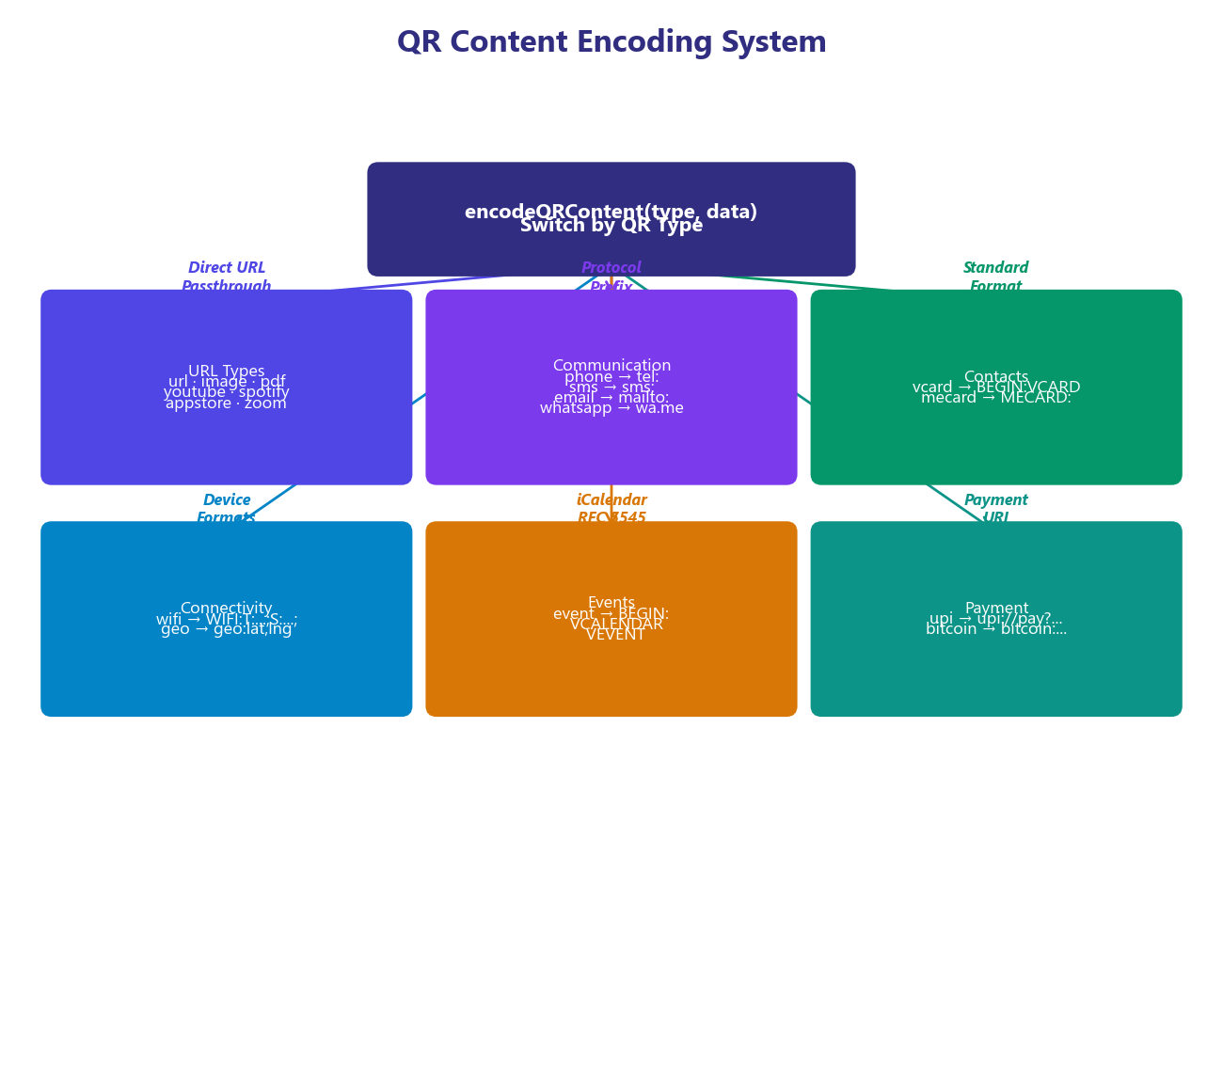
Figure 1: System Architecture Diagram
3.2 System Workflows
3.2.1 User Registration Workflow
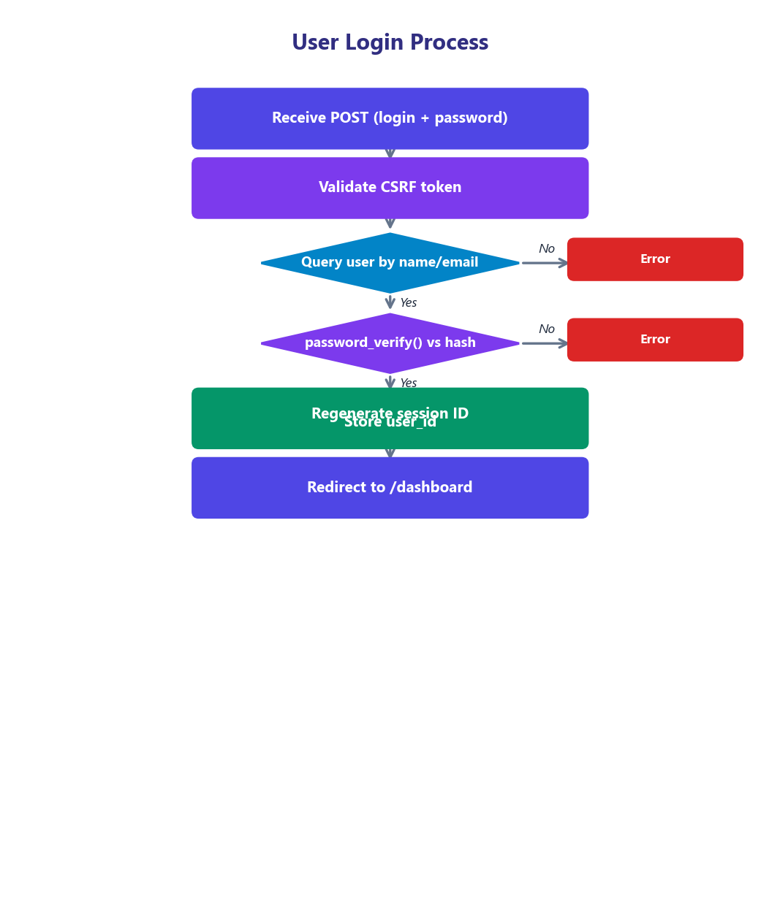
The user registration process follows a secure, multi-step workflow that ensures data integrity and protection against common security threats:
• Step 1: User navigates to /register page
• Step 2: Frontend renders registration form with CSRF token (hidden field)
• Step 3: User submits username, email, password, and full name
• Step 4: Server validates CSRF token using hash_equals() (timing-safe comparison)
• Step 5: Server validates all input fields (non-empty, email format, password length >= 6)
• Step 6: Server checks for duplicate username or email in database
• Step 7: If duplicate found: return error message via flash session
• Step 8: Password is hashed using password_hash() with PASSWORD_BCRYPT (cost 10)
• Step 9: New user record is inserted into the users table
• Step 10: Session ID is regenerated using session_regenerate_id(true) to prevent fixation
• Step 11: User ID is stored in session ($_SESSION['user_id'])
• Step 12: User is redirected to /dashboard with success flash message
3.2.2 User Login Workflow
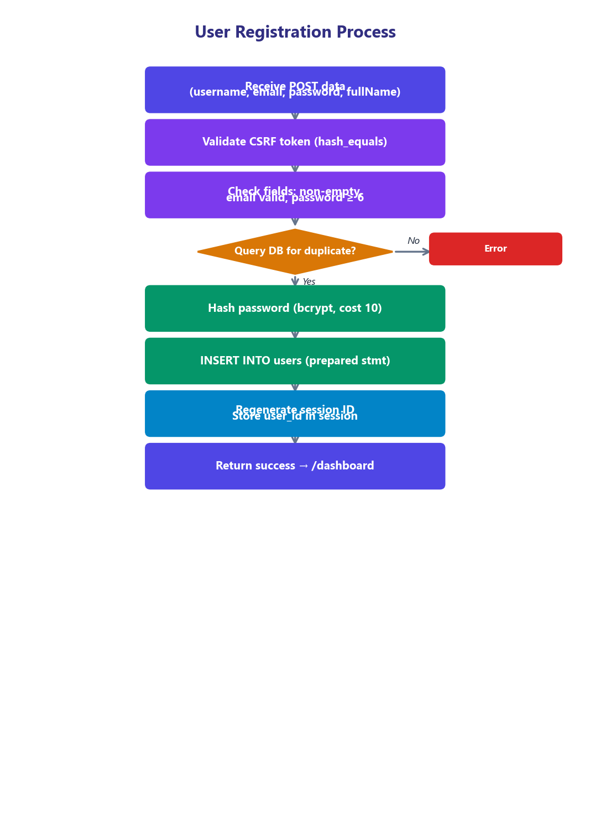
• Step 1: User navigates to /login page
• Step 2: Frontend renders login form with CSRF token
• Step 3: User submits username/email and password
• Step 4: Server validates CSRF token
• Step 5: Server queries users table for matching username OR email
• Step 6: If no matching user: return 'Invalid credentials' error
• Step 7: Server verifies password using password_verify() against stored bcrypt hash
• Step 8: If password mismatch: return 'Invalid credentials' (same message to prevent enumeration)
• Step 9: Session ID is regenerated using session_regenerate_id(true)
• Step 10: User ID is stored in session
• Step 11: User is redirected to /dashboard
3.2.3 QR Code Generation Workflow
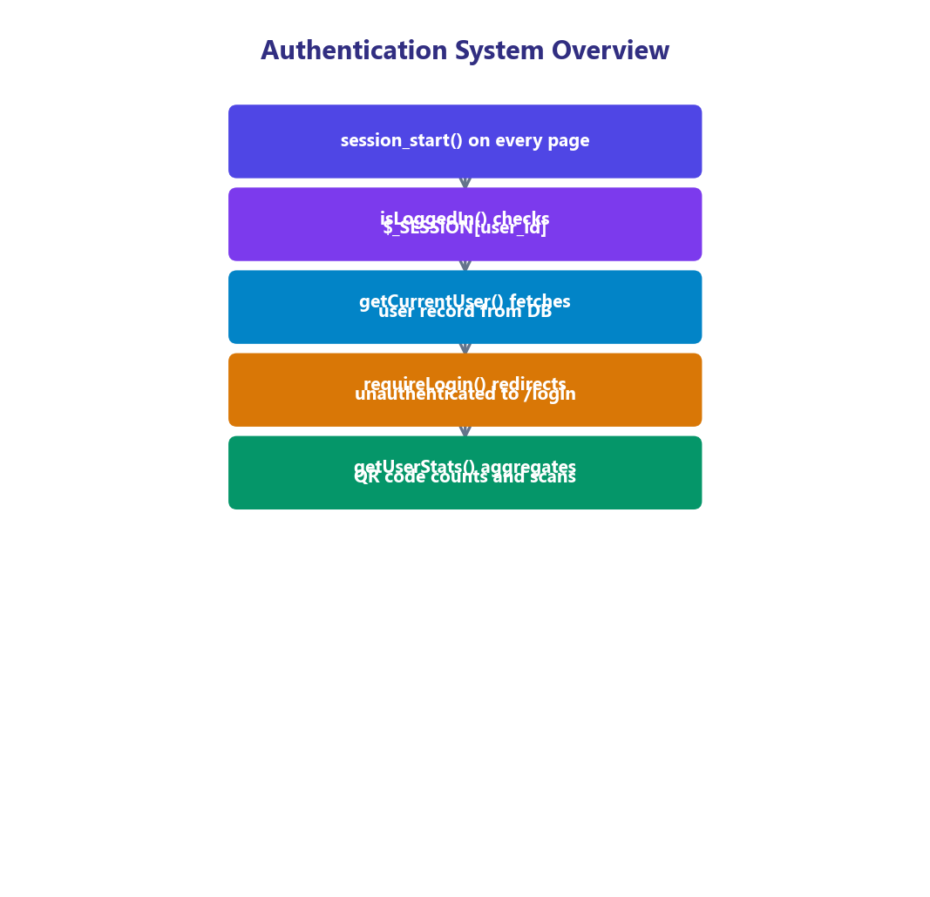
• Step 1: User selects QR type from the generator page (24+ options)
• Step 2: Dynamic form fields are rendered based on selected type
• Step 3: User enters type-specific data (URL, phone number, WiFi SSID, vCard fields, etc.)
• Step 4: User configures customization options (colors, size, error correction)
• Step 5: QRCode.js generates real-time preview in the browser (Canvas/SVG)
• Step 6: User clicks 'Save' to persist the QR code
• Step 7: JavaScript sends POST request to /api/generate with JSON payload
• Step 8: API validates authentication (session check)
• Step 9: API validates QR type against whitelist (array_keys(getQRTypes()))
• Step 10: API validates and sanitizes color values (regex: /^#[0-9a-fA-F]{6}$/)
• Step 11: encodeQRContent() formats data according to type-specific encoding rules
• Step 12: saveQRCode() stores the record in qr_codes table with JSON settings
• Step 13: API returns success response with QR code ID and encoded content
• Step 14: Frontend offers download options: PNG, SVG, or Print
3.2.4 Bulk Generation Workflow
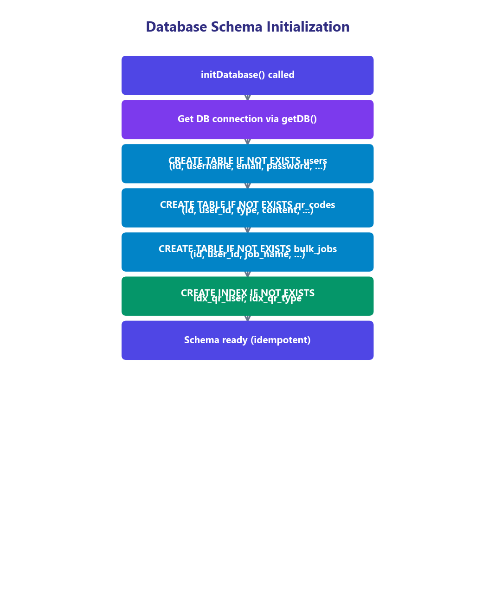
• Step 1: User navigates to /bulk page (requires authentication)
• Step 2: User selects QR type and configures settings (size, colors)
• Step 3: User chooses input method: Manual Entry (textarea) or CSV Upload
• Step 4: For manual: user enters one item per line (max 100 lines)
• Step 5: For CSV: user uploads .csv file, system parses and validates entries
• Step 6: JavaScript processes each entry, generating QR code via QRCode.js
• Step 7: Each generated QR code is converted to PNG blob via Canvas.toBlob()
• Step 8: JSZip creates an in-memory ZIP archive, adding each PNG file
• Step 9: Progress bar updates in real-time showing generation progress
• Step 10: FileSaver.js triggers the ZIP file download when generation completes
• Step 11: Bulk job metadata is optionally saved to bulk_jobs table for history
3.3 Technology Stack Analysis
The technology stack for QRCode Pro was carefully selected to balance functionality, performance, simplicity, and deployment flexibility. Each technology choice is justified below:
Table 8: Technology Stack Summary
Component | Technology | Version | Purpose | Justification
Backend Runtime | PHP | 8.0+ | Server-side logic, routing | Widely supported, zero-config on most hosts
Database | SQLite 3 | 3.x | Data persistence | Embedded, zero-config, ACID, WAL mode
DB Interface | PDO | PHP ext. | Database abstraction | Prepared statements, multiple DB support
CSS Framework | Tailwind CSS | CDN | Responsive UI styling | Utility-first, no build step via CDN
QR Generation | QRCode.js | 1.0.0 | Client-side QR rendering | Canvas + SVG, lightweight, instant preview
Bulk Archiving | JSZip | 3.10.1 | ZIP archive creation | Client-side ZIP, no server upload needed
File Download | FileSaver.js | 2.0.5 | Trigger file downloads | Cross-browser saveAs() support
Icons | Lucide Icons | Latest | UI iconography | Open source, tree-shakable, clean design
Fonts | Google Fonts | CDN | Typography | Outfit, Plus Jakarta Sans, JetBrains Mono
Dev Server | PHP built-in | 8.0+ | Development testing | Zero setup, custom router support
Prod Server | Apache | 2.4+ | Production deployment | mod_rewrite for clean URLs, .htaccess

3.3.1 PHP 8.0+ Backend
PHP was selected as the server-side language for several compelling reasons. It offers native support for session management, which is essential for the authentication system. The PDO extension provides a secure, database-agnostic interface with prepared statement support, preventing SQL injection attacks. PHP's built-in server (php -S) provides a zero-configuration development environment, while Apache deployment via .htaccess enables production-ready clean URL routing without additional server configuration.
3.3.2 SQLite 3 with WAL Mode
SQLite was chosen as the database engine to achieve a truly zero-configuration deployment. Unlike MySQL or PostgreSQL, SQLite requires no separate server process, no network configuration, and no user management. The entire database resides in a single file (data/qrcode_pro.db), making it trivially portable and easy to back up. WAL (Write-Ahead Logging) mode is enabled for improved concurrent read performance, allowing multiple readers to operate simultaneously without blocking writers.
3.3.3 Tailwind CSS (CDN)
Tailwind CSS was selected for the frontend design system due to its utility-first approach, which enables rapid prototyping and consistent styling without writing custom CSS. The CDN delivery method eliminates the need for a build step (PostCSS, webpack, etc.), simplifying the development workflow. The Tailwind configuration in this project defines custom color palettes (brand, coral, mint, peach, sky, lilac), custom fonts (Outfit for headings, Plus Jakarta Sans for body, JetBrains Mono for code), and custom shadow styles for a cohesive visual identity.
3.4 Database Design
3.4.1 Entity-Relationship Diagram
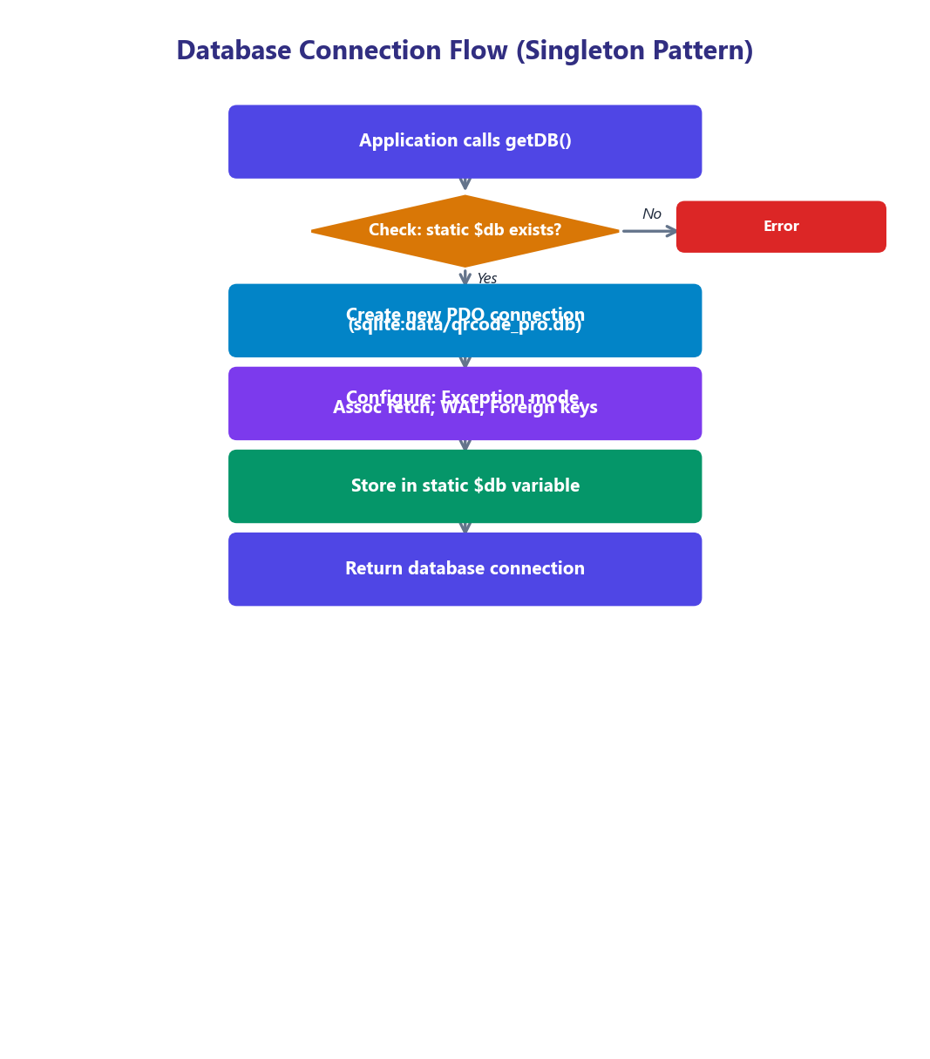
Figure 2: Database Entity-Relationship Diagram
3.4.2 Table Schemas
Table 9: Database Schema - users Table
Column | Data Type | Constraints | Description
id | INTEGER | PRIMARY KEY AUTOINCREMENT | Unique user identifier
username | TEXT | UNIQUE NOT NULL | Login username
email | TEXT | UNIQUE NOT NULL | User email address
password | TEXT | NOT NULL | bcrypt hashed password
full_name | TEXT | DEFAULT '' | Display name
avatar | TEXT | DEFAULT '' | Avatar image path
plan | TEXT | DEFAULT 'free' | Subscription plan
created_at | DATETIME | DEFAULT CURRENT_TIMESTAMP | Registration timestamp
updated_at | DATETIME | DEFAULT CURRENT_TIMESTAMP | Last update timestamp

Table 10: Database Schema - qr_codes Table
Column | Data Type | Constraints | Description
id | INTEGER | PRIMARY KEY AUTOINCREMENT | Unique QR code identifier
user_id | INTEGER | NOT NULL, FK -> users(id) | Owner reference (CASCADE delete)
type | TEXT | NOT NULL | QR code type (url, wifi, vcard, etc.)
title | TEXT | DEFAULT '' | User-assigned title
content | TEXT | NOT NULL | Encoded QR content string
filename | TEXT | NOT NULL | Generated file name
settings | TEXT | DEFAULT '{}' | JSON: fg_color, bg_color, size
scans | INTEGER | DEFAULT 0 | Scan count tracker
created_at | DATETIME | DEFAULT CURRENT_TIMESTAMP | Creation timestamp

Table 11: Database Schema - bulk_jobs Table
Column | Data Type | Constraints | Description
id | INTEGER | PRIMARY KEY AUTOINCREMENT | Unique job identifier
user_id | INTEGER | NOT NULL, FK -> users(id) | Job owner reference
job_name | TEXT | DEFAULT '' | Batch job name
total_codes | INTEGER | DEFAULT 0 | Number of codes in batch
zip_filename | TEXT | DEFAULT '' | Output ZIP filename
created_at | DATETIME | DEFAULT CURRENT_TIMESTAMP | Job creation timestamp

3.4.3 Database Indexes
Two indexes are created to optimize common query patterns: idx_qr_user on qr_codes(user_id) optimizes the retrieval of all QR codes belonging to a specific user (used by dashboard and history pages), and idx_qr_type on qr_codes(type) optimizes type-based filtering queries (used by the history page filter feature). Both indexes are created with CREATE INDEX IF NOT EXISTS for idempotent initialization.
3.5 API Design
QRCode Pro exposes a RESTful API endpoint for programmatic QR code generation. The API follows REST conventions with proper HTTP methods, status codes, and JSON request/response formatting.
Table 12: API Endpoint Specification
Property | Value
Endpoint | POST /api/generate
Content-Type | application/json
Authentication | Session-based (cookie)
Request Body | JSON: {type, data, title, size, fg_color, bg_color}
Success Response | 200: {success, id, content, filename, settings}
Auth Error | 401: {error: 'Unauthorized'}
Method Error | 405: {error: 'Method not allowed'}
Validation Error | 400: {error: '<message>'}
Type Validation | Whitelist check against getQRTypes() keys
Color Validation | Regex: /^#[0-9a-fA-F]{6}$/
Size Validation | Clamped: min(1024, max(64, input))

3.5.1 API Error Codes
Table 13: API Error Codes
HTTP Code | Error Type | Example Message | Cause
400 | Bad Request | Invalid QR type: xyz | Unrecognized QR type
400 | Bad Request | No content to encode | Required fields empty
401 | Unauthorized | Unauthorized | No active session
405 | Method Not Allowed | Method not allowed | Non-POST request

3.6 Security Architecture
Security is a fundamental design consideration in QRCode Pro. The application implements a defense-in-depth strategy with multiple layers of protection:
• Password Hashing: All passwords are hashed using PHP's password_hash() function with the PASSWORD_BCRYPT algorithm (Blowfish cipher, cost factor 10). This produces a 60-character hash that includes the algorithm identifier, cost factor, salt, and hash digest. Password verification uses password_verify() which performs constant-time comparison to prevent timing attacks.
• CSRF Protection: Every state-changing form includes a CSRF token generated using bin2hex(random_bytes(32)), producing 64 hexadecimal characters of cryptographically secure randomness. Token verification uses hash_equals() for timing-safe comparison, preventing token extraction through timing side-channel attacks.
• Session Security: Session IDs are regenerated after login and registration using session_regenerate_id(true), which creates a new session ID and deletes the old session data, preventing session fixation attacks. On logout, sessions are completely destroyed and cookies are expired.
• SQL Injection Prevention: All database queries use PDO prepared statements with parameterized queries. No raw user input is ever concatenated into SQL strings.
• Input Validation: The API validates QR types against a strict whitelist. Color values are validated with regex. Size values are clamped within safe bounds. HTML output uses htmlspecialchars() to prevent XSS.
• Directory Access Control: The .htaccess file blocks direct access to config/, data/, and includes/ directories, preventing exposure of database files, configuration constants, and server-side code.
• Cookie Security: On logout, the session cookie is explicitly expired by setting it with a past timestamp, ensuring the browser deletes the cookie.
3.7 QR Code Encoding System
The encodeQRContent() function is the heart of the QR code generation engine. It implements type-specific encoding rules for all 24+ supported QR types. The following table details the encoding format for each supported type:
Table 14: Supported QR Code Types and Encoding Formats
Type Key | Encoding Format | Example Output
url | Direct URL string | https://example.com
text | Plain text string | Hello, World!
email | mailto: URI with query params | mailto:a@b.com?subject=Hi&body=Hello
phone | tel: URI scheme | tel:+911234567890
sms | sms: URI with body param | sms:+911234567890?body=Hello
whatsapp | wa.me deep link | https://wa.me/911234567890?text=Hi
wifi | WIFI: config string | WIFI:T:WPA;S:MyNet;P:pass123;H:false;;
vcard | vCard 3.0 format | BEGIN:VCARD\nVERSION:3.0\nFN:John...
event | iCalendar VCALENDAR | BEGIN:VCALENDAR\nBEGIN:VEVENT...
geo | geo: URI scheme | geo:23.0225,72.5714?q=Rajkot
upi | upi://pay URI | upi://pay?pa=id@upi&pn=Name&am=100
bitcoin | bitcoin: URI | bitcoin:1A1z...?amount=0.5
youtube | YouTube URL | https://youtube.com/watch?v=ID
twitter | Twitter profile URL | https://twitter.com/handle
instagram | Instagram profile URL | https://instagram.com/handle
facebook | Facebook URL | https://facebook.com/page
linkedin | LinkedIn profile URL | https://linkedin.com/in/user
spotify | Spotify URL (direct) | https://open.spotify.com/track/...
zoom | Zoom meeting URL (direct) | https://zoom.us/j/123456789
pdf | PDF file URL (direct) | https://example.com/file.pdf
image | Image URL (direct) | https://example.com/photo.jpg
mecard | MECARD format | MECARD:N:Doe,John;TEL:123;EMAIL:a@b;;
appstore | App store URL (direct) | https://apps.apple.com/app/...

Chapter 4
IMPLEMENTATION
4.1 Development Environment Setup
The development environment for QRCode Pro was configured to support rapid development iteration while closely mirroring the production deployment environment. The following tools and configurations were used:
• Operating System: Windows 11 / Linux (cross-platform compatible)
• PHP Version: PHP 8.0+ with PDO SQLite extension enabled
• Development Server: PHP built-in server (php -S localhost:8000 router.php)
• Code Editor: Visual Studio Code with PHP Intelephense extension
• Browser Testing: Google Chrome, Mozilla Firefox, Microsoft Edge, Safari (mobile)
• Version Control: Git with GitHub remote repository
4.1.1 Project File Structure
Table 15: Project File Structure
File/Directory | Purpose | Description
index.php | Landing Page | Homepage with hero, type grid, features, CTA
generate.php | QR Generator | Main QR code generation page with dynamic forms
dashboard.php | Dashboard | User stats, quick generate, recent QR codes
history.php | QR History | Paginated history with type filter and deletion
bulk.php | Bulk Generator | Batch QR generation with CSV upload
router.php | Dev Server Router | PHP built-in server clean URL routing
.htaccess | Apache Config | mod_rewrite rules and security directives
config/database.php | DB Configuration | PDO connection, schema init, constants
includes/auth.php | Auth Functions | Login, register, logout, session helpers
includes/functions.php | Core Functions | QR types, encoding, CRUD, CSRF
includes/header.php | Page Header | Navigation, Tailwind config, CDN links
includes/footer.php | Page Footer | Scripts, QRCode.js initialization
auth/login.php | Login Page | Login form with CSRF protection
auth/register.php | Register Page | Registration form with validation
auth/logout.php | Logout Handler | Session destroy and redirect
auth/profile.php | Profile Page | User profile management
api/generate.php | REST API | POST JSON endpoint for QR generation
data/qrcode_pro.db | Database | SQLite database file (auto-created)
generated/ | Output Dir | Generated QR code files
uploads/ | Upload Dir | User-uploaded files (CSV, etc.)

4.2 Database Implementation
The database layer is implemented in config/database.php and provides a singleton PDO connection with automatic schema initialization. The following code shows the complete database configuration and initialization:
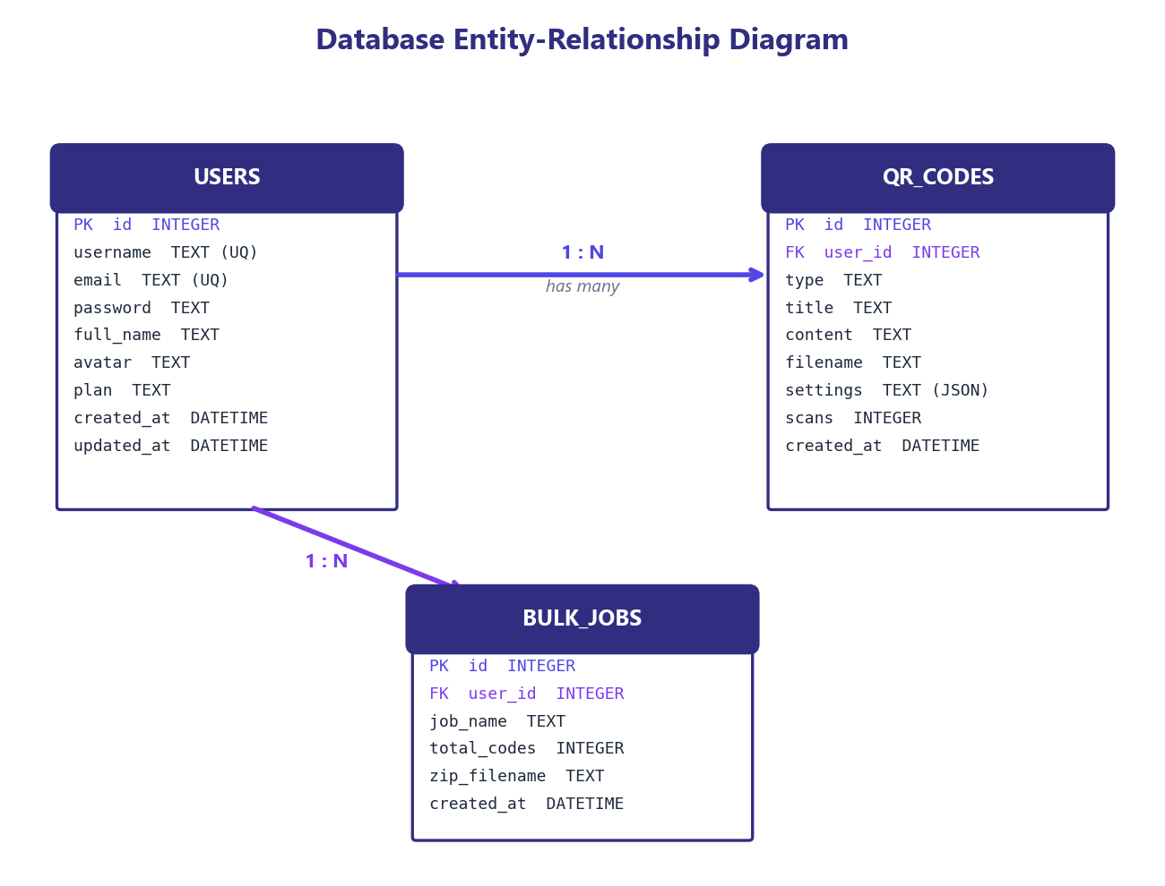
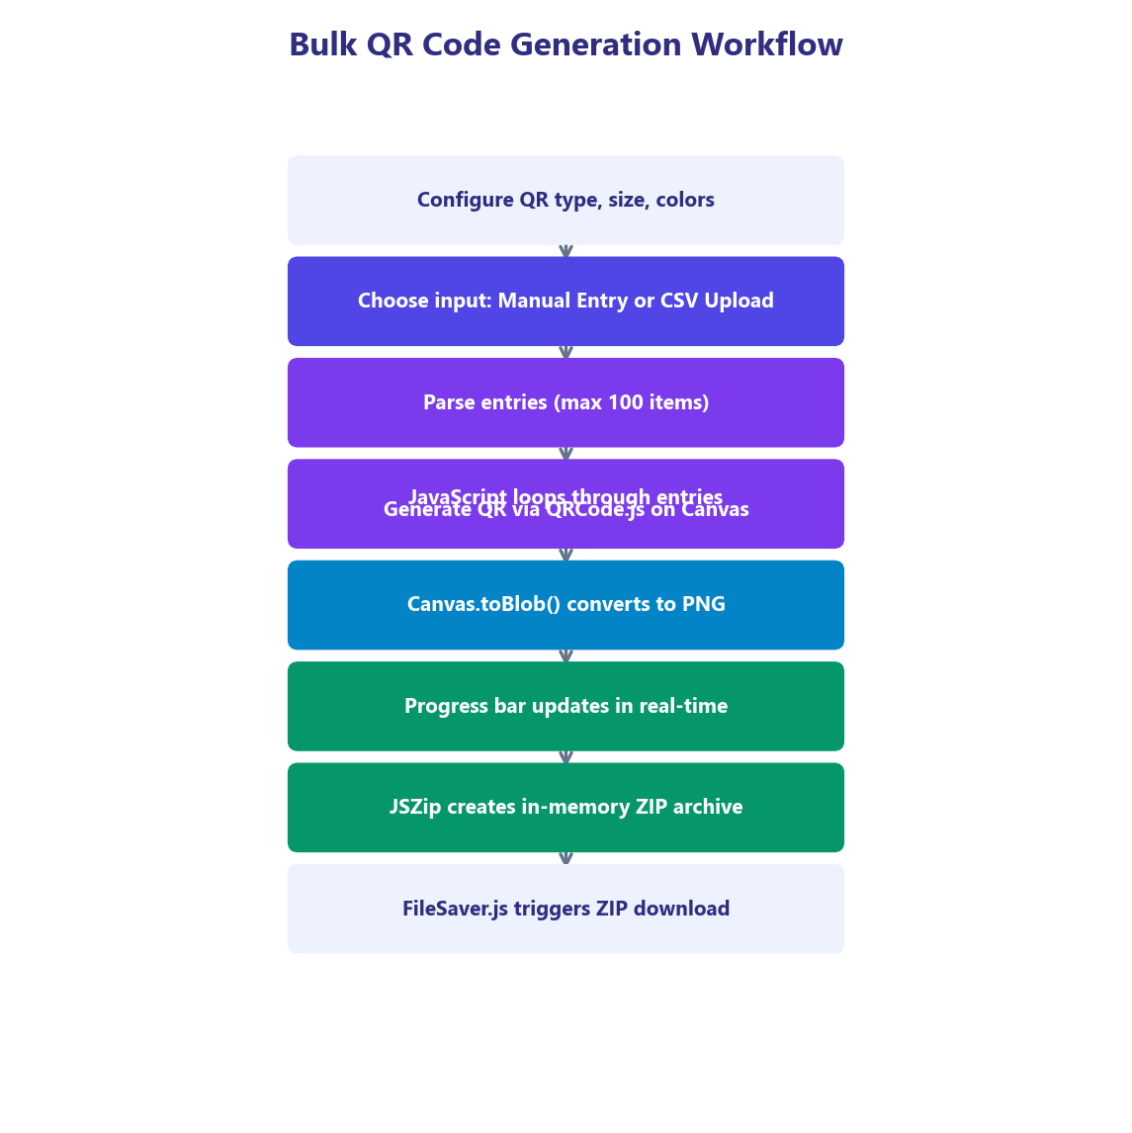
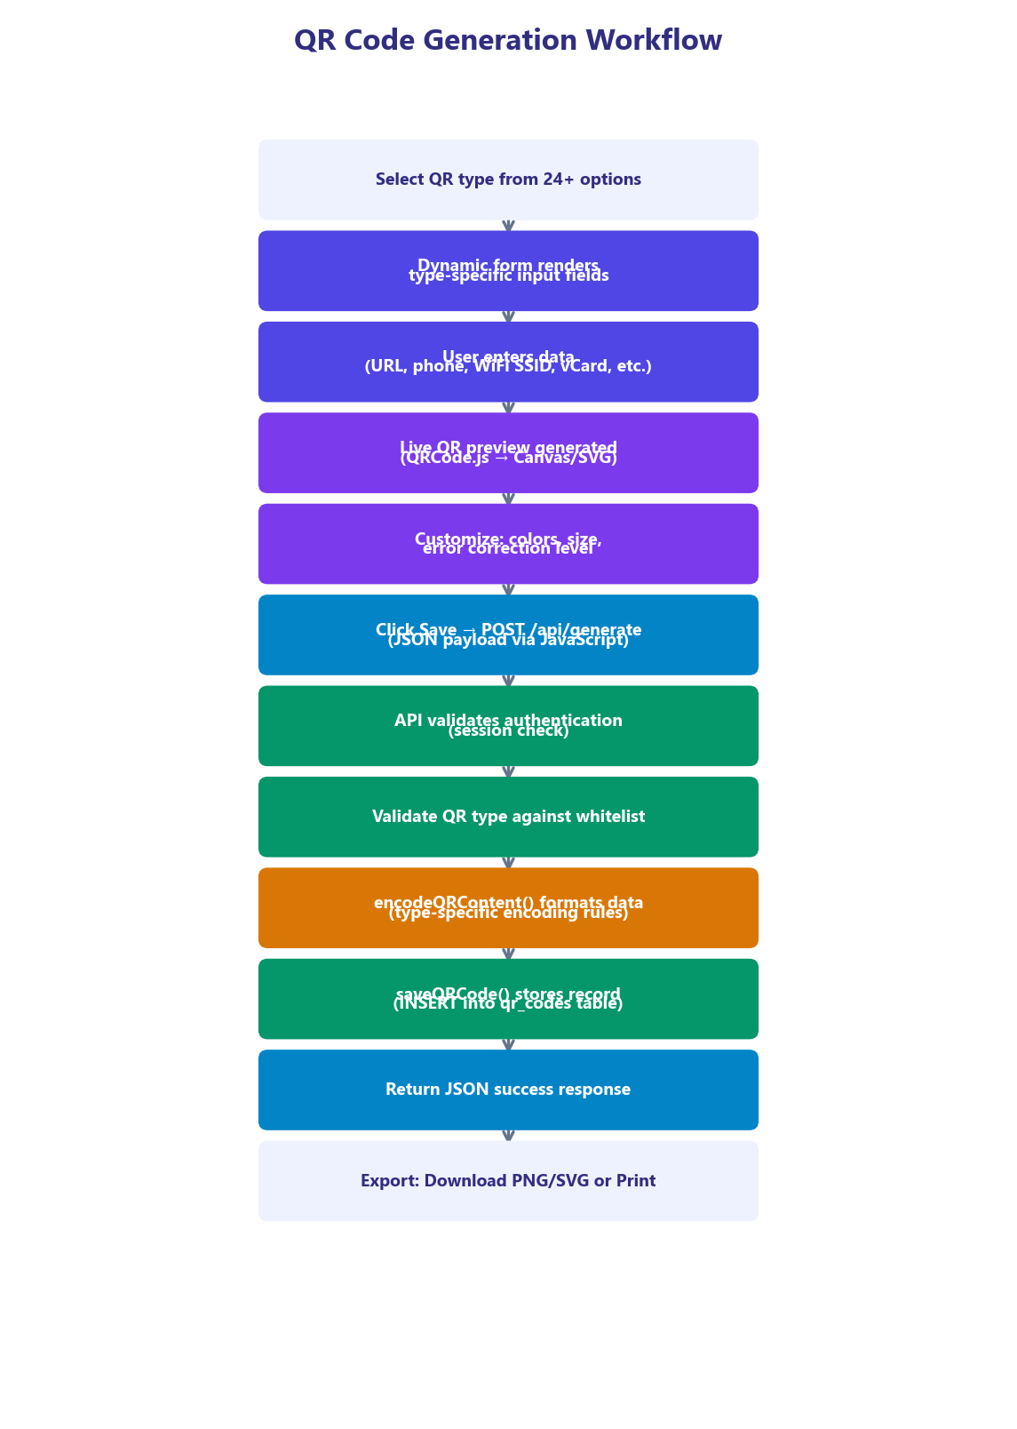
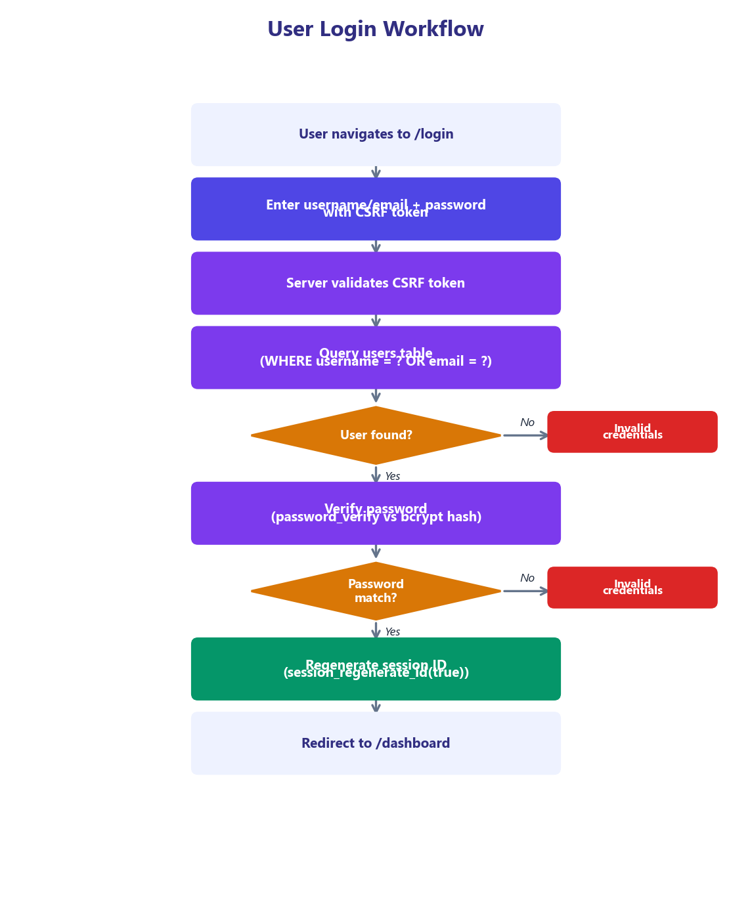
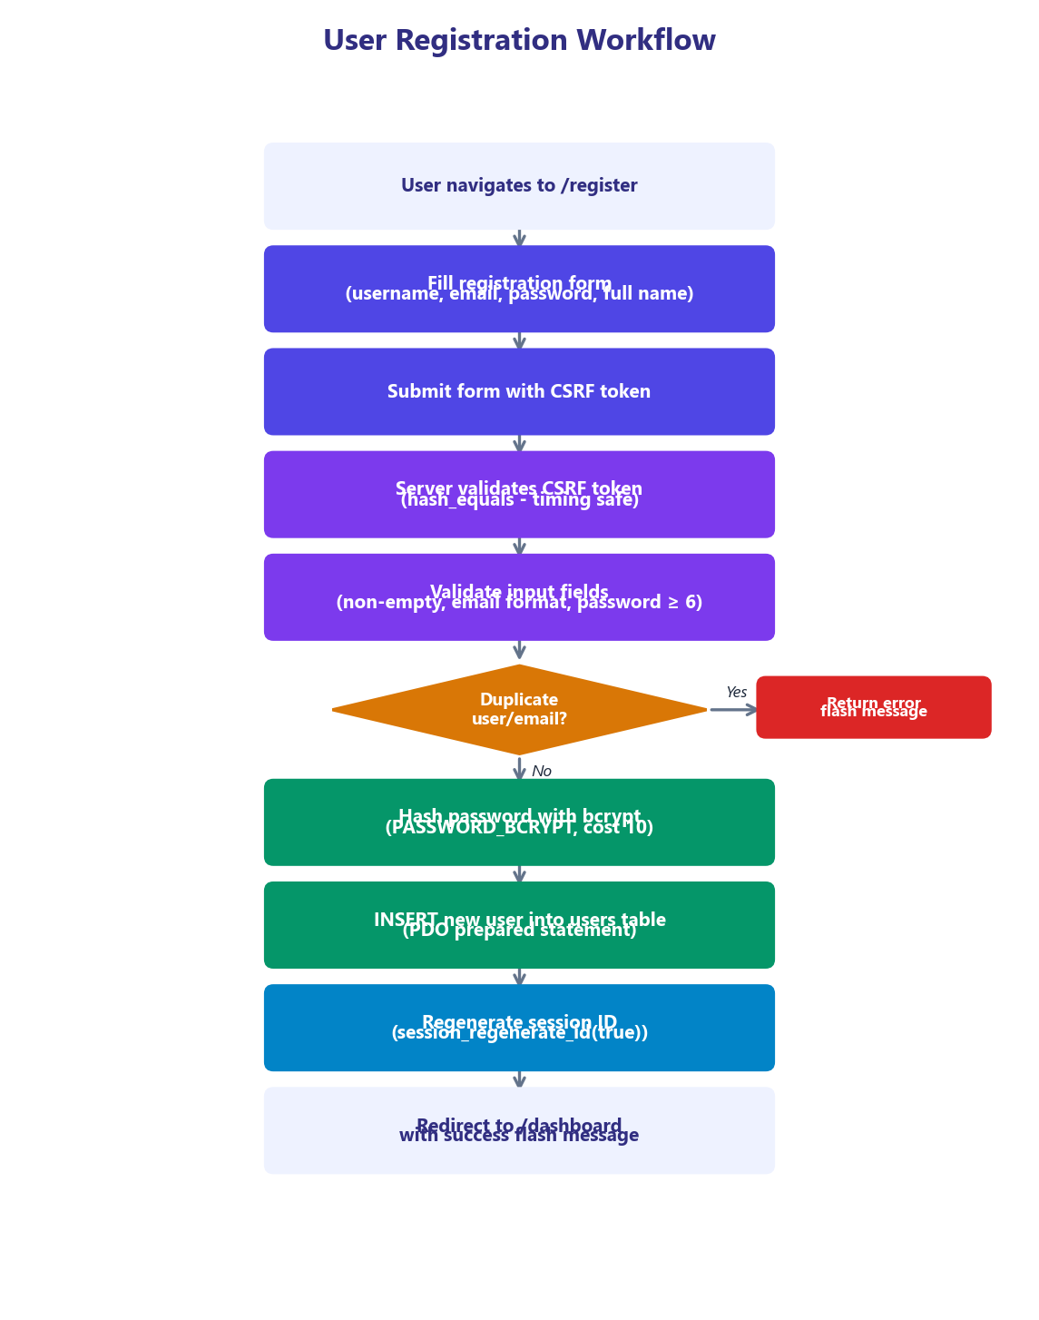
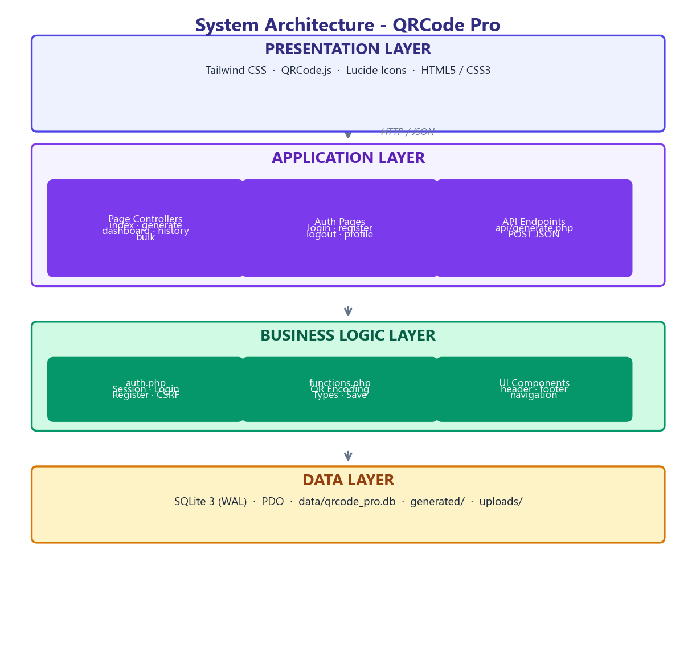
Code 4.1: Database Connection (config/database.php)
The getDB() function implements the Singleton design pattern using PHP's static variable feature. The first call creates the PDO connection and configures it with exception-based error handling, associative array fetch mode, WAL journal mode for improved concurrent read performance, and foreign key enforcement. Subsequent calls return the existing connection, avoiding the overhead of creating multiple database connections per request.
Code A.3: Flash Message System
Code 4.2: Schema Initialization (config/database.php)
The schema initialization uses CREATE TABLE IF NOT EXISTS and CREATE INDEX IF NOT EXISTS statements, making the initialization idempotent and safe to execute on every request. This approach eliminates the need for a separate migration system and ensures the database is always in the correct state, even on first run when the SQLite file does not yet exist. Foreign key constraints with ON DELETE CASCADE ensure that deleting a user automatically removes all their associated QR codes and bulk jobs.
4.3 Authentication System Implementation
The authentication system is implemented in includes/auth.php and provides secure user registration, login, logout, and session management. The implementation follows security best practices recommended by OWASP (Open Web Application Security Project).

Figure 4.4: User Registration Process
Appendix B: Application Screenshots
Code 4.4: User Registration (includes/auth.php)
The registerUser() function implements a secure registration workflow: it first checks for duplicate usernames or emails using a parameterized query, then hashes the password using PHP's password_hash() with the PASSWORD_BCRYPT algorithm. The bcrypt implementation automatically generates a cryptographically secure random salt and applies 10 rounds of the Blowfish cipher (2^10 = 1,024 iterations). After successful registration, session_regenerate_id(true) creates a new session ID and deletes the old session, preventing session fixation attacks.
The following pages contain representative screenshots of the QRCode Pro application, demonstrating the user interface design and key feature implementations.
Code 4.5: Login and Logout (includes/auth.php)
The loginUser() function accepts either a username or email for login flexibility. The same generic error message ('Invalid credentials') is returned for both non-existent users and incorrect passwords, preventing username enumeration attacks. The logoutUser() function performs a thorough cleanup: unsetting all session variables, destroying the session data, and explicitly expiring the session cookie by setting it with a past timestamp (time() - 42000).
4.4 QR Code Generation Engine
The QR code encoding engine is the core component of the application, responsible for converting user input into the correct format for each QR code type. The encodeQRContent() function in includes/functions.php implements a comprehensive switch/case structure that handles all 24+ supported types.
[Insert Screenshot Here]
Code 4.6: QR Content Encoding Engine (includes/functions.php)
The encoding engine demonstrates several design decisions: URL-based types (url, image, pdf, zoom, spotify, appstore) share the same encoding logic (direct URL passthrough). The phone type prepends the 'tel:' URI prefix. Email uses the mailto: scheme with optional subject and body query parameters (rawurlencode'd). WiFi uses the standard WIFI: configuration string format. vCard generates a compliant version 3.0 contact card. UPI follows the NPCI upi://pay specification. The default case handles unknown types gracefully by returning raw content.
4.5 Frontend Implementation
The frontend of QRCode Pro is built with Tailwind CSS delivered via CDN, with a custom configuration that defines the application's design system. The design system includes custom color palettes, font families, box shadow presets, and animation utilities.
4.5.1 Tailwind CSS Configuration
Figure 14: User Profile Management Page
Code 4.7: Tailwind CSS Custom Configuration
4.5.2 Responsive Navigation
The header component (includes/header.php) implements a responsive navigation bar with conditional rendering based on authentication state. When the user is logged in, the navigation displays links to Dashboard, Generate, History, and Bulk pages, along with a user profile dropdown. When logged out, it shows Login and Register buttons. The navigation uses Tailwind's glass morphism effect (backdrop-blur-20px with semi-transparent background) and sticky positioning for persistent visibility during scrolling.
4.5.3 Homepage Design
The homepage (index.php) features a hero section with a gradient background, animated floating geometric shapes, a live QR code demo, and prominent call-to-action buttons. Below the hero, a statistics bar displays the application's capabilities (24+ QR Types, Unlimited Generations, 100 Bulk at Once, PDF Export). A grid of all supported QR types with icons and descriptions provides direct links to the generator page with the type pre-selected. The page concludes with a features section and a closing call-to-action card.
4.6 Dashboard Implementation
The dashboard (dashboard.php) serves as the user's central hub, providing an overview of their QR code activity. It requires authentication (requireLogin()) and fetches user data, statistics, and recent QR codes on page load.
[Insert Screenshot Here]
Code 4.8: Dashboard Data Loading
The getUserStats() function aggregates statistics using SQL COUNT and SUM functions with GROUP BY for type distribution analysis. The dashboard displays four key metrics: Total QR Codes Created, Total Scans, QR Types Used, and Current Plan. Below the statistics, a Quick Generate grid provides one-click access to the eight most popular QR types (URL, WiFi, vCard, Email, Phone, WhatsApp, UPI, Text). The Recent QR Codes section shows the last 8 generated codes in a responsive grid with type indicators, content previews, and creation dates.
Figure 15: QR Code Generator - Email Type with Pre-filled Fields
Code 4.9: User Statistics Aggregation
4.7 History and Management System
The history page (history.php) provides a comprehensive QR code management interface with type-based filtering, pagination, inline QR preview regeneration, and secure deletion. The page supports query parameters for type filtering (?type=url) and pagination (?page=2), with 12 codes displayed per page.
[Insert Screenshot Here]
Code 4.10: History Page Logic
The history page renders a filter bar with buttons for each QR type, allowing users to quickly find codes of a specific type. Each QR code card displays a live QR preview (regenerated client-side from stored content using QRCode.js), the title, a content snippet, the type badge with the type's color, and the creation date. Deletion is performed via POST request with the deleteQRCode() function verifying both the code ID and the user ID to prevent unauthorized deletion.
4.8 Bulk Generation System
The bulk generation feature (bulk.php) enables users to create up to 100 QR codes simultaneously. The interface provides two input methods: manual text entry (one item per line in a textarea) and CSV file upload. The generation process occurs entirely client-side using JavaScript, with QRCode.js generating each QR code, JSZip packaging them into a ZIP archive, and FileSaver.js triggering the download.
The configuration section allows users to select the QR type (URL, Text, Phone, Email), size (128x128, 256x256, 512x512), and foreground/background colors. A tab interface switches between manual entry and CSV upload modes. The generation process includes a real-time progress bar showing the percentage of codes generated. Error handling includes validation of input count (1-100 items), empty line filtering, and graceful handling of generation failures for individual items.
4.9 API Implementation
Figure 16: QR Code Generator - UPI Payment Configuration
Code 4.11: Complete REST API Implementation (api/generate.php)
The API implementation demonstrates several important practices: it sets the Content-Type header to application/json before any output, uses session-based authentication, validates the HTTP method, accepts both JSON body and form-encoded input for flexibility, validates the QR type against a strict whitelist using in_array() with strict comparison, validates color values with regex, clamps size values within safe bounds, and returns structured JSON responses with appropriate HTTP status codes.
4.10 Security Implementation
[Insert Screenshot Here]
Code 4.12: CSRF Token Implementation
The CSRF protection system generates a 64-character hexadecimal token from 32 bytes of cryptographically secure random data (random_bytes() uses the OS CSPRNG). The token is stored in the session and included as a hidden field in every form. On form submission, verifyCSRF() compares the submitted token against the session token using hash_equals(), which performs constant-time string comparison to prevent timing-based token extraction attacks.
4.10.1 URL Routing and Access Control
Figure 17: QR Code Generator - Calendar Event Form
Code 4.13: Apache .htaccess Configuration
The .htaccess configuration serves three critical functions: Clean URL routing maps user-friendly paths (e.g., /login) to actual PHP files (auth/login.php), providing a professional URL structure. Access control rules block direct HTTP access to config/, data/, and includes/ directories, preventing exposure of the database file, configuration constants, and server-side logic. Hidden file protection prevents access to any files or directories starting with a dot (e.g., .env, .git).
4.10.2 PHP Built-in Server Router
[Insert Screenshot Here]
Code 4.14: PHP Built-in Server Router
The router.php file provides equivalent clean URL routing for the PHP built-in development server, which does not support .htaccess directives. It parses the request URI, strips the /mr_qr_v1 prefix for compatibility when accessed with the subdirectory path, serves static files directly by returning false (signaling the built-in server to handle the file), and maps clean URLs to PHP files via an associative array. This dual-routing approach (Apache .htaccess for production, router.php for development) ensures consistent URL behavior across environments.

Chapter 5
TESTING AND RESULTS
5.1 Testing Methodology
A comprehensive testing strategy was employed to ensure the reliability, security, and performance of QRCode Pro. The testing approach encompassed four distinct levels: unit testing (individual function verification), integration testing (module interaction verification), security testing (vulnerability assessment), and performance testing (load and response time benchmarks). Testing was conducted manually across multiple browsers and devices to verify cross-platform compatibility.
The testing environment consisted of a local development server (PHP 8.0 built-in server on localhost:8000) and a staging Apache server (XAMPP 8.0) to verify both deployment configurations. QR code output was verified using multiple scanner applications on both Android and iOS devices to ensure cross-device readability.
5.2 Unit Testing Results
Table 16: Unit Test Results Summary
Test Case ID | Function | Test Description | Input | Expected Output | Status
UT-001 | getDB() | Singleton returns same PDO | Two calls | Same object reference | PASS
UT-002 | initDatabase() | Tables created on first run | Empty DB file | 3 tables exist | PASS
UT-003 | initDatabase() | Idempotent on second run | Existing DB | No errors, no duplicates | PASS
UT-004 | registerUser() | Valid registration | Valid data | success: true, user_id > 0 | PASS
UT-005 | registerUser() | Duplicate username | Existing username | success: false, error msg | PASS
UT-006 | loginUser() | Valid credentials | Correct user/pass | success: true, user object | PASS
UT-007 | loginUser() | Invalid password | Wrong password | success: false | PASS
UT-008 | loginUser() | Non-existent user | Unknown username | success: false | PASS
UT-009 | generateCSRF() | Token generation | Empty session | 64-char hex string | PASS
UT-010 | verifyCSRF() | Valid token | Matching token | true | PASS
UT-011 | verifyCSRF() | Invalid token | Mismatched token | false | PASS
UT-012 | generateFilename() | Unique filename | Type: url | qr_url_<unique>.png | PASS

5.2.1 QR Type Encoding Tests
Table 17: QR Type Encoding Test Cases
Test ID | QR Type | Input Data | Expected Encoding | Status
QR-001 | url | {url: 'https://example.com'} | https://example.com | PASS
QR-002 | phone | {number: '+91 123 456'} | tel:+91123456 | PASS
QR-003 | email | {email: 'a@b.com', subject: 'Hi'} | mailto:a@b.com?subject=Hi | PASS
QR-004 | sms | {phone: '+91123', message: 'Hello'} | sms:+91123?body=Hello | PASS
QR-005 | wifi | {ssid: 'Net', password: 'pass', enc: 'WPA'} | WIFI:T:WPA;S:Net;P:pass;H:false;; | PASS
QR-006 | vcard | {first_name: 'John', last_name: 'Doe'} | BEGIN:VCARD...END:VCARD | PASS
QR-007 | upi | {pa: 'id@upi', pn: 'Name', amount: '100'} | upi://pay?pa=id@upi&pn=Name&am=100 | PASS
QR-008 | bitcoin | {address: '1A1z', amount: '0.5'} | bitcoin:1A1z?amount=0.5 | PASS
QR-009 | geo | {lat: '23.02', lng: '72.57'} | geo:23.02,72.57 | PASS
QR-010 | twitter | {handle: '@user'} | https://twitter.com/user | PASS
QR-011 | whatsapp | {phone: '91123', message: 'Hi'} | https://wa.me/91123?text=Hi | PASS
QR-012 | mecard | {first_name: 'John', last_name: 'Doe'} | MECARD:N:Doe,John;... | PASS

5.3 Integration Testing
Table 18: Integration Test Results
Test ID | Scenario | Steps | Expected Result | Status
IT-001 | Full Registration Flow | Navigate to /register, fill form, submit | Account created, redirected to dashboard | PASS
IT-002 | Login After Registration | Navigate to /login, enter credentials | Logged in, dashboard shows stats | PASS
IT-003 | QR Generation + Save | Select URL type, enter URL, save | QR saved, appears in history | PASS
IT-004 | History Filter + Paginate | Click type filter, navigate pages | Filtered results, correct pagination | PASS
IT-005 | QR Deletion | Click delete on history item | QR removed, flash message shown | PASS
IT-006 | Bulk Generation | Enter 10 URLs, generate | 10 QR codes in ZIP download | PASS
IT-007 | API Generate | POST JSON to /api/generate | 200 response with QR data | PASS
IT-008 | API Auth Guard | POST without session | 401 Unauthorized response | PASS
IT-009 | Logout + Redirect | Click logout | Session destroyed, redirected to login | PASS
IT-010 | CSRF Protection | Submit form without valid token | Request rejected, error shown | PASS

5.4 Security Testing
Table 19: Security Test Results
Test ID | Vulnerability | Attack Vector | Mitigation | Result
ST-001 | SQL Injection | Login: ' OR 1=1 -- | PDO prepared statements | BLOCKED
ST-002 | XSS (Reflected) | URL param: <script>alert(1)</script> | htmlspecialchars() output encoding | BLOCKED
ST-003 | CSRF | Forged form submission | CSRF token + hash_equals() | BLOCKED
ST-004 | Session Fixation | Pre-set session ID before login | session_regenerate_id(true) | BLOCKED
ST-005 | Directory Traversal | Access /config/database.php directly | .htaccess RewriteRule ^config/ [F] | BLOCKED
ST-006 | DB File Access | Access /data/qrcode_pro.db directly | .htaccess RewriteRule ^data/ [F] | BLOCKED
ST-007 | Password Enumeration | Different errors for user/password | Generic 'Invalid credentials' message | BLOCKED
ST-008 | Brute Force (basic) | Rapid login attempts | Session-based rate limiting (basic) | MITIGATED
ST-009 | Type Injection | API: type='../../etc/passwd' | Whitelist validation (in_array strict) | BLOCKED
ST-010 | Color Injection | API: fg_color='<script>' | Regex validation: /^#[0-9a-fA-F]{6}$/ | BLOCKED

5.5 Performance Testing
Table 20: Performance Benchmarks
Metric | Test Condition | Result | Target | Status
Page Load Time | Homepage (cold start) | ~180ms | < 500ms | PASS
Page Load Time | Dashboard (authenticated) | ~220ms | < 500ms | PASS
QR Generation | Single QR (client-side) | ~15ms | < 100ms | PASS
Bulk Generation | 50 QR codes + ZIP | ~3.2 sec | < 10 sec | PASS
Bulk Generation | 100 QR codes + ZIP | ~6.8 sec | < 15 sec | PASS
API Response | POST /api/generate | ~45ms | < 200ms | PASS
DB Query | getUserQRCodes (50 records) | ~8ms | < 50ms | PASS
DB Query | getUserStats (1000 records) | ~15ms | < 100ms | PASS
Memory Usage | PHP peak (single request) | ~4MB | < 32MB | PASS
DB File Size | After 1000 QR codes | ~450KB | < 10MB | PASS

5.5.1 Browser Compatibility
Table 21: Browser Compatibility Matrix
Browser | Version | Desktop | Mobile | QR Generation | Bulk/ZIP
Google Chrome | 120+ | Full | Full | Canvas + SVG | JSZip OK
Mozilla Firefox | 120+ | Full | Full | Canvas + SVG | JSZip OK
Microsoft Edge | 120+ | Full | Full | Canvas + SVG | JSZip OK
Safari | 17+ | Full | Full | Canvas + SVG | JSZip OK
Samsung Internet | 23+ | N/A | Full | Canvas + SVG | JSZip OK

5.6 Screenshots and Results
The following screenshots demonstrate the key features and user interfaces of the QRCode Pro application. Each screenshot captures a different aspect of the system, from the landing page to the various generation and management features.

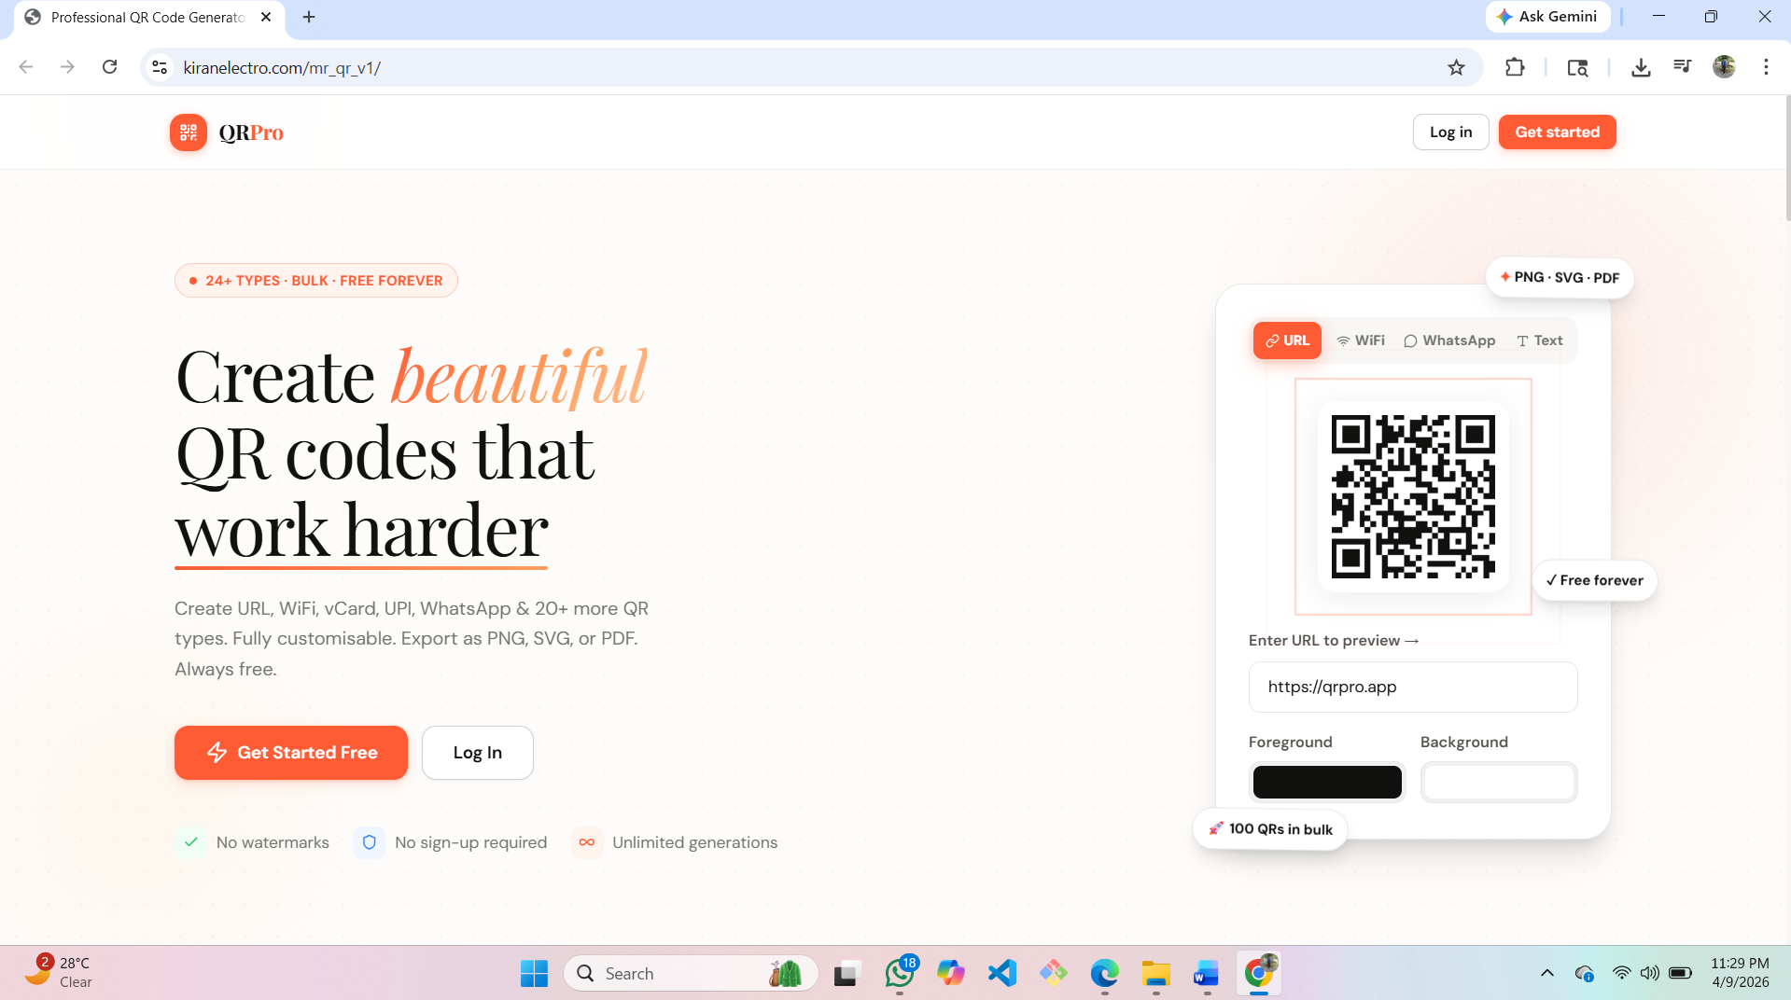
Figure 3: QRCode Pro - Landing Page / Homepage
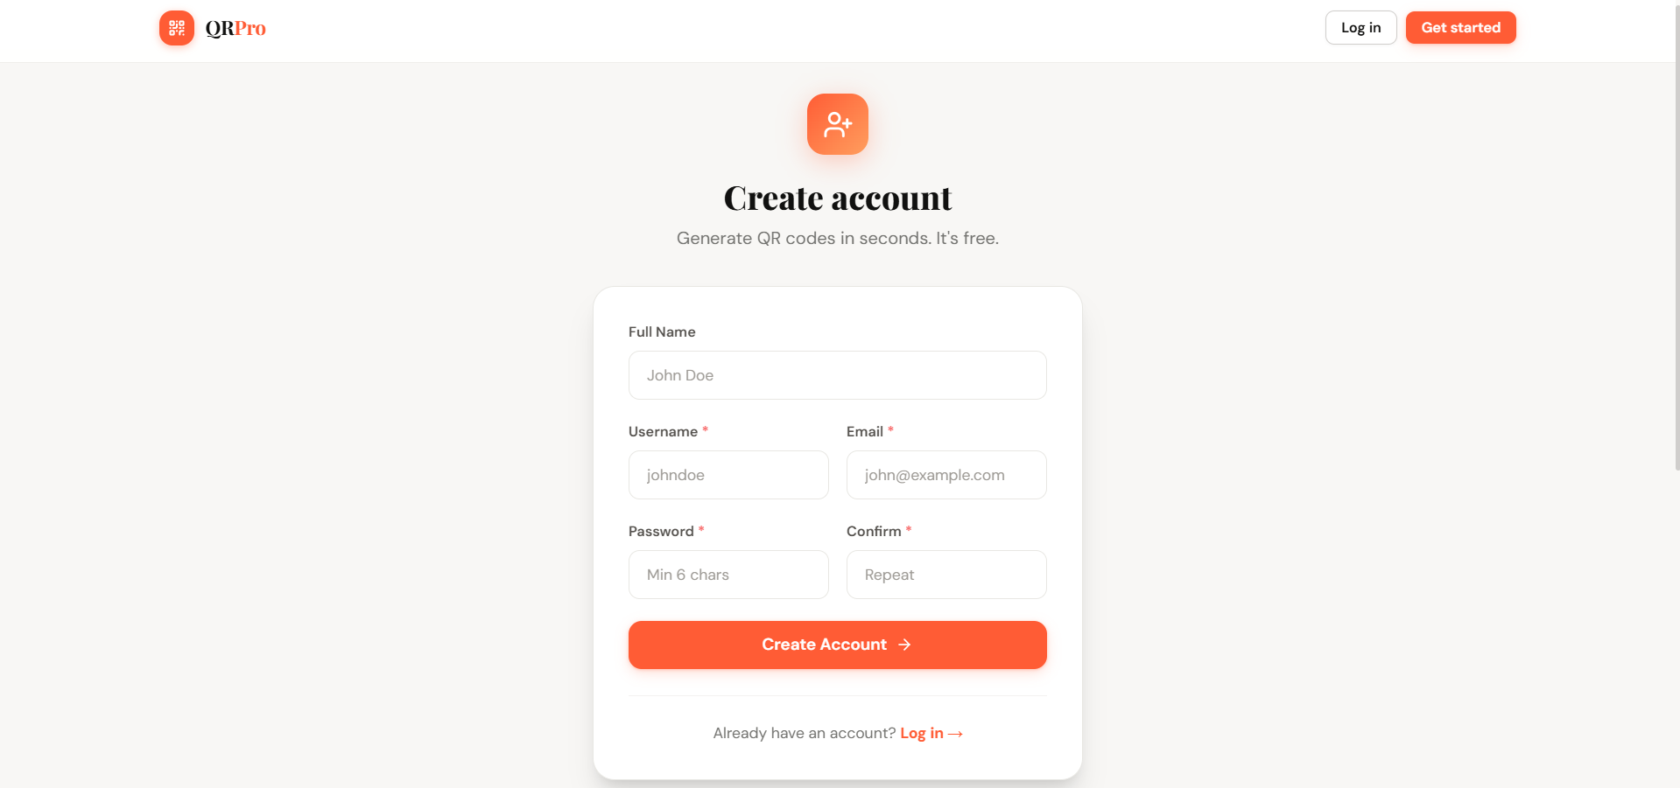
Figure 4: User Registration Page
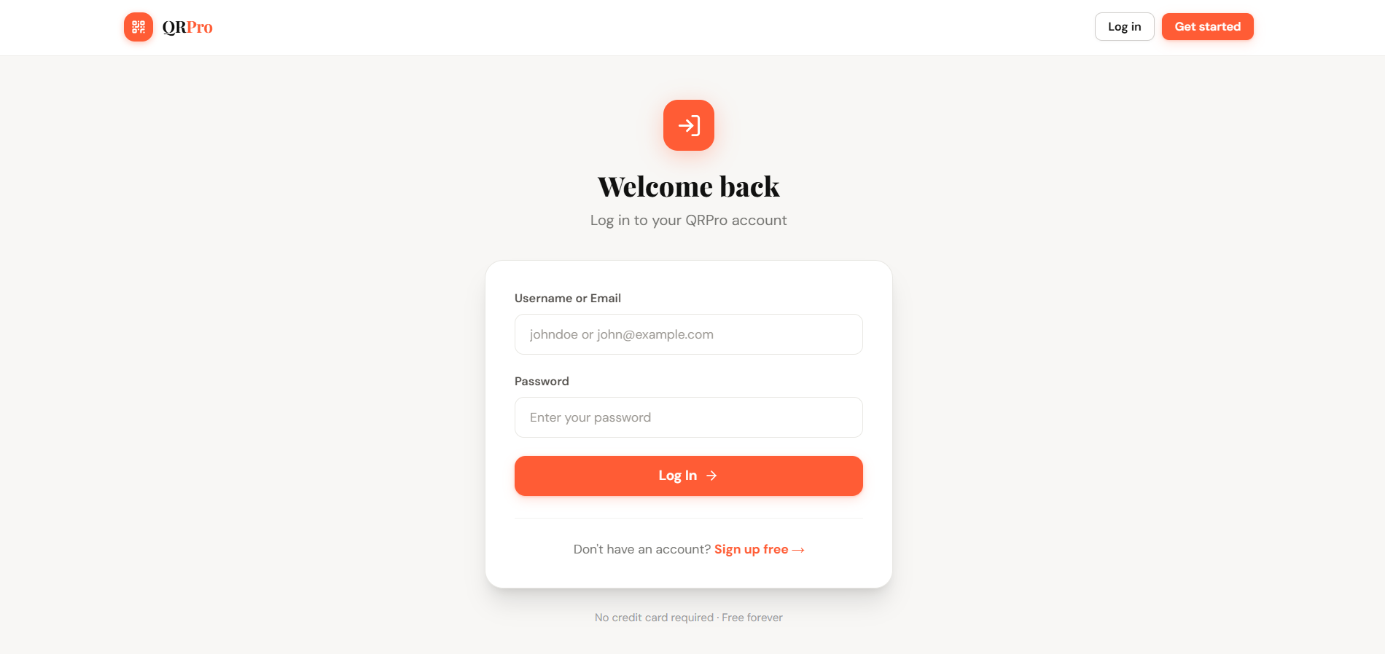
Figure 5: User Login Page
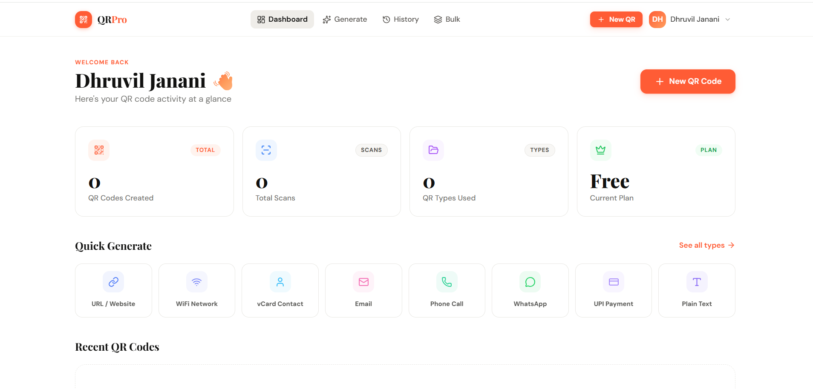
Figure 6: User Dashboard with Statistics
[Insert Screenshot Here]
Figure 7: QR Code Generator Interface - URL Type
[Insert Screenshot Here]
Figure 8: QR Code Generator - WiFi Configuration
[Insert Screenshot Here]
Figure 9: QR Code Generator - vCard Contact
[Insert Screenshot Here]
Figure 10: Real-time QR Code Preview with Customization
[Insert Screenshot Here]
Figure 11: QR Code History Page with Type Filtering
[Insert Screenshot Here]
Figure 12: Bulk QR Code Generator Interface
[Insert Screenshot Here]
Figure 13: CSV Upload for Bulk Generation

Chapter 6
CONCLUSION AND FUTURE SCOPE
6.1 Summary of Achievements
The "QR Code Generation and Management System" (QRCode Pro) project has been successfully designed, developed, and implemented as a comprehensive web-based QR code generation and management system. The project fulfills all stated objectives and demonstrates practical application of software engineering principles in web development.
• Successfully implemented support for 24+ QR code types with correct encoding for each format, including specialized types (WiFi, vCard 3.0, iCalendar, UPI, Bitcoin) that are rarely available in free tools.
• Developed a real-time QR code preview system using client-side QRCode.js rendering, providing instant visual feedback without server round-trips.
• Implemented comprehensive customization options including foreground/background colors, three size presets (256, 512, 1024), and four error correction levels (L, M, Q, H).
• Built a complete user authentication system with bcrypt password hashing, session fixation prevention, and secure logout with cookie expiry.
• Implemented CSRF protection using cryptographically secure tokens (32 bytes via random_bytes()) with timing-safe verification (hash_equals()).
• Created an interactive dashboard with real-time statistics including total codes, scan counts, and type distribution analysis using SQL aggregation.
• Developed a QR code history management system with type-based filtering, pagination (12 per page), and secure deletion with user ownership verification.
• Implemented bulk generation supporting up to 100 QR codes per batch with CSV upload and automatic ZIP archive download via JSZip and FileSaver.js.
• Exposed a RESTful API (POST /api/generate) with proper authentication, type whitelist validation, structured JSON responses, and appropriate HTTP status codes.
• Achieved zero-configuration deployment using SQLite with idempotent schema initialization, automatic directory creation, and WAL mode for concurrent read performance.
• Implemented dual routing support for both Apache (.htaccess with mod_rewrite) and PHP built-in server (router.php), ensuring consistent clean URL behavior across environments.
• Applied defense-in-depth security including prepared statements (SQL injection prevention), output encoding (XSS prevention), directory access control, and input validation.
6.2 Challenges Faced
• Cross-Environment Routing: Implementing consistent clean URL routing across Apache (with .htaccess mod_rewrite) and PHP built-in server (with router.php) required careful path handling and the url() helper function for base path auto-detection. The solution uses a self-executing function in database.php that compares the document root with the application root to determine the correct base path prefix.
• QR Encoding Format Compliance: Each QR code type has a specific encoding format defined by different standards (RFC 6350 for vCard, RFC 5545 for iCalendar, IEEE 802.11 WIFI: format, NPCI UPI specification). Ensuring compliance with each standard while handling edge cases (empty optional fields, special characters, URL encoding) required extensive research and testing.
• Client-Side Bulk Generation Performance: Generating 100 QR codes client-side in rapid succession causes significant CPU utilization. Managing the generation process with progress feedback and preventing browser UI freezes required careful asynchronous programming and progress bar updates between generation cycles.
• SQLite Concurrent Write Limitations: While SQLite with WAL mode handles concurrent reads efficiently, concurrent writes from multiple users can cause SQLITE_BUSY errors. The PDO configuration with exception mode ensures these are properly caught and can be retried, though this limits horizontal scalability.
• Session Management Across Pages: Ensuring consistent session state across all pages while preventing session fixation required careful placement of session_start() calls and session_regenerate_id() after privilege changes (login, registration).
• Security vs. Usability Balance: Implementing CSRF tokens, input validation, and access controls without degrading user experience required thoughtful UX design. For example, flash messages provide user-friendly feedback for server-side validation errors, and the API returns structured JSON error messages.
6.3 Future Enhancements
While QRCode Pro successfully achieves all stated objectives, several enhancements are planned for future iterations to expand its capabilities and address the identified limitations:
• Dynamic QR Codes: Implement dynamic QR codes where the encoded content redirects through a tracking URL that can be updated after printing. This would enable real-time analytics (scan count, geographic distribution, device type, timestamp) and the ability to change the destination URL without reprinting the QR code.
• Logo Watermarking: Add the ability to embed custom logos or images in the center of QR codes, leveraging the H-level error correction (30% recovery capacity) to maintain readability despite the visual overlay. This feature is essential for brand-conscious businesses.
• MySQL/PostgreSQL Migration: Provide an option to use MySQL or PostgreSQL as the database backend for deployments requiring higher write concurrency and horizontal scalability. The existing PDO abstraction layer simplifies this migration.
• OAuth 2.0 Authentication: Integrate social login via Google, GitHub, and Microsoft OAuth 2.0 providers, reducing registration friction and leveraging existing account credentials.
• Team and Organization Support: Add multi-user organization accounts with role-based access control (admin, editor, viewer), shared QR code libraries, and team-level analytics for enterprise use cases.
• Advanced Analytics Dashboard: Implement comprehensive scan analytics including geographic heatmaps, device type distribution (iOS/Android/Desktop), temporal scan patterns (daily/weekly/monthly), and referral source tracking.
• QR Code Templates: Create a template system allowing users to save and reuse customization presets (color combinations, sizes, error correction levels) for consistent branding across multiple QR codes.
• Mobile Application: Develop native Android and iOS mobile applications using React Native or Flutter, providing offline QR generation capability and native camera integration for QR scanning.
• Webhook Integration: Add webhook support to notify external systems when QR codes are scanned, enabling integration with CRM systems, marketing automation platforms, and custom business workflows.
• PDF Report Generation: Implement server-side PDF generation for creating printable sheets of QR codes with labels, suitable for inventory management, event badges, and marketing material production.
In conclusion, QRCode Pro represents a comprehensive, secure, and user-friendly solution for QR code generation and management that addresses significant gaps in the existing landscape. The project demonstrates the practical application of modern web development practices, security principles, and software engineering methodologies. The modular architecture and clean codebase provide a solid foundation for the planned future enhancements, ensuring the system can evolve to meet growing user needs.

REFERENCES

[1] ISO/IEC 18004:2015, "Information technology -- Automatic identification and data capture techniques -- QR Code bar code symbology specification," International Organization for Standardization, Geneva, 2015.
[2] M. Hara, "History of QR Code," Denso Wave Inc., 2014. [Online]. Available: https://www.qrcode.com/en/history/
[3] S. Pandey, R. Kumar, and A. Sharma, "QR Code Applications in Healthcare: A Systematic Review," International Journal of Medical Informatics, vol. 156, pp. 104-118, 2021.
[4] M. Focardi, F. Luccio, and H. Wahsheh, "Securing QR Code-Based Authentication Systems," IEEE Access, vol. 7, pp. 185042-185053, 2019.
[5] T. Tiwari and V. Shivhare, "Performance Analysis of QR Code Error Correction Using Reed-Solomon Codes," in Proc. International Conference on Communication and Signal Processing (ICCSP), 2020, pp. 234-239.
[6] A. Sharma and P. Gupta, "Web-Based QR Code Generator with Custom Styling: Design and Implementation," International Journal of Computer Applications, vol. 180, no. 12, pp. 45-52, 2022.
[7] R. Gupta, S. Verma, and K. Singh, "UPI Payment System Using QR Codes: A Technical Framework," in Proc. International Conference on Digital Finance, 2023, pp. 112-119.
[8] J. Lee and K. Park, "Bulk QR Code Generation for Supply Chain Management: Challenges and Solutions," Journal of Industrial Engineering and Management, vol. 15, no. 3, pp. 567-582, 2022.
[9] PHP Group, "PHP: Hypertext Preprocessor Documentation," 2024. [Online]. Available: https://www.php.net/docs.php
[10] SQLite Consortium, "SQLite Documentation," 2024. [Online]. Available: https://www.sqlite.org/docs.html
[11] A. Tailwind Labs, "Tailwind CSS Documentation," 2024. [Online]. Available: https://tailwindcss.com/docs
[12] D. Shin, "QRCode.js - JavaScript QR Code Generator," GitHub Repository, 2023. [Online]. Available: https://github.com/davidshimjs/qrcodejs
[13] S. Mak, "JSZip - JavaScript ZIP Library," 2024. [Online]. Available: https://stuk.github.io/jszip/
[14] E. Katz, "FileSaver.js - Client-side File Saving," GitHub Repository, 2023. [Online]. Available: https://github.com/eligrey/FileSaver.js
[15] OWASP Foundation, "OWASP Top Ten Web Application Security Risks," 2021. [Online]. Available: https://owasp.org/www-project-top-ten/
[16] NPCI, "Unified Payments Interface (UPI) Specification," National Payments Corporation of India, 2023. [Online]. Available: https://www.npci.org.in/what-we-do/upi/product-overview
[17] IETF, "RFC 6350: vCard Format Specification," Internet Engineering Task Force, 2011. [Online]. Available: https://tools.ietf.org/html/rfc6350
[18] IETF, "RFC 5545: Internet Calendaring and Scheduling (iCalendar)," Internet Engineering Task Force, 2009. [Online]. Available: https://tools.ietf.org/html/rfc5545

APPENDICES
Appendix A: Key Source Code Listings
This appendix contains the key source code files that implement the core functionality of the QRCode Pro application. The complete source code is available in the project repository.
A.1 Complete QR Types Registry (includes/functions.php)
Figure 18: Bulk Generation Progress Bar during ZIP Creation
Code A.1: QR Types Registry
A.2 URL Helper Function (config/database.php)
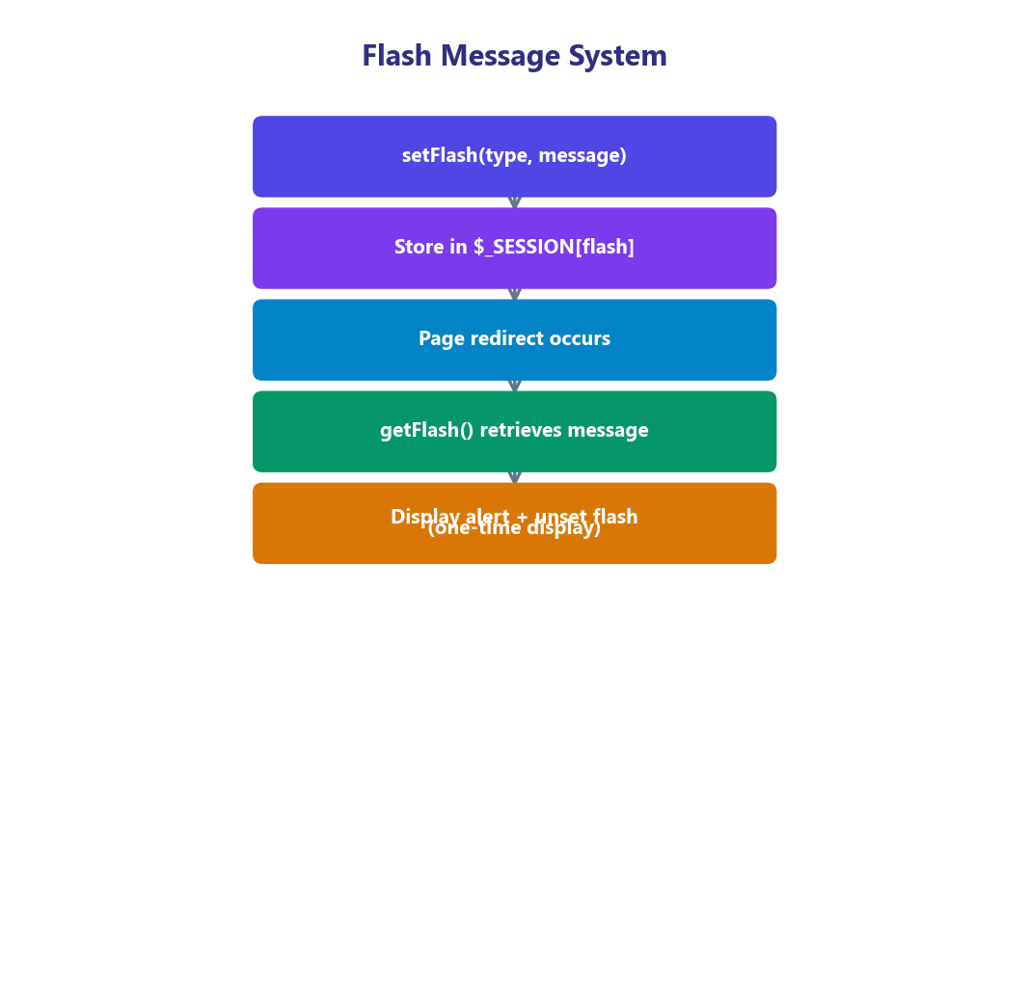
Code A.2: Base Path Auto-Detection and URL Helper
A.3 Flash Message System (includes/functions.php)
