Game Design Document

Fill up the following document

1. Write the title of your project.

THE MOON PROJECT

1. What is the goal of the game?

TO DEFEAT THE ALIENS AND SHOW THAT WE CAN WIN OVER ALIENS TOO

1. Write a brief story of your game.

My game ‘s story revolves around the people on the earth going to

The moon to defeat the people of the moon and as they do they unlock many moves to defeat the villan or boss and as they do their difficulty increases

1. Which are the playing characters of this game?

* Playing characters are the ones who respond to the user based on the input from the user.
* Cars, monkeys, dinos, wizards, etc., are the playing characters in the game.

|  |  |  |
| --- | --- | --- |
| Number | Character Name | What can this character do? |
| 1 | NARUTO | HE CAN FIGHT AND UNLOCK NOW MOVES |
| 2 | SOLDIER S | FIGHT FROM BEHIND |
| 3 |  |  |
| 4 |  |  |
| 5 |  |  |
| 6 |  |  |
| 7 |  |  |
| 8 |  |  |

1. Which are the Non-Playing Characters of this game?

* Non-Playing characters are the ones that don't have an action or behavior when the user interacts with the game.
* Hurdles, stones, bananas, coins, etc., are non-playing characters in the game.

|  |  |  |
| --- | --- | --- |
| Number | Character Name | What can this character do? |
| 1 | LEVEL 1 MONSTER | FIGHT THE MAIN CHARACTER |
| 2 | LEVEL 2 MONSTER | FIGHT THE MAIN CHARACTER |
| 3 | LEVEL 3 MONSTER | FIGHT THE MAIN CHARACTER |
| 4 | LEVEL 4 MONSTER | FIGHT THE MAIN CHARACTER |
| 5 | BOSS | IT IS VERY DIFFICULT TO DEFEAT HIM |
| 6 |  |  |
| 7 |  |  |
| 8 |  |  |

Draw your imagination of this game. What does this game look like?

* Draw the game either on your computer or on paper.
* Add images of the game scenes to show each of the playing and non-playing characters at least once.



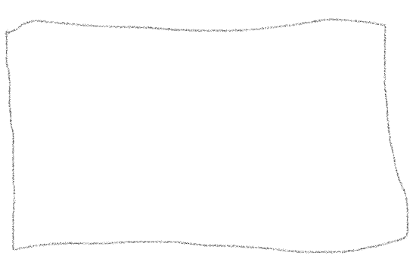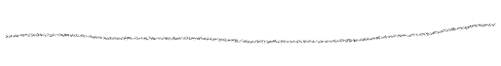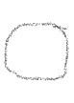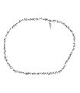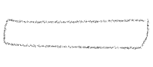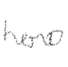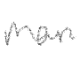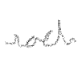

How do you plan to make your game engaging?

I plan to make it engaging by increasing the health of my villans and the hero but the villan will have a great more heath than the hero and every level the character will have more moves