Project 2

Name: Aadish Joshi

ID: asj170430

Question 1:

Write an OpenCV program that can detect a winking face. You may want to build your program

by changing the example program DetectWink.py.

Explanation:

Created detect method using fame:

*Boolean DetectWink (Frame, Location, ROI)*

*Return True : if wink is detected*

*Else False*

Screenshots:

On old images: 19 detections, 7 non-detections.

One new Images: 19 detections, 15 non-detections.

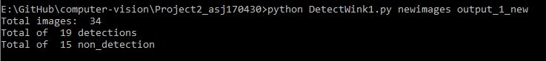



Question 2

The requirements for the second program are the same as the requirements for the _rst program,

except that it must start by applying a _lter to the image. The _lter can be histogram equalization,

smoothing, or anything else that you may consider to be useful.

Created a filter method to add filter using key.

*def filter(frame, key):*

*if key == 1:*

*gray_frame = cv2.equalizeHist(gray_frame)*

*elif key == 2:*

*gray_frame = cv2.GaussianBlur(dummy_frame, (3, 3), 0)*

*elif key == 3:*

*gray_frame = cv2.equalizeHist(gray_frame)*

*gray_frame = cv2.medianBlur(gray_frame, 5)*

*return gray_frame*

Results:

For old images: 20 detections, 8 non-detections

For new images: 22 detections. 12 non-detections

