SVKM's NMIMS
Mukesh Patel School of Technology Management & Engineering
A.Y. 2025 – 26

Course: Database Management Systems
Project Report
Program |  | B.Tech (Computer Engineering)
Semester |  | IV
Name of the Project: |  | E-Commerce Database Management System
Details of Project Members
Batch: B2 | Roll No. | Name
 | L048 | Aadit Rangnekar
 | L077 | Anirudh Rajgopal
Date of Submission: |  | April 2026

Contribution of Each Project Member
Roll No. | Name | Contribution
L048 | Aadit Rangnekar | Database schema design, SQL queries + code, backend API (Flask)
L077 | Anirudh Rajgopal | ER diagram, normalization, analytics module, testing

GitHub Link of Project: https://github.com/aadit19R/DBMS-project.git

Table of Contents
Sr. No. | Topic | Page No.
1 | Problem Statement | 3
2 | Components of Database Design | 3
3 | Entity Relationship Diagram | 5
4 | Relational Model | 6
5 | Normalization | 6
6 | SQL Queries | 7
7 | Project Demonstration | 13
8 | Self-Learning Beyond Classroom | 19
9 | Learning from the Project | 19
10 | Challenges Faced | 20
11 | Conclusion | 21

I. Problem Statement
The rapid growth of online retail has created a pressing need for robust, scalable, and well-structured database systems that can support the end-to-end operations of an e-commerce platform. Traditional spreadsheet-based or ad hoc approaches are insufficient to manage the complex relationships between products, suppliers, customers, orders, and inventory across multiple warehouse locations.
This project aims to design and implement a fully functional relational database for an E-Commerce platform. The system must support two distinct user roles: a regular customer who can browse products, add items to a shopping cart, place orders, and track order history; and an administrator who can manage inventory, process and update order statuses, view customer records, and gain business insights through analytics.
The core requirements of the system are as follows. The platform must maintain a product catalogue organised by category, with each product linked to a supplier and tracked across one or more warehouses. Customers must be able to register and log in securely, after which they can place orders that atomically deduct stock from warehouse inventory to prevent overselling. Each order may contain multiple line items, and the system must accurately track the quantity and unit price at the time of purchase. The administrator must be able to update order statuses (pending, shipped, delivered, or cancelled), remove or reduce order items with automatic inventory restock, and run custom SQL queries against the live database. In addition, an analytics dashboard must surface key performance indicators such as total revenue, average order value, best-selling products, low-stock alerts, and sales trends over time.
The database is implemented in MySQL, with a Python Flask backend exposing a RESTful API secured by JSON Web Tokens (JWT). A browser-based frontend built with HTML, Tailwind CSS, and Chart.js consumes these APIs, providing a single-page interface for both customers and administrators.

II. Components of Database Design
Entities and Their Attributes
1. Suppliers — Stores information about product vendors. Primary Key: supplier_id (INT, AUTO_INCREMENT). Attributes: name (VARCHAR 100), email (VARCHAR 100, UNIQUE), phone (VARCHAR 20), address (TEXT).
2. Products — Represents items available for sale on the platform. Primary Key: product_id (INT, AUTO_INCREMENT). Attributes: name (VARCHAR 150), price (DECIMAL 10,2), category (VARCHAR 50), supplier_id (FK → suppliers).
3. Customers — Holds personal and contact information for registered shoppers. Primary Key: customer_id (INT, AUTO_INCREMENT). Attributes: name (VARCHAR 100), email (VARCHAR 100, UNIQUE), phone (VARCHAR 20), address (TEXT).
4. Orders — Records each purchase transaction made by a customer. Primary Key: order_id (INT, AUTO_INCREMENT). Attributes: customer_id (FK → customers), order_date (DATE), status (ENUM: pending/shipped/delivered/cancelled), total_amount (DECIMAL 10,2).
5. Order_Items — Represents individual line items within an order. Primary Key: order_item_id (INT, AUTO_INCREMENT). Attributes: order_id (FK → orders), product_id (FK → products), quantity (INT), unit_price (DECIMAL 10,2). A UNIQUE constraint is placed on (order_id, product_id) to prevent duplicate entries for the same product within a single order.
6. Warehouses — Stores details of physical storage locations. Primary Key: warehouse_id (INT, AUTO_INCREMENT). Attributes: name (VARCHAR 100), location (VARCHAR 150), capacity (INT).
7. Warehouse_Inventory — Tracks the quantity of each product stored at each warehouse. Primary Key: inventory_id (INT, AUTO_INCREMENT). Attributes: warehouse_id (FK → warehouses), product_id (FK → products), quantity_stored (INT, DEFAULT 0). A UNIQUE constraint on (warehouse_id, product_id) ensures no duplicate inventory rows for the same product-warehouse pair.
8. Users — Manages authentication credentials for both customers and administrators. Primary Key: user_id (INT, AUTO_INCREMENT). Attributes: username (VARCHAR 50, UNIQUE), email (VARCHAR 100, UNIQUE), password_hash (VARCHAR 255), role (ENUM: admin/user), customer_id (FK → customers, nullable for admin accounts).

Relationships Among Entities
Suppliers – Products (One-to-Many): One supplier can supply many products, but each product is sourced from exactly one supplier. This is enforced by the foreign key fk_product_supplier on products.supplier_id. The participation of Products is total (each product must have a supplier); the participation of Suppliers is partial.
Customers – Orders (One-to-Many): One customer can place many orders, but each order belongs to exactly one customer. Enforced via fk_order_customer on orders.customer_id. Customer participation is partial; Order participation is total.
Orders – Order_Items (One-to-Many): A single order can have multiple line items. Enforced via fk_oi_order on order_items.order_id. Both participate totally.
Products – Order_Items (One-to-Many): A product can appear in many order line items across different orders. Enforced via fk_oi_product on order_items.product_id. Participation of Order_Items is total.
Warehouses – Warehouse_Inventory (One-to-Many): One warehouse holds inventory records for many products. Enforced via fk_wi_warehouse.
Products – Warehouse_Inventory (One-to-Many): A product can be stocked in multiple warehouses. Enforced via fk_wi_product. Together, Warehouses and Products form a composite key in Warehouse_Inventory, making this effectively a many-to-many relationship resolved by the junction table.
Users – Customers (One-to-One, optional): A regular user account is linked to a customer profile via customer_id. Admin accounts have a NULL customer_id, making this participation partial on both sides.

III. Entity Relationship Diagram
The Entity-Relationship (ER) diagram below illustrates the logical structure of the database, including all eight entities, their attributes, primary keys, and the cardinality of relationships between them. Single lines indicate partial participation and double lines indicate total participation. The diagram was produced using standard ER notation.
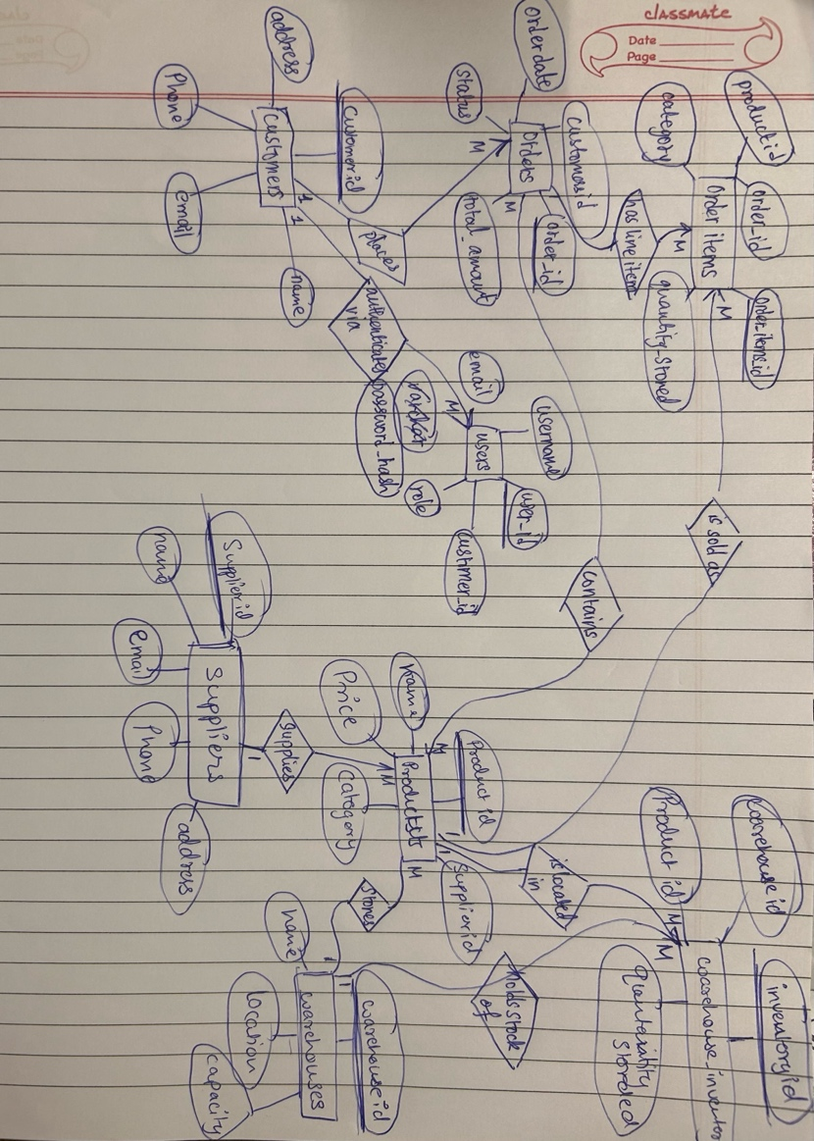
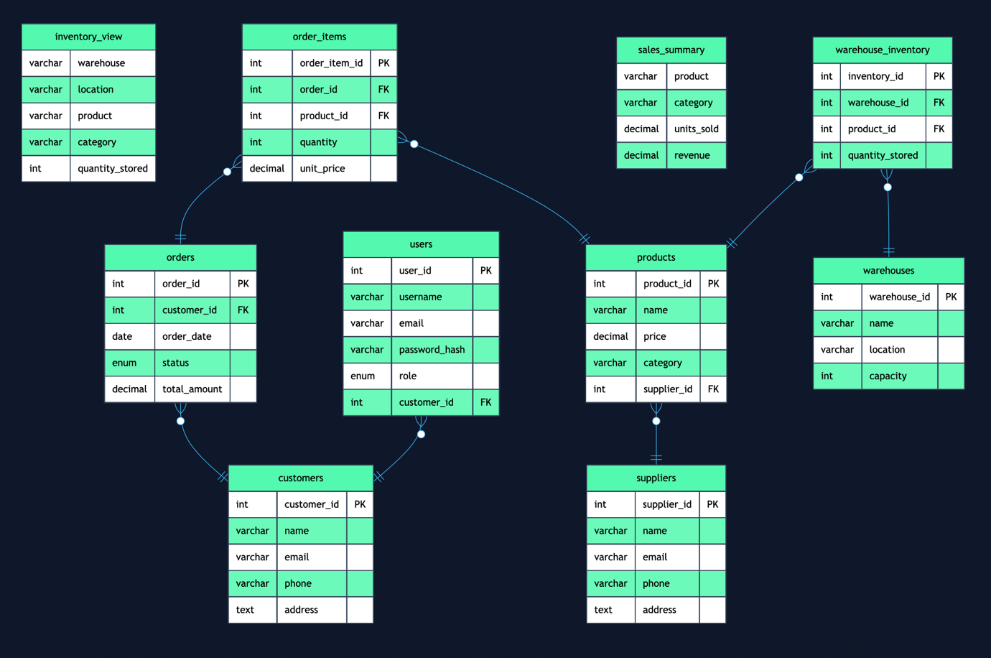
The diagram clearly shows that Order_Items acts as a junction entity resolving the many-to-many relationship between Orders and Products, while Warehouse_Inventory resolves the many-to-many relationship between Warehouses and Products. The Users entity sits alongside Customers as an authentication layer, linked by a one-to-one optional association.

IV. Relational Model
The ER diagram was converted into the following relational schema. Primary keys are underlined and foreign keys are denoted with an asterisk (*).
Suppliers (supplier_id, name, email, phone, address)
Products (product_id, name, price, category, supplier_id*)
Customers (customer_id, name, email, phone, address)
Orders (order_id, customer_id*, order_date, status, total_amount)
Order_Items (order_item_id, order_id*, product_id*, quantity, unit_price) — UNIQUE(order_id, product_id)
Warehouses (warehouse_id, name, location, capacity)
Warehouse_Inventory (inventory_id, warehouse_id*, product_id*, quantity_stored) — UNIQUE(warehouse_id, product_id)
Users (user_id, username, email, password_hash, role, customer_id*)

Database Views
sales_summary — A virtual view that aggregates total units sold and revenue per product by joining order_items with products. Columns: product, category, units_sold, revenue.
inventory_view — A virtual view that maps each product to its warehouse location and current stock quantity by joining warehouse_inventory with warehouses and products. Columns: warehouse, location, product, category, quantity_stored.

V. Normalization
Normalization was applied to the database to eliminate redundancy and ensure data integrity. Each of the eight relations is evaluated below.
First Normal Form (1NF)
A relation is in 1NF if all attributes contain only atomic (indivisible) values and each column holds values of a single type. All eight tables satisfy 1NF: every column stores a single atomic value, there are no repeating groups, and each row is uniquely identified by its primary key. For example, a customer's address is stored as a single TEXT field; no multi-valued or composite attributes exist.
Second Normal Form (2NF)
A relation is in 2NF if it is in 1NF and every non-key attribute is fully functionally dependent on the entire primary key (relevant only for composite keys). The only tables with a meaningful composite candidate key are Order_Items and Warehouse_Inventory, both of which use a surrogate integer primary key (order_item_id and inventory_id respectively). However, examining the business keys:
Order_Items — Candidate key: (order_id, product_id). Non-key attributes quantity and unit_price are dependent on the full composite key, not just order_id or product_id alone. Therefore it is in 2NF.
Warehouse_Inventory — Candidate key: (warehouse_id, product_id). Non-key attribute quantity_stored depends on both warehouse and product together, not on either alone. Therefore it is in 2NF.
All remaining tables have simple single-column primary keys, so the 2NF condition is satisfied trivially for them.
Third Normal Form (3NF)
A relation is in 3NF if it is in 2NF and no non-key attribute is transitively dependent on the primary key through another non-key attribute. The following analysis demonstrates that each table satisfies 3NF:
Products — price and category depend directly on product_id. supplier_id is a foreign key, not a derivable non-key attribute. No transitive dependency exists.
Orders — total_amount is stored as a derived value for performance, but it is functionally determined at order creation time and updated transactionally. status, order_date, and customer_id all depend directly on order_id.
Users — All attributes (username, email, password_hash, role, customer_id) depend directly on user_id. There is no chain X → Y → Z where Y is a non-key.
All eight relations are verified to be in Third Normal Form. Boyce-Codd Normal Form (BCNF) is also satisfied for all tables, as no non-trivial functional dependency exists in which the determinant is not a candidate key.

VI. SQL Queries
The database was implemented using MySQL. The following section presents twenty-two SQL queries that demonstrate the breadth of concepts covered in the course. Each entry states the objective, provides the SQL code, and notes the concept illustrated. Output snapshots are to be pasted alongside each query.
Query 1 — Retrieve the Full Product Catalogue (Basic SELECT with JOIN)
Objective: Display all products along with their supplier name and total stock aggregated across all warehouses.
SELECT p.product_id, p.name, p.price, p.category, s.name AS supplier, IFNULL(SUM(wi.quantity_stored), 0) AS total_stock FROM products p JOIN suppliers s ON p.supplier_id = s.supplier_id LEFT JOIN warehouse_inventory wi ON p.product_id = wi.product_id GROUP BY p.product_id, p.name, p.price, p.category, s.name ORDER BY p.product_id;
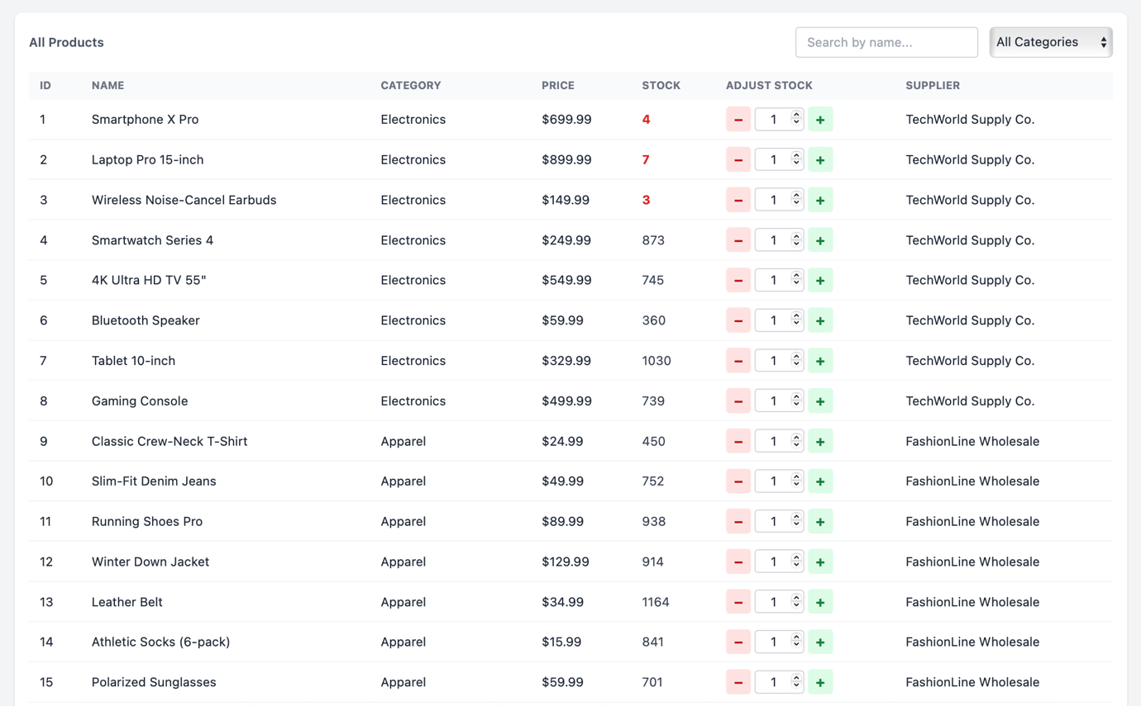

Query 2 — List All Orders with Customer Name and Item Count (JOIN + GROUP BY)
Objective: Show each order together with the customer's name, date, status, total amount, and the number of distinct items ordered.
SELECT o.order_id, c.name AS customer, o.order_date, o.status, o.total_amount, COUNT(oi.order_item_id) AS item_count FROM orders o JOIN customers c ON o.customer_id = c.customer_id JOIN order_items oi ON o.order_id = oi.order_id GROUP BY o.order_id, c.name, o.order_date, o.status, o.total_amount ORDER BY o.order_date DESC;
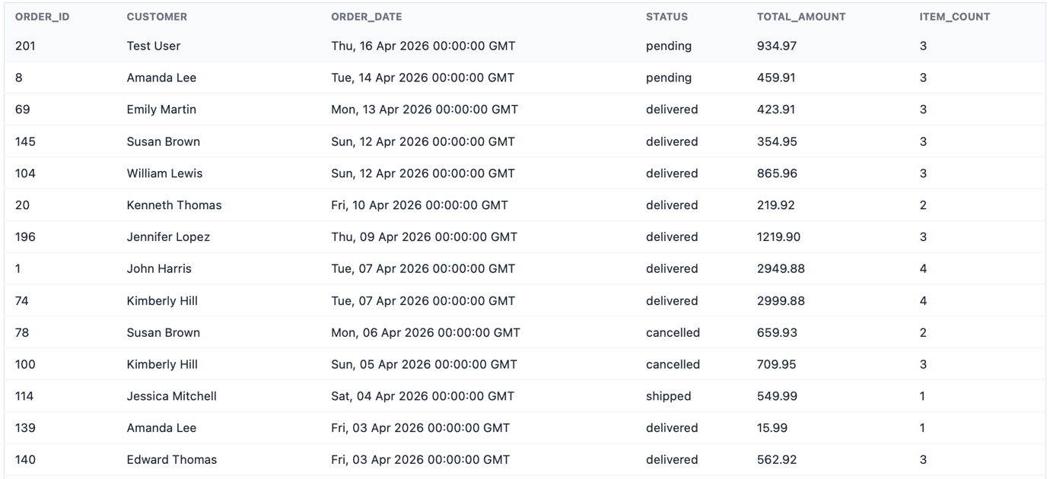
Query 3 — Top 5 Best-Selling Products by Revenue (Aggregate + ORDER BY + LIMIT)
Objective: Identify which products generate the most revenue by summing quantity × unit_price across all delivered or shipped orders.
SELECT p.name, SUM(oi.quantity) AS total_qty, SUM(oi.quantity * oi.unit_price) AS revenue FROM order_items oi JOIN products p ON oi.product_id = p.product_id GROUP BY p.product_id, p.name ORDER BY revenue DESC LIMIT 5;
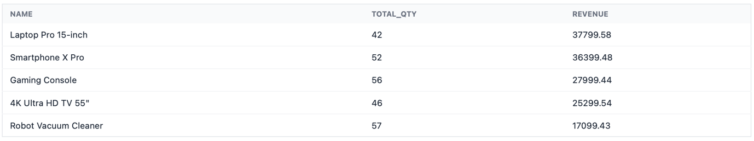
Query 4 — Monthly Revenue Trend (DATE_FORMAT + GROUP BY)
Objective: Show month-wise total revenue and average order value, excluding cancelled orders.
SELECT DATE_FORMAT(order_date, '%Y-%m') AS month, SUM(total_amount) AS revenue, AVG(total_amount) AS avg_order_value FROM orders WHERE status != 'cancelled' GROUP BY month ORDER BY month;
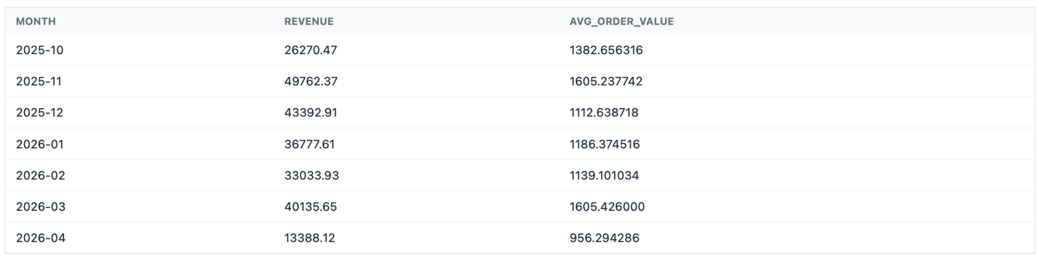

Query 5 — Products with Low Total Stock (HAVING with Aggregate)
Objective: Flag products whose combined stock across all warehouses falls below 10 units.
SELECT p.name, SUM(wi.quantity_stored) AS total_stock FROM warehouse_inventory wi JOIN products p ON wi.product_id = p.product_id GROUP BY p.product_id, p.name HAVING SUM(wi.quantity_stored) < 10 ORDER BY total_stock ASC;
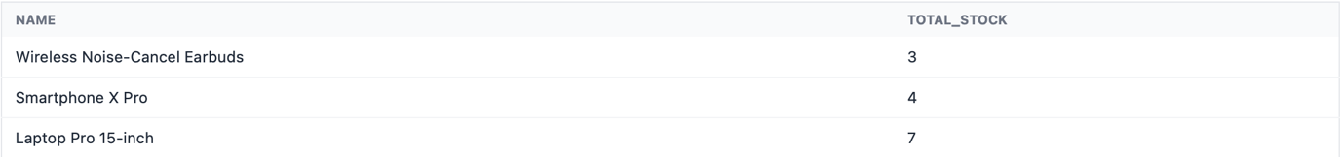

Query 6 — High-Value Customers (Subquery in HAVING)
Objective: List customers whose total lifetime spend exceeds the overall average order value.
SELECT c.name, COUNT(o.order_id) AS total_orders, SUM(o.total_amount) AS total_spent FROM customers c JOIN orders o ON c.customer_id = o.customer_id GROUP BY c.customer_id, c.name HAVING SUM(o.total_amount) > (SELECT AVG(total_amount) FROM orders) ORDER BY total_spent DESC;
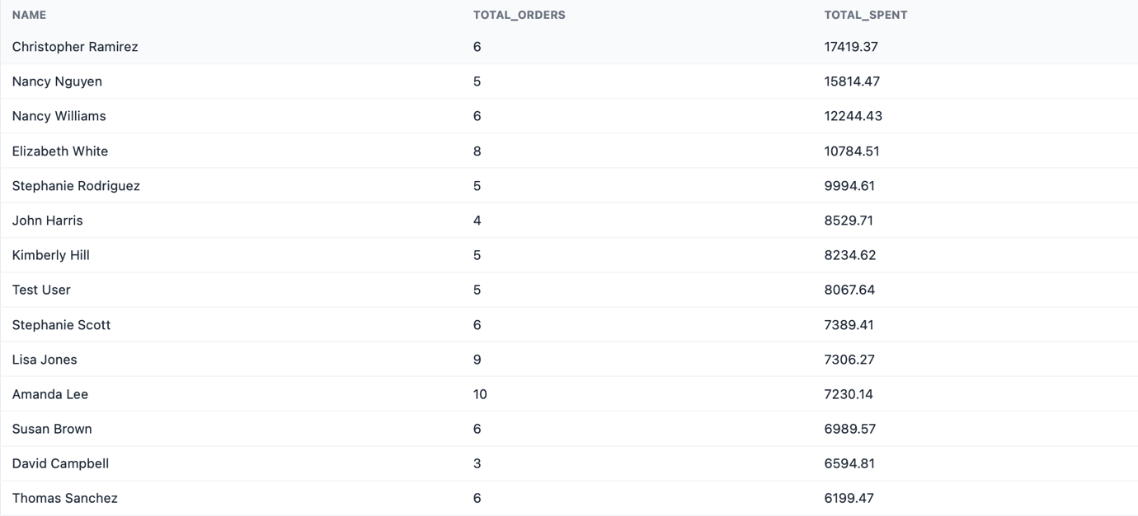

Query 7 — All Pending Orders Sorted by Date (WHERE + ORDER BY)
Objective: Retrieve all pending orders to serve as a priority queue for the admin dashboard.
SELECT order_id, customer_id, DATE_FORMAT(order_date, '%Y-%m-%d') AS order_date, total_amount FROM orders WHERE status = 'pending' ORDER BY order_date ASC LIMIT 5;
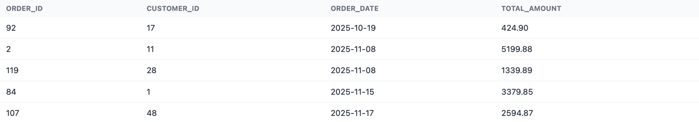

Query 8 — Revenue Breakdown by Product Category (GROUP BY + JOIN)
Objective: Determine which product categories contribute the most to overall revenue.
SELECT p.category, SUM(oi.quantity * oi.unit_price) AS category_revenue FROM orders o JOIN order_items oi ON o.order_id = oi.order_id JOIN products p ON oi.product_id = p.product_id WHERE o.status != 'cancelled' GROUP BY p.category ORDER BY category_revenue DESC;
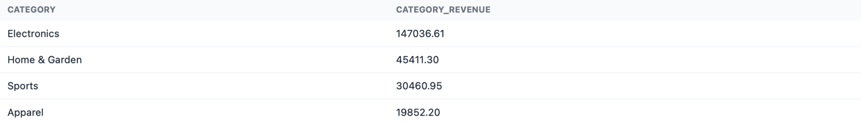

Query 9 — Inventory View Across All Warehouses (Multi-Table JOIN)
Objective: Display a cross-reference of every product's stock level at each warehouse location.
SELECT w.name AS warehouse, w.location, p.name AS product, p.category, wi.quantity_stored FROM warehouse_inventory wi JOIN warehouses w ON wi.warehouse_id = w.warehouse_id JOIN products p ON wi.product_id = p.product_id ORDER BY w.name, p.name;
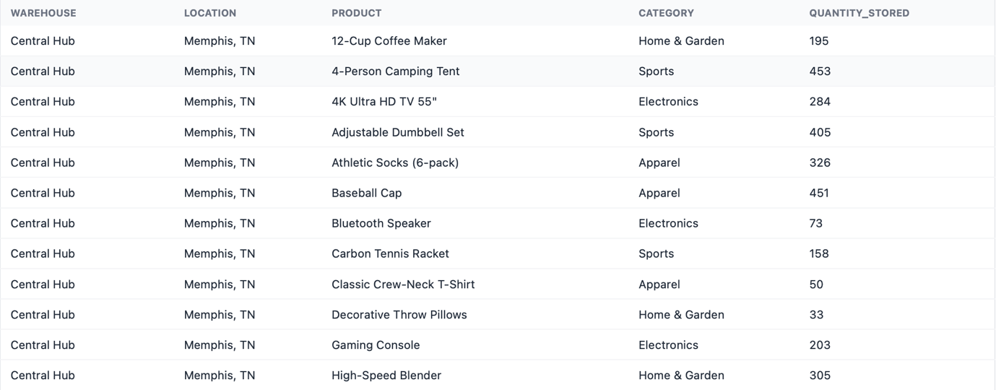

Query 10 — Sales by Day of the Week (DAYNAME + GROUP BY)
Objective: Identify which days of the week see the highest order volume.
SELECT DAYNAME(order_date) AS day_name, COUNT(*) AS order_count FROM orders WHERE status != 'cancelled' GROUP BY day_name ORDER BY FIELD(day_name,'Sunday','Monday','Tuesday', 'Wednesday','Thursday','Friday','Saturday');
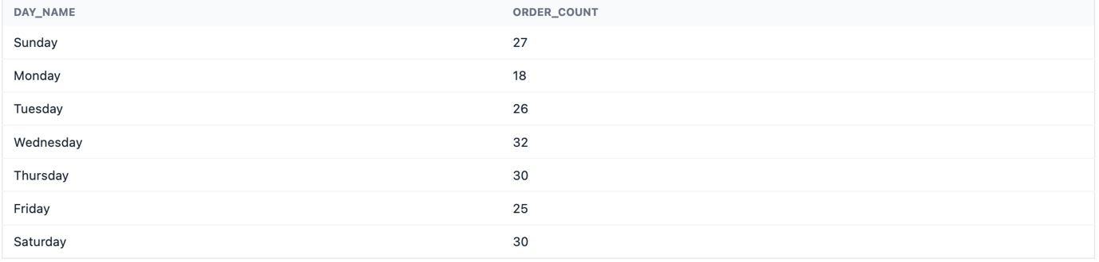

Query 11 — Inventory Velocity: Sales Rate vs Stock (Derived Column)
Objective: Calculate how fast each product is selling relative to its current warehouse stock.
SELECT p.name, SUM(oi.quantity) AS units_sold, MAX(wi.quantity_stored) AS current_stock, ROUND(SUM(oi.quantity) / MAX(wi.quantity_stored), 4) AS velocity FROM order_items oi JOIN orders o ON oi.order_id = o.order_id JOIN products p ON oi.product_id = p.product_id LEFT JOIN warehouse_inventory wi ON p.product_id = wi.product_id WHERE o.status != 'cancelled' GROUP BY p.product_id, p.name HAVING MAX(wi.quantity_stored) > 0 ORDER BY velocity DESC LIMIT 5;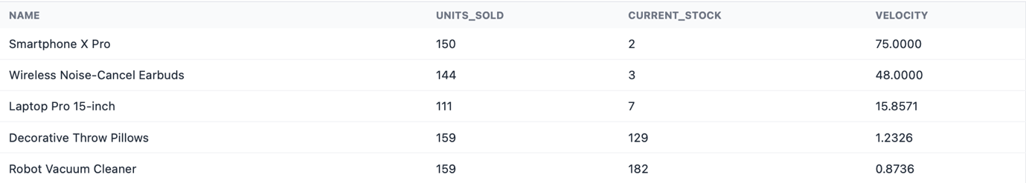

Query 12 — Find Customers Who Have Never Placed an Order (NOT EXISTS)
Objective: Identify registered customers who have not yet made a purchase.
SELECT customer_id, name, email FROM customers c WHERE NOT EXISTS ( SELECT 1 FROM orders o WHERE o.customer_id = c.customer_id );

VII. Project Demonstration
The following section describes each feature of the E-Commerce Database Management System as implemented in the browser-based frontend. Screenshots are to be inserted beneath each description.
Tools / Software / Libraries Used
Backend: Python 3, Flask (web framework), Flask-JWT-Extended (JWT authentication), mysql-connector-python (MySQL driver), Werkzeug (password hashing), itsdangerous (password-reset tokens).
Database: MySQL 8.
Frontend: HTML5, Tailwind CSS (utility-first styling via CDN), Chart.js (bar, line, pie, and radar charts), Mermaid.js (ER diagram rendering), svg-pan-zoom (interactive diagram navigation).

Feature 1 — Login Page
The application opens with a clean login screen that prompts the user for a username and password. On successful authentication the Flask backend issues a signed JWT containing the user's role (admin or user) and an optional customer_id. This token is stored in memory by the frontend and attached as a Bearer header to every subsequent API request, ensuring that all protected routes remain inaccessible without a valid session. A 'Forgot Password' link is also available that initiates a time-limited password-reset flow via a token generated with itsdangerous.
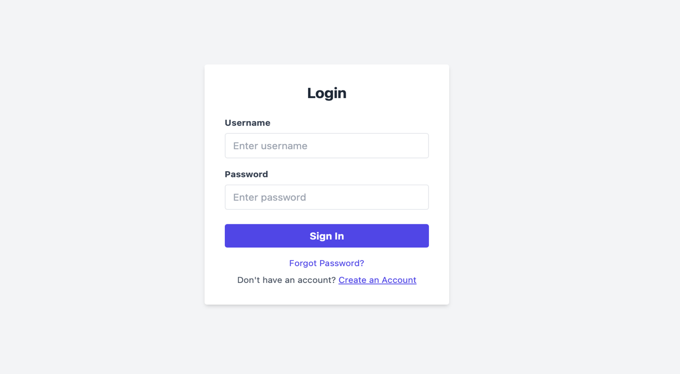

Feature 2 — Registration Page
New users can register by providing a name, email address, username, and password. The backend validates that neither the username nor the email is already taken, then atomically creates a customer profile record and an associated user account. The password is hashed using Werkzeug's scrypt implementation before storage, ensuring that plain-text credentials are never persisted in the database.
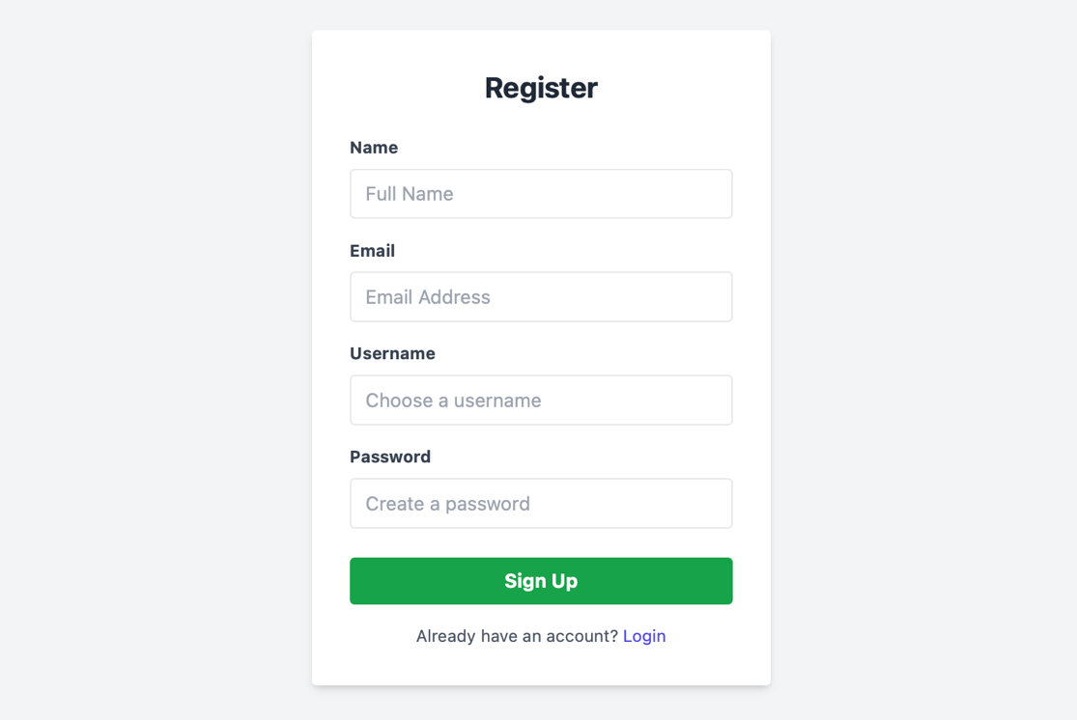
Feature 3 — Product Storefront (Customer View)
After logging in as a regular user, the customer is presented with the product storefront. This page fetches the full product catalogue from the /products endpoint, which performs a JOIN across products, suppliers, and warehouse_inventory to display each item's name, category, price, supplier, and live stock level. Products with zero stock are visually flagged. The customer can click 'Add to Cart' on any available item, and the cart icon in the navigation bar updates to reflect the running item count.
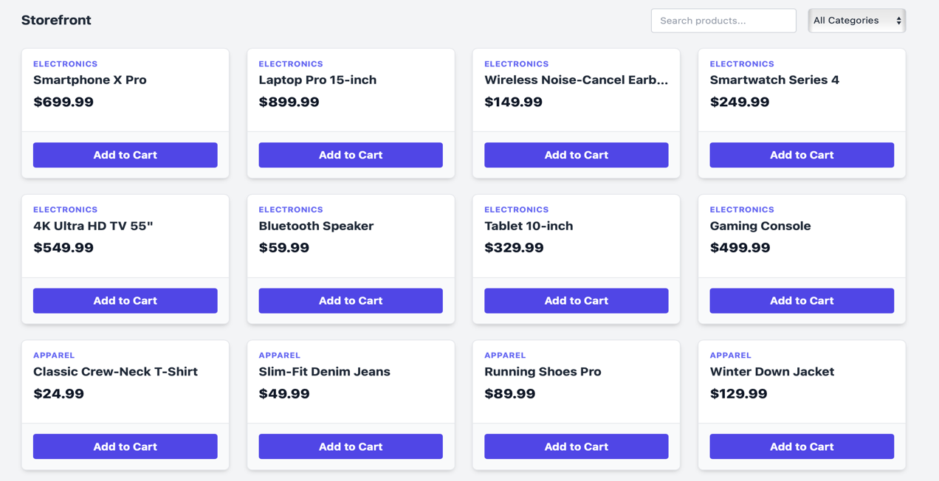

Feature 4 — Shopping Cart and Checkout
The shopping cart panel lists all items the customer has selected, showing the product name, quantity, unit price, and line total. The customer can adjust quantities or remove items before proceeding to checkout. When the customer confirms the order, the frontend calls the /checkout endpoint, which opens a database transaction, atomically deducts the required quantity from warehouse_inventory for each item using a conditional UPDATE that fails if stock is insufficient, inserts an order record, inserts the corresponding order_items rows, and then commits. Any stock shortfall causes the entire transaction to roll back, preventing partial orders.
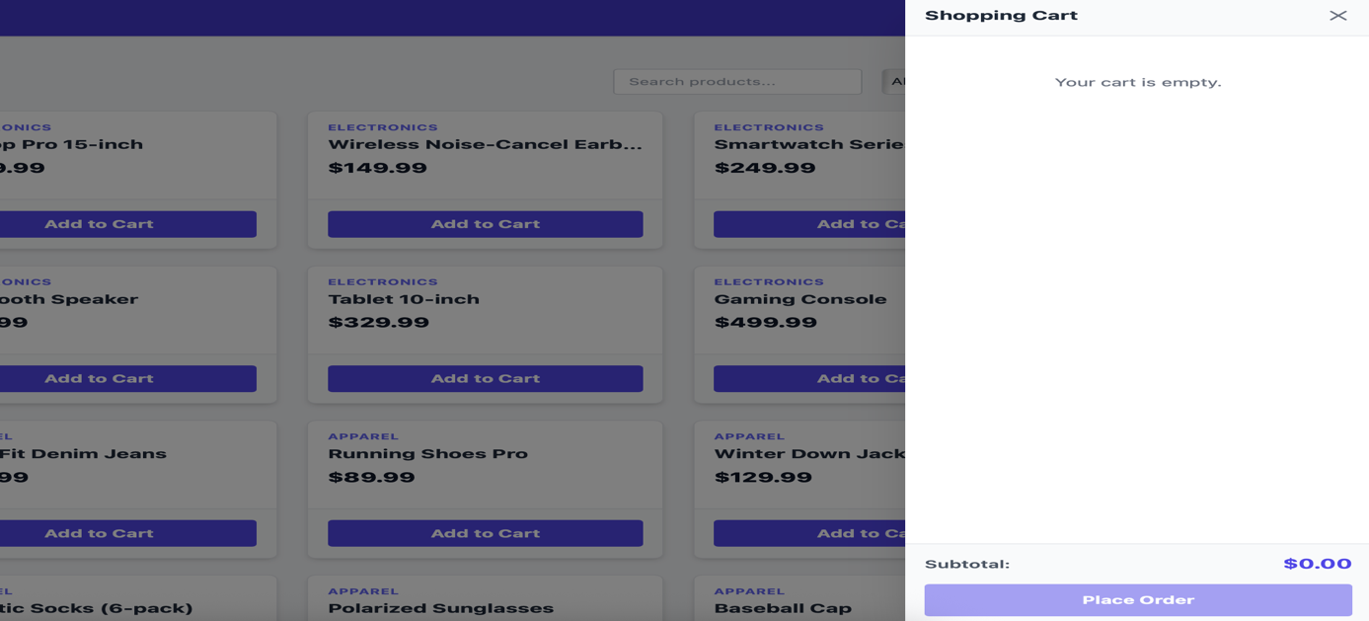
Feature 5 — My Orders (Customer Order History)
The 'My Orders' section displays the authenticated customer's complete order history, fetched from the /my-orders endpoint. Each order card shows the order ID, date, current status (pending, shipped, delivered, or cancelled), and total amount. Expanding an order reveals the individual line items with product names, quantities, and unit prices. The data is retrieved by first fetching all orders for the logged-in customer, then performing a second query to fetch all associated order_items in a single IN-clause lookup, which are then joined client-side for display.
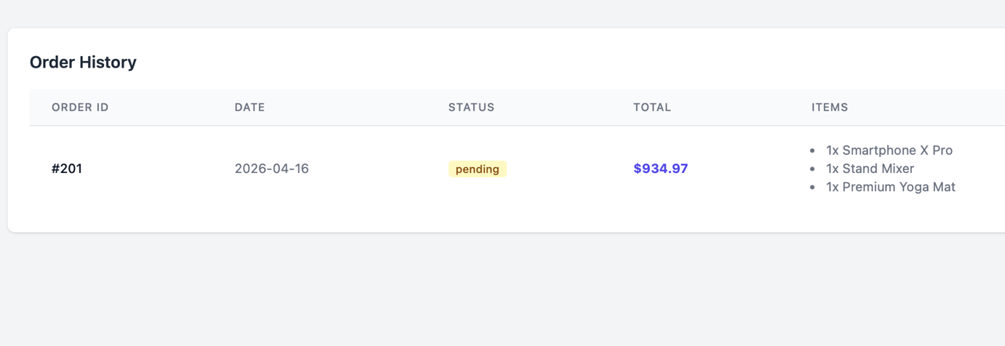

Feature 6 — Admin Dashboard Overview
The admin dashboard landing page presents a high-level summary of business performance. Four KPI cards display total orders, total sales revenue, number of active customers, and total products in the catalogue — all computed from a single query using scalar subqueries. Below the KPIs, a table lists the top five best-selling products by units sold, a low-stock alert table highlights products whose aggregate warehouse stock has dropped below the threshold, and a pending orders table shows the five oldest unprocessed orders sorted by ascending date.
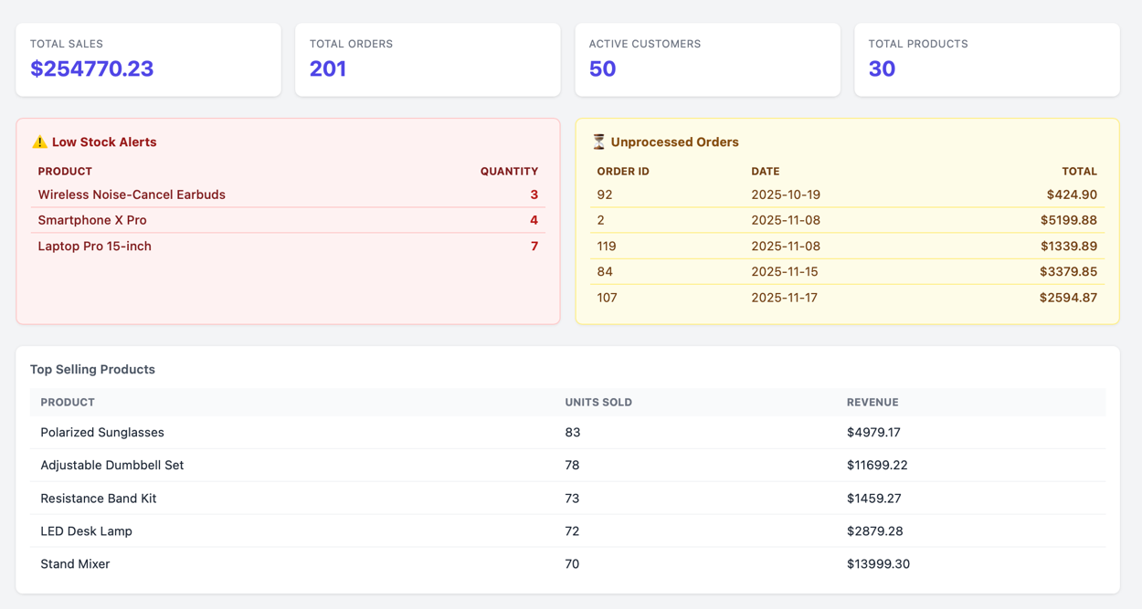
Feature 7 — Admin Analytics (Charts and KPI Trends)
The analytics tab provides date-filterable visual reporting rendered with Chart.js. A line chart plots month-wise revenue and average order value over the selected period. A doughnut chart shows the revenue split by product category. A radar chart visualises inventory velocity (the ratio of units sold to current stock) for the top five products, providing a quick view of which items are selling fastest relative to their availability. A bar chart breaks down order volume by day of the week. When a date range is selected, trend badges appear next to the KPI values, showing the percentage change compared to the equivalent preceding period.
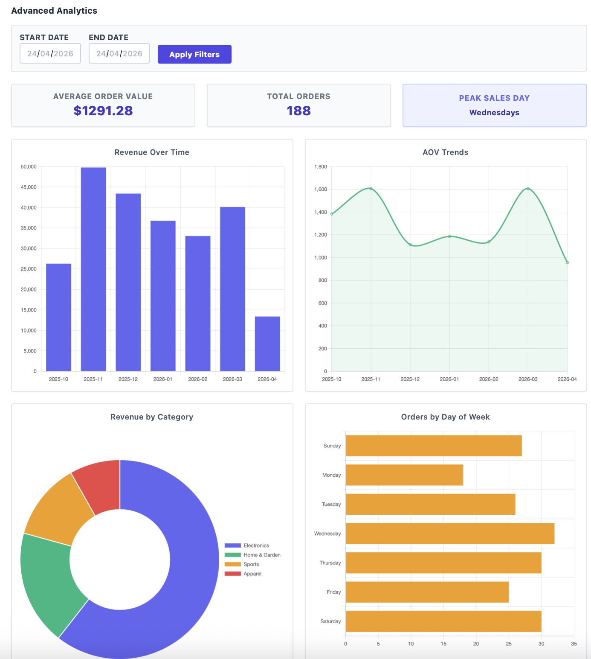
Feature 8 — Admin Order Management
The orders management panel lists every order in the system across all customers. Each row is expandable to reveal the line items, and the admin can update an order's status via a dropdown (pending → shipped → delivered / cancelled). The admin can also remove an individual product from an order or reduce its quantity; both operations are executed within a database transaction that simultaneously restocks warehouse_inventory and recalculates the order's total_amount, ensuring that inventory figures and financial records remain consistent at all times.
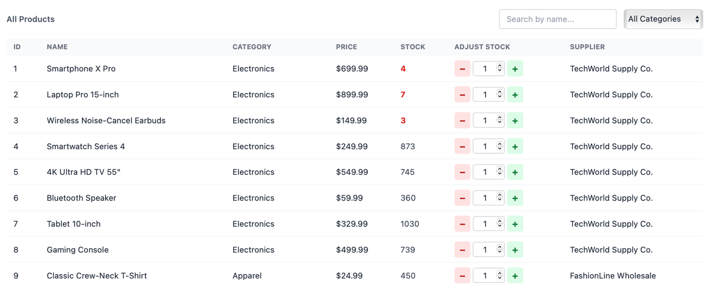
Feature 9 — Admin Customer Management
The customers panel provides the admin with a read-only tabular view of all registered customers, including their customer ID, full name, email address, phone number, and registered address. This view is secured behind the admin role check, and the data is retrieved with a simple SELECT on the customers table ordered by customer_id. The panel is intended to support customer lookup and verification tasks.
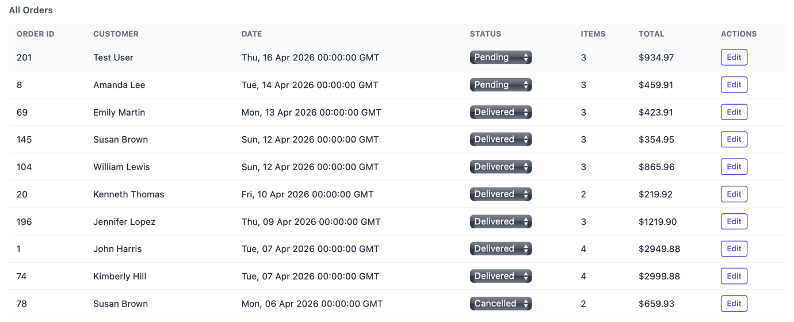
Feature 10 — Admin SQL Query Runner
The SQL Query Runner allows the admin to execute arbitrary SQL statements directly against the live ecommerce_db database from within the browser interface. The backend guards this feature with a regex-based blocklist that rejects any query containing DDL keywords (DROP, TRUNCATE, ALTER, CREATE, RENAME), preventing accidental or malicious schema modifications while still allowing full SELECT, INSERT, UPDATE, and DELETE access. Query results are returned as a dynamic table with auto-generated column headers. The panel also displays the full database schema — tables, column names, data types, and key types — introspected at runtime from information_schema, making it easy to reference the schema while composing queries.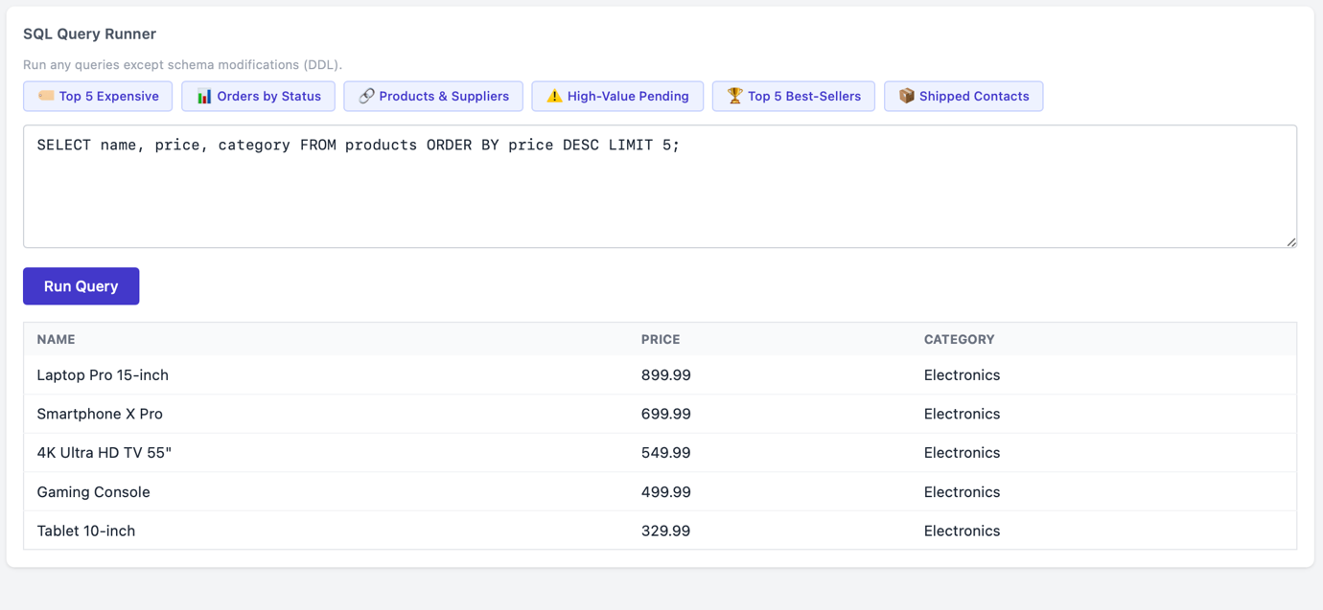

Feature 11 — Admin Schema Map (Interactive ER Diagram)
The Schema Map tab renders an interactive Entity-Relationship diagram of the live database directly in the browser, generated dynamically using Mermaid.js erDiagram syntax. The diagram is built from schema metadata retrieved via the /schema-metadata endpoint, which queries information_schema for all tables, columns, and foreign key relationships. The resulting SVG is made pannable and zoomable using the svg-pan-zoom library, allowing the admin to navigate large schemas conveniently. Primary keys are highlighted in blue and foreign keys in a contrasting colour, and relationship lines depict the cardinality as extracted from the actual database constraints.
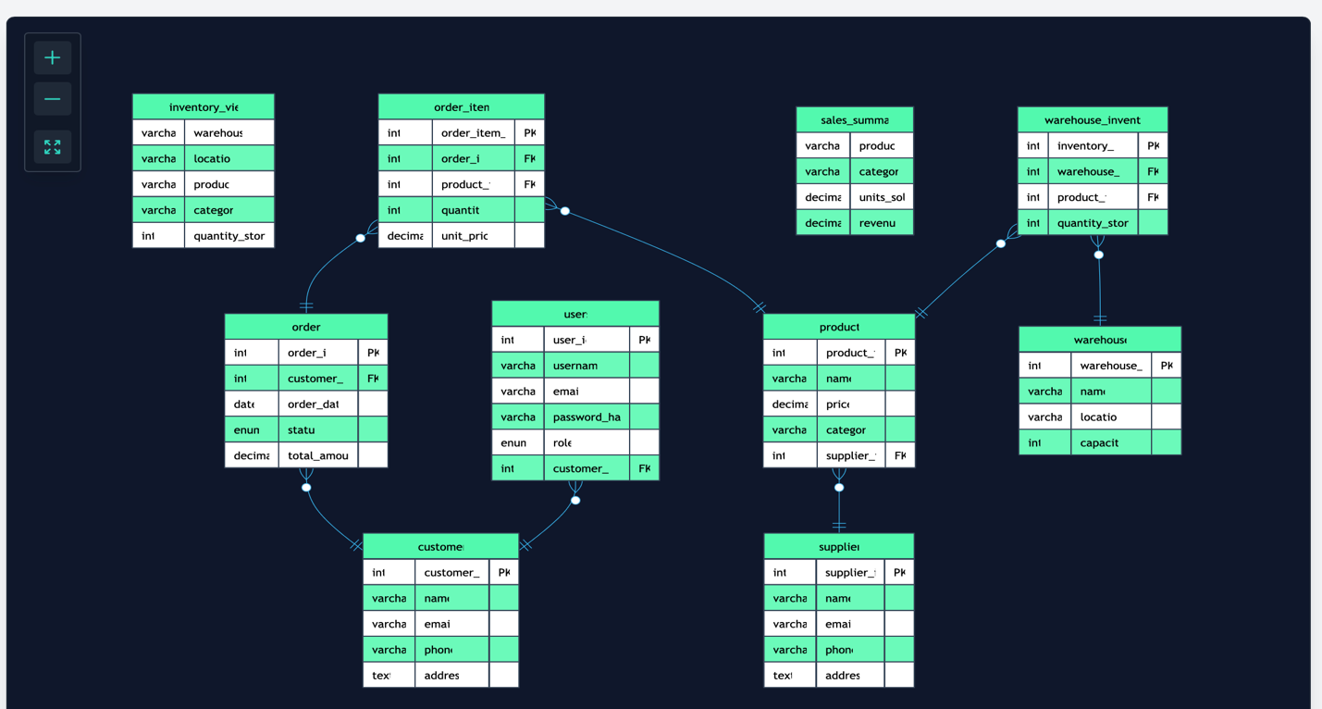
VIII. Self-Learning Beyond Classroom
While the course covered the theoretical foundations of relational databases, the implementation of this project required us to independently learn and apply several topics that go beyond the standard syllabus.
JSON Web Tokens (JWT) for Stateless Authentication: We studied how JWT works — the structure of the header, payload, and signature — and how Flask-JWT-Extended handles token issuance, validation, and claims extraction. We learned to embed custom claims such as role and customer_id into the token payload so that the backend can authorise requests without an additional database lookup on every call.
Database Transactions and Atomicity: The checkout and order-editing endpoints require strict ACID guarantees. We learned how to use explicit transaction management in mysql-connector-python (conn.start_transaction(), cursor.execute(...), conn.commit() / conn.rollback()) to ensure that a failed stock deduction or item insertion rolls back the entire operation, leaving the database in a consistent state.
MySQL INFORMATION_SCHEMA: To build the dynamic schema map, we explored how MySQL exposes metadata about its own structure through the INFORMATION_SCHEMA virtual database. We learned to query COLUMNS, KEY_COLUMN_USAGE, and TABLE_CONSTRAINTS to programmatically discover table structures and foreign key relationships at runtime, without hardcoding any schema details in the application code.
Chart.js Data Visualisation: None of us had prior experience with Chart.js. We studied the library's documentation to implement responsive line, bar, doughnut, and radar charts, and learned how to pass dynamic data from API responses into chart datasets, update charts in place when the date filter changes, and configure axis labels, tooltips, and legends.
Mermaid.js ER Diagram Rendering: We explored Mermaid.js's erDiagram syntax and learned how to programmatically generate diagram markup from the schema metadata returned by the backend, then render it client-side as an interactive SVG. Integrating svg-pan-zoom for navigation required reading the library's API documentation independently.
Password Hashing with scrypt: We researched why plain-text password storage is a security vulnerability and learned about Werkzeug's generate_password_hash and check_password_hash functions, which use the memory-hard scrypt algorithm to make brute-force attacks computationally expensive.

IX. Learning from the Project
This project bridged the gap between theoretical database concepts taught in class and their practical application in a real-world system. The key takeaways are summarised below.
ER Modelling Translates Directly to Code: Going through the process of identifying entities, their attributes, and inter-entity relationships before writing a single line of SQL made the schema much cleaner. Decisions made at the ER stage — such as resolving many-to-many relationships through junction tables like order_items and warehouse_inventory — directly influenced how straightforward the SQL queries became later.
Normalisation Prevents Real Bugs: We initially considered storing product price directly inside order_items as a convenience. After applying normalisation principles we realised that doing so correctly — storing the price at the time of purchase as unit_price rather than a reference to the current catalogue price — is essential to avoid reporting errors when product prices change over time.
Transactions Are Non-Negotiable for Consistency: Early versions of the checkout logic performed stock deductions and order insertions in separate statements without a transaction. Testing quickly revealed race conditions where concurrent checkouts could oversell a product. Wrapping the entire checkout in a transaction with a conditional UPDATE (quantity_stored >= required) solved this correctly.
The Value of Views: Creating views like sales_summary and inventory_view taught us that encapsulating complex multi-table joins in a named view makes the application code much simpler and the queries easier to maintain and test independently.
Full-Stack Awareness: Working across the database schema, the Flask API, and the JavaScript frontend gave us an appreciation for how each layer depends on the others. A column rename in the database requires a corresponding fix in every API query and every frontend key reference, which reinforced the importance of consistent naming conventions throughout the project.

X. Challenges Faced
Atomic Stock Deduction: Ensuring that two users cannot simultaneously purchase the last unit of a product was the most technically challenging aspect. A simple SELECT followed by UPDATE is susceptible to a race condition. The solution was to use a single conditional UPDATE statement (SET quantity_stored = quantity_stored - N WHERE quantity_stored >= N) and check the affected row count; if zero rows were updated, the product had insufficient stock and the transaction was rolled back.
Stateless Role-Based Authorisation: Because HTTP is stateless, we needed a way to identify both the user's identity and their role on every API request without a server-side session. JWT with custom claims solved this, but we initially struggled with token expiry handling and ensuring that the frontend redirected to login whenever a 401 response was received.
Dynamic ER Diagram Generation: Building the schema map required fetching foreign key metadata from information_schema and converting it into valid Mermaid.js erDiagram syntax on the fly. Handling edge cases such as self-referencing tables and composite foreign keys, and ensuring the Mermaid renderer did not crash on unusual schema patterns, required significant debugging.
Transactional Order Editing: The admin order-editing feature — which allows individual items to be removed or reduced — required a careful transaction that simultaneously updates order_items, restocks warehouse_inventory, and recalculates orders.total_amount. Getting the sequence of operations correct and handling partial failures without leaving inconsistent data took multiple iterations.
Frontend and Backend Integration: Since the frontend is a static HTML file served separately from the Flask API, cross-origin resource sharing (CORS) had to be configured on the backend using Flask-CORS. Debugging CORS preflight failures and ensuring that the JWT was transmitted correctly in the Authorization header required careful reading of browser developer tools and network logs.

XI. Conclusion
This project successfully demonstrates the design and implementation of a fully normalised relational database for an E-Commerce platform, backed by a secure RESTful API and an interactive browser-based interface. Starting from a problem statement, we progressed through entity identification, ER modelling, relational schema conversion, normalisation analysis, and finally the implementation of over twenty SQL queries covering all major concepts from the course syllabus.
The system handles real-world concerns such as concurrent stock deductions via atomic transactions, role-based access control via JWT, and live analytics via aggregation queries — all built on a clean, third-normal-form database schema. The self-learning component of the project exposed us to technologies such as JWT authentication, Chart.js visualisation, and MySQL INFORMATION_SCHEMA introspection that significantly broaden our understanding of how database systems integrate with modern application stacks.
The key takeaway from this project is that a well-designed database schema, adhering to normalisation principles and enforcing referential integrity through foreign keys, dramatically simplifies the application logic built on top of it. Constraints at the database level catch errors that would otherwise surface as subtle bugs in the application, making the system more robust and maintainable. We are confident that the skills acquired during this project — from data modelling to transaction management to analytics queries — will be directly applicable in our future academic and professional work.

