Front-End UI/UX Mini Project

## 1. Title Page

Project Title: Product Landing Website

Submitted By: Sureka K(2462368)

Gudisa Hasya Reddy(2462327)

Martin Philip Ruben (2462341)

College Email ID: [sureka.k@btech.christuniversity.in](mailto:sureka.k@btech.christuniversity.in)

gudisa.hasya[@btech.christuniversity.in](mailto:vadapalli.lakshmi@btech.christuniversity.in)

martin.philip[@btech.christuniversity.in](mailto:vadapalli.lakshmi@btech.christuniversity.in)

Course: UI/UX Design Fundamentals

Instructor Name: Ms.Nagaveena

Institution: Christ University

## Date of Submission: 26/09/2025

## 2. Abstract

## This project is a responsive, single-page product landing website showcasing the Kawasaki Ninja H2R superbike. The site is intended to present key features, specifications, gallery, FAQs, and calls to action (Learn More, Buy Now, Contact) in a visually appealing, user-friendly layout. It demonstrates front-end web development skills, including structuring content with HTML, styling with CSS, and ensuring a seamless user experience across devices.

## 3. Objectives

## To present the Ninja H2R’s specifications, unique selling points, and media (images, video) in a compelling, cohesive manner.

## To create a responsive and clean single-page layout that adapts to different screen sizes (desktop, tablet, mobile).

## To ensure intuitive navigation (anchor links, sectioning) and clear calls to action (Learn More, Buy Now, Contact).

## To practice and demonstrate proficiency in HTML5, CSS3, responsive design, and visual presentation.

## To handle common user needs (FAQ section, contact form) on a product page.

## 4. Scope of the Project

## This project focuses on creating a front-end product landing page for the Kawasaki Ninja H2R using HTML5, CSS3, and JavaScript. It includes sections such as Hero Banner, Specifications, Gallery, Features, FAQ, About, and Contact. JavaScript is used for smooth scrolling, FAQ toggling, and dynamic effects. The website remains static, with no backend integration, but forms a scalable base for future enhancements like functional forms, animations, and e-commerce features.

## 5. Tools & Technologies Used

| **Tool/Technology** | **Purpose** |
| --- | --- |
| **HTML5** | Semantic markup and content structure |
| **CSS3** | Styling, layout, responsiveness |
| **JavaScript (Vanilla JS)** | Interactivity (smooth scrolling, FAQ toggle, dynamic behavior) |
| **VS Code** | Code editor |
| **Chrome DevTools** | Testing and debugging |
| **GitHub Pages** | Hosting and deployment |

## 6. HTML Structure Overview

1. Semantic tags used: <header>, <nav>, <main>, <section>, <footer>
2. Sections included: Hero, Specifications, Gallery, Features, FAQ, About, Contact
3. Navigation implemented with <ul> and anchor links for smooth scrolling
4. FAQ and buttons enhanced with JavaScript event listeners

## 7. CSS Styling Strategy

## External stylesheet (style.css) for modular code organization

## Flexbox & CSS Grid for layout consistency

## Media Queries for responsiveness across breakpoints

## Hover effects for buttons and gallery images

## Consistent typography and color palette for brand identity

## 8. Key Features

|  |  |
| --- | --- |
| **Feature** | **Description** |
| **Responsive Design** | Works seamlessly on desktop, tablet, and mobile |
| **Hero Banner** | Full-width banner with title and CTA buttons |
| **Specifications Section** | Well-structured details of the Ninja H2R |
| **Gallery Section** | Grid layout with hover effects |
| **FAQ Section** | JavaScript-based toggle for interactive Q&A |

## 9. Challenges Faced & Solutions

| **Challenge** | **Solution** |
| --- | --- |
| Elements overlapping on smaller screens | Applied **media queries** to reorganize layout |
| Managing layout with floats | Replaced floats with **Flexbox & Grid** |
| Typography scaling issues | Used **relative units (em/rem)** |
| Adding interactivity without breaking layout | Implemented **modular JavaScript** for isolated functionality (FAQ toggle, scroll) |
| Smooth navigation | Used **JavaScript scrollIntoView / CSS scroll-behavior** for fluid transitions |

## 10. Outcome

## Developed a responsive, interactive, and engaging product landing page

## Successfully combined HTML, CSS, and JavaScript for structure, style, and interactivity

## Learned how to integrate UI/UX design principles into a real-world landing page project

## Published project live using GitHub Pages for easy access

## 11. Future Enhancements

## Add animations & transitions (scroll-triggered effects, parallax)

## Implement backend functionality for contact form submissions

## Add a theme toggler (light/dark mode) for better UX personalization

## Extend the site into a full e-commerce page with cart and payment gateway

## Use lazy loading for gallery images to optimize performance

## 12. Sample Code

## 

## 13. Screenshots of Final Output

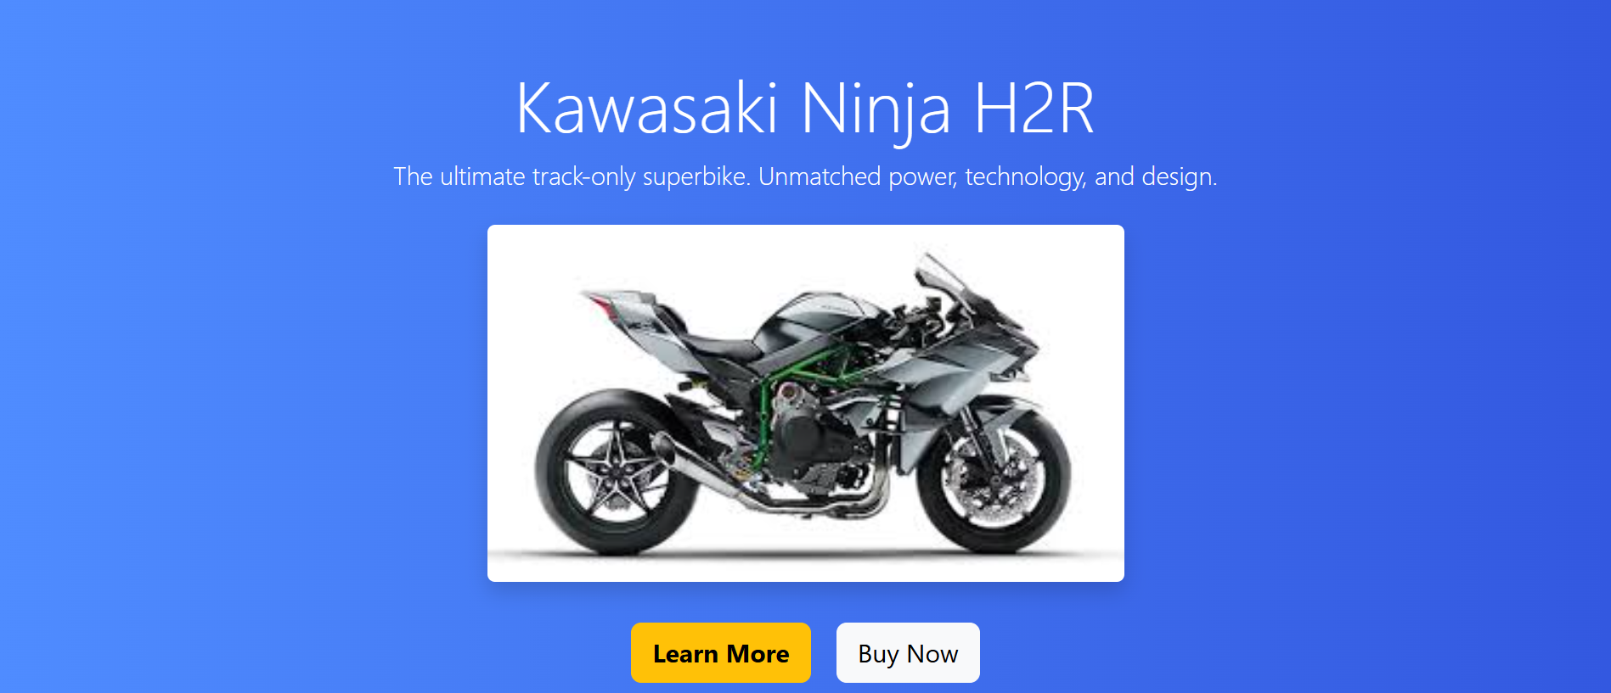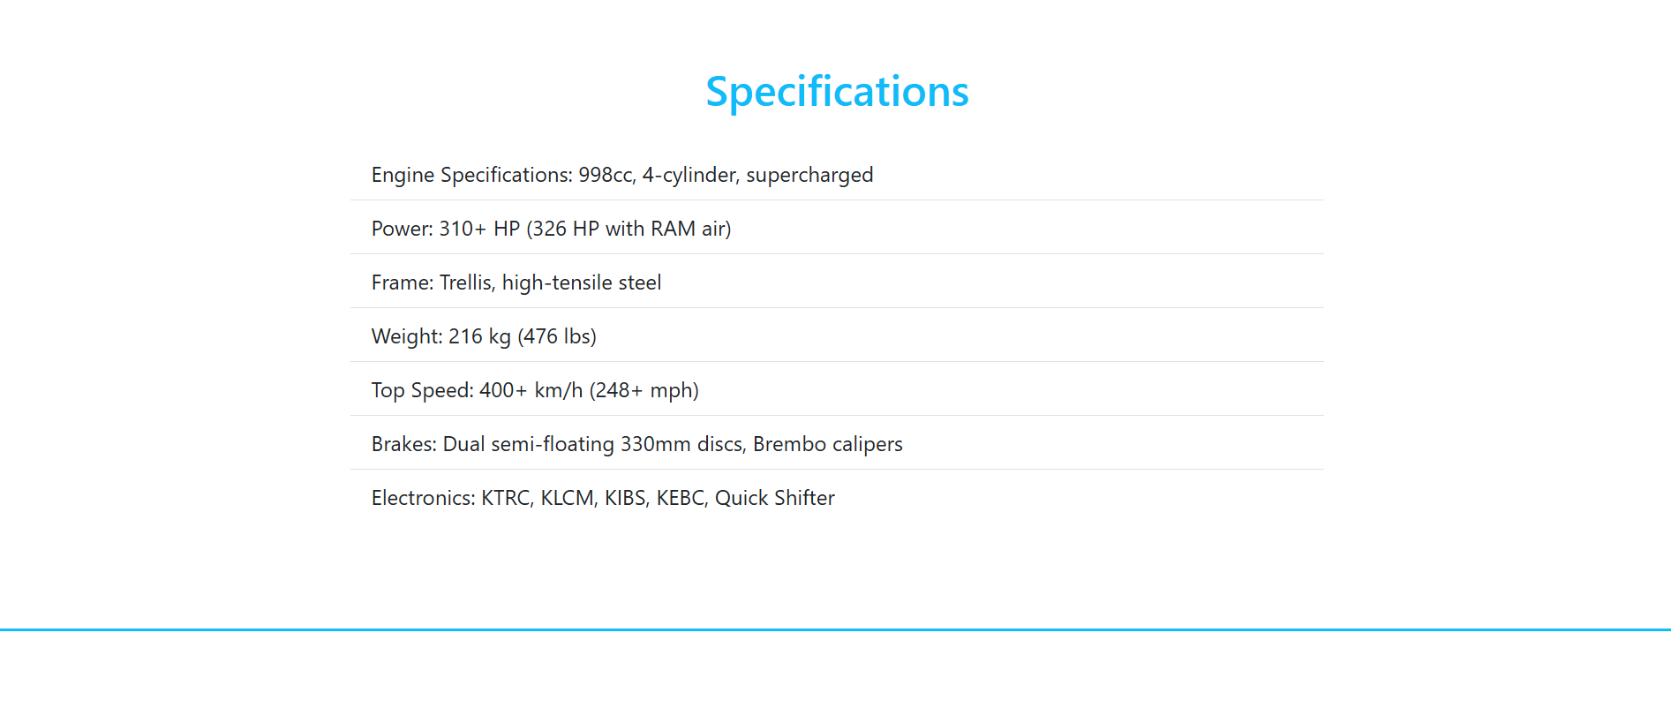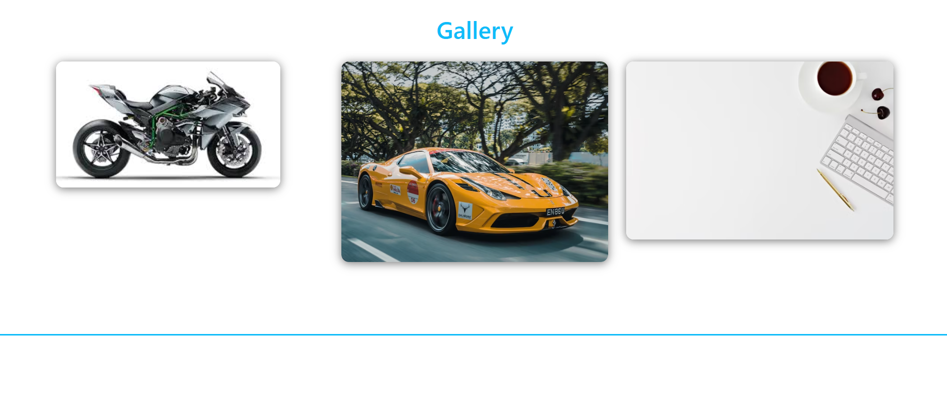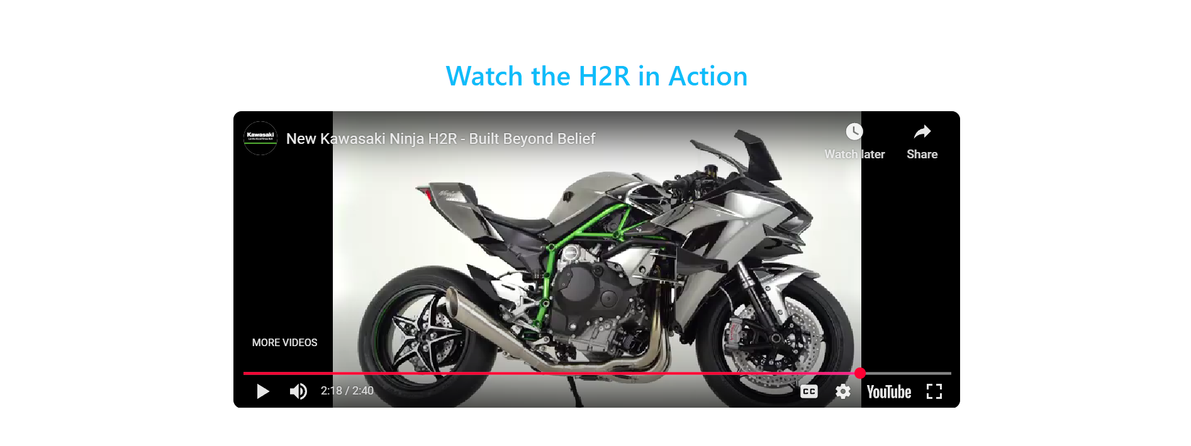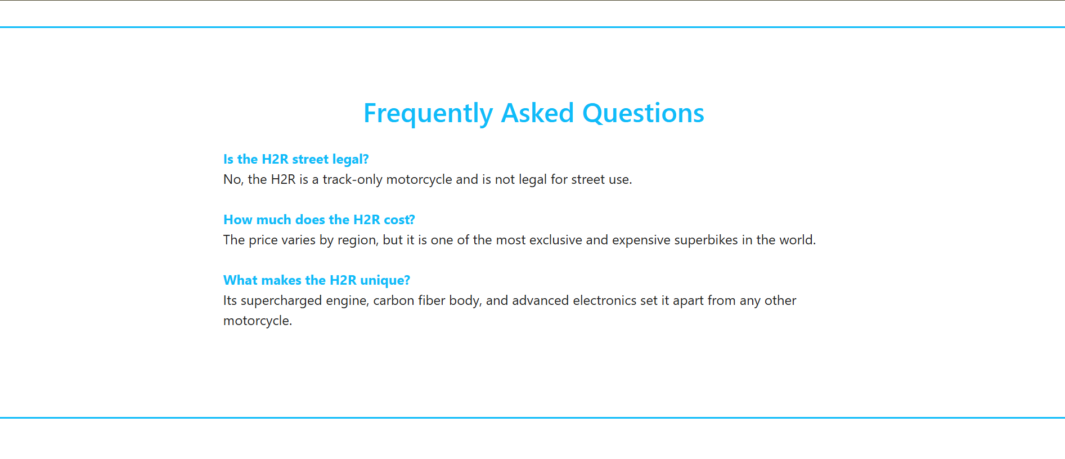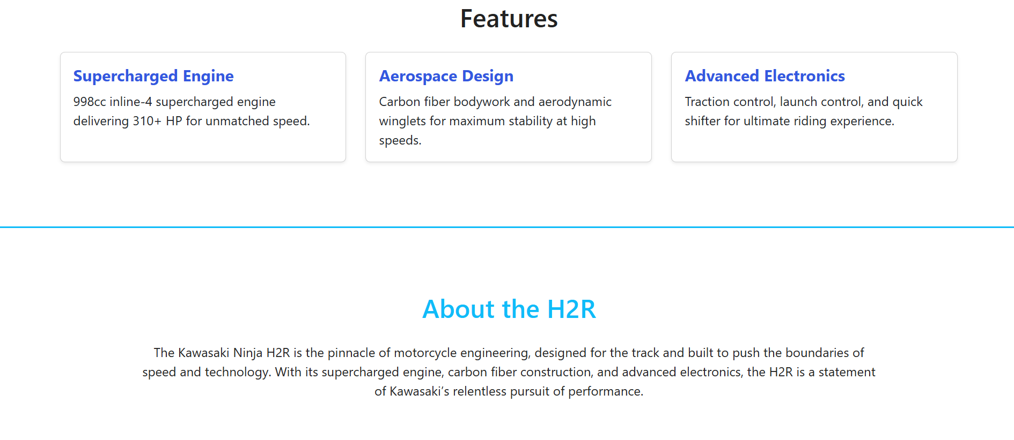

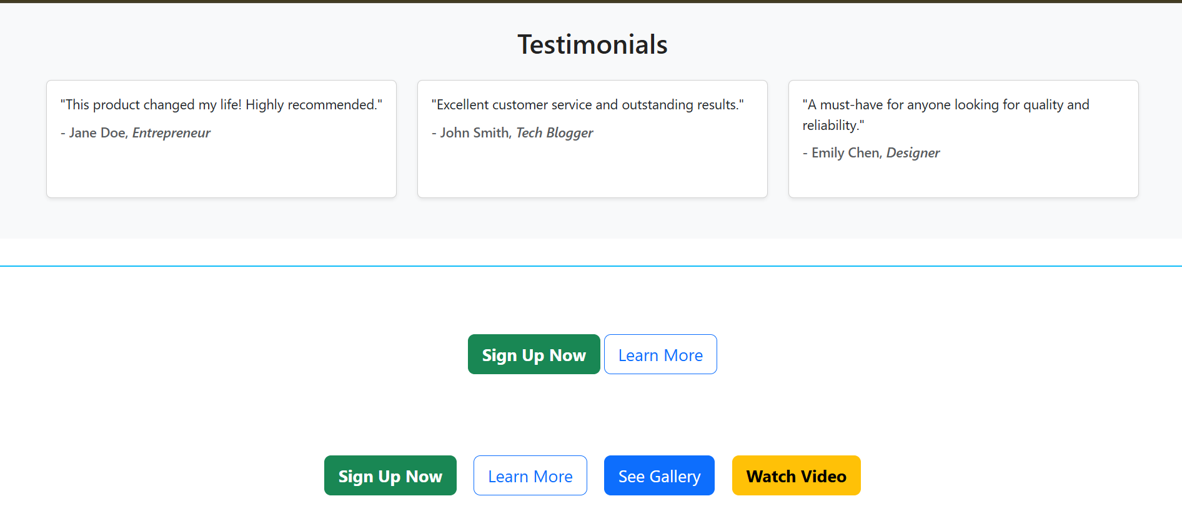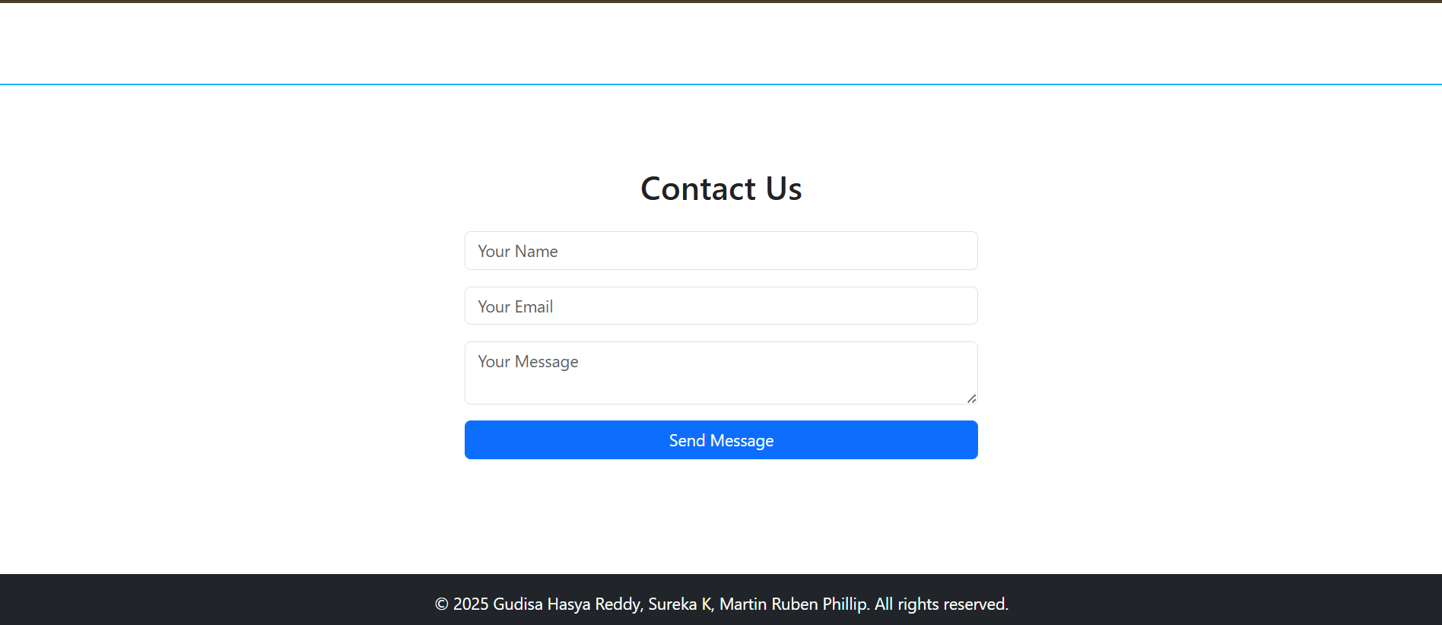

## 14. Conclusion

## The Kawasaki Ninja H2R Product Landing Page demonstrates how HTML, CSS, and JavaScript can be combined to create a responsive, interactive, and visually appealing web experience. With smooth navigation, dynamic FAQs, and structured design, the project showcases strong front-end development and UI/UX design skills. While the site currently serves as a static landing page, it establishes a solid foundation for future expansion into a complete e-commerce or promotional platform.

## 15. References

• L&T LMS: https://learn.lntedutech.com/Landing/MyCourse