**Front-End UI/UX Mini Project**

**1. Title Page**

**Project Title:** Financial Tracker  
**Submitted By:**

*Gudisa Hasya Reddy (2462327)*

*Sureka K (2462368)*

*Aadithya Vimal (2462302)*

**College Email ID:**

[gudisa.hasya@btech.christuniversity.in](mailto:gudisa.hasya@btech.christuniversity.in)

[sureka.k@btech.christuniversity.in](mailto:sureka.k@btech.christuniversity.in)

[aadithya.vimal@btech.christuniversity.in](mailto:aadithya.vimal@btech.christuniversity.in)

**Course:** UI/UX Design Fundamentals  
**Instructor Name:** Ms. Nagaveena  
**Institution:** Christ University  
**Date of Submission:** 13/08/2025

**2. Abstract**

This project showcases the design and implementation of a responsive Financial Tracker web application built using HTML5, Tailwind CSS, and custom CSS styling. The application allows users to log incomes and expenses, categorize transactions, and visualize financial data through interactive charts using Chart.js. It includes category management, a built-in calculator, and a responsive layout optimized for both desktop and mobile devices. Accessibility, simplicity, and visual clarity were prioritized. The current version is static, but provides a foundation for future enhancements such as persistent storage and authentication.

**3. Objectives**

* Track finances through an easy-to-use interface.
* Categorize transactions for better budgeting.
* Visualize data using charts for quick insights.
* Ensure responsive and mobile-friendly design.
* Include an integrated calculator for quick inputs.
* Allow creation of custom categories.
* Promote accessibility with semantic HTML and high-contrast colors.

**4. Scope of the Project**

The Financial Tracker is a **front-end** web application that enables users to:

* Add income and expense transactions
* Organize transactions into categories
* View summaries through interactive charts
* Use a calculator for quick amount entry
* Access the application seamlessly across devices

This version is static and does not store data persistently or include multi-user features.

**5. Tools & Technologies Used**

| **Tool/Technology** | **Purpose** |
| --- | --- |
| HTML5 | Structure & content markup |
| Tailwind CSS | Utility-first responsive styling |
| Custom CSS | Additional animations & effects |
| Chart.js | Data visualization |
| Font Awesome | Icons |
| VS Code | Code editing |
| Chrome DevTools | Testing & debugging |

**6. HTML Structure Overview**

* Semantic HTML5 elements used: <header>, <section>, <div>, <canvas>
* Three-column responsive layout:
  + **Left Column:** Transaction form, category modal, calculator modal
  + **Middle Column:** Recent transactions with filters
  + **Right Column:** Financial overview and charts
* Modal pop-ups for calculator and adding categories

**7. CSS Styling Strategy**

* Tailwind CSS for core layout, spacing, and responsive design
* Custom CSS for hover effects, animations, and fine-tuning
* Mobile adjustments with media queries for single-column layout on smaller screens

**8. Key Features**

| **Feature** | **Description** |
| --- | --- |
| Transaction Management | Add income or expense entries with date, time, and notes |
| Category Management | Create new income/expense categories |
| Built-in Calculator | For quick numeric entry |
| Financial Summary | Shows total income, expenses, and balance |
| Interactive Charts | Visual breakdown of income and expenses |
| Responsive Design | Adapts to all screen sizes |

**9. Challenges Faced & Solutions**

| **Challenge** | **Solution** |
| --- | --- |
| Aligning complex form elements | Used Tailwind’s Flexbox & Grid utilities |
| Managing category addition | Implemented modal for easy input |
| Chart responsiveness | Used Chart.js responsive settings |
| Small screen usability | Applied media queries for stacked layout |

**10. Outcome**

* Developed a functional and visually appealing financial tracking interface
* Fully responsive design
* Enhanced understanding of Tailwind utility classes and Chart.js integration
* Laid foundation for adding backend and interactivity

**11. Future Enhancements**

* Backend storage for persistent data
* User authentication
* Advanced filtering and export features
* Improved calculator with more functions
* Dark mode toggle

**12. Sample Code**

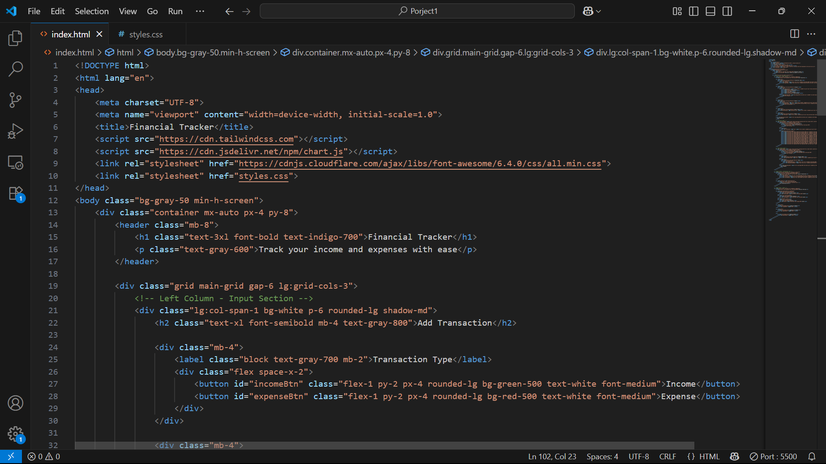

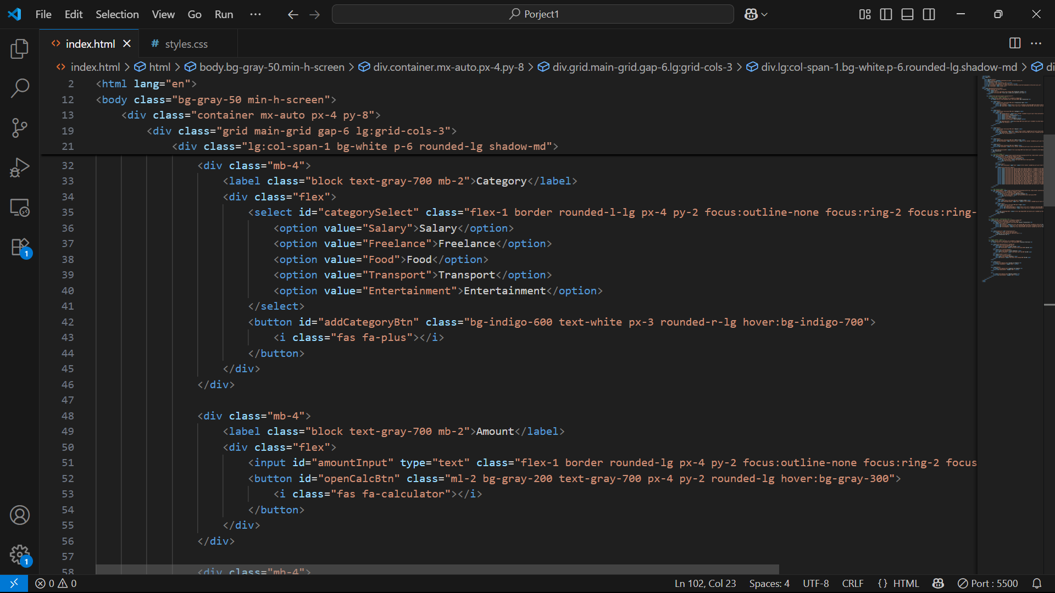

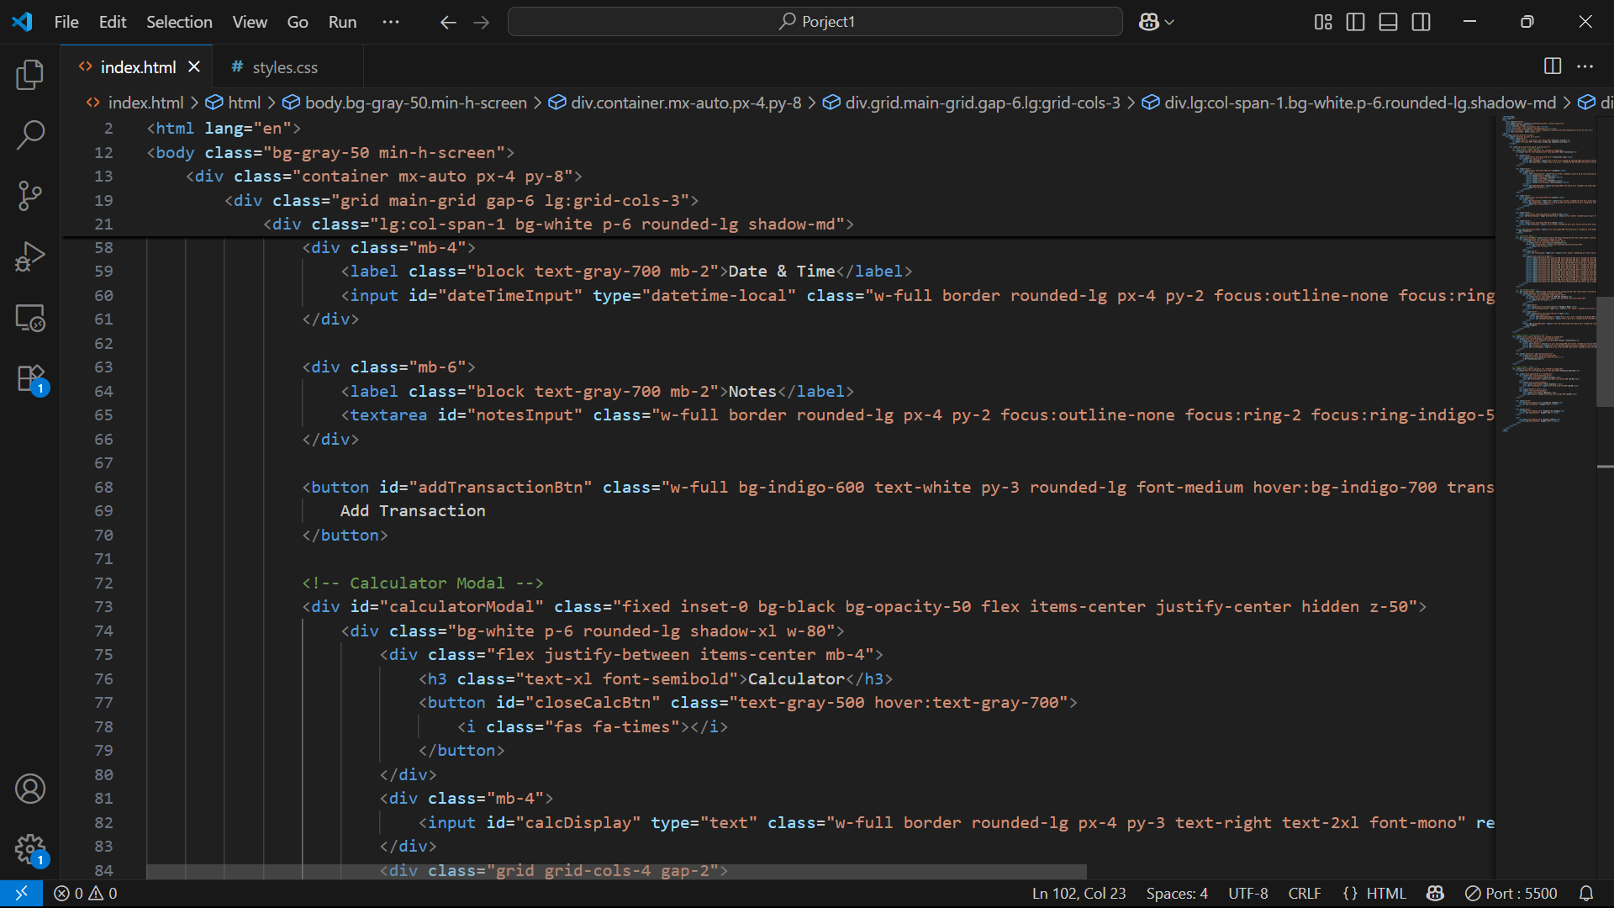

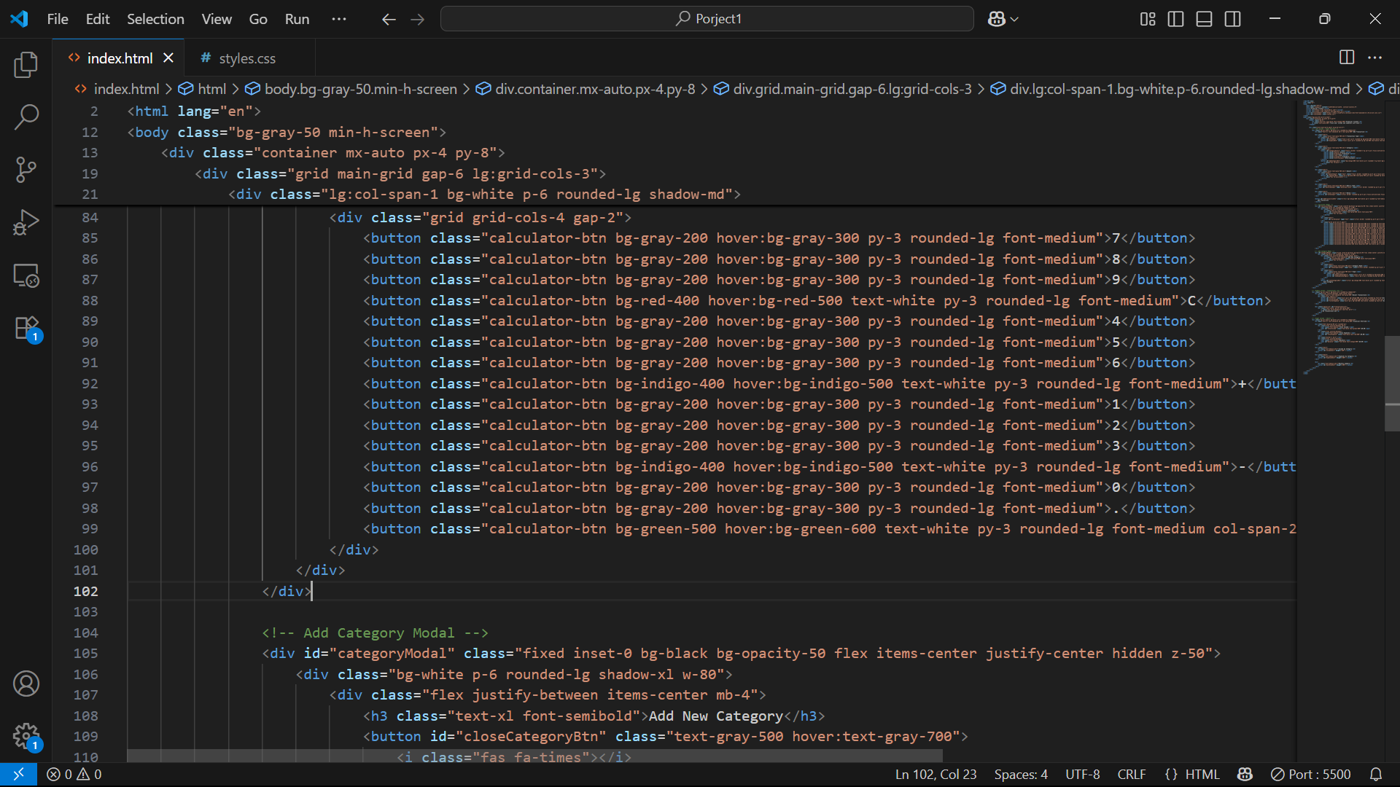

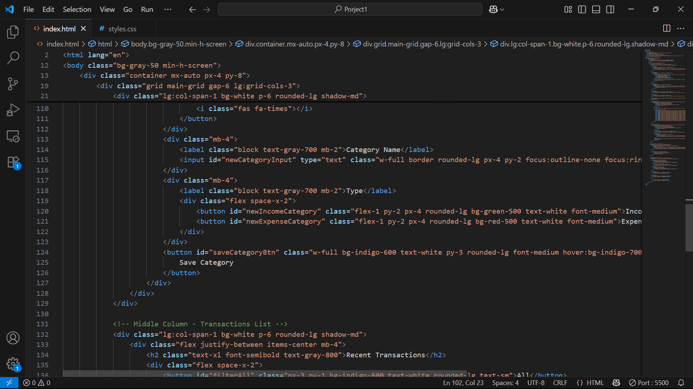

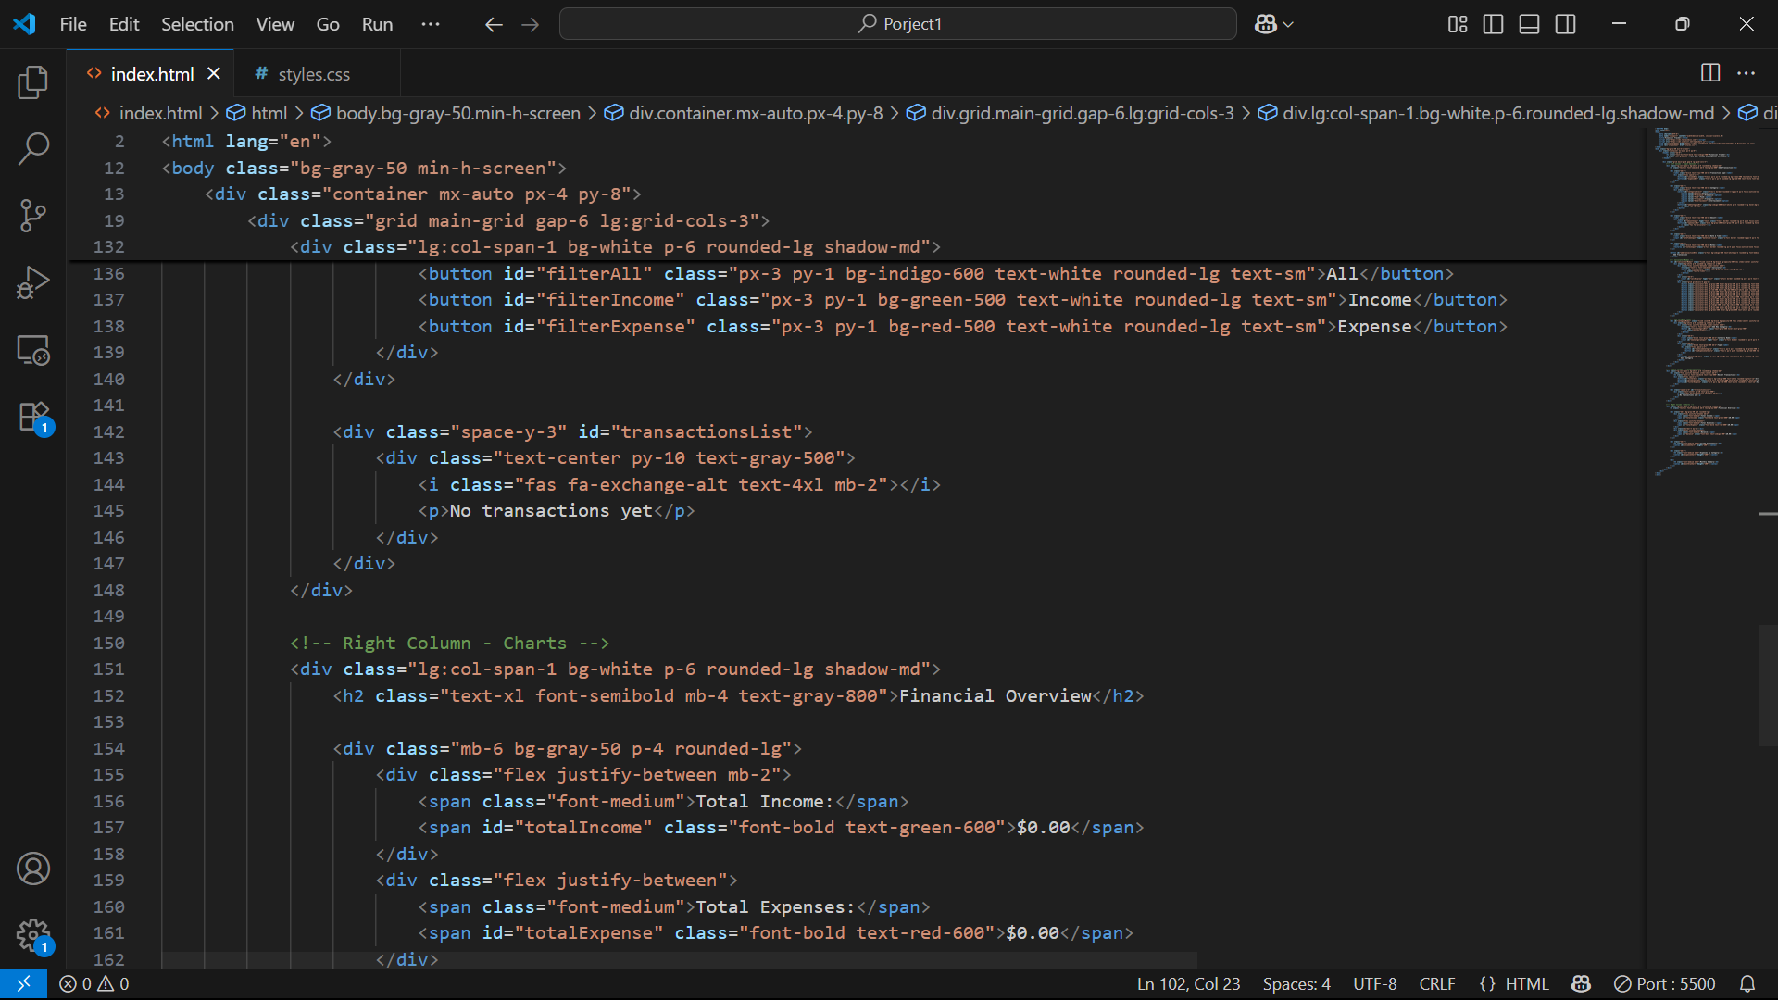

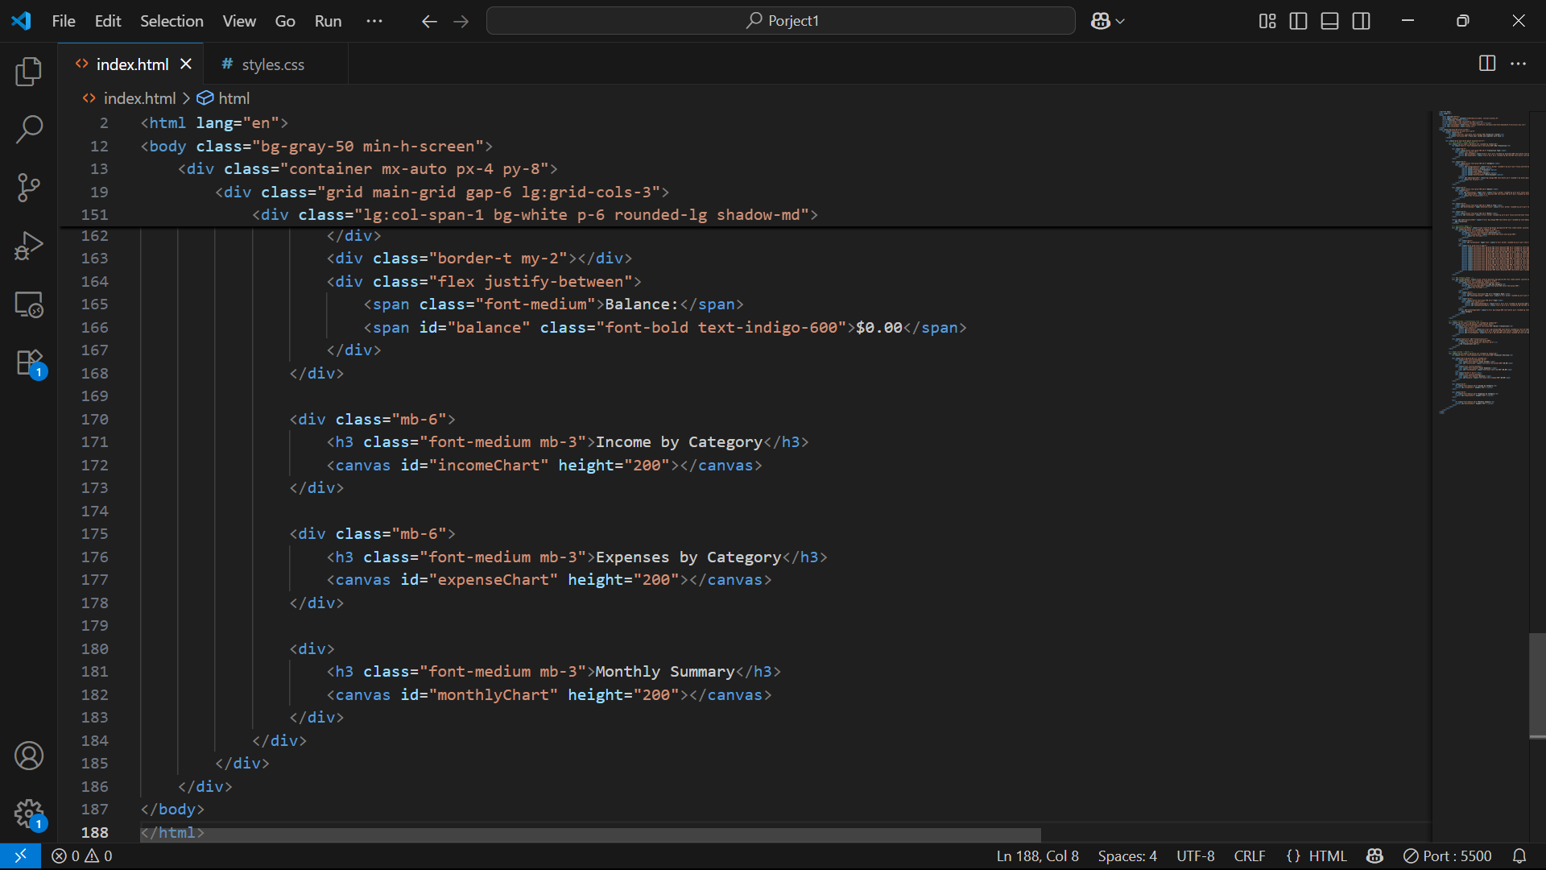

**13. Screenshots of Final Output**

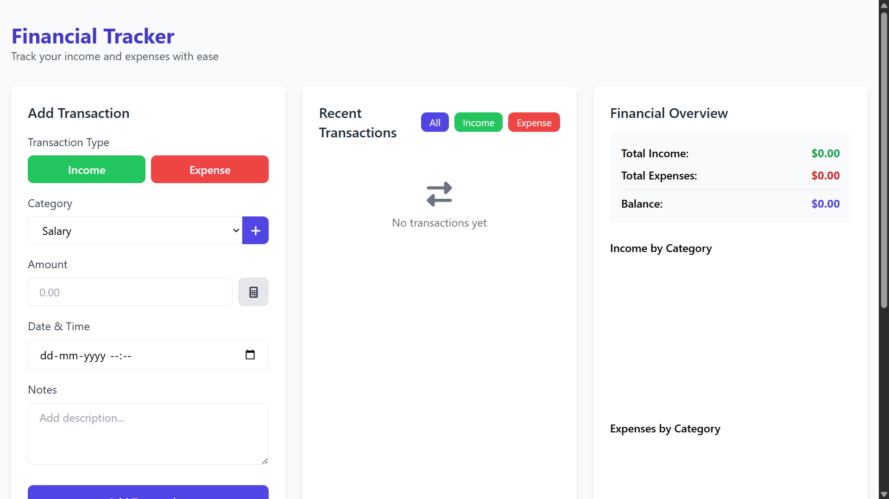

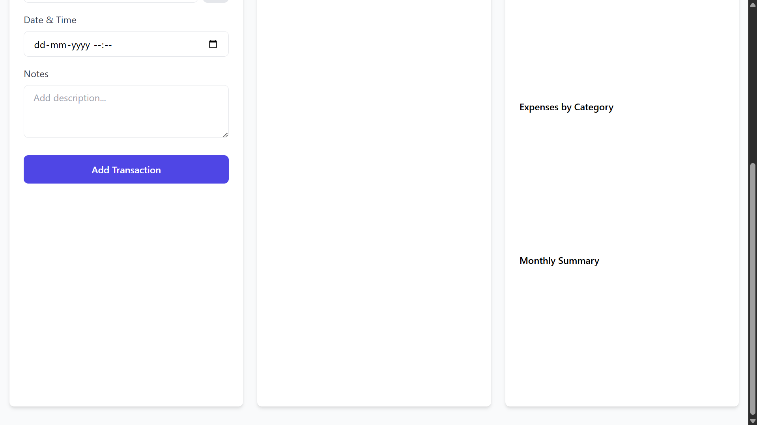

**14. Conclusion**

The Financial Tracker delivers a clean, modern, and responsive interface for managing personal finances. It combines HTML5, Tailwind CSS, and Chart.js to provide an accessible and user-friendly platform. With features like category creation, a built-in calculator, and financial charts, it offers a solid foundation for further development into a fully functional application with data persistence and user authentication.

**15. References**

* Tailwind CSS – <https://tailwindcss.com>
* Chart.js – https://www.chartjs.org
* Font Awesome – https://fontawesome.com
* MDN Web Docs – https://developer.mozilla.org