Computer Vision Assignment

Image restoration and segmentation · Feature extraction and matching · Face and object detection in video
Name: Aaditi Apale PRN: 1272250538 Date: 27 October 2026
Github (hyperlink)
Github URL: https://github.com/aaditi0227/Computer-Vision-CCA3

Overview
This document records the three computer-vision tasks carried out for the assignment, organised under the six required headings: Input, Source Code, Output, Explanation, Comparison and Conclusion. Everything was implemented in Python using OpenCV, scikit-image, NumPy, pandas and Ultralytics (YOLOv8) inside Jupyter notebooks. Task numbers follow the headings inside the notebooks (the notebook files themselves are named Task3, Task4 and Task5).
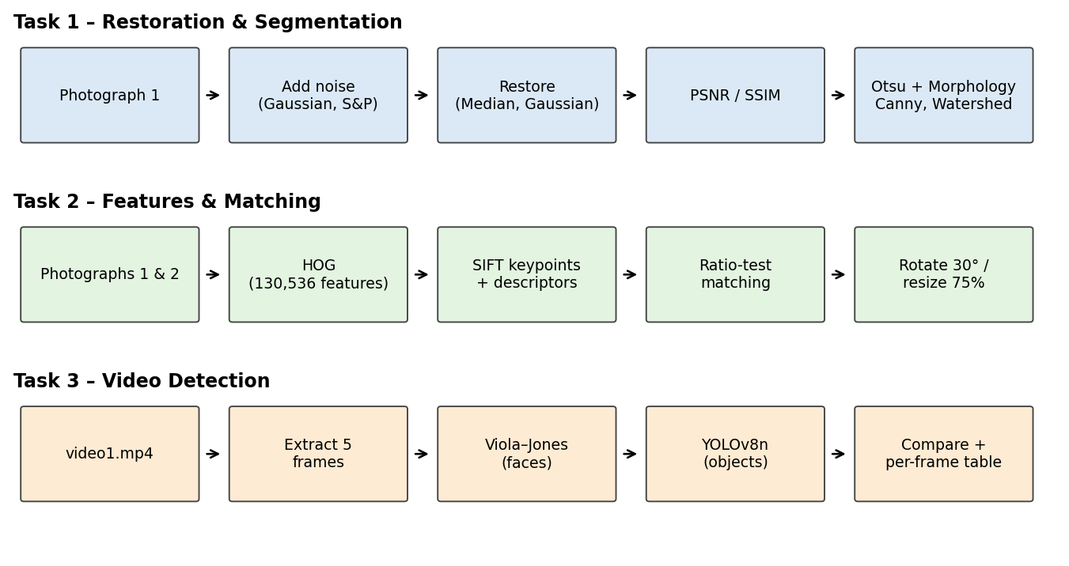
Figure 1: Processing pipeline of the three tasks. Each row is one task, read left to right.

1. Input
Two photographs of the same desk (taken from different positions) and one short road-traffic video were used. Table 1 lists the exact input data; Figures 1–3 show the originals.
Table 1: Details of the input data
Item | File | Details
Photograph 1 | images/image1.jpeg | 1280 × 960 px, RGB. A desk scene: a blue illustrated notebook, a closed silver laptop with stickers, a phone and small accessories. Resized to 600 × 400 px for Tasks 1 and 2.
Photograph 2 | images/image2.jpeg | 1280 × 960 px, RGB. The same desk photographed from a different position and angle. Resized to 600 × 400 px; used in Task 2 only.
Video | video/video1.mp4 | 576 × 1024 px (portrait), 25 fps, 330 frames, about 13.2 s. A road junction with cars, a school van, scooters, pedestrians and a traffic light. Five evenly spaced frames were extracted for processing.
Pretrained models | yolov8n.pt, haarcascade_frontalface_default.xml | YOLOv8 nano weights (trained on the COCO dataset) and the Haar cascade for frontal faces that ships with OpenCV.
Libraries | — | OpenCV (cv2), scikit-image, NumPy, pandas, Matplotlib, Ultralytics.

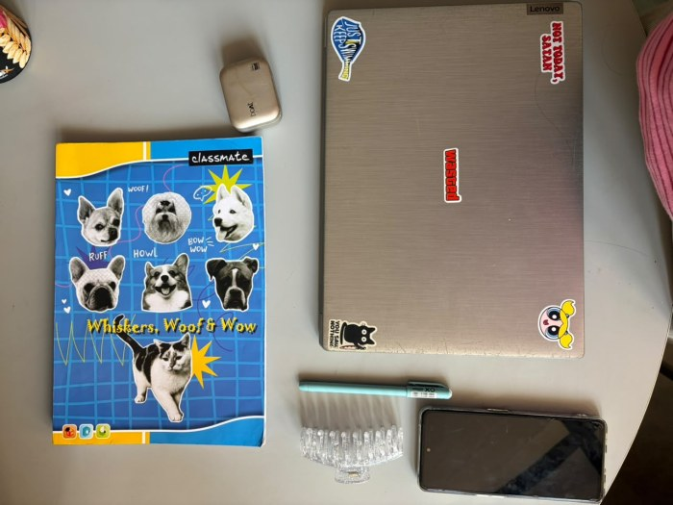  Figure 2: Original photograph 1. Reference image for Tasks 1 and 2. | 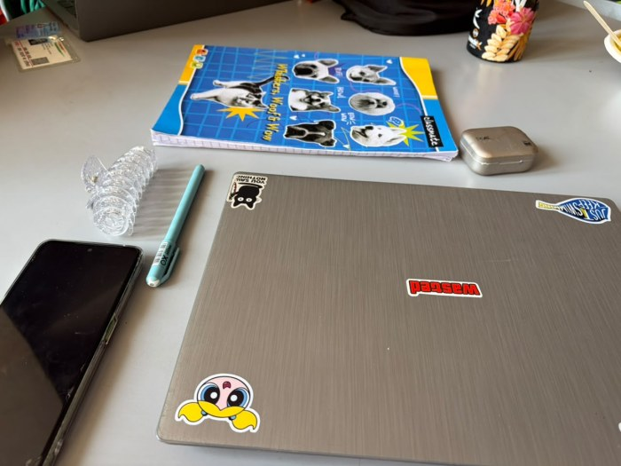  Figure 3: Original photograph 2. Same scene, different viewpoint (Task 2).

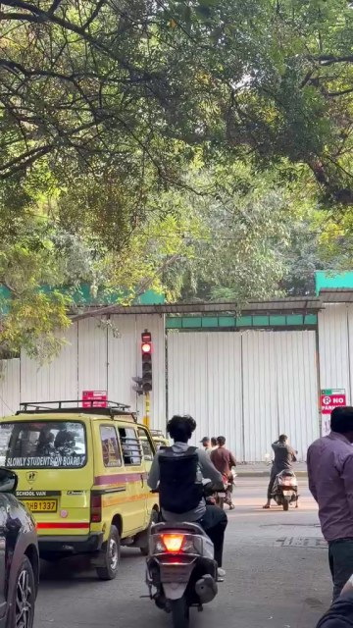  Figure 4: Video frame 1 (index 0, 0.00 s). | 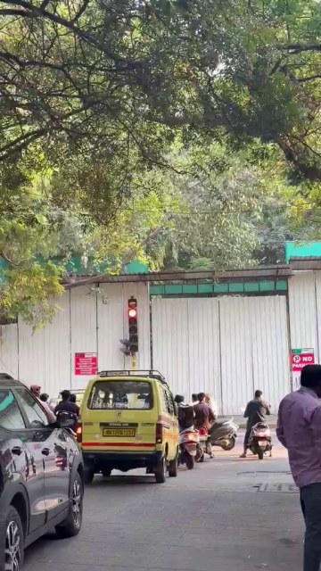  Figure 5: Video frame 2 (index 82, 3.28 s). | 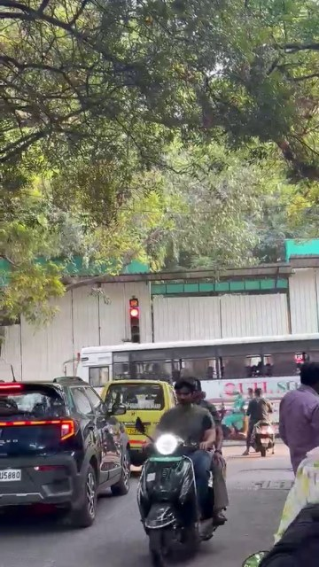  Figure 6: Video frame 3 (index 164, 6.56 s).
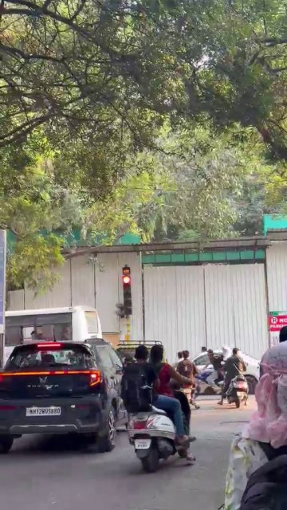  Figure 7: Video frame 4 (index 246, 9.84 s). | 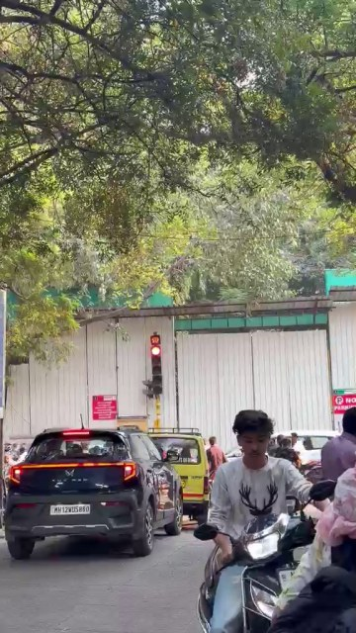  Figure 8: Video frame 5 (index 329, 13.16 s).
The five frames above were taken with equal spacing from the original video and are the input for Task 3.

2. Source Code
The listings below are condensed from the notebooks: the core processing steps are kept exactly as run, while plotting, display and file-saving lines are left out for readability. The complete notebooks are submitted alongside this document.

Task 1: Image restoration and segmentation
import cv2
import numpy as np
import pandas as pd
from skimage.metrics import peak_signal_noise_ratio, structural_similarity

# ---------- Input ----------
original_bgr = cv2.imread("images/image1.jpeg")
original = cv2.cvtColor(original_bgr, cv2.COLOR_BGR2RGB)
original = cv2.resize(original, (600, 400))

# ---------- Add noise ----------
np.random.seed(42)
original_float = original.astype(np.float32) / 255.0

gaussian_noise = np.random.normal(0, 0.08, original_float.shape)
gaussian_noisy = np.clip(original_float + gaussian_noise, 0, 1)
gaussian_noisy = (gaussian_noisy * 255).astype(np.uint8)

salt_pepper_noisy = original.copy()
noise_amount = 0.04
total_pixels = original.shape[0] * original.shape[1]
n = int(noise_amount * total_pixels)
rows = np.random.randint(0, original.shape[0], n)
cols = np.random.randint(0, original.shape[1], n)
salt_pepper_noisy[rows, cols] = np.random.choice([0, 255], size=(n, 1))

# ---------- Restoration (median vs Gaussian, 5x5) ----------
gaussian_median = cv2.medianBlur(gaussian_noisy, 5)
gaussian_filtered = cv2.GaussianBlur(gaussian_noisy, (5, 5), 0)
salt_pepper_median = cv2.medianBlur(salt_pepper_noisy, 5)
salt_pepper_gaussian = cv2.GaussianBlur(salt_pepper_noisy, (5, 5), 0)

# ---------- Quality metrics ----------
for name, img in images_for_metrics.items(): # dict of the six images above
psnr = peak_signal_noise_ratio(original, img, data_range=255)
ssim = structural_similarity(original, img, channel_axis=2, data_range=255)

# ---------- Thresholding ----------
gray = cv2.cvtColor(original, cv2.COLOR_RGB2GRAY)
threshold_value, binary_image = cv2.threshold(
gray, 0, 255, cv2.THRESH_BINARY + cv2.THRESH_OTSU)

# ---------- Morphology (5x5 kernel) ----------
kernel = np.ones((5, 5), np.uint8)
erosion = cv2.erode(binary_image, kernel, iterations=1)
dilation = cv2.dilate(binary_image, kernel, iterations=1)
opening = cv2.morphologyEx(binary_image, cv2.MORPH_OPEN, kernel)
closing = cv2.morphologyEx(binary_image, cv2.MORPH_CLOSE, kernel)

# ---------- Canny edge detection ----------
blurred_gray = cv2.GaussianBlur(gray, (5, 5), 0)
edges = cv2.Canny(blurred_gray, threshold1=100, threshold2=200)

# ---------- Watershed segmentation ----------
watershed_bgr = cv2.resize(original_bgr, (600, 400))
watershed_gray = cv2.cvtColor(watershed_bgr, cv2.COLOR_BGR2GRAY)
watershed_blur = cv2.GaussianBlur(watershed_gray, (5, 5), 0)

_, mask_a = cv2.threshold(watershed_blur, 0, 255,
cv2.THRESH_BINARY + cv2.THRESH_OTSU)
mask_b = cv2.bitwise_not(mask_a)
binary_mask = mask_a if np.count_nonzero(mask_a) <= np.count_nonzero(mask_b) else mask_b

k3 = np.ones((3, 3), np.uint8)
sure_background = cv2.dilate(binary_mask, k3, iterations=3)
distance = cv2.distanceTransform(binary_mask, cv2.DIST_L2, 5)
_, sure_foreground = cv2.threshold(distance, 0.35 * distance.max(), 255,
cv2.THRESH_BINARY)
sure_foreground = sure_foreground.astype(np.uint8)
unknown = cv2.subtract(sure_background, sure_foreground)

number_of_labels, markers = cv2.connectedComponents(sure_foreground)
markers = markers + 1
markers[unknown == 255] = 0
markers = cv2.watershed(watershed_bgr, markers)

segmented = cv2.cvtColor(watershed_bgr, cv2.COLOR_BGR2RGB)
segmented[markers == -1] = [255, 0, 0] # boundaries in red

Task 2: Feature extraction and image matching
import cv2
import numpy as np
from skimage.feature import hog
from skimage import exposure

# ---------- Input: two photographs of the same scene ----------
image1 = cv2.cvtColor(cv2.imread("images/image1.jpeg"), cv2.COLOR_BGR2RGB)
image2 = cv2.cvtColor(cv2.imread("images/image2.jpeg"), cv2.COLOR_BGR2RGB)
image1 = cv2.resize(image1, (600, 400))
image2 = cv2.resize(image2, (600, 400))
gray1 = cv2.cvtColor(image1, cv2.COLOR_RGB2GRAY)
gray2 = cv2.cvtColor(image2, cv2.COLOR_RGB2GRAY)

# ---------- HOG ----------
hog_features, hog_image = hog(
gray1, orientations=9, pixels_per_cell=(8, 8), cells_per_block=(2, 2),
visualize=True, feature_vector=True)
hog_visualization = exposure.rescale_intensity(
hog_image, in_range=(0, np.max(hog_image)))
print("Number of HOG features:", len(hog_features)) # 130536

# ---------- SIFT keypoints and descriptors ----------
sift = cv2.SIFT_create()
keypoints1, descriptors1 = sift.detectAndCompute(gray1, None) # 751 x 128
keypoints2, descriptors2 = sift.detectAndCompute(gray2, None) # 727 x 128

keypoints_image1 = cv2.drawKeypoints(
image1, keypoints1, None, flags=cv2.DRAW_MATCHES_FLAGS_DRAW_RICH_KEYPOINTS)

# ---------- Matching: brute force + Lowe's ratio test ----------
def match_sift_features(img_a, img_b):
kp_a, desc_a = sift.detectAndCompute(img_a, None)
kp_b, desc_b = sift.detectAndCompute(img_b, None)
matcher = cv2.BFMatcher(cv2.NORM_L2)
pairs = matcher.knnMatch(desc_a, desc_b, k=2)
good = [p[0] for p in pairs
if len(p) == 2 and p[0].distance < 0.75 * p[1].distance]
return kp_a, kp_b, good, len(pairs)

kp1, kp2, good_matches, _ = match_sift_features(gray1, gray2)
matching_image = cv2.drawMatches(image1, kp1, image2, kp2, good_matches[:50], None)

# ---------- Robustness test 1: rotate image 2 by 30 degrees ----------
h, w = gray2.shape
M = cv2.getRotationMatrix2D((w // 2, h // 2), 30, 1.0)
rotated_image2 = cv2.warpAffine(image2, M, (w, h))
rotated_gray2 = cv2.cvtColor(rotated_image2, cv2.COLOR_RGB2GRAY)
_, _, rotated_matches, _ = match_sift_features(gray1, rotated_gray2)

# ---------- Robustness test 2: resize image 2 to 75 % ----------
resized_image2 = cv2.resize(image2, None, fx=0.75, fy=0.75,
interpolation=cv2.INTER_LINEAR)
resized_gray2 = cv2.cvtColor(resized_image2, cv2.COLOR_RGB2GRAY)
_, _, resized_matches, _ = match_sift_features(gray1, resized_gray2)

Task 3: Face and object detection in video
import cv2
import numpy as np
import pandas as pd
from ultralytics import YOLO

# ---------- Read the video and extract 5 evenly spaced frames ----------
cap = cv2.VideoCapture("video/video1.mp4")
total_frames = int(cap.get(cv2.CAP_PROP_FRAME_COUNT)) # 330
fps = cap.get(cv2.CAP_PROP_FPS) # 25.0

frame_positions = np.linspace(0, total_frames - 1, 5, dtype=int)
extracted_frames = []
for i, position in enumerate(frame_positions):
cap.set(cv2.CAP_PROP_POS_FRAMES, int(position))
success, frame = cap.read()
if success:
path = f"task3_outputs/frames/frame_{i + 1}.jpg"
cv2.imwrite(path, frame)
extracted_frames.append(path)
cap.release()

# ---------- Method 1: Viola-Jones (Haar cascade) face detection ----------
face_cascade = cv2.CascadeClassifier(
cv2.data.haarcascades + "haarcascade_frontalface_default.xml")

original_frame = cv2.imread(extracted_frames[0])
gray_frame = cv2.cvtColor(original_frame, cv2.COLOR_BGR2GRAY)
faces = face_cascade.detectMultiScale(
gray_frame, scaleFactor=1.1, minNeighbors=5, minSize=(30, 30))

viola_frame = original_frame.copy()
for (x, y, w, h) in faces:
cv2.rectangle(viola_frame, (x, y), (x + w, y + h), (0, 255, 0), 2)

# ---------- Method 2: YOLOv8n (pretrained on COCO) ----------
model = YOLO("yolov8n.pt")
result = model.predict(source=extracted_frames[0], conf=0.25, verbose=False)[0]
yolo_frame = result.plot()

detection_data = []
for box in result.boxes:
detection_data.append({
"Object": model.names[int(box.cls[0])],
"Confidence": round(float(box.conf[0]), 3),
"X1": int(box.xyxy[0][0]), "Y1": int(box.xyxy[0][1]),
"X2": int(box.xyxy[0][2]), "Y2": int(box.xyxy[0][3])})

# ---------- YOLOv8n on all 5 extracted frames ----------
all_detections = []
for frame_number, frame_file in enumerate(extracted_frames, start=1):
r = model.predict(source=frame_file, conf=0.25, verbose=False)[0]
for box in r.boxes:
all_detections.append({
"Frame": frame_number,
"Object": model.names[int(box.cls[0])],
"Confidence": round(float(box.conf[0]), 3)})

3. Output

3.1 Task 1: Restoration and segmentation

Noise added to the photograph
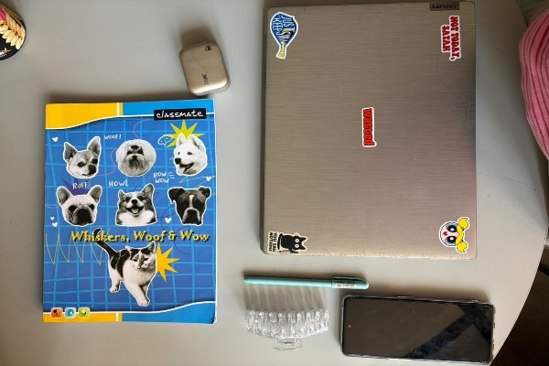  Figure 9: Original (resized). 600 × 400 px reference. | 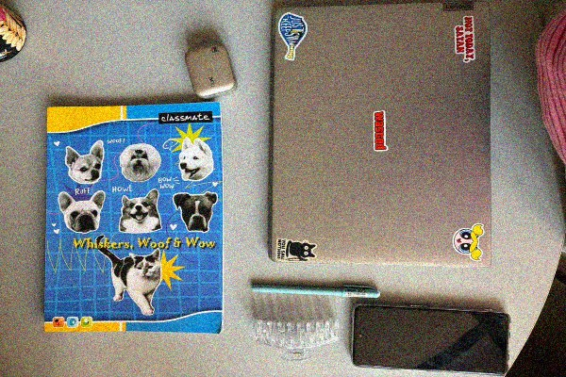  Figure 10: Gaussian noise. σ = 0.08, fine colour grain over the whole image. | 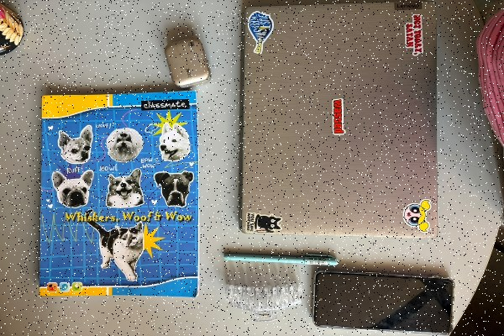  Figure 11: Salt-and-pepper noise. 4 % of pixels set to black or white.

Restored images
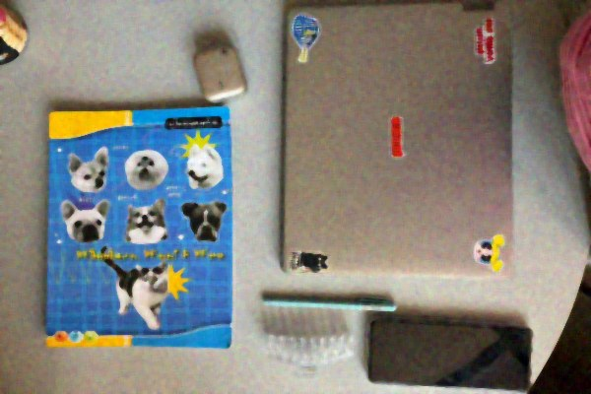  Figure 12: Gaussian noise + median filter (5×5). Grain removed, slightly blotchy. | 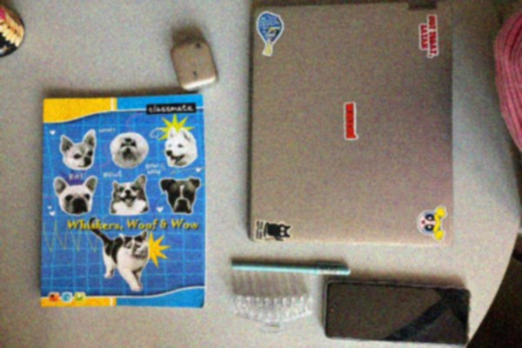  Figure 13: Gaussian noise + Gaussian filter (5×5). Smoothest result.
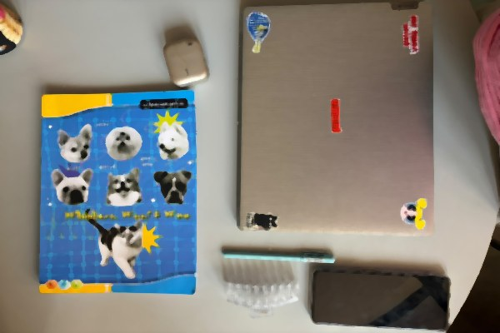  Figure 14: Salt-and-pepper + median filter (5×5). Isolated dots removed cleanly. | 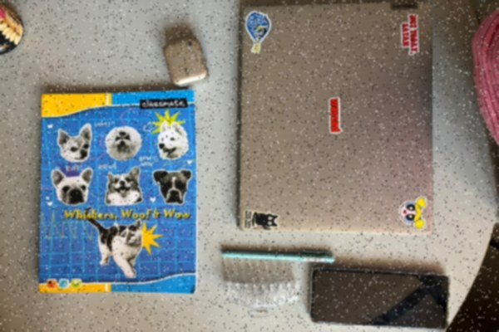  Figure 15: Salt-and-pepper + Gaussian filter (5×5). Dots are blurred, not removed.

Table 2: Restoration quality against the original image
Image | PSNR (dB) | SSIM
Gaussian noise (no filter) | 22.05 | 0.3596
Gaussian noise + median filter | 24.04 | 0.7111
Gaussian noise + Gaussian filter | 25.69 | 0.7321
Salt-and-pepper noise (no filter) | 19.35 | 0.4078
Salt-and-pepper + median filter | 24.48 | 0.8586
Salt-and-pepper + Gaussian filter | 24.92 | 0.6751

Thresholding and morphological operations
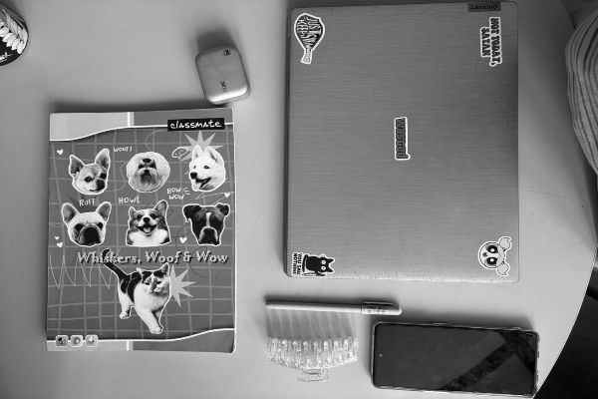  Figure 16: Grayscale image. Input to thresholding and Canny. | 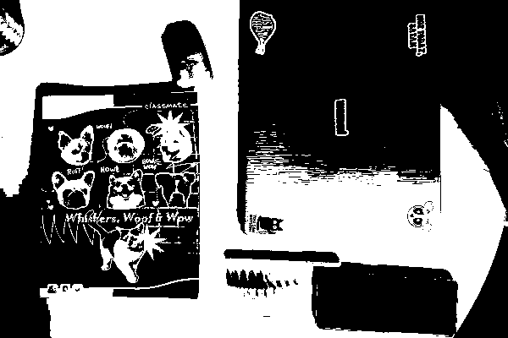  Figure 17: Otsu binary threshold (T = 133). Bright surfaces white, dark notebook cover black.

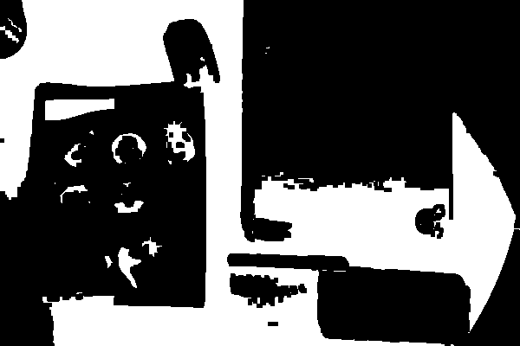  Figure 18: Erosion (5×5). White areas shrink. | 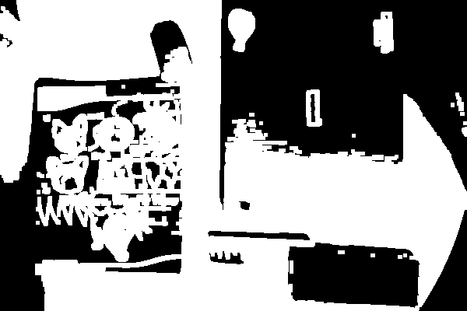  Figure 19: Dilation (5×5). White areas grow. | 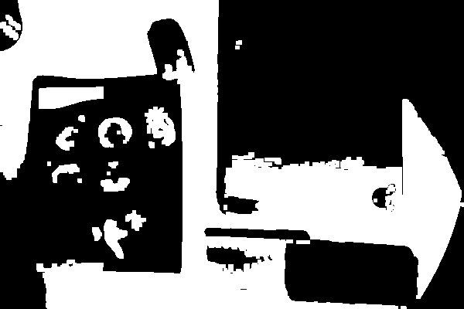  Figure 20: Opening (5×5). Small white specks removed.

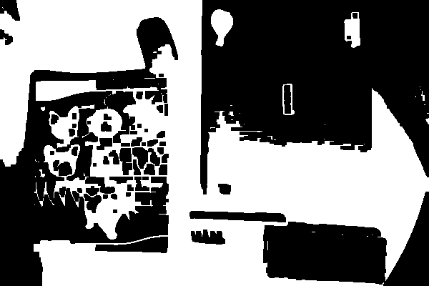
Figure 21: Closing (5×5). Small black gaps filled.

Edge detection
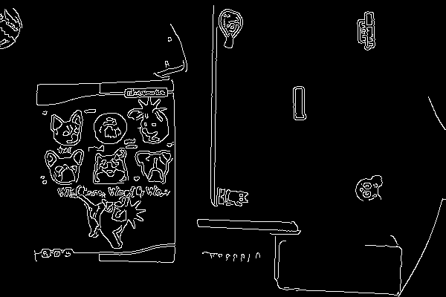
Figure 22: Canny edge map (thresholds 100 / 200). Outlines of the notebook, dog illustrations, laptop and phone.

Watershed segmentation
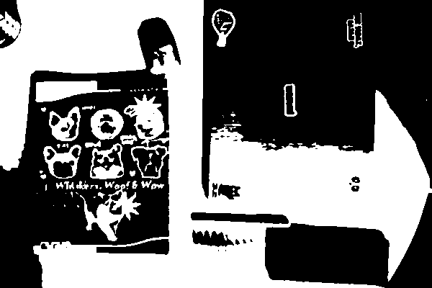  Figure 23: Binary foreground mask. | 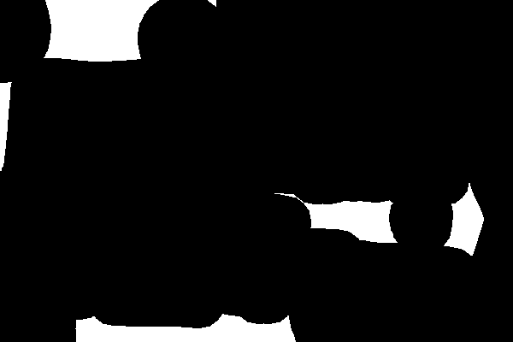  Figure 24: Sure foreground. Core of each object (distance transform > 35 % of max). | 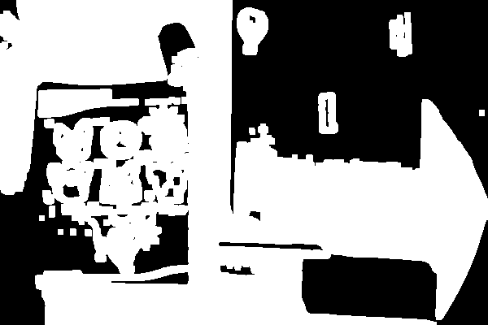  Figure 25: Sure background. Mask dilated 3 times.

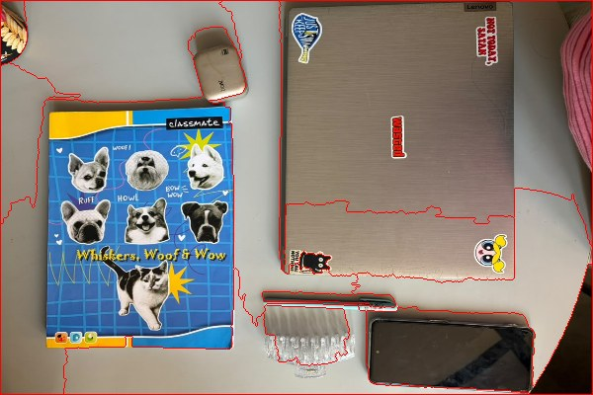  Figure 26: Segmented image. Region boundaries drawn in red. | 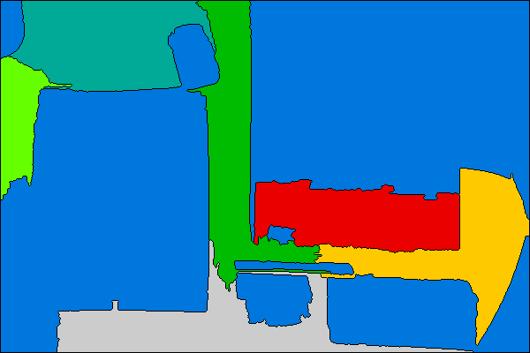  Figure 27: Watershed label map. 6 foreground markers gave 7 labelled regions including the background.

3.2 Task 2: Feature extraction and matching
Figure 28: Photograph 1 (600 × 400). | 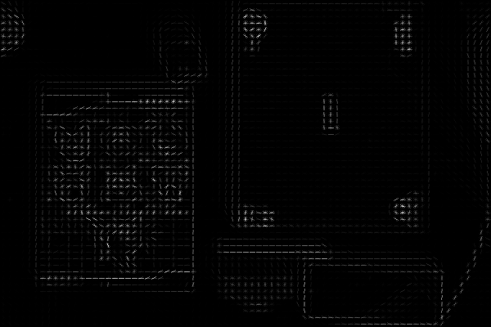  Figure 29: HOG visualisation. Short bars show the dominant gradient direction in each 8 × 8 cell; strongest along object edges.

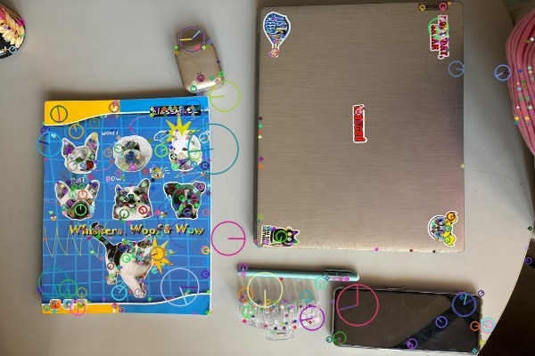  Figure 30: SIFT keypoints, image 1 (751 points). Circle size = scale, line = orientation. | 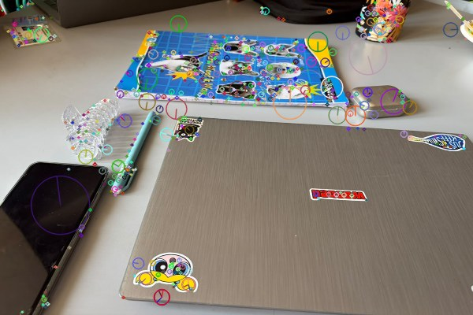  Figure 31: SIFT keypoints, image 2 (727 points).

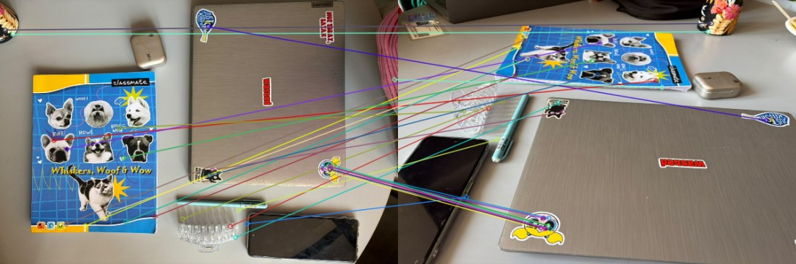
Figure 32: SIFT matches, original pair (31 good matches). Lines join matching keypoints in the two photographs.

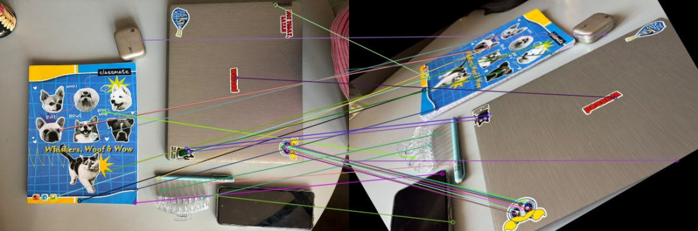
Figure 33: SIFT matches after rotating image 2 by 30° (30 good matches). Black corners appear because the rotated image is cropped to its original size.

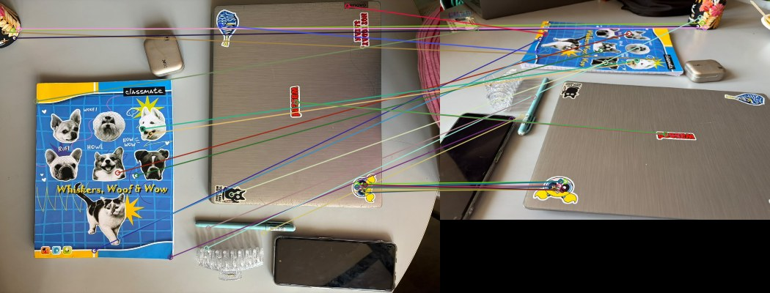
Figure 34: SIFT matches after resizing image 2 to 75 % (28 good matches).

Table 3: Feature extraction results
Quantity | Photograph 1 | Photograph 2
SIFT keypoints detected | 751 | 727
SIFT descriptor array shape | 751 × 128 | 727 × 128
HOG feature-vector length | 130,536 | not computed

3.3 Task 3: Face and object detection in video
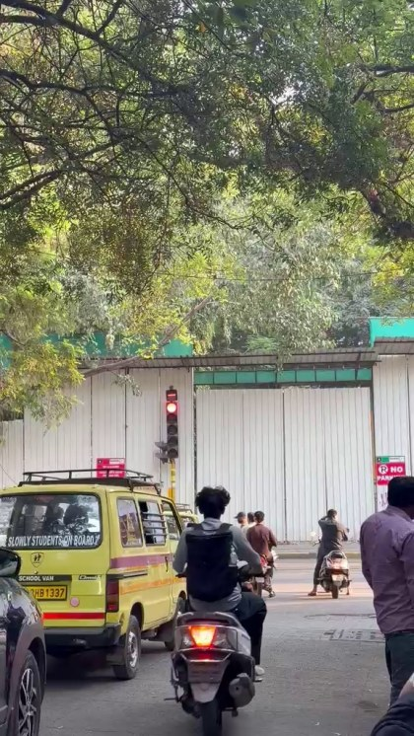  Figure 35: Viola–Jones result, frame 1. 0 faces detected, so no boxes are drawn. | 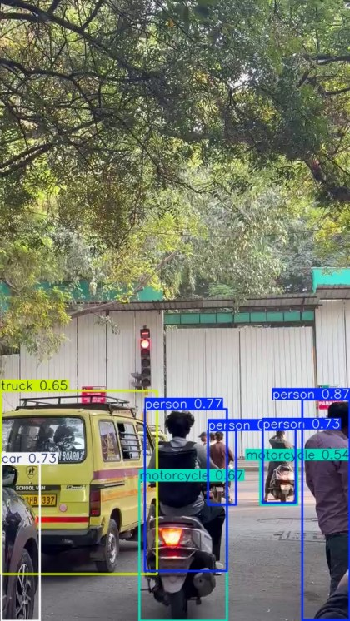  Figure 36: YOLOv8n result, frame 1. 8 objects detected with class and confidence.

Table 4: YOLOv8n detections on frame 1 (confidence threshold 0.25)
Object | Confidence | X1 | Y1 | X2 | Y2
person | 0.869 | 497 | 658 | 575 | 1022
person | 0.774 | 238 | 674 | 373 | 941
person | 0.731 | 432 | 707 | 486 | 829
car | 0.730 | 2 | 764 | 65 | 1023
person | 0.705 | 342 | 709 | 388 | 832
motorcycle | 0.674 | 229 | 792 | 373 | 1023
truck | 0.646 | 1 | 644 | 258 | 946
motorcycle | 0.539 | 428 | 758 | 489 | 832

Table 5: YOLOv8n detections across the five extracted frames
Frame | person | car | motorcycle | truck | traffic light | Total
1 | 4 | 1 | 2 | 1 | 0 | 8
2 | 4 | 2 | 1 | 1 | 1 | 9
3 | 5 | 2 | 1 | 0 | 0 | 8
4 | 5 | 1 | 2 | 0 | 0 | 8
5 | 5 | 2 | 1 | 0 | 0 | 8
All frames | 23 | 8 | 7 | 2 | 1 | 41

Mean confidence by class over all frames: car 0.70, truck 0.58, person 0.57, motorcycle 0.50, traffic light 0.30. The full detection list is saved in all_frame_detections.csv.

4. Explanation

4.1 Task 1: Image restoration and segmentation
Goal. Damage a clean photograph with two kinds of noise, try to repair it with two filters, measure how well the repair worked, and then split the image into meaningful parts.
Noise models. Gaussian noise adds a small random value to every pixel (here with standard deviation 0.08 on a 0–1 scale, roughly 20 grey levels), which looks like fine grain. Salt-and-pepper noise instead replaces a few pixels (4 % of the image size) with pure black or pure white, so it appears as isolated dots. A fixed random seed (42) makes the experiment repeatable.
Restoration filters. The Gaussian filter replaces each pixel with a weighted average of its 5×5 neighbourhood, which smooths everything, including edges. The median filter replaces each pixel with the middle value of its 5×5 neighbourhood, so extreme values such as black or white dots are simply thrown away.
Quality measures. PSNR (peak signal-to-noise ratio, in dB) summarises the average pixel error against the original, and higher is better. SSIM (structural similarity, 0 to 1) compares local structure such as edges and texture, and higher is better. Results are in Table 2: the Gaussian filter gave the best PSNR (25.69 dB, on Gaussian noise) and the median filter on salt-and-pepper noise gave the best SSIM (0.8586).
Segmentation techniques. Otsu thresholding automatically chooses the grey level (133 here) that best separates dark from bright pixels, producing a black-and-white image. Erosion, dilation, opening and closing then clean that binary image using a 5×5 block: erosion shrinks white regions, dilation grows them, opening (erosion then dilation) removes small white specks, and closing (dilation then erosion) fills small black holes. Canny edge detection blurs the image, finds strong intensity changes, and keeps thin edges between the thresholds 100 and 200. Watershed treats the image like a landscape: the “sure foreground” (cores of objects, found with a distance transform) and “sure background” are used as starting markers and the algorithm floods outward until the regions meet, marking boundaries in red.
Output obtained. The watershed step separated several areas (six foreground markers, seven labelled regions), but some large irregular regions remain because the result depends heavily on the quality of the markers and the single global threshold.

4.2 Task 2: Feature extraction and image matching
Goal. Describe the content of an image with numerical features, and check whether the same physical points can be found again in a second photograph of the scene.
HOG (Histogram of Oriented Gradients). The image is divided into 8×8-pixel cells; for each cell a 9-bin histogram records which edge directions are present. Cells are grouped in overlapping 2×2 blocks and normalised, giving a feature vector of 74 × 49 blocks × 36 values = 130,536 numbers. HOG describes the overall shape and edge layout, which is why the visualisation looks like a sketch of the scene.
SIFT (Scale-Invariant Feature Transform). SIFT finds distinctive points (corners and blobs) at several scales and describes each by a 128-number vector built from local gradient directions, so the description does not change much when the image is scaled or rotated. It found 751 keypoints in photograph 1 and 727 in photograph 2.
Matching. Every descriptor of image 1 was compared with all descriptors of image 2 using Euclidean distance (brute-force matcher). A match was kept only if the nearest neighbour was clearly better than the second nearest (Lowe’s ratio test, distance < 0.75 × second distance), which removes ambiguous matches. The original pair gave 31 good matches. To test robustness, image 2 was rotated by 30° and, separately, shrunk to 75 %, and the matching was repeated.
Output obtained. The match count only dropped from 31 to 30 (rotation) and 28 (scaling), so the matching stayed stable. One limit of this experiment: the ratio test does not prove that each surviving match is geometrically correct, and no outlier rejection such as RANSAC was applied, so the counts show how many matches survived the test and not how many were verified correct.

4.3 Task 3: Face and object detection in video
Goal. Take frames from a video and compare a classical face detector with a modern deep-learning object detector.
Frame extraction. The video was opened with OpenCV (330 frames at 25 fps) and five frames at equal spacing were saved (indices 0, 82, 164, 246 and 329).
Viola–Jones. This classical method slides windows of increasing size over the grayscale image and checks simple light/dark rectangle patterns (Haar features) using a cascade of fast classifiers that reject non-faces early. The frontal-face cascade was used with scaleFactor 1.1, minNeighbors 5 and a minimum size of 30×30 pixels. It found no faces in frame 1.
YOLOv8n. YOLO (“You Only Look Once”) is a convolutional neural network that looks at the whole image once and directly predicts boxes, class labels and confidence scores. The small pretrained model recognises the 80 COCO classes. With a confidence threshold of 0.25 it found 8 objects in frame 1 (4 persons, 2 motorcycles, 1 car, 1 truck) and 41 objects across all five frames.
Missed or incorrect detections (visual check of frame 1). Viola–Jones found nothing because the people in the frame are seen from behind or the side, are small, or are partly hidden, and this cascade only detects roughly frontal faces. In the YOLO result, the yellow school van is labelled “truck” (the COCO label set has no “van” class), and the red traffic light near the centre of frame 1 has no box; a traffic light is detected only once, in frame 2, with a low confidence of 0.30. Detections with confidence close to 0.25–0.35 (for example some persons in frames 3–5) should be treated with caution; only frame 1 was inspected on the annotated image.

5. Comparison

5.1 Median filter vs Gaussian filter
Table 6: Improvement over the unfiltered noisy image
Noise type | Filter | PSNR gain (dB) | SSIM gain | Better by
Gaussian | Median 5×5 | +1.99 | +0.3515
Gaussian | Gaussian 5×5 | +3.64 | +0.3725 | PSNR and SSIM
Salt-and-pepper | Median 5×5 | +5.13 | +0.4508 | SSIM (clearly)
Salt-and-pepper | Gaussian 5×5 | +5.57 | +0.2673 | PSNR (slightly)

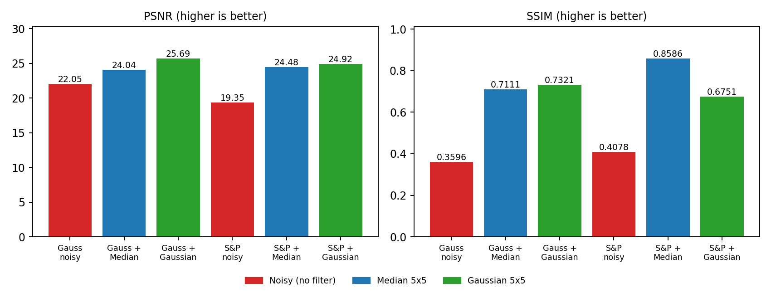
Figure 37: PSNR and SSIM for all noisy and restored images. Red = noisy, blue = median, green = Gaussian.

For Gaussian noise the Gaussian filter is the better match: averaging neighbours cancels random zero-mean noise, and it wins on both PSNR and SSIM. For salt-and-pepper noise the two metrics disagree. The Gaussian filter has a marginally higher PSNR (24.92 vs 24.48 dB) because averaging reduces the average pixel error, but it only blurs the black and white dots into their surroundings. The median filter removes the dots outright and keeps edges sharper, which shows up as a much higher SSIM (0.8586 vs 0.6751) and a visibly cleaner image, so the median filter is the better choice for impulse noise.

5.2 Morphological operations
Table 7: Effect of each operation on the binary image (5×5 kernel)
Operation | How it works | Visible effect in our outputs
Erosion | Keeps a pixel white only if the whole 5×5 neighbourhood is white | White regions shrink; thin white details inside the notebook cover almost disappear
Dilation | Makes a pixel white if any pixel in the neighbourhood is white | White regions grow and merge; gaps between the illustrations fill in
Opening | Erosion followed by dilation | Small white specks are removed while larger shapes keep roughly their size
Closing | Dilation followed by erosion | Small black holes and narrow gaps are filled while the overall shape is kept

5.3 SIFT matching under rotation and scaling
Table 8: Good matches for each experiment
Experiment | Good matches | Relative to original pair
Original image pair | 31 | 100 %
Image 2 rotated by 30° | 30 | 96.8 %
Image 2 resized to 75 % | 28 | 90.3 %

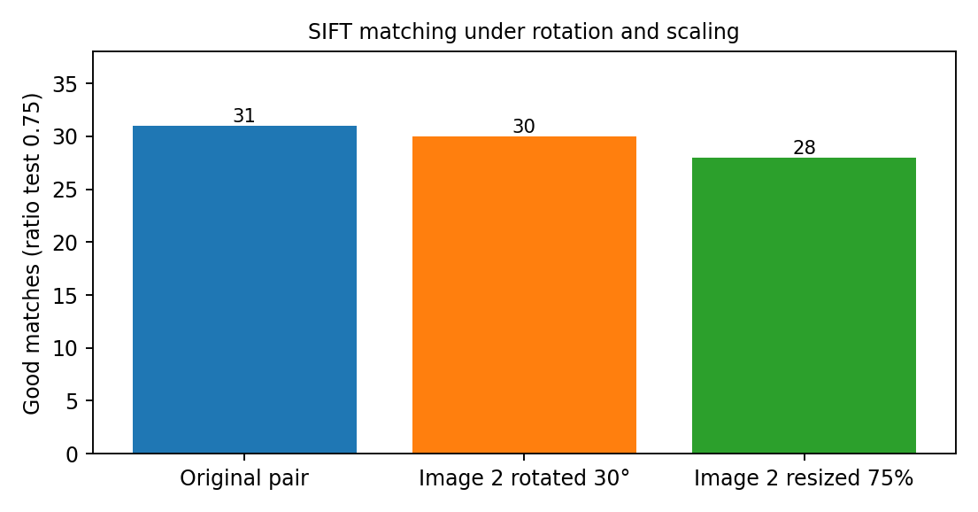
Figure 38: Number of good SIFT matches in each experiment.

Rotation barely affects the count, as expected from SIFT’s orientation assignment. Shrinking the image costs a little more (about 10 %), because some fine-scale keypoints no longer exist at the smaller size.

5.4 Viola–Jones vs YOLOv8n
Table 9: Comparison of the two detection methods
Aspect | Viola–Jones (Haar cascade) | YOLOv8n
Approach | Hand-designed Haar features with a boosted cascade of classifiers | Pretrained convolutional neural network (single pass)
Detects | Frontal faces only | 80 COCO classes (person, car, motorcycle, truck, traffic light, …)
Output | Boxes only | Boxes, class labels and confidence scores
Detections on frame 1 | 0 | 8 (4 person, 2 motorcycle, 1 car, 1 truck)
Strengths | Very light and fast; no GPU or large model file | Handles many object types, sizes and viewpoints
Limitations seen here | Missed people turned away from the camera or too small | School van labelled “truck”; red traffic light missed in frame 1; some low-confidence detections

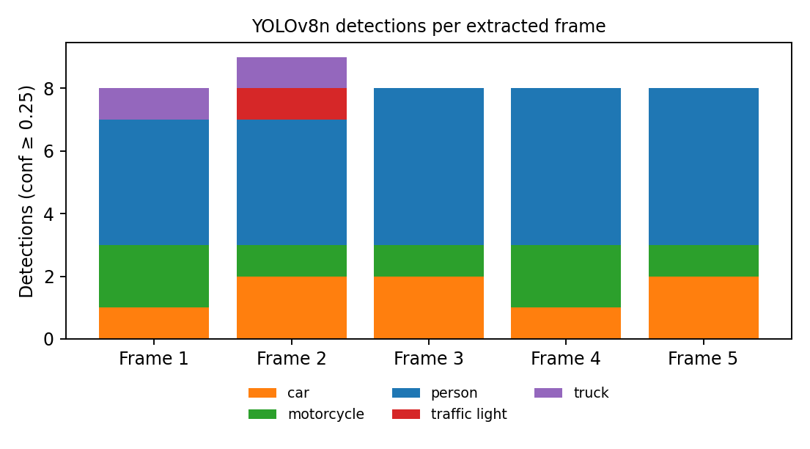
Figure 39: YOLOv8n detections per frame, split by class.

The two methods have different purposes, so the numbers are not a like-for-like score: Viola–Jones answers “is there a frontal face?”, YOLO answers “what objects are here?”. On this traffic video, whose subjects are mostly seen from behind or the side, the face detector had nothing to find while YOLO gave a useful description of the scene.

6. Conclusion
Three tasks were carried out on two photographs and one video. In Task 1, Gaussian filtering worked best for Gaussian noise (25.69 dB PSNR, SSIM 0.7321), and the median filter worked best for salt-and-pepper noise when judged by SSIM (0.8586) and by eye; Otsu thresholding, morphology, Canny edges and watershed then produced binary masks, edge maps and a region segmentation, although watershed left some large irregular regions. In Task 2, HOG produced a 130,536-value descriptor, SIFT found 751 and 727 keypoints, and ratio-test matching gave 31 good matches that fell only to 30 after a 30° rotation and 28 after 75 % scaling. In Task 3, Viola–Jones found no faces in the traffic frame, whereas YOLOv8n detected 8 objects in frame 1 and 41 across five frames, with a few misclassifications and misses.
Table 10: Summary of key results
Task | Techniques | Main result
1. Restoration and segmentation | Gaussian / salt-and-pepper noise, median and Gaussian filters, PSNR, SSIM, Otsu, morphology, Canny, watershed | Best PSNR 25.69 dB (Gaussian + Gaussian filter); best SSIM 0.8586 (salt-and-pepper + median filter)
2. Features and matching | HOG, SIFT, brute-force matching with ratio test | 31 / 30 / 28 good matches (original / rotated / resized)
3. Video detection | Frame extraction, Viola–Jones, YOLOv8n | 0 faces vs 8 objects on frame 1; 41 YOLO detections over 5 frames

Limitations
- Photographs were resized to 600 × 400 px, which changes the 4:3 aspect ratio of the originals.
- Filter sizes and thresholds (5×5 kernels, Canny 100/200, 35 % watershed marker) were fixed and not tuned; each experiment used one image or one video.
- SIFT matches were not geometrically verified, and the detection results have no ground-truth labels, so the detection analysis is based on visual inspection of frame 1 plus the confidence scores.

