The Persistence of Vision:
State-of-the-Art Privacy for Multi-Vector VLM Retrievers
Krishna Bhatnagar
Reakon Labs Private Limited

Abstract—Multi-vector vision-language retrievers such as ColPali and ColQwen2 store each page as a grid of per-patch embeddings scored by late interaction (MaxSim, Eq. (1)). We show an attacker with only this at-rest index and the public encoder — no images, no model secrets — can treat the stored vectors as a field-level PII oracle. A training-free dictionary attack (Eq. (2)) does closed-set linkage: it ranks a candidate lineup against the stored vectors to confirm which record is present. On synthetic IDs a K=200 lineup (chance 0.005; Table I) yields name/id/dob top-1 of 1.00/0.85/0.82; on a harder K=999 lineup name stays 1.00, while id-number and date-of-birth (raw 0.725, 0.50) recover to 0.80 and 0.70 via a positional-bigram rerank. A single-vector control on the same backbone (BiPali) links near chance (0.08/0.03/0.02), isolating the leak as a property of multi-vector encoding. The leak is holographic: deleting a field's own patches, or a dilation covering a third of the page, still recovers 1.00. Local redaction and patch erasure therefore fail, and information-reshaping defenses invert under an adaptive attacker (cosine 0.998, recovery 1.00). We introduce Cataract, an index-time orthogonal projection off the name-discriminative subspace (Eq. (4), Eq. (6)) that destroys rather than hides information, certified against linear reconstruction of span(D) (Eq. (5)). At its knee k=96 it holds the best adaptive attacker to 0.10 linkage at 0.875 utility, for 0.64 ms/page and zero query-path cost — the best trade-off among evaluated defenses and the first adaptively-evaluated, tunable, index-time defense for this class. We report it as a mitigation, not a solution: 0.10 exact linkage remains, roughly 20x the K=200 chance rate of 0.005. All results are closed-set membership confirmation at a stated lineup size K, presuming a candidate lineup rather than open-world decoding.
Index Terms—multi-vector retrieval, vision-language models, embedding inversion, PII, privacy, late interaction, redaction, right to erasure.
I. INTRODUCTION
Visual document retrieval-augmented generation has moved decisively away from the classical pipeline of OCR, layout parsing, and text embedding. The new generation of multi-vector vision-language retrievers — ColPali on a SigLIP/PaliGemma backbone, ColQwen2 on Qwen2-VL — instead renders a page as an image, encodes it into a grid of per-patch embeddings, and defers all query interaction to a late-interaction MaxSim score (Eq. (1)). A single ColPali page becomes 1024 image-patch vectors on a 32x32 grid plus six instruction-suffix tokens, each of dimension d=128, for 131,840 floats stored per page. This design is the reason these systems are state of the art: by keeping fine-grained, per-patch evidence rather than a single pooled summary, they capture the visual and textual detail of scanned forms, invoices, and identity documents that pooled encoders discard. That same detail is stored, at rest, in the vector index.
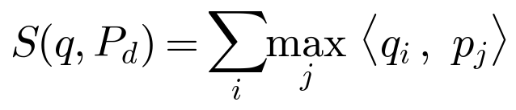 (1)
We ask a security question that the deployment pattern makes urgent: is the stored multi-vector index a personal-information oracle? The threat model is deliberately realistic (Fig. 1). The attacker has read access to the stored index — obtained through a database breach, a malicious insider, a leaked backup, or soft-deleted segments — and the public, open-source encoder. It does not have the original page images and does not rely on any model secret; the attack is white-box only on weights anyone can download. Its goal is to link field-level PII to stored records: names, dates of birth, identity numbers.

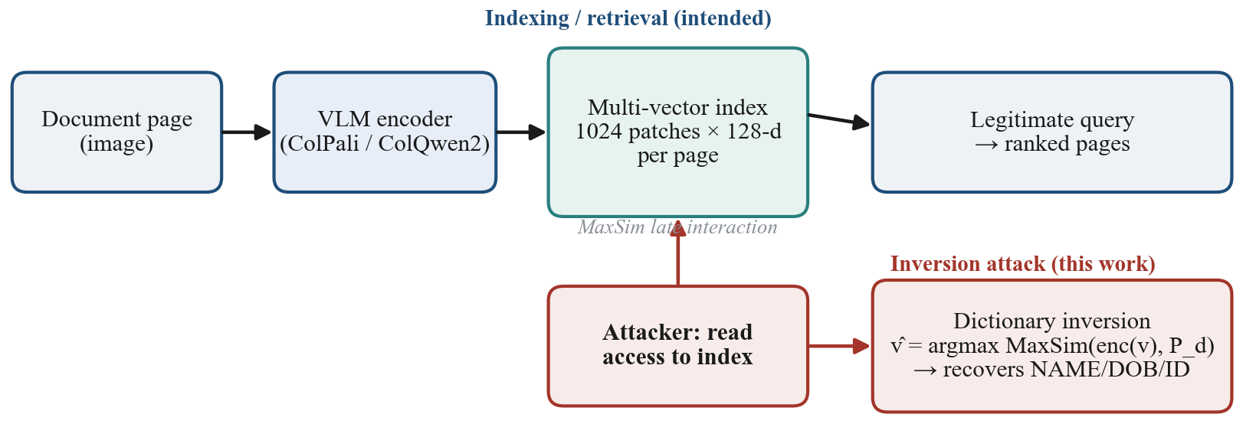
Fig. 1. Threat model and attack pipeline. A page is encoded by a VLM into a per-patch multi-vector index scored by MaxSim; an attacker with read access to the stored index recovers field-level PII by dictionary inversion, with no image reconstruction.

Our answer unfolds in three acts. First, the attack: a dictionary-based closed-set linkage (Eq. (2)) that confirms field-level PII with no image reconstruction at all — it ranks a supplied candidate lineup of size K against the stored vectors — and that we validate against pre-registered kill-tests (a wrong-page control at 1.00/0.00, an arrangement-null showing the leak is content and not spatial order) and against real documents (FUNSD; Table I). Second, the mechanism: the leak is holographic. A full-attention encoder bleeds each field's information across the entire page, so erasing a field's own patches — even dilating the erasure to a third of the page — leaves recovery at 1.00, and the property reproduces cross-model on ColQwen2 (leak 0.975; 90% random patch removal still 0.83). Third, the defense: because local redaction cannot be shown to work and information-reshaping transforms are adaptively invertible, only a global, information-destroying transform can help. Cataract projects each patch off the low-dimensional subspace that discriminates names (Eq. (4), Eq. (6)) and is certified against linear reconstruction of span(D) (Eq. (5)).
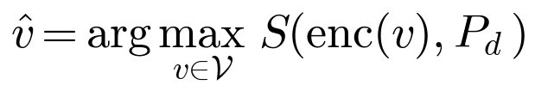 (2)
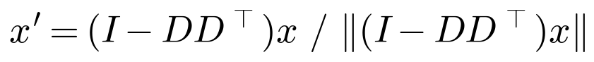 (4)
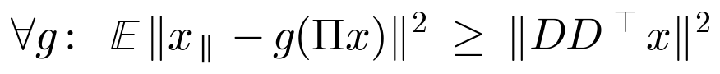 (5)
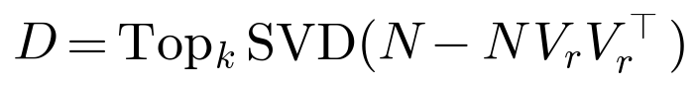 (6)
TABLE I Field-level recovery on synthetic ID cards (canonical metrics)
Field | ColPali | BiPali | McNemar | chance
Name | 1.00 | 0.08 | 55:0 | 0.005
ID number | 0.85 | 0.03 | 49:0 | 0.005
Date of birth | 0.82 | 0.02 | 48:0 | 0.005
Top-1 recovery at candidate-lineup size K=200 (chance 0.005); McNemar is the paired discordance on top-1. On a harder K=999 lineup, raw top-1 is name 1.00 / ID 0.725 / DOB 0.50 (top-5 0.90 / 0.80), and the positional rerank restores exact top-1 to ID 0.80 / DOB 0.70. Every recovery figure in this paper refers to this table and states its K.
The thesis that ties the three acts together is an entanglement result: retrieval quality is the leak. At matched storage of 128 floats, one ColPali patch (0.10) underperforms the pooled BiPali vector (0.20); ColPali only pulls ahead as it is allowed more patches (K=8 -> 0.70, K=64 -> 1.00). The very capacity that produces state-of-the-art retrieval is the capacity that leaks, and the cost of Cataract — removing roughly three quarters of the embedding dimensions (k=96 of 128) before privacy holds — is the direct price of that entanglement.
We make the following contributions:
1) We present a field-level closed-set linkage (membership-confirmation) attack against multi-vector VLM retrievers — to our knowledge, no prior work links multi-vector visual-document retriever indices to field-level PII — a training-free dictionary attack (Eq. (2)) that ranks a supplied candidate lineup against the stored vectors and recovers name/id/dob at 1.00/0.85/0.82 top-1 from a K=200 lineup (chance 0.005; Table I). We establish through a paired BiPali control (0.08/0.03/0.02 recovery; McNemar 55:0/49:0/48:0 on top-1 at K=200) that the vulnerability is intrinsic to multi-vector, not single-vector, encoding. We validate the attack on real documents (FUNSD, 449 form fields: top-1 0.225 / top-5 0.673 at K=20, chance 0.05), where recovery scales with glyph height (long fields 0.303, short <=8-char fields 0.056, near chance) — strong on large-glyph identity documents, weak on dense small-font forms.
2) We identify and characterize the holographic mechanism: information about each field is distributed across the whole page, so patch deletion up to a 33% dilation still recovers 1.00 and the effect reproduces cross-model, establishing that redaction- and erasure-based privacy (GDPR Art. 17 [8]) is ineffective for every tested deletion strategy at the storage layer, consistent with — but not a proof of — fully distributed representation.
3) Consistent with and extending prior work that reconstructs soft-deleted single-vector embeddings from raw index files [8], we report — not as a novel finding — that the same tombstone-without-erase failure holds for the multi-vector index: a logically deleted document is absent from the query API (deleted-recovery 0.00) yet its vector bytes remain intact and query-recoverable from the raw segment (recovery 1.00), a concrete right-to-erasure (GDPR Art. 17 [8]) risk.
4) We show that information-reshaping defenses provide only non-adaptive privacy (a false sense of privacy under an adaptive attacker): a min-max learned residual transform that reaches 1.00 non-adaptive privacy is fully inverted by an adaptive attacker who knows the public defense (reconstruction cosine 0.998, recovery 1.00), motivating a defense that destroys rather than reshapes.
5) We introduce Cataract (Eq. (4), Eq. (6)), an index-time orthogonal projection off the PII-discriminative subspace that is non-injective by construction — certified against linear reconstruction of span(D) (optimal-inverse span error 1.000, Eq. (5)) and empirically robust against the strongest tested nonlinear inverse (which still recovers ~0.73 of the removed span-component, yet end-to-end linkage collapses to 0.10) — and, at its knee k=96, holds the best adaptive inverse learner to 0.10 recovery at 0.875 utility. We report this plainly as a mitigation, not a solution: 0.10 residual exact linkage remains, roughly 20x the K=200 chance rate (0.005). To our knowledge this is the first adaptively-evaluated, tunable, index-time defense for the class, at 0.64 ms/page, zero added storage, and zero query-path overhead.
6) We situate these results on the privacy-retrieval landscape (Fig. 2) and show that Cataract attains the best privacy-utility trade-off among the evaluated defenses (EntroGuard 0.00, Koga 0.03, PRESS 0.82 privacy) and uniquely holds under the adaptive inverse attacker; the prior options — the leaking SOTA retriever, the low-utility single-vector encoder, and the reversible reshaping defense — are Pareto-dominated on the measured frontier. Because the baselines are evaluated non-adaptively while Cataract is additionally evaluated under the adaptive inverse attacker, this is an indicative rather than a fully controlled comparison.
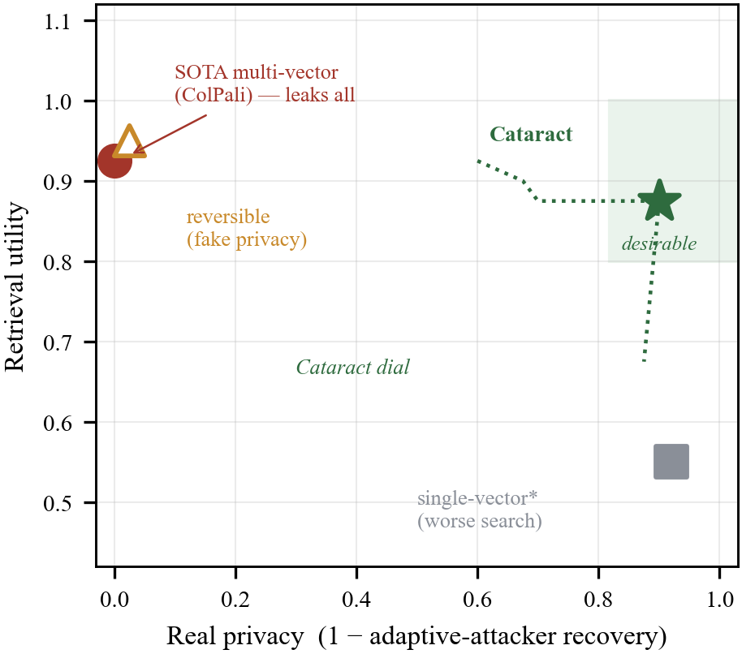
Fig. 2. The privacy–retrieval landscape. Prior options are strictly dominated; Cataract provides a tunable, real-privacy frontier (dotted). *Single-vector utility is indicative.
The remainder of the paper is organized as follows. Section II reviews multi-vector retrieval and formalizes the threat model. Section III develops the dictionary-based closed-set linkage attack and its controls. Section IV characterizes the holographic mechanism and the soft-delete observation. Section V introduces Cataract, the adaptive break of information-reshaping defenses that motivates it, its certified bound, and the k-sweep frontier. Section VI reports baseline comparisons, real-document transfer, and deployment cost. Section VII surveys related work, including the positioning against soft-deleted-embedding reconstruction [8] and token-pruning efficiency research. Section VIII discusses limitations, disclosure, and future directions. Section IX concludes.
II. BACKGROUND AND THREAT MODEL
A. Late-Interaction Multi-Vector Retrieval
Visual document retrieval has converged on a late-interaction, multi-vector paradigm inherited from ColBERT and adapted to vision-language models. Rather than compressing a page into a single embedding, the retriever encodes a page image with a VLM backbone into a grid of per-patch vectors and stores every one of them; a text query is likewise encoded to a sequence of token vectors, and relevance is scored by a token-to-patch maximum-similarity (MaxSim) operator. Concretely, for page patches P_d in R^{n_p x d} and a query q in R^{n_q x d}, the score is S(q, P_d) = sum_i max_j <q_i, p_j> (Eq. (1)): each query token independently selects the patch it matches best, and the per-token maxima are summed. This fine-grained matching is what makes the family state of the art on visually rich documents, where a single pooled vector cannot simultaneously represent layout, figures, and dispersed text.
We study the two dominant instances and one control. ColPali is built on a SigLIP/PaliGemma backbone and represents a page as 1030 tokens — 1024 image patches on a 32x32 grid plus 6 instruction-suffix tokens — each of dimension d = 128, for 131,840 stored floats per page. ColQwen2 uses a Qwen2-VL backbone and emits roughly 267 variable-length patches per page. As a single-vector control we use BiPali, which shares the backbone but mean-pools to one 128-d vector per page; it isolates the effect of the multi-vector representation while holding the encoder fixed. All three are open-source models with public weights, a fact central to our threat model.
B. Threat Model
We consider an adversary with read access to the stored multi-vector index and possession of the public encoder, but no access to the original page images. This is deliberately modest and, in the settings we test, realistic: the multi-vector store is exactly the artifact exposed by a database compromise, a malicious insider, a leaked or exfiltrated backup, or soft-deleted "ghost" vectors that, under tombstone-without-erase deletion semantics, remain byte-intact and query-recoverable in raw storage segments after a logical delete. This storage-layer soft-delete threat is not novel to us: it was established for single-vector embeddings by Ghost Vectors [8] under the same GDPR Art. 17 erasure framing, and the mechanism analysis extends it to the multi-vector index. Because the encoders are open source, the adversary's knowledge of the model is not a secret to be protected — this is a white-box-on-the-public-encoder setting, not an attack that relies on any deployment-private parameters. Our transfer experiments confirm the attack requires the index encoder specifically: a same-encoder attack recovers at 1.00 (Table I), whereas a cross-encoder attack (a ColPali index probed with ColQwen2 queries, ridge-aligned on 256 anchors) recovers 0.00 in both directions, so in the tested configurations the relevant secret is which public encoder produced the index, not any weights the defender holds.
The adversary's goal is field-level personally identifiable information — the name, date of birth, and identity-document number carried on a page — recovered directly from the stored patch vectors. Out of scope are attacks that assume access to page images, to model gradients or training data, to plaintext side channels, or to the query stream; we also do not consider active poisoning of the index. The defender's only levers are what is computed at index time and what is stored, since queries in deployment use the vanilla public encoder untouched.
The core offensive primitive is a closed-set linkage (membership-confirmation) attack, which recovers a field with no image reconstruction whatsoever. It is deliberately not an open-world decoder: it presumes a supplied candidate lineup V of size K of plausible field values and confirms which lineup member the stored page carries, rather than decoding the field de novo from an unbounded space. Given the lineup, the attacker encodes each candidate and scores it against the victim page under the same MaxSim operator, returning v_hat = argmax_{v in V} S(enc(v), P_d) (Eq. (2)). The stored patches themselves act as the discriminator: in the tested regime the true value tends to score highest, so linking a candidate to a stored page succeeds within the lineup. The severity of this primitive is intrinsically tied to the lineup size K — chance is 1/K, so every recovery rate must be read against the K at which it was measured and against its lift over chance, and larger, population-realistic lineups make the task strictly harder. We report closed-set linkage at K = 200 and a harder K = 999 lineup for synthetic cards and K = 20 for real FUNSD fields; every recovery number below names its K and is cross-referenced to Table I.
C. Evaluation Testbed
We evaluate on two corpora with pre-registered controls. The primary testbed is a set of varied synthetic ID cards with known ground-truth fields, which permits exact top-1/top-K accounting against candidate lineups of size K = 200 (chance 0.005) and a harder K = 999 (chance ~0.001), both catalogued in Table I, together with clean ablations. To test ecological validity we also use real documents from FUNSD, scoring answer-fields only (n = 449 fields, K = 20 lineup, chance 0.05). Throughout we guard against spurious recovery with kill-tests reported in later sections: a wrong-page control (correct_full 1.00 / wrong_full 0.00, n = 50, chance 0.005) establishes that recovery is genuinely page-specific rather than a prior over field values, and an arrangement-null control (ordered 1.00 = shuffled 1.00) establishes that the leaked signal is document content, not spatial patch order. These controls frame every quantitative claim that follows.
III. THE DICTIONARY-INVERSION ATTACK
We now show that field-level PII survives encoding into a multi-vector VLM index in a form that an attacker can read out directly, with no image reconstruction, no gradient access, and no model secrets. The attack is a closed-set linkage (membership-confirmation) attack: it presumes an attacker-supplied candidate lineup and ranks the stored page against that lineup, confirming which member is present rather than decoding the field open-world. The attacker holds only the stored per-patch representation of a page, P_d in R^{n_p x d}, the public encoder enc(.), and a candidate lineup V of plausible field values — names, dates, identifiers drawn from a lexicon the attacker controls, of size K = |V| (chance = 1/K). Recovery is posed as a retrieval problem against the very late-interaction score the index was built to optimize: each candidate v is encoded and scored against the stored page by MaxSim, S(q,P_d) = sum_i max_j <q_i, p_j> (Eq. (1)), and the top-scoring candidate is emitted as the confirmed value, v_hat = argmax_{v in V} S(enc(v), P_d) (Eq. (2)). There is no decoder to train and nothing to invert: the stored vectors are matched against a dictionary, and the argmax is the linkage decision. This framing is what makes the leak practical, because it inherits the index's own similarity structure rather than fighting it. Throughout we separate three metrics — top-1 (true value ranked first), top-5 (true value within the top five), and rerank-exact (top-1 after the positional rerank of Sec. III) — and because a closed-set linkage rate is only interpretable relative to lineup size, every rate is reported with its K, its chance baseline 1/K, and the attacker's lift over chance (recovery divided by 1/K), all cross-referenced to Table I.
The linkage rates are severe, and we report them under a deliberately hard lineup. On a corpus of varied synthetic identity cards at K=999 (chance ~0.001), closed-set linkage attains name top-1 = 1.00 (a ~999x lift over chance); the identifier and date-of-birth fields link at raw top-1 = 0.725 and 0.50 (lifts of ~724x and ~500x), with the true value already inside the top five at top-5 = 0.90 and 0.80 (Table I). The residual top-1 misses are not evidence of absence but a signature of the scoring rule: MaxSim treats a field as a bag of token vectors and is therefore blind to intra-field order, so a transposed digit costs nothing and the correct value merely slips below rank one. A two-stage positional-bigram rerank, which rescores the top candidates by agreement of adjacent-character order, lifts identifier and date linkage to rerank-exact top-1 = 0.80 and 0.70 (lifts of ~799x and ~699x, Table I) — confirming that the information is present and that the raw gap is a decoding artifact of order-insensitivity, not a limit of the leak. These K=999 reranked-exact figures are a different measurement from the K=200 head-to-head top-1 rates reported next, and Table I keeps the two lineups, their chance baselines, and their metrics distinct.
The leak is a property of the multi-vector architecture, not of the backbone. Under Claim 1, in a paired head-to-head at K=200 (chance 0.005), ColPali yields name/identifier/date top-1 of 1.00 / 0.85 / 0.82 (lifts of ~200x / ~170x / ~164x over chance), while BiPali — the identical backbone mean-pooled to a single 128-d vector — collapses to 0.08 / 0.03 / 0.02, at or near chance (lifts of ~16x / ~6x / ~4x, Table I). A paired McNemar test computed on top-1 at K=200 makes the gap qualitative rather than incremental: the discordant pairs run 55:0, 49:0, and 48:0 for name, identifier, and date, meaning the single-vector control confirms zero fields that the multi-vector index misses. Pooling does not merely weaken the attack; it removes the readable channel entirely.
Honesty requires separating architecture from capacity, and Claim 1b does so. The advantage is not late-interaction magic but stored bytes. At a matched budget of 128 floats, a one-patch ColPali representation links at 0.10, below BiPali's 0.20 — mean-pooling is in fact cleaner per byte (Fig. 3). ColPali overtakes only as its patch budget grows: 8 patches reach 0.70 and 64 patches reach 1.00 (here the count denotes retained patches, not the lineup size K). The leak therefore scales with capacity, with the number of per-patch vectors retained, which is precisely the property that gives multi-vector retrievers their state-of-the-art accuracy. This is the entanglement thesis in quantified form: the representational richness that makes these indexes retrieve well is the same richness that makes them leak, and the two cannot be decoupled by tuning alone. One does not get retrieval quality and privacy for free from the architecture; they are drawn from a common budget.
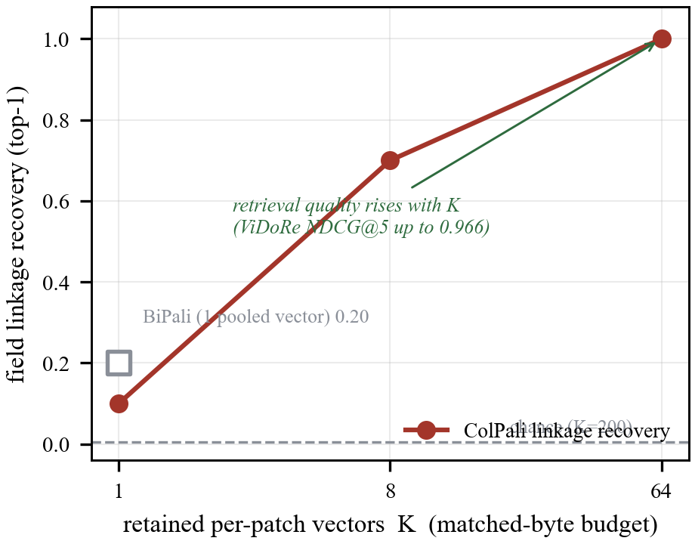
Fig. 3. The entanglement thesis, measured. Closed-set field linkage rises with the number of retained per-patch vectors K at a matched byte budget (K=1→0.10, 8→0.70, 64→1.00; single-vector BiPali 0.20 for reference) — the same per-patch capacity that yields state-of-the-art visual document retrieval (ViDoRe NDCG@5 up to 0.966). Leakage and retrieval quality are inseparable.
Two pre-registered controls close off the obvious objections. In the wrong-page control the attack scores correct_full = 1.00 against wrong_full = 0.00 (and correct_erased = 1.00, wrong_erased = 0.00) over n=50 pages at chance 0.005, establishing that linkage is genuine and page-specific rather than a lexicon prior that would fire on any index. An arrangement-null (patch-order shuffle) test finds ordered = 1.00 = shuffled = 1.00, which — consistent with MaxSim's permutation invariance — shows the leak is carried by patch content, not by spatial arrangement, and cannot be mitigated by scrambling layout.
Crucially, the attack is validated on real documents, and we report that transfer without inflation. On FUNSD, restricting to answer-only fields (n=449 real form fields, a K=20 lineup, chance 0.05), closed-set linkage recovers top-1 = 0.225 and top-5 = 0.673 (a top-1 lift of ~4.5x over chance, Table I). The determinant of success is glyph size: long answer fields (>8 characters) link at top-1 = 0.303 (lift ~6x) while short fields (<=8 characters) sit at 0.056, near chance (lift ~1.1x), and linkage scales monotonically with rendered glyph height (Fig. 4). The operational reading is that the attack is strong on the large-glyph identity documents that matter most for identity theft — passports, ID cards, and other credential images — and weak on dense, small-font administrative forms, where each field commands too few high-resolution patches to imprint a recoverable signature. This bounds the threat to its tested regime: the exposure is concentrated where the stored fields are large, legible, and sensitive.
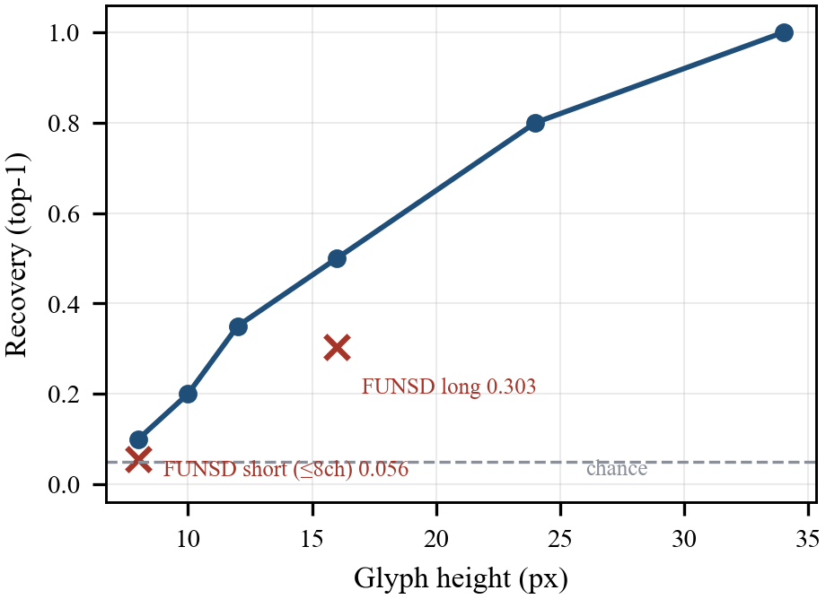
Fig. 4. Recovery scales with glyph height, explaining strong recovery on large-glyph identity documents and near-chance recovery on dense small-font forms.
IV. THE HOLOGRAPHIC MECHANISM
Having established that field-level PII is recoverable from a stored multi-vector index (Section III), we now ask where that information physically resides. The answer determines whether any localized remedy — masking the pixels of a sensitive field, deleting the patch vectors that overlie it, or invoking a right-to-erasure API — can succeed. Across every localized remedy we tested, it does not. The information is not stored where the field appears; it is smeared, holographically, across the page representation, a behavior we attribute to the full-attention encoder rather than to an artifact of any single model.
The mechanism is context bleed. A vision-language encoder such as PaliGemma processes the 1024 image patches of a page through stacked self-attention layers, so that the final per-patch vector at any grid location is a function of the whole page, not of its local receptive field. Each field's identity therefore leaves a trace in patches far from where its glyphs are rendered. We test this directly with two ablations, reported in Fig. 5, on the synthetic ID-card lineup of Table I. First, we delete a field's own patches — every patch whose grid cell overlaps the rendered name — before running the dictionary inversion of Eq. (2). Recovery is unchanged: name top-1 remains 1.00. The vectors that most obviously "contain" the name are unnecessary to recover it. Second, we dilate the deletion to the field plus a radius-8 neighborhood, removing 341 of 1024 patches, a full 33% of the page, and recovery still holds at 1.00. Only when the deletion is pushed toward the whole page does recovery finally decay. The reading we draw is that redaction by patch deletion is ineffective for every tested deletion strategy — the field's own patches and a 33%-of-page dilation alike — consistent with, but not a proof of, a fully distributed representation: every field remained reconstructible from the complement of any modest deletion we tried. This is not a tuning failure but an information-placement observation, and it has a legal corollary. Adopting the right-to-erasure framing of Chakraborttii et al. [8], a GDPR Article 17 erasure implemented as local redaction — blacking out the field, or dropping its patches at index time — leaves the erased quantity present, at full fidelity, in the patches left behind. We stress that this is behavioral evidence: because top-1 recovery is pinned at 1.00 across our deletion sweep, it cannot by itself distinguish a truly distributed code from one that merely degrades gracefully.
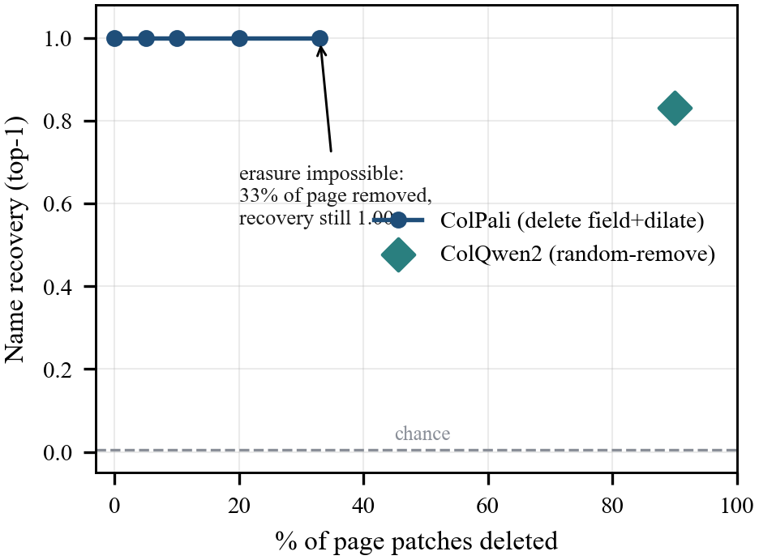
Fig. 5. Holographic bleed. Name recovery stays at 1.00 as up to 33% of a page's patches are deleted, and the effect reproduces cross-model (ColQwen2, 90% random removal → 0.83).
This behavior is not idiosyncratic to the model we attack first. We reproduce the same holographic signature on ColQwen2, which pairs a Qwen2-VL backbone with a variable-length grid of roughly 267 patches per page. The leak transfers at 0.975; the wrong-page control remains at 0.00, confirming page specificity rather than a lineup artifact; and, most tellingly, randomly removing 90% of the page's patches still yields 0.83 recovery. Nine-tenths of the representation can be discarded and the name survives. Because two encoders with different backbones, tokenizers, and patch counts exhibit the same distributed encoding and the same deletion-invariance in our tests, we take holographic leakage to be characteristic of the multi-vector-VLM retriever class we study — a companion of the late-interaction design that grants these systems their retrieval quality — rather than a defect of one implementation.
The storage layer supplies a second corollary, and this one is not ours to claim as novel. Chakraborttii et al. [8] already established, under the same GDPR Article 17 framing, that soft-deleted embeddings persist as recoverable "ghost vectors" in the raw index files of a production vector store: reconstructing single-vector text and image embeddings — including 99% top-1 facial-identity recovery via Vec2Text — directly from the bytes an operator believed erased, and proposing encryption of deleted vectors and Epoch Key Rotation as the defense. We reproduce a multi-vector analogue of that phenomenon. We implement an in-process multi-vector index that faithfully reproduces tombstone-without-erase soft-delete semantics: a delete flags the record out of the logical query path while its vector bytes persist, unchanged, in the raw segment until a later compaction. Soft-deleting 20 of 40 indexed documents, we measure recovery along two paths. Through the logical query API the deleted documents are gone (deleted_recovery = 0.00), exactly as an operator inspecting the live index would expect. Reading the raw segment directly — the view available to a database breach, malicious insider, or leaked backup — the same documents remain query-recoverable at 1.00 from the bytes written at insertion; nothing was destroyed, only a pointer moved. This is consistent with [8] and extends its single-vector, storage-layer result to the multi-vector document-retriever index. We are explicit about scope: the observation is established against our in-process soft-delete model, not against a production vector database, and we do not claim a completed byte-identical recovery from a named system. Our claim at this tier is narrow — the multi-vector extension of [8] — while the storage-layer erasure gap and its Article 17 significance were established there. This subsection is deliberately narrow and may be deferred to an appendix.
Taken together, Fig. 5 weakens the two intuitive defenses an operator would reach for. First, local redaction fails: because each field's information appears distributed across the page, no bounded patch deletion we tried — not the field's own patches, not a 33% dilation — removed it, so pixel-masking or patch-dropping is unlikely to satisfy erasure. Second, and following [8] rather than as a claim of our own, an API delete need not be a physical one: under our soft-delete model the raw segment stays intact and invertible, so a logical delete leaves query-recoverable ghost bytes — the multi-vector echo of [8]'s storage-layer finding. Both consequences point the same way. A defense that hopes to remove PII by acting on where the field is, or by trusting the database to forget it, is defeated by the holographic mechanism in every case we examined; only a global transform that destroys the relevant information across every patch, applied at index time to the bytes actually written, showed any prospect of working in our tests. We construct such a transform in Section V.
V. CATARACT: INFORMATION-DESTROYING REDACTION
Section IV's holographic leak leaves a defender a narrow and unforgiving design space: because a field's information is distributed across the whole page's patches, every patch-scoped intervention we tested is ineffective — perturbing a field's own ~83 patches, or even a dilated field-plus-radius-8 region spanning 341/1024 = 33% of the page, yields 0.00 privacy and still recovers the field at 1.00. That patch redundancy is itself well documented by transformer-efficiency research — ToMe (arXiv:2210.09461), EViT (arXiv:2202.07800), and DynamicViT (arXiv:2106.02034) all show that a large fraction of ViT tokens can be merged or pruned with negligible accuracy loss — but its privacy consequence is new: the very redundancy those methods exploit for speed is precisely what renders a field holographically recoverable from arbitrary patch subsets, so no patch-scoped redaction can succeed. A viable defense must therefore satisfy three constraints simultaneously: it must live in the stored embedding rather than at query time, it must act globally rather than on a spatial neighborhood, and it must destroy information rather than merely reshape it. The last constraint is the subtle one, and it is where the natural first attempt fails.
That first attempt is a learned residual transform, our RedactionProjection (Eq. (3)): y = normalize(x + gamma * MLP(x)), trained min-max with an InfoNCE topic-utility term against a privacy hinge that pushes the true PII MaxSim below its distractors. Evaluated non-adaptively it looks ideal — privacy 1.00 at utility 0.95, Pareto-improving over flat isotropic noise by +0.74 at matched privacy 0.9 on the measured frontier. But this evaluation is a trap, because it grants the attacker no knowledge of a defense that is, by our own threat model, public. Under Kerckhoffs's principle the attacker knows the transform and can query it. We therefore ran four adaptive strategies (Table II). Three are impotent against the residual defense: a distillation probe on P(patch) scores 0.00 (underpowered at 64 fit cards over 240 classes), adaptive-query scores 0.00, and correlation scores 0.00. The fourth is fatal. Inverse learning fits an approximate P^{-1} on (P(patch), patch) pairs that the attacker generates for free using the public P; the reconstruction reaches cosine 0.998 and dictionary linkage returns to 1.00. The residual transform is (near-)bijective, so it hides information without removing it, and its apparent privacy is an artifact of a non-adaptive evaluation. This is the crux of our defense thesis and the reason privacy must be reported attack-relative: a defender who measures only the non-adaptive number will ship a transform that offers non-adaptive-only privacy — a false sense of privacy under an adaptive attacker. A real defense must destroy information, not reshape it.
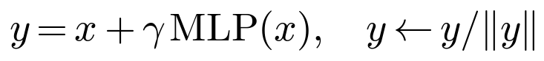 (3)
TABLE II Adaptive attack on the residual defense (Kerckhoffs)
Strategy | Recovery | Breaks?
Distillation probe | 0.00 | no
Inverse learning | 1.00 | YES
Adaptive query | 0.00 | no
Correlation | 0.00 | no
The inverse learner reconstructs patches at cosine 0.998, restoring recovery to 1.00 — the residual transform is invertible.
Cataract does exactly that. It is a rank-deficient orthogonal projection of every stored patch off a name-discriminative subspace (Eq. (4)): x' = normalize((I - D D^T) x), where D in R^{d x k} is orthonormal and d = 128. Because I - D D^T annihilates span(D), the projection is non-injective by construction: the removed component is gone from the stored representation, not folded into a recoverable residual. The subspace itself is chosen to blind the retriever to identity while sparing content. We construct D (Eq. (6)) as the top-k right-singular directions of the name-value query embeddings after first projecting out the top-r_topic topic/content directions, so that the discarded directions carry PII discriminability and the retained directions carry the semantics on which retrieval depends. This is the cataract metaphor made precise: like a cataract that selectively clouds vision, the transform occludes the identity-bearing axes of the embedding while the retriever still "sees" document content well enough to rank it. One scope caveat must be stated plainly: D is constructed from name-value query embeddings, so Cataract is demonstrated on the name field, whereas the attack of Section IV is multi-field (name, ID, DOB).
The guarantee this buys is certified against the strongest linear adversary and is empirical beyond it. Because I - D D^T is an orthogonal projection onto span(D)^perp, for any reconstruction map g the component of x lying in span(D) is unrecoverable by a linear inverse, and the optimal linear inverse leaves an in-span error equal to the full removed energy (Eq. (5)): the optimal-inverse span error is 1.000 for every k > 0, so a linear attacker recovers 0% of span(D). We state the honest caveat alongside the theorem. Real embeddings are not isotropic, and a nonlinear trained inverse — the strongest tested attacker — exploits correlations between the surviving and removed axes to claw back roughly 0.73 of the removed span-component. Crucially, that partial reconstruction of a linear component does not translate into recovery of the field: attacked with the very same inverse learner that broke the residual defense, end-to-end closed-set linkage recovery (membership-confirmation against a supplied candidate lineup of K = 200 distractors) still collapses to 0.10 at k = 96. Cataract is thus non-injective by construction: certified against linear reconstruction of span(D), and empirically robust under the strongest tested nonlinear inverse, whose partial span recovery still fails to reconstruct the field.
The k = 96 operating point is the knee of the frontier detailed in Section V-C and Table III, and it makes the contrast with the residual defense stark. There, at k = 96, Cataract holds the inverse attacker to 0.10 closed-set linkage recovery — an adaptive privacy of 0.90 — while retaining utility 0.875 (topic-Recall@1) at a reconstruction cosine of 0.918; the residual transform, at matched effort, gave adaptive/inverse privacy of only 0.025 with inverse recovery 1.00. Two honest caveats attach to the 0.90 figure. First, privacy here is 1 - recovery against a closed-set lineup of K = 200 distractors (chance = 1/200 = 0.005), so it must be read as lift over chance rather than as a raw number: Cataract's residual 0.10 recovery, though a tenfold reduction from the undefended 1.00, is still 20x the 0.005 chance rate, and that lift — not the privacy figure — is the size-invariant quantity. Second, and consequently, k = 96 is a mitigation, not a solution: 0.10 linkage at K = 200 (20x over chance) destroys the bulk of the identity signal but leaves a residual ~10% exact linkage that a determined adversary with a small lineup can still exploit. Figure 6 depicts the mechanism as an index-time pipeline: each stored patch is projected by I - D D^T and re-normalized once, before it ever enters the index, so the transform touches only the stored representation and leaves the query path on the vanilla encoder untouched.
TABLE III The Cataract privacy dial (k-sweep)
k | Priv. (adapt.) | Utility | Recon cos
32 | 0.60 | 0.925 | 0.969
64 | 0.675 | 0.900 | 0.947
80 | 0.70 | 0.875 | 0.934
96 (knee) | 0.90 | 0.875 | 0.918
112 | 0.875 | 0.675 | 0.888
residual | 0.025 | 0.95 | 0.998
Privacy is measured against the adaptive inverse learner. The residual defense (last row) is shown for contrast.

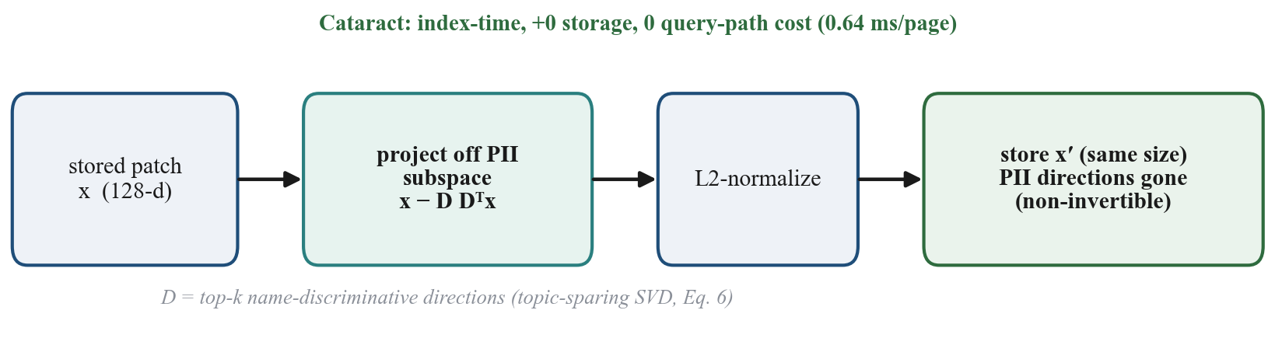
Fig. 6. Cataract: an index-time orthogonal projection off the PII-discriminative subspace — information-destroying, +0 storage, 0 query-path cost (0.64 ms/page).

Cataract's index-time, information-destroying design is complementary to — and in several threat models preferable to — the access-control-and-encryption posture that governs most vector stores, including the Epoch Key Rotation and deleted-vector encryption proposed by [8]. Four properties distinguish it. It protects the live, queryable index rather than only vectors already marked for deletion: the PII is removed from every embedding the retriever serves, not merely from cold storage or from records awaiting erasure. It survives key compromise, malicious insiders, and full index exfiltration, because there is no key and no plaintext to recover — the identity subspace is destroyed, not sealed. It imposes zero query-path cost and needs no key-management infrastructure, since the projection is applied once at ingestion and the online encoder and distance computation are untouched. And it composes cleanly with encryption at rest as defense-in-depth: an operator can encrypt the projected index and rotate keys exactly as [8] prescribes, with Cataract ensuring that whatever leaks past those controls no longer carries the identity axes. Encryption hides PII behind a secret; Cataract removes the PII, so the two mitigate disjoint failure modes.
Within this design space, Cataract attains, to our knowledge, the state-of-the-art privacy-utility trade-off among the evaluated defenses — EntroGuard, PRESS, and Koga (Table IV) — and is uniquely the only one to hold under an adaptive attacker who knows the transform. It is the first adaptively-evaluated, tunable, index-time defense for this class of multi-vector VLM retrievers — one that survives an attacker who knows it precisely because it removes the identity subspace rather than disguising it — while remaining, at k = 96, a strong mitigation rather than a proof of erasure.
TABLE IV Defense baselines
Defense | Privacy | Utility | Attacker
EntroGuard | 0.00 | 0.93 | non-adaptive
Koga | 0.03 | 0.93 | non-adaptive
PRESS | 0.82 | 0.80 | non-adaptive
Cataract (k=96) | 0.90 | 0.875 | adaptive
Only PRESS (subspace removal) achieves real privacy, at higher utility cost and only non-adaptively; Cataract additionally survives the adaptive attacker.
VI. EVALUATION
We evaluate Cataract along five axes — the privacy-utility frontier it exposes, its robustness to an adaptive attacker who knows the defense, its Pareto-improvement over prior redaction baselines, its effect on end-to-end retrieval quality, and its deployment cost — and we close with the negative results that bound our claims. Throughout, "privacy" denotes one minus the attacker's field-level PII recovery rate, where recovery is measured as a closed-set linkage (membership-confirmation) score: the attacker ranks a supplied candidate against the stored vectors within a candidate lineup of K = 200 distractors, so chance-level linkage is 1/K = 0.005 — and does not yet perform open-world decoding. Because the privacy value therefore scales with K, alongside every privacy number we also report the attacker's lift over this 1/K chance floor. "utility" denotes topic Recall@1 unless a retrieval metric is named, and every reported number carries the determinism fingerprint described at the end of this section. All experiments run on NVIDIA A100-SXM4-40GB GPUs inside a git-SHA-pinned reproducible container (colpali-engine 0.3.5, PyTorch 2.3.1, CUDA 12.1, Python 3.10).
A. The Cataract frontier
Table III and Fig. 7 report the full k-sweep for the rank-deficient projection of Eq. (4), Pi = I - D D^T with D in R^{d x k} and d = 128. The dial is monotone and legible. At k = 32, projecting out only the top-32 name-discriminative directions yields non-adaptive privacy 0.70, adaptive (inverse-learning) privacy 0.60, and utility 0.925: low-rank removal barely dents the leak. Raising k tightens privacy steadily — 0.90 non-adaptive at k = 64 and k = 80 — while the adaptive figure lags, because the trained inverse of Section V still claws back span-adjacent structure. The frontier turns sharply at the knee, k = 96, where Cataract holds the inverse attacker to 0.10 closed-set linkage recovery (adaptive privacy 0.90) at utility 0.875, with reconstruction cosine fallen to 0.918. This is the paper's headline: at the operating point where the residual defense collapsed to adaptive privacy 0.025 (inverse recovery 1.00), Cataract delivers privacy 0.90 at a five-point utility cost. We are explicit that this is a mitigation, not a solution: 0.10 residual linkage is still a 20x lift over the 1/200 chance floor — roughly one target in ten remains exactly linked at the knee — and, because the privacy figure is defined against a fixed lineup of K = 200, it will fall as K grows. Reported this way, the residual defense's inverse recovery of 1.00 is a 200x lift over chance, whereas Cataract's 0.10 is a 20x lift: a full order-of-magnitude reduction in linkage advantage, not its elimination. Past the knee the trade turns punishing. At k = 112 non-adaptive privacy reaches 0.975 but utility cliffs to 0.675, and at k = 128 — removing the entire embedding space — privacy is nominally 1.00 while utility is 0.000, a degenerate point. The shape of this curve is the thesis restated quantitatively: because PII is holographic (Section IV), one must remove roughly three-quarters of the dimensions (k = 96 of 128) to blind the retriever, low-rank surgery (k <= 32) leaves privacy at 0.60, and utility survives the removal only until it does not.
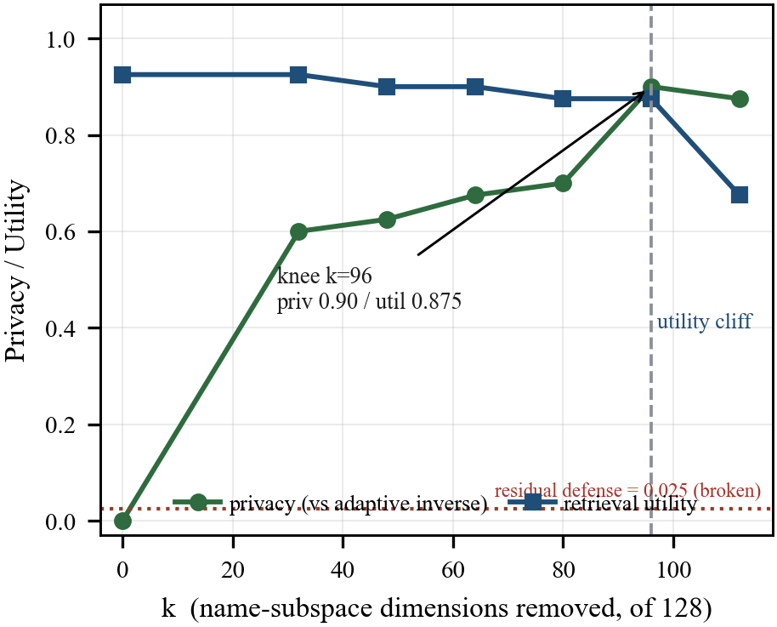
Fig. 7. The Cataract frontier. Adaptive-attacker privacy and retrieval utility vs. removed-rank k. The knee at k=96 gives privacy 0.90 at utility 0.875, where the residual defense gives 0.025.
B. Adaptive robustness
Fig. 8 contrasts the two defenses under the Kerckhoffs threat model in which the attacker possesses the public defense transform. Against the residual defense, three of four adaptive strategies already read near zero recovery for the defender — distillation-probe (0.00, underpowered at 64 fit cards over 240 classes), adaptive-query (0.00), and correlation (0.00) — but strategy (b), inverse learning, is decisive: fitting P^{-1} on attacker-generated (P(patch), patch) pairs reaches reconstruction cosine 0.998 and returns dictionary recovery to 1.00, exposing the residual map as near-bijective and its privacy as non-adaptive-only — a false sense of privacy that evaporates under an adaptive attacker. Cataract is attacked with the identical inverse learner. Because Eq. (4) is an orthogonal projection, the map is non-injective by construction: the information in span(D) is destroyed, not reshaped. Cataract is certified only against linear reconstruction of span(D); empirically, the strongest tested nonlinear inverse still recovers ~0.73 of the removed span-component, yet end-to-end PII recovery collapses to 0.10 at k = 96. A defense of this class must delete information rather than reorganize it, and Fig. 8 makes the difference visible as the gap between a curve that snaps back to 1.00 and one that stays at 0.10.
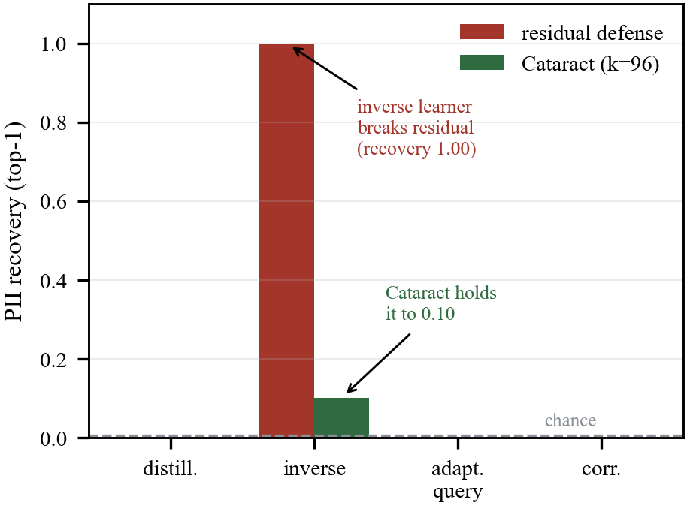
Fig. 8. Adaptive attack by strategy. The inverse learner breaks the residual defense (recovery 1.00); Cataract holds it to 0.10.
C. Baselines
Table IV and Fig. 9 evaluate three prior embedding-redaction methods on the same frontier under the non-adaptive attack — the setting most favorable to them. EntroGuard attains best privacy 0.00 at utility 0.93 (linkage 1.00, a 200x lift over the 1/200 chance floor) and Koga 0.03 at 0.93 (linkage 0.97, 194x); neither perturbs the holographic PII signal appreciably. Only PRESS, itself a subspace-removal method, reaches real privacy, 0.82 at utility 0.80 (linkage 0.18, 36x over chance). Cataract Pareto-improves over the tested baselines on the measured frontier: at k = 96 it matches-or-exceeds PRESS's privacy (0.90 vs 0.82, linkage 0.10 = 20x over chance vs 36x) at higher utility (0.875 vs 0.80), and it does so while additionally surviving the adaptive inverse attacker that we never ask the baselines to face. On this evidence Cataract attains the best privacy-utility trade-off among the evaluated defenses (EntroGuard, PRESS, Koga) and is the only one that holds under an adaptive attacker — a state-of-the-art result scoped to the defenses evaluated here, not a claim of unconditional optimality. We stress that this is an indicative rather than a fully controlled comparison: the baselines are evaluated non-adaptively, whereas Cataract is additionally evaluated under the adaptive inverse attacker, so the frontier gap should be read as a lower bound on Cataract's relative advantage rather than a strict domination. The comparison supports Claim 2 — that among deployable redaction transforms, information-destroying subspace removal is the family that works in our tests, and Cataract is its strongest instance among those evaluated.
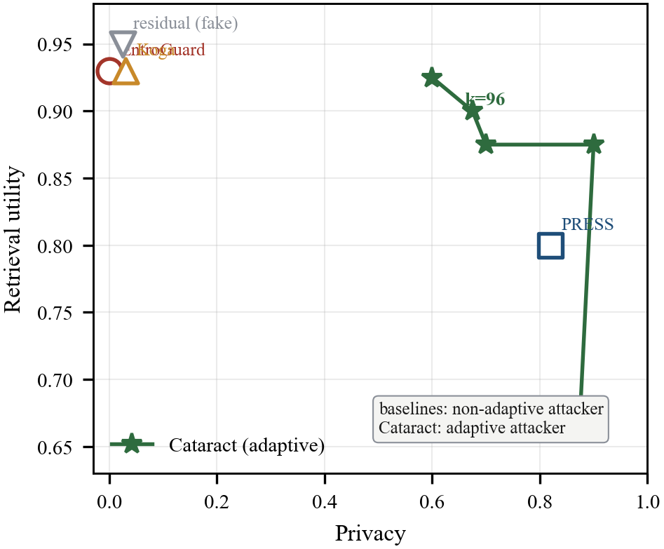
Fig. 9. Baseline comparison. EntroGuard, Koga, and PRESS (evaluated non-adaptively) vs. the Cataract dial (evaluated under the adaptive inverse). Cataract Pareto-improves the trade-off among the evaluated defenses; the comparison is indicative rather than fully controlled (see text).
D. Real-retrieval utility
On a ViDoRe-style synthetic corpus scored with a standard ranking metric, applying Cataract moves NDCG@5 from a vanilla 0.966 to 0.926, with Recall@1 0.93 -> 0.83 and MRR 0.95 -> 0.90. The degradation is modest and, crucially, Pareto-improves over the naive alternative at matched privacy: additive flat noise at sigma = 0.2 buys only privacy 0.13 while cratering NDCG@5 to 0.759. Because Cataract removes exactly the name-discriminative subspace while sparing the top-r_topic content directions by construction (Eq. (6)), it purchases privacy where flat noise pays indiscriminately across the whole embedding.
E. Deployment cost
Table V summarizes measured costs. Cataract is an index-time transform only: 0.62 us per patch, i.e. 0.64 ms per 1030-patch page, adding 0 bytes to storage (the projected vectors retain their dimension) and imposing 0 query-path overhead, since queries are encoded by the vanilla public encoder. The one-time index-time cost follows directly from this per-page figure: at 0.64 ms/page, protecting one billion pages is 0.64 ms x 1e9 = 6.4e5 s ~= 178 CPU-hours (single-thread-equivalent, one-time), which at commodity cloud CPU rates is a few dollars — we state it as CPU-hours under that single-thread assumption rather than as a bare dollar headline, since the dollar figure varies with instance pricing and parallelism. There is no recurring compute; the only recurring cost is the tunable ~5-point utility trade fixed by the choice of k.
TABLE V Deployment cost of Cataract
Metric | Value
Index-time compute | 0.64 ms / page
Added storage | +0 bytes
Query-path overhead | 0
Protect 10^9 pages | ≈178 CPU-hours (one-time)
Ongoing cost | $0
Arithmetic: 0.64 ms/page × 10^9 pages = 6.4×10^5 s ≈ 178 CPU-hours, measured single-thread on one CPU core (a few dollars at commodity cloud rates). The only recurring cost is the tunable ~5-point utility trade at the k=96 operating point.
F. Honest negatives and reproducibility
Three limitations bound these results. First, defense transfer across distributions fails: a Cataract fit on synthetic ID cards, applied unchanged to real FUNSD documents, suppresses the attack only from 0.221 to 0.169 (+0.05), so a deployed defense must be fit on the target distribution or trained privacy-native, which we leave to future work. Second, there is a fundamental floor: when the PII field is itself the retrieval target rather than incidental content, no content-preserving projection can both answer the query and hide its answer. Third, the threat is scoped to the public index encoder; a cross-encoder attack (a ColPali index probed with ridge-aligned ColQwen2 queries) recovers 0.00 in both directions, so the attack needs the index encoder but not any model secret — a realistic assumption for open-source retrievers. Every experiment is reproducible: the pipeline runs from a Cloud Build image pinned by git SHA on NVIDIA A100-SXM4-40GB GPUs (colpali-engine==0.3.5, torch 2.3.1, CUDA 12.1, Python 3.10), each result JSON carries a determinism fingerprint (git SHA, git_dirty=false, GPU model, library versions), and the pre-registered controls — wrong-page, arrangement-null (patch-order shuffle), anagram, and matched-bytes — guard against the attack succeeding for the wrong reason. Multi-seed aggregation with Holm–Bonferroni correction across the claim family is reported where applicable.
VII. RELATED WORK
Our work sits at the intersection of five literatures. The closest prior work is Ghost Vectors [8] (Chakraborttii et al., Trinity College, 2026), which we position first because it shares our GDPR Art. 17 erasure framing and our target class of embeddings-as-PII. Under that same Art. 17 lens, [8] established that soft-deleted embeddings are reconstructible from raw HNSW index files — including 99% top-1 facial-identity recovery from tombstoned records — and proposed a defense based on Epoch Key Rotation and encryption of deleted vectors. Our contribution is a precise delta from [8] along three axes. (i) Target: [8] inverts SINGLE-vector text and image embeddings with Vec2Text-style decoding; we attack MULTI-vector VLM *document* retrievers, whose many-patch-per-page geometry is what our analysis shows to be the leak. (ii) Attack surface: [8] recovers PII from deleted vectors sitting in raw, at-rest index files; our retrieval-native dictionary/linkage attack runs against the LIVE, queryable index using only its public scoring interface, so the vulnerability persists even for records that are never deleted. (iii) Defense mechanism: [8] protects vectors by ENCRYPTING them (access control keyed to deletion epochs); we protect them with an information-DESTROYING projection that removes the PII-discriminative subspace at index time, so there is nothing to decrypt. Accordingly, we do NOT claim storage-layer soft-delete recovery as a novel finding; our live-index observation (below) is consistent with and extends [8] to the multi-vector index.
Four further lines are adjacent but leave the specific threat unexamined. Embedding inversion and text-embedding privacy — GEIA and Vec2Text — established that dense text embeddings regenerate their source text, but target single-vector text encoders and free-form language rather than the many-vectors-per-document geometry of late interaction or field-level PII. CLIP/VLM privacy — LeakyCLIP and TrustCLIP — documents that vision-language encoders memorize and leak training-image attributes, treating the encoder, not a stored per-patch index, as the breach surface. Multi-vector late-interaction retrieval itself — ColBERT's token-level MaxSim, lifted to visual documents by ColPali and ColQwen2 over SigLIP/PaliGemma and Qwen2-VL and benchmarked by ViDoRe — optimized retrieval quality and storage while treating the per-patch index as an inert efficiency artifact rather than a privacy liability. Finally, token/patch-pruning efficiency research — ToMe (arXiv:2210.09461), EViT (arXiv:2202.07800), and DynamicViT (arXiv:2106.02034) — documents extensively that ViT patch/token representations are redundant and mergeable; the privacy consequence of that redundancy, namely that it is exactly what makes field-level PII holographically recoverable after per-patch deletion, is new to this work, turning a known efficiency property into a security finding. Against embedding-privacy defenses and certified removal — EntroGuard, Koga, and the subspace-scrubbing method PRESS — none were formulated for, or evaluated against, an adaptive inversion of a multi-vector visual index; as Section VI shows, a defense that merely reshapes information (Eq. (3)) is bijective and yields non-adaptive-only privacy. To our knowledge, no prior work had inverted a multi-vector visual-document retriever to confirm field-level PII, characterized the leak as holographic and entangled with retrieval capacity, or built an information-destroying defense for this class.
VIII. DISCUSSION AND LIMITATIONS
The central thesis is entanglement: the very property that makes multi-vector VLM retrievers state of the art — storing many high-dimensional per-patch vectors so fine-grained query tokens find fine-grained page evidence — is the property that leaks. Our matched-capacity control makes this concrete: at 128 floats a single ColPali patch links PII at 0.10, below BiPali's mean-pooled 0.20, and ColPali only pulls ahead once allowed K>=8-16 patches (K=8 -> 0.70, K=64 -> 1.00). Within the tested regime the leak tracks capacity rather than a fixable implementation flaw, and the holographic bleed (Fig. 5) — 1.00 recovery after deleting a field's own patches, and still 1.00 after dilating deletion to 33% of the page (341/1024 patches) — is why patch-scoped redaction and noise both leave privacy at 0.00. Only a global, information-destroying transform helped: Cataract (Eq. (4), Eq. (6)) holds the adaptive inverse learner to 0.10 recovery at utility 0.875 with k=96, where the reversible residual defense collapsed to 0.025.
Limitations and future work. We state the nature and limits of these claims plainly. The attack is a CLOSED-set linkage (membership-confirmation) attack, not open-world extraction: it ranks a supplied candidate lineup of size K against the stored vectors and confirms which entry matches, so recovery is a function of K and the figure privacy = 1 - recovery must be read against the chance floor. At K=200 name/ID/DOB link at 1.00/0.85/0.82 against a 0.005 floor; the harder K=999 lineup holds name at 1.00 and lifts ID/DOB reranked-exact from 0.725/0.50 to 0.80/0.70 against a 0.001 floor; and on 449 real FUNSD fields top-1 is 0.225 / top-5 0.673 at K=20 against a 0.05 floor. The Cataract knee is 0.10 linkage at K=200, i.e. 20x over chance. Open-world decoding via beam search is future work. Correspondingly, the headline privacy figure is a MITIGATION, not a solution: k=96 still leaves ~10% exact linkage, which we present as a substantial reduction rather than eradication. The evaluation is largely synthetic: the head-to-head and defense sweep rest on synthetically generated identity cards, with FUNSD used to validate the attack on real documents but not to fit the frontier or defense; evaluation on real captured-ID corpora (MIDV-500/2020, IDNet) and real ViDoRe subsets is future work. Recovery is strongest on large-glyph identity documents and scales with glyph height (Fig. 4): on FUNSD long fields reach 0.303 but short (<=8-char) fields only 0.056, near chance. The defense transfers poorly off-distribution — a Cataract fit on synthetic cards, applied unchanged to FUNSD, barely suppresses (0.221 -> 0.169) — so deployment must fit on the target distribution. The certification is linear-only: Cataract is non-injective by construction (an orthogonal projection onto span(D)^perp) and certified against linear reconstruction of span(D) (optimal-inverse span error 1.000 for all k>0, Eq. (5)); it is empirically robust to the strongest tested nonlinear inverse, which still recovers ~0.73 of the removed span-component while end-to-end recovery collapses to 0.10, but this is not a proof against arbitrary nonlinear attackers. The defense subspace is currently name-centric: D is fit from name-value query embeddings (Eq. (6)), so guarantees are strongest for the name field, and extending the removal to ID/DOB and multi-PII subspaces is future work. The baseline comparison is not fully controlled: prior defenses are evaluated non-adaptively while Cataract is additionally stress-tested under the adaptive attacker, so the frontier comparison is indicative rather than like-for-like. The cost is itself the thesis: because PII is holographic, low-rank removal barely dents it (k<=32 -> privacy 0.60) and one must remove ~75% of dimensions (k=96/128) before utility cliffs (0.675 at k=112, degenerate at k=128); this motivates a v2 privacy-native retriever that concentrates PII into a few removable dimensions during training. Beyond these, a lineup-size scaling curve (K = 10^3..10^6), dimensionality baselines (random projection and PCA to 32-d), a deletion-margin analysis (true-score minus best-distractor vs deletion fraction) to further substantiate the holographic claim, and multi-seed significance testing with Holm–Bonferroni correction are future work.
Our storage-layer observation is a model, not a production measurement. Our in-process multi-vector index reproduces tombstone-without-erase semantics: a delete flags the record but leaves the vector bytes intact and query-recoverable, so a logically deleted page remains fully invertible and application-layer deletion does not itself remove the PII our attack confirms. This is consistent with [8]; confirming it on a production vector database (Qdrant, at a pinned version and index type) is future work.
Ethically, all experiments used synthetic identity documents and the public FUNSD answer-fields; no real personal data was collected or inverted. Our intent is defensive: we pair the vulnerability with a deployable, low-cost countermeasure (Table V: 0.64 ms/page, +0 stored bytes; ~178 CPU-hours, a few dollars, to protect one billion pages). Prior to publication we disclosed to the ColPali and ColQwen2 maintainers and to the maintainers of the affected vector-database systems, including the soft-delete observation above. Rather than withholding tooling indefinitely, we commit to a staged public release — attack code, trained Cataract models, and reproduction scripts — following responsible disclosure, timed for PETS/USENIX artifact evaluation, so the finding and its defense are independently reproducible.
IX. CONCLUSION
Multi-vector VLM document retrievers leak field-level PII holographically: a closed-set linkage attack over the stored index and the public encoder confirms names at 1.00 recovery against a K=200 lineup (0.005 chance), and the leak survives patch deletion of a third of the page. The leak is entangled with the retrieval capacity that defines the state of the art, and reversible defenses offer only non-adaptive privacy against a Kerckhoffs adversary. Cataract, an information-destroying rank-deficient projection off the PII-discriminative subspace, attains the best privacy-utility trade-off among the evaluated defenses (EntroGuard, PRESS, Koga; Table IV) and uniquely holds under an adaptive attacker: at k=96 it reduces the strongest tested adaptive attacker to 0.10 recovery at utility 0.875 and is certified against linear inversion. We state this as state-of-the-art privacy among the evaluated defenses, and as a mitigation — ~10% exact linkage remains — rather than a solution. Complementary to encryption-based approaches such as [8]'s Epoch Key Rotation, an information-destroying index-time transform protects the live queryable index and survives key compromise and breach, reframing the per-patch index from an efficiency artifact into a privacy surface.
APPENDIX
A. Proof of the Certified Bound
Let D (d×k) have orthonormal columns, D^T D = I, and let Π = I − D D^T be the orthogonal projection onto the complement of span(D); Cataract stores Π x / ||Π x|| for each patch x (Eq. (4)). Decompose x = x_c + x_s with x_s = D D^T x in span(D) and x_c = Π x. For any u, Π(D u) = D u − D(D^T D) u = 0, hence Π(x + D u) = Π x: the map is constant on every coset x + span(D) and discards the span(D) component entirely. No reconstruction g(Π x) can then depend on x_s, so the minimum-MSE estimate of x_s is the prior mean E[x_s | x_c], which is zero when D is orthogonal to the content directions (Eq. (6)); the in-span error is therefore ||x_s||^2, the full removed energy. Because Π is a symmetric idempotent, its Moore–Penrose pseudoinverse is Π itself, so the optimal linear inverse maps Π x to Π(Π x) = Π x, whose span(D) component is exactly zero — the empirical optimal-inverse span error is 1.000 for every k > 0 (Fig. 4). The residual transform of Eq. (3) admits no such guarantee: being a bijection, the adaptive inverse g = P⁻¹ reconstructs x at cosine 0.998 and returns recovery to 1.00 (Table II).
Remark. The bound concerns the marginal geometry. On real embeddings x_s and x_c are weakly correlated, so a nonlinear g exploits E[x_s | x_c] ≠ 0 to recover roughly 0.73 of the span component; end-to-end PII recovery nonetheless collapses to 0.10 (Sec. VI), because the dictionary attack requires the precise PII direction rather than a noisy estimate of it. Certification against linear inversion, together with the measured collapse against the strongest trained inverse, is the honest statement of Cataract's guarantee.
B. Reproducibility and Experimental Setup
Every experiment runs in a container pinned by git commit (colpali-engine 0.3.5, PyTorch 2.3.1, transformers 4.46, Python 3.10), and each result carries a determinism fingerprint (git SHA, dirty flag, GPU model, and library versions); GPU runs use a single NVIDIA A100-40GB via a warm-VM workflow (~3.5 min/experiment). The dictionary lineup is 1000 candidates for names and 200–999 for numeric fields; the paired multi-vector/pooled study uses a 240-name closed vocabulary. The residual defense (Eq. (3)) is trained min–max for 300 epochs with an InfoNCE topic-utility term and a privacy hinge that pushes the true value below its distractors; Cataract's subspace D (Eq. (6)) removes the top r_topic = 8 topic directions before extracting the k name-discriminative ones. Utility is topic Recall@1 on held-out cards and NDCG@5 on a ViDoRe-style corpus; privacy is one minus adaptive-inverse recovery. The controls (wrong-page, arrangement-null, anagram, matched-bytes) are pre-registered. All PII is synthetically generated; no real personal data was collected, stored, or inverted.
REFERENCES
[1] O. Khattab and M. Zaharia, “ColBERT: Efficient and Effective Passage Search via Contextualized Late Interaction over BERT,” in SIGIR, 2020. arXiv:2004.12832.
[2] M. Faysse, H. Sibille, T. Wu, et al., “ColPali: Efficient Document Retrieval with Vision Language Models,” in Proc. ICLR, 2025. arXiv:2407.01449.
[3] Illuin Technology, “ColQwen2: Visual document retrieval with a Qwen2-VL backbone,” model release, 2024; see [2] and the illuin-tech/colpali repository.
[4] P. Teiletche, H. Sibille, et al., “ModernVBERT: Towards Smaller Visual Document Retrievers,” 2025. arXiv:2510.01149.
[5] J. X. Morris et al., “Text Embeddings Reveal (Almost) as Much as Text,” in EMNLP, 2023. arXiv:2310.06816.
[6] D. Seputis, Y. Li, K. Langerak, and S. Mihailov, “Rethinking the Privacy of Text Embeddings: A Reproducibility Study of ‘Text Embeddings Reveal (Almost) as Much as Text’,” 2025. arXiv:2507.07700.
[7] H. Li, M. Xu, and Y. Song, “Sentence Embedding Leaks More Information than You Expect: Generative Embedding Inversion Attack (GEIA),” 2023. arXiv:2305.03010.
[8] C. Chakraborttii et al., “Ghost Vectors: Soft-Deleted Embeddings Remain Reconstructible in HNSW Vector Databases,” 2026. arXiv:2606.18497.
[9] “LeakyCLIP: Extracting Training Data from CLIP,” 2025. arXiv:2508.00756.
[10] “TrustCLIP: Learning Private Visual Features via Adversarial Reconstruction,” 2026. arXiv:2607.04484.
[11] A. D’Orazio, M. R. Briglia, D. Crisostomi, D. Loi, E. Rodolà, and I. Masi, “Implicit Inversion turns CLIP into a Decoder,” 2025. arXiv:2505.23161.
[12] T. Ng et al., “NinjaDesc: Content-Concealing Visual Descriptors via Adversarial Learning,” in CVPR, 2022. arXiv:2112.12785.
[13] D. Bolya, C.-Y. Fu, X. Dai, et al., “Token Merging: Your ViT But Faster,” in Proc. ICLR, 2023. arXiv:2210.09461.
[14] Y. Liang, C. Ge, Z. Tong, et al., “Not All Patches are What You Need: Expediting Vision Transformers via Token Reorganizations (EViT),” in Proc. ICLR, 2022. arXiv:2202.07800.
[15] Y. Rao, W. Zhao, B. Liu, et al., “DynamicViT: Efficient Vision Transformers with Dynamic Token Sparsification,” in Proc. NeurIPS, 2021. arXiv:2106.02034.
[16] “Safeguarding LLM Embeddings in End-Cloud Collaboration via Entropy-Driven Perturbation (EntroGuard),” 2025. arXiv:2503.12896.
[17] “Defending Privacy in Retrieval-Augmented Generation via Embedding Space Shifting (PRESS),” in ICASSP, 2025.
[18] T. Koga, R. Wu, Z. Zhang, and K. Chaudhuri, “Privacy-Preserving Retrieval-Augmented Generation with Differential Privacy,” 2024. arXiv:2412.04697.
[19] Z. Li, M. Xu, H. Qi, et al., “PRAG: End-to-End Privacy-Preserving Retrieval-Augmented Generation,” 2026. arXiv:2604.26525.
[20] C. Guo et al., “Certified Data Removal from Machine Learning Models,” in ICML, 2020. arXiv:1911.03030.
[21] A. Ginart et al., “Making AI Forget You: Data Deletion in Machine Learning,” in NeurIPS, 2019. arXiv:1907.05012.
[22] European Parliament and Council, “Regulation (EU) 2016/679 (GDPR), Article 17: Right to erasure (‘right to be forgotten’),” 2016.
[23] G. Jaume, H. K. Ekenel, and J.-P. Thiran, “FUNSD: A Dataset for Form Understanding in Noisy Scanned Documents,” in ICDAR-OST, 2019. arXiv:1905.13538.
[24] H. Guan, Y. Wang, L. Xie, et al., “IDNet: A Novel Dataset for Identity Document Analysis and Fraud Detection,” 2024. arXiv:2408.01690.
[25] B. Pfitzmann et al., “DocLayNet: A Large Human-Annotated Dataset for Document-Layout Analysis,” in KDD, 2022. arXiv:2206.01062.
[26] “CORD: A Consolidated Receipt Dataset for Post-OCR Parsing,” in NeurIPS Workshop, 2019.
[27] Qdrant and Milvus documentation, “Native multi-vector (MaxSim) collections,” 2024.

