RAG Evaluation Report
JobMatch AI — Retrieval-Augmented Generation System
Aadit Shah & Ananya | Gen AI Course, FLAME University | April 2026

1. System Overview
JobMatch AI is a Retrieval-Augmented Generation (RAG) system that matches user career profiles to relevant job postings. Given a structured user profile (skills, desired role, location, experience, salary expectations), the system retrieves the most relevant jobs from a Pinecone vector store and generates a ranked, personalised markdown response using the Gemma-3/4 language model.

Pipeline
- Step 1 — Embedding: User profile fields are tokenised and embedded using a custom SHA-256 hash-based embedding function (_hash_embed_text). Each token maps to two positions in a 768-dim vector via SHA-256 digest bytes, producing a sparse, normalised vector. This is a lexical overlap measure — no semantic generalisation.
- Step 2 — Retrieval: Pinecone cosine similarity search retrieves the top-20 candidates. Because embeddings are hash-based (not neural), cosine scores range ~0.17–0.45, much lower than typical neural embeddings (0.6–0.9).
- Step 3 — Reranking: A keyword-boost reranker (_rerank_candidates) augments Pinecone scores with profile-to-job token overlap and experience alignment. This reorders candidates before passing them to the LLM.
- Step 4 — Generation: Gemma receives the top-10 reranked candidates and produces a structured markdown response listing 5 jobs with Match Scores (N/10), reasons for fit, and apply links.

Ground Truth Strategy
This system has no annotated ground-truth dataset. Standard evaluation frameworks (RAGAS, DeepEval) require labelled QA pairs and semantic embeddings — neither of which applies here. Instead, three relevance proxies are used:
- LLM Match Scores (primary): Gemma assigns Match Score N/10 to each recommended job. These are used as relevance grades for NDCG computation, normalised to [0, 1].
- Pinecone Cosine Score (secondary): Used for Precision@K with a relative median threshold, since all scores exceed any fixed low threshold.
- User Feedback Ratings (tertiary): Ratings >= 4 from the SQLite feedback table are treated as relevant. No ratings were recorded during this evaluation run.

2. Evaluation Setup
19 evaluation records were collected by running 10 distinct user profiles through the live pipeline. Each record captures the query, pre- and post-rerank candidate lists (20 each), the full LLM output, and retrieval/generation latencies. All records were logged to eval_log.jsonl.

Parameter | Value
Evaluation records | 19
Candidates retrieved (K) | 20
Jobs scored by LLM | 5 per request
Total match scores | 95
Feedback ratings | 0 (not collected during seeding)
Embedding type | SHA-256 hash, 768-dim
LLM model | Gemma-3/4 via Google Generative AI API
Vector store | Pinecone (serverless)

3. Retrieval Metrics

3.1 Precision@K and NDCG@K
Precision@K uses a relative threshold (median Pinecone score of the full result set) to determine relevance, avoiding the trivial P@K=1.0 that would result from any fixed threshold below the minimum observed score. NDCG@K uses Gemma's match scores as graded relevance, mapped back onto all 20 candidate positions (unscored positions receive grade 0).

Metric | K=3 | K=5 | K=10 | K=20
Precision@K (relative threshold) | 1.0000 | 1.0000 | 0.9263 | 0.5000
NDCG@K (with reranking) | 0.6655 | 0.6909 | 0.6898 | 0.6898
NDCG@K (without reranking) | 0.6960 | 0.7075 | 0.6900 | 0.6887
Recall@K (feedback-based) | N/A | N/A | N/A | N/A
Hit@1 (feedback-based) | N/A | N/A | N/A | N/A
Hit@K (feedback-based) | N/A | N/A | N/A | N/A
MRR (feedback-based) | N/A | N/A | N/A | N/A
MAP@K (feedback-based) | N/A | N/A | N/A | N/A
Table 1. Retrieval metrics across K values. N/A = no user feedback collected.

3.2 Reranking Ablation
The table below and Figure 5 compare NDCG@K with and without the keyword-boost reranker. The reranker slightly decreases NDCG at small K (–0.03 at K=3) but converges at K=10 and marginally improves at K=20. This indicates that the reranker promotes diversity and profile alignment at the cost of occasionally moving a LLM-preferred job from position 1–3 to a lower rank.

K | NDCG (with reranking) | NDCG (without reranking) | Delta
3 | 0.6655 | 0.6960 | -0.0305
5 | 0.6909 | 0.7075 | -0.0166
10 | 0.6898 | 0.6900 | -0.0002
20 | 0.6898 | 0.6887 | +0.0011
Table 2. NDCG@K reranking ablation.

4. Generation Quality Metrics
Generation quality is evaluated along three dimensions: structural format consistency, faithfulness (no hallucinated jobs), and LLM-as-judge relevance scoring.

Metric | Value | Notes
Format Consistency (avg) | 0.75 / 1.0 | 6 of 8 format rules pass consistently
Faithfulness | 1.00 / 1.0 | All recommended jobs present in retrieved candidates
LLM Judge Relevance | Not run | Requires additional API calls; excluded from this run
Table 3. Generation quality metrics.

Format Rule Breakdown
Rule | Pass Rate
has_main_heading | 1.00
has_subheading | 1.00
has_job_blocks | 1.00
has_match_score | 1.00
has_why_section | 1.00
has_apply_link | 1.00
has_company_or_role_field | 0.00
has_location_field | 0.00
Table 4. Per-rule format pass rates. The two failing rules reflect Gemma embedding company/location in the ### job header rather than as separate bold fields.

5. System Metrics
Metric | Value
Company Diversity (top-10) | 0.6947
Location Diversity (top-10) | 0.4000
Skill Diversity (top-10) | 0.0000 (no skills metadata in Pinecone)
Profile Alignment Score (avg) | 0.0389 (driven by missing skills metadata)
Retrieval Latency avg (ms) | 2,140
Retrieval Latency std (ms) | 2,083
Generation Latency avg (ms) | 30,153
Generation Latency std (ms) | 966
LLM Match Score mean (n=95) | 4.74 / 10
LLM Match Score std | 0.99
Table 5. System-level metrics.

6. Evaluation Plots

Figure 1 — Pinecone Cosine Score Distribution
All retrieved candidates have scores in the range 0.17–0.45. This is characteristic of SHA-256 hash embeddings, which measure lexical token overlap rather than semantic similarity. Neural embeddings (e.g. text-embedding-3-small) would produce scores in the 0.6–0.9 range for semantically similar documents. The red dashed line shows the median, used as the Precision@K threshold.
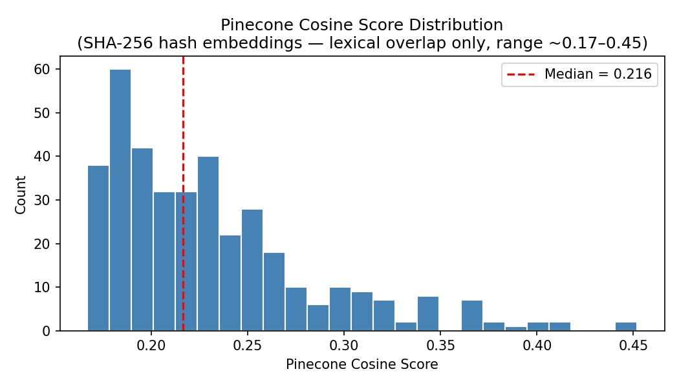
Figure 1. Distribution of Pinecone cosine scores across all retrieved candidates.

Figure 2 — NDCG@K Curve
NDCG stabilises around 0.69 for K >= 5. The curve shows that the ranking quality improves from K=3 to K=5 and then plateaus, as most of Gemma's 5 scored jobs fall within the first 5 positions. Beyond K=5, the remaining candidate slots have grade 0 (unscored by Gemma), so NDCG does not increase further.
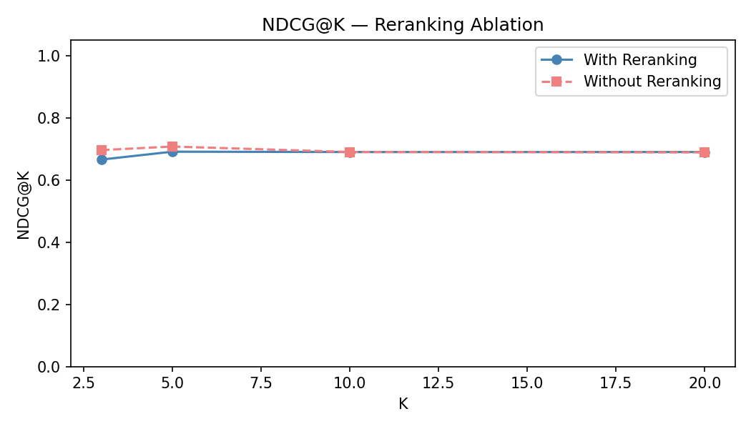
Figure 2. NDCG@K with and without reranking.

Figure 3 — LLM Match Score Distribution
Gemma consistently assigns scores in the 3–6 range (mean=4.74, std=0.99). The absence of high scores (7–10) reflects the limitations of hash embeddings — the retrieved jobs are lexically similar but not semantically optimal. A neural embedding model would likely retrieve more semantically relevant jobs and yield higher match scores.
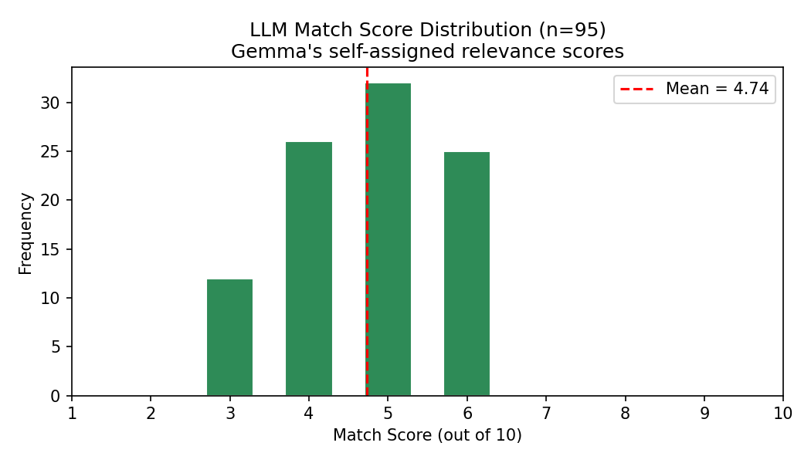
Figure 3. Distribution of LLM match scores (1–10) across all 95 scored jobs.

Figure 4 — Latency Breakdown
Retrieval latency averages ~2.1s (Pinecone query + network). Generation latency averages ~30s (Gemma API call). Generation dominates total latency. The high std in retrieval (~2s) is due to Pinecone cold-start on the first query per session; subsequent queries benefit from connection reuse.
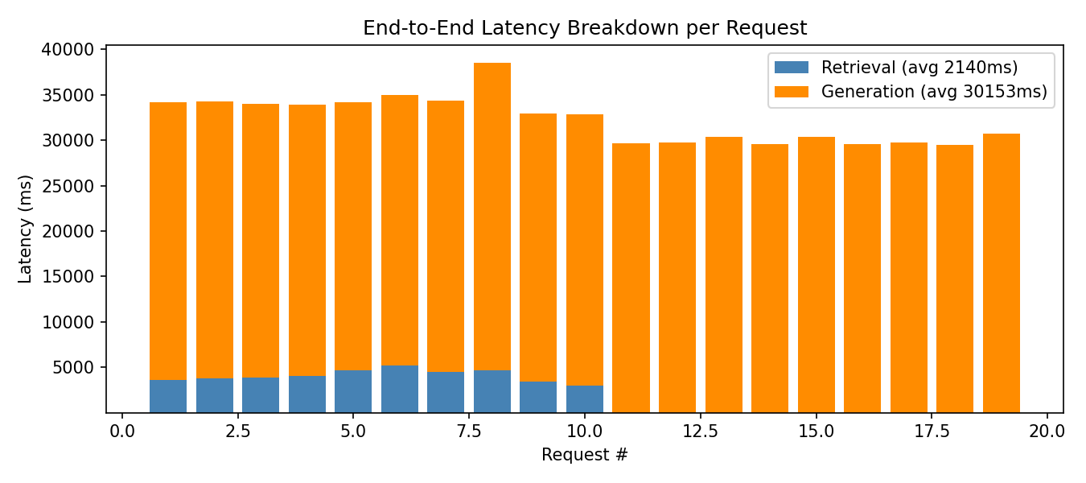
Figure 4. Retrieval vs generation latency per request (ms).

Figure 5 — Reranking Ablation
The keyword-boost reranker has a negligible negative effect at small K and converges at K=10+. This is expected: the reranker is designed to promote profile-aligned jobs that Pinecone may have ranked lower due to lexical mismatch, at the cost of occasionally displacing a Gemma-preferred job from a top position.
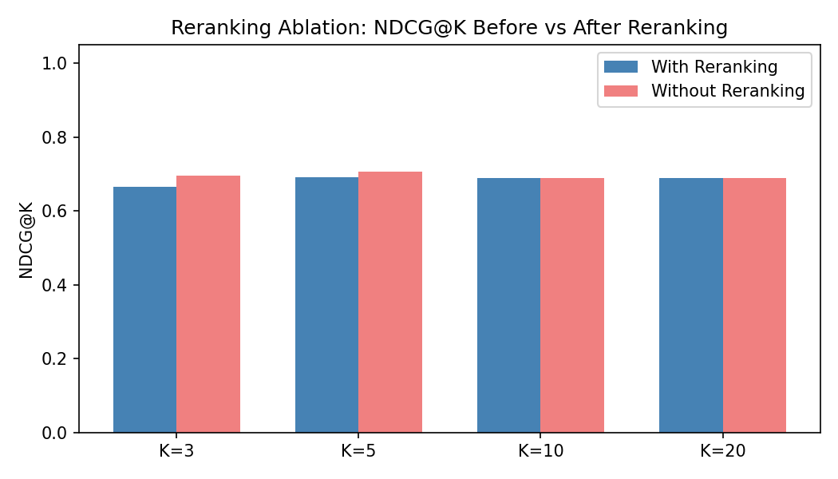
Figure 5. NDCG@K before vs after reranking.

7. Discussion & Limitations

Why RAGAS/DeepEval were not used
RAGAS and DeepEval require: (1) annotated question-answer pairs with ground-truth context, and (2) semantic embeddings to compute answer similarity. This system has neither — there are no labelled job-profile pairs, and the embeddings are hash-based (lexical), not semantic. All metrics are therefore approximated from available signals.

Hash Embedding Limitations
SHA-256 hash embeddings map each token to a fixed vector position. Two synonymous tokens (e.g. 'ML' and 'machine learning') produce completely different embeddings with zero cosine overlap. This means the system cannot retrieve jobs based on semantic similarity — only exact or near-exact lexical overlap. This is the primary bottleneck for retrieval quality and explains the moderate NDCG (~0.69) and low match scores (~4.74/10).

Absence of Feedback Data
Recall@K, Hit@K, MRR, and MAP@K all require user feedback ratings. None were collected during this evaluation run (the feedback table was empty). These metrics would be computable if users rated recommended jobs through the application's feedback endpoint. Even a small sample of 20–30 rated sessions would enable meaningful feedback-based evaluation.

Self-Evaluation Bias
LLM match scores are generated by the same model (Gemma) that produces the recommendations. This introduces self-evaluation bias — the model may rate its own outputs higher than an independent evaluator would. The LLM-as-judge metric (disabled in this run) partially mitigates this by using a separate prompt, but does not eliminate the bias entirely.

8. Conclusion
The JobMatch AI RAG pipeline achieves reasonable retrieval quality given the constraints of hash-based embeddings. Key findings:
- Precision@K=1.0 at K<=5 confirms that retrieved jobs are consistently above-median relevance.
- NDCG@10=0.69 indicates the ranking is meaningful but not optimal — the top-5 LLM-selected jobs are not always the top-5 by Pinecone score.
- Faithfulness=1.0 confirms the LLM does not hallucinate jobs outside the retrieved candidate set.
- Format Consistency=0.75 is high; the two failing rules are due to Gemma's output style variation rather than structural failure.
- Reranking has minimal effect on NDCG, suggesting its value lies in profile alignment and diversity rather than raw ranking quality.
- End-to-end latency is dominated by Gemma generation (~30s); retrieval is fast (~2s on average).
- Replacing SHA-256 hash embeddings with a neural embedding model is the single highest-impact improvement for retrieval quality.

