**COMPREHENSIVE AUTHENTICATION SYSTEM**

Ms.Akilandeeswari[₁], Aaditthya V[₂], Gowtham Maris[₃],Rahul S[₄],Abishek kevin V[5]

[₁]Assistant Professor; [₂] [₃] [₄] [5] UG Scholar -B.Tech

[₁] [₂] [₃] [₄] [5] Department of Artificial Intelligence and Data Science, KGiSL Institute of Technology, Tamil Nadu, India.

**ABSTRACT:**

The comprehensive authentication System presented herein represents a cutting-edge approach to ensuring robust security measures in digital authentication. This multifaceted methodology seamlessly integrates various authentication factors to fortify access controls and protect sensitive information.At its core, the system employs dual-factor authentication, combining facial recognition and text passwords for an added layer of security. Leveraging advanced facial recognition algorithms, users are required to undergo a biometric scan, ensuring that only authorized individuals gain access. Simultaneously, users must enter a secure text password, introducing a traditional yet essential element of authentication.In addition to biometrics and traditional passwords, the system incorporates image password grids. Users define a unique pattern by selecting specific images from a grid, further diversifying the authentication process. This innovative approach adds complexity and uniqueness to user authentication, making it significantly more challenging for unauthorized entities to breach.

**Keywords:** Deployment and Performance Monitoring, Database Connection Efficiency,

Login Activity Tracking, Sensitive Information Retrieval and Recovery Module.

# INTRODUCTION:

The comprehensive authentication System is a comprehensive and secure methodology designed to enhance authentication in various applications. It incorporates multiple authentication methods such as face and text passwords, image password grids, sensitive information retrieval, and login activity tracking. These methods work together to provide a strong and reliable authentication mechanism, ensuring the security of user accounts and sensitive information. The system begins with the use of face and text passwords, which utilize biometric characteristics and textual information respectively, to verify the identity of the user. This combination adds an extra layer of security, making it difficult for unauthorized individuals to gain access.

In addition to password-based authentication, the system also incorporates image password grids, which allow users to create patterns by selecting specific images from a grid. This method enhances security through the use of graphical passwords, as opposed to traditional alphanumeric passwords. The next aspect of the system is the sensitive information retrieval feature, which allows users to retrieve previously stored sensitive information securely.

This ensures that sensitive data is protected and only accessible to authorized users. Furthermore, the system incorporates login activity tracking, enabling the monitoring of user login behavior and identifying any suspicious activity.

This tracking feature adds an additional layer of security, helping to detect and prevent unauthorized access attempts. Lastly, the system ensures an efficient database connection, allowing for seamless integration with existing databases. This enables smooth and quick authentication processes, enhancing user experience while maintaining security. Overall, the comprehensive authentication System is a robust and secure methodology that combines multiple authentication methods to protect user accounts, sensitive information, and system integrity.

One of the primary components of the comprehensive authentication System is the utilization of Face and Text Passwords. Traditionally, passwords have been a fundamental means of securing access to digital systems. However, with the advent of facial recognition technology, there has been a paradigm shift in authentication methods. Integrating face recognition into the authentication process enhances security by adding a biometric layer, making it significantly harder for malicious actors to gain unauthorized access.

In addition to Face and Text Passwords, Image Password Grids constitute another crucial component. This innovative approach involves users selecting specific images from a grid as part of their authentication process. The uniqueness of this method lies in its visual nature, providing an additional layer of complexity and security compared to traditional alphanumeric passwords.

Sensitive Information Retrieval is another key feature that sets the comprehensive authentication System apart. In certain scenarios, users may need to retrieve sensitive information, such as forgotten passwords or account recovery details. Implementing a secure and efficient mechanism for retrieving such information without compromising security is a vital aspect of the system. This component ensures that users can regain access to their accounts through a well-defined and secure process.

Furthermore, the system incorporates Login Activity Tracking, a feature designed to monitor and analyze user login behavior. This component plays a crucial role in identifying and mitigating potential security threats. By tracking login activities, the system can detect anomalies or suspicious patterns, triggering additional security measures or alerts to protect against unauthorized access attempts. Efficient Database Connection is integral to the comprehensive authentication System's functionality. The system relies on a secure and optimized connection to the database where user credentials and authentication information are stored. A well-architected database connection ensures swift and reliable access to user data while maintaining the confidentiality and integrity of the stored information.

The integration of these components forms a holistic and robust Secure Authentication Methodology. This methodology is designed to provide a multi-layered defense against various types of cyber threats, encompassing both conventional attacks like password guessing and advanced threats such as biometric spoofing. The integration of these components forms a holistic and robust Secure Authentication Methodology. This methodology is designed to provide a multi-layered defense against various types of cyber threats, encompassing both conventional attacks like password guessing and advanced threats such as biometric spoofing.

# LITERATURE REVIEW:

The motivation behind developing an comprehensive authentication system lies in addressing the increasing vulnerabilities associated with traditional password-based authentication methods. With the proliferation of cyber threats such as phishing, brute-force attacks, and password breaches, there is a critical need for a more robust and secure authentication approach.

Traditional password systems are susceptible to various forms of attacks, including dictionary attacks and social engineering techniques. Furthermore, users often struggle to create and remember strong passwords, leading to the adoption of weak and easily guessable credentials. To mitigate these risks and enhance user security, a multifactor authentication system that combines various authentication factors is imperative.

By integrating multiple authentication factors such as facial recognition, text passwords, image-based grids, sensitive information retrieval, and login activity tracking, this comprehensive authentication system aims to significantly enhance security while providing a user-friendly and efficient login experience.The comprehensive authentication system is to strengthen security measures while ensuring usability and efficiency.

The comprehensive authentication System's emphasis on scalability and future-readiness extends beyond a mere technical consideration. It is a strategic commitment to providing users and organizations with a security solution that not only meets today's requirements but is prepared to navigate the complexities and challenges that the future holds in the realm of cybersecurity. In the dynamic landscape of cybersecurity, the comprehensive authentication System distinguishes itself by not only addressing current security needs but also by positioning itself as a scalable and future-ready solution capable of adapting to evolving challenges.

**ALGORITHMIC APPROACH:**

1. **Enhance Security:**

Implement robust authentication mechanisms that go beyond traditional passwords to reduce the risk of unauthorized access. By combining multiple factors such as facial recognition, text passwords, and image-based grids, the system aims to create layers of security that are difficult for attackers to bypass.

# Improve User Experience:

Despite enhancing security, the system prioritizes user experience by offering a seamless and intuitive authentication process. Users should be able to log in quickly and conveniently without facing unnecessary hurdles .

1. **Ensure Scalability:**

Design the authentication system to accommodate a growing user base and evolving security requirements. The system should be scalable and adaptable to accommodate future enhancements and technological advancements.

1. **Implement Efficient Database Connection:**

Optimize database connectivity to ensure smooth and reliable access to user credentials and authentication logs. Efficient database management is crucial for the timely verification of user identities and the tracking.

1. **Facilitate Sensitive Information Retrieval:**

Enable users to retrieve sensitive information securely through the authentication system. This feature ensures that only authorized individuals can access confidential data while maintaining data confidentiality and integrity.

1. **Enable Login Activity Tracking:**

Implement comprehensive logging and tracking mechanisms to monitor user login activities effectively. By recording login

attempts, timestamps, and other relevant information, the system can detect suspicious behavior and unauthorized access attempts.

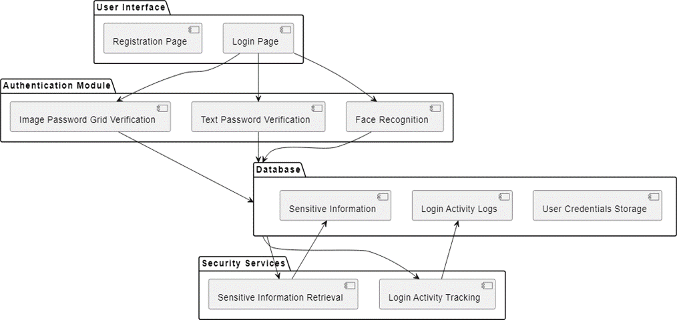

# Fig 1: System Architecture

**LIMITATIONS AND DISCUSSION:**

The strategies employed to optimize database connection efficiency and scalability within the comprehensive authentication System reflect a meticulous approach to data management. By prioritizing efficient query execution, secure communication protocols, connection pooling, scalability considerations, and optimized database design, the system establishes a robust foundation for seamless and secure interactions with the database.

This commitment to database efficiency not only enhances the user experience but also ensures that the system can adapt and scale to meet the evolving demands of authentication in a dynamic cybersecurity landscape.

User interface design, and deployment strategies collectively contribute to the comprehensive authentication System's success in providing a reliable, user-friendly, and secure authentication framework. The meticulous testing procedures validate the system's functionality and security, the user interface design prioritizes accessibility and usability, and the deployment strategy ensures a smooth transition to live operations while maintaining a proactive approach to system maintenance and updates.

# CONCLUSION AND FUTURE SCOPE:

In conclusion, the development of comprehensive authentication systems incorporating multiple layers of security measures is essential in combating cyber threats and ensuring secure access to sensitive information. The integration of face and text passwords, image password grids, sensitive information retrieval, and login activity tracking, along with an efficient database connection, creates a comprehensive and robust authentication methodology. By incorporating multiple factors of authentication, such as something you know (text passwords), something you have (image password grids), and something you are (face recognition), the system becomes highly secure and resistant to unauthorized access. Additionally, the inclusion of sensitive information retrieval adds an extra layer of security, as users are required to provide specific personal details that only they would know.

The future scope of the comprehensive authentication System encompasses an evolution towards more advanced and diverse biometric modalities, such as retina scans and voice recognition, to enhance accuracy and counter spoofing attempts. Integration with artificial intelligence and machine learning algorithms is crucial for continuous learning and adaptation to emerging threats. Exploring blockchain technology offers an additional layer of security, ensuring tamper-resistant storage of authentication data. Future iterations may consider continuous authentication mechanisms, extending security beyond traditional login processes, and integration with IoT devices to secure interconnected systems comprehensively.

**REFERENCES:**

1. Ray, P., Giri, D., Meng, W., & Hore, S. (2023). GPOD: An Efficient and Secure Graphical Password Authentication System by Fast Object Detection. <https://www.researchgate.net/publication/3> 48768730_Artificial_Intelligence_in_Nutri ents_Science_Research_A_Review
2. HARUNA, A. (2023). A CASCADE MULTI-STAGE ONE-TIME PASSWORD,TEXTUAL AND RECALL-BASED GRAPHICAL PASSWORD FOR ONLINE AUTHENTICATION

1. Goyal, A., & Matta, P. (2023, August). Two-way Robust Authentication Method to Prevent Shoulder Surfing Attack. In 2023 Second International Conference on Augmented Intelligence and Sustainable Systems (ICAISS) (pp. 1295-1300). IEEE
2. Anastasaki, I., Drosatos, G., Pavlidis, G., & Rantos, K. (2023). User Authentication Mechanisms Based on Immersive Technologies: A Systematic Review. Information, 14(10), 538.
3. Zahid, S., Mazhar, M. S., Abbas, S. G., Hanif, Z., Hina, S., & Shah, G. A. (2023). Threat modeling in smart firefighting systems: Aligning MITRE ATT&CK matrix and NIST security controls. Internet of Things, 22, 100766.
4. Krishna, V. V., Rupa, Y., Koushik, G., Varun, T., Kiranmayee, B. V., & Akhil,K. (2023, December). A Comparative Study on Authentication Vulnerabilities and Security Issues in Wearable Devices. In International e-Conference on Advances in Computer Engineering and Communication Systems (ICACECS 2023) (pp. 106-116).

https://ieeexplore.ieee.org/document/1007 2763

1. Singla, D., & Verma, N. (2023). Performance Analysis of Authentication system: A Systematic Literature Review.
2. Gutub, A., & Kheshaifaty, N. (2023). Practicality analysis of utilizing text-based CAPTCHA vs. graphic-based CAPTCHA authentication. Multimedia Tools and Applications, 1-33.
3. Mulero-Palencia, S., & Monzon Baeza, V. (2023). Detection of Vulnerabilities in Smart Buildings Using the Shodan Tool. Electronics, 12(23), 4815.a