Assessment-3: Designing for Resilience and Observability

Introduction –

Lab Purpose: The purpose of this lab is to design and implement a resilient and observable distributed system. It demonstrates the practical application of architectural patterns like Circuit Breakers and Retries with Exponential Backoff to handle failures gracefully. The system also includes a Chaos Engineering component to proactively test and verify its resilience against common failure modes like network delays and service errors.
Chosen Technologies:
- Node.js: Backend
- Docker: Containerizing applications
- Minikube: To run single node Kubernetes clusters locally
- MongoDB: Document Database
- Chaostoolkit: Chaos Engineering
Application Basic Functionality: The application has 2 services –
- Client-service – Implements resilience patterns like circuit breakers
- Backend-service - Simple User Registration service with some chaos engineering endpoints for mimicking chaos

Setup & Configuration –
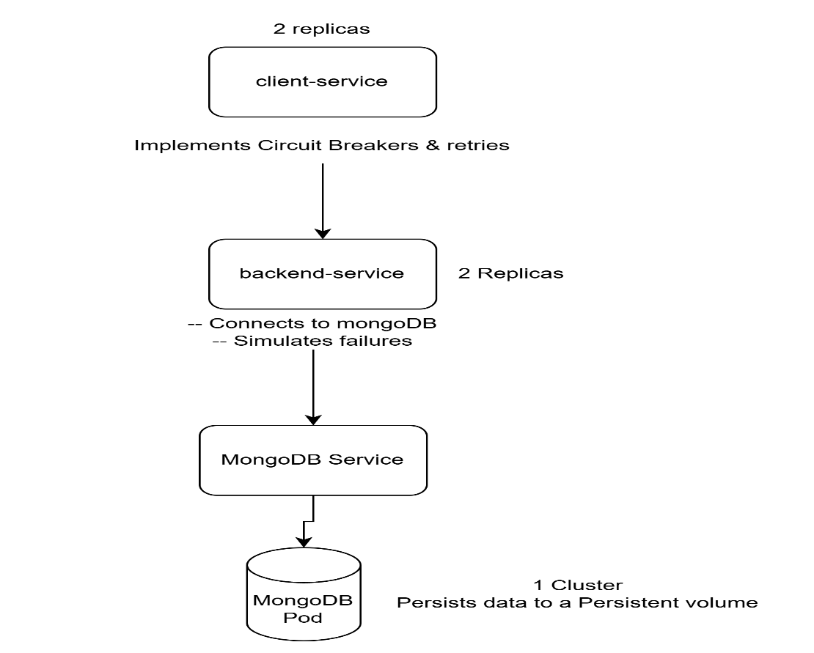

This system consists of 3 main components as highlighted above –
- Client
- Backend
- Mongodb
Docker Images –
Each service has its own Dockerfile to create a container image:
- backend-service/Dockerfile: This builds the backend service image. It uses a node:alpine base image, installs dependencies, compiles the TypeScript code, and exposes port 3000.
- client-service/Dockerfile: This builds the client service image from a node:alpine base, installs dependencies, compiles the code, and exposes port 3001.
- frontend/Dockerfile: Dockerfile for the frontend was not found in the provided file listing.
- mongo:7.0: The official MongoDB image is used for the database.

Kubernetes Deployment:
The k8s/ directory contains the manifests for deploying the application to a Kubernetes cluster:
- namespace.yaml: Creates a user-registration namespace to isolate the application components.
- mongodb-pvc.yaml & mongodb-deployment.yaml: These create a PersistentVolumeClaim to request 2Gi of storage and a Deployment to run a single replica of MongoDB. The data is persisted to the volume.
- mongodb-service.yaml: Exposes the MongoDB deployment within the cluster at mongodb-service:27017.
- backend-deployment.yaml & client-deployment.yaml: These define Deployments for the backend and client services, each running two replicas for high availability. They include resource requests and limits, as well as liveness and readiness probes to ensure the services are healthy.
- backend-service.yaml & client-service.yaml: These create services to expose the backend and client deployments. The client-service is of type NodePort, making it accessible from outside the cluster on port 30001.
STEPS –
- Start Minikube on cmd(Using minikube to deploy Kubernetes cluster)
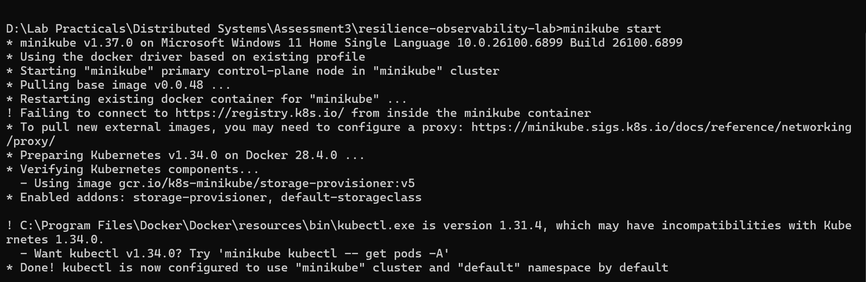
- Build the backend and client service image
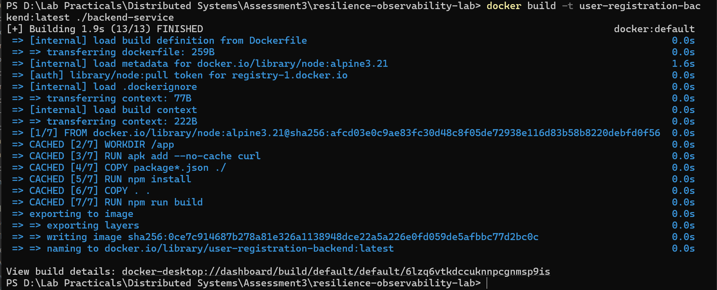
- Check if images are built as expected
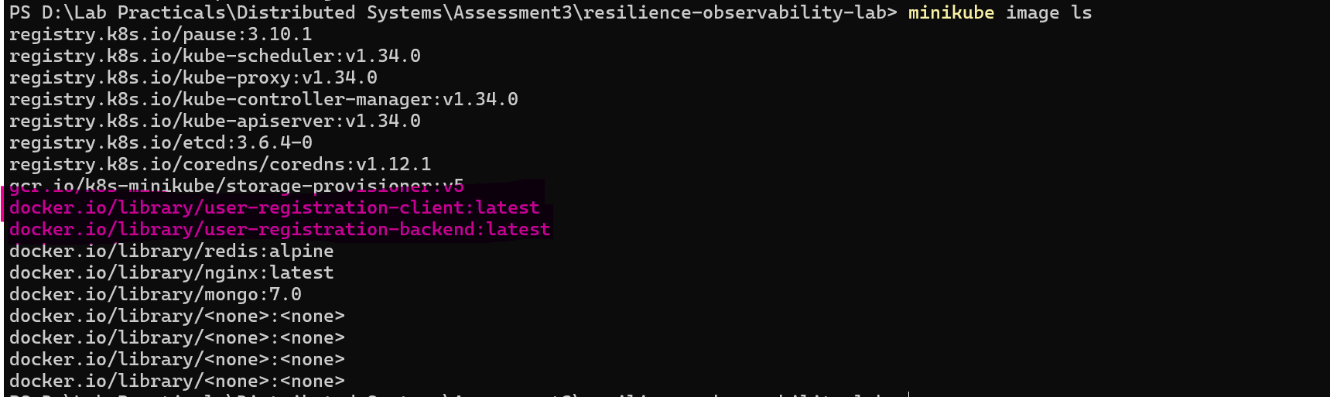
- Deploy to Kubernetes
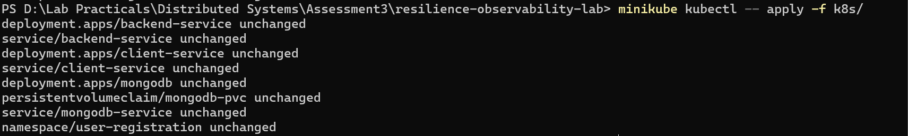
- Verify Pod Deployment
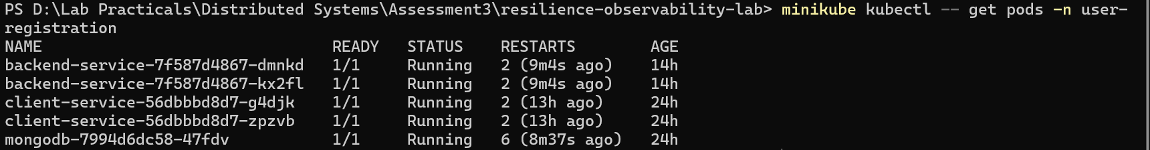
- Baseline Testing – Working as expected when we get users
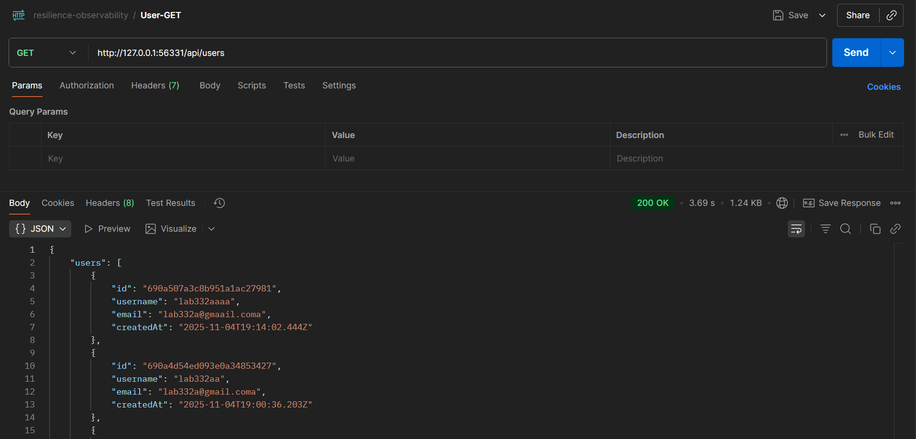

Resilience Experiments –
1. Circuit Breaker Pattern
Configuration:
The Circuit Breaker is implemented in the client-service as a custom CircuitBreaker class. It is configured with the following parameters upon initialization:
- failureThreshold: 5: The circuit will "trip" and move to the OPEN state after 5 consecutive failures.
- resetTimeout: 60000 (60 seconds): When the circuit is OPEN, it will wait for 60 seconds before transitioning to the HALF_OPEN state.
- halfOpenMaxAttempts: 3: In the HALF_OPEN state, the circuit breaker will allow 3 trial requests to pass through to the backend. If all 3 succeed, the circuit will reset to CLOSED. If any of them fail, it will immediately return to the OPEN state and restart the resetTimeout.

STEPS –
- Simulate Error
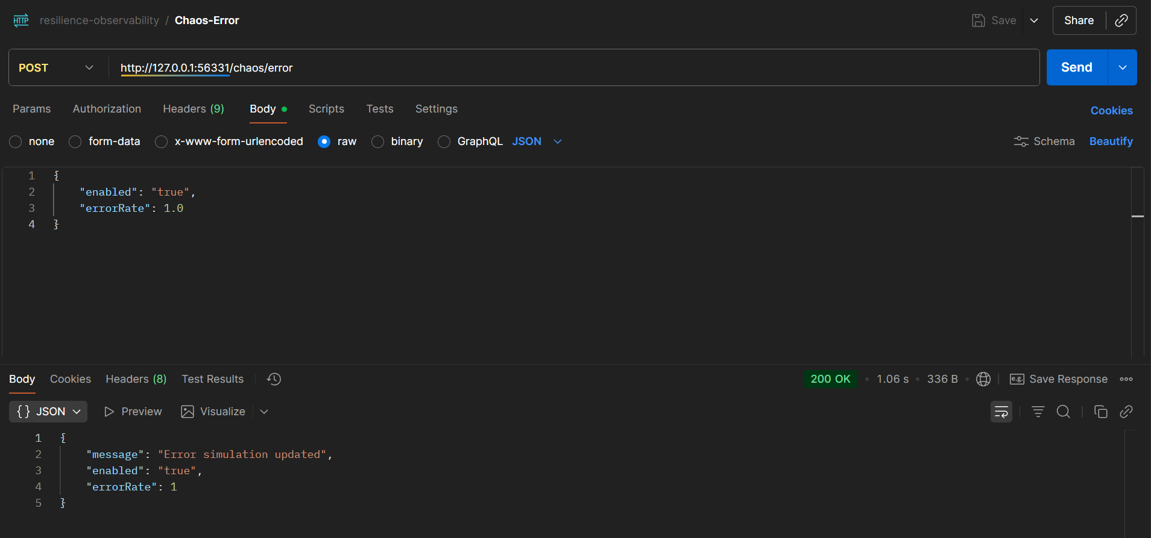
This will make the backend code throw error on each call to mimic failure
- Hit the service endpoint for more than 5 times so that the circuit goes from CLOSE to OPEN state. After this, no matter how many calls go to the client, they are not forwarded to the backend. This showcases resilience in our system
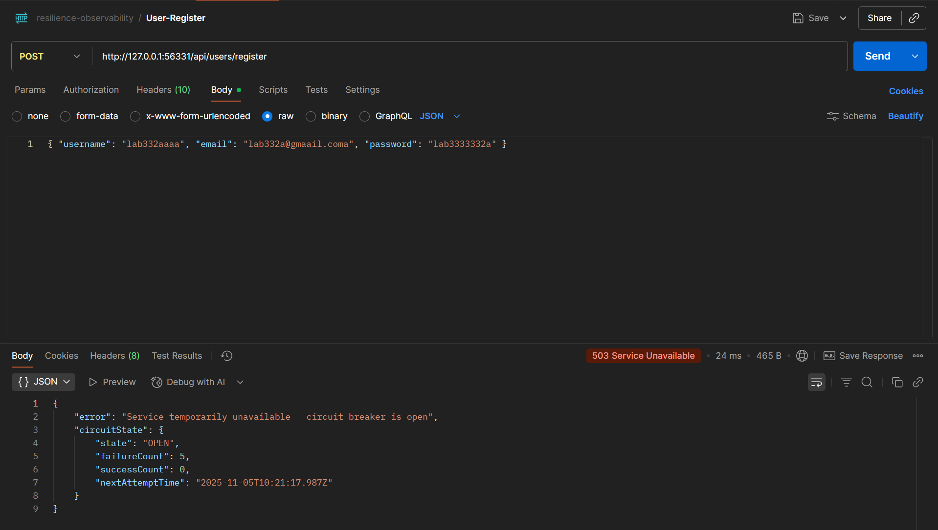
- After 60s pause, try hitting the service again so that it goes into HALF-OPEN state. The calls go through successfully to the backend. If there are 3 successful call straight, the circuit will go back to being in the close state
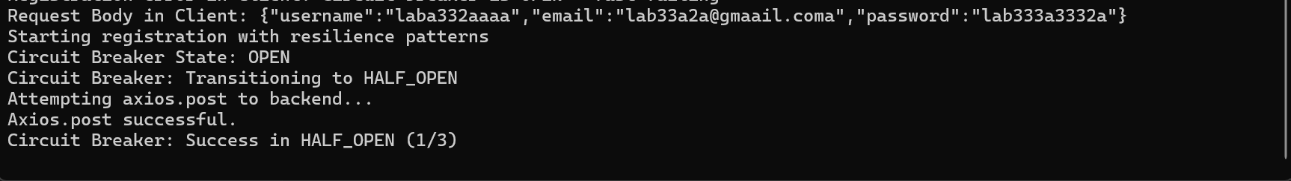
- If in case the call fails again, the circuit will go back to the OPEN state
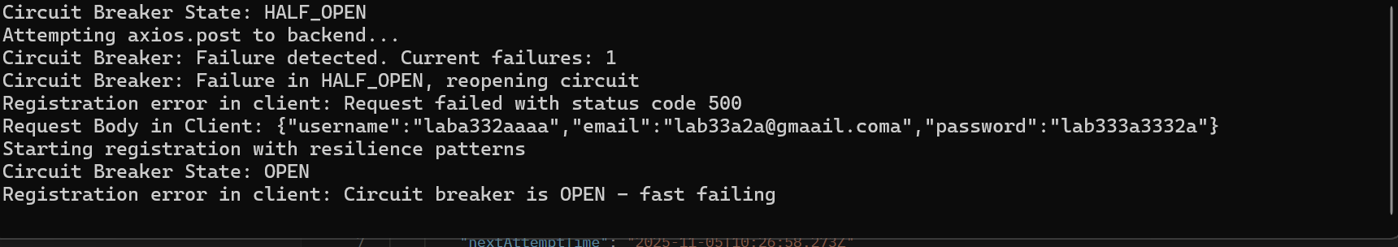
- Pro (Increased Availability & Performance): The primary benefit of the Circuit Breaker is that it prevents a cascading failure. By isolating the failing backend, the client-service and frontend remain responsive. Users get an immediate, albeit negative, response instead of a long wait followed by a timeout. This improves the overall system availability and user experience under partial failure conditions. It also gives the downstream service (the backend) breathing room to recover without being overwhelmed by a storm of retries.
- Con (Stale Data/Delayed Consistency): In the OPEN state, no new user registrations can occur. This is a trade-off between availability and consistency. The system is available (it responds quickly), but it's not fully functional. For a non-critical feature like user registration, this is often an acceptable trade-off. For a core e-commerce checkout process, the business requirements might demand a different strategy.
- Justification: This pattern is ideal for protecting a service from a dependency that is experiencing a complete outage or high latency. It is a direct application of the Fault Tolerance principle. By failing fast, the system remains predictable and prevents resource exhaustion (e.g., holding open connections, thread starvation) in the client-service.

- Exponential Backoff & Jitter
The retry logic is implemented in the retryWithBackoff function in the client-service. It is configured as follows:
- maxRetries: 3: It will attempt the operation a total of 4 times (the initial attempt + 3 retries).
- initialDelay: 1000 (1 second): The delay before the first retry.
- backoffMultiplier: 2: The delay will double after each failed attempt (1s, 2s, 4s, etc.).
- maxDelay: 10000 (10 seconds): The maximum delay between retries will be capped at 10 seconds.
- jitterFactor: 0.3: A random amount of time (±30% of the calculated delay) is added to each backoff period.
Crucially, the retry logic is smart: it will not retry on 4xx client errors (like "Username already exists") or if the circuit breaker is OPEN.

  - Reduce the Error Rate to 50%
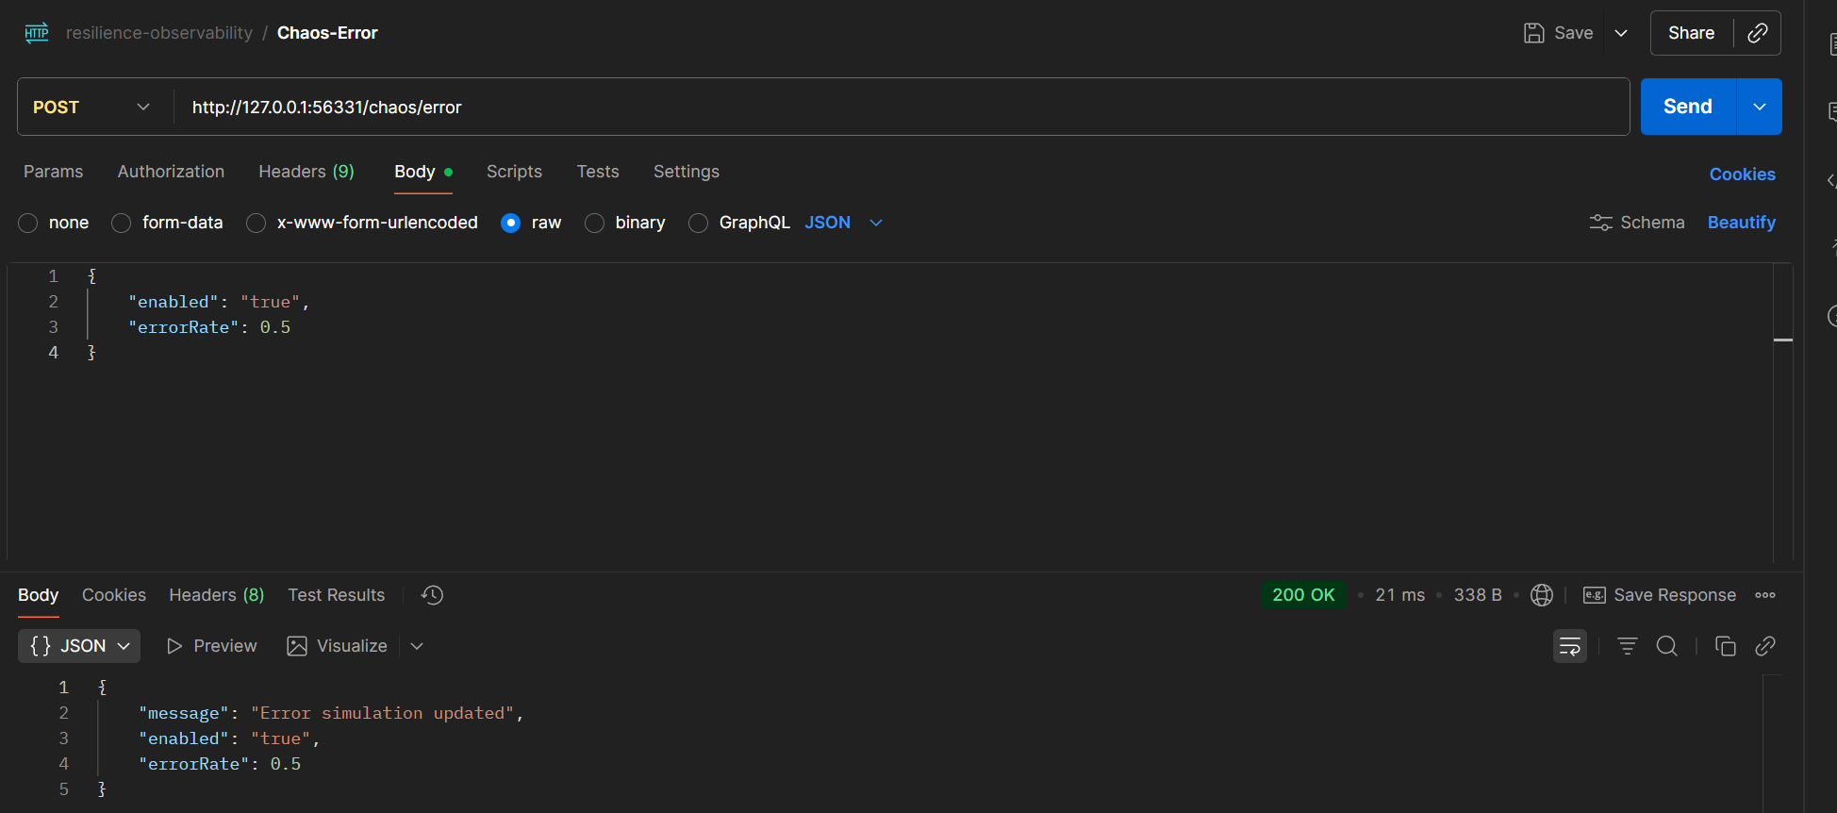

  - Hit the get users endpoint until it fails. Check the logs for the client-service it will showcase that the request got retried atleast 4 times before it went for failure
    - In this we can see that the client-service retried the call 2 times before it got a success response
    - The UI would experience some lag but in the end will get a success response showcasing resilience in the system
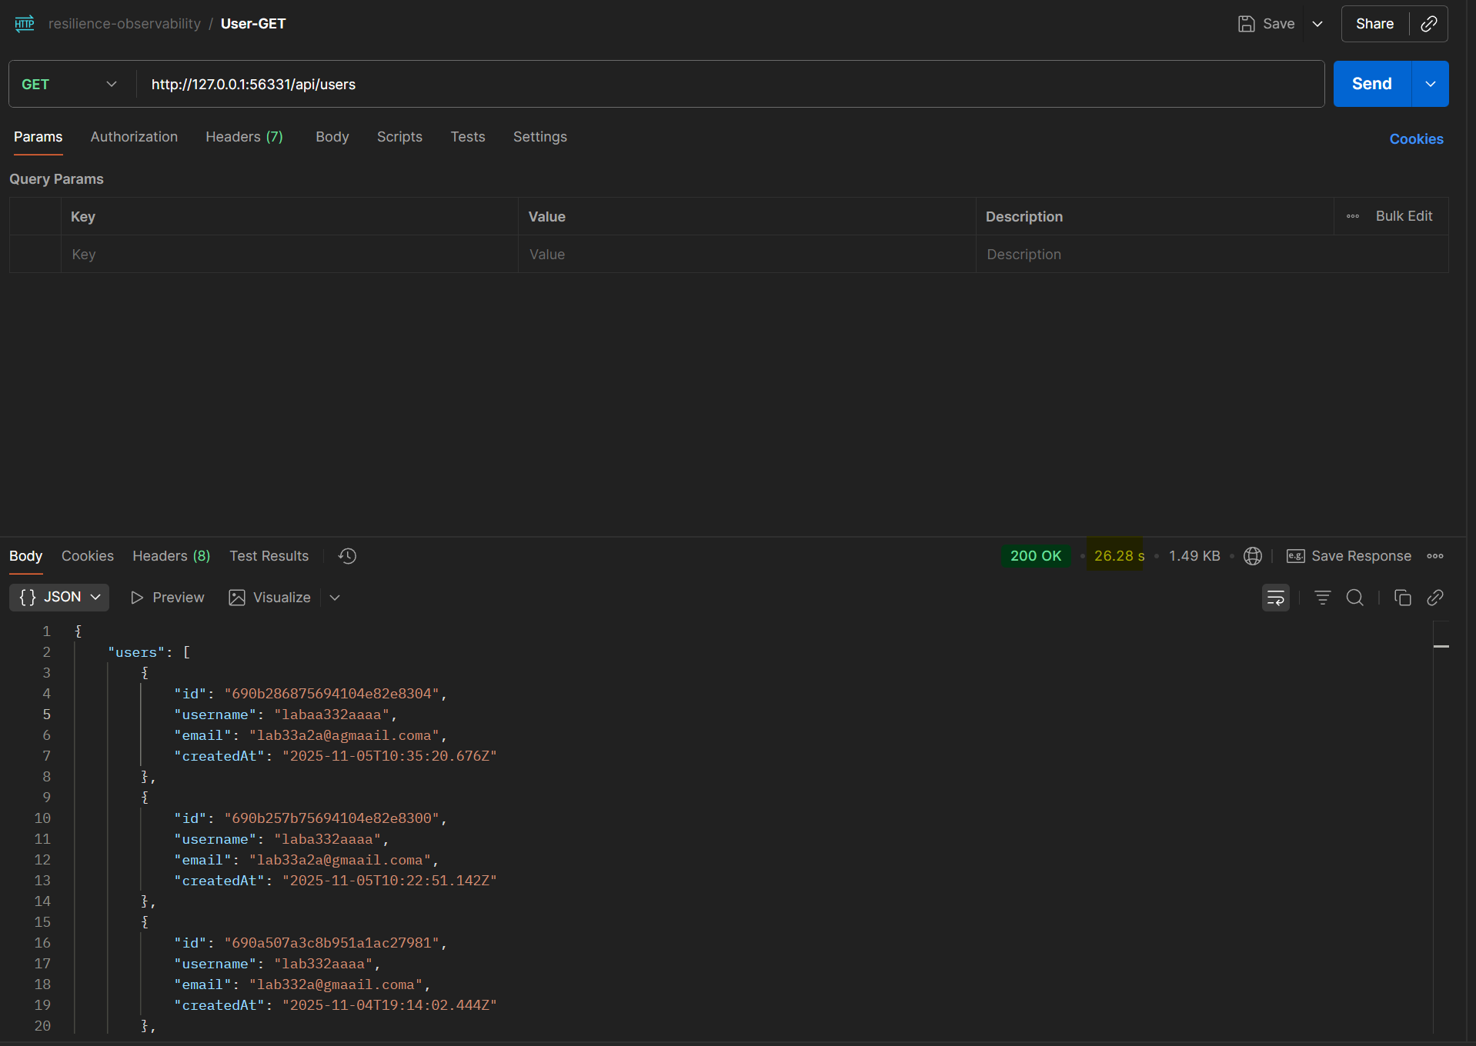
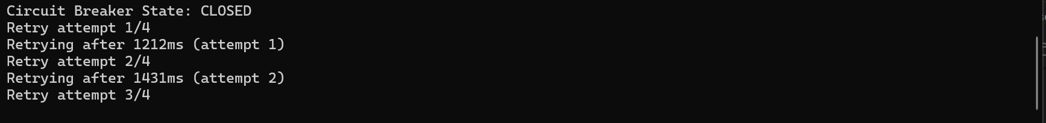
Observations (Predicted Behavior):
- Transient Failure: Imagine the backend-service has a brief hiccup and fails a single request with a 500 error (but not enough to trip the circuit breaker).
- First Retry: The client-service will catch the error. Instead of immediately failing, it will wait for approximately 1 second (plus or minus jitter) and then automatically retry the registration request.
- Success on Retry: If the backend has recovered and the second attempt succeeds, the user on the frontend will simply experience a slightly longer loading time but will ultimately see a success message. They will be unaware that a transient failure occurred and was handled automatically.
- Thundering Herd Prevention: The "jitter" is critical in a system with many clients. If a backend service fails and then recovers, all clients might retry at the exact same time, causing a "thundering herd" that could knock the service over again. The random jitter spreads out the retry attempts, smoothing the load on the recovering service.
Architectural Trade-offs & Justification:
- Pro (Improved Resilience to Transient Faults): This pattern makes the system much more resilient to temporary, intermittent failures, such as a brief network glitch, a pod restarting, or a temporary database deadlock. It directly improves the availability of the system from the user's perspective.
- Con (Increased Latency): The main trade-off is increased latency. A request that requires one or more retries will take significantly longer to complete. If the operation is time-sensitive, a long retry chain might not be acceptable.
- Con (Risk of Masking Deeper Issues): Aggressive retry logic can sometimes mask underlying chronic problems with a service. If a service is constantly struggling, retries might keep it "limping along" when it should be allowed to fail so that the root cause can be investigated.
- Justification: Retries are perfect for handling transient, non-idempotent failures. For an operation like user registration, which is generally idempotent (retrying with the same data won't create duplicate users because of the unique username/email check), this pattern is very effective. It aligns with the principle of designing for failure, assuming that temporary faults are inevitable in a distributed environment.

Chaos Experiments –
Tool Used – chaostoolkit
YAML Manifest –
{
"version": "1.0.0",
"title": "Backend Service Resilience Test",
"description": "Test the resilience of the user registration system when the backend service experiences failures",
"tags": [
"kubernetes",
"resilience",
"circuit-breaker"
],
"configuration": {
"namespace": "user-registration"
},
"steady-state-hypothesis": {
"title": "System is healthy and responsive",
"probes": [
{
"type": "probe",
"name": "backend-service-is-available",
"tolerance": 200,
"provider": {
"type": "http",
"url": "http://localhost:30000/health",
"timeout": 5
}
},
{
"type": "probe",
"name": "client-service-is-available",
"tolerance": 200,
"provider": {
"type": "http",
"url": "http://localhost:30001/health",
"timeout": 5
}
},
{
"type": "probe",
"name": "circuit-breaker-is-closed",
"tolerance": {
"type": "jsonpath",
"path": "$.state",
"expect": "CLOSED"
},
"provider": {
"type": "http",
"url": "http://localhost:30001/circuit-breaker/status"
}
}
]
},
"method": [
{
"type": "action",
"name": "terminate-backend-pod",
"provider": {
"type": "python",
"module": "chaosk8s.pod.actions",
"func": "terminate_pods",
"arguments": {
"label_selector": "app=backend",
"ns": "user-registration",
"rand": true,
"qty": 1
}
},
"pauses": {
"after": 10
}
},
{
"type": "probe",
"name": "verify-circuit-breaker-opens",
"provider": {
"type": "http",
"url": "http://localhost:30001/circuit-breaker/status"
}
},
{
"type": "action",
"name": "wait-for-recovery",
"provider": {
"type": "process",
"path": "sleep",
"arguments": "30"
}
}
],
"rollbacks": [
{
"type": "action",
"name": "reset-circuit-breaker",
"provider": {
"type": "http",
"url": "http://localhost:30001/circuit-breaker/reset",
"method": "POST"
}
}
]
}

With this experiment we,
- Terminate Backend Pod
- Randomly terminates one backend pod in the Kubernetes cluster
- Verify Circuit Breaker Response
- Checks if the circuit breaker opens as expected
- Wait for Recovery
- Waits 30 seconds to allow system recovery
4. Rollbacks
Contains cleanup actions:
- Resets the circuit breaker to its initial state
This experiment helps validate that:
- The circuit breaker works as designed
- The system degrades gracefully when the backend fails
- The system recovers properly after failure

STEPS –
  - Forward the client service & backend service to port 3000 and 3001 respectively. SUCCESS
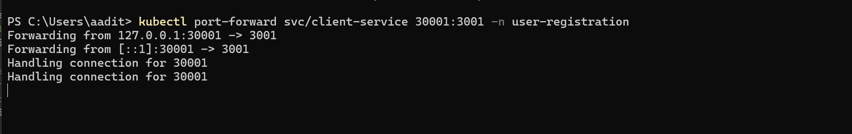
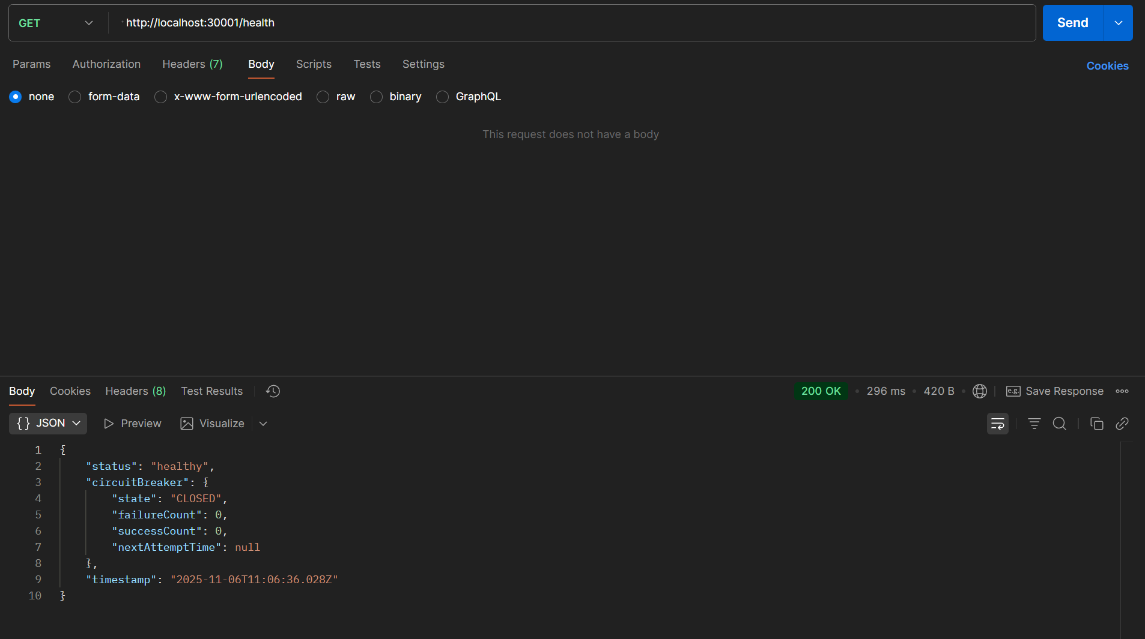
  - Run the pod-termination.json file
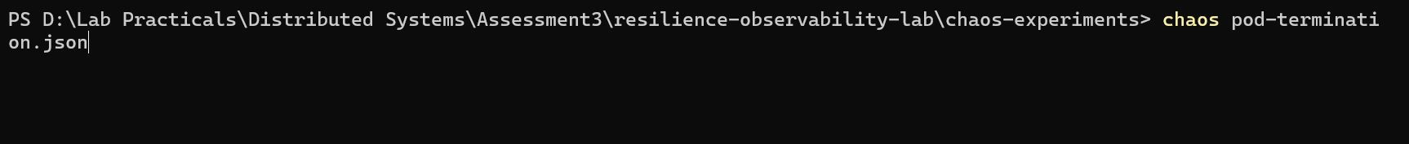
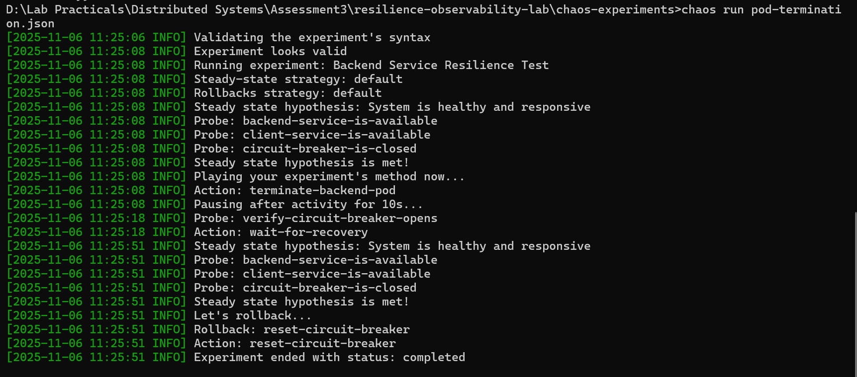
Conclusions From This Test
- Fault Detection
  - System can detect when backend service fails
  - Circuit breaker transitions from CLOSED to OPEN state
- Failure Isolation
  - Client service protects itself using circuit breaker
  - Failed requests are fast-failed when circuit is OPEN
  - Prevents cascading failures
- Self-Recovery
  - Kubernetes automatically replaces terminated pod
  - System recovers without manual intervention
  - Circuit breaker returns to CLOSED state after recovery
- Resilience Patterns Work
  - Circuit breaker implementation is functioning
  - System degradation is graceful
  - Recovery mechanisms are effective

Conclusion
This lab gave a hands-on understanding of how to build systems that can stay reliable even when things go wrong. By working with patterns like Circuit Breaker, Retry with Exponential Backoff and Jitter, and using Chaos Engineering, we learned how to make applications that don’t just work when everything is fine, but also handle failures smoothly when they happen.
Right from the start, the main idea was that in distributed systems, failures are a normal part of life. Services can go down, networks can slow, or pods can restart at any time. The goal isn’t to stop failures from happening but to design the system so it can recover or keep running without completely breaking. This lab helped put that idea into practice.
Key Learnings:
- Understanding Failures:
By simulating real problems like backend crashes and network delays, we saw how quickly small issues can affect the whole system if not handled properly. This helped in understanding why resilience is so important.
- Circuit Breaker in Action:
The circuit breaker helped the system avoid total failure by quickly stopping calls to the backend when it was down. This made sure the client stayed responsive and users didn’t have to wait long for failed requests. It showed that failing fast is sometimes better than waiting for a timeout.
- Retries with Backoff and Jitter:
The retry logic helped recover from short-term issues. With exponential backoff and jitter, retries were spread out, preventing all clients from retrying at the same time. This pattern made the system more stable and increased the chance of success when temporary problems occurred.
- Chaos Engineering Results:
Running chaos experiments using the Chaos Toolkit made it clear how the system behaves under stress. By intentionally breaking parts of the system, we could see that our resilience patterns worked as expected. The client handled backend failures gracefully and recovered once things returned to normal.
- Balancing Trade-offs:
These experiments also showed that resilience has its costs. Retries can cause small delays, and circuit breakers can temporarily block requests. But these trade-offs are acceptable because they make the system more reliable and keep it available to users even during issues.
- Better Observability and Design:
Collecting logs and checking metrics during the tests helped us understand what was happening inside the system. This made it easier to spot problems and confirmed that our resilience patterns were working correctly.
Overall Impact:
By the end of this lab, the system became more than just a working client and backend setup, it turned into a resilient and self-healing application. The experiments proved that resilience patterns are not optional; they are essential for keeping distributed systems running smoothly.
This lab also improved not only technical skills like using Kubernetes, Node.js, and chaos tools, but also architectural thinking, understanding how to design systems that can handle failure without affecting the user experience.
In short, this lab showed that building reliable systems is not about avoiding problems but preparing for them. With the right patterns and design choices, a system can stay stable, recover on its own, and continue serving users even when parts of it fail.

