Project: A College Website

#### -by Aaska, Aaditya.

1. Login Page :-

--If someone is already registered on this website, then one can use his/her username and password to log in.

--If not, then he/she can register by clicking the link REGISTER.

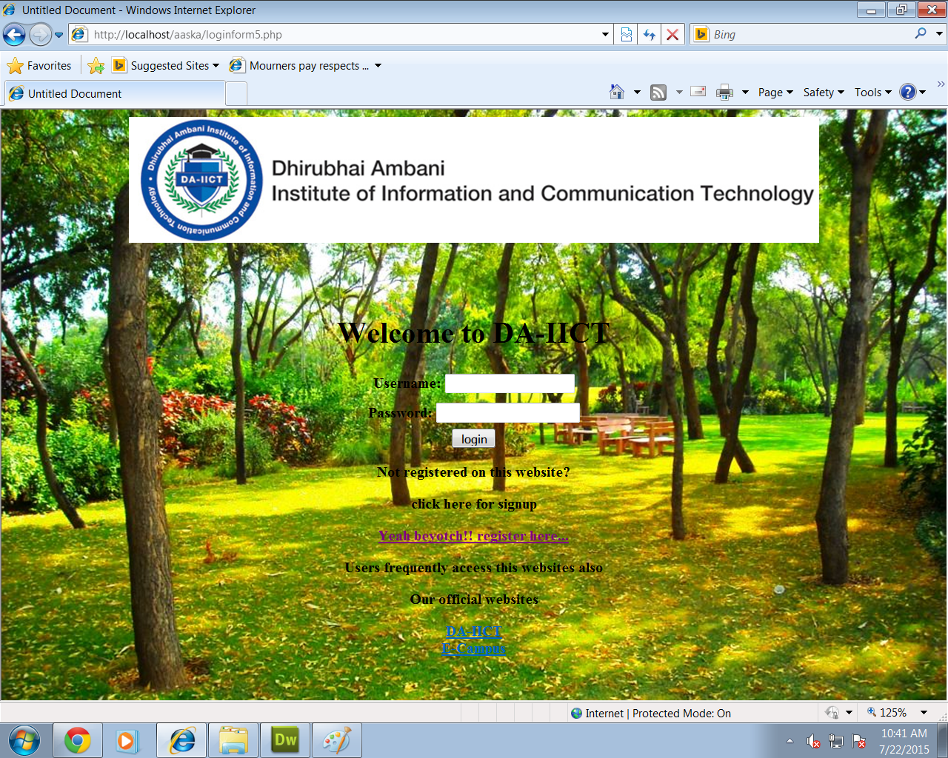

In login form both the fields are mandatory. If user leaves any field blank or types it wrong then it will print an error message on that page, because of the validation.

1. Registration Form:-

--in this form also, every single field is mandatory. Every field is set to a validation. And also, confirmed password should match the password.

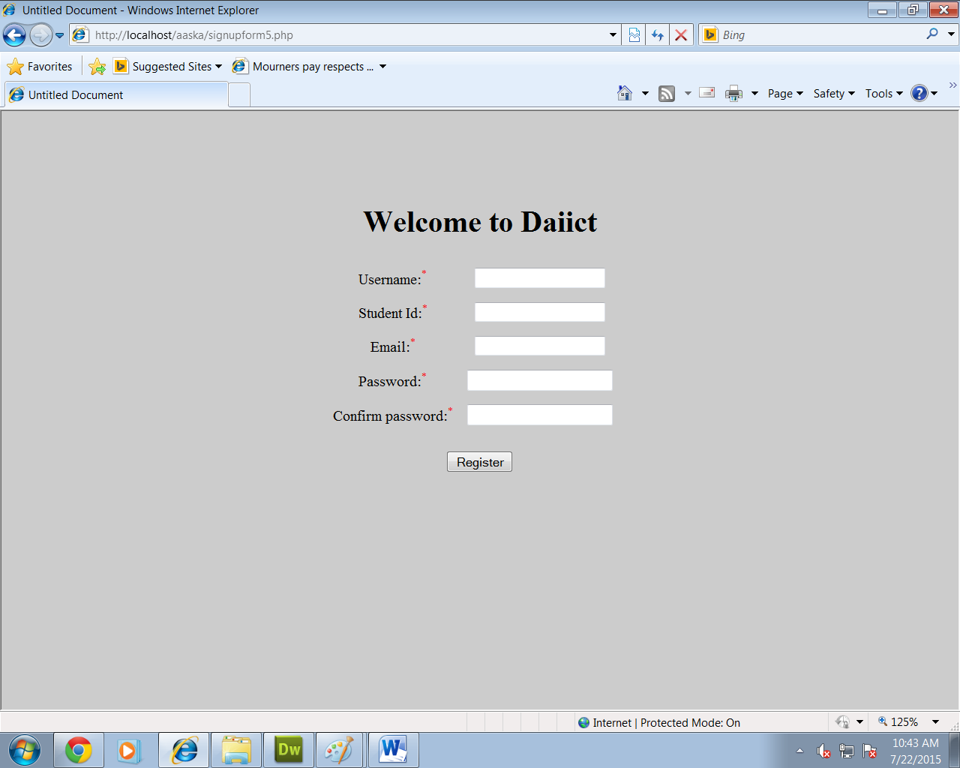

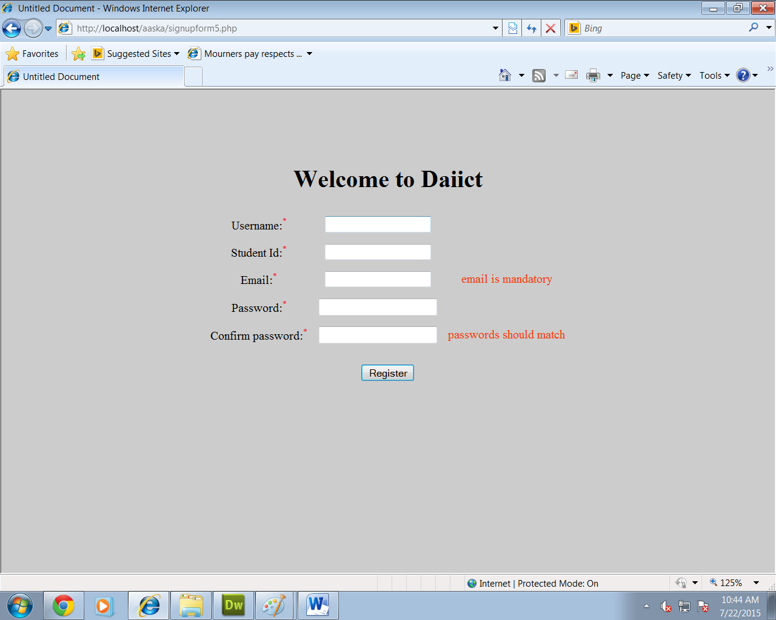

--this is how, errors are shown when in this case, user left email field blank and entered wrong password in the confirm password field.

--by clicking the register button, a user gets registered in daiict database and a session of his/her username is created and it will redirect user to the homepage.

1. Homepage:-

* In the given case, username is saurabh. So, the session of ‘saurabh’ is created and it is shown on the top-right of the webpage….’howdy saurabh’.

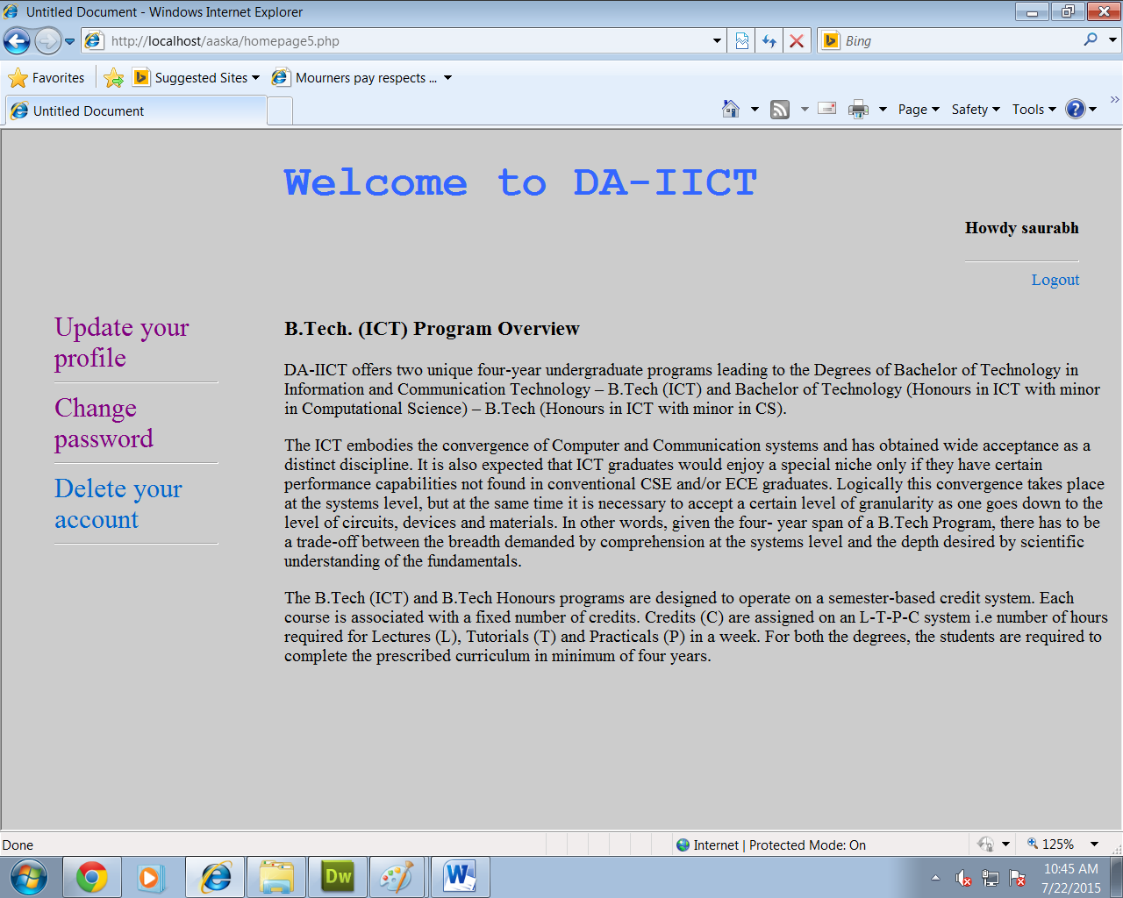

1. Logout:-

* User can sign out of his account by clicking the logout button. After clicking the button, the given message will be shown and if user clicks ok, then it will be redirected to the loginpage and will destroy the session.

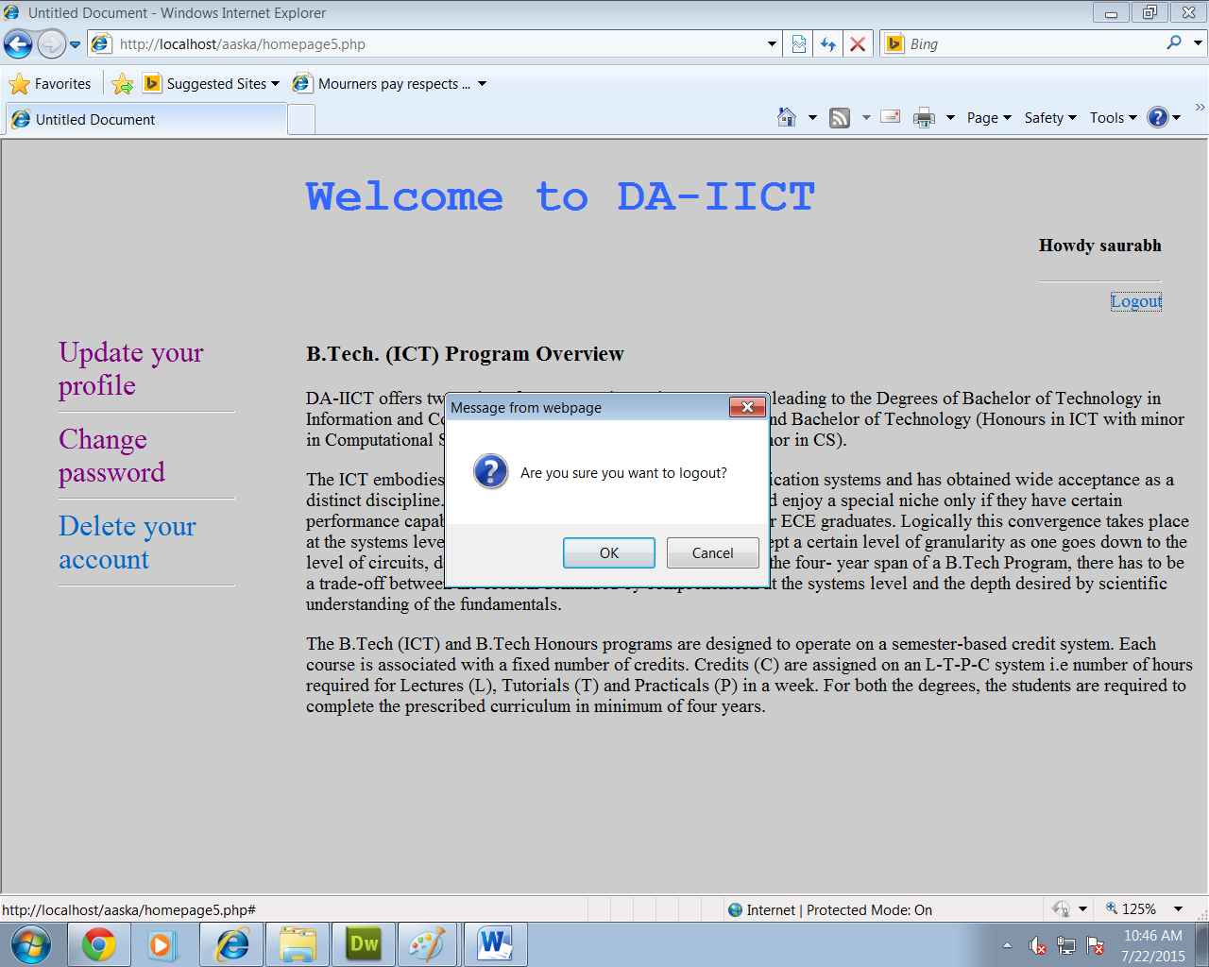

2) Change Password:-

-- this form is also having validations which will check for the

1) empty fields

2) if old password matches the current password that is there in the database.

3) new password matches the confirm password.

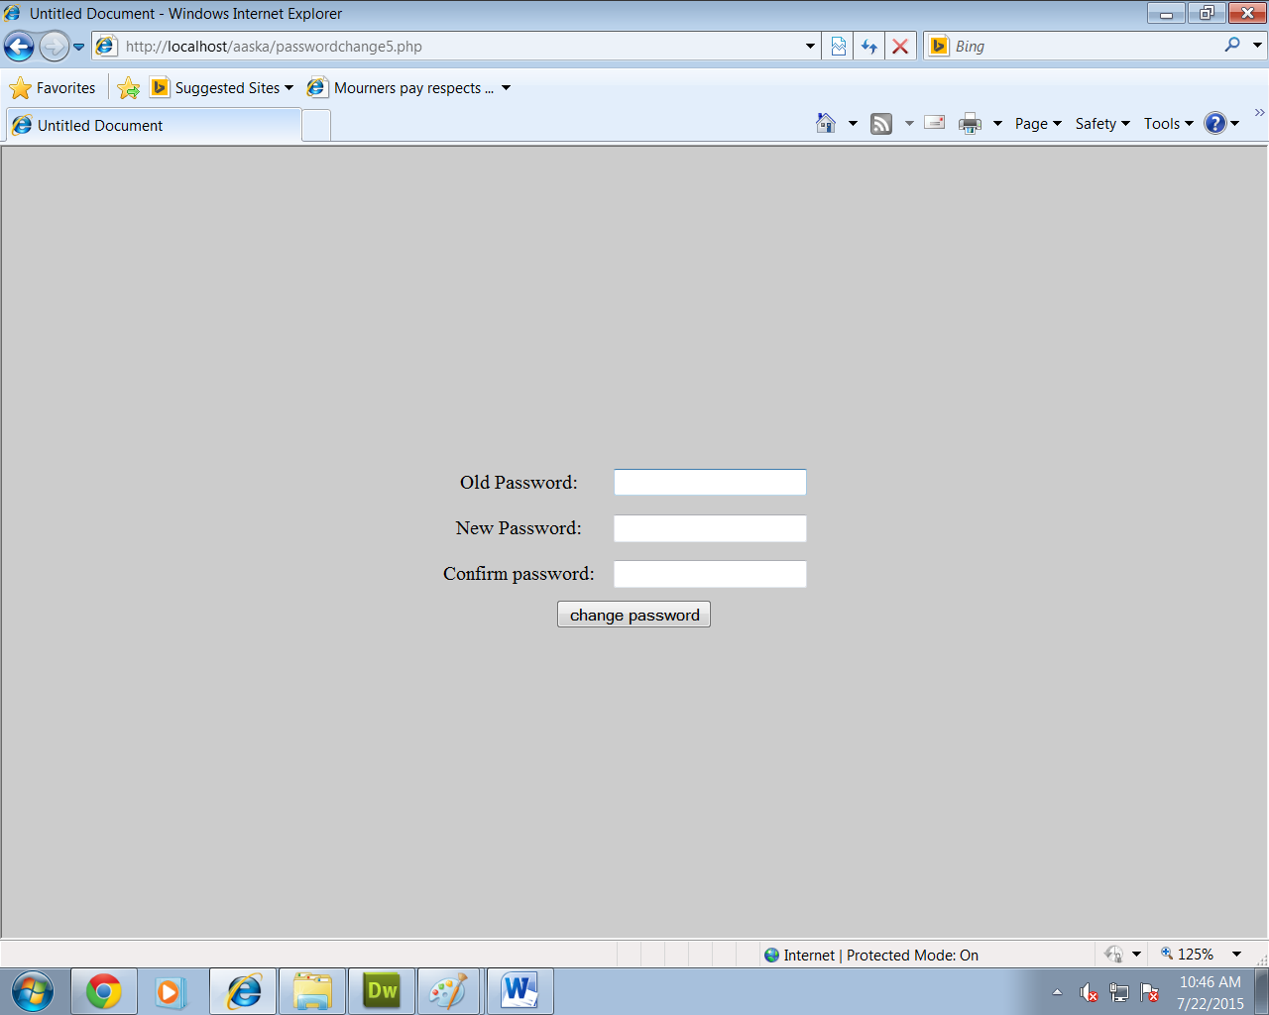

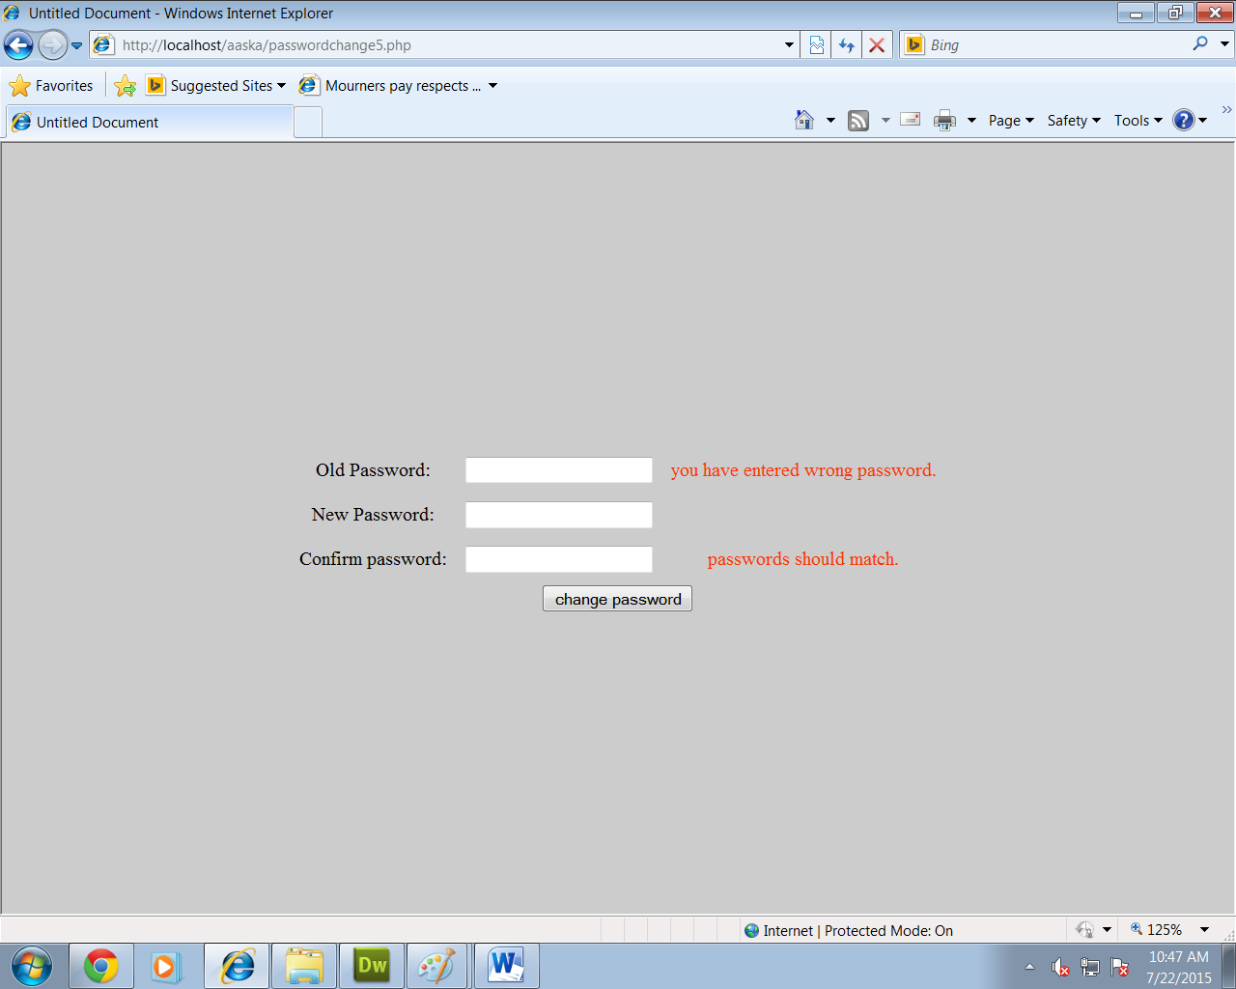

* This screenshots shows the errors displayed when user typed wrong password and also the new password and confirmed password didn’t match.

-- if none of the 3 errors exists , then only the password will be changed and a an alert box will be shown showing the given message.

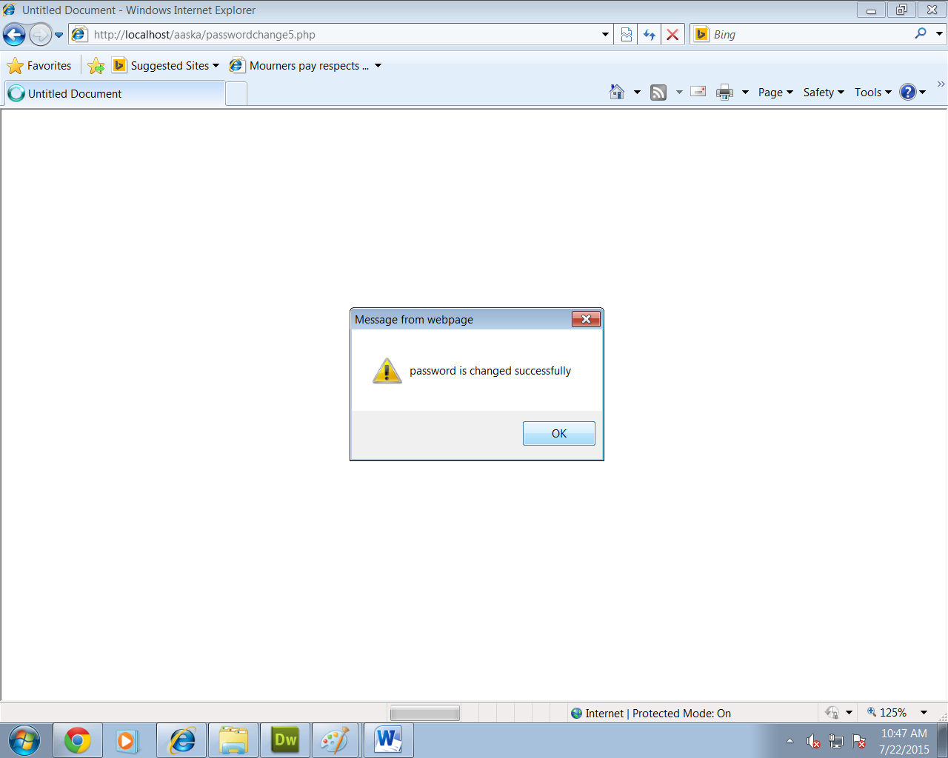

1. Delete your Account:-

* If you click the link ‘delete your account’, then it will show the message box and if user presses ok, then his data will be permenantly deleted from the daiict database and all the sessions created will get destroyed and it will redirect the user to the loginpage.

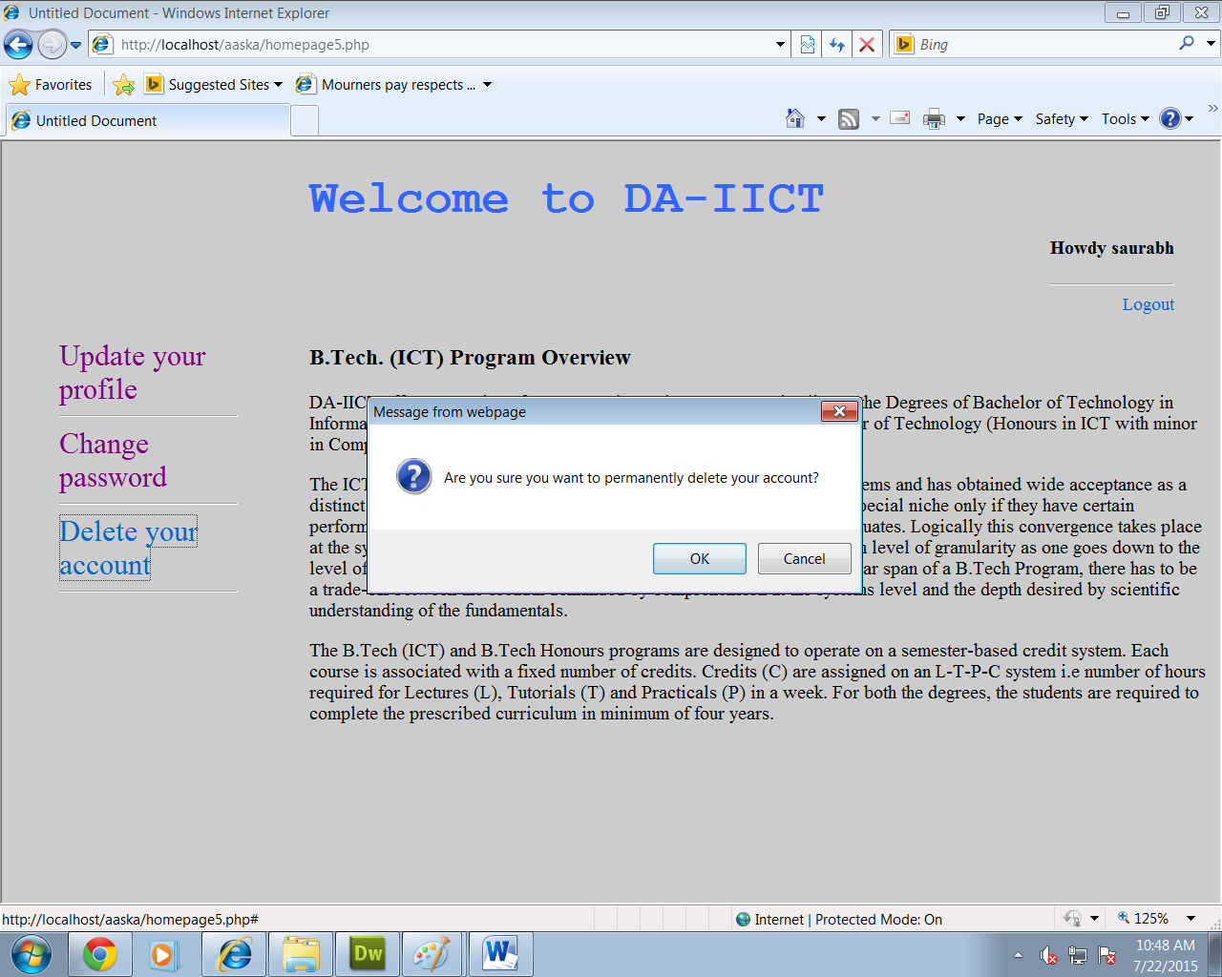

1. Update your Profile:-

--when user presses ‘update your profile’ option ,the given page will be shown.

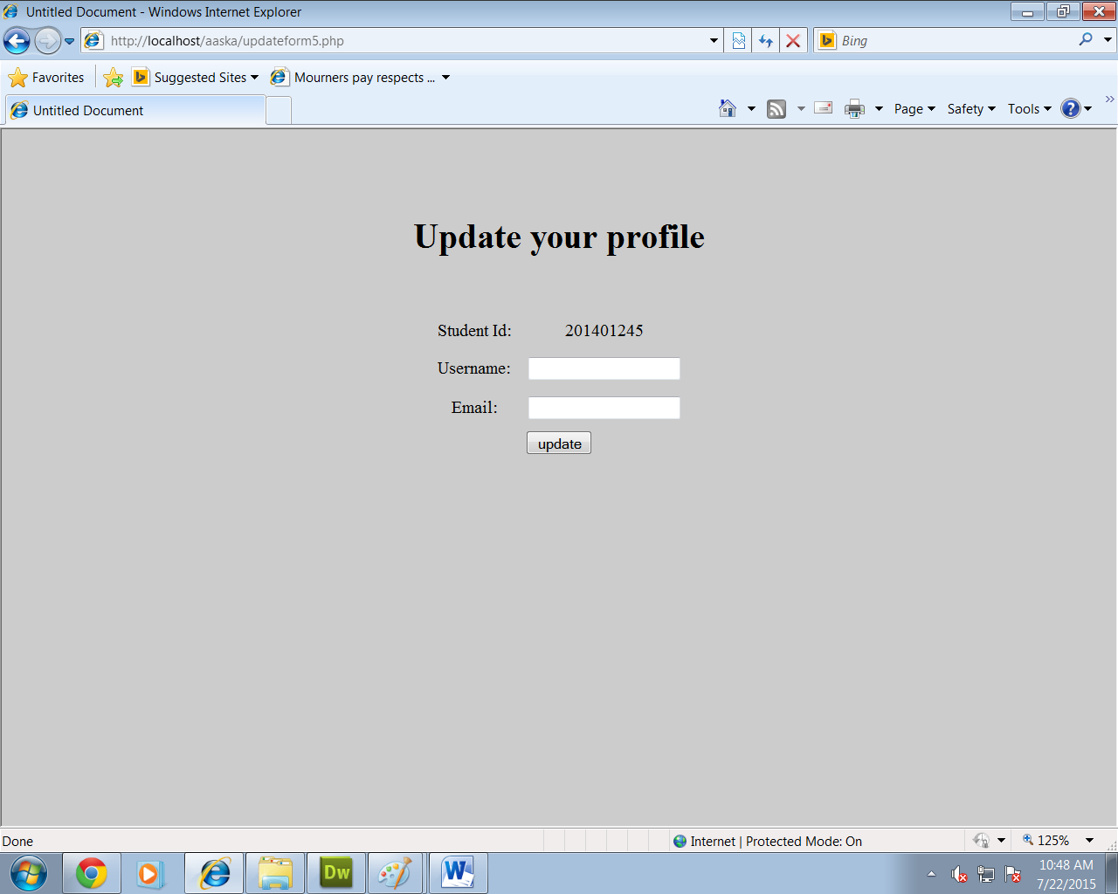

--User can change any of the given information that he wants. It is not mandatory to type in all the fields. By clicking the update button it will fetch user to the homepage and sessions will be changed accordingly.

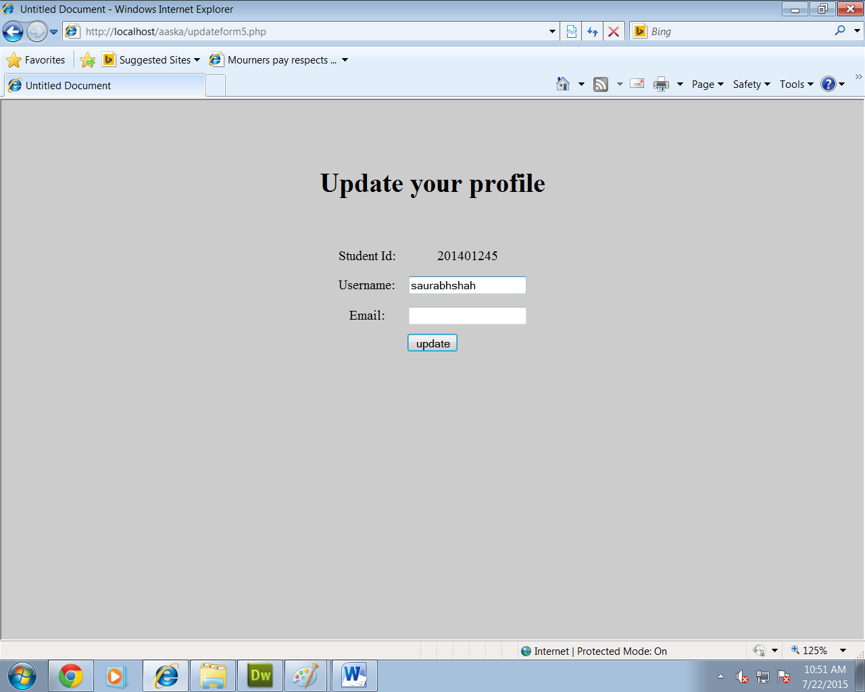

--------------------------------------------------------DONE---------------------------------------------------------------------------