MLOps Experimental Learning Assignment
End-to-End ML Model Development, CI/CD, and Production Deployment

Heart Disease Prediction System
Submitted By
GROUP NO 36
MAHESHWARI ADITYA LALCHAND (2024AA0582)
P Kiran Kumar (2024AB05247)
Sabarinathan M (2024AB05248)
Kannan P Nair (2024AB05250)
Vishal Arora (2024AB05008)

Course: MLOps (S1-25_AIMLCZG523)
BITS Pilani

Total Marks: 50

Table of Contents
- Introduction and Objective
- Data Acquisition & Exploratory Data Analysis
- Feature Engineering & Model Development
- Experiment Tracking with MLflow
- Model Packaging & Reproducibility
- CI/CD Pipeline & Automated Testing
- Model Containerization
- Production Deployment
- Monitoring & Logging
- Conclusion

1. Introduction and Objective
This project implements a complete MLOps pipeline for heart disease prediction using the UCI Heart Disease dataset. The objective is to design, develop, and deploy a scalable and reproducible machine learning solution utilizing modern MLOps best practices.

1.1 Problem Statement
Build a machine learning classifier to predict the risk of heart disease based on patient health data, and deploy the solution as a cloud-ready, monitored API.

1.2 Dataset Overview
The Heart Disease UCI Dataset contains 14 features including:
- Age, Sex, Chest Pain Type (cp)
- Resting Blood Pressure (trestbps), Serum Cholesterol (chol)
- Fasting Blood Sugar (fbs), Resting ECG Results (restecg)
- Maximum Heart Rate (thalach), Exercise Induced Angina (exang)
- ST Depression (oldpeak), Slope, Number of Vessels (ca), Thalassemia (thal)
- Target: Binary (0 = No Disease, 1 = Disease Present)

2. Data Acquisition & Exploratory Data Analysis

2.1 Data Download & Preprocessing
The dataset was obtained from the UCI Machine Learning Repository. A download script (download_data.py) automates data acquisition. Preprocessing included handling missing values, converting target to binary, and ensuring numeric features.

2.2 Dataset Statistics
Metric | Value
Total Samples | 297
Number of Features | 13
No Disease (Class 0) | 160 (53.9%)
Disease Present (Class 1) | 137 (46.1%)

2.3 Target Distribution
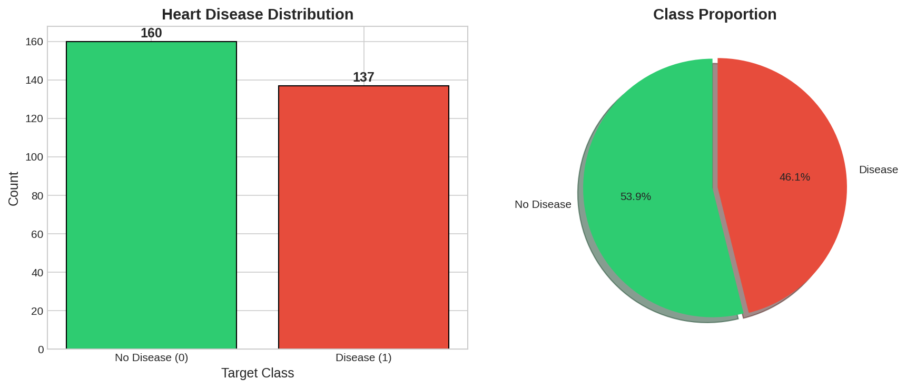

2.4 Correlation Heatmap
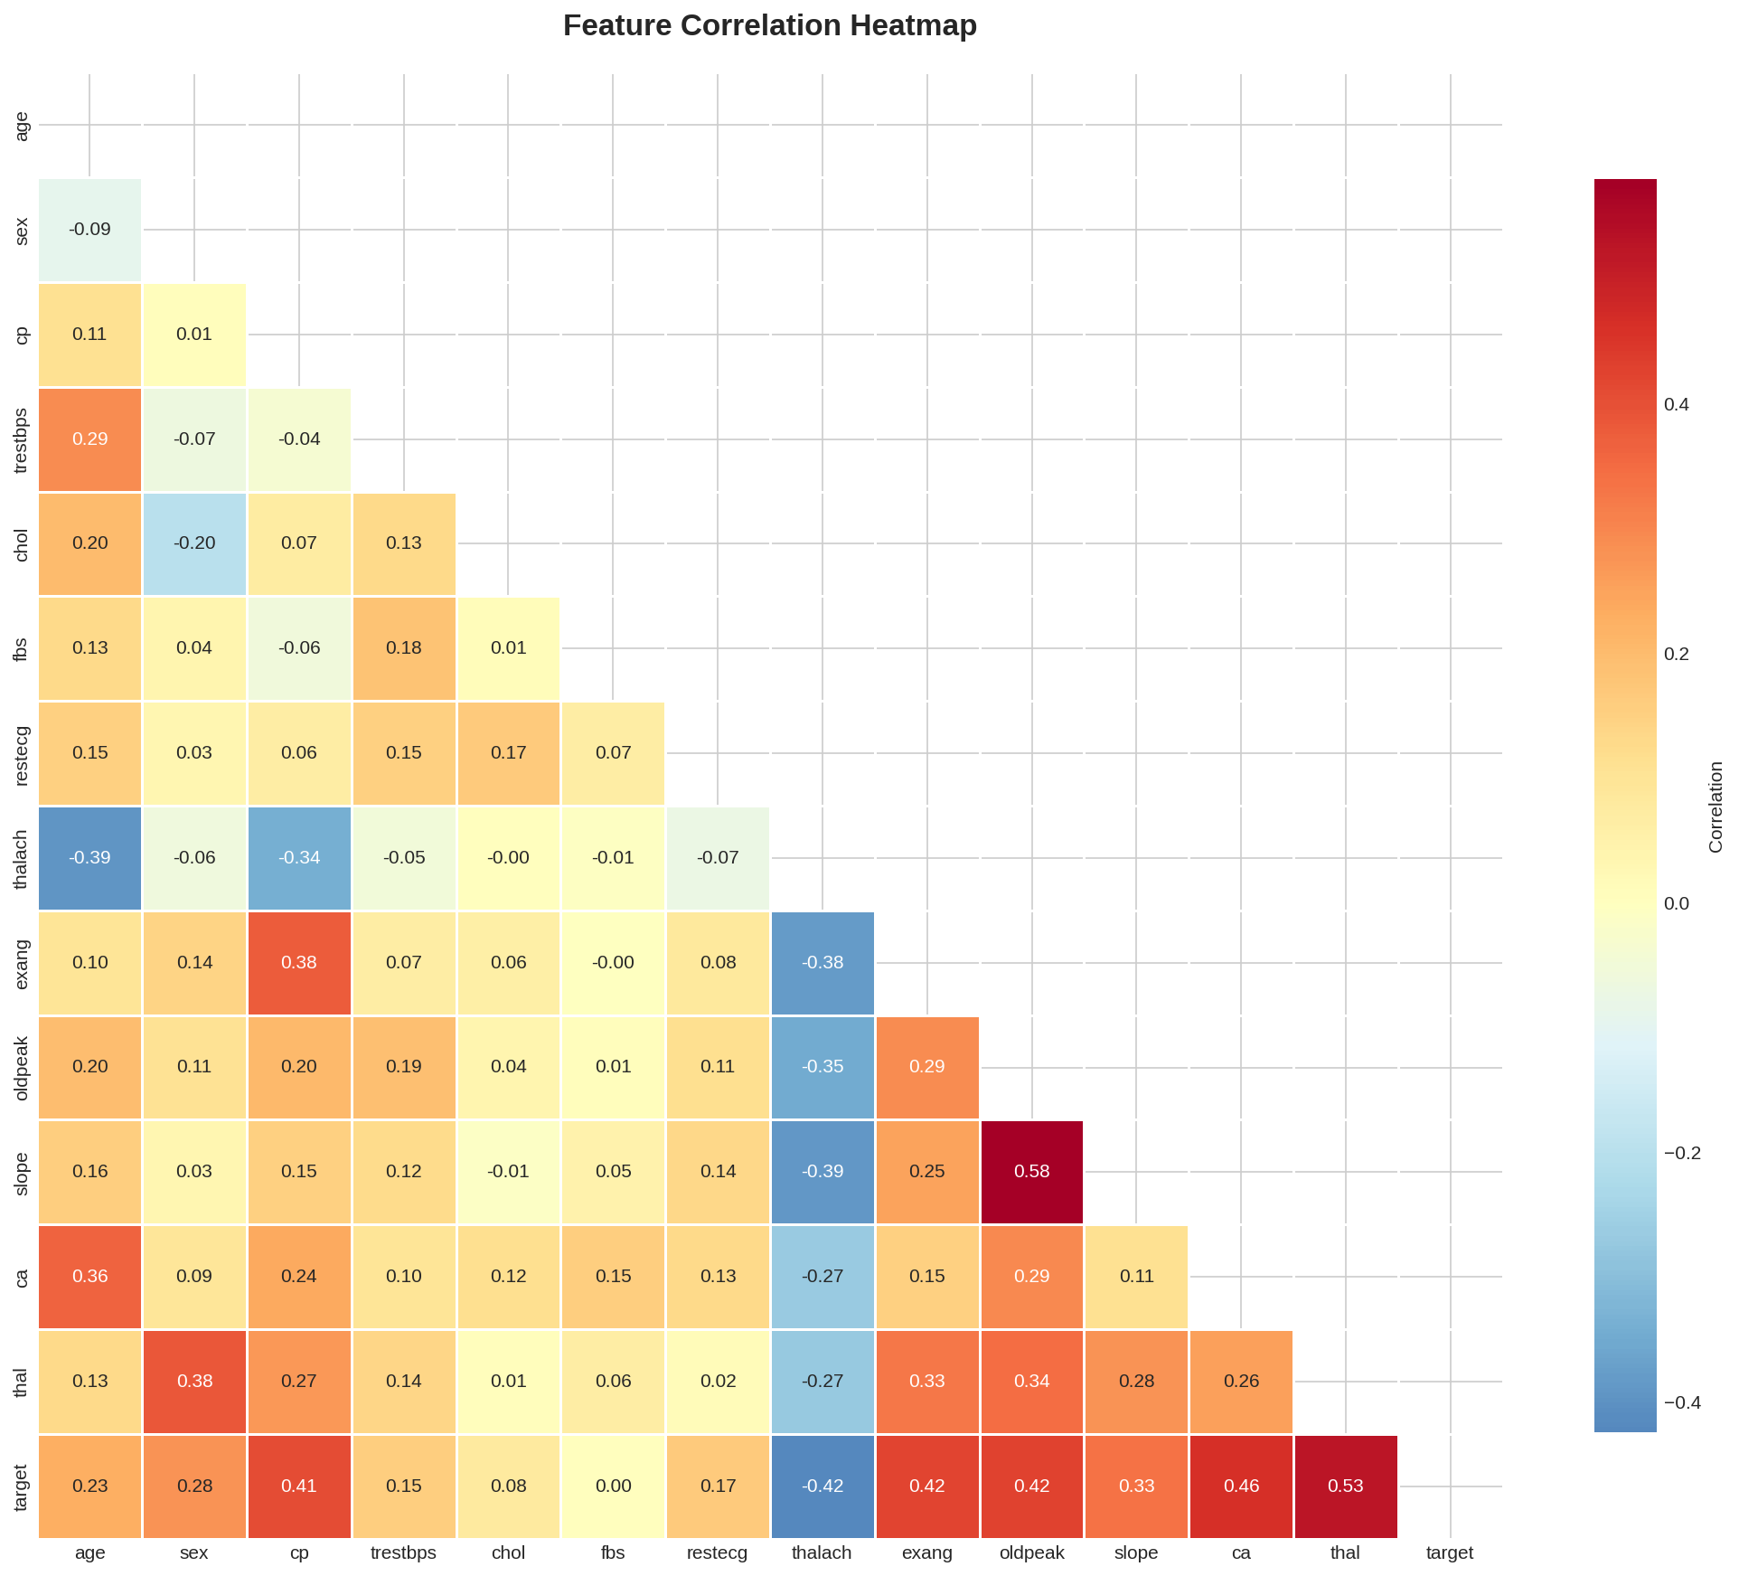

2.5 Feature Distributions
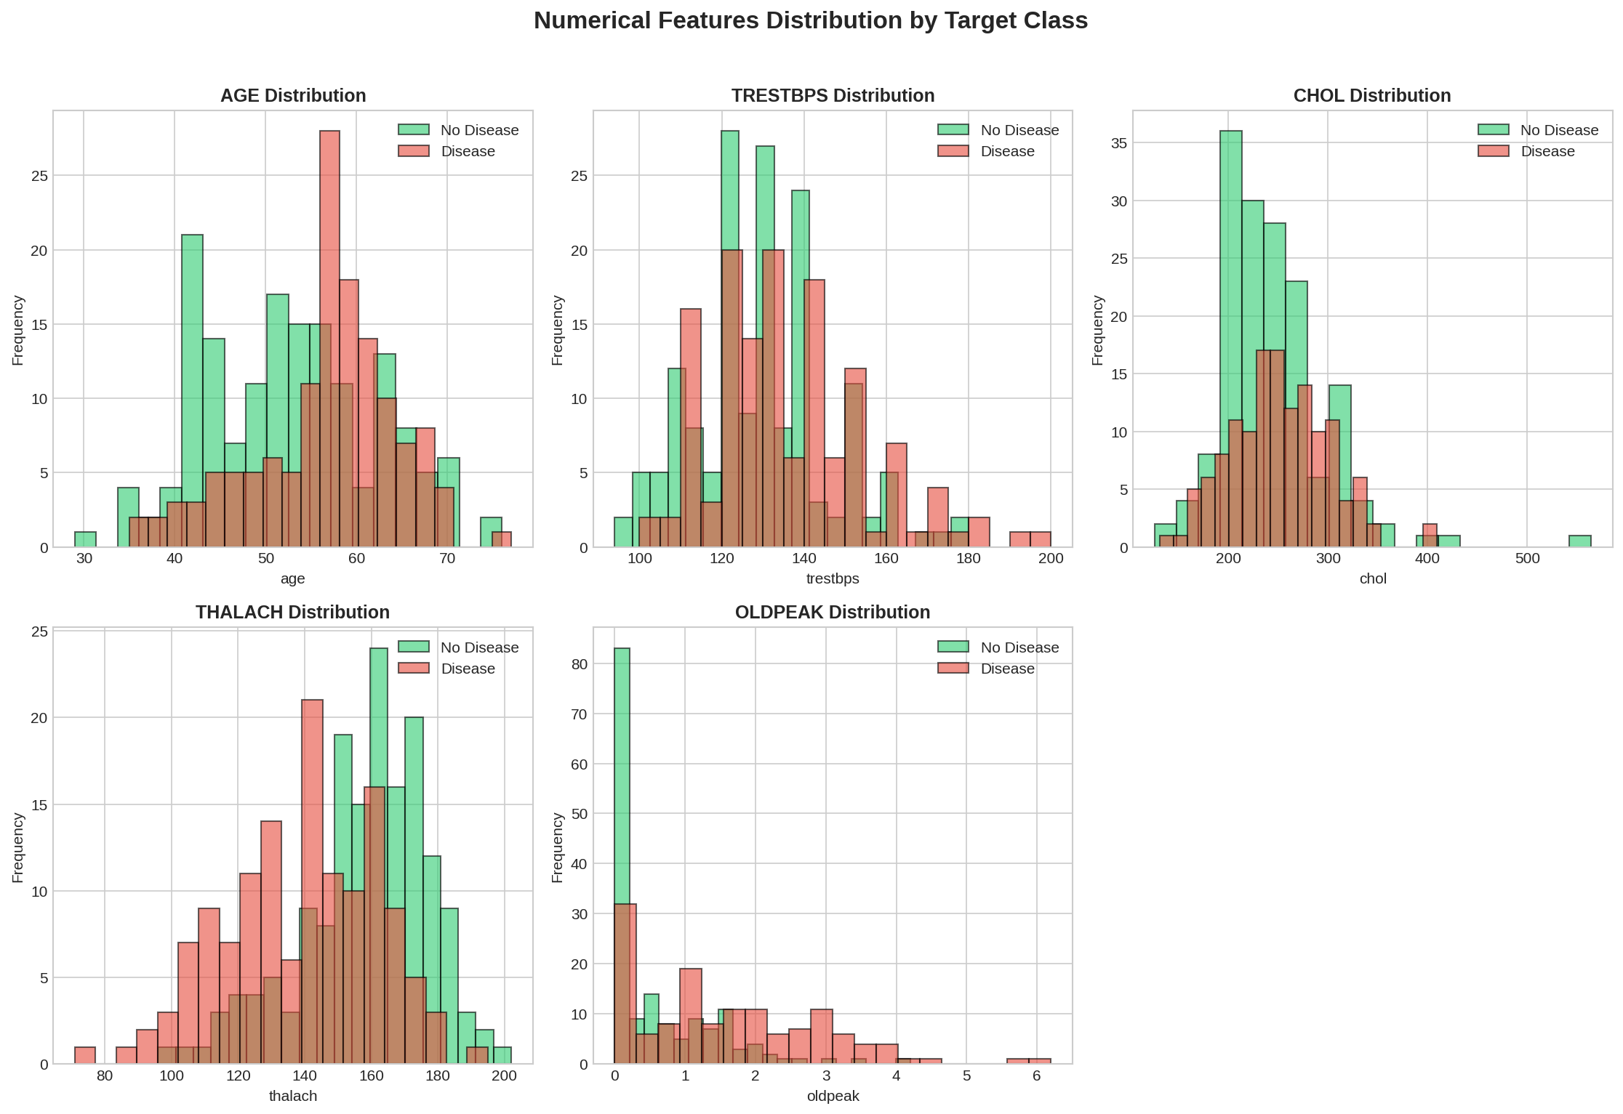

3. Feature Engineering & Model Development

3.1 Feature Engineering
Feature engineering involved StandardScaler for numerical feature normalization, train-test split (80-20) with stratification, and retention of all 13 features for model training.

3.2 Models Trained
Three classification models were trained with hyperparameter tuning using GridSearchCV with 5-fold cross-validation:
- Logistic Regression: C values [0.01, 0.1, 1, 10], L2 penalty
- Random Forest: n_estimators [50, 100, 200], max_depth [5, 10, 15, None]
- Gradient Boosting: n_estimators [50, 100], learning_rate [0.01, 0.1, 0.2]

3.3 Model Performance Comparison
Model | Accuracy | Precision | Recall | F1 | ROC-AUC
Logistic Reg. | 86.67% | 88.46% | 82.14% | 85.19% | 95.09%
Random Forest | 83.33% | 87.50% | 75.00% | 80.77% | 94.64%
Gradient Boost | 81.67% | 84.00% | 75.00% | 79.25% | 90.96%

3.4 ROC Curves Comparison
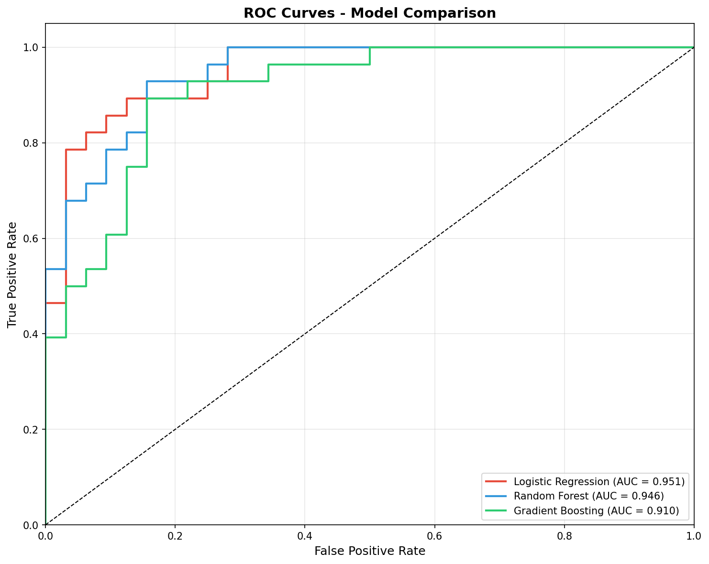

3.5 Confusion Matrix - Best Model
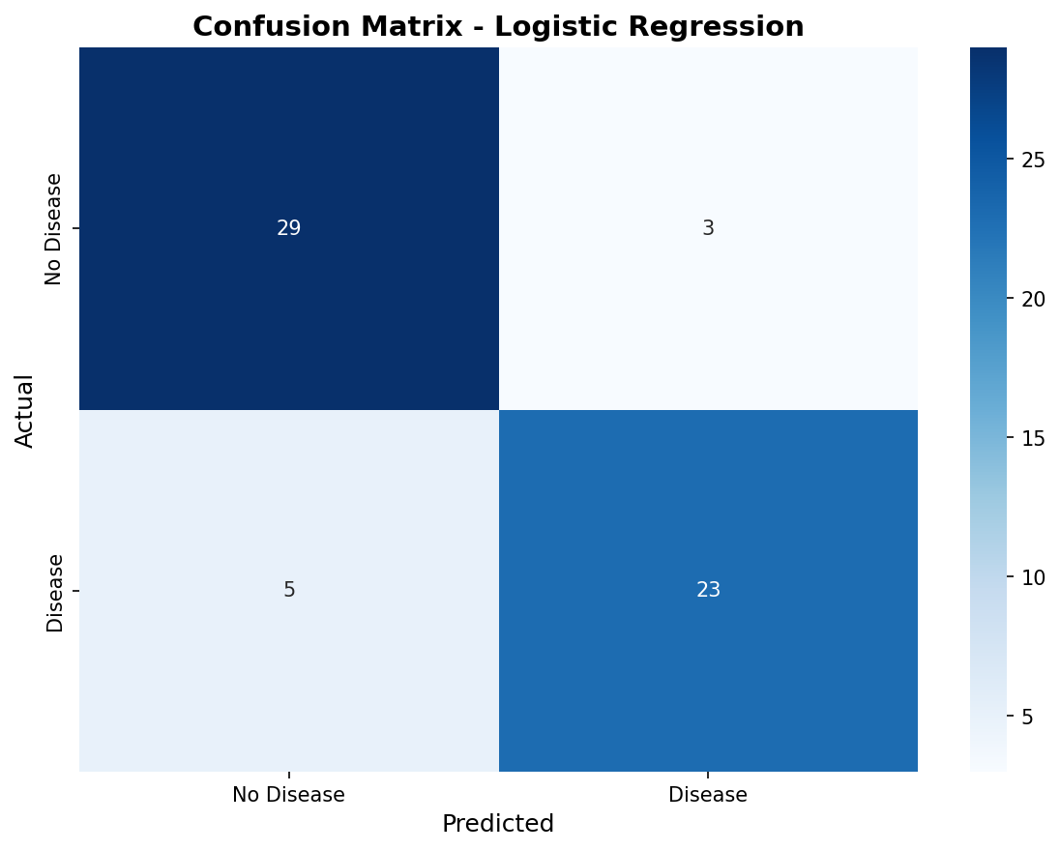

4. Experiment Tracking with MLflow
MLflow was integrated for comprehensive experiment tracking. All model training runs were logged with:
- Parameters: Hyperparameters for each model configuration
- Metrics: Accuracy, precision, recall, F1-score, ROC-AUC, CV scores
- Artifacts: Confusion matrices, ROC curves, feature importance plots
- Models: Serialized sklearn models for each run

4.1 MLflow Experiment Structure
Experiment Name: heart_disease_prediction
Tracking URI: file:///mlruns

4.2 Best Model Selection
Based on ROC-AUC score (95.09%), Logistic Regression was selected as the best model for deployment. The model achieves excellent discrimination between disease and non-disease cases while maintaining good interpretability.

5. Model Packaging & Reproducibility

5.1 Saved Artifacts
The following artifacts were saved for reproducibility:
- pipeline.pkl: Complete sklearn pipeline with scaler and model
- best_model.pkl: Trained Logistic Regression model
- scaler.pkl: Fitted StandardScaler transformer
- feature_names.pkl: List of 13 feature names

5.2 Requirements File
A comprehensive requirements.txt file specifies all dependencies with version constraints to ensure reproducibility across environments.

5.3 Preprocessing Pipeline
The sklearn Pipeline object encapsulates both preprocessing (StandardScaler) and prediction (LogisticRegression) steps, ensuring consistent transformations.

6. CI/CD Pipeline & Automated Testing

6.1 GitHub Actions Workflow
A comprehensive CI/CD pipeline was implemented using GitHub Actions with the following stages:
Stage | Description
Lint | Code quality checks with flake8 and black
Test | Unit tests for data, model, and API (pytest)
Train | EDA and model training with artifact upload
Docker | Build, test, and save Docker image
Security | Vulnerability scanning with Trivy
Deploy | Production deployment (manual trigger)

6.2 Test Coverage
45 unit tests covering:
- Data Tests (15): File existence, loading, quality, preprocessing
- Model Tests (15): File existence, loading, prediction, performance
- API Tests (15): Endpoints, validation, response format

7. Model Containerization

7.1 Docker Configuration
The model is containerized using Docker with the following specifications:
- Base Image: python:3.11-slim
- Framework: FastAPI with uvicorn server
- Port: 8000
- Health Check: Built-in health endpoint monitoring
- Security: Non-root user execution

7.2 API Endpoints
Endpoint | Method | Description
/predict | POST | Make heart disease prediction
/health | GET | Health check endpoint
/metrics | GET | Prometheus metrics
/docs | GET | Swagger API documentation

8. Production Deployment

8.1 Kubernetes Configuration
The application is deployed to Kubernetes with the following configuration:
- Deployment: 3 replicas with rolling update strategy
- Service: LoadBalancer type for external access
- HPA: Auto-scaling from 2-10 pods based on CPU/memory
- Ingress: NGINX ingress controller for routing
- Resources: CPU: 100m-500m, Memory: 256Mi-512Mi

8.2 Health Probes
- Liveness Probe: Checks /health endpoint every 30s
- Readiness Probe: Checks /health endpoint every 10s

9. Monitoring & Logging

9.1 Prometheus Metrics
The API exposes Prometheus metrics at /metrics endpoint:
- predictions_total: Counter of total predictions by result type
- prediction_latency_seconds: Histogram of prediction latency
- api_requests_total: Counter of requests by endpoint and method

9.2 Grafana Dashboard
Grafana is configured to visualize request rate, latency percentiles, prediction distribution, error rates, and resource utilization.

9.3 Application Logging
Structured logging includes request/response logging, prediction results with confidence scores, error tracking, and model health status events.

10. Conclusion
This MLOps project successfully demonstrates end-to-end machine learning pipeline development following industry best practices.

10.1 Summary of Achievements
- Model Performance: 95.09% ROC-AUC with Logistic Regression
- Test Coverage: 45 unit tests covering data, model, and API
- CI/CD Pipeline: Fully automated with GitHub Actions
- Containerization: Production-ready Docker image
- Deployment: Kubernetes manifests with auto-scaling
- Monitoring: Prometheus metrics with Grafana dashboards

10.2 Repository Structure
All deliverables are organized in a GitHub repository containing source code, Dockerfile, requirements, tests, Kubernetes manifests, and documentation.

10.3 Future Improvements
- Implement model versioning and A/B testing
- Add data drift detection and model retraining triggers
- Enhance monitoring with custom business metrics
- Implement feature store for feature management
--- End of Report ---

