**Digital Assignment**

**“D’Wave Advantage” –**

**A Modern scalable quantum processor built for business**

*Identify one recent processor*

* **Processor name: D’Wave Advantage** **QPU** (Quantum processing Unit)
* **No of cores: 5760 Qubits and 35000+ couplers**

(Since it is a quantum superprocessor, it has qubits, Couplers and Josephson’s Junctions instead of conventional computing cores).

* **Design diagram** to discuss the internal contents of it:

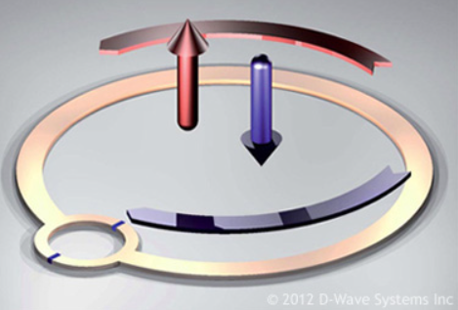Quantum processors leverage the power of quantum mechanics, probability and statistics to perform complex computation tasks. D’Wave processors use SQUID (Super Conducting Quantum Interference devices) -the quantum equivalent of a transistor

This image shows how quantum particles like electrons are laid on an extremely cooled superconducting processor and its quantum attributes are manipulated and observed in order to do the computation.

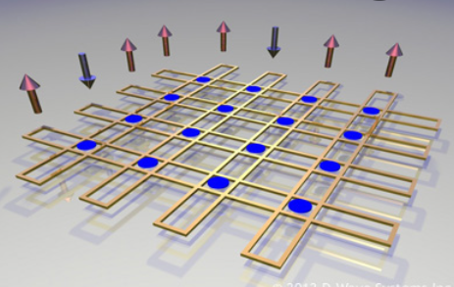

The image alongside is a schematic Illustration of 8 qubit loops with 16 coupler elements to allow the exchange of information. Mathematically, these elements couple together variables in the problem that we wish to solve.

In a D’Wave Quantum Computer, although most of the computational circuitry is composed of the qubits, Couplers and Josephson’s Junctions, A small but vital part of it is the readout part of the computer which remains out of action during the computation but comes into play after the computation is over and helps to query and interpret the results of the computation by reading the classical states of qubits.

* **Its special use:  Application area in which it is used:**

D’Wave quantum processors are used in many domains by a lot of big companies and research institutions around the world.

The most common application area of **“D’Wave Advantage processor”** are:

* Financial Modeling
* Transportation and Supply Chain
* Energy research, Weather Forecasting And Climate Change
* Machine Learning and Artificial Intelligence
* Pharmaceutical and Drug Research and Development
* Quantum Modeling and Research
* Complex business problems… etc.
* **Can it be used as: Parallel/Multicore/Multi utility/GPU/…?**

Yes, D’Wave Quantum Processors are capable of scaling to multi-qubit. For this, the qubits must be connected together such that they can exchange information through quantum entanglement. This is achieved through the use of elements known as couplers. These couplers are made from superconducting loops. By putting together such elements together, a programmable fabric can be built which is also the fundamental part of the processor. D’Wave Advantage is mostly renowned as the first ever commercial quantum computer with extremely high number of **Qubits ~5700.**

* **Give an Application name that you can use: title and 2 to 3 lines of statement regarding the application.**

Quantum computers do not have general purpose Softwares like conventional computers do. They are mostly either custom made or designed for special purpose applications. However, there are certain software systems developed by the manufacturer and developer of quantum systems that can be used to actually program the computer according to the custom requirements.

In case of D’Wave, **Ocean Software** is used to make application programs and it fits between the applications and compute resource of a quantum computer.