-6X-5 0101(5) 1011(-5)

0110(6) 1100(6X2)

1010(-6) 0100(-6X2)

4/2 🡪even 2clock cycle

2’sArithmetic shift

|  |  |  |  |  |  |  |  |  |  |  |
| --- | --- | --- | --- | --- | --- | --- | --- | --- | --- | --- |
|  | A |  |  |  |  |  | Q | Q0 | Q-1 |  |
| 0 | 0 | 0 | 0 |  | 1 | 0 | 1 | 1 | 0 |  |
| 0 | 1 | 1 | 0 |  | 1 | 0 | 1 | 1 | 0 | -M |
| 0 | 0 | 1 | 1 |  | 0 | 1 | 0 | 1 | 1 | 1st s |
| 0 | 0 | 0 | 1 |  | 1 | 0 | 1 | 0 | 1 | 2nd S |
| 0 | 1 | 1 | 0 |  |  |  |  |  |  | -M |
| 0 | 1 | 1 | 1 |  | 1 | 0 | 1 | 0 | 1 |  |
| 0 | 0 | 1 | 1 |  | 1 | 1 | 0 | 1 | 0 | 1st |
| 0 | 0 | 0 | 1 |  | 1 | 1 | 1 | 0 | 1 | 2nd |
|  |  |  | 16 |  | 8 | 4 | 2 | 0 |  | 30 |

|  |  |  |  |  |  |  |  |  |  |  |  |  |  |  |
| --- | --- | --- | --- | --- | --- | --- | --- | --- | --- | --- | --- | --- | --- | --- |
|  | A |  |  |  |  |  |  |  | Q |  |  |  | Q-1 |  |
| 0 | 0 | 0 | 0 | 0 | 0 |  | 1 | 1 | 0 | 1 | 1 | 1 | 0 |  |
| 1 | 1 | 0 | 1 | 0 | 1 |  | 1 | 1 | 0 | 1 | 1 | 1 | 0 | -m |
| 1 | 1 | 1 | 0 | 1 | 0 |  | 1 | 1 | 1 | 0 | 1 | 1 | 1 | 1st s |
| 1 | 1 | 1 | 1 | 0 | 1 |  | 0 | 1 | 1 | 1 | 0 | 1 | 1 | 2nd s  T1 |
| 0 | 1 | 0 | 1 | 1 | 0 |  |  |  |  |  |  |  |  |  |
| 0 | 1 | 0 | 0 | 1 | 1 |  | 0 | 1 | 1 | 1 | 0 | 1 | 1 | (2m) |
| 0 | 0 | 1 | 0 | 0 | 1 |  | 1 | 0 | 1 | 1 | 1 | 0 | 1 | 1st s |
| 0 | 0 | 0 | 1 | 0 | 0 |  | 1 | 1 | 0 | 1 | 1 | 1 | 0 | 2nd s  T2 |
| 1 | 1 | 0 | 1 | 0 | 1 |  |  |  |  |  |  |  |  |  |
| 1 | 1 | 1 | 0 | 0 | 1 |  | 1 | 1 | 0 | 1 | 1 | 1 | 0 | (-m) |
| 1 | 1 | 1 | 1 | 0 | 0 |  | 1 | 1 | 1 | 0 | 1 | 1 | 1 | 1st |
| 1 | 1 | 1 | 1 | 1 | 0 |  | 0 | 1 | 1 | 1 | 0 | 1 | 1 |  |
|  |  |  |  |  |  |  |  |  |  |  |  |  |  |  |
|  |  |  |  |  | 1 | 1 | 0 | 0 | 0 | 1 | 1 |  |  |  |
|  |  |  |  |  | 64 | 32 | 16 | 8 | 4 | 2 | 1 |  |  | -99 |

11X-9

001011(11) 110101(-11) 010110(11X2) 101010(-11X2)

9(001001) 110111(-9)

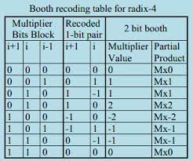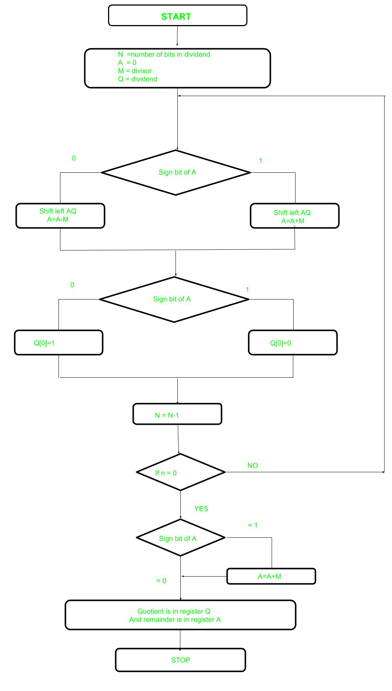

|  |  |  |  |  |  |  |  |  |  |  |  |  |
| --- | --- | --- | --- | --- | --- | --- | --- | --- | --- | --- | --- | --- |
|  |  | A | N+1 |  |  |  |  |  | Q | n🡪4 |  |  |
| 0 | 0 | 0 | 0 | 0 |  | 1 | 0 | 1 | 1 |  |  |  |
| 0 | 0 | 0 | 0 | 1 |  | 0 | 1 | 1 |  |  | ls | a-m |
| 1 | 1 | 1 | 0 | 1 |  |  |  |  |  |  |  |  |
| 1 | 1 | 1 | 1 | 0 |  | 0 | 1 | 1 | 0 |  |  | 1st |
| 1 | 1 | 1 | 0 | 0 |  | 1 | 1 | 0 |  |  |  |  |
| 0 | 0 | 0 | 1 | 1 |  |  |  |  |  |  |  |  |
| 1 | 1 | 1 | 1 | 1 |  | 1 | 1 | 0 | 0 |  |  | 2nd |
| 1 | 1 | 1 | 1 | 1 |  | 1 | 0 | 0 |  |  |  |  |
| 0 | 0 | 0 | 1 | 1 |  |  |  |  |  |  |  | A+(-m) |
| 0 | 0 | 0 | 1 | 0 |  | 1 | 0 | 0 | 1 |  |  | 3rd |
| 0 | 0 | 1 | 0 | 1 |  | 0 | 0 | 1 |  |  |  |  |
| 1 | 1 | 1 | 0 | 1 |  |  |  |  |  |  |  |  |
| 0 | 0 | 0 | 1 | 0 |  | 0 | 0 | 1 | 1 |  |  | 4th |

11/3

1011(end)

3🡪 00011 (m) -3🡪11101

|  |  |  |  |  |  |  |  |  |  |  |  |  |
| --- | --- | --- | --- | --- | --- | --- | --- | --- | --- | --- | --- | --- |
|  |  | A | N+1 |  |  |  |  |  | Q | n🡪4 |  |  |
| 0 | 0 | 0 | 0 | 0 |  | 1 | 1 | 0 | 1 |  |  |  |
| 0 | 0 | 0 | 0 | 1 |  | 1 | 0 | 1 |  |  |  | ls |
| 1 | 1 | 1 | 0 | 0 |  |  |  |  |  |  |  |  |
| 1 | 1 | 1 | 0 | 1 |  | 1 | 0 | 1 | 0 |  |  | 1st |
| 1 | 1 | 0 | 1 | 1 |  | 0 | 1 | 0 |  |  |  | ls |
| 0 | 0 | 1 | 0 | 0 |  |  |  |  |  |  |  | + |
| 1 | 1 | 1 | 1 | 1 |  | 0 | 1 | 0 | 0 |  |  | 2nd |
| 1 | 1 | 1 | 1 | 0 |  | 1 | 0 | 0 |  |  |  |  |
| 0 | 0 | 1 | 0 | 0 |  |  |  |  |  |  |  |  |
| 0 | 0 | 0 | 1 | 0 |  | 1 | 0 | 0 | 1 |  |  | 3rd |
| 0 | 0 | 1 | 0 | 1 |  | 0 | 0 | 1 |  |  |  | Ls |
| 1 | 1 | 1 | 0 | 0 |  |  |  |  |  |  |  | - |
| 0 | 0 | 0 | 0 | 1 |  | 0 | 0 | 1 | 1 |  |  | 4th |

13/4

1101(13)

00100(4) 11100(-4)