Advanced Data Visualization and Storytelling with Python
COVID-19 Data Analysis
Objective: To analyze COVID-19 data using Python and create meaningful visualizations that communicate trends, patterns, relationships, and insights to a non-technical audience.

1. Introduction
The COVID-19 pandemic generated a large amount of data related to confirmed cases, deaths, recoveries, and active cases across different countries and regions. This project uses Python-based data analysis and visualization techniques to transform the raw dataset into an understandable visual narrative.

2. Dataset Description
The dataset contains 49,068 records and 10 columns representing COVID-19 observations across 187 countries and regions. The analyzed period extends from January 22, 2020 to July 27, 2020.
Important variables include Country/Region, Date, Confirmed, Deaths, Recovered, Active, Latitude, Longitude, Province/State, and WHO Region.

3. Tools and Technologies
Python, Pandas, NumPy, Matplotlib, Seaborn, and Google Colab were used for data processing, analysis, and visualization.

4. Data Cleaning and Preparation
The dataset was checked for missing values, duplicate records, and data types. No duplicate records were identified. Missing values in the Province/State column were replaced with "Unknown" because province-level information was not available for all countries. The Date column was converted to datetime format and the major COVID-19 measures were confirmed as numerical variables.

5. Exploratory Data Analysis
Exploratory analysis was performed to understand the statistical characteristics of confirmed cases, deaths, recovered cases, and active cases. Country-level aggregation was also performed to compare the highest cumulative confirmed case counts.

6. Visualization 1 – Global Confirmed COVID-19 Cases Over Time
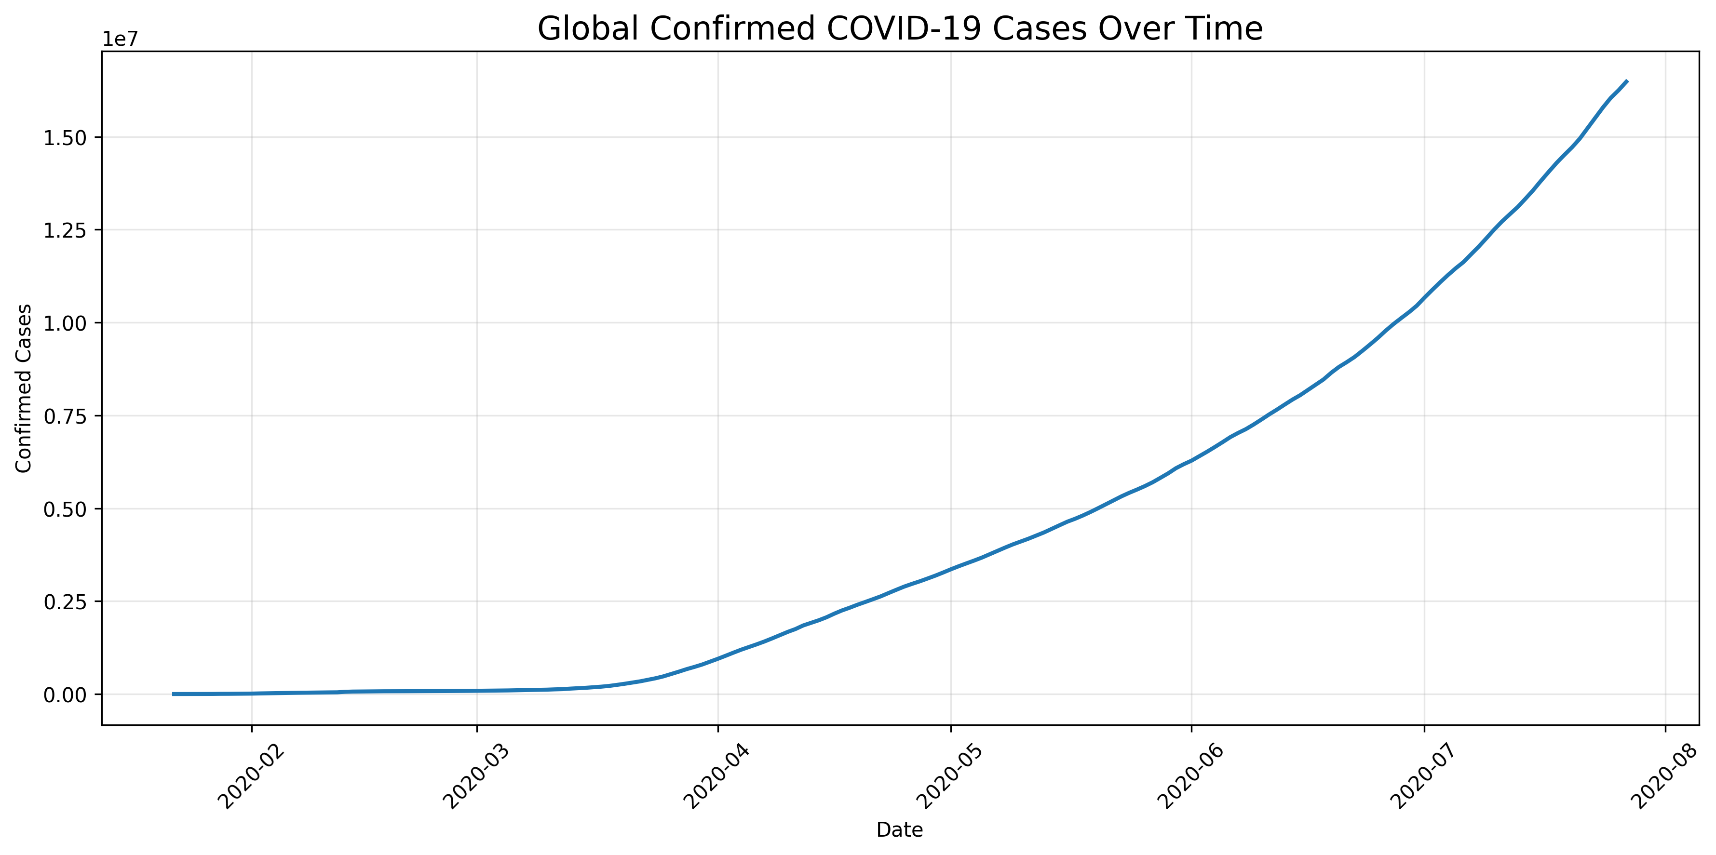
A line chart was used to show the progression of cumulative confirmed COVID-19 cases over time. The chart establishes the overall temporal progression of the pandemic during the analyzed period.

7. Visualization 2 – Top 10 Countries by Confirmed Cases
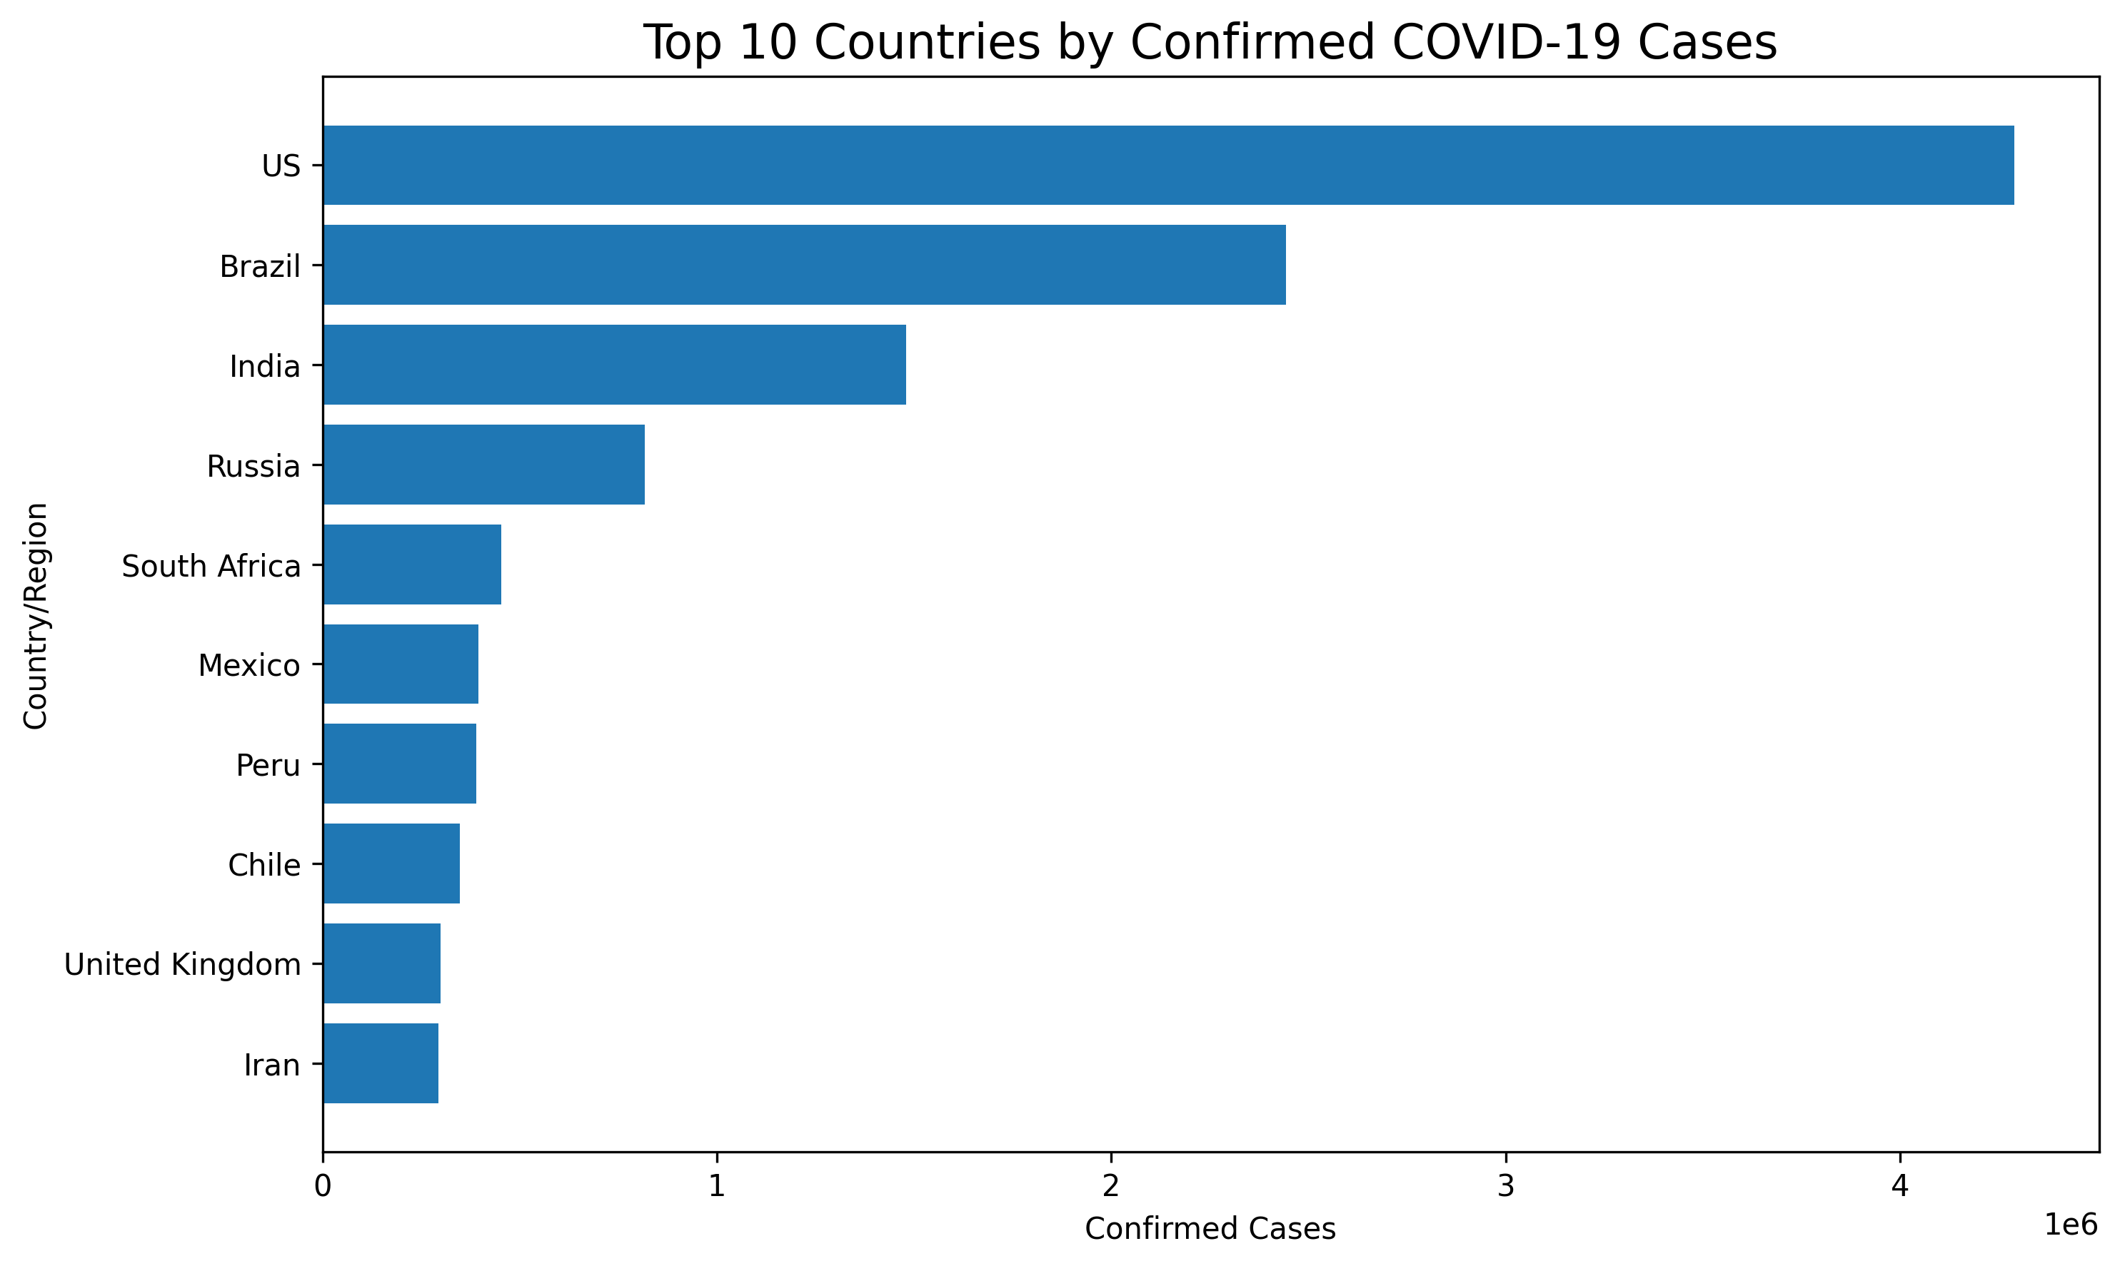
A horizontal bar chart was selected to compare the cumulative confirmed cases across the ten countries with the highest values in the dataset. The United States, Brazil, and India appear among the countries with the highest cumulative counts.

8. Visualization 3 – Global COVID-19 Deaths Over Time
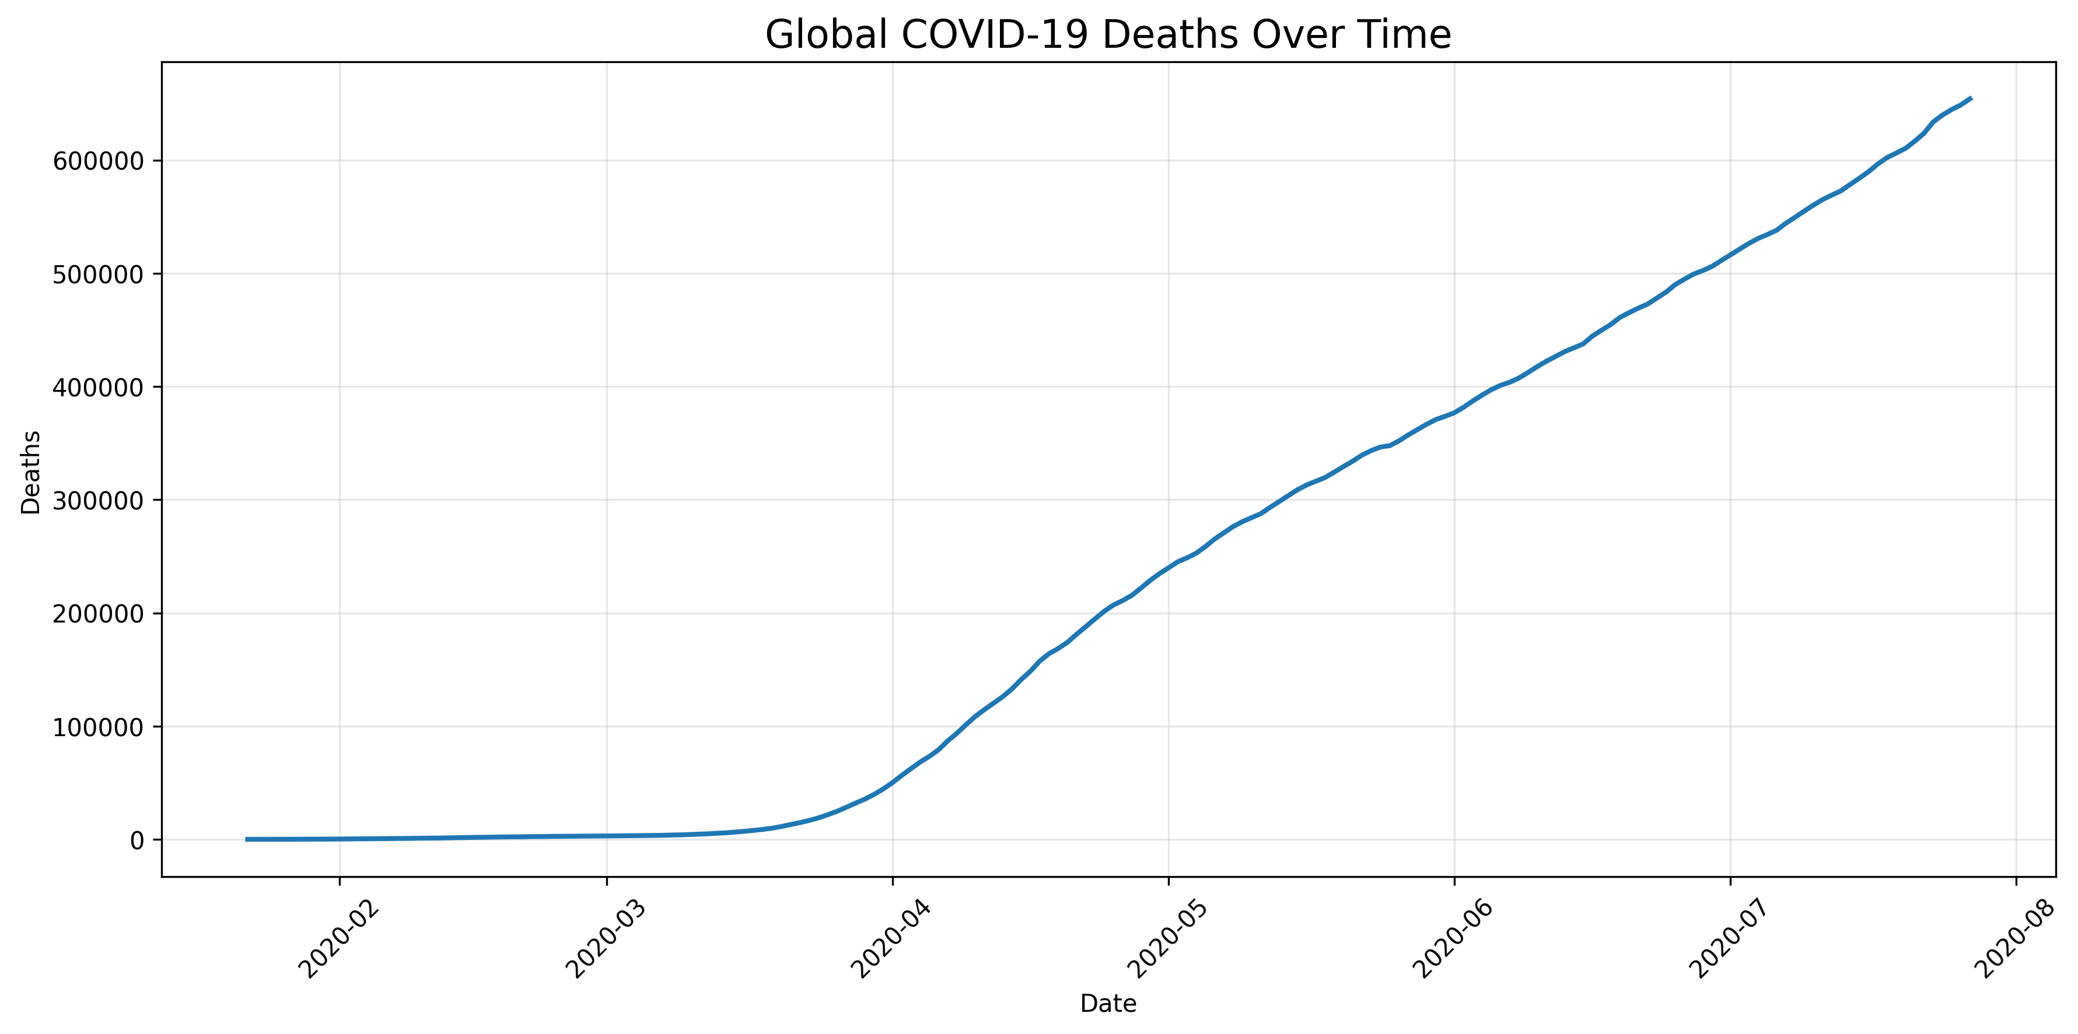
This line chart presents the cumulative number of reported deaths over the analyzed period. It adds a mortality perspective to the overall data story.

9. Visualization 4 – Confirmed Cases vs Deaths
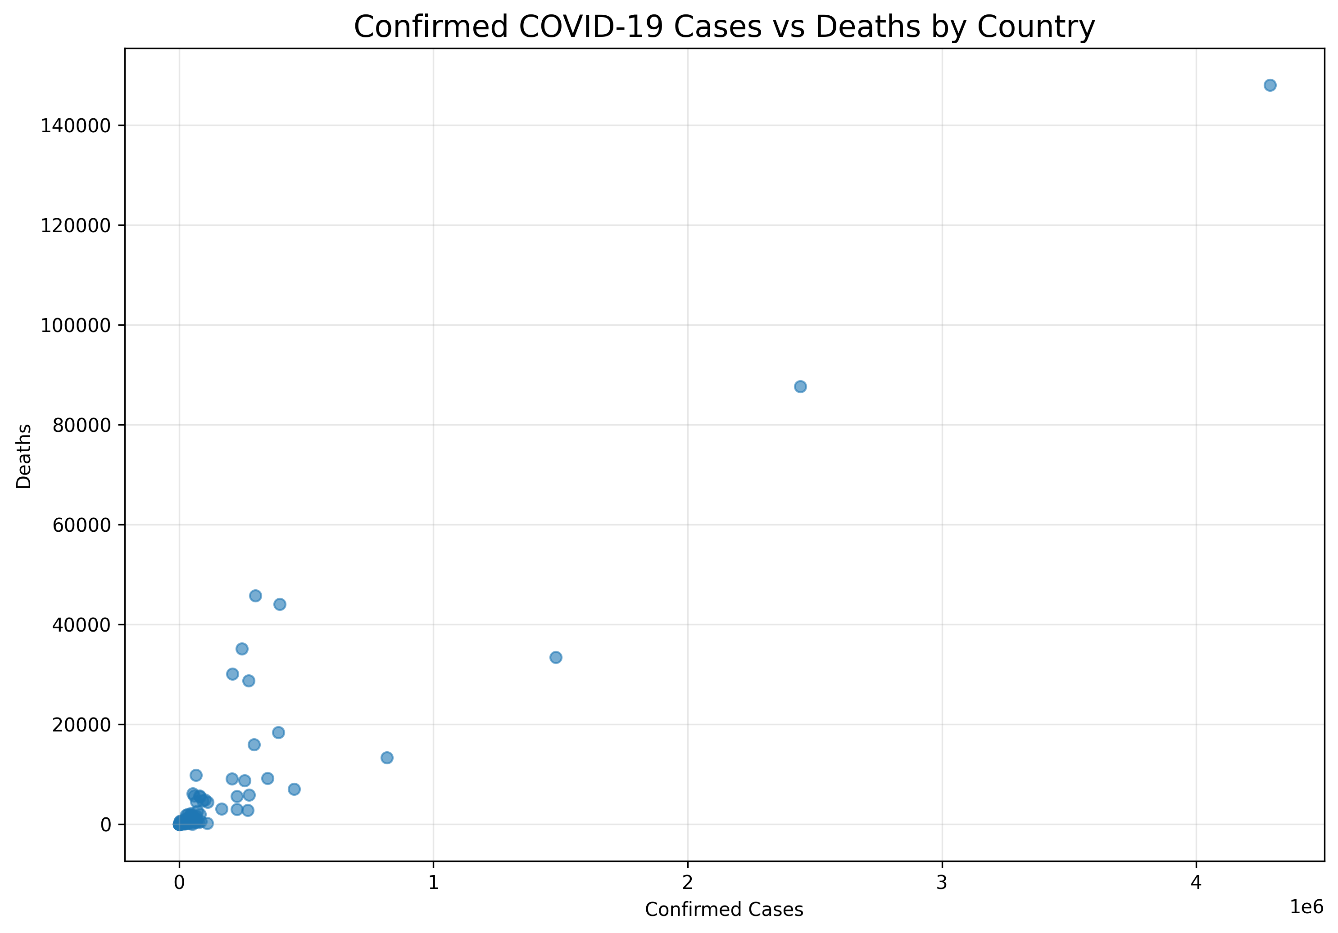
The scatter plot examines the relationship between cumulative confirmed cases and reported deaths across countries. It shows the degree to which countries with higher reported case counts also tend to have higher reported death counts.

10. Visualization 5 – COVID-19 Correlation Heatmap
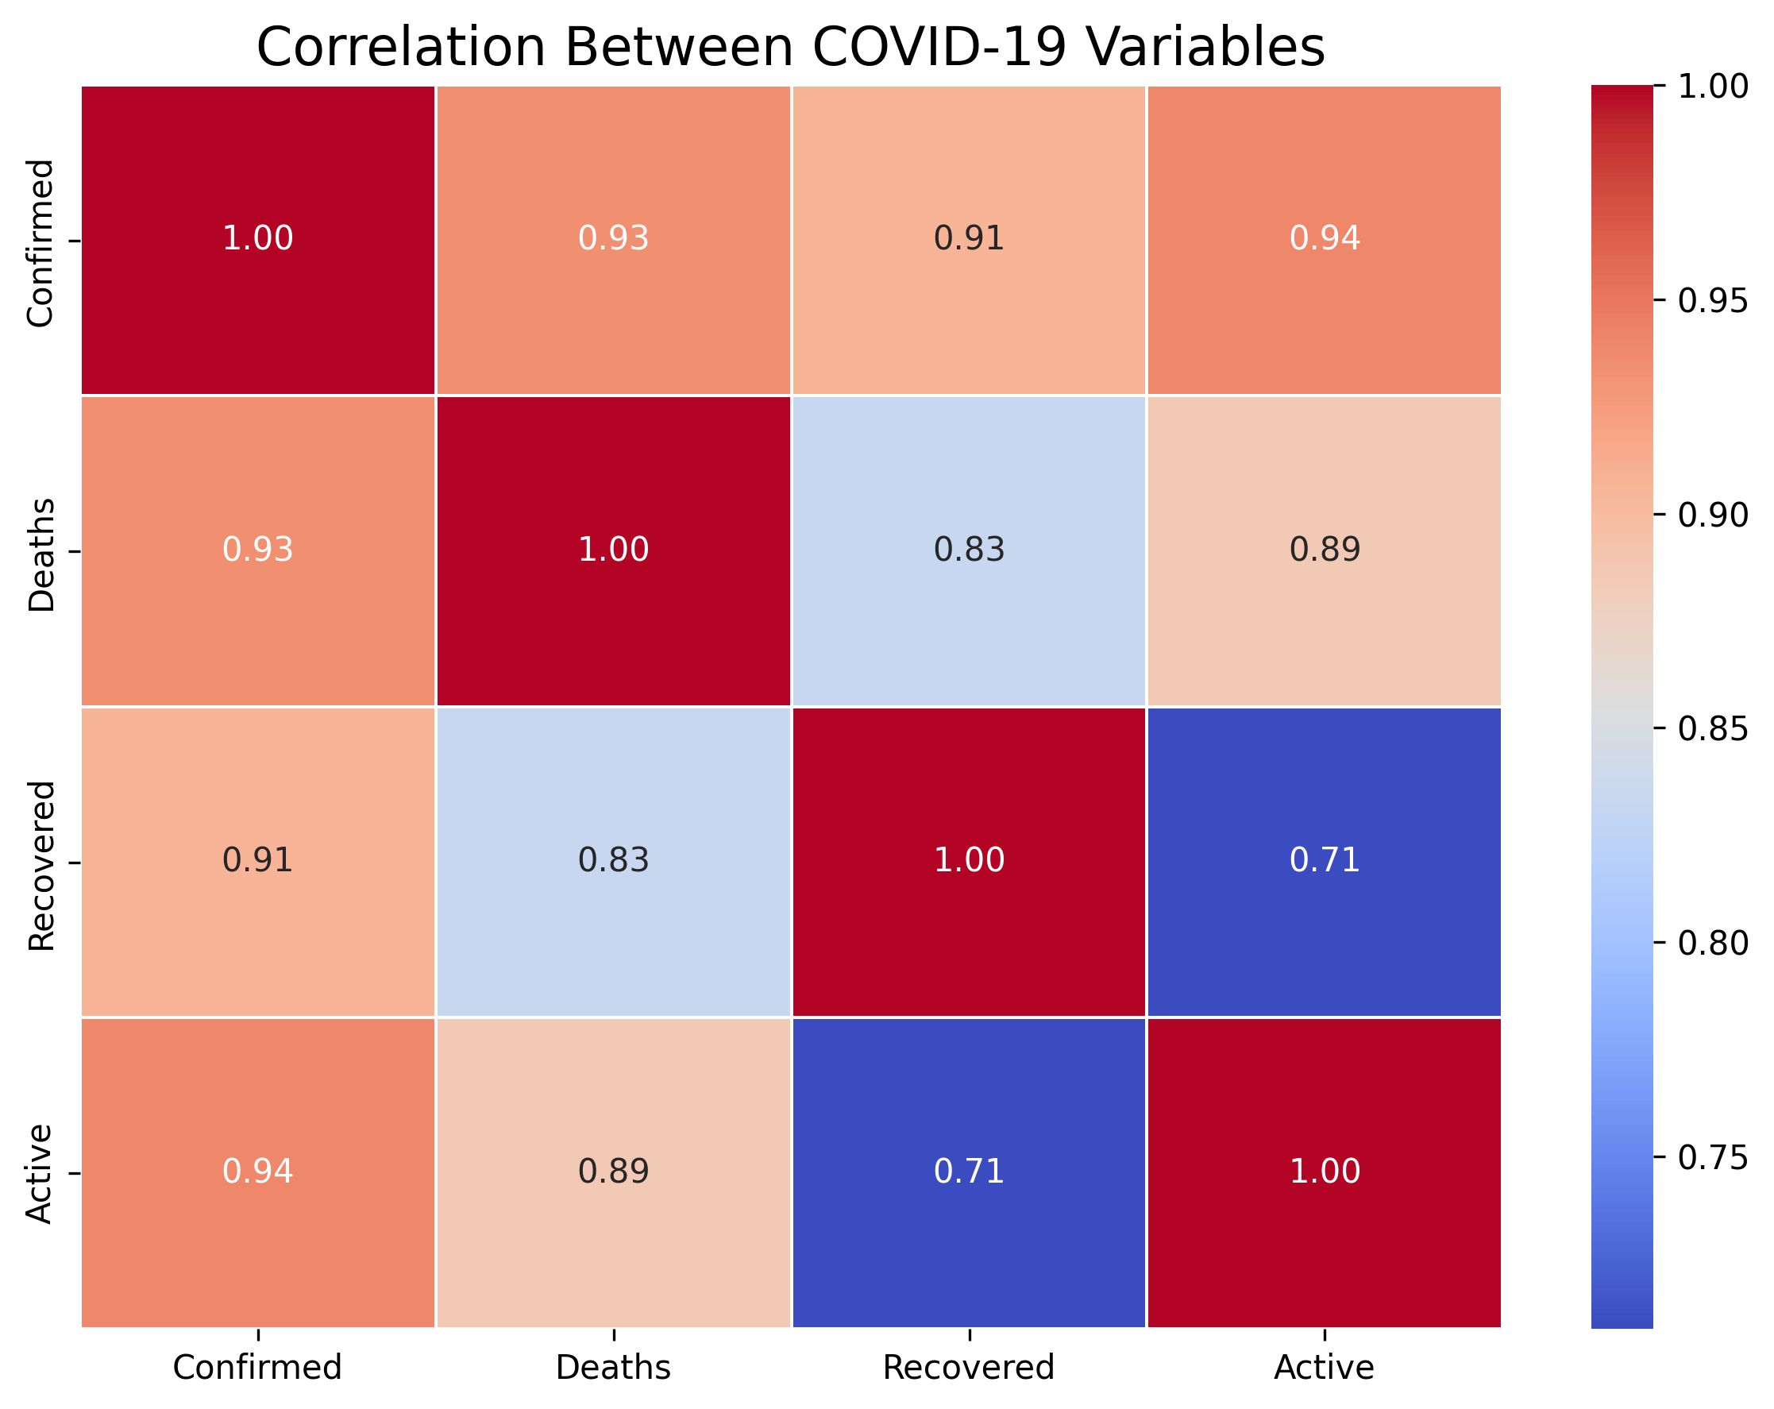
The correlation heatmap summarizes relationships between confirmed cases, deaths, recovered cases, and active cases. Correlation values should be interpreted as statistical relationships rather than evidence of causation.

11. Visualization 6 – Distribution and Outlier Analysis
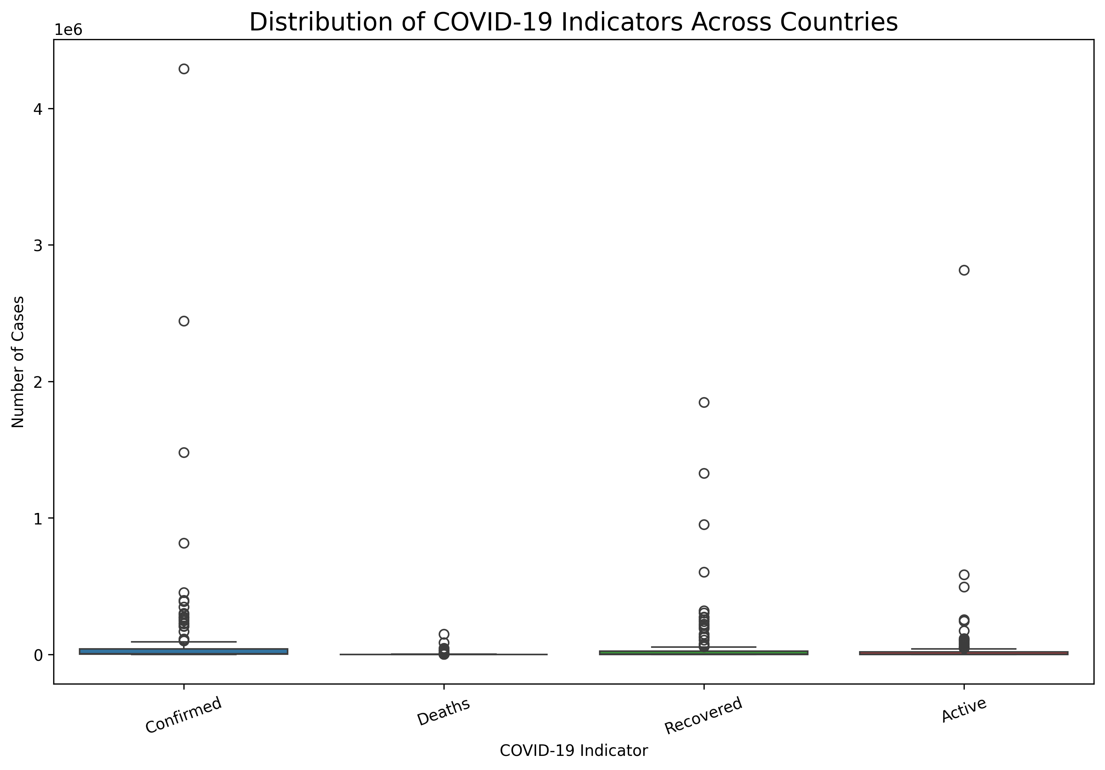
The box plot compares the distributions of major COVID-19 indicators across countries. It helps identify the spread of the data and unusually high observations.

12. Overall Data Story
The analysis presents COVID-19 from multiple perspectives. The time-series analysis demonstrates the growth of cumulative confirmed cases and deaths. Country-level analysis demonstrates geographic differences in reported case counts. The scatter plot examines the relationship between cases and deaths, while the correlation heatmap provides a statistical overview of the major COVID-19 indicators. The box plot highlights differences in distribution and extreme observations.

13. Scientific and Business Implications
The insights from this analysis can support healthcare resource planning, outbreak monitoring, geographic comparison, mortality monitoring, and data-driven decision-making. From a business perspective, organizations can use pandemic trends for operational planning, supply-chain decisions, workforce planning, and stakeholder communication.

14. Conclusion
This project demonstrates how Python-based visualization can transform a large COVID-19 dataset into an understandable data story. Multiple visualization techniques were used to examine time trends, geographic differences, relationships, correlations, and distributions.

15. References
1. COVID-19 dataset used for the analysis.
2. Python Documentation.
3. Pandas Documentation.
4. Matplotlib Documentation.
5. Seaborn Documentation.
6. Google Colab.

