FINAL COMPREHENSIVE
DATA SCIENCE PROJECT REPORT
End-to-End Data Acquisition • EDA • Visualization • Statistical Analysis • Machine Learning

Report Component | Included Work
Week 1 | Data Acquisition, Cleaning & Exploratory Data Analysis
Week 2 | COVID-19 Advanced Data Visualization & Storytelling
Week 3 | Advertising Expenditure & Sales Statistical Analysis
Week 4 | Machine Learning Model Development & Evaluation

Prepared as a consolidated internship/project submission

Table of Contents
1. Executive Summary
2. 1. Project Overview and Learning Progression
3. 2. Overall Methodology
4. 3. Week 1 — Data Acquisition, Cleaning and EDA
5. 4. Week 2 — COVID-19 Visualization and Storytelling
6. 5. Week 3 — Advertising Expenditure and Sales Statistical Analysis
7. 6. Week 4 — Machine Learning Model Development and Evaluation
8. 7. Cross-Project Synthesis and Strategic Recommendations
9. 8. Business and Research Outcomes
10. 9. Limitations and Risk Considerations
11. 10. Future Improvement Roadmap
12. 11. Technical Skills Demonstrated
13. 12. Conclusion
14. Appendix — Selected Code Snippets and Visual Evidence
15. References

Executive Summary
This report consolidates four project reports completed across the data science workflow. The work progresses from data acquisition and cleaning, through exploratory analysis and advanced visualization, to statistical modeling and supervised machine learning. Each project uses a distinct dataset and therefore its numerical findings are reported separately rather than being combined.
Project | Dataset / Scope | Main Outcome
Week 1 | Student Performance; 50 cleaned rows × 8 columns | Demonstrated data quality, cleaning, EDA and feature relationships.
Week 2 | COVID-19; 49,068 records, 187 countries/regions | Built a visual narrative for time, geographic, relationship and distribution patterns.
Week 3 | Advertising; 200 observations | TV–Sales r=0.78; regression R²=0.897, RMSE=1.67, MAE=1.25.
Week 4 | Breast Cancer Wisconsin; 569 samples, 30 features | Logistic Regression achieved 99.12% test accuracy and ROC-AUC 0.995.

Across the four weeks, the strongest transferable lesson is that model performance depends on the full analytical pipeline: data quality and preprocessing, appropriate visualization, suitable model selection, multiple evaluation metrics, error analysis, and cautious interpretation. The projects also emphasize that strong statistical or test-set performance is not by itself evidence of causation or real-world deployment readiness.

1. Project Overview and Learning Progression
The four projects represent a progressive data science workflow. Week 1 focuses on acquiring and cleaning data and establishing basic exploratory understanding. Week 2 develops visualization and storytelling skills on a larger longitudinal and geographic dataset. Week 3 introduces correlation, regression and business-oriented interpretation. Week 4 applies supervised machine learning to a binary classification problem and evaluates the model with multiple metrics.
Stage | Primary Skill | Evidence from Reports
1 | Data preparation | Missing-value handling, duplicate removal, data-type validation
2 | EDA & visualization | Distributions, scatter plots, heatmaps, time-series and geographic comparisons
3 | Statistical analysis | Correlation, descriptive statistics, regression and residual analysis
4 | Machine learning | Train/test split, scaling, pipeline, Logistic Regression and evaluation
5 | Decision support | Recommendations, limitations, error analysis and future improvements

2. Overall Methodology
The consolidated workflow is:
Data Acquisition → Data Inspection → Data Cleaning → EDA → Visualization → Statistical/ML Modeling → Evaluation → Error Analysis → Interpretation → Recommendations

2.1 Data Quality
Week 1 explicitly distinguishes simulated data defects from natural source-data defects: missing values and duplicate rows were intentionally introduced into a working copy for the educational exercise. The final cleaned dataset returned to 50 rows × 8 columns. Week 2 documents missing Province/State values handled as 'Unknown', date conversion and duplicate checks. Week 4 uses a pipeline so scaling parameters are learned from the training data, reducing leakage risk.

2.2 Model Evaluation Philosophy
The projects use multiple forms of evidence: descriptive statistics, visual inspection, correlation, regression metrics, confusion matrix, ROC curve and error analysis. This reduces the risk of relying on a single metric or visualization.

3. Week 1 — Data Acquisition, Cleaning and EDA
The Student Performance project contains 50 records and features including Student_ID, Gender, Age, Study_Hours_Per_Day, Attendance_Rate, Math_Score, Science_Score and Extracurricular_Activity. The project covers acquisition, inspection, cleaning, preprocessing, EDA, visualization and documentation.
The source report states that a working copy was expanded to 52 rows × 8 columns by intentionally introducing missing cells and duplicate rows. After cleaning, the final dataset was 50 × 8. fileciteturn2file3L22-L28

3.1 Cleaning and Preprocessing
- Numeric missing values were imputed with column medians.
- Categorical missing values were imputed with the mode.
- Duplicate rows were identified and removed.
- Analytical columns were converted to appropriate numeric/categorical types.
These procedures are documented in the Week 1 report as the core data-quality workflow. fileciteturn2file3L31-L40

3.2 Descriptive Findings
Variable | Mean | Std. Dev. | Min | Max
Age | 19.400 | 1.125 | 18.0 | 22.0
Study Hours/Day | 4.010 | 1.599 | 1.0 | 6.5
Attendance Rate | 79.510 | 11.138 | 60.5 | 95.0
Math Score | 78.260 | 12.272 | 45.0 | 92.0
Science Score | 77.100 | 13.251 | 55.0 | 95.0

The report identifies a positive correlation of approximately 0.30 between Science Score and Math Score, while attendance and study hours show observable positive trends with academic scores. fileciteturn2file3L62-L74
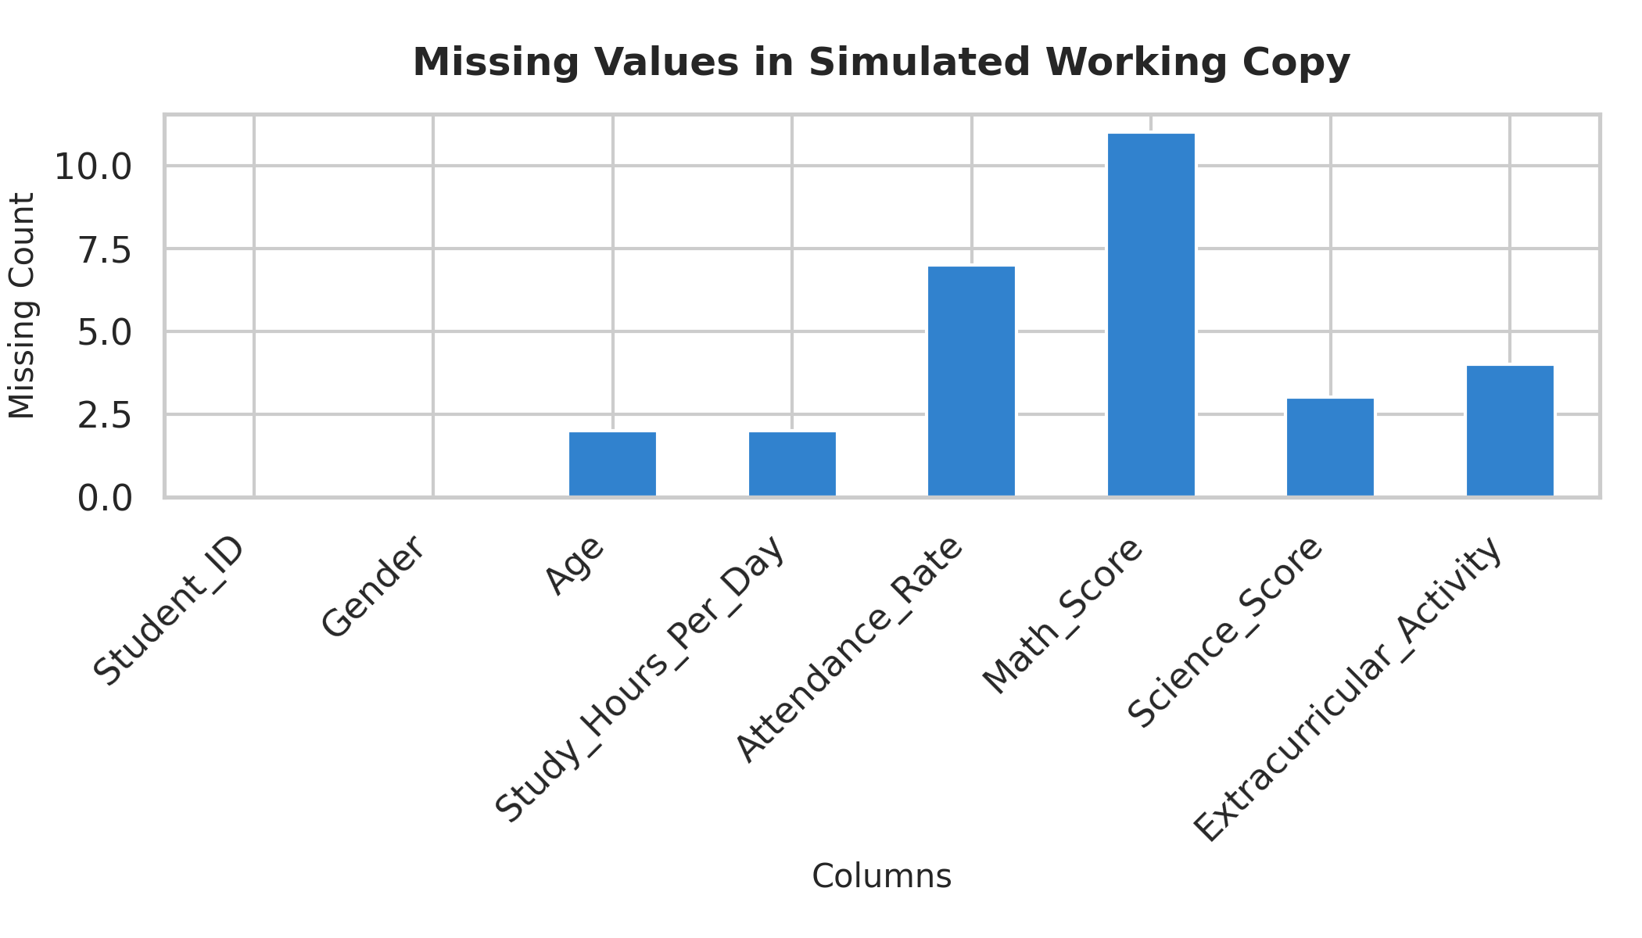
Week 1 Figure 1. Visualization from the Student Performance EDA report
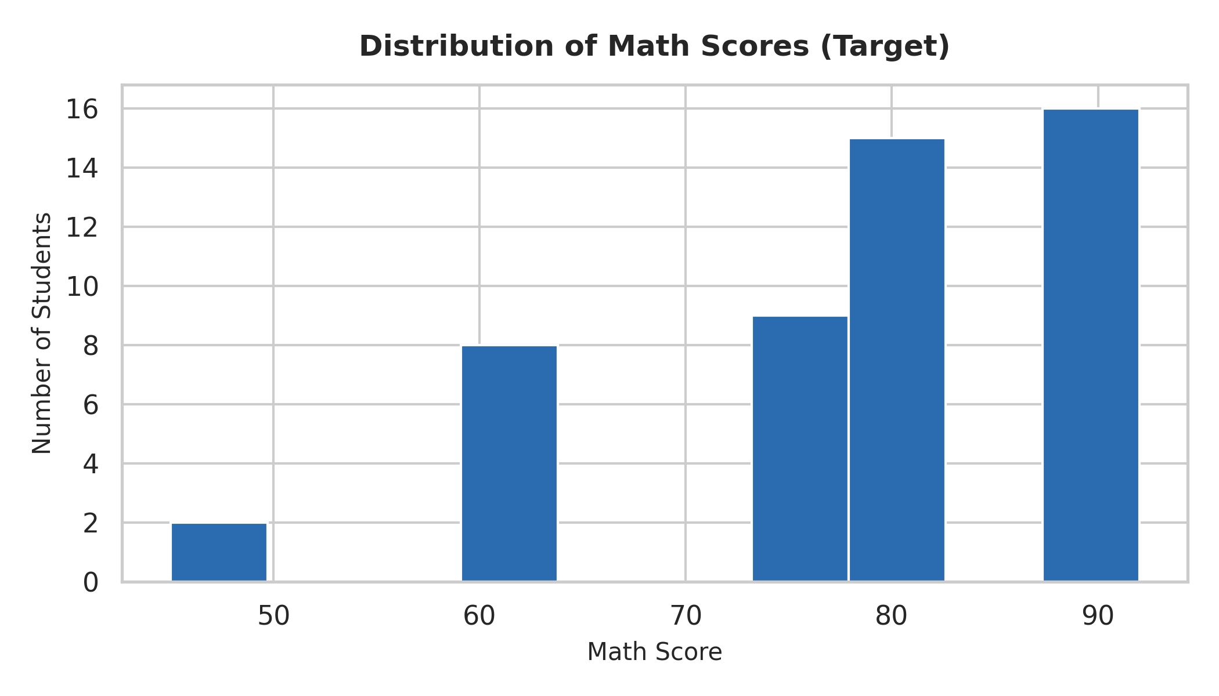
Week 1 Figure 2. Visualization from the Student Performance EDA report
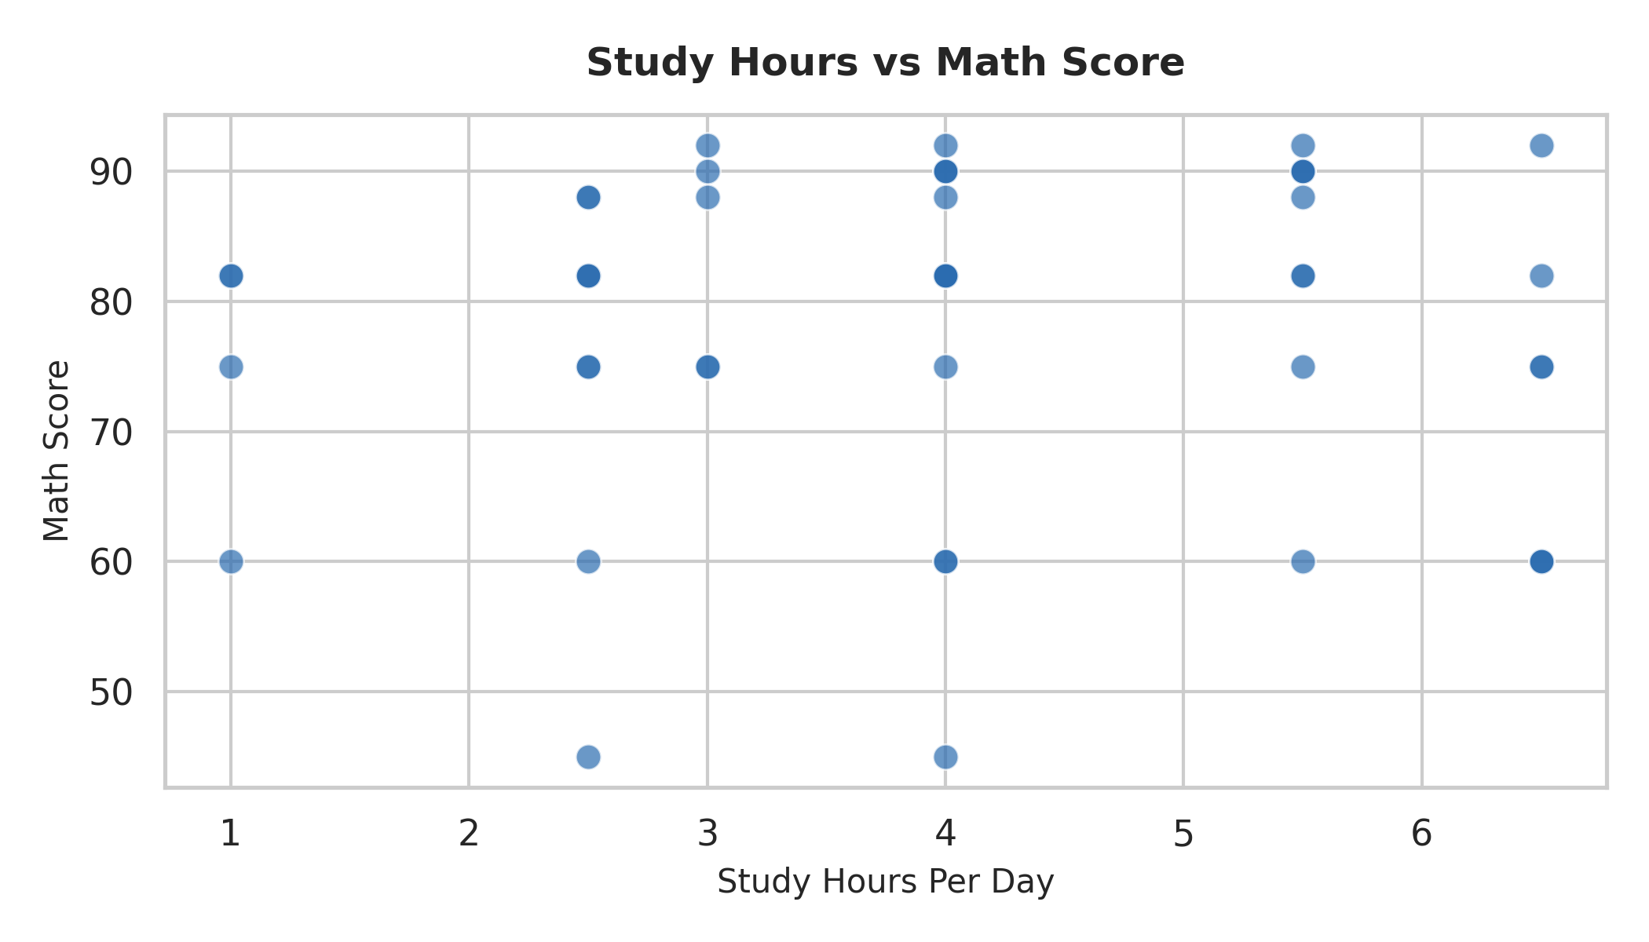
Week 1 Figure 3. Visualization from the Student Performance EDA report
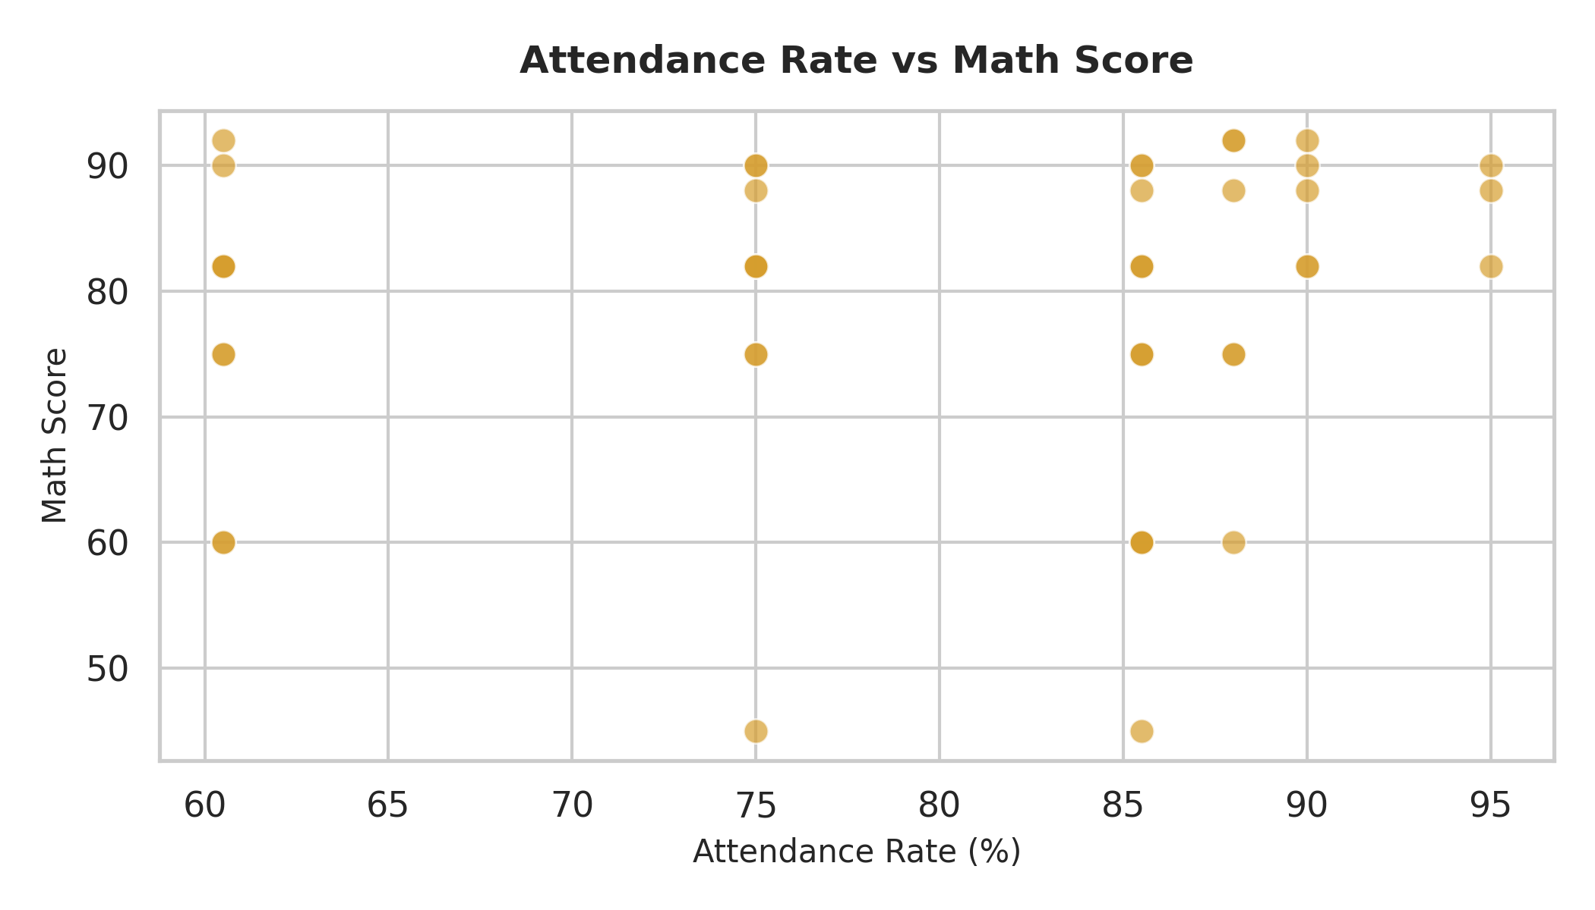
Week 1 Figure 4. Visualization from the Student Performance EDA report
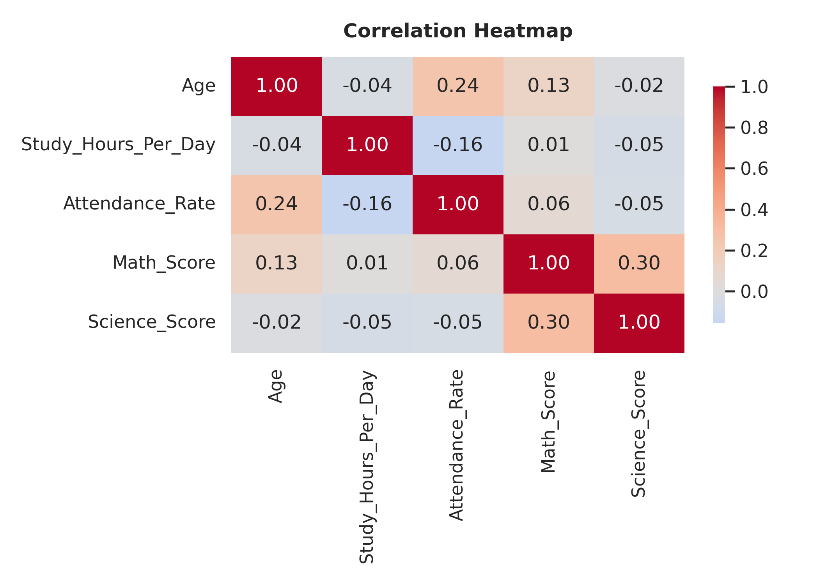
Week 1 Figure 5. Visualization from the Student Performance EDA report

4. Week 2 — COVID-19 Visualization and Storytelling
The COVID-19 project analyzes 49,068 records across 187 countries and regions from January 22, 2020 to July 27, 2020. Variables include Country/Region, Date, Confirmed, Deaths, Recovered, Active, Latitude, Longitude, Province/State and WHO Region. The objective is to communicate trends, patterns, relationships and insights through Python visualization.
The source report documents the dataset scope and variables. fileciteturn2file2L7-L18

4.1 Data Preparation
- No duplicate records were identified.
- Missing Province/State values were replaced with 'Unknown'.
- Date was converted to datetime format.
- Major COVID-19 measures were confirmed as numerical variables.
These preparation steps are explicitly documented in the Week 2 report. fileciteturn2file2L19-L24

4.2 Visualization Story
- Global confirmed cases over time establish the temporal progression.
- Top-10 country bar charts provide geographic comparison.
- Global deaths over time add a mortality perspective.
- Confirmed Cases vs Deaths examines the cross-country relationship.
- A correlation heatmap summarizes relationships among major indicators.
- Box plots reveal distribution and unusually high observations.
The report frames these visualizations as complementary perspectives rather than isolated charts. fileciteturn2file2L56-L66
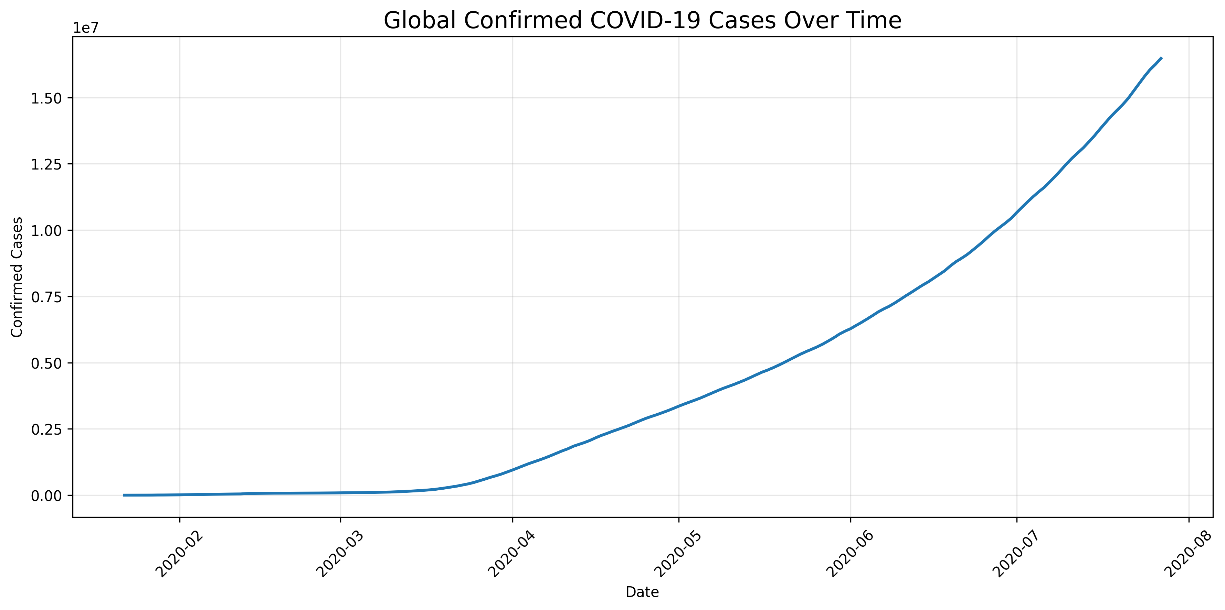
Week 2 Figure 1. COVID-19 visualization
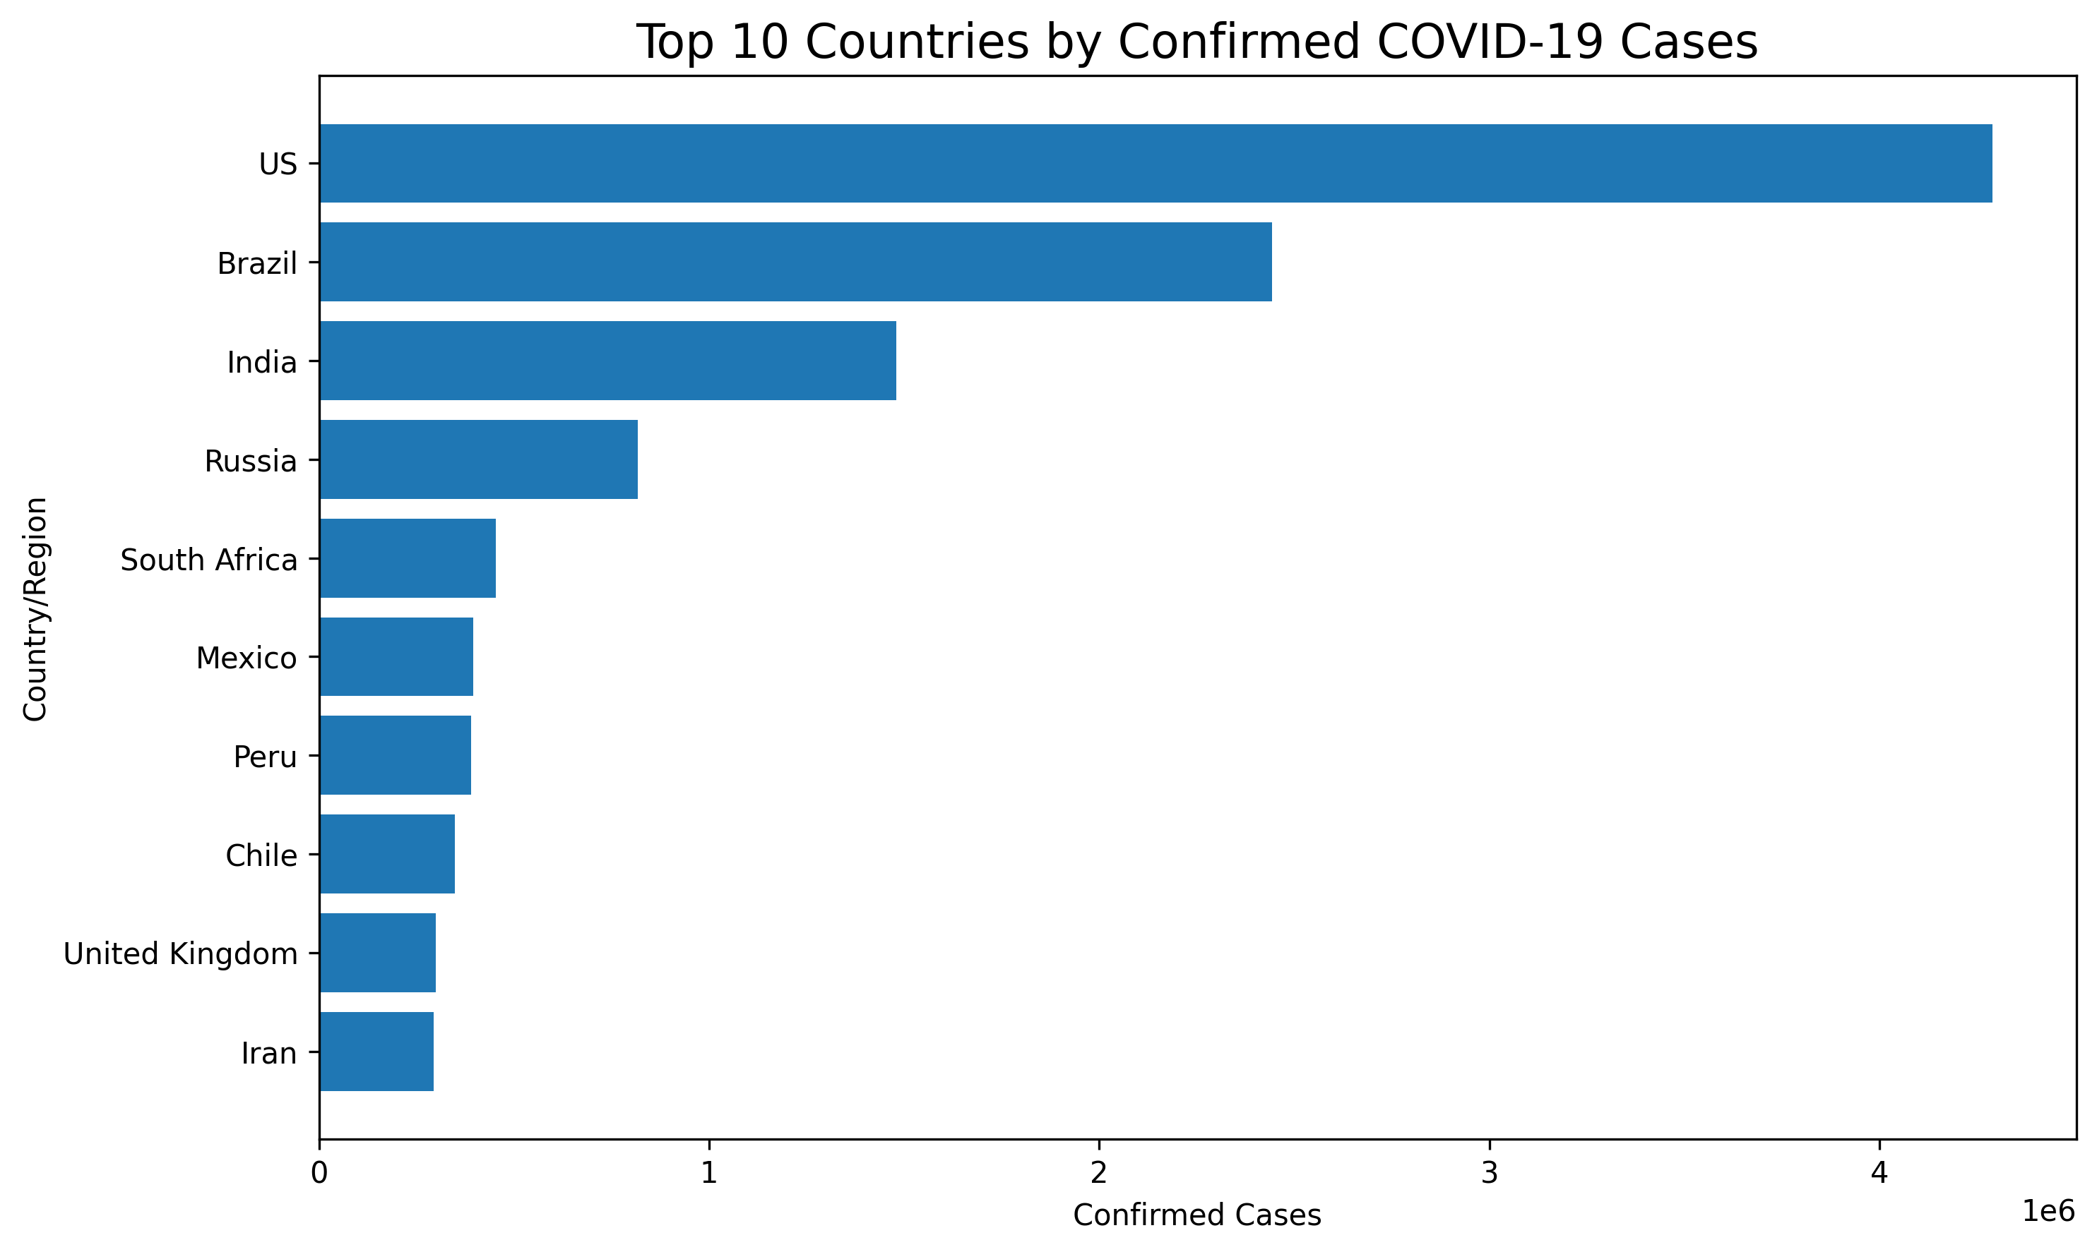
Week 2 Figure 2. COVID-19 visualization
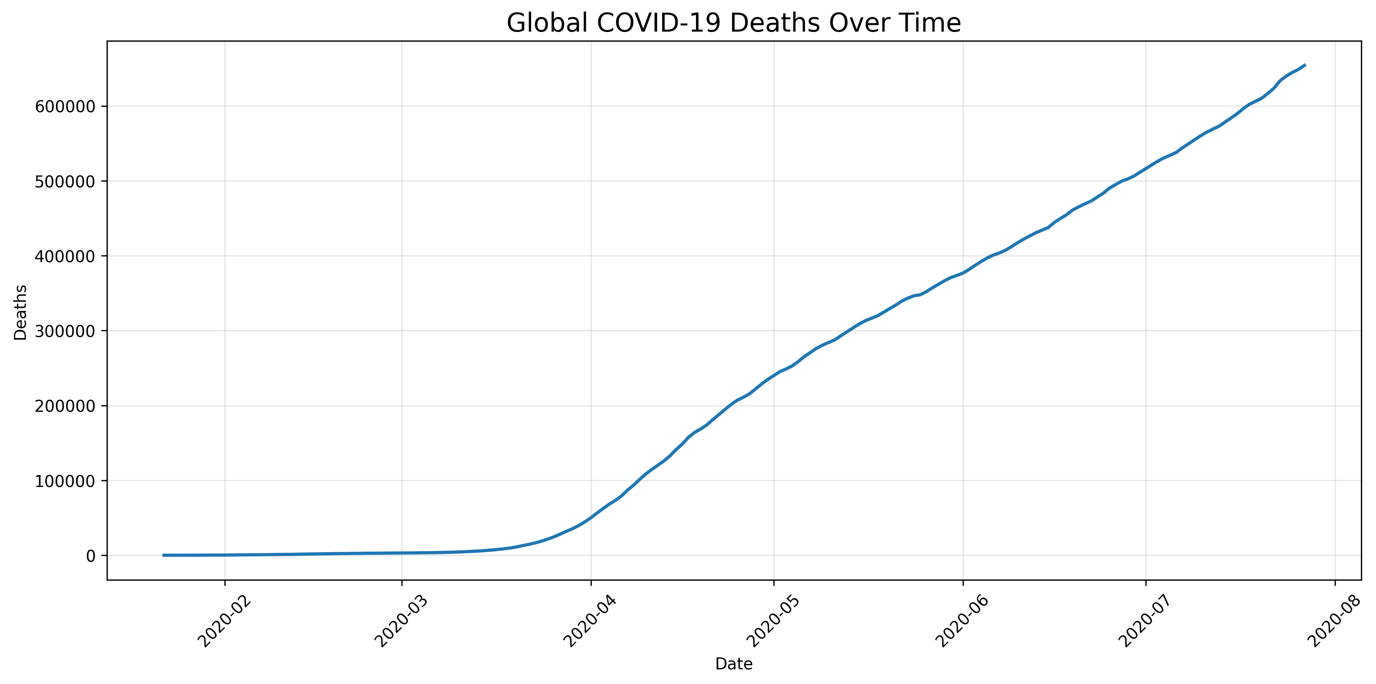
Week 2 Figure 3. COVID-19 visualization
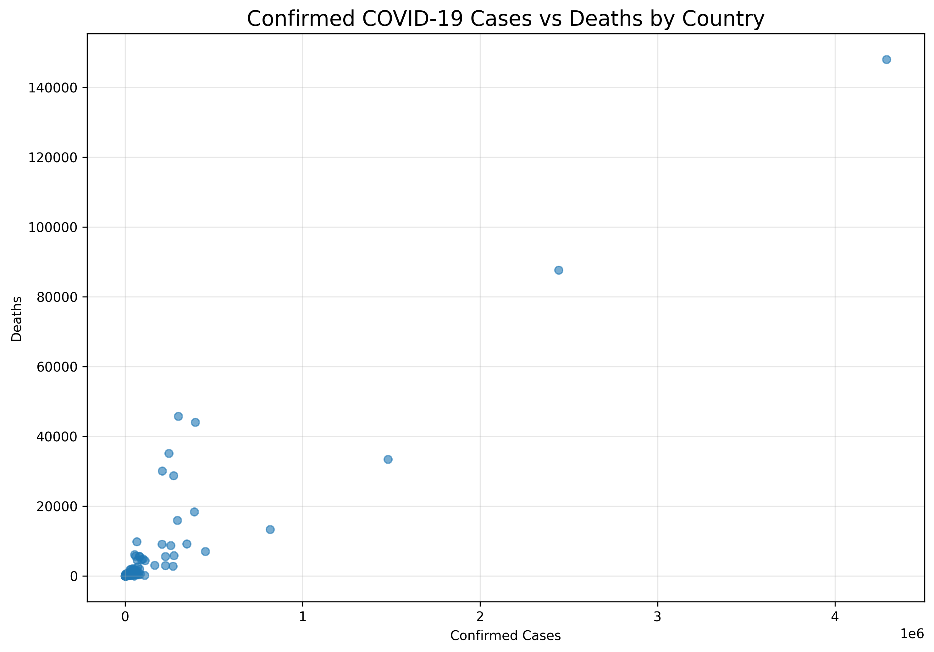
Week 2 Figure 4. COVID-19 visualization
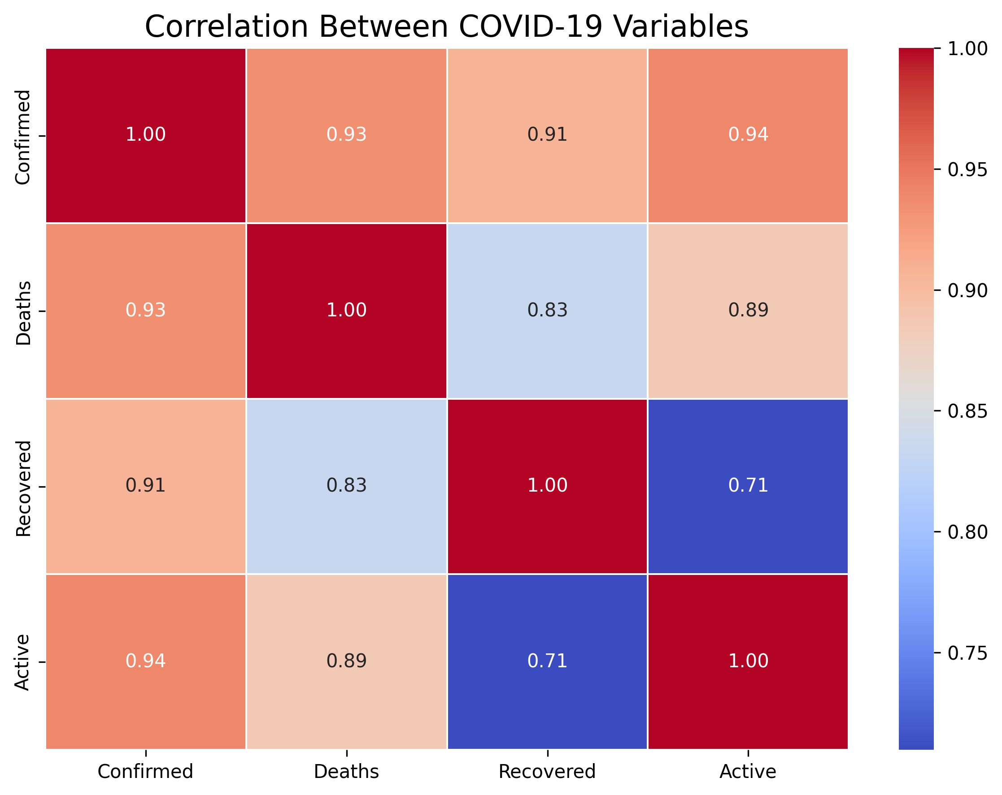
Week 2 Figure 5. COVID-19 visualization
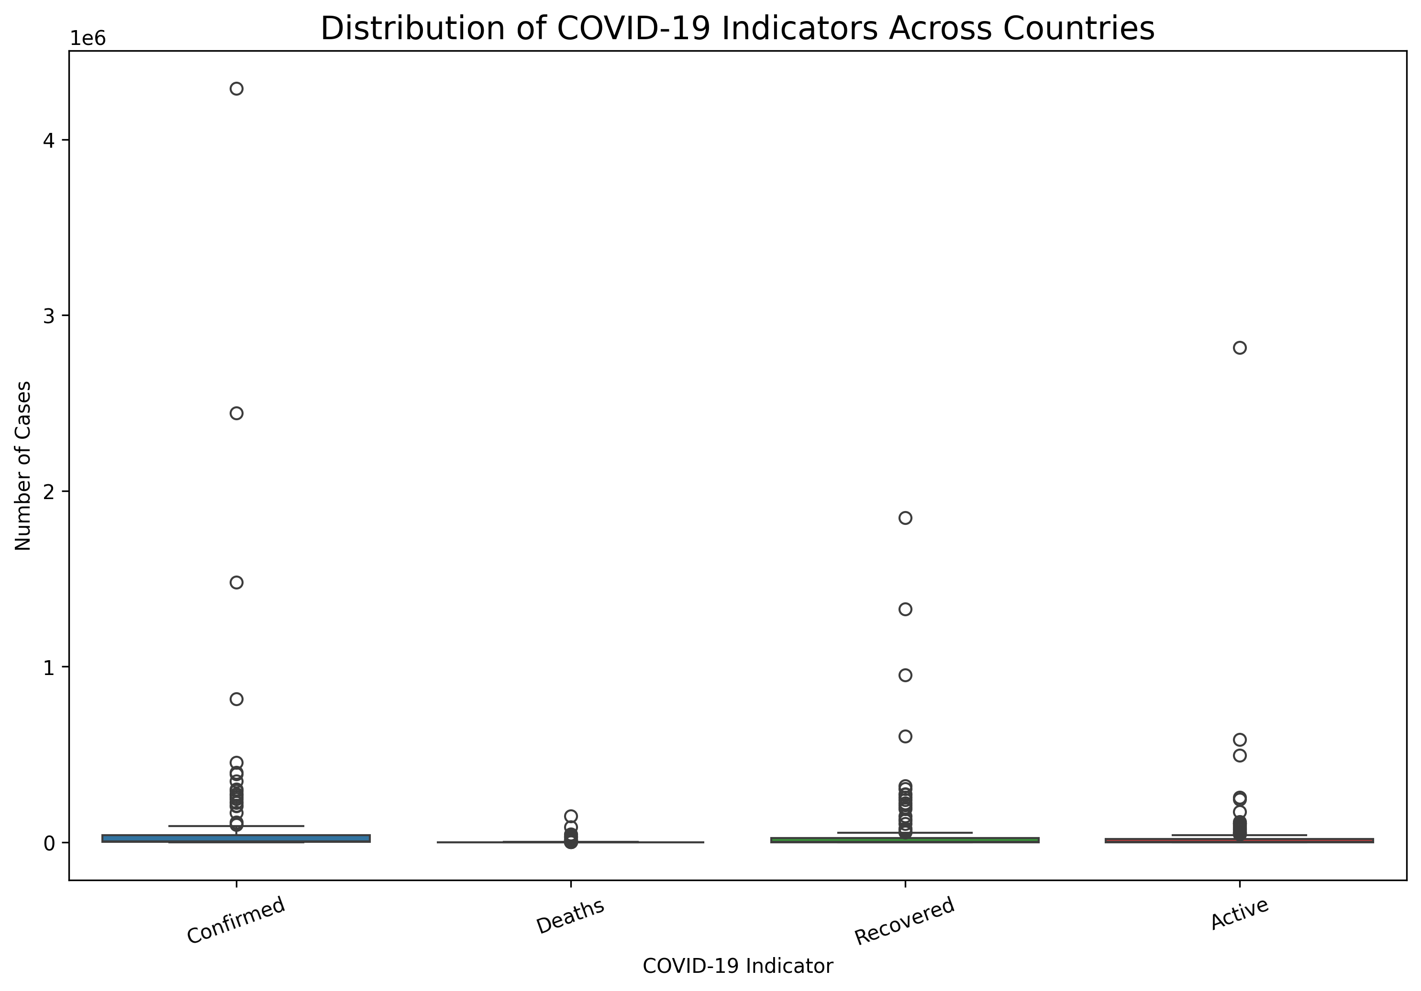
Week 2 Figure 6. COVID-19 visualization

5. Week 3 — Advertising Expenditure and Sales Statistical Analysis
The Advertising dataset contains 200 observations with TV, Radio and Newspaper advertising variables and Sales as the outcome. The analysis combines descriptive statistics, correlation analysis, bivariate regression visualizations, multiple linear regression, residual analysis and TV-based grouping.
These scope and methodology details are stated in the statistical analysis report. fileciteturn2file1L5-L16

5.1 Core Statistical Results
Measure | Result
TV–Sales correlation | 0.78
Radio–Sales correlation | 0.58
Newspaper–Sales correlation | 0.23
Regression R² | 0.897
RMSE | 1.67 sales units
MAE | 1.25 sales units
Sales median | 12.9
Middle 50% of Sales | 10.4–17.4

The source report documents these results and the fitted equation. fileciteturn2file1L5-L16

5.2 Regression Equation
Predicted Sales = 2.939 + (0.0458 × TV) + (0.1885 × Radio) + (−0.0010 × Newspaper)
The report characterizes this as a strong in-sample relationship and explicitly notes that residual analysis should be considered when evaluating assumptions and unusual observations. fileciteturn2file1L49-L53

5.3 Interpretation
TV has the strongest linear relationship with Sales, Radio has a positive relationship, and Newspaper has a comparatively weaker relationship. Higher TV advertising groups display higher typical Sales values. These are associations in the supplied dataset, not proof of causation.
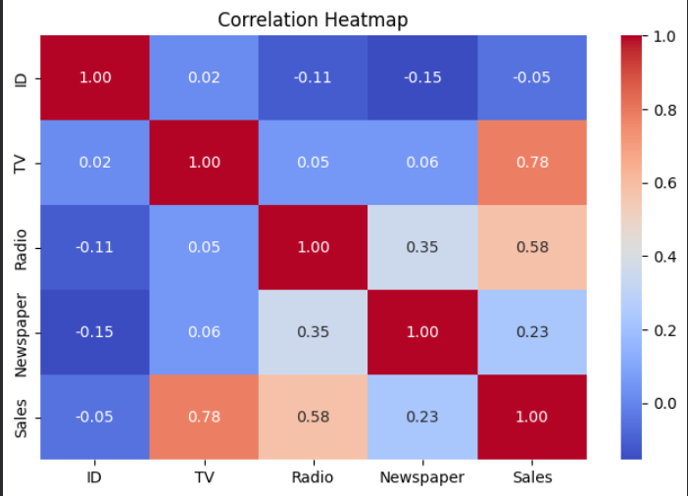
Week 3 Figure 1. Advertising/Sales analysis visualization
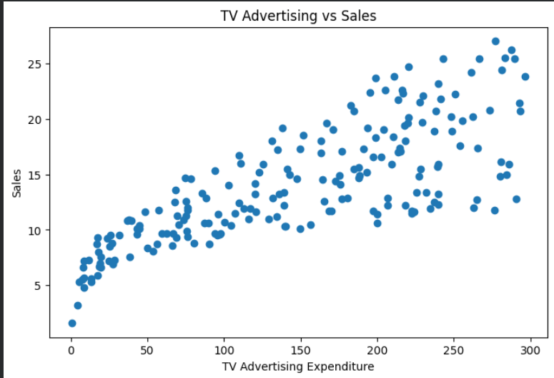
Week 3 Figure 2. Advertising/Sales analysis visualization
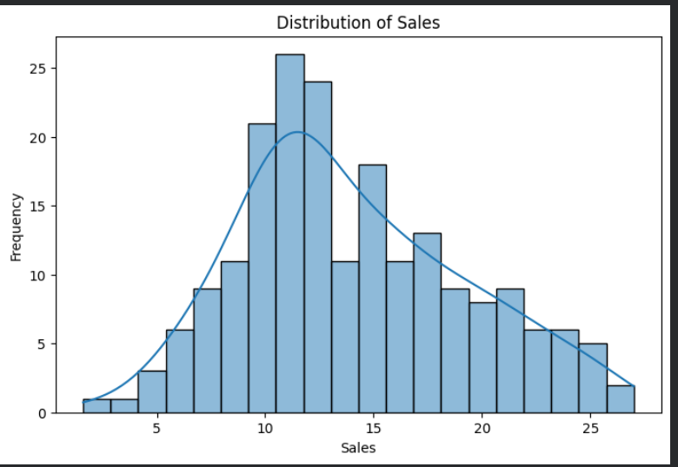
Week 3 Figure 3. Advertising/Sales analysis visualization
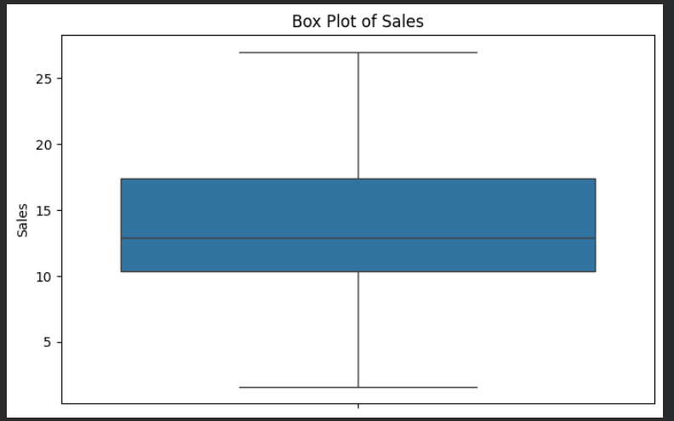
Week 3 Figure 4. Advertising/Sales analysis visualization
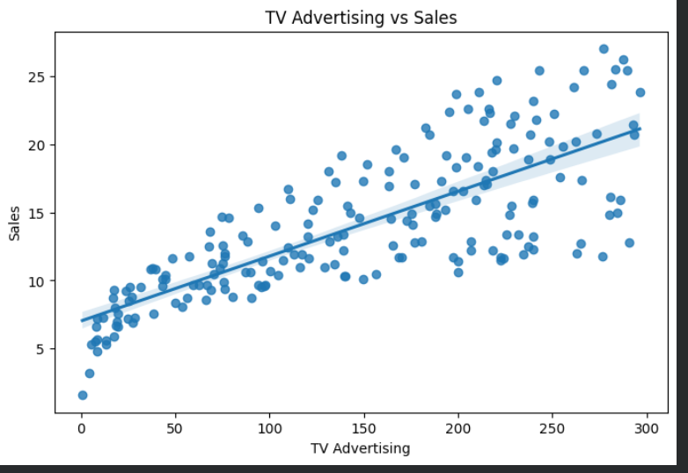
Week 3 Figure 5. Advertising/Sales analysis visualization
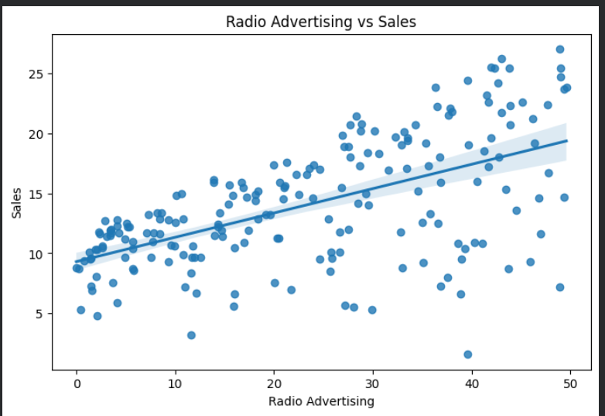
Week 3 Figure 6. Advertising/Sales analysis visualization
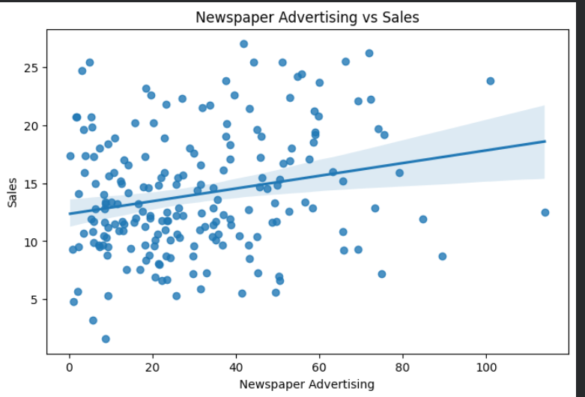
Week 3 Figure 7. Advertising/Sales analysis visualization
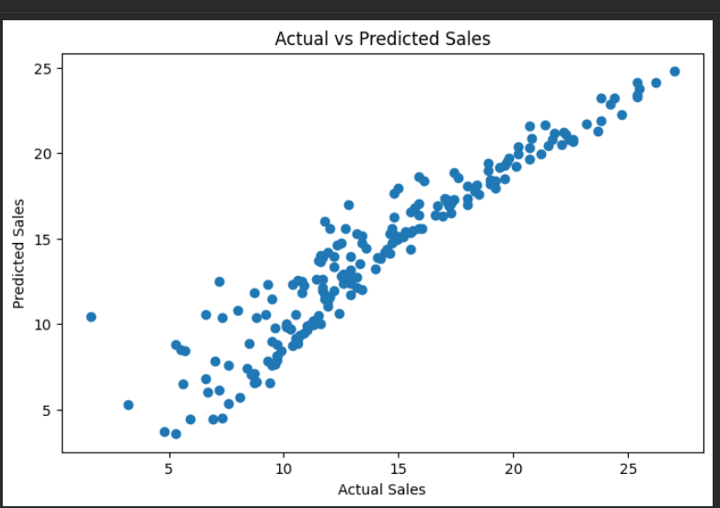
Week 3 Figure 8. Advertising/Sales analysis visualization
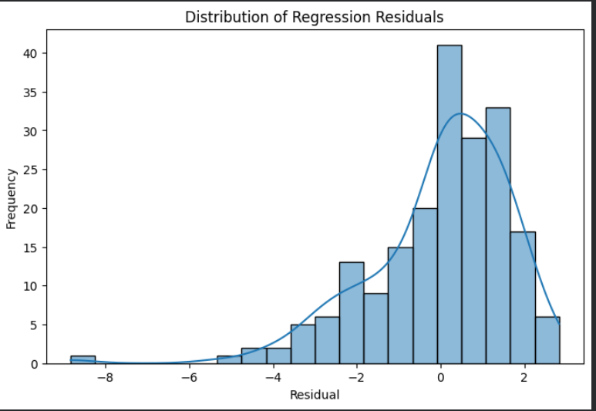
Week 3 Figure 9. Advertising/Sales analysis visualization
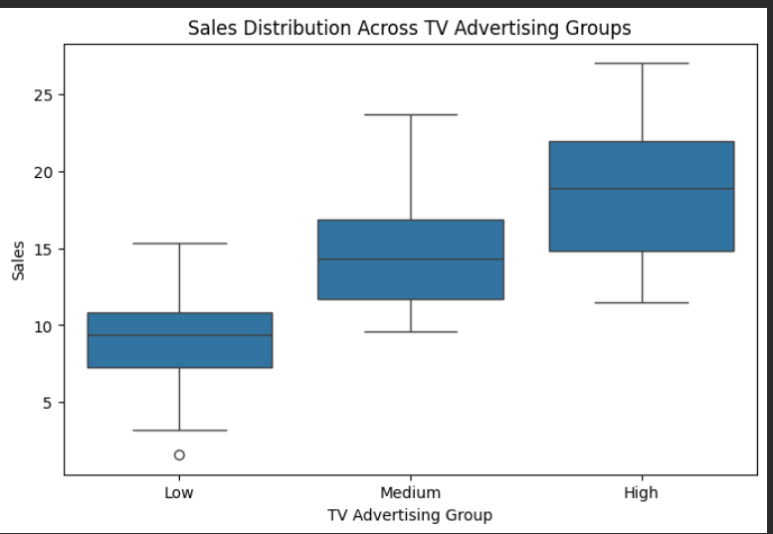
Week 3 Figure 10. Advertising/Sales analysis visualization

6. Week 4 — Machine Learning Model Development and Evaluation
The Week 4 project uses the Breast Cancer Wisconsin Diagnostic dataset, containing 569 observations and 30 numerical input features. It is a binary classification problem with malignant and benign classes. Logistic Regression was selected as a baseline classifier.
The dataset and task description are documented in the Week 4 report. fileciteturn2file0L24-L45

6.1 Preprocessing and Model Pipeline
- 80% of the data was used for training and 20% for testing.
- Stratified splitting was used to preserve class distribution.
- StandardScaler standardized numerical features.
- A Scikit-learn Pipeline combined scaling and Logistic Regression to reduce leakage risk.
These preprocessing decisions are documented in the source report. fileciteturn2file0L46-L56

6.2 Model Results
Metric | Result
Accuracy | 99.12%
Precision | 98.61%
Recall | 98.61%
F1-score | 98.61%
ROC-AUC | 0.995

The report states that there were two incorrect predictions in the 114-sample test set. fileciteturn2file0L90-L102

6.3 Confusion Matrix and ROC Interpretation
The confusion matrix reports 41 malignant and 71 benign samples correctly classified, with one malignant sample classified as benign and one benign sample classified as malignant. The ROC-AUC of 0.995 indicates strong discrimination on this test set.
The source report also cautions that high test-set performance should not be interpreted as proof of real-world clinical performance and recommends independent validation. fileciteturn2file0L104-L129
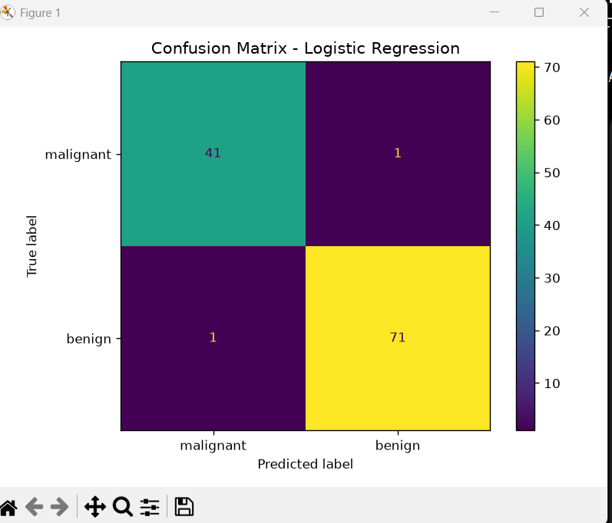
Week 4 Figure 1. Machine learning evaluation visualization
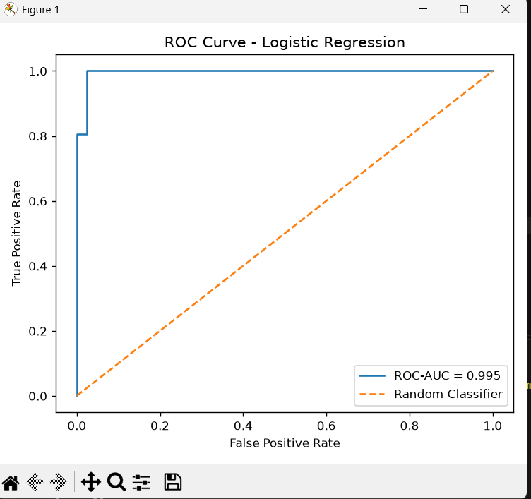
Week 4 Figure 2. Machine learning evaluation visualization

7. Cross-Project Synthesis and Strategic Recommendations
The four projects collectively demonstrate that data science is not only model building. The workflow begins with trustworthy data, continues through exploratory understanding and communication, and ends with evaluation, interpretation and decision support.

7.1 Strategic Recommendations

Establish a Data Quality Checklist
Before modeling, verify missingness, duplicates, types, outliers and whether any defects are natural or intentionally introduced. Week 1 demonstrates why this distinction matters. fileciteturn2file3L75-L78

Choose Visualizations Based on the Question
Use time-series plots for trends, bars for comparisons, scatter plots for relationships, heatmaps for correlation structure and box plots for distributions/outliers. Week 2 demonstrates this storytelling approach. fileciteturn2file2L30-L55

Use Multiple Evaluation Metrics
Avoid relying on one metric. Week 3 uses R²/RMSE/MAE, while Week 4 combines accuracy, precision, recall, F1 and ROC-AUC. This gives a more complete view of model behavior.

Validate Before Deployment
Use cross-validation, independent datasets or out-of-sample testing before operational decisions. Week 4 specifically recommends cross-validation and independent testing. fileciteturn2file0L130-L146

Treat Association Carefully
Correlation and regression can identify relationships but do not prove causality. The Advertising and COVID-19 reports explicitly make this distinction. fileciteturn2file1L64-L68

Perform Error Analysis
Inspect residuals, false positives and false negatives rather than reporting only aggregate performance. Week 4 documents two classification errors and possible sources. fileciteturn2file0L118-L129

8. Business and Research Outcomes
Capability | Demonstrated Outcome | Potential Use
Data quality | Cleaning, imputation, duplicate removal, type validation | More reliable downstream analysis
Data storytelling | Six complementary COVID-19 visual perspectives | Stakeholder communication and monitoring
Statistical modeling | Advertising/Sales regression and residual analysis | Decision support and preliminary forecasting
Classification | Logistic Regression with ROC-AUC and confusion matrix | Benchmarking classification workflows
Reproducibility | Documented Python workflows and libraries | Repeatable analysis and future iteration

These outcomes are potential applications derived from the project workflows; they should be validated against the requirements and context of any real organization before operational use.

9. Limitations and Risk Considerations
- Each week uses a different dataset, so numerical findings should not be aggregated into one model or treated as evidence about a common population.
- Week 1 uses an educational dataset in which missing values and duplicates were intentionally introduced in a working copy.
- Week 2 covers a historical COVID-19 period only through July 27, 2020 and therefore does not describe later pandemic developments.
- Week 3 regression metrics are in-sample and the relationships are associational.
- Week 4 performance comes from one train/test split; the source report recommends cross-validation and independent datasets.
- High classification performance on a benchmark dataset does not establish clinical diagnostic validity.
These limitations are grounded in the individual project reports. fileciteturn2file0L127-L146 fileciteturn2file1L64-L68

10. Future Improvement Roadmap
Priority | Improvement | Expected Benefit
1 | Cross-validation and independent test sets | More reliable estimates of generalization
2 | Hyperparameter tuning and model comparison | Better understanding of model alternatives
3 | Feature selection and diagnostics | Simpler and potentially more robust models
4 | Advanced outlier/error analysis | Better understanding of unusual observations
5 | More representative/current datasets | Improved external validity
6 | Experimentation / causal designs | Stronger evidence for intervention effects
7 | Automated dashboards and monitoring | Faster stakeholder feedback and model monitoring

The Week 1 report proposes advanced outlier detection and predictive modeling; Week 4 proposes cross-validation, tuning, model comparison, feature selection, threshold analysis and independent testing. fileciteturn2file3L80-L87 fileciteturn2file0L138-L146

11. Technical Skills Demonstrated
- Python programming and notebook-based analysis
- Pandas and NumPy for data manipulation
- Data cleaning, missing-value imputation and duplicate handling
- Exploratory Data Analysis and descriptive statistics
- Matplotlib and Seaborn visualization
- Correlation and regression analysis
- Scikit-learn preprocessing and modeling
- Pipeline construction and data-leakage awareness
- Classification evaluation with confusion matrix and ROC-AUC
- Residual/error analysis
- Technical documentation and data storytelling

12. Conclusion
This consolidated project demonstrates a complete progression through the core stages of practical data science. Week 1 established the importance of clean, well-understood data. Week 2 demonstrated how visualization can transform large longitudinal and geographic data into an understandable story. Week 3 extended the workflow into statistical modeling and business interpretation. Week 4 demonstrated supervised machine learning with a complete preprocessing, training and evaluation pipeline.
Taken together, the work shows that strong data science practice requires more than obtaining a high metric. Reliable conclusions depend on data quality, appropriate analytical methods, clear visual communication, multiple evaluation measures, careful error analysis and validation beyond the original sample. The next stage of development should therefore focus on generalization, reproducibility, causal experimentation where appropriate, and stronger real-world validation.

Appendix — Selected Code Snippets and Visual Evidence

A. Week 1 — Data Acquisition and Cleaning
import pandas as pd
df = pd.read_csv('student_performance_with_missing.csv')
print(df.shape)
print(df.isna().sum())
print("Duplicates:", df.duplicated().sum())
# Numeric imputation
df['Math_Score'] = pd.to_numeric(df['Math_Score'], errors='coerce')
df['Math_Score'] = df['Math_Score'].fillna(df['Math_Score'].median())
df = df.drop_duplicates().reset_index(drop=True)

B. Week 3 — Regression
from sklearn.linear_model import LinearRegression
X = df[['TV', 'Radio', 'Newspaper']]
y = df['Sales']
model = LinearRegression()
model.fit(X, y)
predictions = model.predict(X)

C. Week 4 — Logistic Regression Pipeline
model = Pipeline([
("scaler", StandardScaler()),
("classifier", LogisticRegression(max_iter=5000))
])
model.fit(X_train, y_train)
y_pred = model.predict(X_test)
y_prob = model.predict_proba(X_test)[:, 1]
The Week 4 source report provides this pipeline and prediction workflow. fileciteturn2file0L65-L76

References
1. Week 1 Data Acquisition, Cleaning, and Exploratory Analysis report (uploaded source).
2. Week 2 COVID-19 Advanced Data Visualization and Storytelling report (uploaded source).
3. Week 3 Advertising Expenditure and Sales Statistical Analysis report (uploaded source).
4. Week 4 Machine Learning Model Development and Evaluation report (uploaded source).
5. Python, Pandas, NumPy, Matplotlib, Seaborn and Scikit-learn documentation as cited/used in the supplied project reports.

