CSC8104: Enterprise Software and Services
Student No :250501717
Name: Aaditya Anil Kute

For this Coursework I have created 4 Packages(customer, hotel, booking, travel).
customer package:
1.Customer: Stores customer data and defines JPA relationships
2.CustomerRepository: It acts like a data access layer(CRUD with EntityManager)
3.CustomerService: It got business logic(validation, uniqueness check )
4.CustomerValidator: The Validator provides bean-validator helpers that enforce the domain rules.
5.CustomerRestService: The REST service provides JAX-RS endpoints for create, list, get, update, and delete operations, with Swagger annotations and standard HTTP responses.
6.UniqueEmailException: It states that the email should be unique no two same email address can be there for two different customer
hotel package:
1.Hotel: It represents the hotel records stored in the database. It uses JPA annotation for validation and database mapping and connects to booking.
2.HotelRepository: It handles all database operations for hotel. It uses JPA’s EntityManager to run queries, find hotels, and to save changes in the database.
3.HotelService: It contains the business logic for the hotel such as checking if the hotel already exits or to validate the hotel data(it acts as a middle layer between the REST API and the Repository.
4.HotelValidator: It validates the hotel data to make sure it follows all the required rules.
5.HotelRestService: It exposes REST API endpoints for hotels. It also handle http request and returns response.
6.UniqueHotelNameException: It will give an error if someone tries to create hotel with a same name that already exists.

booking package :
The booking package handles everything related to making and managing bookings. It include the Booking class, which stores the booking details such as customer, hotel, dates, and referance number. The BookingDTO and BookingDTOService helps to convert data coming from the API into the Booking object used inside the system. The BookingRepository connects to the database and performs actions like saving, updating, deleting, and finding bookings. The BookingService conteins the booking rules and checks if the BookingValidator makes sure the data is correct before a booking is made. The BookingRestService provides the REST API endpoint so that clients can create, view, or cancel booking. For user who are not registered, the GuestBooking and GuestBookingRestService allow guest bookings. Finally, the UniqueBookingReferenceException is used to show an error when someone enters the booking reference that already exist.
travel package:
The travel package handle communication between the Travel Agent service and the external Hotel, Taxi, and Flight services. The FlightClient, TaxiClient, and HotelClient classes are used to call the remote APIs of these services. The RemoteBooking class stores the combined booking information received from the other services. The TravelAgentBooking and TravelAgentRequest class is used to store the data for a complete travel booking made through the Travel Agent. The TravelAgentService contains the logic for creating a travel booking by calling the other services, while the TravelAgentBookingRepository saves the final booking in the database. Finally, the TravelAgentRestService provide REST API endpoints so user can create and view travel booking through a single unified service.
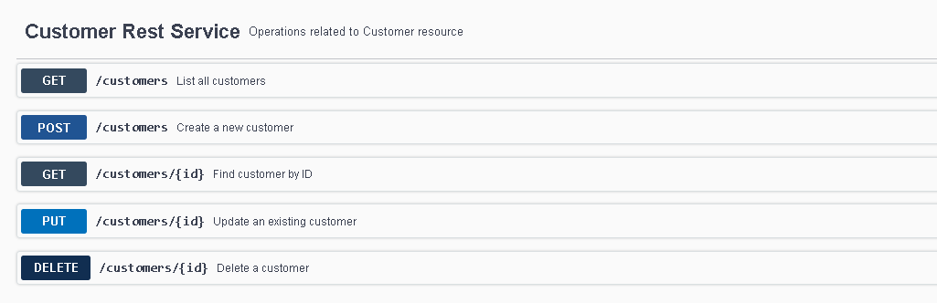
From this we can create customer, List all customer, Find customer by ID, Update an existing customer and Delete a customer using its unique id .(If we delete the customer all the booking for that customer will be deleted.
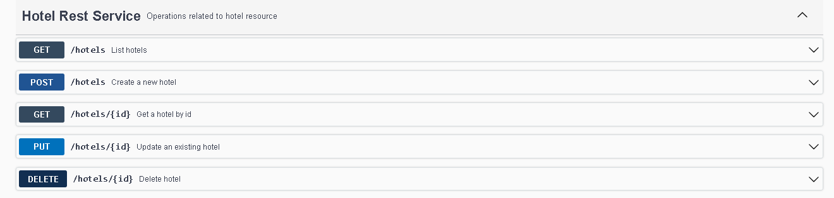
From this we can create Hotel, we can get list of hotel that already exists, get the hotel using its unique id, update the existing hotel and also delete the hotel(if we delete the hotel all the booking for it will automatically get deleted).
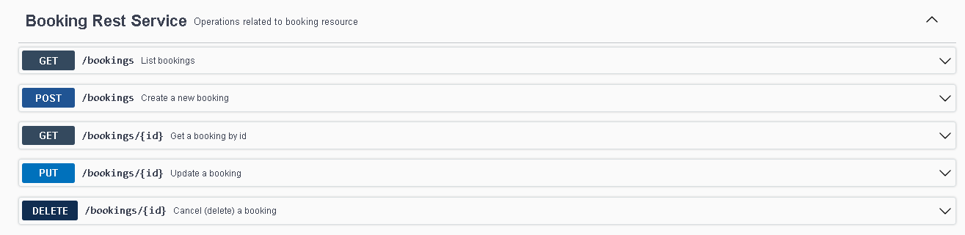
From this we can create a new booking, we can get list of booking that has been made, we can fetch the booking using booking id, we can also update the booking, and can delete the booking.
BookingDTO is used when you already have created the customer and hotel and using the unique id of customer and hotel we can directly generated booking
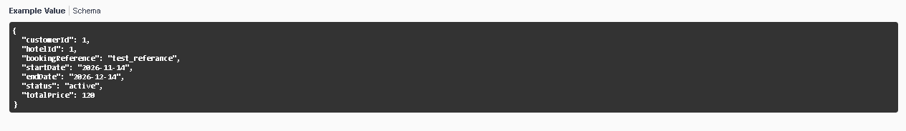
The above snippet shows the data to put for creating the booking
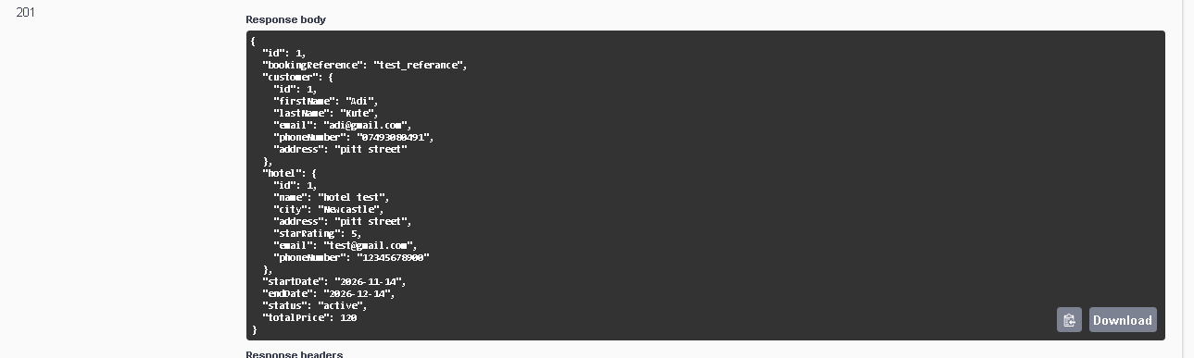
If the entered hotel id and customer id is valid it will create a booking like this.

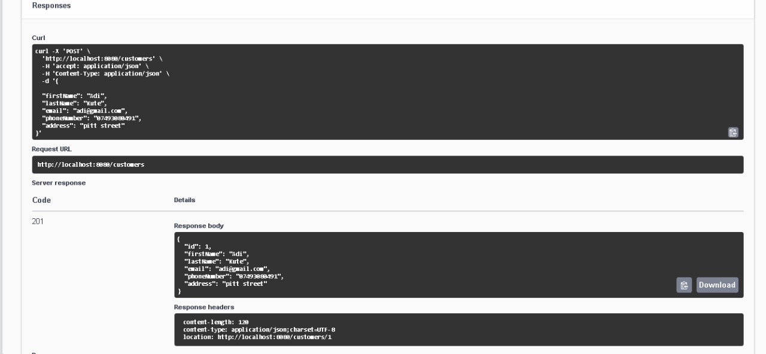
Successful creation(code 201) of customer (The ID is automatically assigned to each customer and is unique.
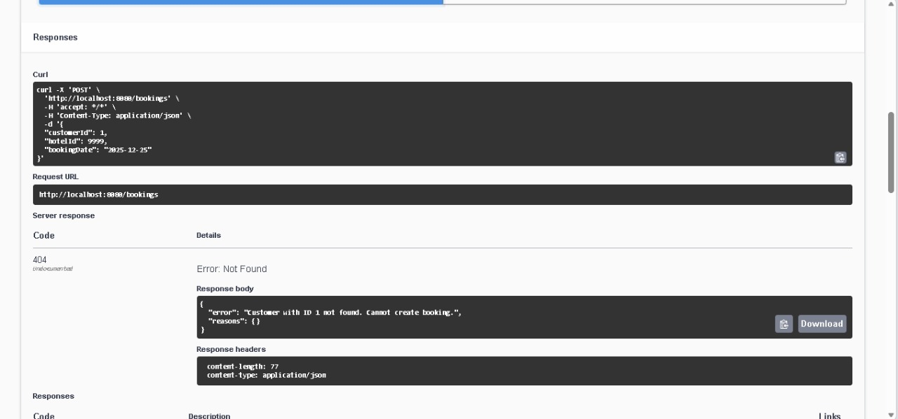
When we try to find a customer that does not exist it give code 404.
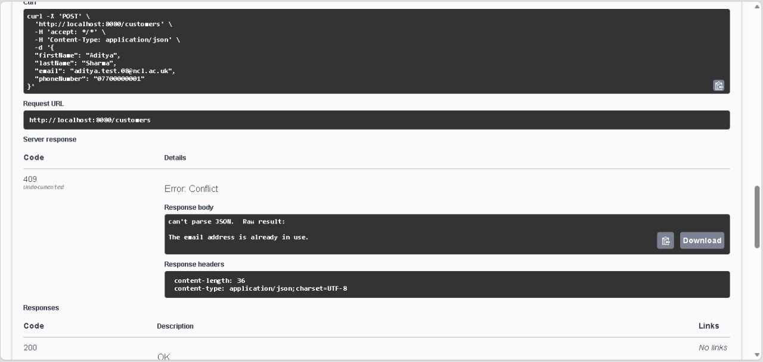
If there already exists a email address and someone is trying to give the same email address again for different customer it gives code 409.

