Sensor design
Requirements:

- Must be entirely of cardboard.
- Must allow for the sensors to be near a mesureable hieght.
- No external light should be allowed to interfere with IR sensor readings.
- Must be able to place all sensors with a distance from the base d where 0.76<d<3.18 mm
- Center sensors for line following must be less than 2 cm apart

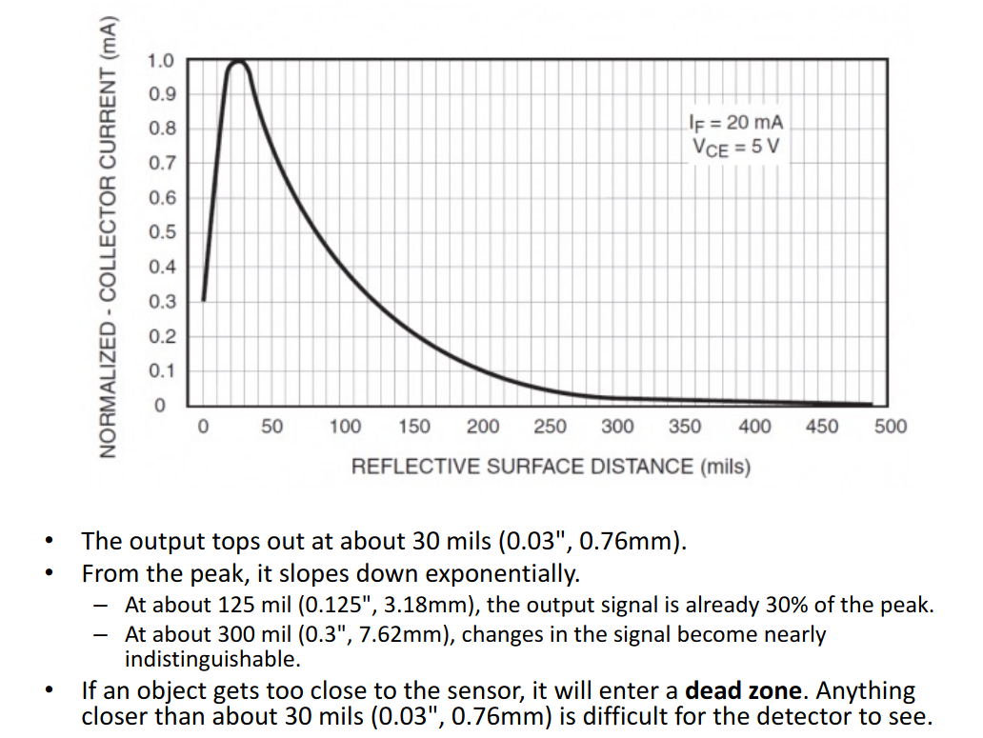
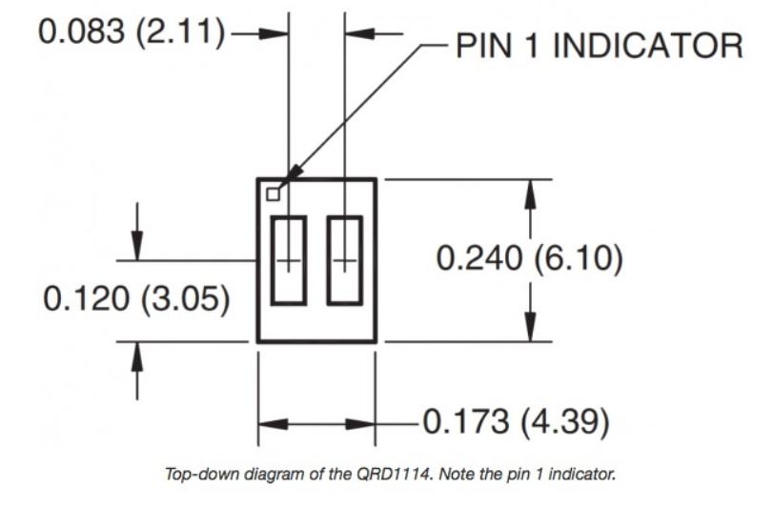
Appendix

