Abstract.
1.0 Introduction
Online discussions can sometimes contain comments that are harmful to other users; detecting which comments are harmful and which are not automatically is an important natural language processing task. The goal of this project is to evaluate and train a model to distinguish among different forms of toxicity across comments.
2.0 Dataset description
The dataset comes from Kaggle: https://www.kaggle.com/c/jigsaw-toxic-comment-classification-challenge. The project contains four data files as described below in the table
File | Rows | Columns | Purpose
train.csv | 159,571 | 8 | Training comments with labels
test.csv | 153,164 | 2 | Test comments without labels
test_labels.csv | 153,164 | 7 | Labels for the test comments
sample_submission.csv | 153,164 | 7 | Example Kaggle submission format

The training dataset (train.csv) includes comments and six labels. The data set used for testing has comments but no labels. The file text label.csv contains labels but no comments.
2.1 Dataset quality check
The data was loaded and explored in the notebook 1_Analysis.ipynb. The notebook was run successfully, and the results were saved in the notebook.
There are no missing values in the loaded files. There are also no duplicate IDs. This means the data is ready for basic analysis and modelling, but the text still needs cleaning before training a model.

Dataset | Rows | Missing Values | Duplicate IDs
train | 159,571 | 0 | 0
test | 153,164 | 0 | 0
test_labels | 153,164 | 0 | 0
sample_submission | 153,164 | 0 | 0

2.2 Label description
The labels are not evenly spread across the dataset. Most comments are clean. Some labels are common, while others are rare. The most common label is toxic. The rarest label is threat.
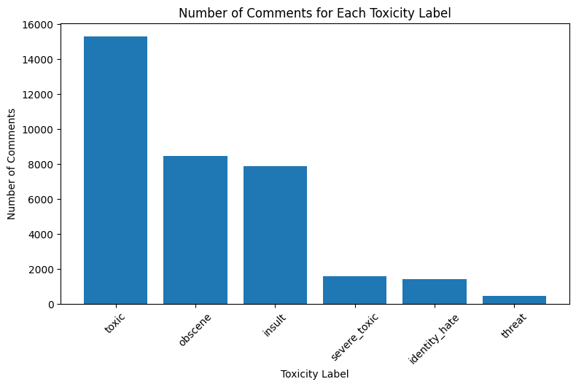

Label | Positive Count | Positive Percent
toxic | 15,294 | 9.58%
obscene | 8,449 | 5.29%
insult | 7,877 | 4.94%
severe_toxic | 1,595 | 1.00%
identity_hate | 1,405 | 0.88%
threat | 478 | 0.30%

This is important because a model could get a high accuracy score by mostly predicting clean comments. That would not be useful. The project should also use precision, recall, F1 score, ROC-AUC, and PR-AUC to judge the models.

2.3 Clean and toxic comment.
For the first task, the six labels were combined into one simple label called any toxic. If a comment has at least one toxic label, it is counted as toxic. If it has no toxic labels, it is counted as clean
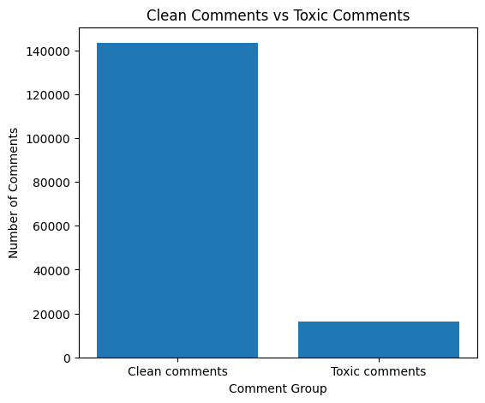

Group | Count | Percent
clean | 143,346 | 89.83%
toxic | 16,225 | 10.17%

Only 10.17% of the training comments are toxic by this definition. This confirms that the binary task is also imbalanced. The model should be checked carefully to make sure it finds toxic comments and does not simply predict clean for most rows.

