Project 1 – Part 1 – Team Blue
Question 1
The red lines indicate Principal Arterial roads, which handle a high volume of traffic and have higher capacities, making them essential for traffic flow.
The green lines denote Minor Arterial roads, which connect major zones to the principal arterials. These roads have lower capacities and traffic flow compared to the Principal Arterials.
The dashed lines represent different types of links based on their colors:
- Black dashed lines are the centroid connectors of the TAZs.
- Blue dashed lines indicate transit-only routes, reserved specifically for public transportation.
- Red dashed lines represent proposed or future roads that have not yet been built but may be constructed in the future.

Question 2
The model shows one lane in both directions for the year 2016 A.D., but it shows two lanes in both directions for the year 2040 A.D.

Question 3
The IDs of the TAZs included in the area are 4240001, 4240002, 4240003, 4240004, 4250001 and 4340001.
In 2016:
- There were 195 motel rooms.
- The Medium Retail area totaled 326,160 KSF, and Low Retail area amounted to 25,600 KSF.
- The undeveloped land comprised 19.428 acres.
- The average household size was 1.965, with a mean household income of $46,212.

Question 4
Flow of Vehicles
Location | Madonna Road | LOVR | Tank Farm Road | Prado Road
Year 2016 | 27234.2273 | 23892.45 | 15259.3977 | 6354.5468
Year 2020 | 25482 | 25671 | 16774 | 8067

Question 5
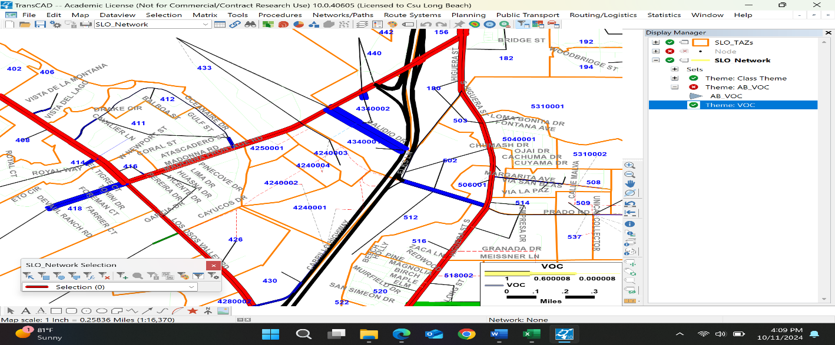
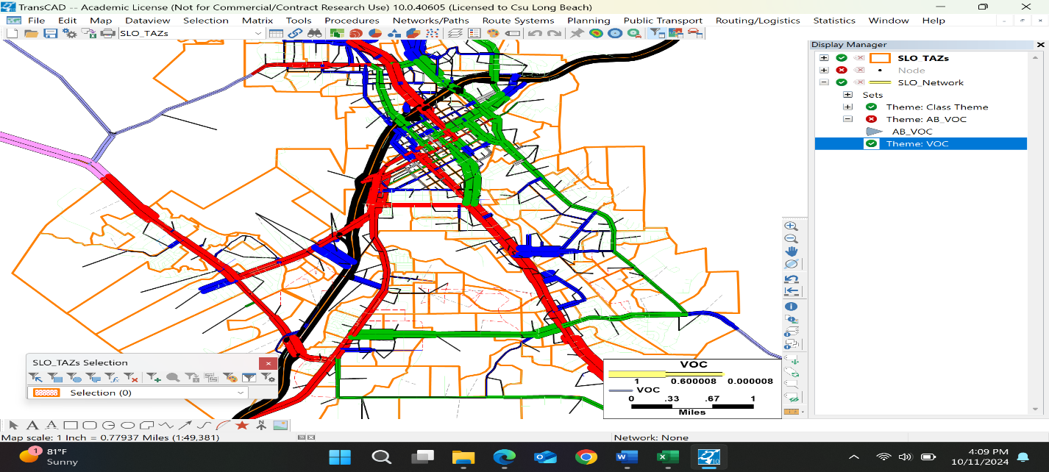
Question 6
According to the model, the 2040 projections show significant changes compared to 2016:
- Single-family homes will increase to 300 units in 2040, from zero in 2016, while multi-family homes will rise to 665 units, also from zero in 2016.
- 100,000 KSF of office space is projected to be utilized in 2040, compared to no office space used in 2016.
- The number of hospital beds will reach 43,200 by 2040, a notable increase from none in 2016.
- Motel rooms will expand to 395 in 2040, up from 195 in 2016.
- Retail space will see significant growth:
    - High retail will increase to 595 KSF in 2040, compared to zero in 2016.
    - Medium retail will grow to 576,944 KSF, up from 326,160 KSF in 2016.
    - Low retail will expand to 29,221 KSF, compared to 25,600 KSF in 2016.
- The undeveloped land remains unchanged at 19.428 acres in both 2016 and 2040.
- Household statistics also remain constant, with the average household size at 1.965 and the mean household income at $46,212 in 2016, with no projected changes in 2040.
Flow of Vehicles
Location | Madonna Road | LOVR | Tank Farm Road | Prado Road
Year 2016 | 27234.2273 | 23892.45 | 15259.3977 | 6354.5468
Year 2020 | 25482 | 25671 | 16774 | 8067
Year 2040 | 37630.2502 | 19614.18 | 10829.6235 | 35770.0587

Question 7
The daily PM peak hour volume from the data view is 16376.55.
The PM peak hour volume can be estimated using the ITE Trip Generation Manual. However, the manual does not cover all the specific points of interest in San Luis Ranch, making it impossible to obtain precise data for the area. While it includes categories such as supermarkets, shopping centers, and walk-in banks, none of these are suitable for determining an exact quantitative value for the peak hour volume for San Luis Ranch.

Project 1 – Part 2 – Team Blue
Questions
2-1: Create a map showing the links in our study area (roughly the area bounded by Los Osos Valley Road, Madonna Rd, and S Higuera Street) where there are different lanes in 2016 vs 2040. Paste image below.
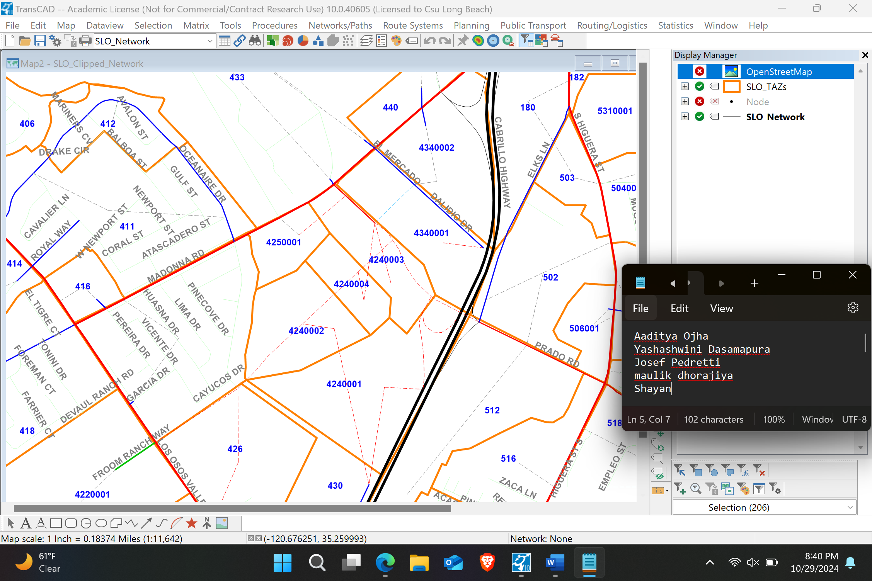
2-2. Use mapping tools to highlight locations with high growth and volumes over 15000 vehicles and 25000 vehicles. Hint: create a selection set including links with volumes over 15000 (or 25000).
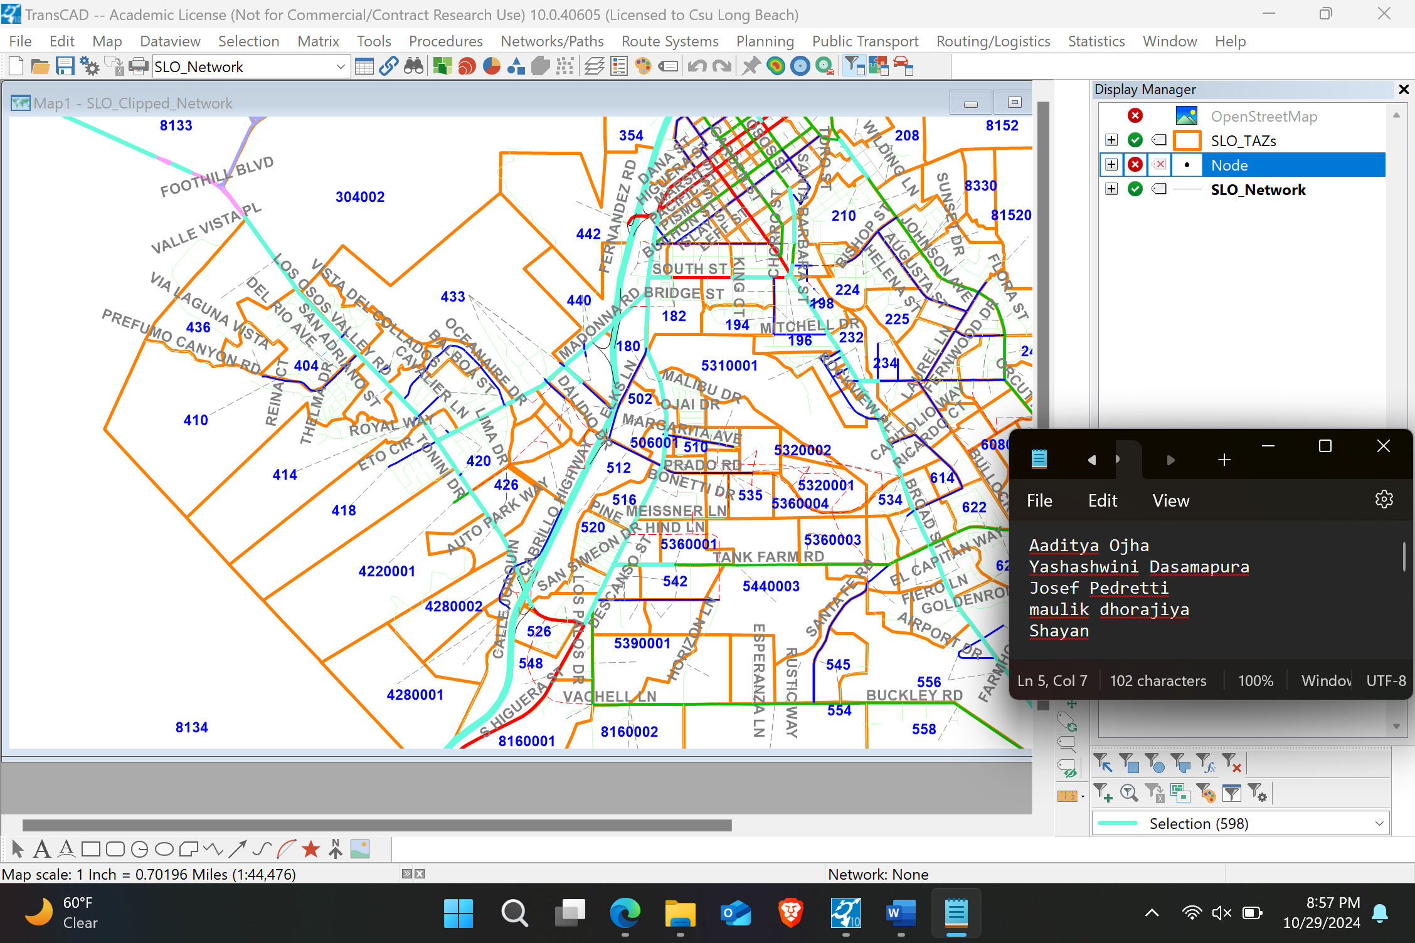
2-3: Using the 2016 and 2040 Summary files and SLO Model Documentation.pdf answer these questions:
- Of the balanced home-based trip types, which constitutes the largest portion of home-based productions? Home- based ______ (Work? School? University? Other?)
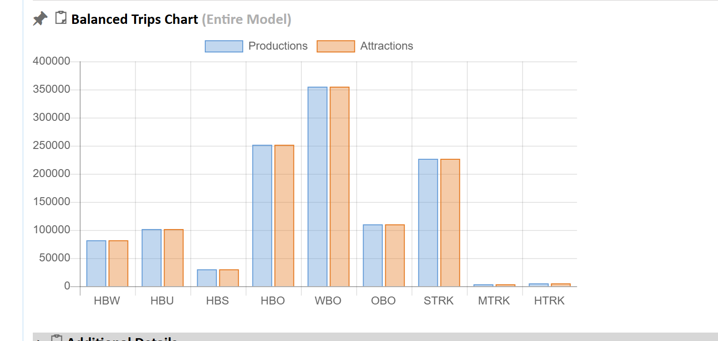
- Bar chart for 2016 Home-based trips; out of which Home-based others is the largest one.

- Does the model balance home-based trips to productions or attractions? What about University trips? Why?
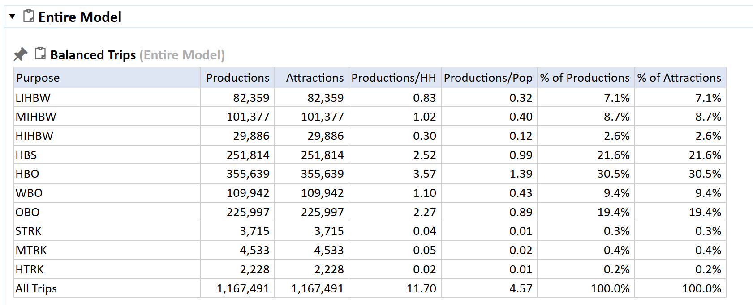
- The model ensures a balance between trips to productions and attractions. The previous graph shows that university trips are also balanced. In a transportation model, the number of attractions must match the number of productions to achieve system balance, as every trip starting from one point needs a corresponding destination.

- What is the portion of trips made by bikes in the entire model? In the City’s Sphere of Influence (SOI)?
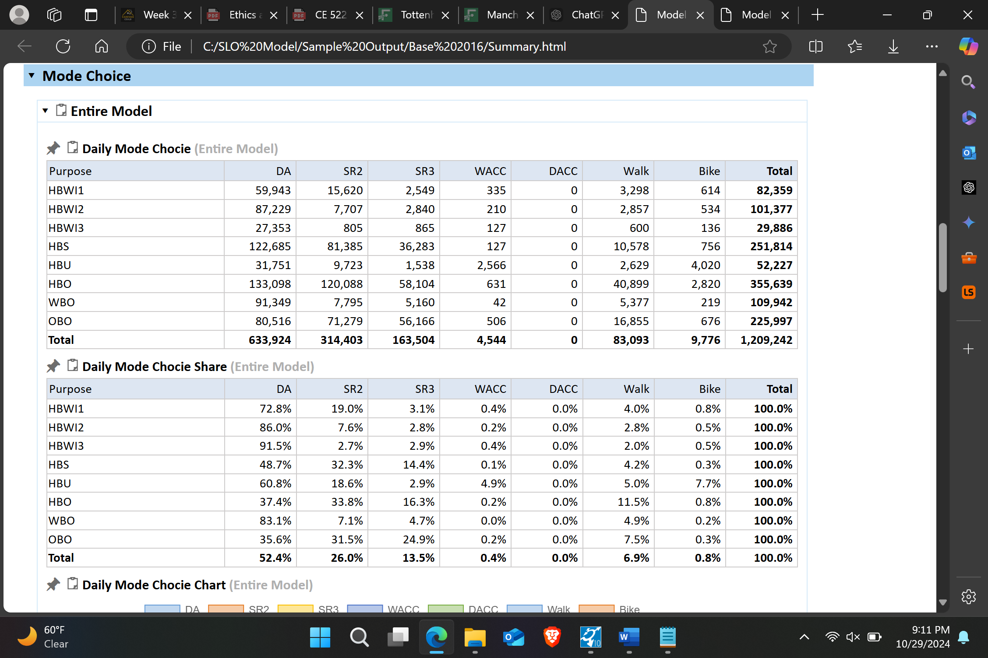
- 0.8% of the vehicles are bikes in the entire model.
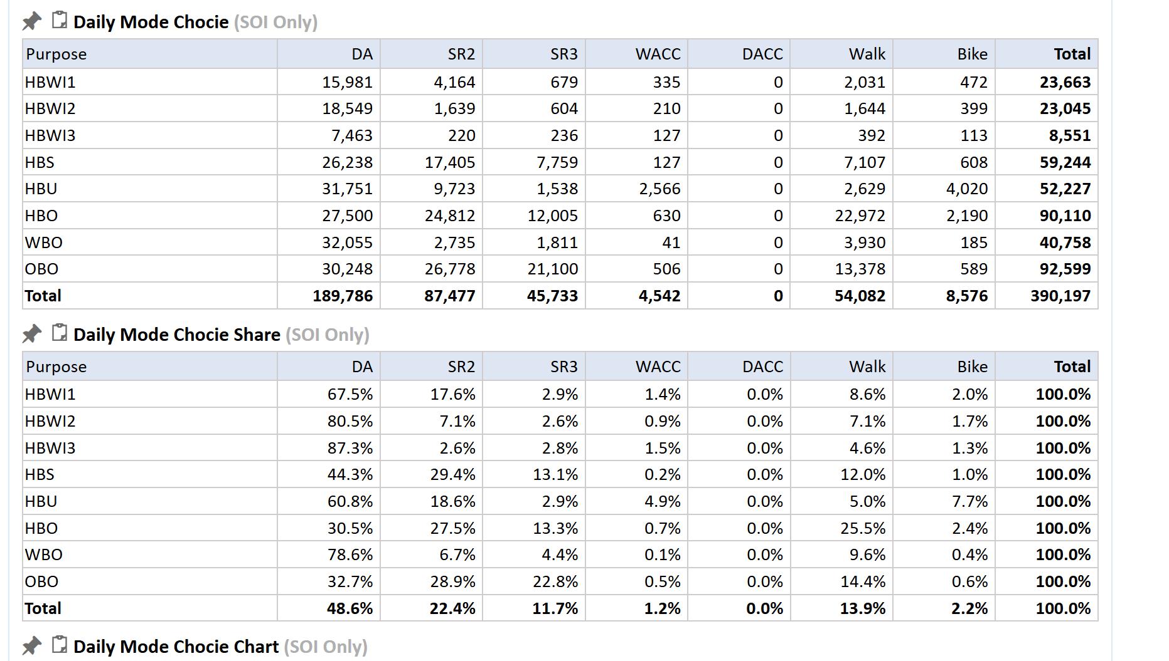
- 2.2% of the vehicles are bikes in the SOI.

- What is the model’s estimated Vehicle Miles Traveled within the SOI?
 | Residential VMT | Commute VMT | Assigned VMT
City | 439,731 | 1,000,833 | 1,078,052
SOI | 504,973 | 1,212,362 | 1,275,213
County | 5,142,480 | 2,179,836 | 10,205,410

- The model's estimated Vehicle Miles Traveled (VMT) within the SOI is the sum of Residential VMT (504,973), Commute VMT (1,212,362), and Assigned VMT (1,275,213), which totals to 2,992,548.

- How many hours of congestion delay are reported within the SOI?
 | CBD | Fringe | Urban | Suburban | Rural | Outside SOI | Total
Freeway | 0 | 0 | 0 | 7 | 1 | 0 | 7
Major Arterial | 3 | 314 | 4 | 777 | 130 | 0 | 1,228
Minor Arterial | 7 | 462 | 190 | 239 | 9 | 0 | 907
Major Collector | 1 | 2,132 | 22 | 2,058 | 0 | 0 | 4,214
Ramps | 0 | 0 | 1 | 77 | 33 | 0 | 110
Urban Local | 0 | 0 | 0 | 0 | 0 | 0 | 0
Highway (Outside SOI) | 0 | 0 | 0 | 0 | 0 | 0 | 0
Arterial (Outside SOI) | 0 | 0 | 0 | 0 | 4 | 0 | 4
Rural Arterial (Outside SOI) | 0 | 0 | 0 | 0 | 0 | 0 | 0
Walk Only Centroid Connectors | 0 | 0 | 0 | 0 | 0 | 0 | 0
Centroid Connectors | 0 | 0 | 0 | 0 | 0 | 0 | 0
Transit Local | 0 | 0 | 0 | 0 | 0 | 0 | 0
Total | 12 | 2,908 | 218 | 3,157 | 178 | 0 | 6,472
- A total of 6,472 hours of congestion delay has been observed.

