**Constructing and Displaying an Airport Model**

**Process**

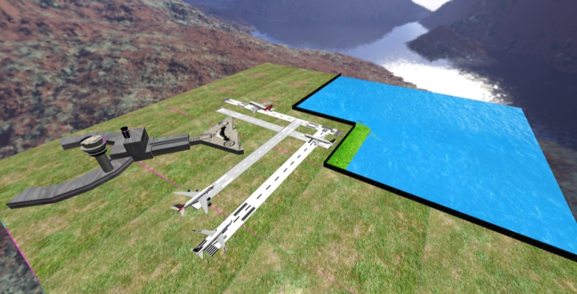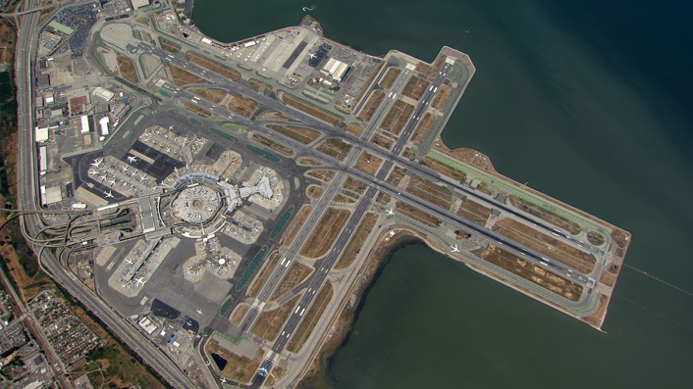  
My airport is based off San Francisco (SFO) airport. SFO has four runways and is next to water. To start of the model, I had to make the terrain. I made this by creating two planes and increasing one above the other. I added a water image to the bottom plane and a grass image to the top plane. SFO airport also has a fence around the airport next to the water, so I created the fence model. I then added four runways overlapping each other. I increased each runway by 0.01 on the y-axis so they don’t collide with each other in OpenGL. I then created the terminal using the 3D buildings mode within Google Earth. I used an image of a window pane to add the window texture. For the top down view I used images from Google Earth to add some realism to the airport. I created the watch tower from scratch, not using any images as I had an idea of what they look like. I got all four plane models from Sketch Up. I had to open them in Sketch Up and export them as an OBJ file. I opened the OBJ file in Maya and then exported them again and used Texture Atlas to create the files with the corresponding texture file. This would load in the OBJ file with corresponding textures files and then output them to the project folder, applying the textures to the faces.

I then resolved the issue with the lighting by adding a shader file and changing the number of the light intensity. I also made the light further away from the ground on the y-axis and increased the draw distance. I then added a skybox which caused quite a few issues. First issue was the skybox rotated with the camera. To fix this I had to make a separate cube map class and link it with the camera. By doing this it locked the rotation and translation in one place. Also I had to re-arrange the image files to load in order as they were not connecting together in the scene.

If I were to improve this scene, I would improve the textures on each of the models as some stretch on parts of a model. This would require playing around with the UV editor in Maya and also getting suitable sized images. Another issue I would try and solve would be the purple lines that appear on the edge of each texture. This would require changing the code within Texture Atlas and my code to make purple lines either disappear or make them harder to see. I would add transparency to the fence as the fence texture has been applied but the model comes out black. If zoomed in, the fence image can be seen. Another improvement would be to add reflection to the water to add more realism. If possible, I would add movement to the water to make it look like its flowing. I would also add an extra class that loads in the models from a text file. This text file would have the position, size and image files and the class would read the file and load in all the models into the scene.

The camera movement controls are Page up and Page down to look up and down. Left and right arrow keys to look left and right. Up and down arrows key to move forward and backward.

**References**

Qantas Model - <https://3dwarehouse.sketchup.com/model/2823a1660cf82561a279e09186ec047a/Qantas-A380-Taking-Off>

Boeing 1 - <https://3dwarehouse.sketchup.com/model/ub68faad2-7d6c-49b6-a884-2e1fb96702e3/United-Airlines-Boeing-767-322ERWL>

Boeing 2 - <https://3dwarehouse.sketchup.com/model/u7fbfb830-15b0-495a-947d-d13a03e7d3a4/United-Airlines-Boeing-767-424ER>

British Airways - <https://3dwarehouse.sketchup.com/model/57855e4927b7c8656155a49bd79504a0/British-Airways-A380>

Cement texture on terminal - <https://static1.squarespace.com/static/57a90dee46c3c496d824320f/t/5a4b054b41920273abb1e85b/1514866018591/wood-texture-floor-wall-gray-tile-1072475-pxhere.com.jpg?format=2500w>

Window pane - <https://i.pinimg.com/474x/b1/61/8d/b1618d0aaf11cd5a8ebecfddf7604622--furniture-decor-home-and-garden.jpg>

Word count without references = 541

Total word count = 604