About Dr. Sharuja Sarap | Thrive With Sharuja
Locale: en
Route: /en/about
URL: http://127.0.0.1:4327/en/about
Discovery source: sitemap static route

SEO Metadata
Title: About Dr. Sharuja Sarap | Thrive With Sharuja
Description: Pediatric OT in Kandivali West, Mumbai — 18+ years supporting children and families.
Keywords: Pediatric Occupational Therapist Mumbai,OT Kandivali,Brain Gym Mumbai,Aquatic Therapy Mumbai,Sensory Integration Mumbai,Autism Support Mumbai,ADHD Support Mumbai,pediatric occupational therapy Mumbai,occupational therapist Kandivali West,child development therapy Mumbai,Pediatric Occupational Therapist Mumbai,OT Kandivali,Dr. Sharuja Sarap OT,Brain Gym Mumbai,Sensory Integration Mumbai
Canonical: https://drsharujasarap.vercel.app/en/about
Open Graph Title: About Dr. Sharuja Sarap | Thrive With Sharuja
Open Graph Description: Pediatric OT in Kandivali West, Mumbai — 18+ years supporting children and families.

Page Content With Media Placement

Hello, I'm Sharuja.
Pediatric occupational therapist in Kandivali West, Mumbai — walking alongside children and families for over 18 years.
Image: Alt: Dr. Sharuja Sarap — pediatric occupational therapist in Kandivali, Mumbai | Section: Hello, I'm Sharuja. | Source: /images/doctor/portrait.jpg
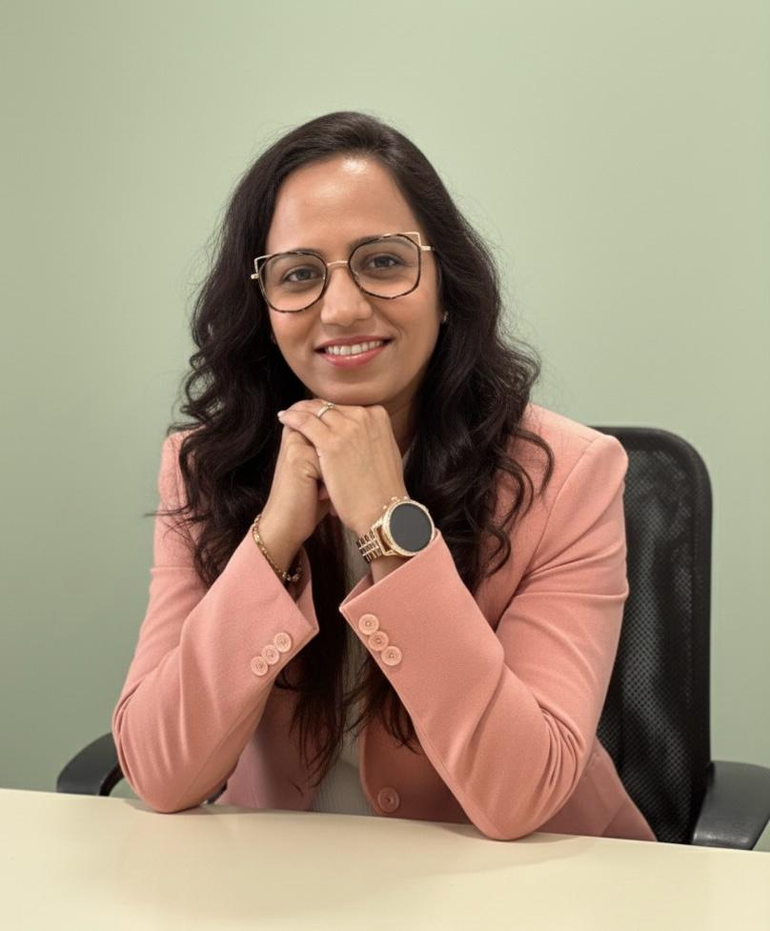
I became an occupational therapist because I believe every child deserves to feel capable in their own daily life — getting dressed, playing, learning, making friends. Not someday. In the small moments that matter now.
Over 18 years in Mumbai, I've learned that parents often arrive tired, worried, and unsure where to start. My job isn't to lecture. It's to listen, observe gently, and help you understand what your child needs — in plain language you can take home.
This clinic is a warm space where children play, explore, and slowly build skills. Parents tell me they leave feeling lighter — with something practical to try, and someone in their corner.

18+ Years Experience
Dedicated pediatric practice supporting children and families across Mumbai.

Master's in Pediatric OT
Advanced training focused on child development, sensory integration, and family-centred care.

Ph.D. Scholar
Ongoing research in how children grow, move, learn, and participate in daily life.

Brain Gym Instructor
Certified to use movement-based strategies that support focus, learning readiness, and coordination.

Research & Conference Participation
Dr. Sharuja actively participates in professional conferences and continuing education — bringing evidence-informed practices to every family she supports. She believes learning never stops, especially when it helps children thrive.
✓Pediatric occupational therapy conferences
✓Sensory integration and reflex integration workshops
✓Brain Gym® and movement-based learning seminars
✓Parent education and school collaboration programs

Family-Centered Practice
You are part of the therapy team. We set goals together, celebrate wins together, and adjust when life changes. Home strategies are always part of the plan — because progress happens between sessions too.
Parents involved in goal-setting from day one
Simple home activities you can actually do
School collaboration when you're ready
Honest conversations — no jargon overload

Specialised Training
Certifications that support thoughtful, individualised care — not one-size-fits-all programmes.
Ph.D. Scholar
Master's in Pediatric Occupational Therapy
Certified Brain Gym Instructor & Practitioner
RMTI (Rhythmic Movement Training Integration)
HWT (Handwriting Without Tears)
OPT (Oral Placement Therapy)
Aquatherapy (IATF, WST, BRRM)
PIASTM (Pediatric Instrument Assisted Soft Tissue Mobilization)
KT Level 1–3 (Kinesio Taping)
MNRI (Masgutova Neurosensorimotor Reflex Integration)
KDCT (Kinesio Dry Cupping Therapy)

Headings
- Hello, I'm Sharuja.
- 18+ Years Experience
- Master's in Pediatric OT
- Ph.D. Scholar
- Brain Gym Instructor
- Research & Conference Participation
- Family-Centered Practice
- Specialised Training

Forms And CTA Labels
- Book a Conversation -> /en/appointment
- Invite Sharuja to Your Program -> /en/invite-sharuja

