Brain Gym® — Pediatric OT Mumbai | Thrive With Sharuja
Locale: en
Route: /en/expertise/brain-gym
URL: http://127.0.0.1:4327/en/expertise/brain-gym
Discovery source: expertiseAreas

SEO Metadata
Title: Brain Gym® — Pediatric OT Mumbai | Thrive With Sharuja
Description: Brain Gym® for children in Mumbai & Kandivali. Movement-based support for focus, learning readiness, and calmer homework with Dr. Sharuja Sarap.
Keywords: Pediatric Occupational Therapist Mumbai,OT Kandivali,Brain Gym Mumbai,Aquatic Therapy Mumbai,Sensory Integration Mumbai,Autism Support Mumbai,ADHD Support Mumbai,pediatric occupational therapy Mumbai,occupational therapist Kandivali West,child development therapy Mumbai,Brain Gym® Mumbai,Brain Gym® Kandivali
Canonical: https://drsharujasarap.vercel.app/en/expertise/brain-gym
Open Graph Title: Brain Gym® — Pediatric OT Mumbai | Thrive With Sharuja
Open Graph Description: Brain Gym® for children in Mumbai & Kandivali. Movement-based support for focus, learning readiness, and calmer homework with Dr. Sharuja Sarap.

Page Content With Media Placement
Home
Expertise & Approaches
Brain Gym®

Brain Gym®
Simple movement before seated work can change the whole mood.
Image: Alt: Therapist-guided fine motor and learning readiness activity during pediatric OT | Section: Brain Gym® | Source: /images/therapy/handwriting-practice.jpg
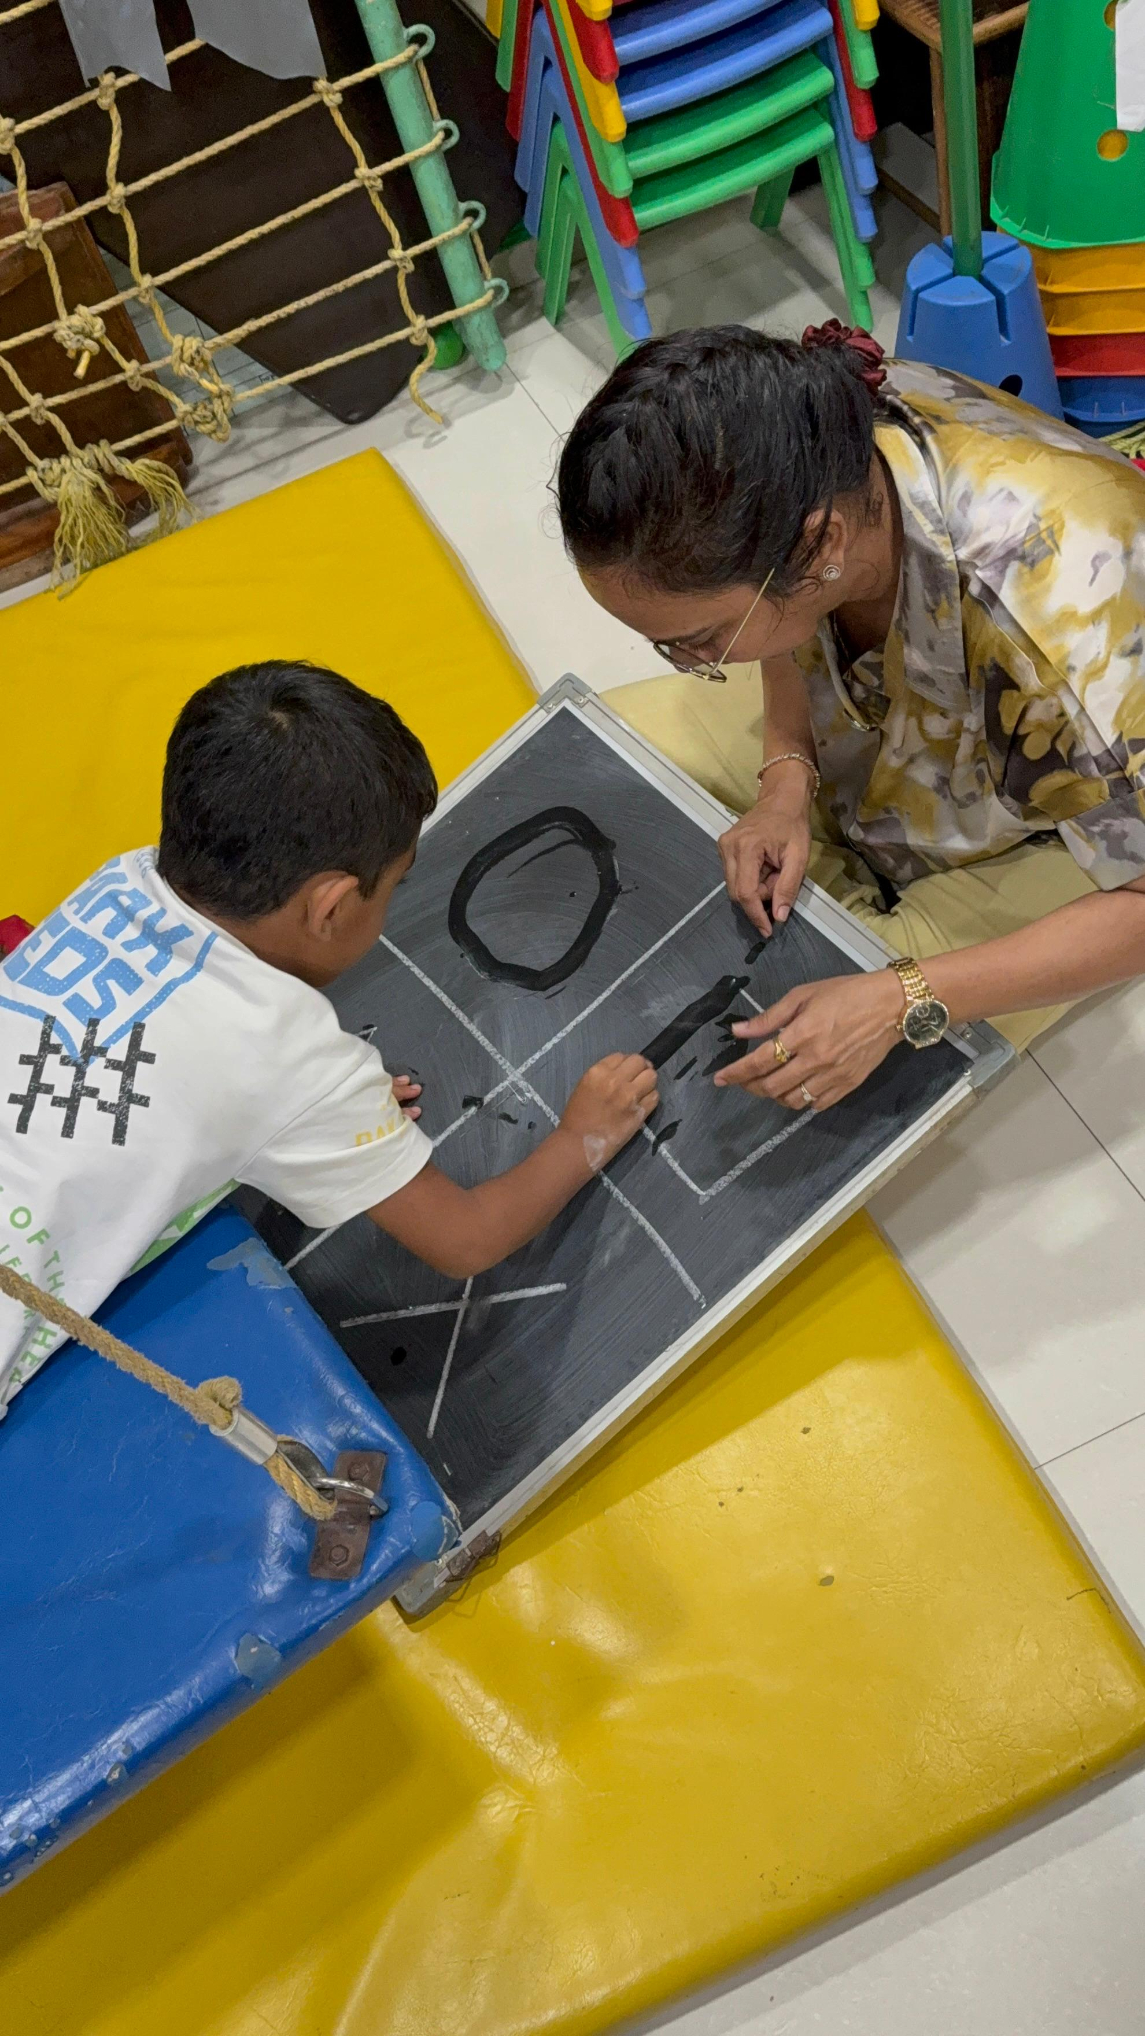

What Is It?
Brain Gym® uses short, purposeful movements to help the body and brain work together — before homework, before reading, before anything that usually ends in frustration. It's not exercise drills. It's a gentle wake-up for focus, coordination, and calm. Many children who fidget, rush, or shut down during seated tasks find that a few minutes of movement makes the next twenty minutes actually possible.

What Parents May Notice
•Homework that used to take an hour now finishes sooner
•A child who can sit a little longer without melting down
•Better letter formation or fewer reversals over time
•Mornings that feel less chaotic before school

How This Helps
✓Activates both sides of the body for smoother learning
✓Supports eye tracking and visual focus for reading
✓Helps children feel alert without feeling wired
✓Gives families a tool before difficult tasks — not after tears

Areas Commonly Supported

Learn More

Who it's for

What a session involves

Brain Gym at home and school

Questions Parents Ask

What is Brain Gym®?

How can Brain Gym® help my child?

When should we consider Brain Gym® for our child?

When should I seek Occupational Therapy for my child?

What happens next if we book a consultation in Kandivali?

Headings
- Brain Gym®
- What Is It?
- What Parents May Notice
- How This Helps
- Areas Commonly Supported
- Learn More
- Who it's for
- What a session involves
- Brain Gym at home and school
- Questions Parents Ask
- What is Brain Gym®?
- How can Brain Gym® help my child?
- When should we consider Brain Gym® for our child?
- When should I seek Occupational Therapy for my child?
- What happens next if we book a consultation in Kandivali?

Forms And CTA Labels
- Home -> /
- Expertise & Approaches -> /en/expertise
- Show more
- Who it's for
- What a session involves
- Brain Gym at home and school
- What is Brain Gym®?
- How can Brain Gym® help my child?
- When should we consider Brain Gym® for our child?
- When should I seek Occupational Therapy for my child?
- What happens next if we book a consultation in Kandivali?
- Book a Consultation -> /en/appointment
- Ask a Question -> /en/contact

JSON-LD / Schema Summary
- Type: BreadcrumbList
- Type: Service | Name: Brain Gym®
- Type: FAQPage
- Type: BreadcrumbList

