Double Doodle Play® — Pediatric OT Mumbai | Thrive With Sharuja
Locale: en
Route: /en/expertise/double-doodle-play
URL: http://127.0.0.1:4327/en/expertise/double-doodle-play
Discovery source: expertiseAreas

SEO Metadata
Title: Double Doodle Play® — Pediatric OT Mumbai | Thrive With Sharuja
Description: Double Doodle Play® in Kandivali — playful bilateral drawing that supports handwriting, reading, and coordination. Pediatric OT with Dr. Sharuja Sarap.
Keywords: Pediatric Occupational Therapist Mumbai,OT Kandivali,Brain Gym Mumbai,Aquatic Therapy Mumbai,Sensory Integration Mumbai,Autism Support Mumbai,ADHD Support Mumbai,pediatric occupational therapy Mumbai,occupational therapist Kandivali West,child development therapy Mumbai,Double Doodle Play® Mumbai,Double Doodle Play® Kandivali
Canonical: https://drsharujasarap.vercel.app/en/expertise/double-doodle-play
Open Graph Title: Double Doodle Play® — Pediatric OT Mumbai | Thrive With Sharuja
Open Graph Description: Double Doodle Play® in Kandivali — playful bilateral drawing that supports handwriting, reading, and coordination. Pediatric OT with Dr. Sharuja Sarap.

Page Content With Media Placement
Home
Expertise & Approaches
Double Doodle Play®

Double Doodle Play®
Drawing with both hands — and both sides of the brain.
Image: Alt: Child practicing coordinated chalkboard work with therapist guidance | Section: Double Doodle Play® | Source: /images/therapy/handwriting-practice.jpg
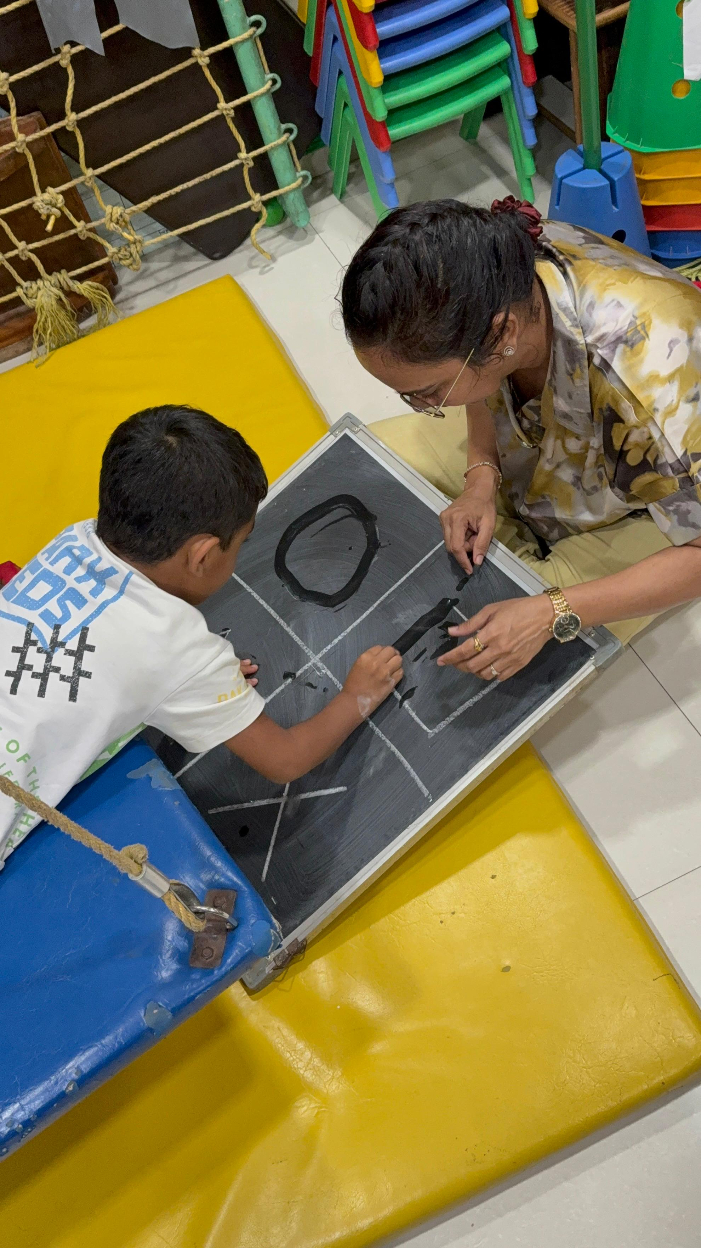

What Is It?
Double Doodle Play® is a joyful Brain Gym® activity where children draw simultaneously with both hands. It looks like art. It feels like play. Underneath, it gently supports bilateral coordination, relaxed grip, eye teaming, and the kind of whole-brain integration that reading and writing depend on. No perfection required — scribbles welcome.

What Parents May Notice
•A child who usually avoids paper tasks actually enjoying drawing
•Looser shoulders and less white-knuckle pencil grip
•Smoother eye movement when reading or copying from the board
•More willingness to try writing after doodling warm-ups

How This Helps
✓Encourages both hemispheres of the brain to communicate
✓Reduces tension in hands, shoulders, and jaw during fine motor work
✓Supports visual-motor skills needed for handwriting
✓Offers a low-pressure entry point for children who fear 'getting it wrong'

Areas Commonly Supported

Learn More

What Double Doodle Play looks like

Who benefits most

Using it at home

Questions Parents Ask

What is Double Doodle Play®?

How can Double Doodle Play® help my child?

When should we consider Double Doodle Play® for our child?

When should I seek Occupational Therapy for my child?

What happens next if we book a consultation in Kandivali?

Headings
- Double Doodle Play®
- What Is It?
- What Parents May Notice
- How This Helps
- Areas Commonly Supported
- Learn More
- What Double Doodle Play looks like
- Who benefits most
- Using it at home
- Questions Parents Ask
- What is Double Doodle Play®?
- How can Double Doodle Play® help my child?
- When should we consider Double Doodle Play® for our child?
- When should I seek Occupational Therapy for my child?
- What happens next if we book a consultation in Kandivali?

Forms And CTA Labels
- Home -> /
- Expertise & Approaches -> /en/expertise
- Show more
- What Double Doodle Play looks like
- Who benefits most
- Using it at home
- What is Double Doodle Play®?
- How can Double Doodle Play® help my child?
- When should we consider Double Doodle Play® for our child?
- When should I seek Occupational Therapy for my child?
- What happens next if we book a consultation in Kandivali?
- Book a Consultation -> /en/appointment
- Ask a Question -> /en/contact

JSON-LD / Schema Summary
- Type: BreadcrumbList
- Type: Service | Name: Double Doodle Play®
- Type: FAQPage
- Type: BreadcrumbList

