Handwriting Without Tears® — Pediatric OT Mumbai | Thrive With Sharuja
Locale: en
Route: /en/expertise/handwriting-without-tears
URL: http://127.0.0.1:4327/en/expertise/handwriting-without-tears
Discovery source: expertiseAreas

SEO Metadata
Title: Handwriting Without Tears® — Pediatric OT Mumbai | Thrive With Sharuja
Description: Handwriting Without Tears® in Mumbai & Kandivali. Multisensory handwriting support for children who struggle with legibility, speed, or pain.
Keywords: Pediatric Occupational Therapist Mumbai,OT Kandivali,Brain Gym Mumbai,Aquatic Therapy Mumbai,Sensory Integration Mumbai,Autism Support Mumbai,ADHD Support Mumbai,pediatric occupational therapy Mumbai,occupational therapist Kandivali West,child development therapy Mumbai,Handwriting Without Tears® Mumbai,Handwriting Without Tears® Kandivali
Canonical: https://drsharujasarap.vercel.app/en/expertise/handwriting-without-tears
Open Graph Title: Handwriting Without Tears® — Pediatric OT Mumbai | Thrive With Sharuja
Open Graph Description: Handwriting Without Tears® in Mumbai & Kandivali. Multisensory handwriting support for children who struggle with legibility, speed, or pain.

Page Content With Media Placement
Home
Expertise & Approaches
Handwriting Without Tears®

Handwriting Without Tears®
Writing that works for school — without the daily battles.
Image: Alt: Therapist-guided handwriting and fine motor practice on a chalkboard | Section: Handwriting Without Tears® | Source: /images/equipment/fine-motor.jpg
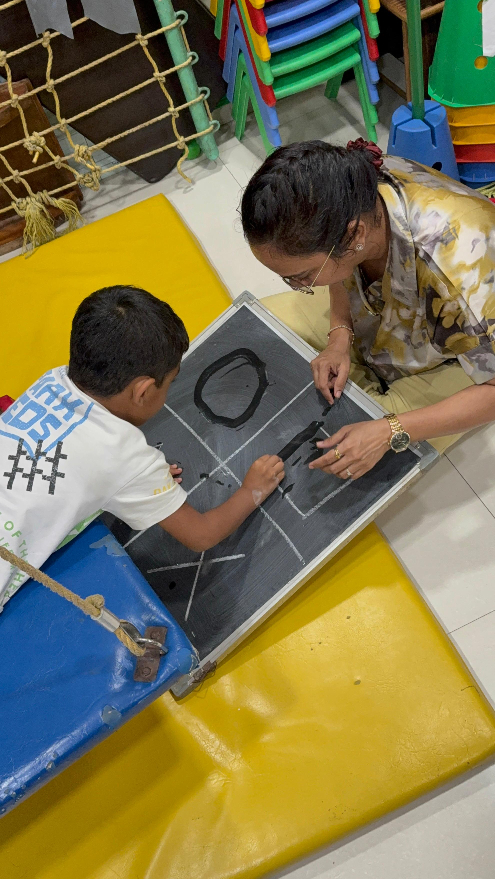

What Is It?
Handwriting Without Tears® (HWT) is a step-by-step, multisensory programme that teaches letter formation through play — wood pieces, wet-dry-try, music, and movement — not endless lined-paper copying. Messy writing is rarely laziness. Often it's weak grip, poor posture, visual-motor gaps, or a body that isn't ready to sit and write. HWT meets children where they are and builds confidence one letter at a time.

What Parents May Notice
•Refusal of written homework or journal tasks
•Complaints of sore hands or tired arms
•Writing so messy that teachers can't read it
•Incomplete tests because writing takes too long

How This Helps
✓Teaches letters in a developmental, logical sequence
✓Uses multisensory tools before pencil-on-paper pressure
✓Addresses grip, posture, and visual-motor skills together
✓Builds speed and endurance gradually — not overnight

Areas Commonly Supported

Learn More

Certified HWT approach

More than handwriting practice

School collaboration

Questions Parents Ask

What is Handwriting Without Tears®?

How can Handwriting Without Tears® help my child?

When should we consider Handwriting Without Tears® for our child?

When should I seek Occupational Therapy for my child?

What happens next if we book a consultation in Kandivali?

Headings
- Handwriting Without Tears®
- What Is It?
- What Parents May Notice
- How This Helps
- Areas Commonly Supported
- Learn More
- Certified HWT approach
- More than handwriting practice
- School collaboration
- Questions Parents Ask
- What is Handwriting Without Tears®?
- How can Handwriting Without Tears® help my child?
- When should we consider Handwriting Without Tears® for our child?
- When should I seek Occupational Therapy for my child?
- What happens next if we book a consultation in Kandivali?

Forms And CTA Labels
- Home -> /
- Expertise & Approaches -> /en/expertise
- Show more
- Certified HWT approach
- More than handwriting practice
- School collaboration
- What is Handwriting Without Tears®?
- How can Handwriting Without Tears® help my child?
- When should we consider Handwriting Without Tears® for our child?
- When should I seek Occupational Therapy for my child?
- What happens next if we book a consultation in Kandivali?
- Book a Consultation -> /en/appointment
- Ask a Question -> /en/contact

JSON-LD / Schema Summary
- Type: BreadcrumbList
- Type: Service | Name: Handwriting Without Tears®
- Type: FAQPage
- Type: BreadcrumbList

