Looking Beyond a Diagnosis — Pediatric OT Mumbai | Thrive With Sharuja
Locale: en
Route: /en/expertise/looking-beyond-a-diagnosis
URL: http://127.0.0.1:4327/en/expertise/looking-beyond-a-diagnosis
Discovery source: expertiseAreas

SEO Metadata
Title: Looking Beyond a Diagnosis — Pediatric OT Mumbai | Thrive With Sharuja
Description: Pediatric OT in Kandivali that sees the whole child — not just a diagnosis. Warm, family-centred care with Dr. Sharuja Sarap for children in Mumbai.
Keywords: Pediatric Occupational Therapist Mumbai,OT Kandivali,Brain Gym Mumbai,Aquatic Therapy Mumbai,Sensory Integration Mumbai,Autism Support Mumbai,ADHD Support Mumbai,pediatric occupational therapy Mumbai,occupational therapist Kandivali West,child development therapy Mumbai,Looking Beyond a Diagnosis Mumbai,Looking Beyond a Diagnosis Kandivali
Canonical: https://drsharujasarap.vercel.app/en/expertise/looking-beyond-a-diagnosis
Open Graph Title: Looking Beyond a Diagnosis — Pediatric OT Mumbai | Thrive With Sharuja
Open Graph Description: Pediatric OT in Kandivali that sees the whole child — not just a diagnosis. Warm, family-centred care with Dr. Sharuja Sarap for children in Mumbai.

Page Content With Media Placement
Home
Expertise & Approaches
Looking Beyond a Diagnosis

Looking Beyond a Diagnosis
Your child is more than a label on a report.
Image: Alt: Dr. Sharuja supporting a child in the sensory gym during a pediatric therapy session | Section: Looking Beyond a Diagnosis | Source: /images/therapy/guided-swing-support.jpg
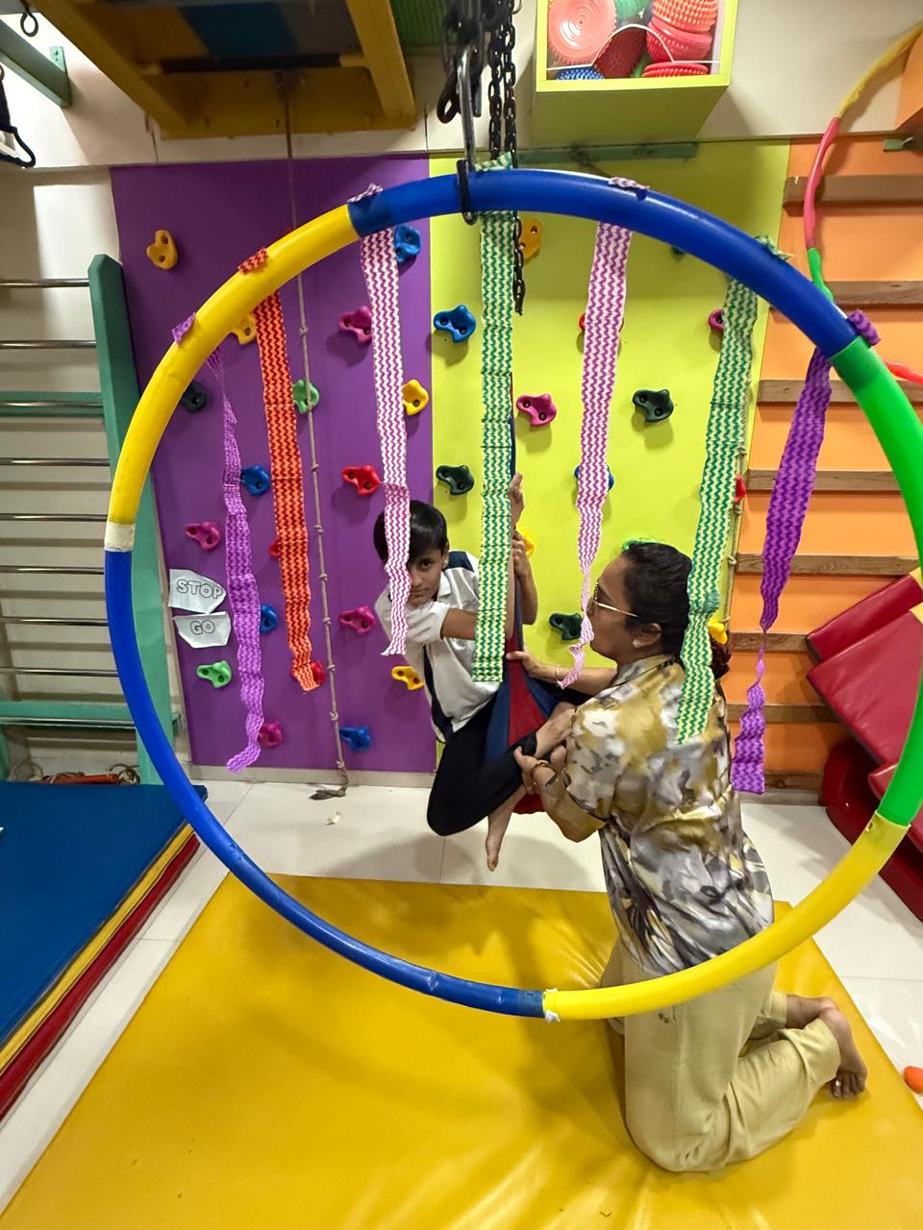

What Is It?
A diagnosis can open doors — to school support, to understanding, to a sense of direction. But it can also feel heavy. Parents sometimes arrive carrying a folder of reports and a heart full of worry, wondering if that's all anyone will see. Here, we start with your child as a whole person: what they love, what frustrates them, what a good day looks like, and what makes them light up. The label may guide us. It never defines them.

What Parents May Notice
•Relief when someone asks about strengths, not just struggles
•Therapy goals that match real life — mornings, meals, playtime — not just clinic tasks
•Less pressure to 'fix' everything at once
•Honest conversations without medical jargon

How This Helps
✓Builds therapy around what matters to your family right now
✓Reduces shame — for children and parents alike
✓Connects clinic work to home, school, and community
✓Uses diagnosis as one piece of a bigger picture

Areas Commonly Supported

Learn More

What this looks like in practice

With or without a diagnosis

Working with schools and doctors

Questions Parents Ask

What is Looking Beyond a Diagnosis?

How can Looking Beyond a Diagnosis help my child?

When should we consider Looking Beyond a Diagnosis for our child?

When should I seek Occupational Therapy for my child?

What happens next if we book a consultation in Kandivali?

Headings
- Looking Beyond a Diagnosis
- What Is It?
- What Parents May Notice
- How This Helps
- Areas Commonly Supported
- Learn More
- What this looks like in practice
- With or without a diagnosis
- Working with schools and doctors
- Questions Parents Ask
- What is Looking Beyond a Diagnosis?
- How can Looking Beyond a Diagnosis help my child?
- When should we consider Looking Beyond a Diagnosis for our child?
- When should I seek Occupational Therapy for my child?
- What happens next if we book a consultation in Kandivali?

Forms And CTA Labels
- Home -> /
- Expertise & Approaches -> /en/expertise
- Show more
- What this looks like in practice
- With or without a diagnosis
- Working with schools and doctors
- What is Looking Beyond a Diagnosis?
- How can Looking Beyond a Diagnosis help my child?
- When should we consider Looking Beyond a Diagnosis for our child?
- When should I seek Occupational Therapy for my child?
- What happens next if we book a consultation in Kandivali?
- Book a Consultation -> /en/appointment
- Ask a Question -> /en/contact

JSON-LD / Schema Summary
- Type: BreadcrumbList
- Type: Service | Name: Looking Beyond a Diagnosis
- Type: FAQPage
- Type: BreadcrumbList

