MNRI® — Pediatric OT Mumbai | Thrive With Sharuja
Locale: en
Route: /en/expertise/mnri
URL: http://127.0.0.1:4327/en/expertise/mnri
Discovery source: expertiseAreas

SEO Metadata
Title: MNRI® — Pediatric OT Mumbai | Thrive With Sharuja
Description: MNRI® reflex integration for children in Kandivali. Foundational nervous system support for movement, regulation, and learning with Dr. Sharuja Sarap.
Keywords: Pediatric Occupational Therapist Mumbai,OT Kandivali,Brain Gym Mumbai,Aquatic Therapy Mumbai,Sensory Integration Mumbai,Autism Support Mumbai,ADHD Support Mumbai,pediatric occupational therapy Mumbai,occupational therapist Kandivali West,child development therapy Mumbai,MNRI® Mumbai,MNRI® Kandivali
Canonical: https://drsharujasarap.vercel.app/en/expertise/mnri
Open Graph Title: MNRI® — Pediatric OT Mumbai | Thrive With Sharuja
Open Graph Description: MNRI® reflex integration for children in Kandivali. Foundational nervous system support for movement, regulation, and learning with Dr. Sharuja Sarap.

Page Content With Media Placement
Home
Expertise & Approaches
MNRI®

MNRI®
When the nervous system needs a stronger foundation first.
Image: Alt: Child using sensory gym equipment with therapist support for movement foundations | Section: MNRI® | Source: /images/therapy-rooms/sensory-gym.jpg
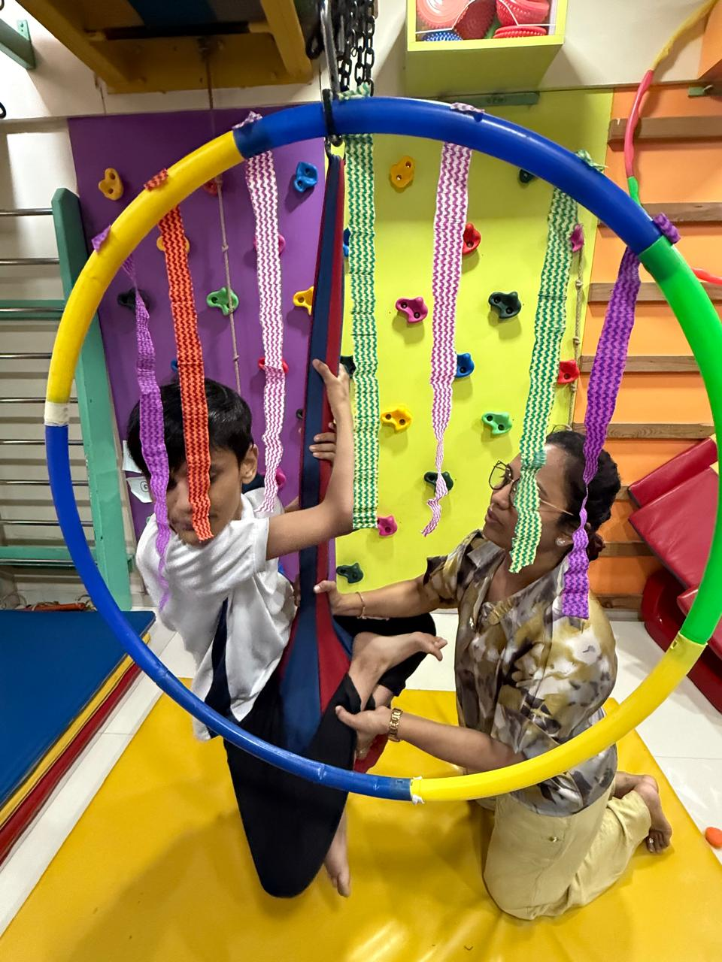

What Is It?
Masgutova Neurosensorimotor Reflex Integration (MNRI®) addresses early reflex patterns that sometimes remain active longer than expected — affecting posture, coordination, emotional regulation, and learning readiness. If skills feel 'almost there' but never quite click, the foundation may need attention first. MNRI uses specialised, respectful protocols within warm, playful sessions — never forceful, always paced to your child.

What Parents May Notice
•Coordination that improves briefly then slips back
•Big emotional reactions disproportionate to the situation
•Difficulty with bike riding, swimming, or complex motor tasks
•Learning challenges that haven't shifted with tutoring alone

How This Helps
✓Integrates retained reflexes that block higher-level skills
✓Strengthens nervous system regulation and resilience
✓Supports motor planning for complex physical tasks
✓Builds readiness for reading, writing, and classroom demands

Areas Commonly Supported

Learn More

What are primitive reflexes?

MNRI vs. RMTI

Gradual, cumulative progress

Questions Parents Ask

What is MNRI®?

How can MNRI® help my child?

When should we consider MNRI® for our child?

When should I seek Occupational Therapy for my child?

What happens next if we book a consultation in Kandivali?

Headings
- MNRI®
- What Is It?
- What Parents May Notice
- How This Helps
- Areas Commonly Supported
- Learn More
- What are primitive reflexes?
- MNRI vs. RMTI
- Gradual, cumulative progress
- Questions Parents Ask
- What is MNRI®?
- How can MNRI® help my child?
- When should we consider MNRI® for our child?
- When should I seek Occupational Therapy for my child?
- What happens next if we book a consultation in Kandivali?

Forms And CTA Labels
- Home -> /
- Expertise & Approaches -> /en/expertise
- Show more
- What are primitive reflexes?
- MNRI vs. RMTI
- Gradual, cumulative progress
- What is MNRI®?
- How can MNRI® help my child?
- When should we consider MNRI® for our child?
- When should I seek Occupational Therapy for my child?
- What happens next if we book a consultation in Kandivali?
- Book a Consultation -> /en/appointment
- Ask a Question -> /en/contact

JSON-LD / Schema Summary
- Type: BreadcrumbList
- Type: Service | Name: MNRI®
- Type: FAQPage
- Type: BreadcrumbList

