RMTI® — Pediatric OT Mumbai | Thrive With Sharuja
Locale: en
Route: /en/expertise/rmti
URL: http://127.0.0.1:4327/en/expertise/rmti
Discovery source: expertiseAreas

SEO Metadata
Title: RMTI® — Pediatric OT Mumbai | Thrive With Sharuja
Description: RMTI® rhythmic movement training for children in Kandivali. Gentle reflex integration for posture, focus, and calm with Dr. Sharuja Sarap.
Keywords: Pediatric Occupational Therapist Mumbai,OT Kandivali,Brain Gym Mumbai,Aquatic Therapy Mumbai,Sensory Integration Mumbai,Autism Support Mumbai,ADHD Support Mumbai,pediatric occupational therapy Mumbai,occupational therapist Kandivali West,child development therapy Mumbai,RMTI® Mumbai,RMTI® Kandivali
Canonical: https://drsharujasarap.vercel.app/en/expertise/rmti
Open Graph Title: RMTI® — Pediatric OT Mumbai | Thrive With Sharuja
Open Graph Description: RMTI® rhythmic movement training for children in Kandivali. Gentle reflex integration for posture, focus, and calm with Dr. Sharuja Sarap.

Page Content With Media Placement
Home
Expertise & Approaches
RMTI®

RMTI®
Gentle rhythmic movement for a steadier body and mind.
Image: Alt: Child using sensory gym equipment with therapist support for movement and regulation | Section: RMTI® | Source: /images/therapy-rooms/sensory-gym.jpg
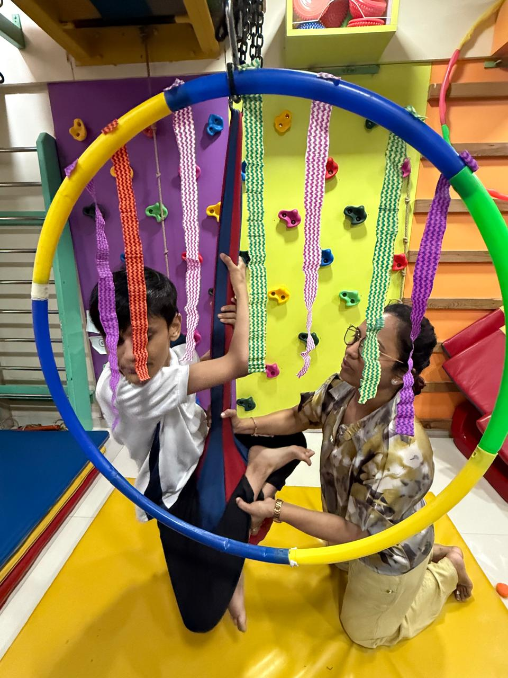

What Is It?
Rhythmic Movement Training Integration (RMTI®) uses soothing, innate movements — like those babies make naturally — to support how the brain and body organise themselves. Some children carry early reflex patterns longer than expected, which can show up as poor posture, clumsiness, anxiety, or difficulty sitting still. RMTI is never forceful. It's rhythmic, calming, and often done with a parent close by.

What Parents May Notice
•A child who slumps, fidgets, or tires quickly during seated work
•Clumsiness that doesn't match their intelligence
•Big emotional reactions to small changes
•Difficulty with reading, writing, or copying from the board

How This Helps
✓Supports integration of early movement patterns
✓Improves postural stability for desk work and play
✓Calms the nervous system through rhythmic input
✓Builds foundations for attention and learning readiness

Areas Commonly Supported

Learn More

What RMTI sessions look like

From infancy through school age

RMTI and other therapies

Questions Parents Ask

What is RMTI®?

How can RMTI® help my child?

When should we consider RMTI® for our child?

When should I seek Occupational Therapy for my child?

What happens next if we book a consultation in Kandivali?

Headings
- RMTI®
- What Is It?
- What Parents May Notice
- How This Helps
- Areas Commonly Supported
- Learn More
- What RMTI sessions look like
- From infancy through school age
- RMTI and other therapies
- Questions Parents Ask
- What is RMTI®?
- How can RMTI® help my child?
- When should we consider RMTI® for our child?
- When should I seek Occupational Therapy for my child?
- What happens next if we book a consultation in Kandivali?

Forms And CTA Labels
- Home -> /
- Expertise & Approaches -> /en/expertise
- Show more
- What RMTI sessions look like
- From infancy through school age
- RMTI and other therapies
- What is RMTI®?
- How can RMTI® help my child?
- When should we consider RMTI® for our child?
- When should I seek Occupational Therapy for my child?
- What happens next if we book a consultation in Kandivali?
- Book a Consultation -> /en/appointment
- Ask a Question -> /en/contact

JSON-LD / Schema Summary
- Type: BreadcrumbList
- Type: Service | Name: RMTI®
- Type: FAQPage
- Type: BreadcrumbList

