Sensory Integration — Pediatric OT Mumbai | Thrive With Sharuja
Locale: en
Route: /en/expertise/sensory-integration
URL: http://127.0.0.1:4327/en/expertise/sensory-integration
Discovery source: expertiseAreas

SEO Metadata
Title: Sensory Integration — Pediatric OT Mumbai | Thrive With Sharuja
Description: Sensory integration therapy in Mumbai & Kandivali for children who struggle with noise, texture, or overwhelm. Warm OT with Dr. Sharuja Sarap.
Keywords: Pediatric Occupational Therapist Mumbai,OT Kandivali,Brain Gym Mumbai,Aquatic Therapy Mumbai,Sensory Integration Mumbai,Autism Support Mumbai,ADHD Support Mumbai,pediatric occupational therapy Mumbai,occupational therapist Kandivali West,child development therapy Mumbai,Sensory Integration Mumbai,Sensory Integration Kandivali
Canonical: https://drsharujasarap.vercel.app/en/expertise/sensory-integration
Open Graph Title: Sensory Integration — Pediatric OT Mumbai | Thrive With Sharuja
Open Graph Description: Sensory integration therapy in Mumbai & Kandivali for children who struggle with noise, texture, or overwhelm. Warm OT with Dr. Sharuja Sarap.

Page Content With Media Placement
Home
Expertise & Approaches
Sensory Integration

Sensory Integration
When the world feels too loud, too scratchy, or too much.
Image: Alt: Child using colorful tactile stepping pads with therapist support in a sensory therapy room | Section: Sensory Integration | Source: /images/therapy/sensory-pathway.jpg
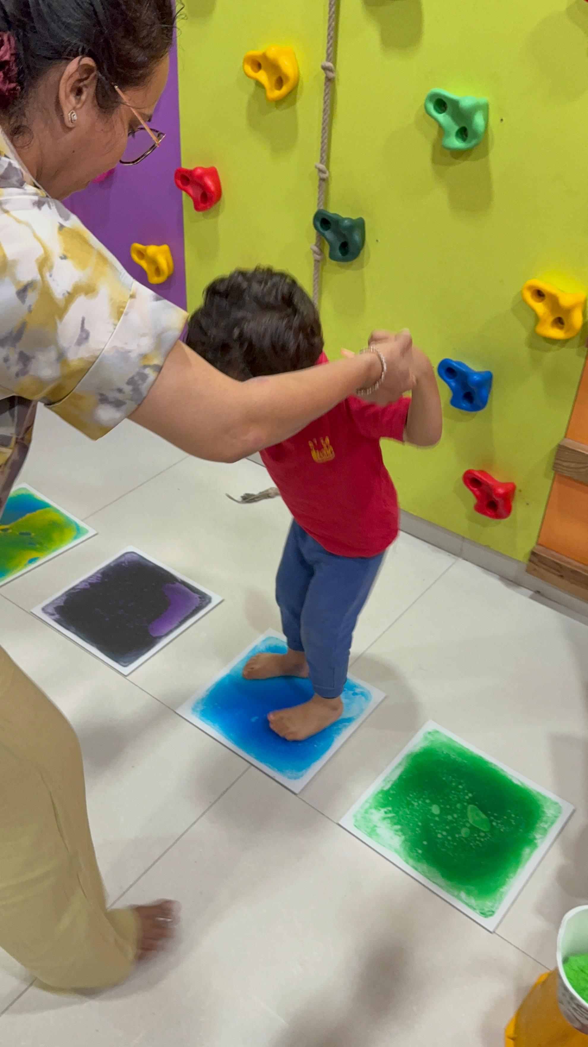

What Is It?
Sensory integration is about how the brain receives and responds to everyday input — touch, sound, movement, taste, and sight. Some children seek more sensation. Some avoid it. Some swing between both in the same afternoon. Neither is misbehaviour. It's a nervous system doing its best. In our sensory-rich gym, we help children explore, regulate, and build skills for calmer participation at home, school, and out in Mumbai's busy world.

What Parents May Notice
•Meltdowns in malls, classrooms, or birthday parties
•Refusal of certain clothes, foods, or haircuts
•Constant movement, crashing, or fidgeting
•Extreme reactions to sounds, lights, or textures

How This Helps
✓Provides safe, guided sensory experiences in a equipped gym
✓Teaches the nervous system to process input more efficiently
✓Builds self-regulation tools children can use outside clinic
✓Reduces fight-or-flight responses to everyday triggers

Areas Commonly Supported

Learn More

Our sensory gym

Ayres-informed approach

Sensory diets for home

Questions Parents Ask

What is Sensory Integration?

How can Sensory Integration help my child?

When should we consider Sensory Integration for our child?

When should I seek Occupational Therapy for my child?

What happens next if we book a consultation in Kandivali?

Headings
- Sensory Integration
- What Is It?
- What Parents May Notice
- How This Helps
- Areas Commonly Supported
- Learn More
- Our sensory gym
- Ayres-informed approach
- Sensory diets for home
- Questions Parents Ask
- What is Sensory Integration?
- How can Sensory Integration help my child?
- When should we consider Sensory Integration for our child?
- When should I seek Occupational Therapy for my child?
- What happens next if we book a consultation in Kandivali?

Forms And CTA Labels
- Home -> /
- Expertise & Approaches -> /en/expertise
- Show more
- Our sensory gym
- Ayres-informed approach
- Sensory diets for home
- What is Sensory Integration?
- How can Sensory Integration help my child?
- When should we consider Sensory Integration for our child?
- When should I seek Occupational Therapy for my child?
- What happens next if we book a consultation in Kandivali?
- Book a Consultation -> /en/appointment
- Ask a Question -> /en/contact

JSON-LD / Schema Summary
- Type: BreadcrumbList
- Type: Service | Name: Sensory Integration
- Type: FAQPage
- Type: BreadcrumbList

