Expertise & Approaches — Pediatric OT Mumbai | Thrive With Sharuja
Locale: en
Route: /en/expertise
URL: http://127.0.0.1:4327/en/expertise
Discovery source: sitemap static route

SEO Metadata
Title: Expertise & Approaches — Pediatric OT Mumbai | Thrive With Sharuja
Description: Eleven certified pediatric OT approaches at Thrive With Sharuja, Kandivali — Brain Gym, sensory integration, aquatic therapy, handwriting, and more.
Keywords: Pediatric Occupational Therapist Mumbai,OT Kandivali,Brain Gym Mumbai,Aquatic Therapy Mumbai,Sensory Integration Mumbai,Autism Support Mumbai,ADHD Support Mumbai,pediatric occupational therapy Mumbai,occupational therapist Kandivali West,child development therapy Mumbai,Pediatric Occupational Therapist Mumbai,OT Kandivali,Brain Gym Mumbai,Aquatic Therapy Mumbai,Sensory Integration Mumbai,Autism Support Mumbai,ADHD Support Mumbai
Canonical: https://drsharujasarap.vercel.app/en/expertise
Open Graph Title: Expertise & Approaches — Pediatric OT Mumbai | Thrive With Sharuja
Open Graph Description: Eleven certified pediatric OT approaches at Thrive With Sharuja, Kandivali — Brain Gym, sensory integration, aquatic therapy, handwriting, and more.

Page Content With Media Placement

How we support growth and participation
Eleven certified programmes — sensory integration, movement, handwriting, feeding, aquatic therapy, and more — woven into plans that fit your child's real life.

Looking Beyond a Diagnosis
Your child is more than a label on a report.
A diagnosis can open doors — to school support, to understanding, to a sense of direction. But it can also feel heavy. Parents sometimes arrive carrying a folder of reports and a heart full of worry, wondering if that's all anyone will see. Here, we start with your child as a whole person: what they love, what frustrates them, what a good day looks like, and what makes them light up. The label may guide us. It never defines them.
✓Builds therapy around what matters to your family right now
✓Reduces shame — for children and parents alike
✓Connects clinic work to home, school, and community
✓Uses diagnosis as one piece of a bigger picture
Image: Alt: Dr. Sharuja guiding handwriting and fine motor practice during a pediatric OT session | Section: Looking Beyond a Diagnosis | Source: /images/therapy/handwriting-practice.jpg
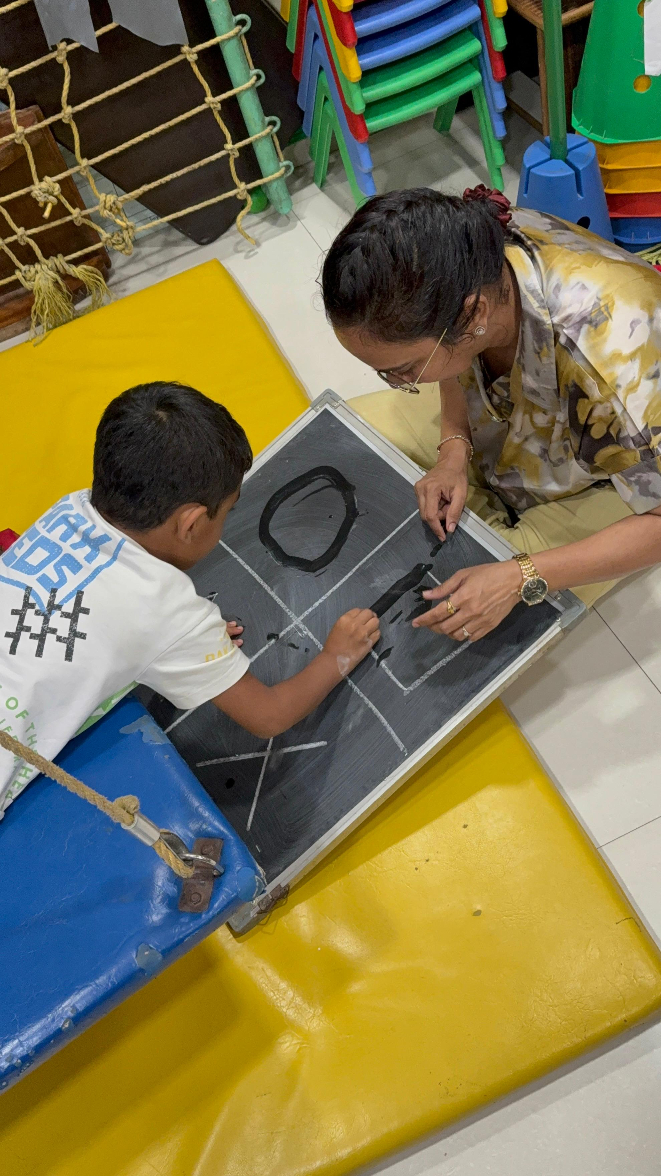

A gentle place to start
You don't need every answer before you reach out. Here's how we think about therapy — in words that make sense at the kitchen table.
Every child is unique. Their therapy journey should be too.
We combine evidence-informed approaches — sensory integration, movement, handwriting, feeding support, and more — into plans that reflect your child's strengths, not just their struggles.
The goal isn't to fix isolated skills on a checklist. It's to help your child participate more comfortably, confidently, and independently in the activities that matter most to your family.

Expertise Ecosystem
Every child is unique. We use a combination of evidence-based approaches to support participation, confidence, independence, and everyday success.
Image: Alt: Therapist-guided sensory swing support in the Thrive With Sharuja gym | Section: Expertise Ecosystem | Source: /images/therapy/guided-swing-support.jpg
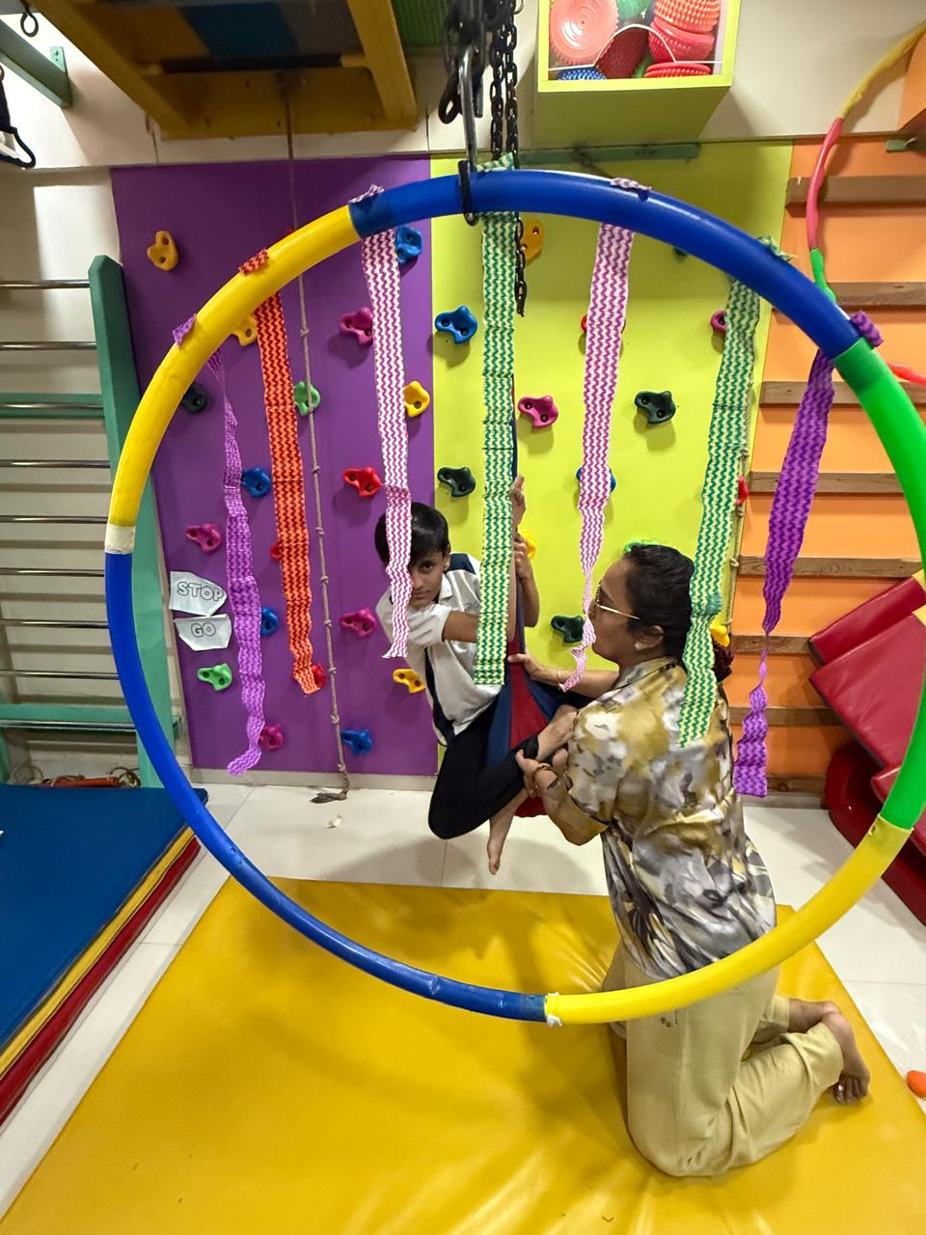

Movement & Motor Development
From crawling and climbing to sitting at a desk and joining playground games — we help children build the strength, coordination, and body awareness that daily life quietly expects. Play-led, never pushy.
Image: Alt: Child using colorful tactile stepping pads in a sensory therapy activity | Section: Movement & Motor Development | Source: /images/therapy/sensory-pathway.jpg
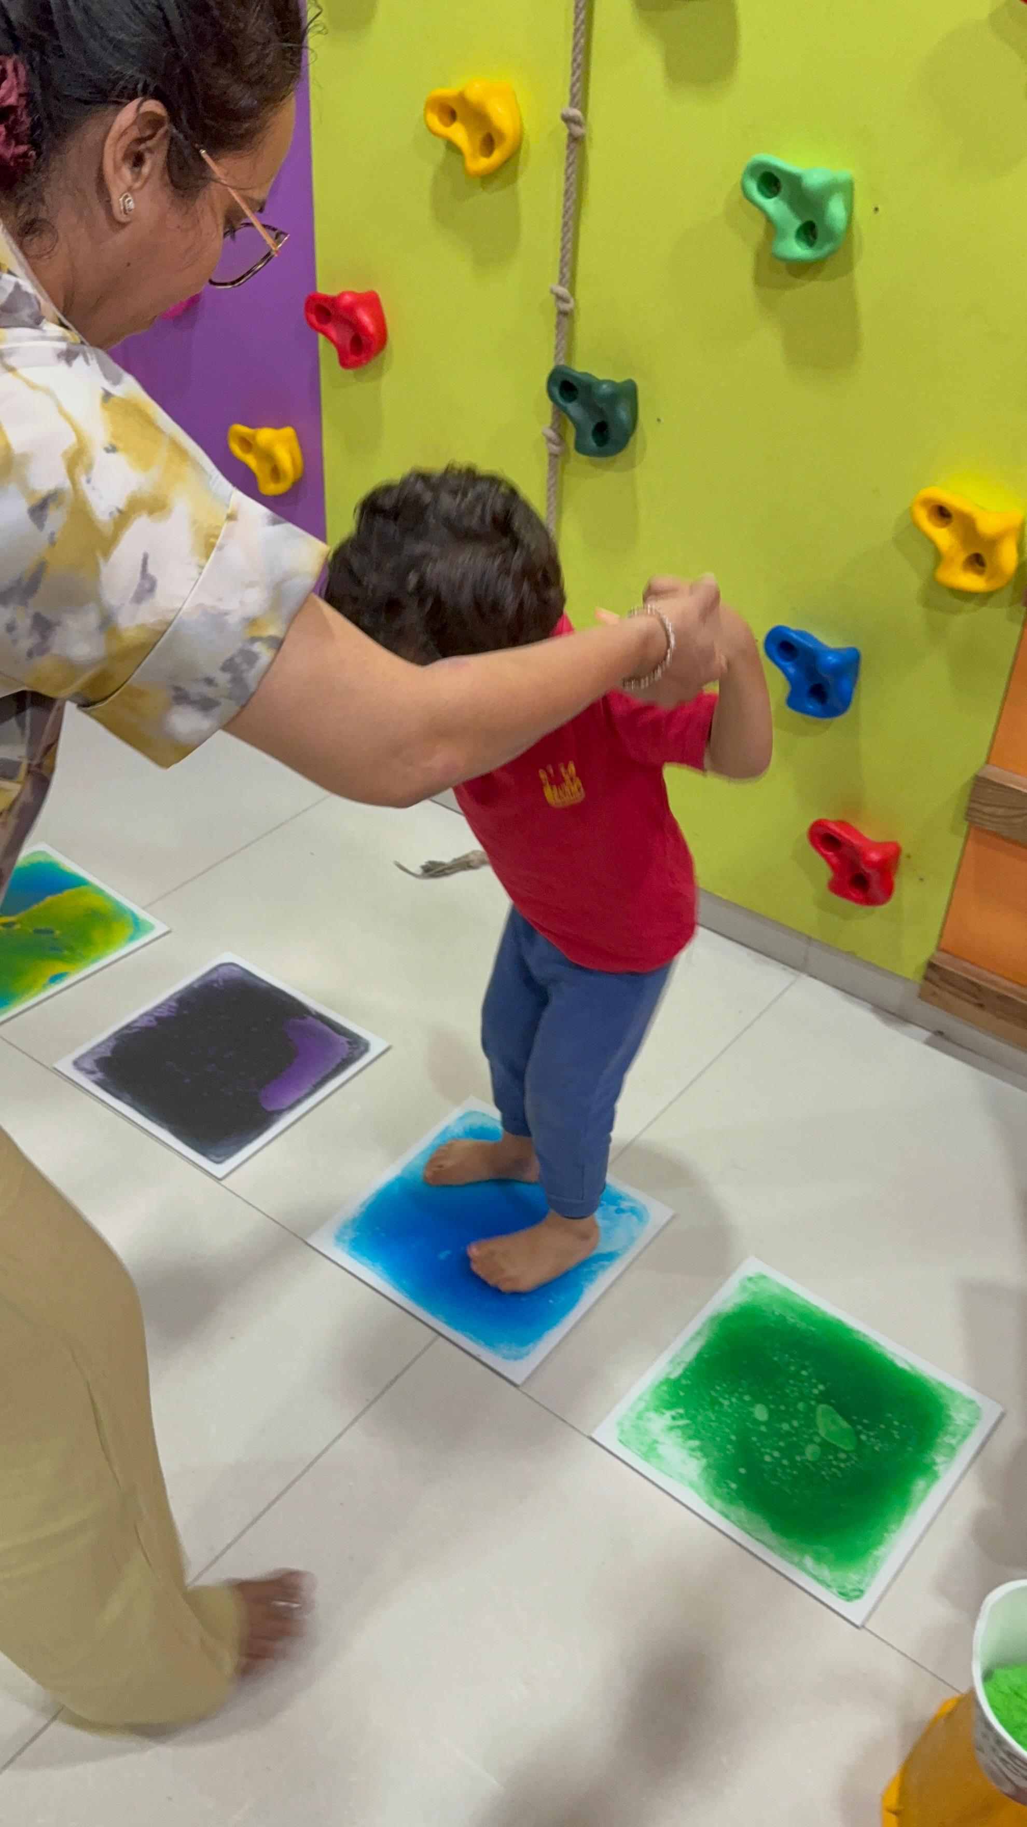

Sensory Processing & Regulation
When the world feels too loud, too scratchy, or too much — we help your child's nervous system find calm. Sensory integration isn't about fixing behaviour. It's about understanding what the body needs to feel safe and ready.

Feeding & Oral Motor Skills
Picky eating, gagging, or mealtime battles aren't always 'behaviour problems.' Often the mouth needs patient, playful preparation. We go at your child's pace — no forcing, no shame — so family meals can feel less stressful.
Image: Alt: Therapist-guided handwriting and fine motor practice on a chalkboard | Section: Feeding & Oral Motor Skills | Source: /images/therapy/handwriting-practice.jpg | Note: Same local image was already embedded earlier in this document.

Handwriting & Learning Readiness
Messy handwriting isn't laziness. Often it's tired hands, weak grip, or a body that isn't ready to sit and write. We build foundations step by step — through play, not endless copying — so school tasks feel more possible.

Aquatic Therapy
In warm water, gravity softens and movement often feels possible for the first time. Children who avoid playgrounds or tire quickly on land frequently shine in the pool — supervised, playful, and always therapeutic.
Image: Alt: Child using sensory gym equipment with therapist support | Section: Aquatic Therapy | Source: /images/therapy-rooms/sensory-gym.jpg
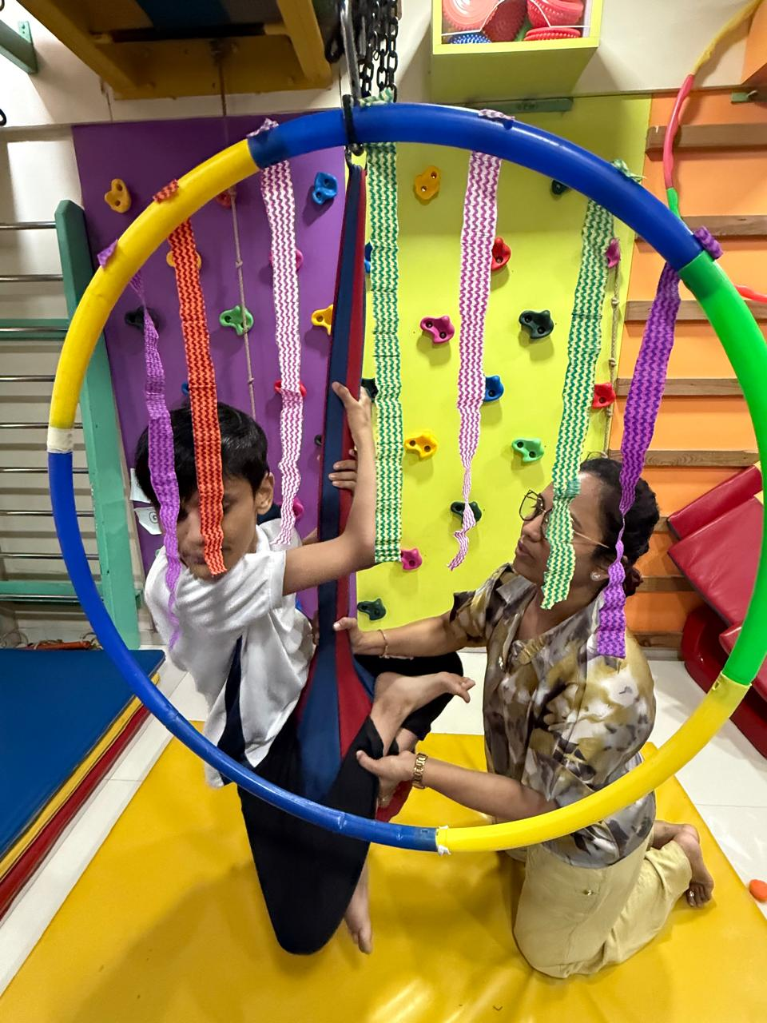

Reflex Integration
Sometimes the body holds onto early reflex patterns that make sitting, writing, and calming down harder than they need to be. RMTI® and MNRI® help rebuild those foundations — gently, respectfully, and always at your child's pace.
Browse by approach

Specialised programmes
Eleven certified approaches — each explained in plain language for families in Kandivali and across Mumbai.

Brain Gym®
Simple movement before seated work can change the whole mood.

Double Doodle Play®
Drawing with both hands — and both sides of the brain.

Sensory Integration
When the world feels too loud, too scratchy, or too much.

RMTI®
Gentle rhythmic movement for a steadier body and mind.

Handwriting Without Tears®
Writing that works for school — without the daily battles.

Oral Placement Therapy®
When mealtimes feel stressful — we start with the mouth, gently.

Aquatic Therapy
Where movement feels lighter — and many children finally relax.

PIASTM
Gentle hands-on relief when tightness gets in the way.

Kinesio Taping®
Subtle support your child can wear during the activities that matter.

MNRI®
When the nervous system needs a stronger foundation first.

KDCT
Very gentle cupping — when muscles hold too much tension.

Headings
- How we support growth and participation
- Looking Beyond a Diagnosis
- A gentle place to start
- Expertise Ecosystem
- Movement & Motor Development
- Sensory Processing & Regulation
- Feeding & Oral Motor Skills
- Handwriting & Learning Readiness
- Aquatic Therapy
- Reflex Integration
- Specialised programmes
- Brain Gym®
- Double Doodle Play®
- Sensory Integration
- RMTI®
- Handwriting Without Tears®
- Oral Placement Therapy®
- PIASTM
- Kinesio Taping®
- MNRI®
- KDCT

Forms And CTA Labels
- Learn more → -> /en/expertise/looking-beyond-a-diagnosis
- Learn More -> /en/expertise/looking-beyond-a-diagnosis
- Learn More -> /en/expertise/sensory-integration
- Learn More -> /en/expertise/oral-placement-therapy
- Learn More -> /en/expertise/handwriting-without-tears
- Learn More -> /en/expertise/aquatic-therapy
- Learn More -> /en/expertise/mnri
- Brain Gym® -> /en/expertise/brain-gym
- Double Doodle Play® -> /en/expertise/double-doodle-play
- Sensory Integration -> /en/expertise/sensory-integration
- RMTI® -> /en/expertise/rmti
- Handwriting Without Tears® -> /en/expertise/handwriting-without-tears
- Oral Placement Therapy® -> /en/expertise/oral-placement-therapy
- Aquatic Therapy -> /en/expertise/aquatic-therapy
- PIASTM -> /en/expertise/piastm
- Kinesio Taping® -> /en/expertise/kinesio-taping
- MNRI® -> /en/expertise/mnri
- KDCT -> /en/expertise/kdct
- Learn more → -> /en/expertise/brain-gym
- Learn more → -> /en/expertise/double-doodle-play
- Learn more → -> /en/expertise/sensory-integration
- Learn more → -> /en/expertise/rmti
- Learn more → -> /en/expertise/handwriting-without-tears
- Learn more → -> /en/expertise/oral-placement-therapy
- Learn more → -> /en/expertise/aquatic-therapy
- Learn more → -> /en/expertise/piastm
- Learn more → -> /en/expertise/kinesio-taping
- Learn more → -> /en/expertise/mnri
- Learn more → -> /en/expertise/kdct
- Book Consultation -> /en/appointment

JSON-LD / Schema Summary
- Type: BreadcrumbList
- Type: LocalBusiness | Name: Thrive With Sharuja

