Clinic Gallery | Thrive With Sharuja
Locale: en
Route: /en/gallery
URL: http://127.0.0.1:4327/en/gallery
Discovery source: sitemap static route

SEO Metadata
Title: Clinic Gallery | Thrive With Sharuja
Description: Tour our child-friendly pediatric OT clinic in Kandivali West, Mumbai.
Keywords: Pediatric Occupational Therapist Mumbai,OT Kandivali,Brain Gym Mumbai,Aquatic Therapy Mumbai,Sensory Integration Mumbai,Autism Support Mumbai,ADHD Support Mumbai,pediatric occupational therapy Mumbai,occupational therapist Kandivali West,child development therapy Mumbai,pediatric therapy clinic Mumbai,OT clinic Kandivali
Canonical: https://drsharujasarap.vercel.app/en/gallery
Open Graph Title: Clinic Gallery | Thrive With Sharuja
Open Graph Description: Tour our child-friendly pediatric OT clinic in Kandivali West, Mumbai.

Page Content With Media Placement

A place where children feel safe to explore
Soft colours, room to move, and corners for quiet when it's all too much.
Clinic moments

A warm look inside therapy at Thrive With Sharuja
Browse real clinic photos as a guided slideshow, then watch short therapy clips with controls whenever you are ready.
Image: Alt: Dr. Sharuja supporting a child on sensory swing equipment inside the pediatric therapy gym | Section: A warm look inside therapy at Thrive With Sharuja | Source: /images/therapy/guided-swing-support.jpg
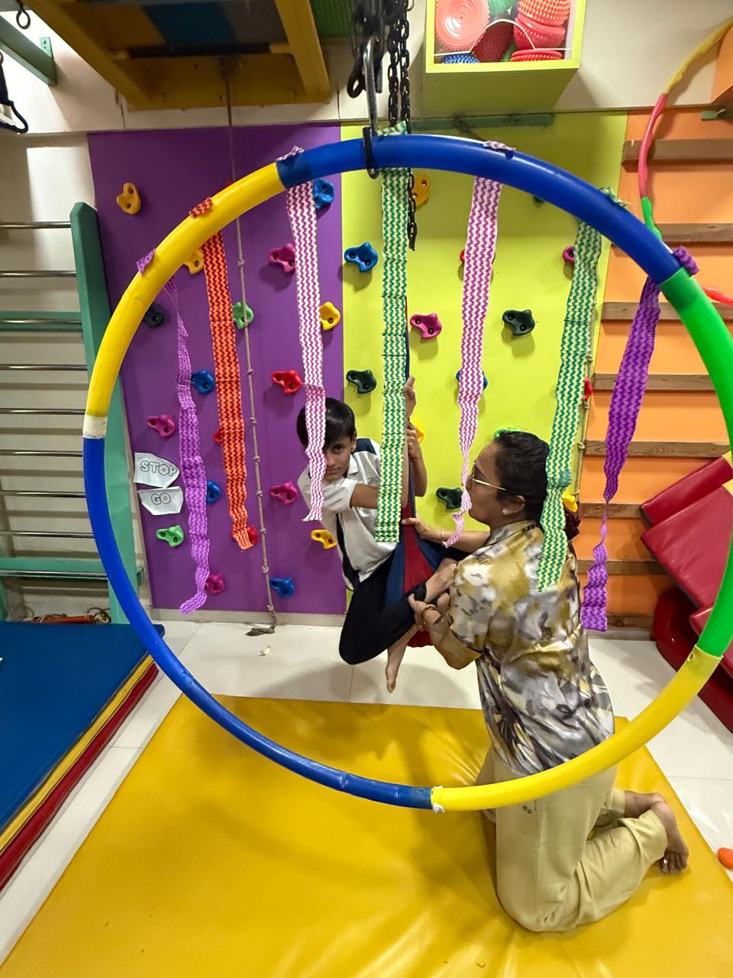
Therapy Room
Guided Swing Support
Photo slideshow

Guided Swing Support
Dr. Sharuja supporting a child on sensory swing equipment inside the pediatric therapy gym

Therapy videos
Short, muted-by-default clips from supervised clinic sessions. Use the video controls to play or pause.

Video
Video Reference: Title: Play clinic video: Handwriting board practice | Caption: Assessment AreaHandwriting board practiceA close look at fine-motor and handwriting readiness work during a guided clinic activity. | Section: Therapy videos | Poster: /images/therapy/handwriting-practice.jpg | Video source: /images/videos/handwriting-board-practice.mp4 | Note: Word export references video files and embeds the poster when available.
Video Poster: Alt: Play clinic video: Handwriting board practice | Caption: Assessment AreaHandwriting board practiceA close look at fine-motor and handwriting readiness work during a guided clinic activity. | Section: Therapy videos | Source: /images/therapy/handwriting-practice.jpg
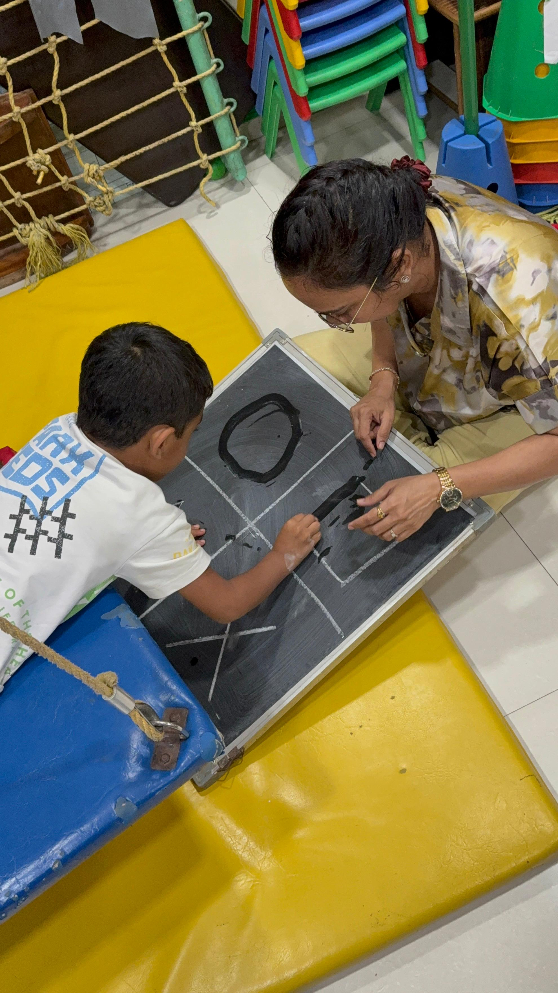
Assessment Area

Handwriting board practice
A close look at fine-motor and handwriting readiness work during a guided clinic activity.

Video
Video Reference: Title: Play clinic video: Sensory pathway guidance | Caption: Child-Friendly EnvironmentSensory pathway guidanceTherapist-supported stepping practice for balance, body awareness, and confidence. | Section: Handwriting board practice | Poster: /images/therapy/sensory-pathway.jpg | Video source: /images/videos/sensory-pathway-guided-play.mp4 | Note: Word export references video files and embeds the poster when available.
Video Poster: Alt: Play clinic video: Sensory pathway guidance | Caption: Child-Friendly EnvironmentSensory pathway guidanceTherapist-supported stepping practice for balance, body awareness, and confidence. | Section: Handwriting board practice | Source: /images/therapy/sensory-pathway.jpg
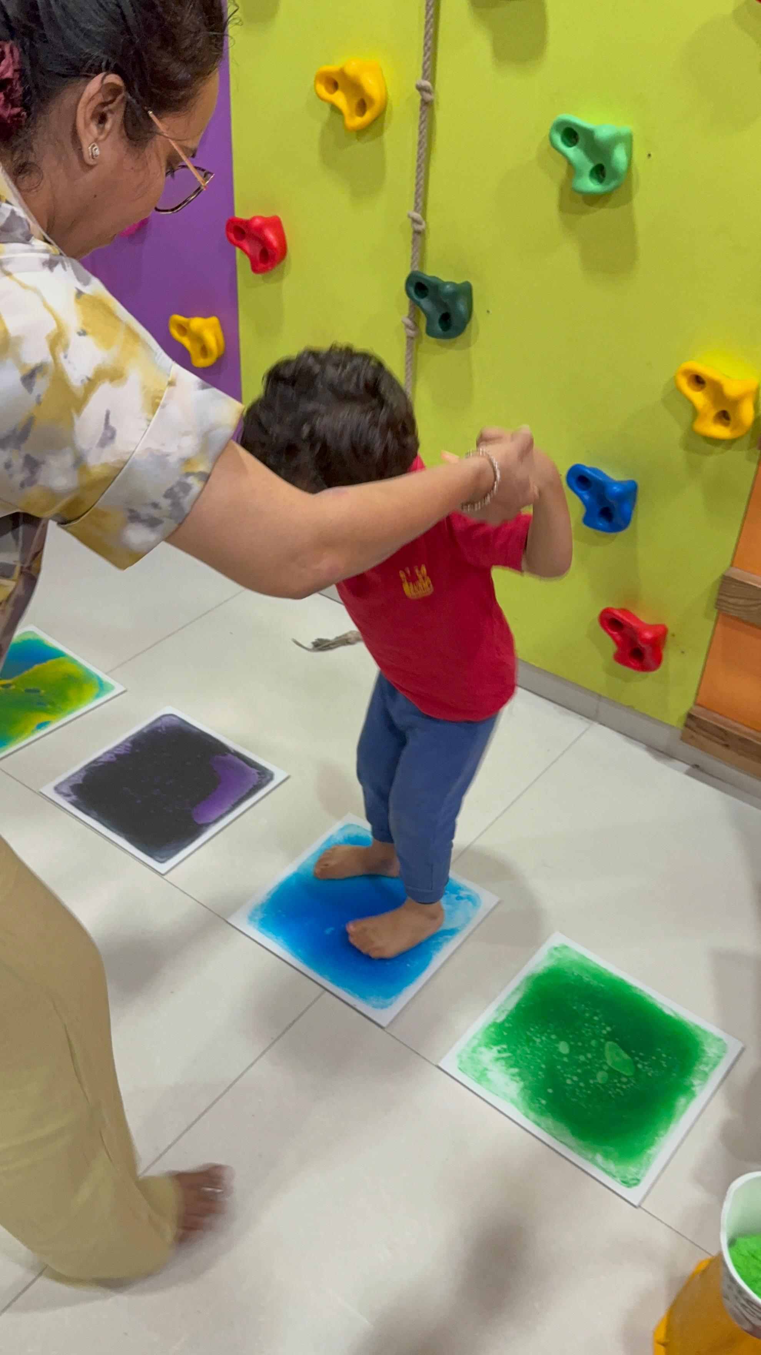
Child-Friendly Environment

Sensory pathway guidance
Therapist-supported stepping practice for balance, body awareness, and confidence.

Video
Video Reference: Title: Play clinic video: Climbing wall balance | Caption: Child-Friendly EnvironmentClimbing wall balanceMovement planning and postural control practice in the colorful sensory gym. | Section: Sensory pathway guidance | Poster: /images/therapy-rooms/climbing-wall.jpg | Video source: /images/videos/climbing-wall-balance-practice.mp4 | Note: Word export references video files and embeds the poster when available.
Video Poster: Alt: Play clinic video: Climbing wall balance | Caption: Child-Friendly EnvironmentClimbing wall balanceMovement planning and postural control practice in the colorful sensory gym. | Section: Sensory pathway guidance | Source: /images/therapy-rooms/climbing-wall.jpg
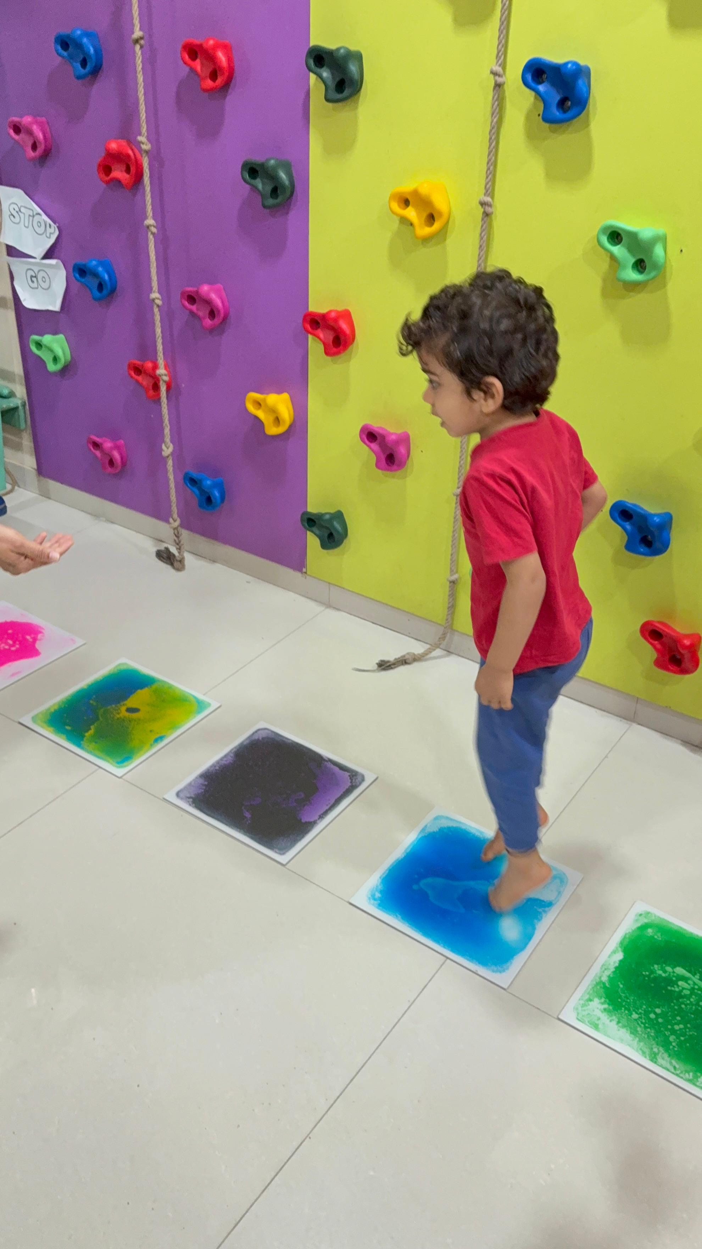
Child-Friendly Environment

Climbing wall balance
Movement planning and postural control practice in the colorful sensory gym.

Video
Video Reference: Title: Play clinic video: Sensory swing session | Caption: Therapy RoomSensory swing sessionSupervised vestibular input in the clinic swing area, shown with native playback controls. | Section: Climbing wall balance | Poster: /images/therapy-rooms/sensory-gym.jpg | Video source: /images/videos/sensory-swing-session.mp4 | Note: Word export references video files and embeds the poster when available.
Video Poster: Alt: Play clinic video: Sensory swing session | Caption: Therapy RoomSensory swing sessionSupervised vestibular input in the clinic swing area, shown with native playback controls. | Section: Climbing wall balance | Source: /images/therapy-rooms/sensory-gym.jpg
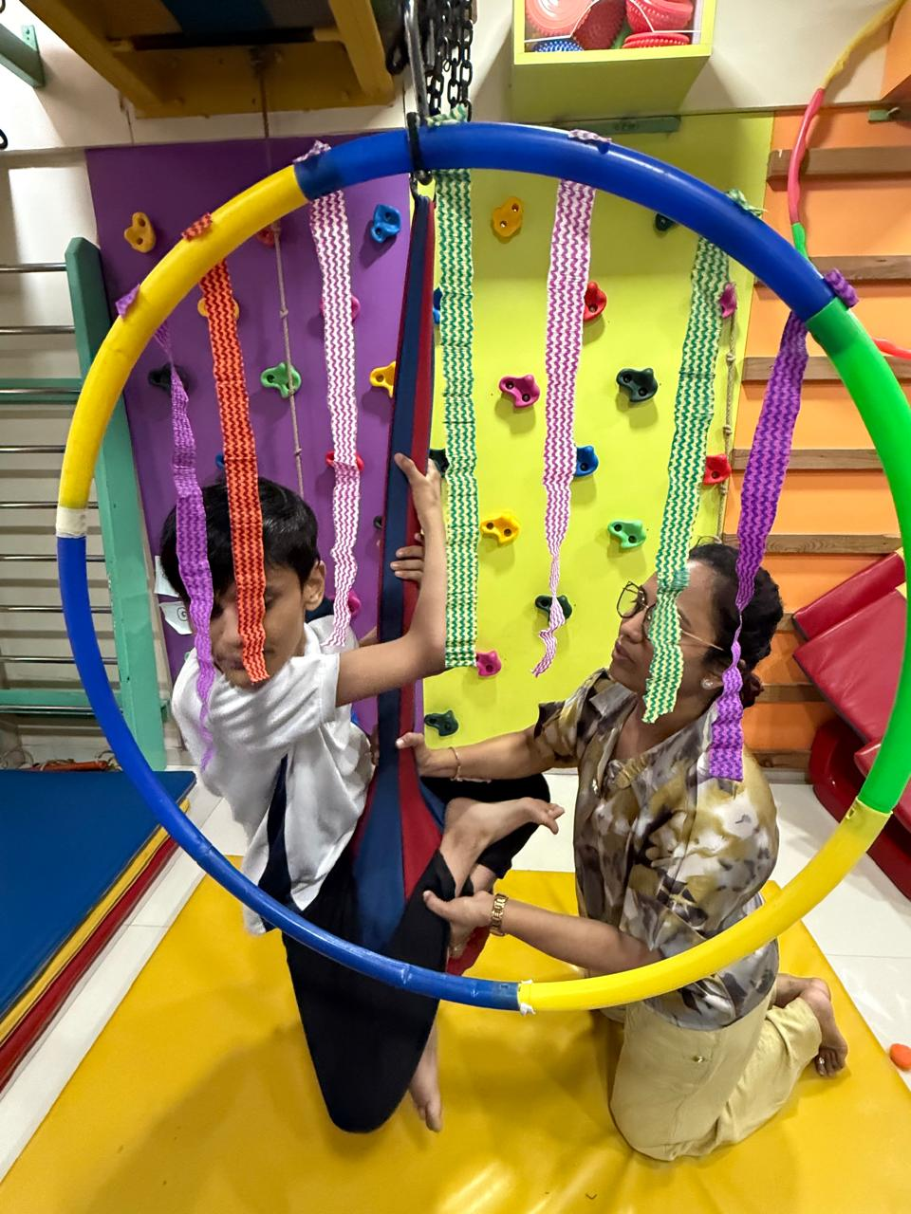
Therapy Room

Sensory swing session
Supervised vestibular input in the clinic swing area, shown with native playback controls.
Image: Alt: Dr. Sharuja supporting a child on sensory swing equipment inside the pediatric therapy gym | Section: Sensory swing session | Source: /images/therapy/guided-swing-support.jpg | Note: Same local image was already embedded earlier in this document.
Therapy Room
Guided Swing Support
Image: Alt: Therapist-guided handwriting and fine motor practice on a chalkboard during pediatric OT | Section: Sensory swing session | Source: /images/equipment/fine-motor.jpg

Assessment Area
Fine Motor Practice
Image: Alt: Child using colorful tactile stepping pads with therapist support in a sensory therapy room | Section: Sensory swing session | Source: /images/therapy/sensory-pathway.jpg | Note: Same local image was already embedded earlier in this document.
Child-Friendly Environment
Sensory Pathway
Image: Alt: Colorful sensory gym equipment including swing supports, climbing holds, and movement tools | Section: Sensory swing session | Source: /images/equipment/sensory-tools.jpg

Therapy Equipment
Sensory Gym Equipment
Image: Alt: Bright pediatric therapy play zone with climbing wall, tactile pads, and child-friendly movement equipment | Section: Sensory swing session | Source: /images/therapy-rooms/climbing-wall.jpg | Note: Same local image was already embedded earlier in this document.
Child-Friendly Environment
Movement Play Zone
Image: Alt: Indoor pediatric sensory gym with a platform swing and colorful climbing equipment for motor development | Section: Sensory swing session | Source: /images/therapy-rooms/sensory-gym.jpg | Note: Same local image was already embedded earlier in this document.
Therapy Room
Sensory Gym
Image: Alt: Child practicing careful stepping on colorful sensory floor pads in the pediatric therapy gym | Section: Sensory swing session | Source: /images/gallery/sensory-pathway-stepping-practice.jpg
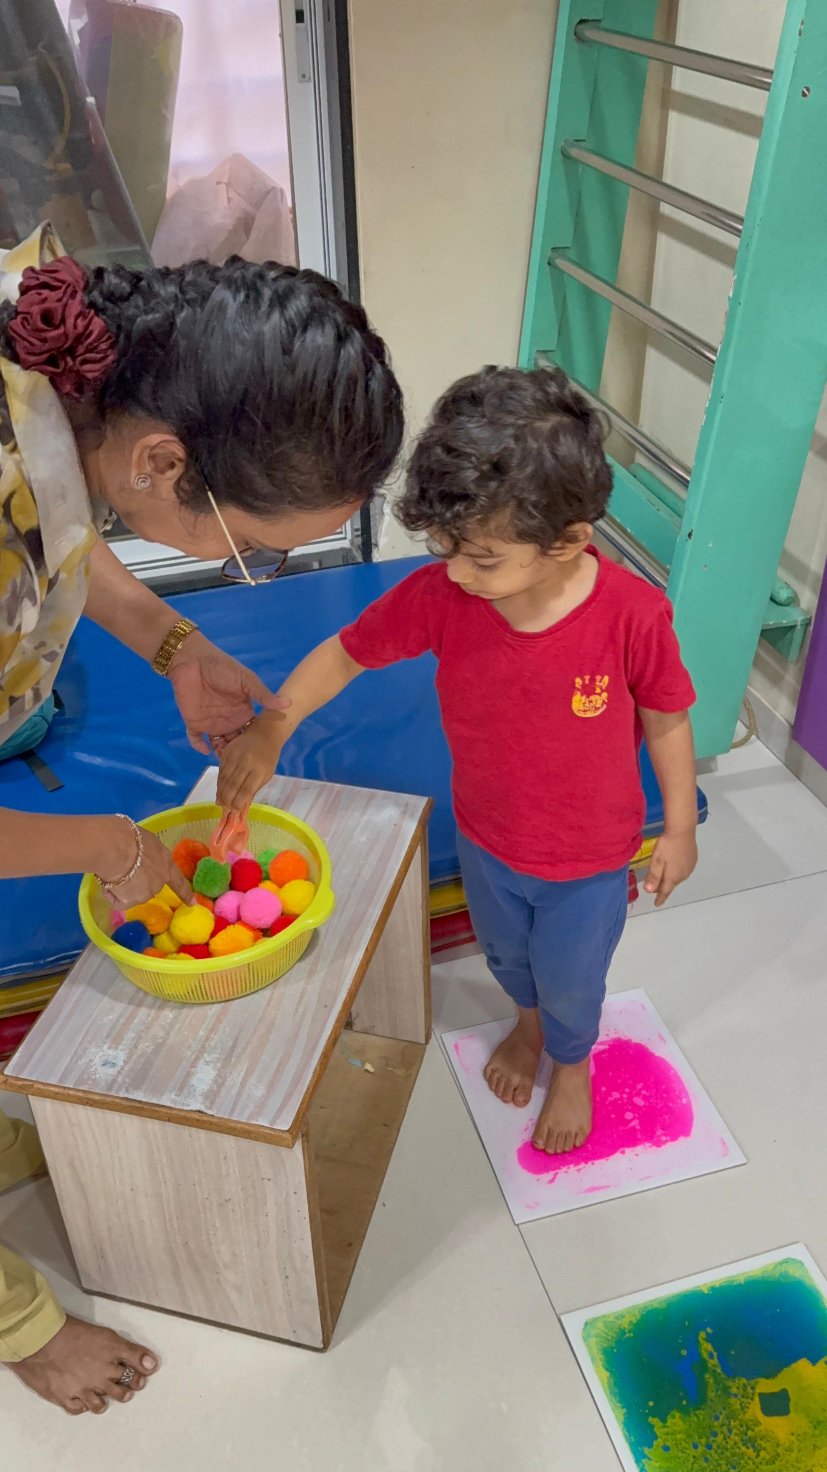
Child-Friendly Environment
Supported Stepping Practice
Image: Alt: Therapist guiding a child through a playful balance and coordination activity with clinic equipment | Section: Sensory swing session | Source: /images/gallery/therapist-guided-balance-play.jpg
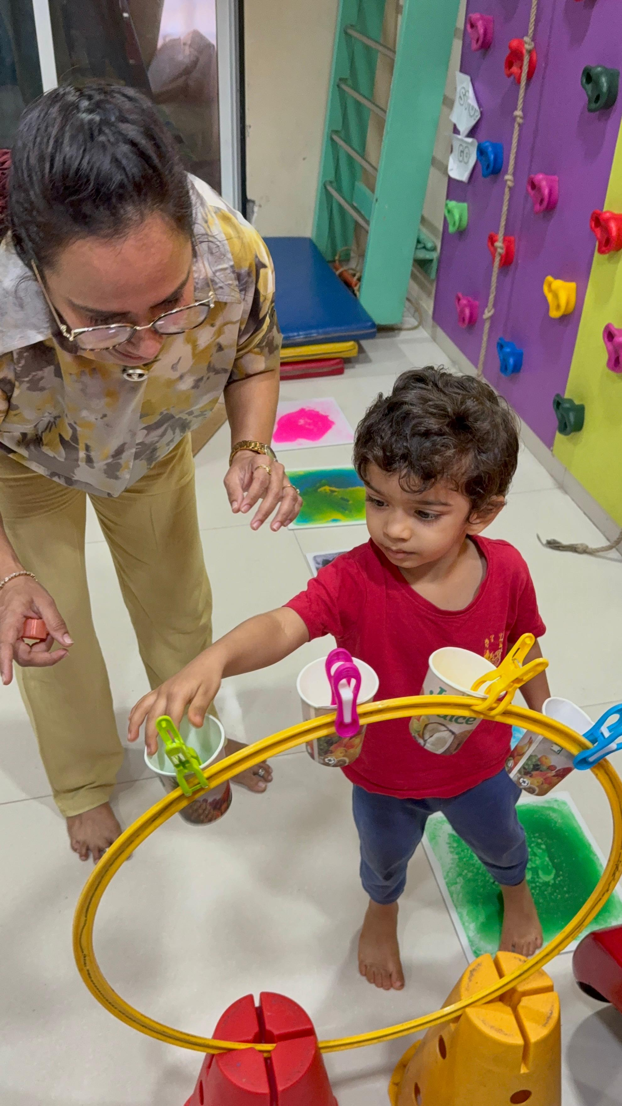
Therapy Equipment
Therapist-Guided Balance Play
Image: Alt: Child practicing movement planning near a colorful climbing wall and sensory stepping pads | Section: Sensory swing session | Source: /images/gallery/climbing-wall-step-practice.jpg
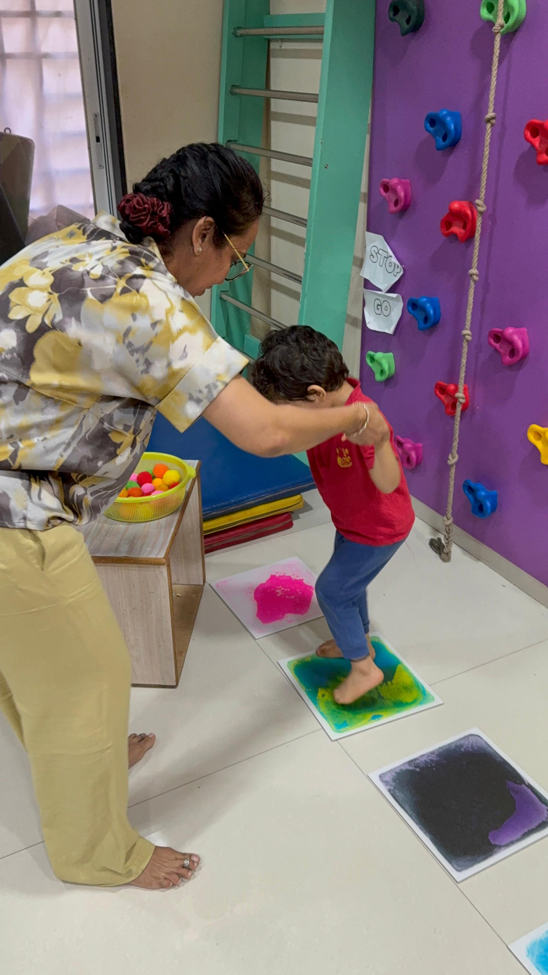
Child-Friendly Environment
Climbing Wall Step Practice
Image: Alt: Child using a ring swing in a supervised pediatric sensory gym session | Section: Sensory swing session | Source: /images/gallery/ring-swing-movement-play.jpg | Note: Referenced because this document already reached the embedded image limit.
Therapy Room
Ring Swing Movement Play
Image: Alt: Therapist supporting a child during a sensory swing activity in the clinic gym | Section: Sensory swing session | Source: /images/gallery/supported-swing-session.jpg | Note: Referenced because this document already reached the embedded image limit.
Therapy Room
Supported Swing Session

Headings
- A place where children feel safe to explore
- A warm look inside therapy at Thrive With Sharuja
- Guided Swing Support
- Therapy videos

Forms And CTA Labels
- Previous photo
- Next photo
- 01Guided Swing Support
- 02Fine Motor Practice
- 03Sensory Pathway
- 04Sensory Gym Equipment
- 05Movement Play Zone
- 06Sensory Gym
- 07Supported Stepping Practice
- 08Therapist-Guided Balance Play
- 09Climbing Wall Step Practice
- 10Ring Swing Movement Play
- 11Supported Swing Session
- All
- Therapy Room
- Assessment Area
- Child-Friendly Environment
- Therapy Equipment
- Therapy RoomGuided Swing Support
- Assessment AreaFine Motor Practice
- Child-Friendly EnvironmentSensory Pathway
- Therapy EquipmentSensory Gym Equipment
- Child-Friendly EnvironmentMovement Play Zone
- Therapy RoomSensory Gym
- Child-Friendly EnvironmentSupported Stepping Practice
- Therapy EquipmentTherapist-Guided Balance Play
- Child-Friendly EnvironmentClimbing Wall Step Practice
- Therapy RoomRing Swing Movement Play
- Therapy RoomSupported Swing Session

