Pediatric Occupational Therapist Mumbai | Thrive With Sharuja
Locale: en
Route: /en
URL: http://127.0.0.1:4327/en
Discovery source: sitemap static route

SEO Metadata
Title: Pediatric Occupational Therapist Mumbai | Thrive With Sharuja
Description: From getting dressed and holding a pencil to joining playtime and making friends — we walk alongside families with warmth, patience, and care.
Keywords: Pediatric Occupational Therapist Mumbai,OT Kandivali,Brain Gym Mumbai,Aquatic Therapy Mumbai,Sensory Integration Mumbai,Autism Support Mumbai,ADHD Support Mumbai,pediatric occupational therapy Mumbai,occupational therapist Kandivali West,child development therapy Mumbai,Pediatric Occupational Therapist Mumbai,OT Kandivali,pediatric OT Kandivali,Dr. Sharuja Sarap occupational therapist
Canonical: https://drsharujasarap.vercel.app/en
Open Graph Title: Pediatric Occupational Therapist Mumbai | Thrive With Sharuja
Open Graph Description: From getting dressed and holding a pencil to joining playtime and making friends — we walk alongside families with warmth, patience, and care.

Page Content With Media Placement

Your child is doing their best. We're here to help the everyday things feel easier.
From getting dressed and holding a pencil to joining playtime and making friends — we walk alongside families with warmth, patience, and care.
Belonging Without Boundaries.
Image: Alt: Dr. Sharuja guiding a child on sensory swing equipment in the Thrive With Sharuja therapy gym | Section: Your child is doing their best. We're here to help the everyday things feel easier. | Source: /images/hero/main.jpg
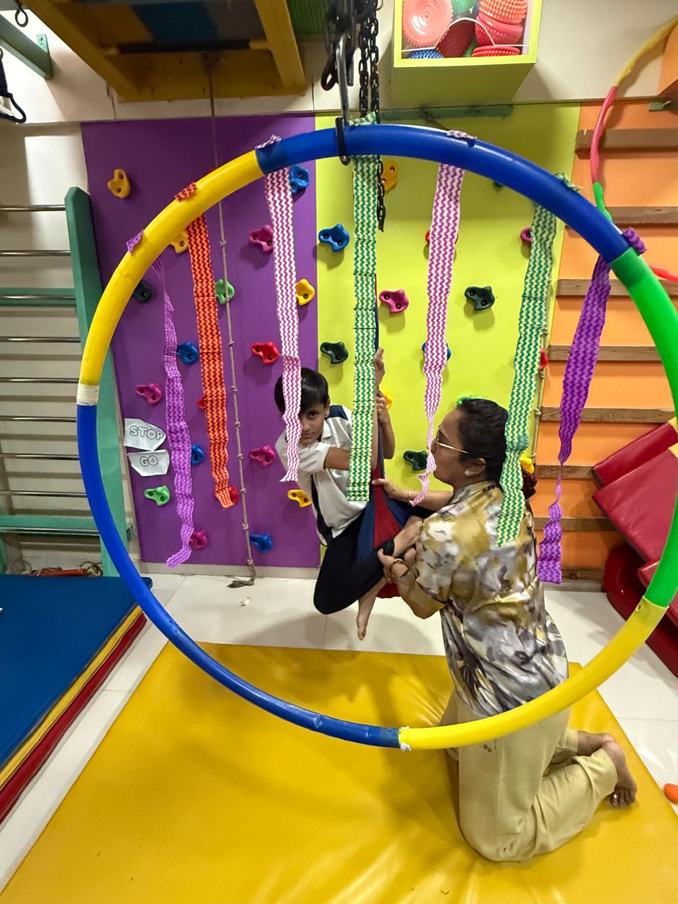
To The Parents Reading This…

You know your child best
Maybe you've been watching little things — a morning that falls apart, homework that takes forever, a child who seems bright but struggles to keep up. Maybe a teacher mentioned something. Maybe you just feel it in your gut.
You don't need to have all the answers before you reach out. You don't need a perfect diagnosis or a clear label. If something feels harder than it should for your child — or for you — that's enough to start a conversation.
We're here to listen first. To meet your child where they are. And to walk with your family, one small step at a time.
Image: Alt: Dr. Sharuja Sarap — Pediatric Occupational Therapist in Kandivali, Mumbai | Section: You know your child best | Source: /images/doctor/portrait.jpg
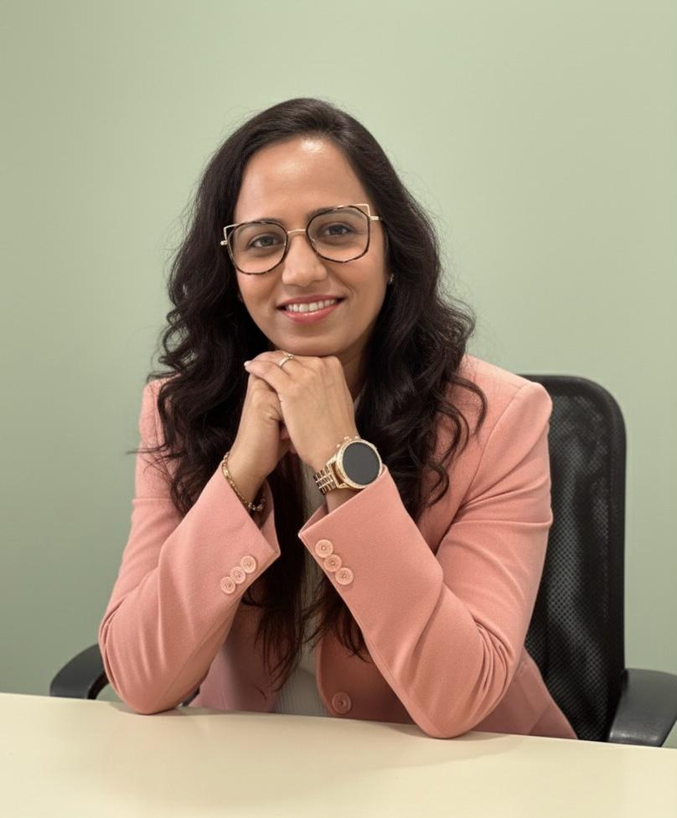
About Dr. Sharuja

Hello, I'm Sharuja.
For over 18 years, I've sat with worried parents and curious children in Kandivali — hearing the stories behind the struggles. I don't rush you. I explain things plainly. And I build therapy around your child, not a checklist.

Expertise Ecosystem
Every child is unique. We use a combination of evidence-based approaches to support participation, confidence, independence, and everyday success.
Image: Alt: Therapist-guided sensory swing support in the Thrive With Sharuja gym | Section: Expertise Ecosystem | Source: /images/therapy/guided-swing-support.jpg


Movement & Motor Development
From crawling and climbing to sitting at a desk and joining playground games — we help children build the strength, coordination, and body awareness that daily life quietly expects. Play-led, never pushy.
Image: Alt: Child using colorful tactile stepping pads in a sensory therapy activity | Section: Movement & Motor Development | Source: /images/therapy/sensory-pathway.jpg
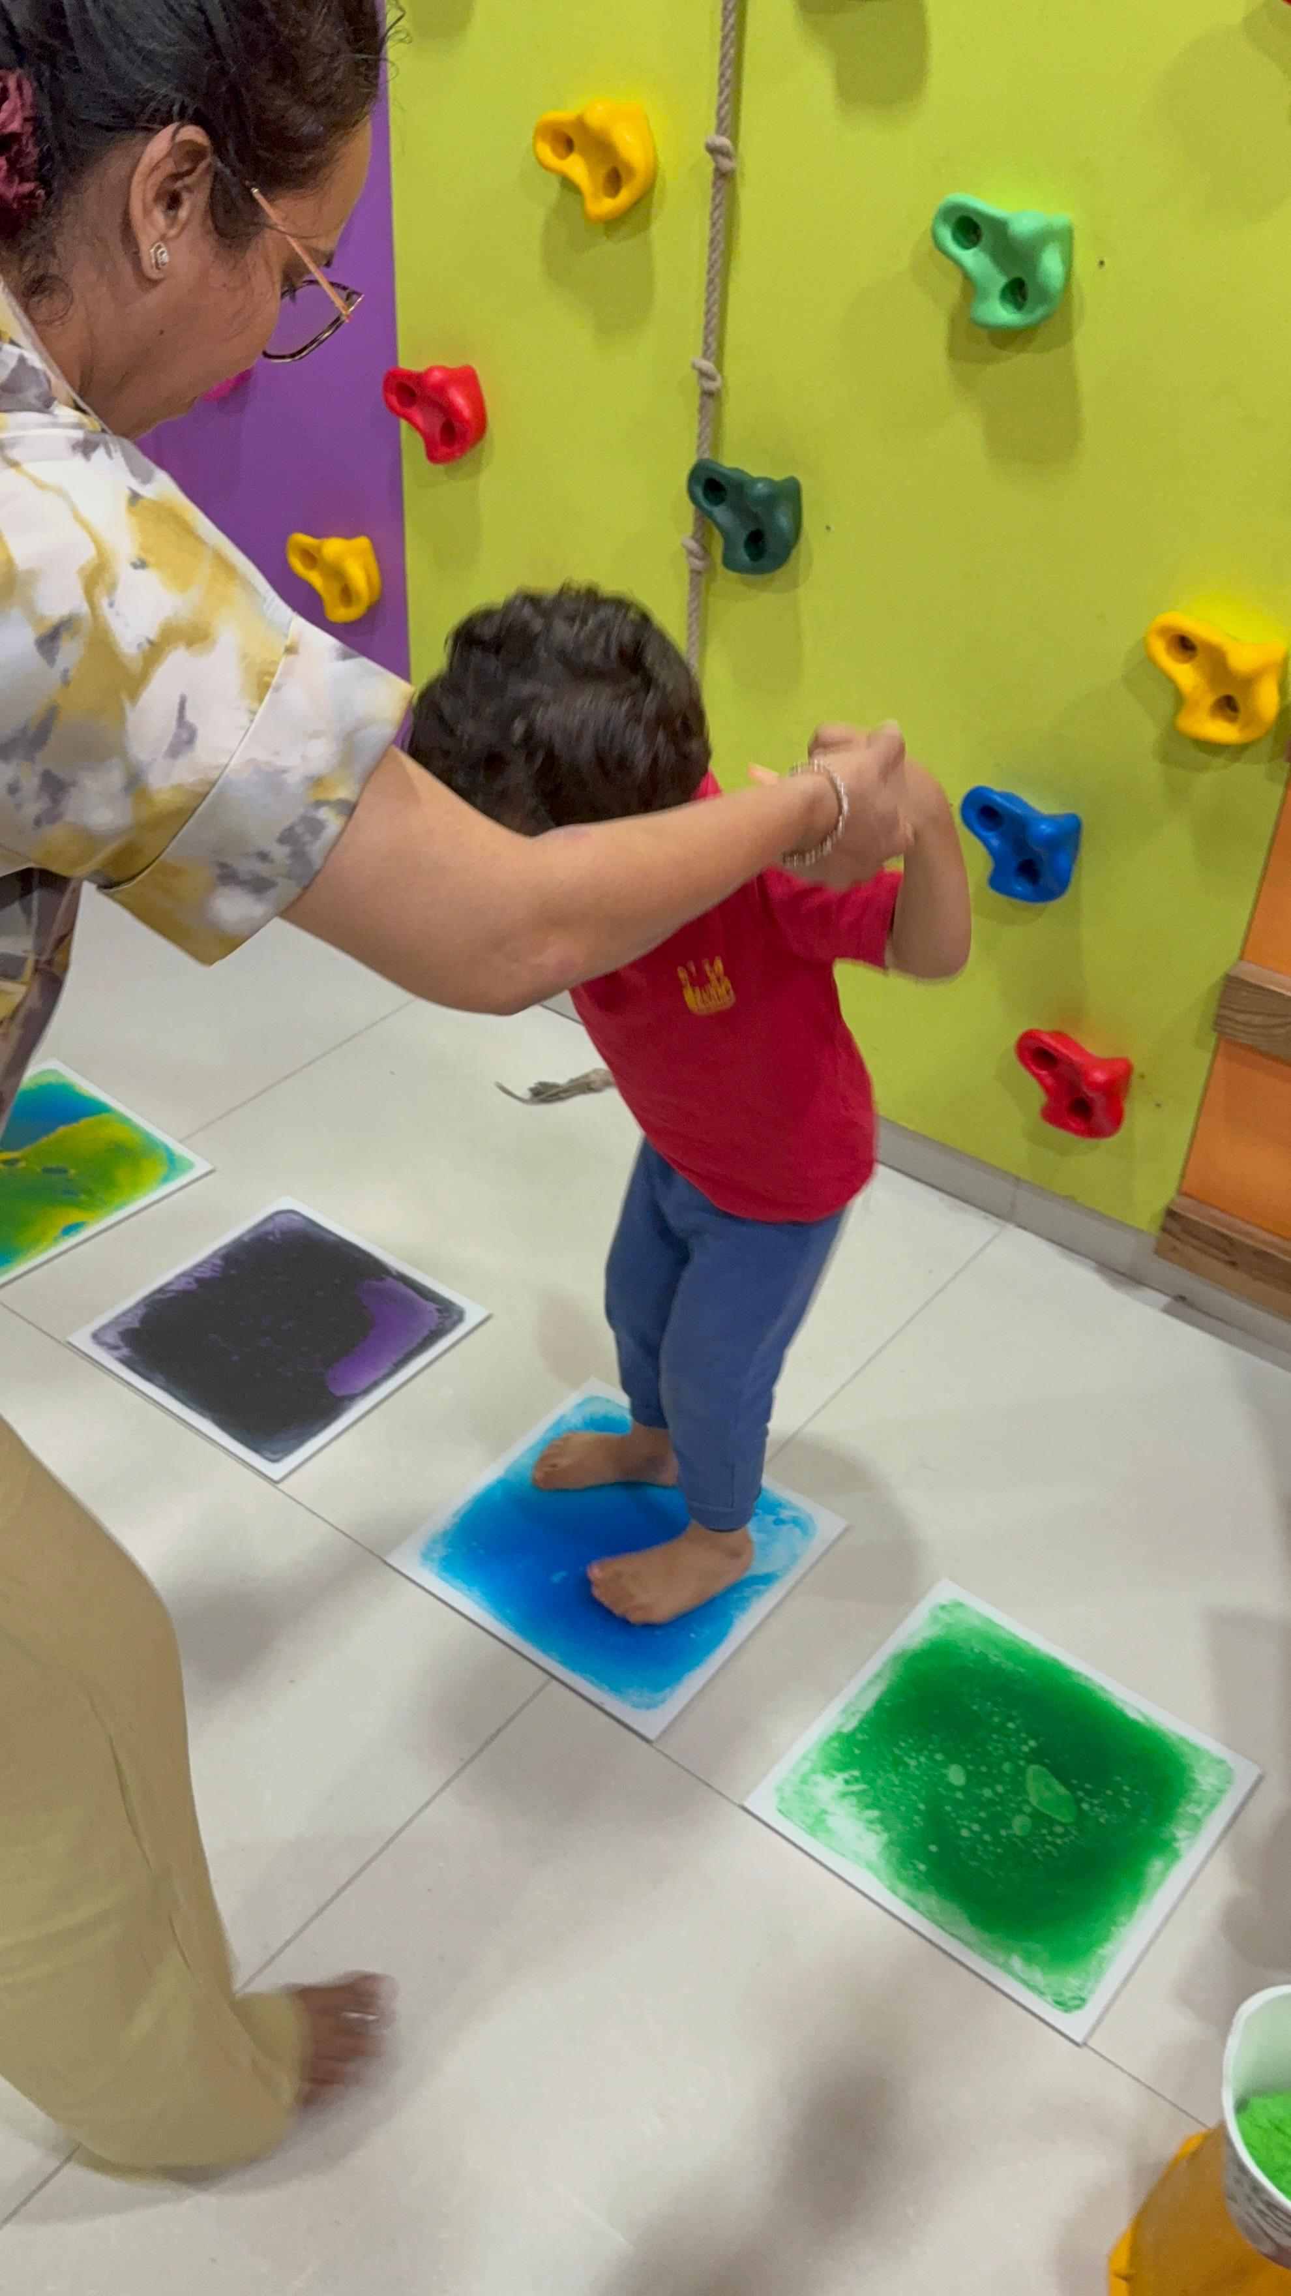

Sensory Processing & Regulation
When the world feels too loud, too scratchy, or too much — we help your child's nervous system find calm. Sensory integration isn't about fixing behaviour. It's about understanding what the body needs to feel safe and ready.

Feeding & Oral Motor Skills
Picky eating, gagging, or mealtime battles aren't always 'behaviour problems.' Often the mouth needs patient, playful preparation. We go at your child's pace — no forcing, no shame — so family meals can feel less stressful.
Image: Alt: Therapist-guided handwriting and fine motor practice on a chalkboard | Section: Feeding & Oral Motor Skills | Source: /images/therapy/handwriting-practice.jpg
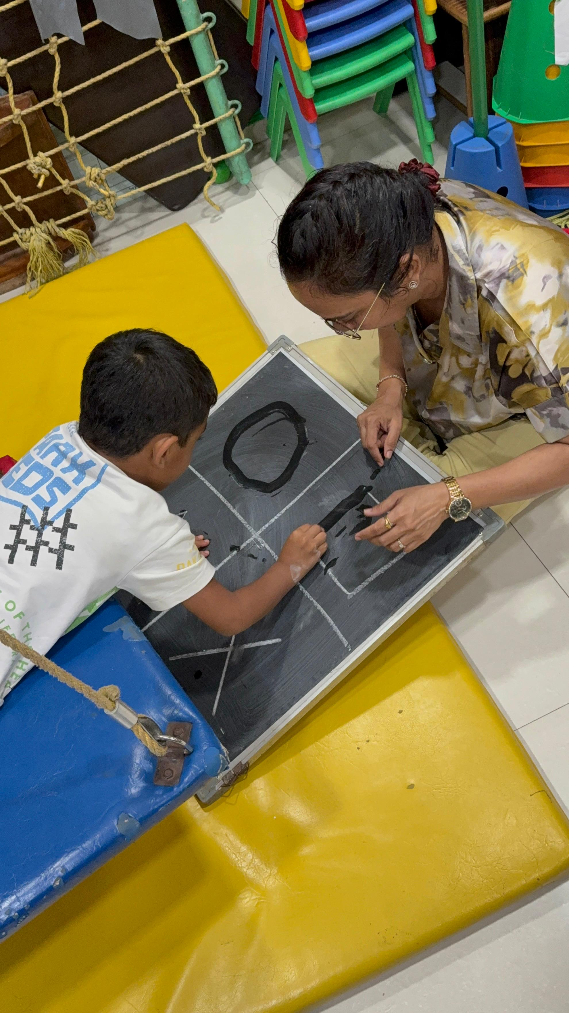

Handwriting & Learning Readiness
Messy handwriting isn't laziness. Often it's tired hands, weak grip, or a body that isn't ready to sit and write. We build foundations step by step — through play, not endless copying — so school tasks feel more possible.

Aquatic Therapy
In warm water, gravity softens and movement often feels possible for the first time. Children who avoid playgrounds or tire quickly on land frequently shine in the pool — supervised, playful, and always therapeutic.
Image: Alt: Child using sensory gym equipment with therapist support | Section: Aquatic Therapy | Source: /images/therapy-rooms/sensory-gym.jpg
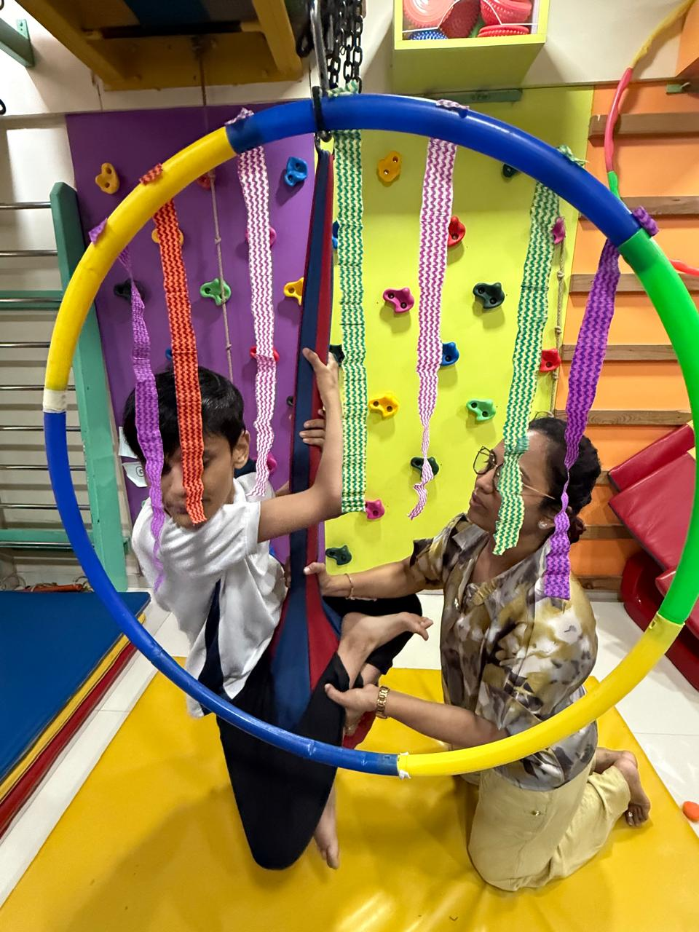

Reflex Integration
Sometimes the body holds onto early reflex patterns that make sitting, writing, and calming down harder than they need to be. RMTI® and MNRI® help rebuild those foundations — gently, respectfully, and always at your child's pace.

Every child's story is different
Whether it's attention, sensory needs, motor skills, or developmental concerns — we're here to help you understand what support might look like.

Autism Spectrum Disorder
Your child's way of being is respected here. We focus on what makes daily life easier — for them and for you.

ADHD
Your child isn't lazy. With the right support, they can feel capable again.

Cerebral Palsy
Every small gain is a real win. We notice them — and so will you.

Developmental Delay
Trust your instinct. You don't have to wait for a label to ask for help.

Sensory Processing Difficulties
It's not bad behaviour. It's a body that needs understanding.

Learning Difficulties
Bright children struggle too. That doesn't mean they can't succeed.

Families who trusted us with their journey
These words are shared with permission. Every child's path is different — but hope shows up in small, real moments.
“Dr. Sharuja understood our son from the very first session. His confidence at school and his ability to manage sensory overload have improved tremendously.”Parent of Aarav, 6Calmer school participation and improved self-regulation
“Dr. Sharuja understood our son from the very first session. His confidence at school and his ability to manage sensory overload have improved tremendously.”
Parent of Aarav, 6
Calmer school participation and improved self-regulation
“The handwriting program was a game-changer. Meera now writes with confidence, and her teachers have noticed a remarkable difference.”Parent of Meera, 8Legible handwriting and classroom readiness
“The handwriting program was a game-changer. Meera now writes with confidence, and her teachers have noticed a remarkable difference.”
Parent of Meera, 8
Legible handwriting and classroom readiness
“Aquatic therapy brought joy back into our child's life. He looks forward to every session and his balance and strength have grown so much.”Parent of Vihaan, 5Improved balance and joyful participation in therapy
“Aquatic therapy brought joy back into our child's life. He looks forward to every session and his balance and strength have grown so much.”
Parent of Vihaan, 5
Improved balance and joyful participation in therapy
“We felt heard, supported, and hopeful from day one. Dr. Sharuja's gentle approach made all the difference for our family.”Parent of Ananya, 7Stronger family routines and emotional connection
“We felt heard, supported, and hopeful from day one. Dr. Sharuja's gentle approach made all the difference for our family.”
Parent of Ananya, 7
Stronger family routines and emotional connection
Stories shared with parental consent. Individual outcomes vary.

Questions parents ask us most
Honest answers — and a full library of 100+ FAQs if you want to dig deeper.

What is pediatric occupational therapy?

Who needs occupational therapy for children?

How does OT help children with autism?

Can OT reduce meltdowns in autistic children?

Can OT help children with ADHD?

How is OT different from medication for ADHD?

Ready when you are
Book a consultation or send us a message. No pressure — just a warm conversation about your child and your concerns.

Headings
- Your child is doing their best. We're here to help the everyday things feel easier.
- You know your child best
- Hello, I'm Sharuja.
- Expertise Ecosystem
- Movement & Motor Development
- Sensory Processing & Regulation
- Feeding & Oral Motor Skills
- Handwriting & Learning Readiness
- Aquatic Therapy
- Reflex Integration
- Every child's story is different
- Autism Spectrum Disorder
- ADHD
- Cerebral Palsy
- Developmental Delay
- Sensory Processing Difficulties
- Learning Difficulties
- Families who trusted us with their journey
- Questions parents ask us most
- What is pediatric occupational therapy?
- Who needs occupational therapy for children?
- How does OT help children with autism?
- Can OT reduce meltdowns in autistic children?
- Can OT help children with ADHD?
- How is OT different from medication for ADHD?
- Ready when you are

Forms And CTA Labels
- Book Consultation -> /en/appointment
- Explore Expertise & Approaches -> /en/expertise
- Scroll to learn more -> #meet-doctor
- Read My Story -> /en/about
- Learn More -> /en/expertise/looking-beyond-a-diagnosis
- Learn More -> /en/expertise/sensory-integration
- Learn More -> /en/expertise/oral-placement-therapy
- Learn More -> /en/expertise/handwriting-without-tears
- Learn More -> /en/expertise/aquatic-therapy
- Learn More -> /en/expertise/mnri
- View All Expertise & Approaches -> /en/expertise
- Autism Spectrum DisorderYour child's way of being is respected here. We focus on what makes daily life easier — for them and for you.Learn more → -> /en/conditions/autism-spectrum-disorder
- ADHDYour child isn't lazy. With the right support, they can feel capable again.Learn more → -> /en/conditions/adhd
- Cerebral PalsyEvery small gain is a real win. We notice them — and so will you.Learn more → -> /en/conditions/cerebral-palsy
- Developmental DelayTrust your instinct. You don't have to wait for a label to ask for help.Learn more → -> /en/conditions/developmental-delay
- Sensory Processing DifficultiesIt's not bad behaviour. It's a body that needs understanding.Learn more → -> /en/conditions/sensory-processing-difficulties
- Learning DifficultiesBright children struggle too. That doesn't mean they can't succeed.Learn more → -> /en/conditions/learning-difficulties
- View All Conditions -> /en/conditions
- Read More Stories → -> /testimonials-milestones
- What is pediatric occupational therapy?
- Who needs occupational therapy for children?
- How does OT help children with autism?
- Can OT reduce meltdowns in autistic children?
- Can OT help children with ADHD?
- How is OT different from medication for ADHD?
- Browse All FAQs → -> /faqs
- Book a Consultation -> /en/appointment
- Contact Us -> /en/contact

JSON-LD / Schema Summary
- Type: FAQPage

